Chapter 4: Designing and Analyzing Jobs

Organizing Work for Strategic Success

Bureaucratic Structure
- Top-down management with many levels and hierarchical communication channels and career paths.
- Specialized jobs with narrowly defined job description.
- Independent performance based.

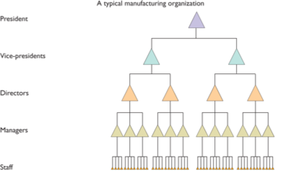

Flat
- Decentralized management approach; few levels and multi directional communication.
- Broadly defined jobs with general descriptions.
- Emphasis on teams and product development.

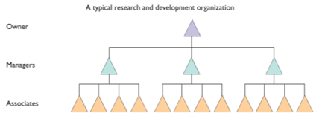

Matrix
- Each job has a functional and product component
- Finance personnel for product B are responsible to finance and Product B executive.
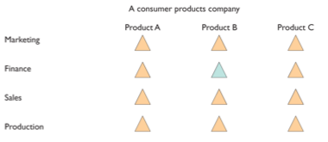

Job Design

Job Design
- Process of systematically organizing work into tasks required to perform a job

Job
- Group of related activities/duties for one or more employees

Position
- Collection of tasks/responsibilities performed by one person.

Job Design Considerations
- Job Specialization: work simplification; industrial engineering
- Behavioral Aspects: job enlargement; job rotation; job enrichment; tem based job design.
- Ergonomic Aspects: physical needs of workers.
- Increasing Job Flexibility: cognitively complex; more team-based; more dependent on social skills and technological analysis; time pressured; mobile; less dependent on geography.

Nature of Job Analysis
- Job analysis — procedure used to determine tasks, duties and responsibilities for each job and the KSA required to perform it.
- job analysis allows for job descriptions and specifications which then lead to HR planning, recruitment and selection, job evaluation, performance appraisal, labour relations, job design, etc.

Steps in Job Analysis
- Identify what the information will be used for.
- Review relevant background information
- Select representative positions/jobs to be analyzed.
- Analyze the jobs.
- Review analysis with incumbent/supervisor
- Develop job description/specification.

Collecting Qualitative Job Analysis Information
- Interviews [individual, group, supervisory]
- Questionnaires
- Observation
- Participant Diary/Log

Collecting Quantitative Job Analysis Information
- Position analysis questionnaire
  - Collects data concerning duties an responsibilities of various jobs
  - Structured questionnaire containing 194 items on six dimensions of job requirements:
    - Information input
    - Mental processes
    - Work output
    - Relationships with others
    - Job context
    - Pace and structure
- Functional Job Analysis
  - Quantitative method for classifying jobs based on types and amounts of responsibility for data, people, and things
  - Performance standards and training requirements are also identified.
- National Occupational Classification [NOC]
  - Reference tool for writing job descriptions and specifications
  - Compiled by the federal government (HumanResources&SkillsDevelopmentCanada).
  - Contains comprehensive, standardized descriptions of about 30,000 occupations and requirements of each.
  - Focuses on occupations [collection of jobs sharing the same duties] not jobs.

Writing Job Descriptions and Job Specifications
- Job Description: a list of duties, responsibilities, reporting relationships, and working conditions of a job— one product of a job analysis
  - Includes: job identification and summary, relationships, duties, authority, performance standards/indicators, working conditions
  - Not legally required; highly advisable
  - Online criteria examined should be the KSA required for the job.
- Job Specifications: list of KSA needed to perform the job— other product of job analysis.
  - Answers the question “What human traits and experience are required to do this job?”
  - All listed qualifications must be BFOR’s based on current job duties and responsibilities.
  - High educational/lengthy experience requirements = systematic discrimination.
  - Persons can be over/under qualified.
  - For entry level jobs, it is important to identify physical and mental demands.

