BPS 2110

Investigating the Lycopodiaceae family of plants for acetylcholinesterase inhibitor activity for the treatment of Alzheimer’s disease

November

Summary:
Alzheimer's disease (AD) is the most prevalent form of dementia and it has been hypothesized to be caused by a reduced synthesis of acetylcholine in the brain. Alkaloids isolated from various species of plants of the Lycopodiaceae family have shown to potentially serve as acetylcholinesterase inhibitors. Here we describe the acetylcholinesterase inhibitor activity of various species of plants from the Lycopodiaceae family.
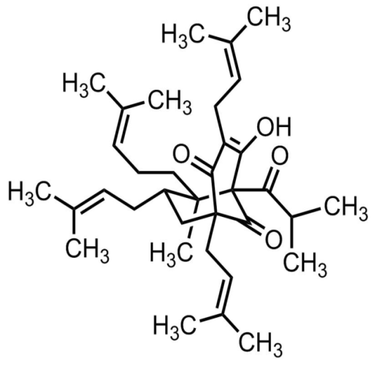
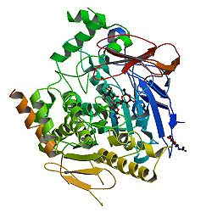

Huperzine A Acetylcholinesterase

-Keywords:
- Alzheimer’s disease
- Lycopodiaceae,
- Acetylcholinesterase

Background and Hypothesis:
Alzheimer’s Disease (AD) is the single most common cognitive impairment of dementia in our ageing society. Today, there are 7.4 million patients living with Alzheimer's disease in North America. For decades, AD was thought to be an untreatable disease, however, recent advancements in natural therapies has challenged this view. The cholinergic hypothesis proposes that the memory deterioration in patients with AD is due to deficits in the brain’s cholinergic system. The most notable deficiency is the decreased synthesis of acetylcholine. As such, extensive research has been done on pursuing acetylcholinesterase inhibitors for the treatment of Alzheimer’s disease.

Researchers have recently isolated various plant derived acetylcholinesterase inhibitors namely galantamine, an alkaloid from the Galanthus alpinus species, and Huperzine A, an alkaloid from the Chinese herb Huperzia serrate. In this report, two articles are featured in which researchers investigate the acetylcholinesterase inhibitory potential of various plant species from the Lycopodiaceae family of plants.

The goal of the first paper was to screen 11 native plant species of Lycopodiaceae for acetylcholinesterase inhibitory activity while at the same time evaluating the antioxidant activity in each plant extract. The goal of the second paper was to investigate the anticholinesterase effects of two species of plants from Lycopodiaceae, H. quadrifariata and H. reflexa, using an in vivo mice model and to then correlate the results with the chemical nature of the plant extracts.

Method of study:
The first paper used a specialized TLC bioautographic method for the development of their Anti- acetylcholinesterase assays. All 11 plant extracts were dissolved in methanol while the TLC plates were developed in a mixture of chloroform, methanol and water. To test for free radical scavenging ability, the extracts were placed on aluminium-backed silica gels and sprayed with a solution of DPPH.

In the second study, six groups of male mice were given various doses of H. reflexa and H. quadrifariata through intraperitoneal injections. Control mice were given injections of a saline solution and 20% DMSO. After 60 minutes, all mice were sacrificed and their brains were removed. The cortex and hippocampi were dissected out and the total acetylcholinesterase activity was determined using a spectrophotometric method.

Results:
In the fist paper, of the 11 plants investigated, only one, Lycopodium clavatum, showed strong inhibition of acetylcholinesterase, while seven plants showed moderate inhibition of acetylcholinesterase and three plants showed weak acetylcholinesterase inhibition. Of the seven plants that showed moderate acetylcholinesterase activity, two plants, H. chamaeleon and H. reflexa, showed antioxidant activity also. As such, Lycopodium clavatum, H. chamaeleon and H. reflexa are three plants from the Lycopodiaceae family that have the potential to be future targets for Alzheimer’s therapy.
In the second paper, H. quadrifariata inhibited enzyme activity in the cortex at all doses that were given to mice with a maximal inhibition rate of 50.4% at the 10 mg/mg dosage. In the hippocampus, H. quadrifariata also inhibited enzyme activity but this time, the maximal inhibition rate was 31% at the 10 mg/kg dosage. Similarly, H. reflexa inhibited enzyme activity in the cortex, achieving a maximal inhibition rate of 74% at the 10mg/kg dosage. In the hippocampus, H. reflexa was able to achieve a maximal inhibition rate of 53% at the same dosage. As these results show, H. reflexa and H. quadrifariata are two species from the Lycopodiaceae family of plants that exhibit acetylcholinesterase inhibition activity in the cortex and the hippocampus of mice and thus have the potential to be the focus of future AD treatments.

Facts about the Lycopodiaceae family of plants :

- Lycopodiaceae is a family of plants that are identified by their vascular characteristics and their ability to bear spores on specialized structures at the apex of their shoots.
- This family of plants has a lengthy history of existence and similar plants have been found as fossils in Devonian and Carboniferous rocks.
- Today, Lycopodiaceae is classified into 5 genera each with hundreds of species of cosmopolitan distribution.
- In the 1980’s, researchers found that a rare species from the Lycopodiaceae family called Huperzia serrate shows very high anti acetylcholinesterase activity. The active compound, Huperzine A, was isolated shortly after.
- Huperzine A has a molecular formula of C15H18N2O, a molecular weight of 242.32 g/mol and a melting point of 217° C
- Due to the rarity of Huperzia serrate, many scientist have been racing to find other species from the Lycopodiaceae family that also exhibit similar anti acetylcholinesterase activity.
- So far, Lycopodium clavatum, H. reflexa, and H. quadrifariata are three species of plants from the Lycopodiaceae family that show the most potential to be a replacement for Huperzia serrate.

Results:
1. E.L. Konrath, B.M. Neves, C.dos S. Passos, P.S. Lunardi, M.G. Ortega, J.L. Cabrera, C.A. Gonçalves, A.T. Henriques. Huperzia quadrifariata and Huperzia reflexa alkaloids inhibit acetylcholinesterase activity in vivo in mice brain. Phytomedicine. (2012), 19, 1321–1324.

2. A. Calderón, J. Williams, R. Sanchez, A. Espinosa, P. Gupta. Lycopodiaceae from Panama: A
new source of acetylcholinesterase inhibitors. Natural Product Research: Formerly
Natural Product Letters. (2012), 14, 82-85.

