Brain Imaging Techniques

- http://www.youtube.com/watch?v=3eZTAAIt3QU
- Advantages and disadvantages of each
- The basic of each technique knowing that we spent most time on PET and fMRI
- CT, PET, SPECT, MRI, TMS, MEG, fMRI

Computerized Tomography (CT) Scanning

- Static, structural images of bone, white vs. gray matter of brain tissue and CSF
- Produced by the differential absorption of X-rays
- Single plane images (2-dimensional)
- More sensitive than X-ray alone
- Requires injection of iodinated radiopaque material
- Used for visualization of blood vessels, tumors and abscesses
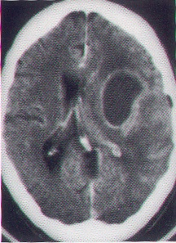
Original PET Scanner

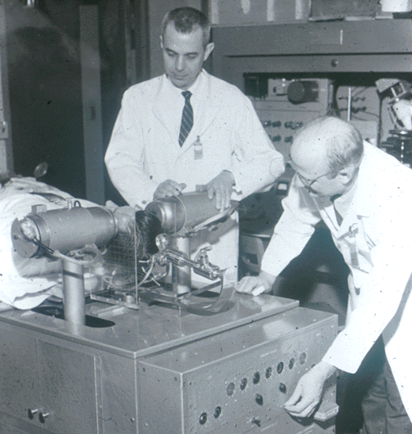

PET Scanners Now

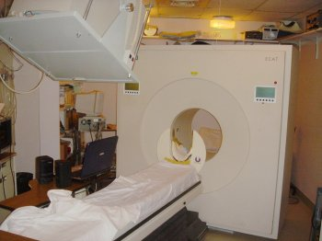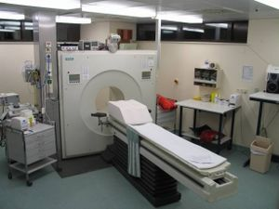

How does PET work?

- View extra slides

Positron Emission Tomography (PET)

- Revolutionized human cognitive processes and psychiatric and neurological disease
- Measures brain function by combining the principles of CT with radioisotopes - spatial resolution = 4-8 mm
- Able to measure the distribution of radioactively labeled tracers in the brain
- Images reflect the distribution in the tissue of an injected or inhaled isotope that emits radiation
PET

- Neuronal activity utilizes glucose - PET can map glucose metabolism with 2-deoxyglucose as it is taken up by neurons and phosphorylated similarly to glucose

PET Images

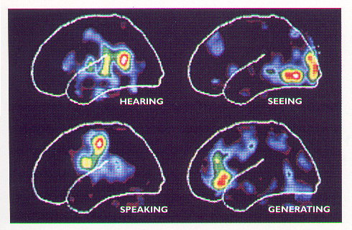

PET and Alzheimer’s
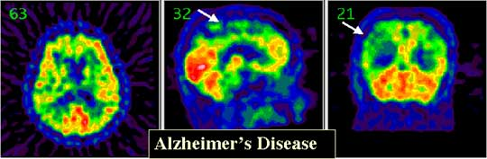
PET and Head Trauma
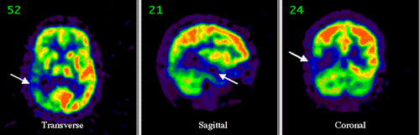

PET – Epilepsy
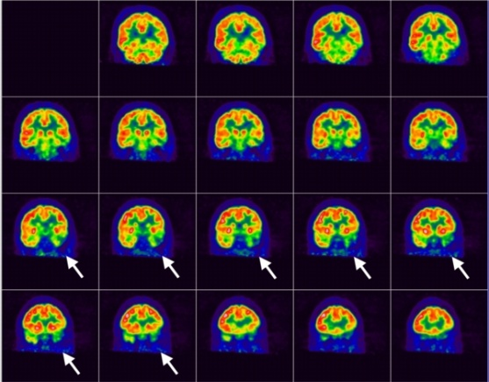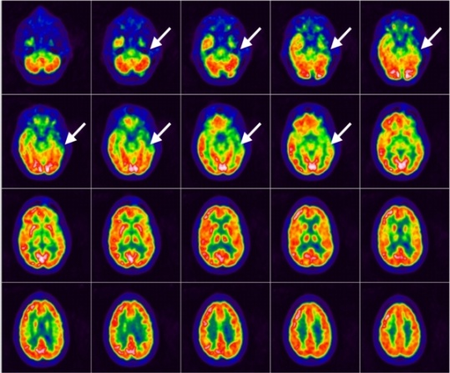

PET

- When the tracer is a ligand for a specific neuroreceptor, the distribution of the labeled tracer provides a quantitative measure of the spatial distribution of accessible receptors, concentration and kinetics of that receptor
- Neurotransmitters, their precursors and receptor ligands can also be labeled – good for drug studies
- A ligand that preferentially binds to DA receptors e.g. raclopride, can be used to map DA receptor location in the living human brain
PET and MDMA
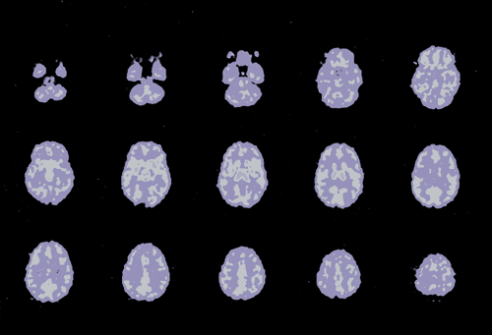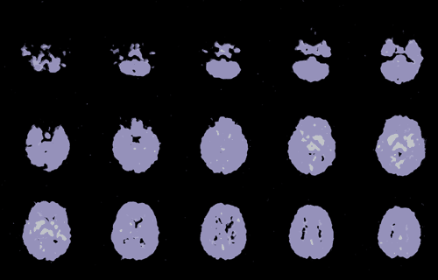

Single Photon Emission Computerized Tomography (SPECT)

- similar to PET but with much less spatial (10-14mm vs. 5-7mm) and temporal resolution
- requires injection of radioactive material

SPECT Images
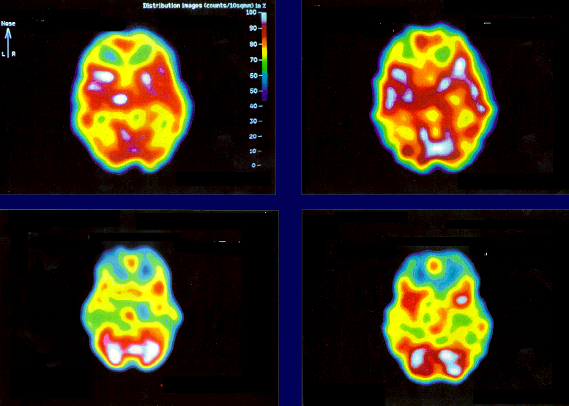

Disadvantages to PET and SPECT

- Poor spatial resolution
- There is competition between endogenous ligand and administered ligand that does not obey the laws of equilibrium binding that are observed in vitro
- Temporal resolution (minutes to hours - blocks)
- Injections of radioactive substances
- Poor patient compliance for return imaging
- Preparation of the labeled tracer (cyclotron)
- Behaviour of ligands
- Expensive ($2000 / hr)
MRI
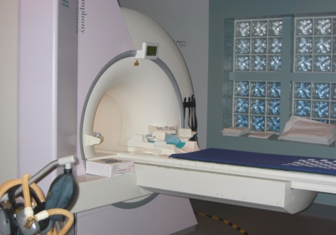

Magnetic Resonance Imaging

- Superior spatial resolution to CT = ~2 mm
- A strong magnetic field aligns the Hydrogen nuclei and causes them to spin along the direction of the applied field (compass needle)
- A radio frequency (RF) pulse tips the spinning nuclei away from the parallel orientation and provides energy
- When the pulse is turned off the nuclei return to their original orientation and release energy in the form of radio waves
- The rate at which nuclei return to a lower energy state is called “relaxation” = time constant T
- Distinct for white matter, gray matter, fat, CSF and infarctions / tumors
- Many modifications of MRI can yield further information, including MR Spectroscopy (MRS), Proton MR, MR Angiography (MRA), etc.
- MRS identifies the chemical makeup of a small voxel within the brain eg. Glycine, glutamine, glutamate, N-acetyl-aspartate, creatinine
MRI Examples
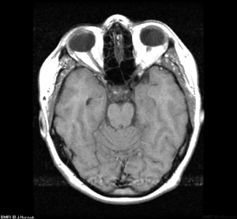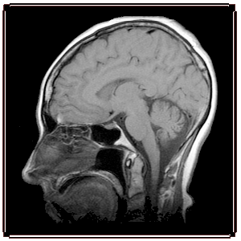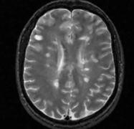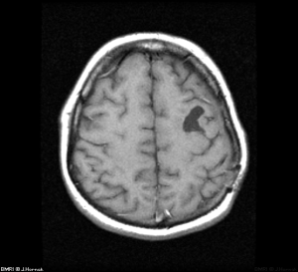

MRSpectroscopy
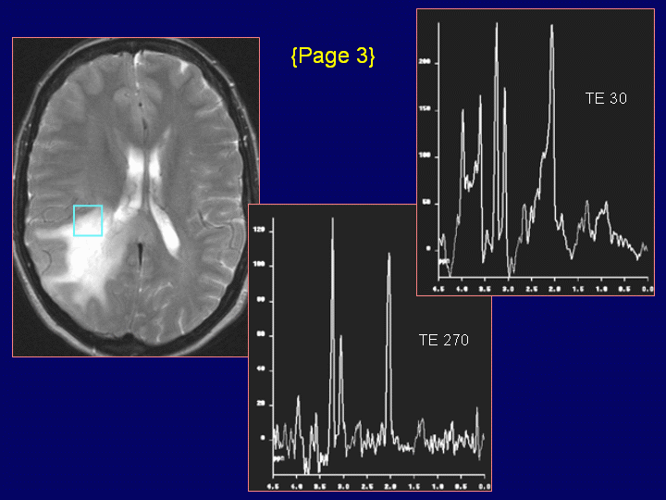

MRAngiography
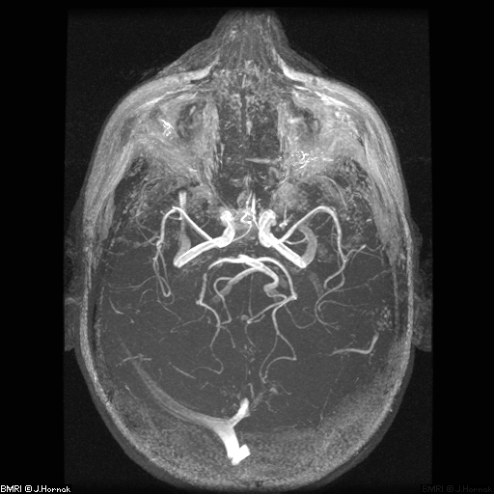

CT versus MRI
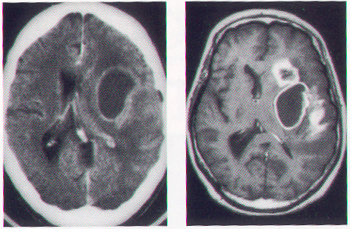
Transcranial Magnetic Stimulation
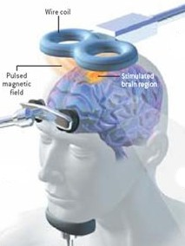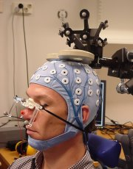
- The cell membrane sustains a potential difference between intra- and extracellular space. In static cells the transmembrane potential is about -70 mV.
- An externally applied electric field may deviate the cell's membrane potential, depolarize the membrane and hence activate excitable tissue.
- May affect gene activity, levels of neurotransmitters, and the formation of proteins important for cellular signaling—any of which could play a role in alleviating depression.

Magnetoencephalography (MEG)
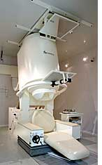
- MEG measures small electrical currents arising inside the neurons of the brain. These currents produce small magnetic fields. MEG generates a map of the magnetic fields produced by the neurons.
- Similar to EEG but less affected by skull and surrounding tissue, thus greater accuracy owing to the minimal distortion of the signal.
- Identifies areas of the brain that are generating seizures.

fMRI
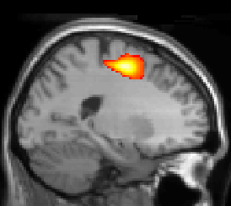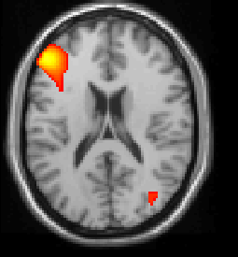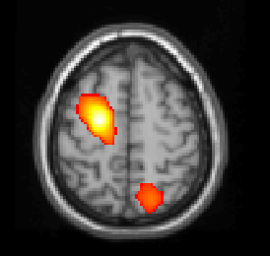
- Measure of blood flow in the brain during cognitive, emotional, behavioural tasks
- Has been validated by comparison studies with PET, ERP and lesion studies
- Noninvasive neuroimaging technique
- Naturally occurring contrast agent or the Blood Oxygen Level Dependent (BOLD) effect

BOLD Effect

- Indirect measure of neuronal activity
- Neuronal activity increases
- Local oxygenated blood increases
- Deoxyhemoglobin decreases
- Magnetic signal increases
- Magnetic change is quantified
- Check extra slides for Increased electrical signal
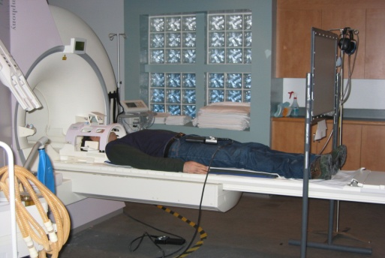

Go/No Go Task

- Stimuli - 50% X and 50% all other letters of the alphabet
- Presentation - each stimulus on for 75ms (ISI 925ms)
- Conditions - Press for X (x5); Press for all letters except X (x5)
- Response - Press the button as fast and as accurately as possible with right index finger for instructed stimuli
- Images - Collected throughout the task = 180 images

Go/No Go fMRI Parameters

- Whole brain echo planar fMRI
- Sampled the brain every 3 s
- Analyzed 180 images using Statistical Parametric Mapping (SPM)

Statistical Analysis

- 5 epochs “Press for X” averaged for 1 mean image
- 5 epochs “Press for all letters except X” for 1 mean image
  - Same sensory and motor processing for each condition.
  - More difficult to ignore the presence of a target letter (X) than to identify the presence of that target.

Response Inhibition =
Mean “Press for all letters except X” - Mean “Press for X”

Advantages of fMRI

- fMRI can show functional differences when no behavioural differences are present. The goal may be accomplished but the brain has done something very different.
- Can investigate plasticity of the brain
  - Compensation
  - Recruitment
  - Reorganization
- Spatial resolution is superior to ERP, PET and SPECT
- Ability to measure blood flow as neural activity occurs with almost real time temporal resolution (6 sec delay)
- Not invasive, no injections, repeat imaging possible
- Performed on standard clinical 1.5 T MR scanner

Problems with fMRI

- Baseline – rest is not a good control
- Required response device
- Movement artifact
- Susceptibility artifact (nasal cavity)
- Claustrophobia (no sedation possible)

What is fMRI Used For?

- Mapping brain function during…
- Motor Processing
- Somatosensory Processing
- Visual Stimulation
- Auditory Stimulation
- Higher Integrative Mental Activity
- Clinical / Neurological Disorders including…
- Psychopathy
- Schizophrenia
- Obsessive Compulsive Spectrum Disorders
- Depression
- Drug Abuse
- Multiple Sclerosis
- Fragile X Syndrome
- Attention Deficit Hyperactivity Disorder
- Post Traumatic Stress Disorder
- Alzheimer’s
- Parkinson's
- Presurgical Mapping
- fMRI can accurately localize the motor strip or language area pre-operatively in patients with lesions near these critical areas to ensure excision will not result in deficits
- 3x less expensive than the Wada test for language dominance.
- Pharmacological Assessment
- Quantify blood flow in response to administered drugs ie. Cocaine, Nicotine
- Measuring neural activity before and after a drug treatment, for example ROH depression study
- Head Injury and Stroke
- Determining the functional consequences of anatomic lesions in a patient.
- Understanding details of how the brain is organized and how it can reorganize and compensate for damage ie. Rehabilitation.
- Helping with long term prognosis of head injury and stroke by assessing functioning rehabilitation and making each program personal.

Image Set Up At Ottawa Hospital

- Image in clinical ‘off times’
- Team of Collaborators – Multidisciplinary
- MRI technologists
- Neurologists
- Neuropsychologists
- Neuroradiologists
- Neuroscientists
- Physicists
- Psychiatrists
- Psychologists

