Disorders of Brain and Behaviour

Psychiatric and Neurologic

- Depression
- Alzheimer's
- Schizophrenia
- Bipolar
- Panic Disorder
- Drug Abuse
- Personality Disorders
- ADD – ADHD
- Tourette’s Syndrome
- Stroke
- Head injury
- Congenital
- Epilepsy
- Encephalitis
- Meningitis
- Autism
- Multiple Sclerosis

Scales

- Glasgow Coma Scale (3-15)
- Mini Mental Assessment (0-30)
- ICD-10 = The International Statistical Classification of Diseases and Related Health Problems
- DSM-IV = Diagnostic and Statistical Manual of Mental Disorders - Fourth Edition (Axis I, Axis II)
  - AXIS 1 - major psychiatric disorders
  - AXIS 2 - personality disorders

Glasgow Coma Scale (3-15)

- Eye Opening
  - None 1 = Even to supra-orbital pressure
  - To pain 2 = Pain from sternum/limb/supra-orbital pressure
  - To speech 3 = Non-specific response, not necessarily to command
  - Spontaneous 4 = Eyes open, not necessarily aware
- Motor Response
  - None 1 = To any pain; limbs remain flaccid
  - Extension 2 = Shoulder adducted and shoulder and forearm internally rotated
  - Flexor response 3 = Withdrawal response or assumption of hemiplegic posture
  - Withdrawal 4 = Arm withdraws to pain, shoulder abducts
  - Localizes pain 5 = Arm attempts to remove supra-orbital/chest pressure
  - Obeys commands 6 = Follows simple commands
- Verbal Response
  - None 1 = No verbalization of any type
  - Incomprehensible 2 = Moans/groans, no speech
  - Inappropriate 3 = Intelligible, no sustained sentences
  - Confused 4 = Converses but confused, disoriented
  - Oriented 5 = Converses and oriented
Mini Mental Assessment (0-30)

- ORIENTATION – one point for each answer
  - Ask: “What is the: (year)(season)(date)(day)(month)?” ____
  - Ask: “Where are we: (state)(county)(town)(hospital)(floor)?” ____
- REGISTRATION – score 1,2,3 points according to how many are repeated
  - Name three objects: Give the patient one second to say each.
  - Ask the patient to: repeat all three after you have said them.
  - Repeat them until the patient learns all three. ____
- ATTENTION AND CALCULATION – one point for each correct subtraction
  - Ask the patient to: begin from 100 and count backwards by 7. Stop after 5 answers - (93, 86, 79, 72, 65) ____
- RECALL – one point for each correct answer
  - Ask the patient to: name the three objects from above. ____
- LANGUAGE
  - Ask the patient to: identify and name a pencil and a watch. (2 points) ____
  - Ask the patient to: repeat the phrase “No ifs, ands, or buts.” (1 point) ____
  - Ask the patient to: “Take a paper in your right hand, fold it in half, and put it on the floor “ (1 point for each task completed properly) ____
  - Ask the patient to: read and obey the following: “Close your eyes.” (1 point) ____
  - Ask the patient to: write a sentence. (1 point) ____
  - Ask the patient to: copy a complex diagram of two interlocking pentagons. (1 point) ____

Example ??

- The patient fulfills a total of at least 6 criteria from the following 3 lists, distributed as indicated:
  - Impaired social interaction (at least 2):
    - Markedly deficient regulation of social interaction by using multiple non-verbal behaviours such as eye contact, facial expression, body posture and gestures
    - Lack of peer relationships that are appropriate to the developmental level
    - Doesn't seek to share achievements, interests or pleasure with others
    - Lacks social or emotional reciprocity
  - Impaired communication (at least 1):
    - Delayed or absent development of spoken language for which the patient doesn't try to compensate with gestures
    - In patients who can speak, inadequate attempts to begin or sustain a conversation
    - Language that is repetitive, stereotyped or idiosyncratic
    - Appropriate to developmental stage, absence of social imitative play or spontaneous, make-believe play
  - Activities, behavior and interests that are repetitive, restricted and stereotyped (at least 1 of):
    - Preoccupation with abnormal (in focus or intensity) interests that are restricted and stereotyped (such as spinning things)
    - Rigidly sticks to routines or rituals that don't appear to have a function
    - Has stereotyped, repetitive motor mannerisms (such as hand flapping)
    - Persistently preoccupied with parts of objects

Histrionic

- A pervasive pattern of excessive emotionality and attention seeking, beginning by early adulthood and present in a variety of contexts, as indicated by 5 (or more) of the following:
  - Discomfort with situations in which the patient is not the center of attention.
  - Relationships that are frequently fraught with inappropriately seductive or sexually provocative behaviour.
  - Expression of emotion is shallow and rapidly shifting.
  - Frequent focusing of attention on self through use of physical appearance.
  - Speech is vague and lacks detail.
  - Overly dramatic expression of emotion.
  - Easy suggestibility (readily influenced by opinions of other people).
  - Belief that relationships are more intimate than they really are.

Treatments

- Biofeedback
- Pharmacotherapy
- Surgery
- Psychotherapy
- Cognitive therapy
- Stem cells

Parkinson’s Disease

- Tremors in relaxed limbs
- Rigidity - a result of simultaneous contraction of flexors and extensors, which tends to lock up the limbs
- Bradykinesia - slowness of movement / difficulty initiating voluntary movement
- Postural instability
- Lack of balance and coordination
- Possible dementia, depression and executive functioning impairments.
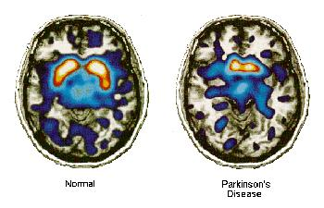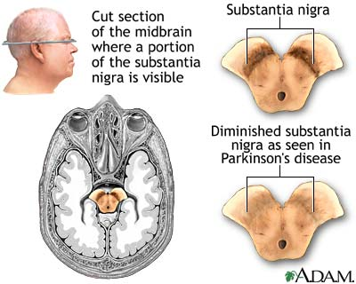
- MPTP – drug induced Parkinson’s symptoms – depletion of substantia nigra DA.
- Nigrostriatal DA pathway = Substantia Nigra to Striatum
- Post-mortems - < 100,000 nigral neurons = DA starved striatum
- ~ 60% of nigral neurons have to be lost, with an 80% depletion of striatal DA, before the symptoms of PD develop.
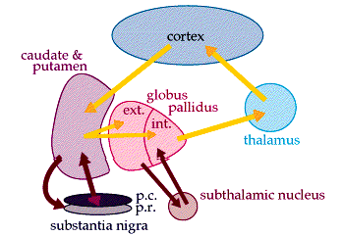
Treatments for Parkinson’s

- MAO inhibitor e.g. Eldepryl – slows down breakdown of DA
- L-DOPA is initially good but becomes problematic (eventual dyskinesia) and is required at greater and greater doses as the disorder progresses.
- Sinemet = L-DOPA plus carbodopa (inhibitor that prevents L-DOPA from being absorbed by tissues other than the brain)
- Use of DA agonists delay use of L-DOPA, reduce eventual dose of L-DOPA and reduce motor problems e.g. Requip and Mirapex.
- e.g. Rascol study

Rascol Study

- Subjects: early PD untreated patients
- Treatment groups
  - Treated with ropinerole (agonist) + could get supplemental L-DOPA or
  - L-DOPA and could only have dose increased
- After 5 years
  - 46% in group 2) had dyskinesia
  - 20% in group 1) had dyskinesia whether supplemented with L-DOPA or not
- PD symptoms were same in each group.
- Better to use a DA agonist for as long as possible.

Fetal DA Neuron Transplants
- Tissue from ventral midbrain of aborted fetuses at 6-9 weeks post-conception.
- Surgically placed into the caudate and/or putamen.
- Grafts reinnervate the denervated striatum, form synaptic connections with host neurons, release DA and produce some functional recovery.
- Mild to moderate improvement in motor disturbances without major side effects.

Lesions

- Pallidotomy or thalamotomy = small electrocoagulative lesions are made in the internal segment of the Globus Pallidus or the ventrolateral nucleus of the thalamus, respectively. Pallidotomy reduces rigidity while the thalamotomy relieves tremor.
- Lesions of the subthalamic nucleus ameliorate some of the motor disturbances (tremor, rigidity, akinesia, bradykinesia) in PD.

Brain Derived Neurotrophic Factor (BDNF)

- BDNF = protein, that in human embryonic midbrain cultures, increases DA content, tyrosine hydroxylase activity, dopaminergic cell body size, neuritic development and complexity.
- BDNF is reduced in the Substantia Nigra, Caudate and Putamen of PD patients.
- L-DOPA increases the expression of BDNF in the striatum of healthy mice.
- BDNF protect DA neurons from toxins so perhaps it could be used as a therapeutic agent against PD?

Role of Glial Derived Neurotrophic Factor (GDNF)

- Injection of GDNF in the striatum or Substantia Nigra of PD rats,
  - Rescues the cell bodies in the substantia nigra
  - Preserves the nigrostriatal projection of DA to the striatum
  - Sustained GDNF over 3–6 months promotes regeneration and significant functional recovery in DA depleted rats and monkeys.
  - Over-expression of GDNF within the nigrostriatal system that is sufficient to block the toxin-induced degeneration of the nigral DA neurons = possibility that this might be a tool for neuroprotective treatments in patients with PD disease.
Other Treatments
- Deep brain stimulators of thalamus and subthalamic nucleus.
- Repeated intramuscular administration of vitamin E exerts a rapid protective effect on the nigrostriatal dopaminergic neurons in the early unilateral model of PD in animals.
- Stem cells.
Subthalamic Nucleus Stimulation

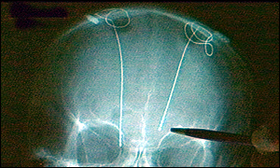

Stem Cells

- Capable of dividing and renewing themselves for long periods through cell division
- Unspecialized
- Can give rise to specialized cell types under certain physiologic or experimental conditions, e.g. special functions such as the beating cells of the heart muscle or the DA producing cells of the brain.
- Can get them not only from embryonic tissue but from adult bone marrow, unbilical cord tissue, adult skin cells
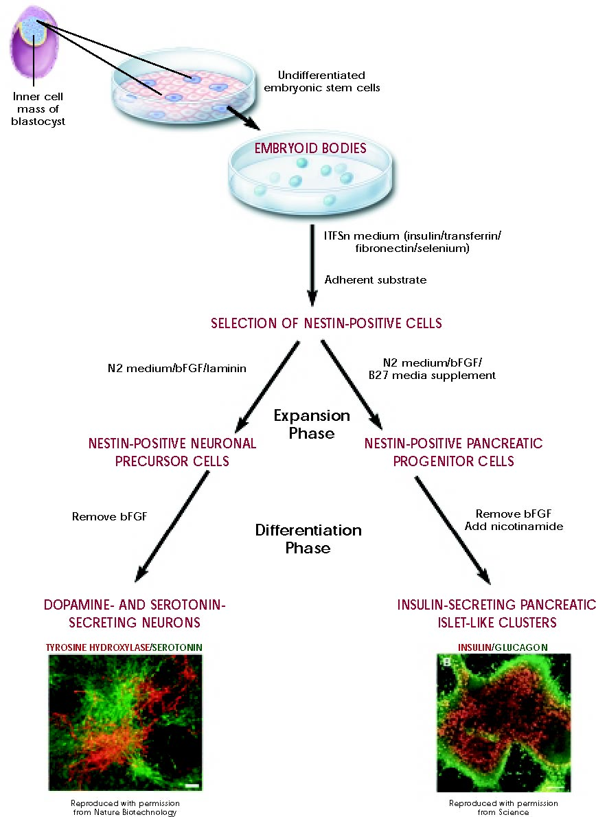
- In the 3- to 5-day-old embryo, stem cells in developing tissues give rise to the multiple specialized cell types that make up the heart, lung, skin, brain and other tissues.
- In some adult tissues, such as bone marrow, muscle, and brain, discrete populations of adult stem cells generate replacements for cells that are lost through normal wear and tear, injury, or disease.

Embryonic Stem Cells

- Stem cells taken from a human embryo.
- Added a gene that produces an antitumour molecule named TRAIL.
- Injected the stem cells into mice with brain tumours.
- The cells localized on the cancer and produced enough TRAIL to cut the tumour size by 50%-70%.
- The cells track the tumour by following chemical signals emitted by the immune system molecules that attack, but fail to destroy, the cancer.
- There have been other animal models of brain injury where naturally occurring stem cells will travel towards and try to repair damaged areas.
Stem Cells in Humans

- National Institute of Neurological Diseases and Stroke
- Brain tissue from female post mortems who had bone marrow transplant from male donors.
- All patients had brain tissue with clumps of Y-positive cells.
- Suggesting that the original donor cells had continued to multiply after differentiating into brain cells.

Umbilical Cord Cells

- Can inject into jugular vein or directly transplant into the brain.
- Researchers first gave the drug, mannitol, to provide temporary passage through the blood-brain barrier then transfused human umbilical cord blood cells into a stroke animal model.
- When used in the first hours and days following a stroke, stroke size decreased by 40 percent and resulting disability was significantly reduced.
- This treatment significantly increased brain levels of neurotrophic factors, which correlated positively with reduced cerebral infarcts and improved behavioural functions.

Deprogramming Stem Cells

- Kyoto Japan, University of Wisconsin
- Created pluripotent human stem cells using ‘deprogramming’ human somatic cells (skin fibroblasts).
- Expose skin cells to specific signaling agents that reprogram the genetic expression pattern of a cell.
- Cells switch from skin cell precursors to more embryonic-like, capable of developing into various other tissues and organ-specific cells.

Controlling Stem Cells

- How cells in the blood enter the brain?
- How to induce them to enter the brain in larger numbers?
- How to promote their differentiation into neurons?
- How to target them to areas of need?
- Are the internal and external signals for cell differentiation similar for all kinds of stem cells?
- Can specific sets of signals be identified that promote differentiation into specific cell types?
- Prevent the introduction of harmful viruses or immune reactions.

Epilepsy

- Elton John, Alexander the Great, Charles Dickens, Vincent Van Gogh, Peter Tchaikovsky, Napoleon, Danny Glover, and Albert Einstein all had epilepsy!
- Epilepsy affects 1% of the population and is thus one of the most common neurological diseases. It can begin at any age.
- Epilepsy is defined as recurring seizures resulting from abnormal, temporary, cell firing, or electrical function in the brain (~5% of all people have a seizure at some point but do not necessarily develop epilepsy).
- In approximately 30% of cases, epilepsy is caused by such events as head trauma, tumor, stroke, or infection. Other reasons are related to a genetic predisposition for epilepsy or an unknown source.
- Epilepsy can produce many kinds of seizures, depending on the part of the brain that is affected.

Frontal Lobe Seizure

Generalized Seizures

- Generalized seizures involve the whole brain. The person loses consciousness and does not remember the seizure afterwards.
- Tonic-clonic: the person becomes rigid and may fall. Then, the muscles relax and tighten rhythmically (a convulsion). The seizure may last for several minutes, leaving the person tired and confused.
- Tonic: muscles tighten without convulsions. A risk of falling, but the seizure does not usually last long or cause tiredness and confusion.
- Atonic: muscles lose tone suddenly. Falling is a risk; recovery is rapid.
- Myoclonic: rapid jerking of one or more limbs, often right after waking from sleep. Can occur in combination with other types of generalized seizures.
- Absence: a temporary lapse of consciousness during which the person stares blankly and does not respond.

Partial Seizures

- Partial seizures involve only a part of the brain and do not always cause loss of consciousness. There are two types:
- Simple: unusual sensations or movements in a part of the body, such as strange tastes, twitching of part of a limb, and partial numbness of an area. Sometimes precede another type of seizure and are then termed "warning" seizures.
- Complex: a decrease in awareness accompanied by repetitive movements such as pacing, chewing, and mumbling. Person may or may not be responsive.

Causes and Triggers

- Brain damage related to birth.
- Brain infection.
- Brain tumours.
- Abnormalities in blood vessels of the brain.
- Genetics.
- Unknown.
- Alcohol - heavy drinking
- Stress
- Patterns of light, especially flickering or rapid strobe light
- Late nights, shift work, and lack of sleep
- Illness, especially with high fever
- Hormones - seizures can be increased just before or during first days of menstruation
Surgery
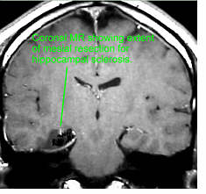
Surgery as Treatment

- The following conditions must be fulfilled:
- The epilepsy must be characterized by partial seizures with or without generalized seizures as well.
- The seizures must be resistant to reasonable efforts at control with medication.
- The proposed surgical procedure must carry a sufficiently low risk of causing unacceptable neurological impairment.
- Epilepsy must be the person’s most disabling medical problem.

Alternate Treatment

- Vagus nerve stimulation (VNS) is designed to prevent seizures by sending regular, mild pulses of electrical energy to the brain via the vagus nerve. These pulses are supplied by a device something like a pacemaker.
- This ‘pacemaker for the brain’ is placed under the skin on the chest wall and a wire runs from it to the vagus nerve in the neck.
- The vagus nerve is part of the autonomic nervous system, which controls functions of the body that are not under voluntary control, such as heart rate. The vagus nerve passes through the neck as it travels between the chest and abdomen and the brainstem of the brain.

Vagus Nerve Stimulation
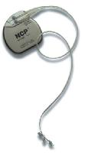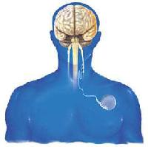
- VNS produces desynchronization of cortical EEG and measurable changes in blood flow in the cerebellum, thalamus and cortex. Perhaps this occurs by activating inhibitory structures in the brain but the precise mode of action of VNS is not known .
- Other areas possibly activated by VNS include the medulla,, parabrachial nucleus, locus coeruleus, hypothalamus, amygdala, hippocampus, cingulate gyrus, and contralateral somatosensory cortex.
- It is thought that perhaps VNS decreases cortical epileptiform activity indirectly by influencing the reticular activating system or that VNS increases the seizure threshold by causing widespread release of GABA and glycine in the brain.

Studies of VNS

- Ben-Menachem et al measured amino acid and neurotransmitter metabolite concentrations in cerebrospinal fluid (CSF) samples of patients on clinical trials of VNS before and 3 months after VNS placement.
- Responders to the VNS had larger amounts of GABA and less glutamate after treatment.

Excitotoxicity

- Glutamate is the most prevalent neurotransmitter in the brain and plays a role in several major neurological processes like LTP.
- When the brain is injured it releases abnormally large amounts of glutamate, over-stimulating the glutamate receptors on the surface membranes of postsynaptic neurons.
- This in turn, causes unusually large amounts of calcium to enter the nerve cells which disrupts biochemical processes within the neuron and activates enzymes that produce free radicals.
- Free radicals are structurally unbalanced chemicals capable of destroying other compounds that form the internal structure of neurons.
- Neuronal cell death as a result of this increase in glutamate and influx of calcium that results in increased free radicals = Excitotoxicity.

Disorders Involving Excitotoxicity

- Excitotoxicity can be triggered by anything that deprives the brain of its normal supply of oxygen e.g. Stroke. That is why there is cell death in the area where the stroke occurs.
- Most treatments to help stroke sufferers needs to be administered quickly after the stroke begins. These drugs include glutamate receptor antagonists.
- These drugs can also be used for traumatic brain injury, epilepsy and hypoglycemia – all disorders that can lead to reduced oxygenation and thus excitotoxicity.
- Parkinson, Huntingtons and Alzheimers also have been linked to excitotoxicity so these drugs might help with these disorders also.

Stroke Treatment

- Thrombolytic drugs = drugs that immediately dissolve the blood clots that cause many strokes, drastically reducing the amount of damage strokes produce. E.g. Tissue plasminogen activator (tPA), r-tPA, streptokinase, urokinase and prourokinase.
- Thrombolytics, however, only work if delivered directly into the bloodstream, either through a vein or an artery (intra-arterial) and only if administered within a few hours of the stroke before the oxygen-deprived nerve cells suffer permanent damage.
- The time window for getting the best results from thrombolytic drugs is three hours from the first signs of stroke.
- ‘Time is brain’
Time is Brain

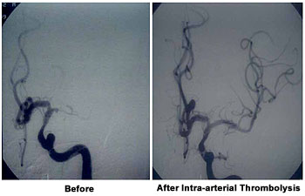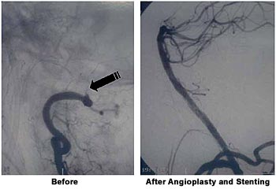

Apoptosis

- Not just excitotoxicity causes neuronal death but an internal self destructive chemical program = cell suicide occurs in response to the damage caused by a lack of oxygen to neurons.
- Need to have drugs that can prevent both excitotoxicity and apoptosis.
- Apoptosis is implicated in the progressive loss of oligodendrocytes in multiple sclerosis.
- Free radicals are also thought to be a major player in aging.

Summary

- Identify and classify disorder.
- Many potential sources of disorders of brain and behaviour e.g. anatomy, chemistry, physiology, genetics, environment.
- New treatments are on the horizon. Animal research needs to be done as do human clinical trials.

