Chapter 7 – How Do Drugs and Hormones Influence the Brain and Behaviour?

Hormones

- Chemicals released by an endocrine gland.
- 8 endocrine glands
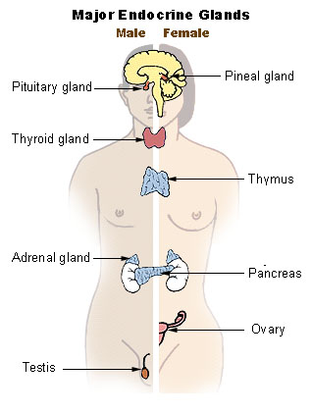
- Hierarchical Control
  - Hormones affect almost every neuron in the brain
  - Hormones Neurons Genes Proteins
  - Four Levels
    - Hypothalamus (releases neurohormones that stimulate the pituitary)pituitary gland (pump hormones into the circulatory system)target endocrine glands (release appropriate hormones into the bloodstream)target organs and tissues (almost every neuron in the brain contains receptors on which various hormones can act)
    - Hypothalamus
      - Hypothalamus links the nervous system to the endocrine system.
      - The pituitary gland and the hypothalamus are the primary regulators of the endocrine system.
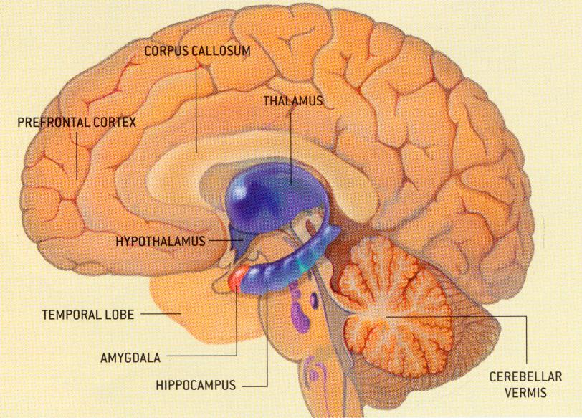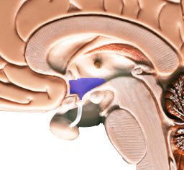
    - Pituitary Gland
    - Target Endocrine Glands
    - Target Organs and Tissues

Endocrine System

- Ultimately the hypothalamus can control every endocrine gland in the body
- AND: alter blood pressure, body temperature and metabolism, adrenaline levels
  - All through the release of hormones

Involvement of Hormone Secretions

- Factors involved in controlling hypothalamic hormone-related activity
  - Feedback Loops
    - Control the amount of hormone that is released
  - Neural Regulation
    - Other brain regions (e.g., limbic system and frontal lobes) influence hormone release
  - Experiential Responses
    - Experience can alter the structure and function of hypothalamic neurons
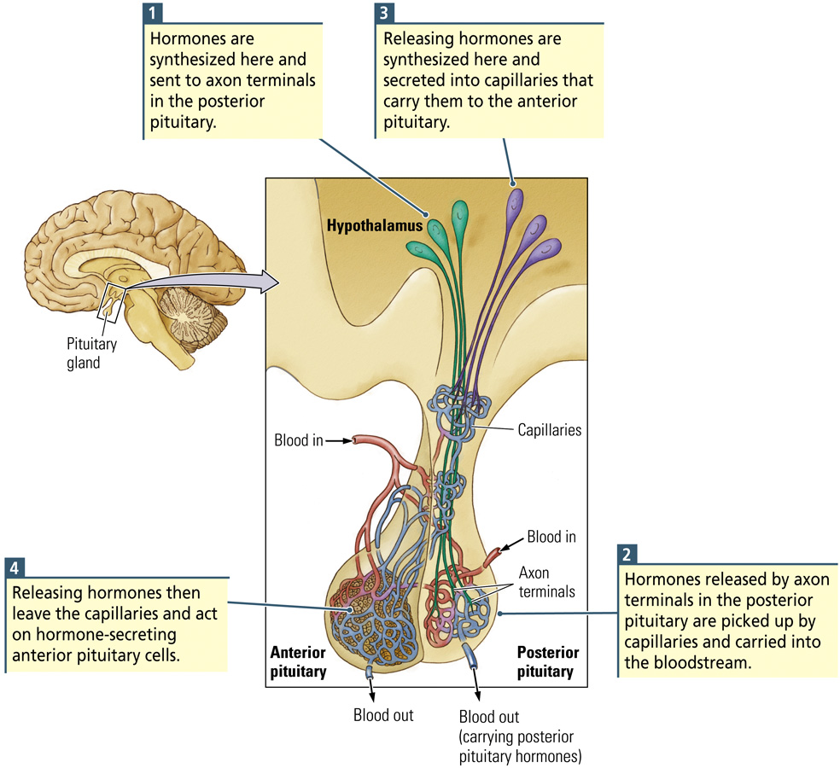

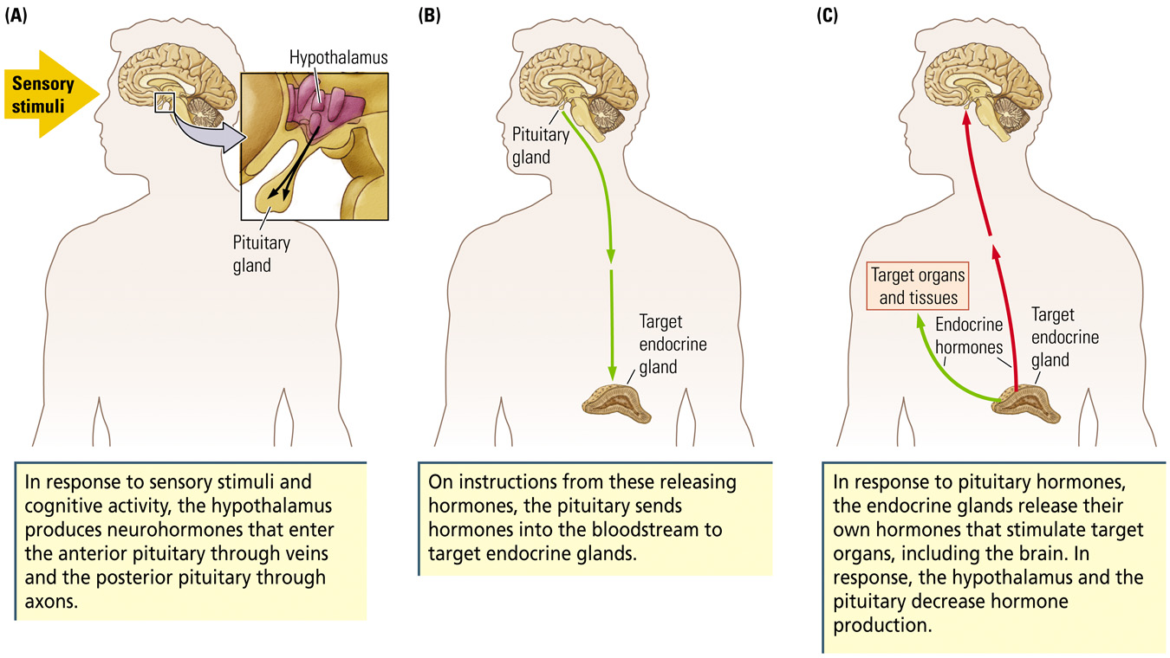
Pituitary Gland

- Hypothalamus produces releasing or release-inhibiting hormone in response to various stimuli processed by the nervous system
- It sends them into the pituitary gland and then
- The posterior pituitary carries the hormone into the bloodstream where they affect other regions of the body
OR
- The anterior pituitary stimulate/ inhibit production and secretion of hormones.

Posterior Pituitary Gland

- Antidiuretic hormone (ADH)=vasopressin Causes the kidneys to form more concentrated urine, conserving water. Thus, the kidneys produce urine with a high solute concentration.
- Oxytocin – Stimulates contractions of the uterus during labour, also causes the release of milk from a nursing mother.
- Both are produced by and released from the hypothalamus.

Anterior Pituitary Gland

- The Master Gland produces
- Growth hormone (GH) that promotes cell division, protein synthesis, bone and muscle growth.
- Prolactin (PRL) – causes mammary gland in breast to develop and produce milk. Also plays a role in carbohydrate and fat metabolism.
- Melanocyte-stimulating hormone – stimulates the melanocytes of the skin, increasing the production of the dark pigment melanin.
AND
  - Controls the secretion of other endocrine glands. E.g. thyroid-stimulating hormone (TSH), adrenocorticotropic hormone (ACTH), follicle-stimulating hormone (FSH) and luteinizing hormone (LH)

Pineal Gland

- Located near the base of the brain
- Consists of portions of neurons, neuroglial cells, and specialized secretory cells called pinealocytes.
- Secretes the hormone melatonin directly into the CSF which takes it into the blood – concentrations increase sharply at night and decrease dramatically during the day, helping to regulate sleep.

Adrenal Glands (Cortex and Medulla)

- Adrenal Cortex – outer portion = 80% of mass of gland
  - Responds to adrenocorticotropic hormone (ACTH) by producing corticosteroids = steroid hormones for normal body function.
  - E.g. aldosterone – regulates the reabsorption of sodium and the excretion of potassium by the kidneys affecting water and salt balance in the body.
  - E.g. cortisol – affects carbohydrate, protein and fat metabolism as well as coping with stress
  - Reduced adrenal cortex activity = Addison’s disease = weight loss, low bl pressure, general weakness – Treatment = regular doses of adrenal cortical hormones.
  - Increased adrenal cortex activity = Cushings Syndrome = obesity, increase bl sugar, high bl pressure, weakening bones – Treatment = decreasing the secretion of hyperactive hormone.
- Adrenal Medulla – thinner portion which is a specialized part of the sympathetic nervous system.
  - Secretes 80% epinephrine (adrenaline) and 20% norepinephrine.
  - Termed ‘fight or flight’ hormones as nerve impulses from the sympathetic nervous system result in the secretion of both.
  - Results in increased heart rate, blood pressure and blood supply to the muscles.

Classifying Hormones by Structure

- Steroid Hormones
  - Fat-soluble chemical messenger synthesized from cholesterol
  - Examples: gonadal (sex) hormones, thyroid
- Peptide Hormones
  - Chemical messenger synthesized by cellular DNA that acts to affect the target cell’s physiology
  - Examples: insulin, growth hormone

Classifying Hormones by Function

- Homeostasis
  - State of internal metabolic balance and regulation of physiological systems in an organism
- Gonadal (sex) hormones
  - Control reproductive functions and sexual appearance and identity
- Stress hormones (e.g., glucocorticoids)
  - Secreted in times of stress (fight or flight); important in protein and carbohydrate metabolism

Homeostatic Hormones

- Homeostasis of intracellular and extracellular environments are essential to life
- Diabetus mellitus
  - Caused by a failure of the pancreas to secrete enough (or any) insulin
  - Hyperglycemia: High blood-glucose levels; cells are not using glucose and therefore are not able to function properly
  - Hypoglycemia: Low blood-glucose levels

Gonadal Hormones

- Sex hormones begin to affect us before we are born and continue to affect us throughout our life
- Organizational Hypothesis
  - Proposal that actions of hormones during development alter tissue differentiation
  - Example: Testosterone masculinizes the brain
- Sex hormones contribute to brain differences:
  - Male brain is slightly larger than female after correcting for body size
  - Right hemisphere is larger than the left hemisphere in men
  - Female brains have higher rates of cerebral blood flow and glucose utilization
  - Parts of the corpus callosum are larger in women
  - Language areas of the brain are somewhat larger in women
- Sex hormones contribute to differences in cognitive performance:
  - Men tend to excel on spatial tasks whereas women tend to excel on verbal tasks
  - Performance of women differs during the course of menstruation
    - Low female sex hormones: Better spatial performance
    - High female sex hormones: Better verbal performance
  - Differences between pre- and post-menopause, and during various stages of pregnancy

Stress Hormones

- Stressor
  - A stimulus that challenges the body’s homeostasis and triggers arousal
- Stress Response
  - The physiological and behavioural arousal and any attempt to reduce the stress
  - Two sequences
    - Fast-acting: Activation of sympathetic nervous system; “fight-or-flight” response
    - Slow-acting: Activation of parasympathetic nervous system; “rest-and-digest” response
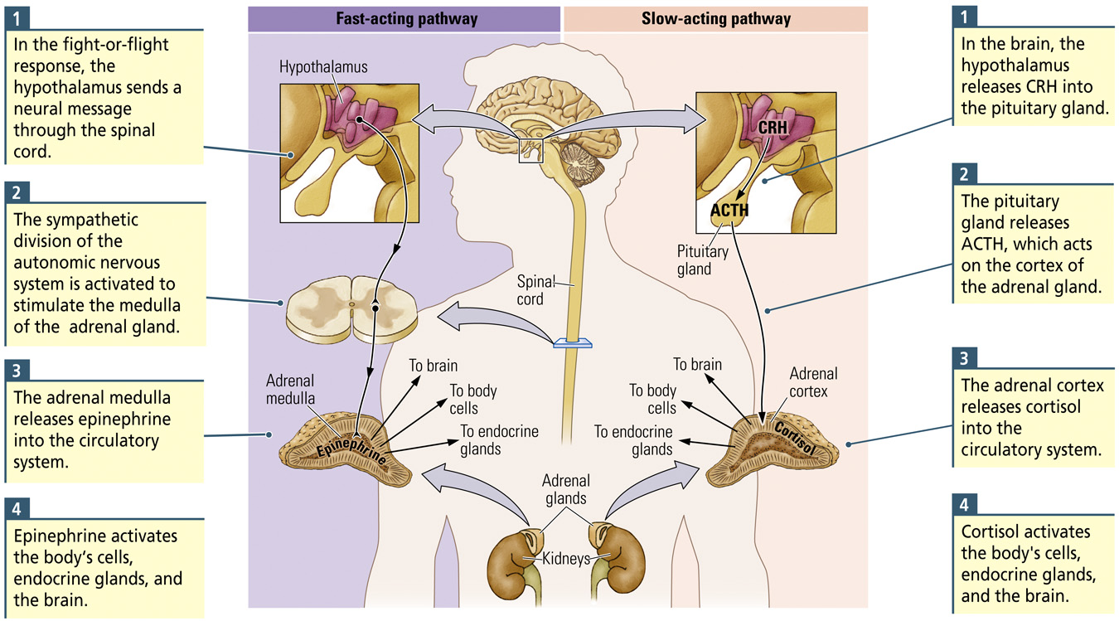

HPA Axis – key for cortisol production

- Hypothalamus secretes vasopressin and corticotropin-releasing hormone (CRH).
- The anterior Pituitary secretes adrenocorticotropic hormone (ACTH)
- Adrenal cortices produce glucocorticoid (or stress) hormones = cortisol.
- Glucocorticoids in turn act back on the hypothalamus and pituitary (to suppress CRH and ACTH production) in a negative feedback cycle.

Ending a Stress Response

- Normally, stress responses are brief
- Stress responses are turned on and off in the brain
- Sapolsky (2003)
  - Hippocampus is involved in turning off the stress response
  - Too much cortisol will damage neurons in the hippocampus
  - Vicious cycle involving prolonged stress, cortisol levels, and hippocampal functioning
- Health is affected by long term stress
- Posttraumatic Stress Disorder
  - Syndrome characterized by physiological arousal symptoms related to recurring memories and dreams related to a traumatic event – for months or years after the event

