Chapter 7 – How Do Drugs and Hormones Influence the Brain and Behaviour?

Focus on New Research: Neural Basis of Drug Cravings

- Mesolimbic Dopamine Pathway
  - Located in Ventral Tegmental Area (VTA)
  - Projects to many areas including the nucleus accumbens (part of the basal ganglia)
  - Contains mesolimbic dopamine (DA) neurons in VTA
  - Nucleus accumbens associated with addictive behaviour
- Phillips and colleagues (2003)
  - Learned associations to drug-related cues (e.g., light) produced dopamine release in the VTA
  - Dopamine release was associated with drug-seeking behavior
  - Normally associated with natural interest in food, sexual activity, or other rewarding stimuli
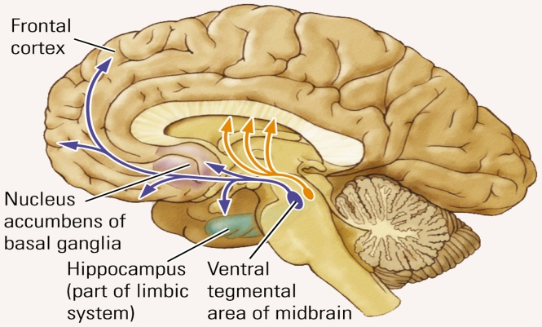

Principles of Psychopharmacology

- Psychopharmacology
  - Study of how drugs affect the nervous system and behavior
- Drugs
  - Chemical compounds administered to produce a desired change in the body
- Psychoactive Drug
  - Substance that acts to alter mood, thought, or behaviour and is used to manage neuropsychological illness
- Drug Routes into the Nervous System
  - Routes of Drug Administration
    - Oral administration is the safest, easiest, and most common route
    - But oral administration is also the most complex as there are more barriers that the drug must cross to have its desired effect (ex. The barriers of the digestive-tract contents and walls)
    - Other methods, such as inhalation or injection, produce much faster effects as there are fewer barriers for the drug to pass and absorb across membranes into the bloodstream easier
    - The fewest obstacles are encountered if a psychoactive drug is injected directly into the brain
    - Oral medication must be absorbed by the lining of the stomach or small intestine, dissolved by the stomach juices, enter the bloodstream where it is then diluted, into the extracellular fluid (therefore molecules must be small enough to pass through the pores of capillaries) where it is further diluted, and where it may be modified or destroyed by various metabolic processes
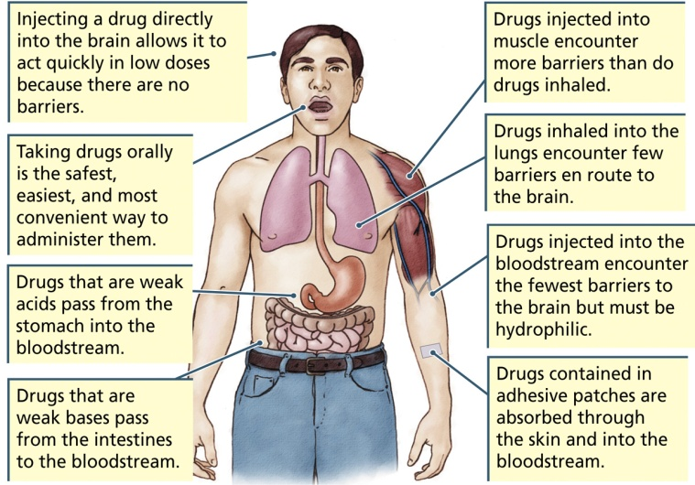
  - Blood-Brain Barrier (BBB)
    - Helps prevent most substances, including drugs, from entering the brain via the bloodstream
    - Endothelial cells in capillaries located throughout the body are not tightly joined, so it is easy for substances to move into and out of the bloodstream
    - In contrast, endothelial cells in the brain are tightly joined and the presence of astrocytes help keep most substances out
    - The glial cells provide a route for the exchange of food and waste between capillaries and the brain’s extracellular fluid and from there to toher cells
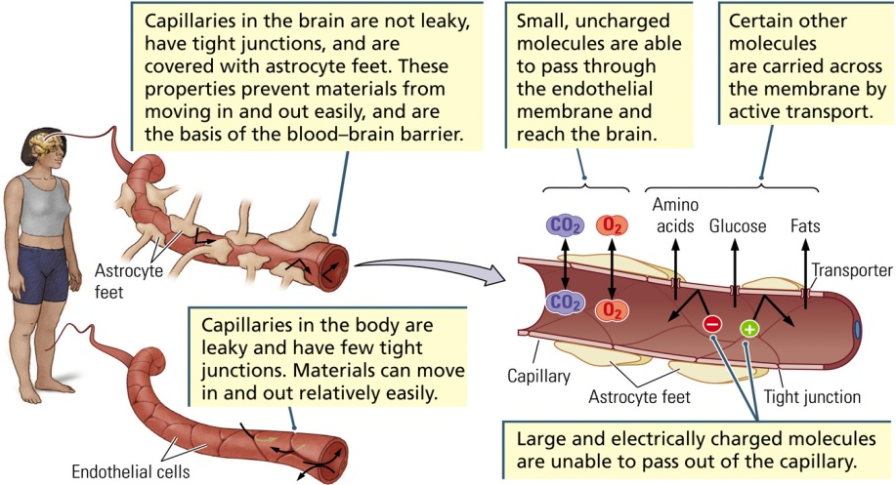
  - Barrier-Free Brain Sites
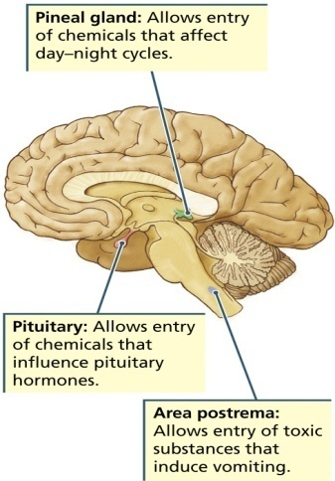
  - Small, uncharged molecules (e.g., oxygen and carbon dioxide) are fat soluble and can freely cross the BBB
  - Larger, charged molecules (e.g., glucose, amino acids, fats) must be actively transported across the BBB
  - It is important that ionic substances not cross the BBB and upset the brain’s electrical activity
  - The BBB protects the brain from the effects of many circulating hormones and from various toxic and infectious substances
  - Difficulty developing drugs for the brain
    - They must be small and uncharged or they must be structurally similar to a substance that already has an active transporter that allows it to pass the BBB
    - Very few can gain access to the CNS
    - Because the BBB works so well it is extremely difficult to find new drugs to use as treatments for brain diseases
  - Elimination of Drugs
    - Drugs are broken down in the kidneys, liver, and intestines
    - Drugs are then excreted in urine, feces, sweat, breast milk, and exhaled air
    - Some substances that cannot be removed may build-up in the body and become toxic
- Individual Differences in Drug Response
  - Factors that influence drug responsiveness:
    - Age: Older individuals are more sensitive to drugs
      - Less effective barriers and less effective at eliminating drugs
    - Body Size: Smaller individuals are more sensitive to drugs
      - Fewer body fluids to dilute drugs
    - Sex: Females are more sensitive to drugs
      - Smaller than men on average
- Drug Action at Synapses
  - Most psychoactive drugs exert their effects by influencing chemical reactions at synapses
  - Agonist: Substance that ENHANCES the function of a synapse
  - Antagonist: Substance that BLOCKS the function of a synapse
  - Drugs can alter chemical processes at any of seven major stages of synaptic transmission
- Synthesis – can take place in the cell body, the axon, or the terminal
- Storage – neurotransmitter is help in storage granules/vesicles
- Release – from terminal’s presynaptic membrane
- Receptor Interaction – on postsynaptic membrane
- Inactivation
- Reuptake
- Degradation
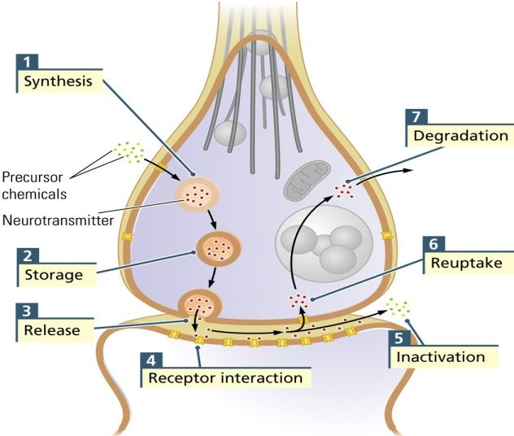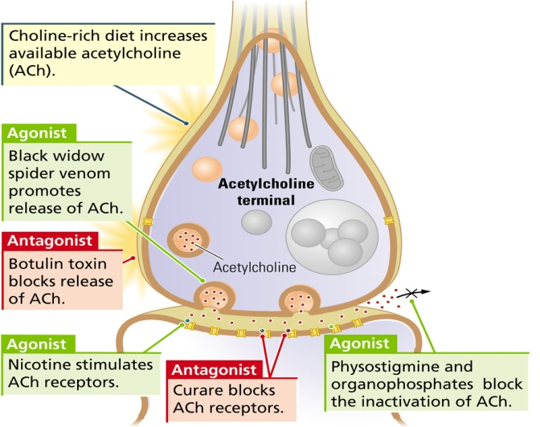
  - An Acetylcholine Synapse: Example of Drug Action (above)
Classification of Psychoactive Drugs

- One can classify a drug by it’s most pronounced behavioural or psychoactive effect
  - Sedative Hypnotics and Antianxiety Agents
  - Antipsychotic Agents
  - Antidepressants
  - Mood Stabilizers
  - Narcotic Analgesics
  - Psychomotor Stimulants
  - Psychedelics and Hallucinogens
  - Many drugs for mental illness were accidental discoveries
- Antianxiety Agents and Sedative Hypnotics
  - At low doses they reduce anxiety, at medium doses they sedate, and at high doses they produce anesthesia or coma, and at very high doses they can kill
  - Barbituates
    - Produce sedation and sleep (e.g., alcohol)
    - Can also produce general anesthesia, coma, and death
  - Benzodiazepines
    - Minor tranquilizers
    - Antianxiety agents
      - Drugs that reduce anxiety (e.g., Valium)
      - Often used for temporary purposes (e.g., coping with stress due to a death in family)
    - 4 roles: anti-convulsants, muscle relaxants, anti-anxiety (angxionotic), sedation/hypnosis
  - Tolerance
    - Lessening of response to a drug over time
    - Larger dose is required to maintain the drug’s initial effect
  - Cross-tolerance
    - Response to a novel drug is reduced because of tolerance developed in response to a related drug
    - Suggests that the two drugs affect a common nervous system target
      - Example: Barbituates and benzodiazepines affect the inhibitory neurotransmitter GABA
  - The GABA Receptor
    - Excitation produces an influx of chloride (Cl-) ions, which hyperpolarizes the neuron
  - The GABA_{A} Receptor Has Two Sites:
    - Sedative-Hypnotic Site: Alcohol and barbiturates
      - Directly influences Cl- influx
- Antianxiety Site: Benzodiazepines
  - Enhances binding effects of GABA
  - Effect is dependent upon amount of GABA present
    - Harder to overdose on antianxiety drugs
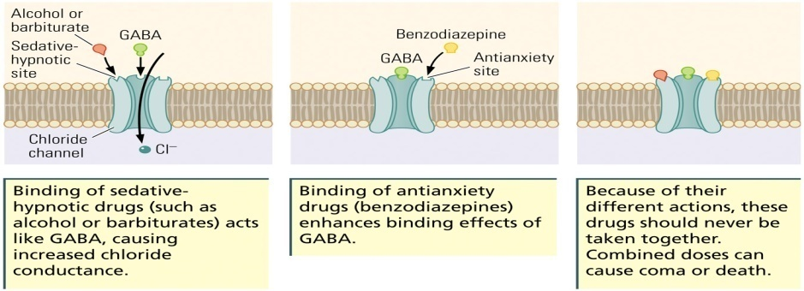
  - Allopregnanolone
    - Natural hormone produced by pineal gland
    - May bind to the sedative-hypnotic site of the GABA_{A} receptor
    - Alcohol may have its sedative effects by facilitating the production of allopregnanolone
    - Higher levels in women than in men
  - Fetal Alcohol Syndrome
    - Pattern of physical malformation and mental retardation observed in some children born to alcoholic mothers
- Antipsychotic Agents
  - Major Tranquilizer (Neuroleptic)
    - Drug that blocks the D₂ dopamine receptor
    - Used mainly for treating schizophrenia
    - Mechanism of therapeutic action is still not understood
      - Immediate effect of reducing motor activity
      - After short period of use, there is a reduction in the symptoms of schizophrenia
      - Negative side effect: Dyskinesia (impaired control of movement); usually reversible if the person stops taking the drug
  - Dopamine Hypothesis of Schizophrenia
    - Proposal that schizophrenia symptoms are due to excess activity of the neurotransmitter dopamine
    - Evidence
      - Antipsychotic drugs block D₂ receptors
      - Amphetamine promotes release of dopamine and can also produce symptoms similar to schizophrenia
      - Antipsychotics control excessive DA activity
    - But there is still no conclusive evidence of dopamine-related differences in the brains of schizophrenic patients
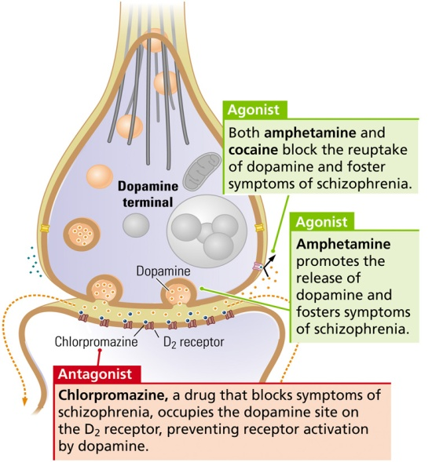
- Antidepressants
  - Major Depression
    - Mood disorder characterized by
      - Prolonged feelings of worthlessness and guilt
      - Disruption of normal eating habits
      - Sleep disturbances
      - General slowing of behavior
      - Frequent thoughts of suicide
    - Common: ~6% of adult population
    - More common in women than in men
  - Three Classes of Antidepressants
- Monoamine Oxidase (MAO) Inhibitors
- Block the enzyme MAO from degrading neurotransmitters such as dopamine, noradrenaline, and serotonin; therefore, more serotonin for release with each action potential
- Tricyclic Antidepressants
- First-generation antidepressants with a chemical structure characterized by three rings that block serotonin reuptake transporter proteins
- Second-Generation Antidepressants
- Action is similar to first-generation antidepressants, but is more selective in its action on the serotonin reuptake transporter proteins; also called atypical antidepressants
- Serotonin remains in the synaptic cleft for a longer period, thus prolonging its action on postsynaptic receptors
      - Selective Serotonin Reuptake Inhibitors (SSRIs)
        - Block the reuptake of serotonin into the presynaptic terminal
  - Although antidepressants affect synapses very quickly, their antidepressive actions take weeks to develop
  - Prozac, an SSRI, enhances neurogenesis in the hippocampus
    - Part of therapeutic effect?
  - ~20% of patients with depression fail to respond to antidepressants, suggesting that other neurotransmitters are likely involved
- Narcotic Analgesics
  - Narcotic Analgesic
    - Drugs with sleep-inducing (narcotic) and pain-relieving (analgesic) properties
    - Opiates:
      - Many of these drugs are derived from opium, an extract of the seeds of the opium poppy
- Pure substances derived from the poppy plant
  - Codeine: ingredient of cough medicines and pain relievers
  - Morphine: powerful pain reliever
  - Nalorphine and Naxolone
    - Opiate antagonists that block the effects of morphine
  - Heroin
    - An opiate drug synthesized from morphine
    - More fat soluble and penetrates the BBB faster than morphine, therefore it produces very rapid pain relief
  - Opiates are potentially addictive
  - Endorphin
    - Peptide hormone that acts as a neurotransmitter and may be associated with feelings of pain or pleasure
    - Mimicked by opiate drugs such as morphine, heroin, opium, and codeine
  - Morphine acts on three opioid-receptor classes
    - Mu, delta, and kappa
    - Mu receptor is critical for morphine’s effect on pain and for its addictive properties
- Stimulants
  - Behavioural Stimulants
    - Increase motor behaviour and elevate a person’s mood and level of alertness
    - Cocaine
      - Obtained from the leaves of the coca plant
      - Addictive
      - Blocks dopamine reuptake
      - Derivates such as Novocaine are used as local anesthetics
    - Amphetamine
      - Dopamine agonist: releases dopamine into the synapse and blocks the reuptake of dopamine, as well; leaves more dopamine available in the synaptic cleft
      - Stimulates the release of DA from presynaptic membranes
    - Some Uses:
      - Initially an asthma treatment
      - Study aid
      - Improvement of alertness and productivity
      - Weight-loss aid
  - General Stimulants
    - Drugs that cause a general increase in the metabolic activity of cells
    - Caffeine
      - Inhibits the enzyme that normally breaks down the second messenger cyclic AMP
      - Increase in cAMP leads to an increase in glucose production within cells, which makes more energy available and allows for higher rates of cellular activity
  - Psychedelic Drugs
    - Alter sensory perception and cognitive processes
    - Four main types
      - Acetylcholine psychedelics
      - Norepinephrine psychedelics (e.g., mescaline)
      - Tetrahydrocannabinol (THC): active ingredient in marijuana
      - Serotonin psychedelics (e.g., lysergic acid diethylamide)

Drugs, Experience, Context, and Genes
- Tolerance
  - How do we develop a tolerance to drugs such as alcohol?
    - Metabolic Tolerance
      - Number of enzymes needed to break down alcohol may increase
      - Any alcohol that is consumed is metabolized more quickly, and so blood-alcohol levels are reduced
    - Cellular Tolerance
      - Activities of brain cells may adjust to minimize the effect of alcohol
      - May help explain why the behavioural signs of intoxication may be very low despite a relatively high blood-alcohol level
    - Learned Tolerance
      - People can learn to cope with effects of alcohol and therefore may not appear to be drunk
  - Tolerance may develop with many other drugs aside from alcohol, such as barbiturates, amphetamine and narcotics.
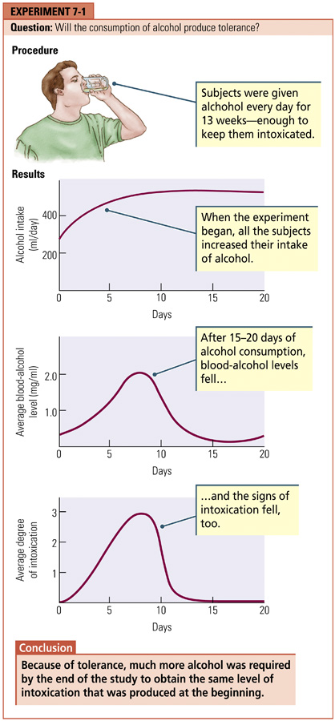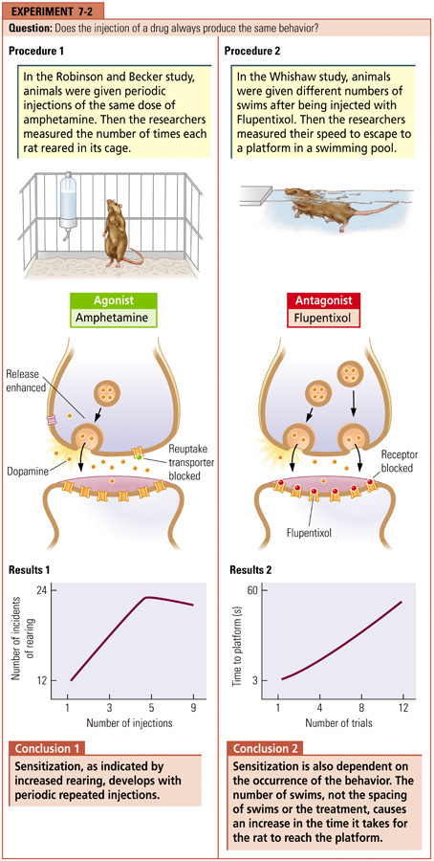
- Sensitization
  - Sensitization
    - Increased responsiveness to successive equal doses of a drug
    - Opposite of tolerance
    - More likely to occur with occasional use
      - Example: Sensitization to amphetamine may be because this drug causes more dopamine release (experiment 7.2 above)
- Addiction and Dependence
  - Substance Abuse
    - Use of a drug for the psychological and behavioural changes that it produces aside from its therapeutic effects
  - Addiction (a.k.a. substance dependence)
    - Desire for a drug manifested by frequent use of the drug, leading to the development of physical dependence in addition to abuse
    - Often associated with tolerance and unpleasant, sometimes dangerous, withdrawal symptoms upon cessation of drug use
  - Withdrawal Symptoms
    - Physical and psychological behaviours displayed by an addict when drug use ends
      - Examples: muscle aches and cramps, anxiety attacks, sweating, nausea, convulsions, death
    - Time-course
      - Withdrawal symptoms from alcohol and morphine start within several hours of last dose and intensify over several days before subsiding
  - Psychomotor Activation
    - Increased behavioural and cognitive activity
    - At certain levels of consumption, the drug user feels energetic and in control
    - Occurs with many drugs
      - Is there a common target (such as dopamine neurons) for abused drugs?
  - Evidence for an Important Role of Dopamine in Drug Abuse
    - Rats will press a bar to receive electrical stimulation of the mesolimbic dopamine system and stop when the dopamine system is blocked; the release of DA is somehow rewarding
    - Abused drugs seem to be dopamine agonists: they cause the release of dopamine or prolong its availability in the synapse even drugs that have no primary action on DA synapses have been found to increase its level
    - Drugs that are dopamine antagonists (i.e.,block the effect of dopamine) are not abused substances
- Explaining Drug Abuse
  - Stages of Addiction
- Pleasure Activation: User likes the experience
- Associative Learning: Pleasure becomes linked to cues associated with the drug experience (e.g., people, places, objects)
- The sight of the drug and the drug-taking context and equipment are repeatedly paired with administering the drug, which produces a pleasurable reaction. Soon the visual cues alone are enough to elicit pleasure
- Incentive Salience: The drug cues become highly desired and sought-after incentives in their own right
  - Incentive-Sensitization Theory
    - When a drug is associated with certain cues, the cues themselves elicit desire for the drug; also called wanting-and-liking theory
    - Wanting (craving) and liking (pleasure) may be produced by different parts of the brain
      - Wanting: Mesolimbic dopamine system; the user increasingly associates the cues related to drug use because he/she has become conditioned to all the cues associated with drug taking
      - Liking: Opioid neurons – with repeated use, liking the drug may decline from its initial level; may also begin to show tolerance to the drug’s effects and so may begin to increase the dosage to increase liking
- Behaviour on Drugs
  - Disinhibition Theory
    - Alcohol has a selective depressant effect on the cortex (the region of the brain that controls judgment), while sparing subcortical structures (those areas of the brain responsible for more-primitive instincts, such as desire)
    - Limitation: behaviour under the influence of alcohol often differs depending upon the context
  - Alcohol Myopia (nearsightedness)
    - Under the influence of alcohol, people respond to a restricted set of immediate and prominent cues and ignore more remote cues and potential consequences
    - Immediate and prominent cues will differ according to the context
- Why Doesn’t Everyone Abuse Drugs?
  - Genetics?
    - Despite some evidence of a genetic contribution, no gene or set of genes related to alcoholism have been found
    - Any satisfactory explanation of drug abuse will require genetic and learning components
  - Personality Traits?
    - Unusual risk-taking may be trait common to drug abusers
- Can Drugs Cause Brain Damage?
  - Many substances, even natural ones such as glutamate, can be neurotoxins
  - It is difficult to determine if recreational drugs are harmful
    - Is it the drug itself or factors associated with drug use?
    - Do drugs initiate problems or aggravate pre-existing conditions?
    - Hard to isolate which ingredients may be the harmful ones
  - Drugs that have been associated with brain damage or cognitive impairments:
    - Amphetamines
      - MDMA (“ecstasy”): Serotonin neurons
      - Methamphetamine: Dopamine neurons
    - Cocaine:
      - Blocks cerebral blood flow
    - Phencyclidine (PCP or “angel dust”):
      - Blocks NMDA receptors
  - Drugs that have NOT been associated with long-lasting brain damage
    - LSD
    - Opiates

MOVIE: saw nature and drug-related images – seeing drug related images had same effect on reward pathways as being injected

