Chapter 6 – How Does the Brain Develop and Adapt?

Correlating Behaviour with Brain Development
- Motor Behaviours
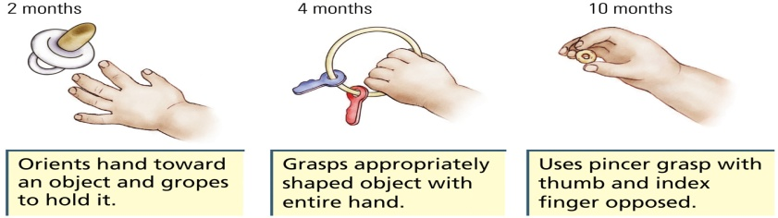
  - Neural changes should proceed these behavioural changes
  - Correlation between myelin formation and the ability to grasp has been found
    - First a group for whole hand movements, then later on another group of neurons for fingers
- Language
  - Language onset is usually between 1 and 2 years of age
  - Language acquisition is largely complete by age 12
  - Neural changes during this time:
    - Increased dendritic complexity and interconnections
    - Increased myelination of speech areas
  - Axons and dendrites for Broca’s area are simple at birth but grow dramatically more dense between 15 and 24 months; correlates with an equally dramatic change in language ability, given that a baby’s vocabulart starts to expand rapidly at about age 2
- Problem-Solving Ability
  - Piaget (1952)
    - Four Stages of Cognitive Development
      - Sensorimotor: Birth to 18-24 months
        - Differentiate self from world, object permanence, cause-effect relationships
      - Preoperational: About 2 to 6 years
        - Form mental representations and can represent them in words and drawings
      - Concrete operational: About 7 to 11 years
        - Mentally manipulate ideas about material things (arithmetic problems)
      - Formal operational: About 12+ years
        - Reason in the abstract, not just in concrete terms
  - Growth Spurts
    - Sporadic period of sudden growth that lasts for a finite time
    - Epstein (1979)
      - Identified five growth spurts in brain mass during development
      - First four coincide with onset of Piaget’s stages, and the last occurs around 14 to 16 years
      - Likely due to growth of glial cells and synapses
        - The growth of synapses is accompanied by increased metabolic demands, which cause neurons to become larger, new blood vessels to form, and new astrocytes to be produced
  - Overman and colleagues (1992)
    - Children can learn a concurrent-discrimination task, believed to depend on the basal ganglia, around 12 months (presented with a pair of objects and had to learn which one was always associated with a food reward)
    - Children can learn a nonmatching-to-sample task, believed to depend on the temporal lobe, around 18 months (had to recognize a previously shown object and NOT choose it)
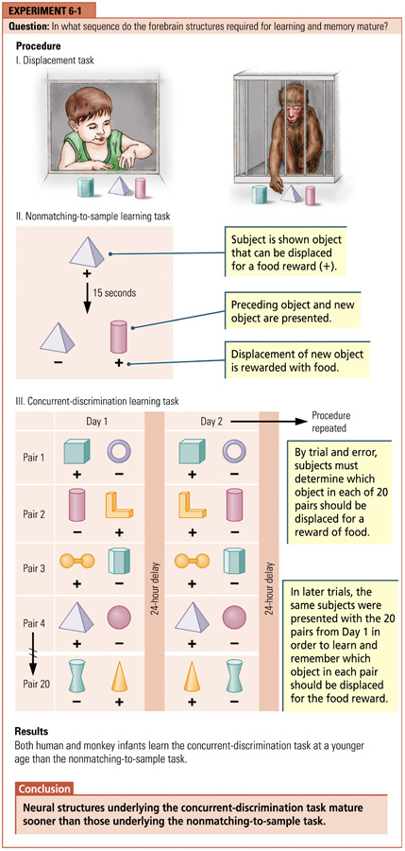
Brain Development and the Environment
- Experience and Cortical Organization
  - Hebb (1947)
    - Cognitively stimulating environments help maximize intellectual development
  - Compared with rats raised in standard lab cages, those raised in “enriched environments” have:
    - Larger and more synapses
    - Larger and more astrocytes
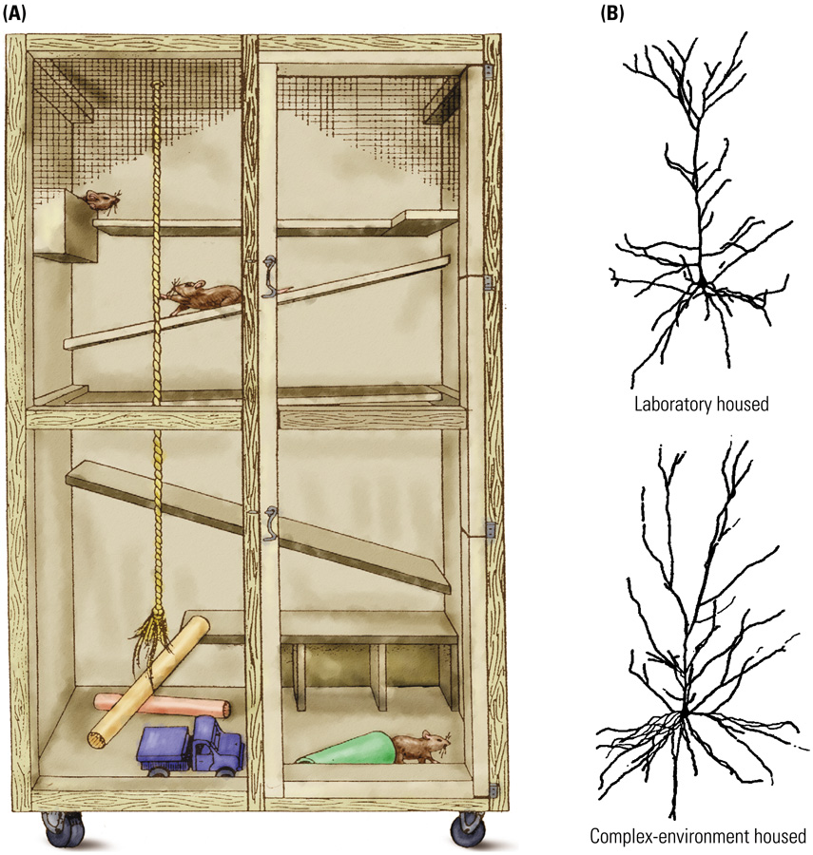
  - Cells in the language and music analysis systems of the auditory complex are altered by early experience and lose much of their plasticity in adulthood
  - The brains of adults are influenced by exposure to new environments and experiences, although probably more slowly and less extensively than the brains of children are
- Experience and Neural Connectivity
  - Prenatally
    - Chemoaffinity Hypothesis: Neurons or their axons and dendrites are drawn toward a signaling chemical that indicates the correct pathway
      - Specific molecules exist in different cells in the various regions of the midbrain, giving each cell a distinctive chemical identity
  - Postnatally
    - Fine-tuning of connections proceeds in an activity-dependent manner
      - Adjacent receptors tend to be activated at the same time, they tend to form synapses on the same neurons in the midbrain
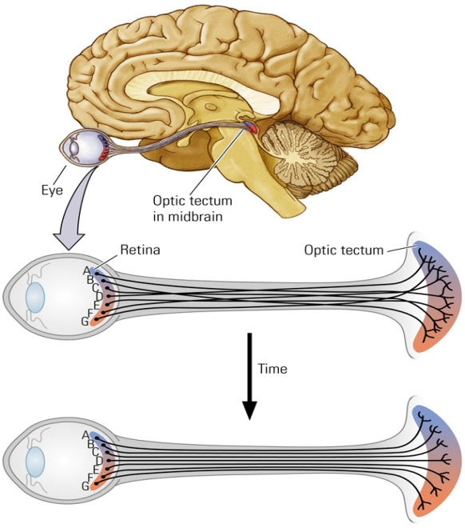
  - Amblyopia
    - A condition in which vision in one eye is reduced as a result of disuse; usually caused by a failure of the two eyes to point in the same direction
    - Visual input from the “lazy eye” does not contribute to the fine tuning of neural connections
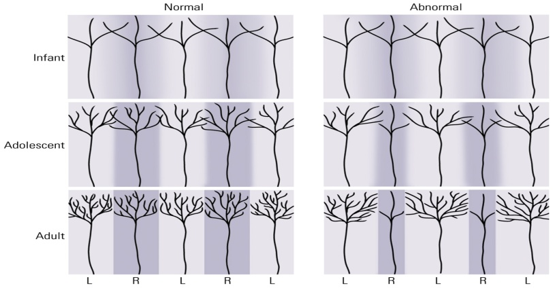
- Critical Periods
  - Critical Periods
    - Developmental “window” during which some event has a long-lasting influence on the brain; often referred to as a sensitive period.
    - Brain development is most sensitive to a specific experience
    - Example: Imprinting
      - Process that predisposes an animal to form an attachment to a specific class of objects or animals at a critical period in development
        - Enlargement of synapses in chick forebrain area IMHV
- Abnormal Experience
  - Early deprivation of sensory experience (e.g., being placed in dark) has the opposite effect of cognitively stimulating environments: atrophy of dendrites
    - Dogs showed virtually no reaction to people or other dogs, appeared to have lost the sensation of pain, unable to learn some tasks
  - Early deprivation of social experience (e.g., raised without maternal contact) has a profoundly negative effect on later intellectual and social behaviours
    - Unable to establish normal relations with other animals
  - Human Cases: If deprivation is relatively short (e.g., less than a few months), the child may be able be to overcome some of the negative effects
    - Abnormal developmental experiences can alter the brain irrevocably
  - Stress in early life has been associated with:
    - Increased amygdalar volumes
    - Decreased hippocampal volumes
    - Later development of depression and anxiety disorders
- Hormones
  - Testosterone (Androgren)
    - Stimulates development of male reproductive organs and the later development of male secondary sexual characteristics (e.g., facial hair) during puberty
  - Masculinization
    - Process by which exposure androgens (male hormones) alters the brain, rendering it “male-like”
    - Does not affect all areas of the brain
  - The presence of testosterone and estrogen both affect the development of the brain
    - Can alter:
      - Number of neurons
      - Dendritic branching
      - Synaptic growth
    - Not just areas of brain related to sexual behaviour: These hormones can affect “higher functions” such as cognition
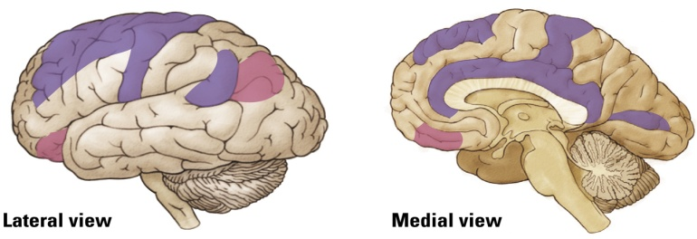
Purple: estrogen, pink: testosterone
  - Bachevalier and colleagues: Postnatal Effects
    - Monkeys
      - Male and females showed different patterns of performance on tests at 2.5 months old
      - Males that had testes removed at birth performed more like females
    - Humans
      - Similarly, males and females showed different patterns of performance around 15 to 30 months of age
      - Sex differences disappeared at 32 to 55 months of age
  - Juraska (1990): Postnatal Effects
    - Rats Reared in Complex Environments
      - Males showed more dendritic growth in the visual cortex than females
      - Females showed more dendritic growth in frontal lobes than males
    - Summary:
      - Sex differences in brain structure exist throughout development
      - As females and males develop, their brains continue to become more and more different from each other
- Injury and Brain Development
  - Humans:
    - Worst time for brain injury:
      - Last half of intrauterine period and the first few months after birth
    - “Better” time for brain injury:
      - First few years after birth
      - More resilient to deficits (e.g., language impairments) than when damage occurs in adults
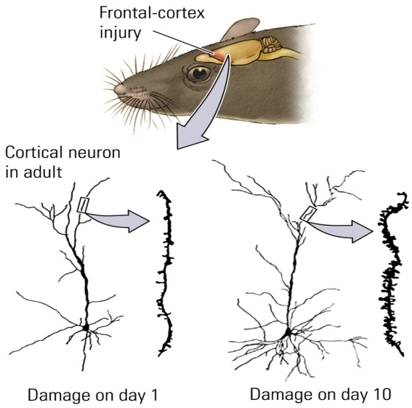
- Drugs and Brain Development
  - Precise effects of drugs on prenatal brain development are poorly understood
  - There is some evidence that
    - Prenatal exposure to psychoactive drugs may increase the chance of later drug use
    - Prenatal exposure to drugs such as nicotine and caffeine increase the chance of learning disabilities and hyperactivity
- Other Kinds of Abnormal Brain Development
  - Spina bifida
    - Spinal cord abnormality due to the failure of the neural tube to close completely
    - Associated with serious motor problems and some cognitive problems
  - Anencephaly
    - Failure of the forebrain to develop
    - Front end of the neural tube does not close
    - Infants typically die soon after birth
  - Abnormal Cell Migration and Differentiation
    - Faulty connections may produce a range of problems, migrating to the wrong locations, mis-positioned cells…
    - Example: Schizophrenia
      - Disorganized pyramidal neurons in the hippocampus
  - Too many synapses (failure of pruning) can also produce neural dysfunction
    - Neurons continue to make dendrites and form connections with other cells to the point at which these neurons become extraordinarily large
  - Behavioural effects of brain damage to a certain area are often not seen until the time at which that particular area matures
    - Example:
      - The frontal lobes continue to develop into adulthood, therefore, the behavioural effects of frontal lobe damage may not be seen until adolescence
- Mental Retardation
  - Impaired cognitive functioning due to abnormal brain development
  - Many causes
    - Genetic abnormalities (e.g., Down’s syndrome)
    - Prenatal exposure to infections (e.g., rubella) or toxins (e.g., alcohol)
    - Birth trauma (e.g., anoxia)
    - Malnutrition
    - Environmental abnormality (e.g., sensory deprivation)
  - Purpura (1974)
    - Examined children with developmental disabilities who died from accidents or diseases unrelated to the nervous system
    - Compared with normal children, dendritic growth was reduced in children with various forms of mental retardation
      - Suggests that there were fewer connections in the brain
      - Dendrite growth was stunted and the spines were very sparse relative to dendrites from children of normal intelligence
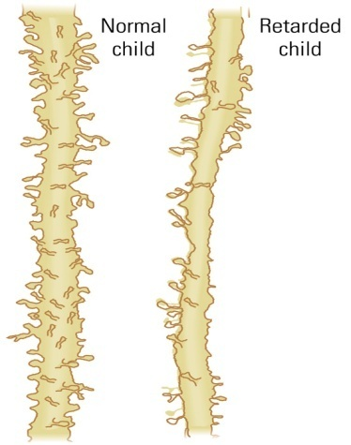

How Do Any of Us Develop a Normal Brain?

- Brain has a substantial capacity to repair minor abnormalities that may occur during development (plasticity)
- There is a “range of normality” with respect to brain development
  - Most of us develop a brain that falls within a certain range of normality
- Plasticity occurs into older adulthood
- By initially overproducing neurons and synapses, the brain has the capacity to correct any errors that might have arisen accidentally

