Chapter 5 – How Do Neurons Communicate and Adapt?

Definitions

- Learning is a relatively permanent change in an organisms’ behaviour as a result of experience.
- Memory is the ability to recall or recognize previous experience, ie. a mental representation of a previous experience.

Role of Synapses in Learning and Memory
- Learning
  - Relatively permanent change in behaviour that results from experience
  - Mediated by structural changes in synapses
    - Increased efficiency
- Memory
  - The ability to recall or recognize previous experience, ie. a mental representation of a previous experience.
- Neuroplasticity
  - The nervous system’s potential for neurophysical or neurochemical change that enhances its adaptability to environmental change and its ability to compensate for injury
  - Adaptability and potential for self-repair
- Habituation Response
  - Habituation
    - Learning behaviour in which a response to a stimulus weakens with repeated stimulus presentations
    - Example: Gill withdrawal response in the marine snail Aplysia californica
    - Your brain is habituated to the customary, ‘background’ sensations
- Neural Basis of Habituation
  - Jet of water stimulates the sensory neuron, which in turn stimulates the motor neuron responsible for the gill withdrawal
  - Accompanying the development of habituation, the excitatory postsynaptic potentials in the motor neuron becoming smaller
  - Less neurotransmitter is released from a habituated neuron than from a non-habituated one
  - With repeated use, CA channels become less responsive to voltage changes and more resistant to the passage of calcium ions
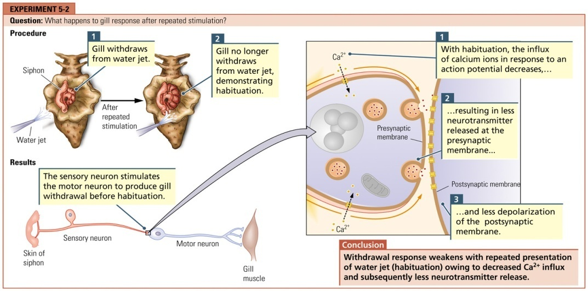
- Sensitization Response
  - Sensitization
    - Learning behaviour in which the response to a stimulus strengthens with repeated presentations of that stimulus because the stimulus is novel or stronger than normal
    - Example: Gill withdrawal response in the marine snail Aplysia californica – can last for minutes or hours
    - An enhanced response to some stimulus, is the opposite of habituation
    - The organism becomes hyper-responsive to a stimulus rather than accustomed to it
- Neural Basis of Sensitization
  - An interneuron (axon contains serotonin) that receives input from a sensory neuron in the tail (and so carries information about the shock) synapses with a sensory neuron. The tail sensory neuron activates the interneuron with the shock, which in turn releases serotonin onto the axon of the sensory neuron
  - The gill withdrawal response is amplified by the action of the interneuron in releasing serotonin onto the presynaptic membrane of the sensory neuron
  - More calcium influx results in more transmitter being released
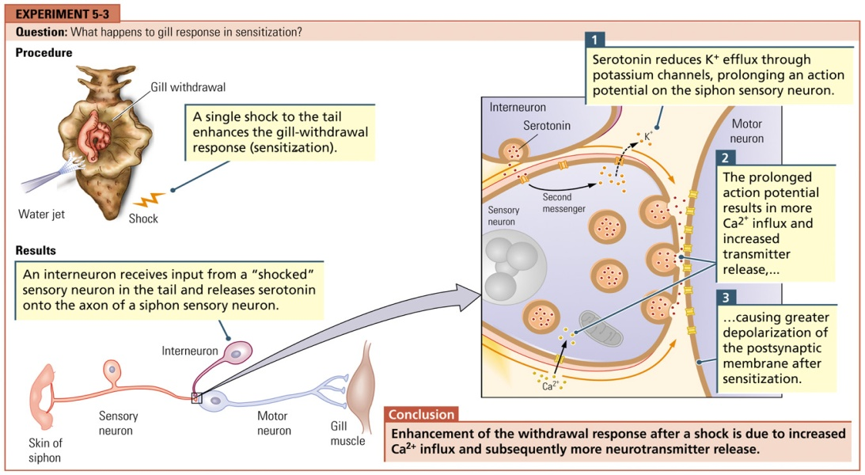
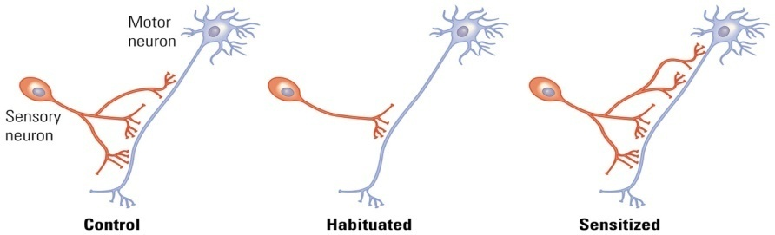
- Associative Learning
  - Linkage of two or more unrelated stimuli to elicit a behavioural response
  - A strong burst of electrical stimulation applied to the presynaptic neuron produces an increase in the amplitude of the EPSP in the postsynaptic neuron
  - First recorded in the hippocampus by Bliss and Lomo in 1973
    - Field Potential:
      - EPSPs from many neurons; recorded with extracellular electrodes
- Long-term Potentiation (LTP)
  - In response to stimulation at a synapse, changed amplitude of an excitatory postsynaptic potential that lasts for hours to days or longer
  - Plays a part in associative learning
  - The strengthening of a connection between two, already connected, neurons which lasts for minutes to months.
  - Can be induced experimentally by applying a sequence of short, high-frequency stimulations to nerve cell synapses.
  - Thus associative and cooperative ie. the activity of several neurons converging onto a single neuron facilitates the strengthening of these synapses.
  - Discovered in the rabbit hippocampus but has been observed in other brain regions e.g. cerebellum.
  - Is commonly regarded as the cellular basis of learning and memory.
- LTP Neurotransmission
  - Glutamate is the key neurotransmitter released into the synapses when LTP occurs.
  - Glutamate binds to several different sub-types of receptors on the post-synaptic neuron e.g. alpha-amino-3-hydroxy-5-methyl-4-isoxazole propionate (AMPA) and N-methyl-D-aspartate (NMDA).
- AMPA Receptor
  - The AMPA receptor is paired with an ion channel so that when glutamate binds to this receptor, sodium ions (Na) enter the post-synaptic neuron leading to depolarization of the post-synaptic dendrite and eventually an action potential that transmits information to the next neuron = facilitation of action potential propagation and thus communication between neurons.
  - glutamate → AMPA receptor → Na influx → depolarization and action potential (EPSP) = strengthening of synapse = LTP
- NMDA Receptor
  - The NMDA receptor is also paired with an ion channel, but there is an influx in calcium (Ca⁺²⁾ ions into the post-synaptic cell when glutamate binds to the NMDA receptor. The glutamate releases the magnesium ions (Mg⁺²) that are blocking the Ca⁺² from entering the cell thus allowing Ca⁺² into the cell, causing a depolarization of the neuron and communication between 2 neurons and thus LTP.
  - glutamate → NMDA receptor → Mg⁺² release → Ca⁺² influx → depolarization and action potential (EPSP) = strengthening of synapse = LTP
- Calcium and LTP
  - The Ca⁺² ions are extremely important intracellular messengers that activate many enzymes by altering their conformation e.g. calmodulin, which becomes active when four Ca⁺² ions bind to it. It then becomes Ca⁺²/calmodulin = the main second messenger for LTP.
  - Ca⁺²/calmodulin then in turn activates other enzymes that allow for a cascade of biochemical reactions that play key roles in LTP.
- Two Phases of LTP
  - Establishment (or induction) - lasts about an hour
    - Can be experimentally induced by a single, high-frequency stimulation. It involves the activity of various enzymes that persist after the Ca⁺² is eliminated, but no protein synthesis.
  - Maintenance (or expression) – can last for days/months
    - Triggered by a series of high-frequency stimuli. Unlike the establishment phase of LTP, the maintenance phase requires the synthesis of new proteins – e.g. the ones that form the receptors and contribute to the growth of new synapses.
  - LTP Summary
    - Rapid, intense stimulation of neurons depolarizes them.
    - Binding of glutamate to their NMDA receptors opens them.
    - Ca⁺² ions flow into the cell through the NMDA receptors and bind to calmodulin.
    - This activates Ca⁺² kinase II (CaMKII).
      - CaMKII phosphorylates AMPA receptors making them more permeable to the inflow of Na+ ions and thus increasing the sensitivity of the cell to depolarization.
      - CaMKII may also increase the number of AMPA receptors at the synapse.
    - Increased gene expression (i.e., protein synthesis — perhaps of AMPA receptors) also occurs during the development of LTP.
    - Additional synapses may also form during the formation of LTP.
- Neurochemistry of LTP
  - Long-Term Depression
    - Another form of synaptic plasticity
    - Neuron becomes less active in response to repeated stimulation
    - Involves NMDA receptors
    - Requires Ca⁺⁺ entry:
      - Decreased responsiveness of AMPA receptors
      - Decreased numbers of AMPA receptors
- Learning at the Synapse
  - The number and size of sensory synapses change in well-trained, habituated and sensitized Aplysia.
    - Number and size decreases in habituated and increase in sensitized
  - What neural processes underlie the persistent, long-term changes of learning?
    - Ca⁺⁺ enters postsynaptic neuron and activates a second messenger (e.g., cyclic AMP) to send instructions to nuclear DNA. The transcription and translation of nuclear DNA initiates structural changes in synapses
    - cAMP alters gene expression in nucleus, which physically alters synapses
      - Structural changes in the synapse (Dendritic spines)
      - Formation or loss of synapses
      - New synapses seem to be required for learning to take place, and cAMP seems to be needed to carry instructions to form them
- New dendritic spines can grow in conjunction with LTP. They adapt to support long-term interneural communication and may provide the neural basis for brain plasticity and learning
- Pavlovian Conditioning
  - Also called respondent conditioning or classical conditioning.
  - Conditioned stimulus (CS), unconditioned response (UR), conditioned response (CR).
  - Cerebellar circuits pair motor responses with environmental events. Amygdala circuits mediate fear conditioning.
- Instrumental Conditioning
  - Also called operant conditioning.
  - Consequences of a behaviour increase or decrease the probability of the behaviour occurring again.
  - Problem solving e.g. Morris Water Maze
- Implicit Memory
  - Expressed through performance without any requirement for conscious memory content = unconscious memory. e.g. how to turn on the computer.
  - Encoded in very much the same way as it is perceived; it is data-driven (“bottom-up” processing).
  - Implicit memories are primed in the specific sensory and motor systems that are recruited for whatever the particular task is.
  - Not a single entity but rather a collection of abilities that include:
    - priming
    - memory for skills and habits
    - classical conditioning
- Priming
  - Enhanced ability to identify or produce a stimulus as a result of its recent presentation (the first encounter with an item results in a representation of that item, which then allows it to be processed more efficiently than items that were not encountered recently).
  - Can be assessed by word stem completion task, fragment completion, free association, perceptual priming, etc.
    - e.g., 2 groups of subjects presented with :
      - “spring, winter, car, boat”
      - “trip, tumble, run, sun”
    - later: define word “fall”
- Skills and Habits
  - Memory of motor, perceptual and cognitive skills.
  - Can be assessed by tasks such as the pursuit-rotator test (figure 13-6) where a small metal disc moves in a circular pattern on a turntable that is also moving, puzzles, etc.
- Explicit Memory
  - Retrieval of an item (facts and events) and confirmation that the item retrieved is the correct item (conscious memory) e.g. Thomas Edison invented the light bulb.
  - Depends on conceptually driven, “top-down”, processing.
  - Depends on the integrity of medial temporal lobe structures, (e.g., hippocampus) and diencephalic structures (e.g., thalamus).
  - For example, word list memorize and retrieve.
  - Further subdivided into episodic and semantic memory (a distinction between remembering and knowing).
- Episodic vs. Semantic
  - Episodic
    - Tied to a specific learning episode or experience.
    - e.g. Was the word butterfly on the list?
    - e.g. Did you have cornflakes for breakfast?
  - Semantic
    - General knowledge not tied to a learning experience.
    - e.g. Is a butterfly a bird?
    - e.g. Are cornflakes a breakfast cereal?
- Memory Systems
  - Slide diagram
- Organic Amnesia
  - Behavioural deficits are limited to long-term memory functions
  - Intact intellectual function and normal or near normal immediate memory
  - Can be produced by damage to:
    - hippocampus and related cortical areas (entorhinal,perihinal and parahippocampal region)
    - basal forebrain,
    - certain thalamic structures
    - prefrontal cortex
- Types of Amnesia
  - Anterograde amnesia: inability to learn new material.
  - Retrograde amnesia: inability to recall things learned before the onset of amnesia (temporally graded—greater deficit for memories acquired just before the onset than for memories of more distant events).
    - The clearest evidence about retrograde amnesia gradients comes from studies using experimental animals, where the delay between initial learning and a lesion can be manipulated directly.
- Preserved Learning in Anterograde Amnesia
  - The claim that anterograde amnesia involves an impairment in the ability to acquire new information isn't exactly true…
    - patient HM (Scolville & Milner) had a bilateral medial temporal lobe resection
      - Note: the amygdala, anterior hippocampus and associated cortical structures (entorhinal cortex) were removed.
- HM’s Neurosurgery
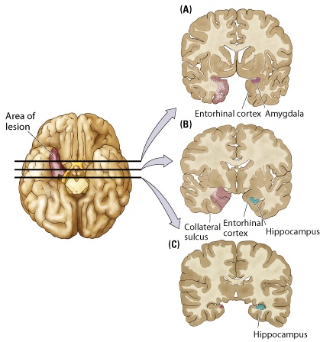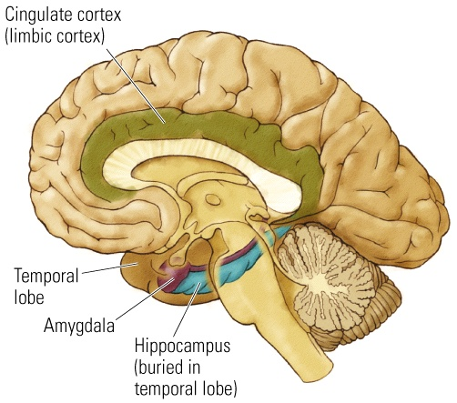
- HM’s Symptoms
  - Severe Amnesia: unable to recall anything that has happened since his surgery in 1953
    - e.g., meal study, father’s death, questions about hospital, + of course formal tests of explicit memory.
  - IQ = 118 (above average).
  - Memories prior to surgery are intact.
  - Implicit memory is intact.
    - e.g., classical conditioning, mirror tracing, repetition priming:
      - (ELEPHANT followed by word stem completion ELE_____)
- Boswell’s Amnesia
  - Patient had herpes simplex encephalitis.
  - Damaged areas include bilateral destruction of the medial temporal lobes, the basal forebrain, the posterior orbitofrontal cortex.
  - Symptoms include a severe anterograde amnesia as well as retrograde amnesia.
    - (e.g., he does know his city of birth but correctly recalls his birth day only about half the time).
  - Hypothesized that the retrograde amnesia has been a result of the damage to the orbitofrontal region
- Mid-Temporal Lobe Structures
  - Slide diagram
- Alzheimer’s Disease
  - Neurodegenerative disease
  - Mainly affects elderly. 10% of people over age 65 and 50% of those over 85 have AD
  - Results in worsening of memory functioning over the progression of the disease
  - Causes unknown (variously attributed to genetic predisposition, abnormal levels of trace elements, immune reactions, slow viruses, etc.)
  - Can only be diagnosed with certainty post-mortem
  - Two principal changes occur:
    - Loss of cholinergic cells in the basal forebrain
    - Presence of neuritic plaques in the cerebral cortex (first appear in the entorhinal cortex and cause cell death)
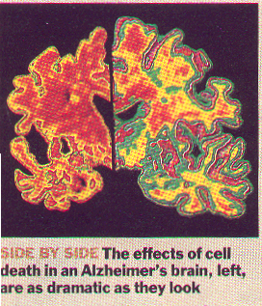
- 10 Warning Signs of AD
  - Ten Warning Signs
    - Memory loss that affects job skills
    - Difficulty performing familiar tasks
    - Problems with language
    - Disorientation to time and place
    - Poor or decreased judgment
    - Problems with abstract thinking
    - Misplacing things
    - Changes in mood or behaviour
    - Changes in personality
    - Loss of initiative
- Basal Forebrain
  - Plays a role in the maintenance of appropriate levels of activity in the forebrain structures so that they can process information.
  - Important in the production of acetylcholine (Ach), which is then distributed widely throughout the brain.
  - Ach affects the ability of brain cells to transmit information to one another, and also encourages plasticity, or learning. Thus, damage to the basal forebrain can reduce the amount of Ach in the brain and impair learning and memory.
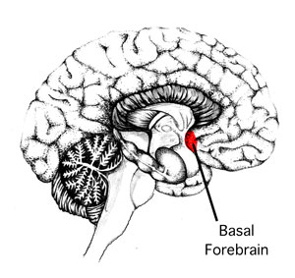
- Korsakoff’s Syndrome
  - Results from chronic alcoholism in conjunction with malnutrition.
  - Thiamine (B1) deficiency results in the death of the medial regions of the thalamus and mammillary bodies of the hypothalamus.
  - Alcohol inhibits the body’s ability to absorb vitamin B1.
  - Symptoms include severe anterograde & retrograde amnesia.
  - Confabulation: make up stories rather than admit that they cannot remember.
  - Lack of insight into their memory impairment.
- Implicit Memory Circuit
  - Parkinson’s Disease
    - Marked by the death of DA producing cells in the substantia nigra (brainstem) projecting to striatum (basal ganglia).
    - Case J.K. started showing memory disturbances related to tasks that he had done all his life:
      - e.g., on one occasion, he stood at the door of his bedroom frustrated by his inability to recall how to turn on the lights.
      - in contrast, he was aware of daily events and could recall explicit events without any trouble.
  - Huntington’s Disease
    - Also marked by damage to the basal ganglia (different part) and implicit memory problems.
- Courchesne Study
  - Refer to slides

FILM – Wednesday, February 25th, 2009 – The Case of the Frozen Addict

- Symptoms resembled those of Parkinson’s – but the patients were around 30 years old and symptoms came overnight, not gradually like Parkinson’s
- Heroin addicts – only common link between the cases; the drugs they took were not usual heroin but designer heroin manufactured synthetically
  - They are altered so they are beyond the reach of the law – not on any drug lists
- Used the drug used to help with Parkinson’s – L-Dopa
  - The patients came back to life and their bodies were ‘unfrozen’
  - If enough cells making dopamine die, it leads to Parkinson’s
  - In the frozen addicts, this process was accelerated – cells making dopamine were deteriorated quickly
- Man wanted to create a drug similar to the structure of Demerol
  - Called MPPP – kind of like heroin but easier to make
  - On animals, the disease was temporary, but it was permanent for humans
    - Not Parkinson’s – cannot produce it in rats (you have to use a primate, like a monkey)
    - Hard to extrapolate results from animal research to humans
  - He must have made a mistake – there was powder remaining from the previous synthesis (MPTP)
  - When he died, his substantia nigra was severely deteriorated like that of Parkinson’s patients
- Strong suspicion that MPTP was the toxin
  - Exposure could cause symptoms – chemists that worked with it for 2-3 weeks (inhalation, skin contact)
- Many need to take medication (L-Dopa) every 2-3 hours, but there are also bad side effects, such as hallucinations and rambling which can cause them to lose severe weight
  - L-Dopa is not a final solution – it may be a therapeutic trap
  - Pargyline can prevent cell death
  - Deprenyl seemed to be slowing the progress of Parkinson’s
- Probably something in the environment that causes Parkinson’s
  - MPTP by itself isn’t toxic – when it enters the brain, MAO in the brain’s disposal caused MPTP to transform into a herbicide (MPP+)
  - If you inhibit MAO, there’s promise for helping with MPP+
  - Pesticides and herbicides are used often – could this be the cause of Parkinson’s?
    - Strong correlation, something in the agricultural areas
    - Near pulp and paper mills
  - Also found everywhere – in foods, beverages, gum…
- Pet scanner can show whether people can get Parkinson’s disease – if the area of the brain is undergoing gradual damage
- Brain grafts – several success stories in humans, fetal tissue implants

