Chapter 5 – How Do Neurons Communicate and Adapt?

Varieties of Neurotransmitters

- About 50 different kinds have been identified
- Some are inhibitory at one location and excitatory at another
- More than one neurotransmitter may be active at a single synapse
- No simple one-to-one relationship between a single neurotransmitter and a single behavior
- Identifying Neurotransmitters
  - Four Criteria
    - The chemical must be synthesized or present in the neuron
    - When released, the chemical must produce a response in a target cell
    - The same response must be obtained when the chemical is experimentally placed on the target
    - There must be a mechanism for removal after the chemical’s work is done
  - Identifying transmitters in the CNS is not easy; thousands of synapses are packed around every neuron, preventing easy access to a single synapse and its activities
  - Putative transmitter – a chemical that has not yet been shown to meet all the criteria
  - ACh was the first identified CNS neurotransmitter
    - All the motor-neuron axons leaving the spinal cord use ACh as a transmitter
    - Renshaw Loop: Each of these axons has an axon collateral within the spinal cord that synapses on a nearby CNS interneuron, which synapses back on the motor neuron’s cell body
      - Axon collateral may release ACh
      - Forms a feedback circuit that enables the motor neuron to inhibit itself from becoming overexcited if it receives a great many excitatory inputs from other parts of the CNS
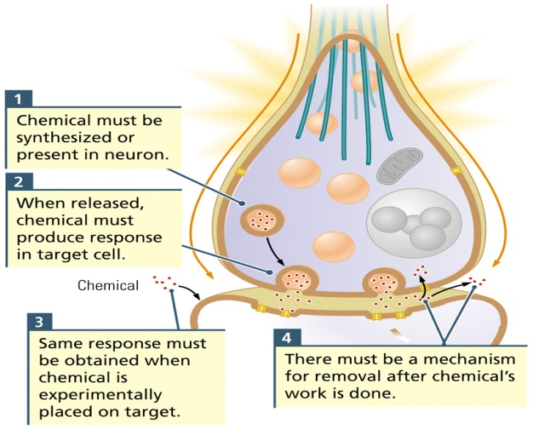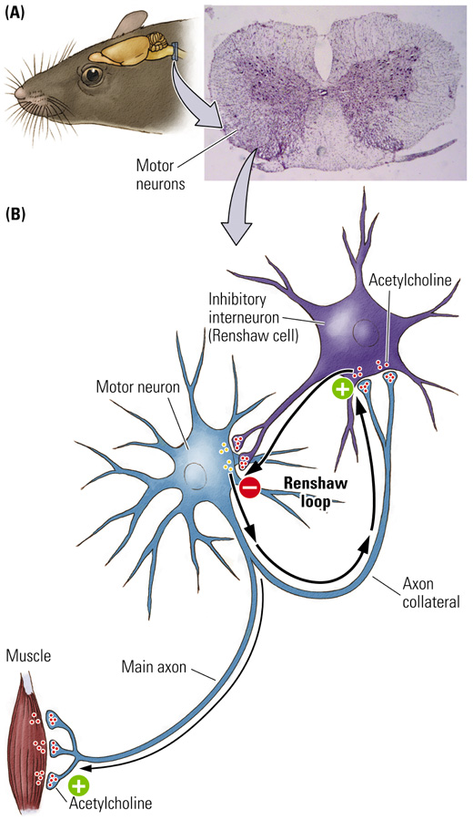
- Classifying Neurotransmitters
  - Three Groups
- Small-Molecule Transmitters
- Class of quick-acting neurotransmitters
- Synthesized in the axon terminal from products derived in the diet and packaged ready for use in axon terminals
- Level and activity in the body can be influenced by diet
- Many neuroactive drugs are designed to reach the brain by the same route of small-molecule transmitters
- Examples:
  - Acetylcholine (ACh)
  - Amines: Dopamine (DA), Norepinephrine (NE), Serotonin (5-HT)
  - Amino Acids: Glutamate (Glu), Gamma-aminobutyric acid (GABA), Glycine (Gly), Histamine
      - Synthesis of Acetylcholine
        - Present at the junction of neurons and muscles, including the heart, and in the CNS
        - Choline – breakdown product of fats
        - Acetate – found in acidic foods
        - Two important enzymes: Acetyl coenzyme A, Choline acetyltransferace (ChAT)
      - Breakdown of Acetylcholine
        - Enzyme: Acetylcholinesterace (AChE)
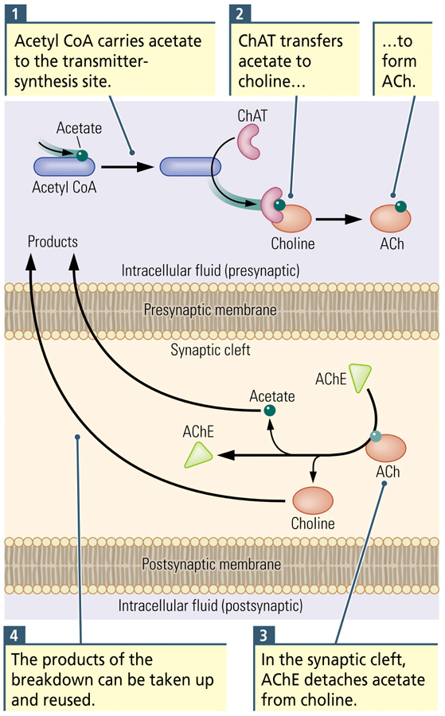
      - Synthesis of the Amines
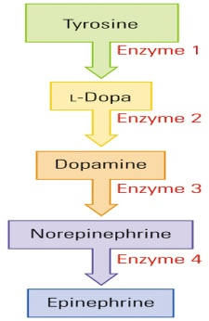
      - Rate-Limiting Factor
        - Any enzyme that is in limited supply, thus restricting the pace at which a chemical can be synthesized
        - Example: Tyrosine hydroxylase
      - Amino Acids
        - Glutamate: main excitatory transmitter in forebrain and cerebellum (Type I excitatory synapses have glutamate as a neurotransmitter)
        - GABA: main inhibitory transmitter in forebrain and cerebellum (Type II inhibitory synapses have GABA as a neurotransmitter)
- Peptide Transmitters
- Neuropeptide
  - A multifunctional chain of amino acids that act as a neurotransmitter
  - Molecular chains of amino acids connected by peptide bonds
  - Synthesized from mRNA on instructions from the cell’s DNA
  - Do not bind to ion channels; do not have direct effects on the voltage of the postsynaptic membrane
    - They activate synaptic receptors that indirectly influence cell structure and function
  - Most are assembled on the neuron’s ribosomes, packaged in a membrane by Golgi bodies, and transported by the microtubules to the axon terminals
    - A slow process compared with small-molecule neurotransmitters
  - Act slowly and are not replaced quickly
  - Have an enormous range of functions in the nervous system (act as hormones, regulate eating, pleasure and pain…)
      - Examples:
        - Opioids
        - Neurohypophyseals
        - Secretins
        - Insulins
        - Gastrins
        - Somatostatins
- Transmitter Gases
      - Synthesized in cell, as needed, and after synthesis, each gas diffuses away, easily crossing the cell membrane and immediately becoming active
      - Examples: Nitric Oxide (chemical messenger in many parts of the body), Carbon Monoxide
        - Both activate metabolic processes in cells, including those modulating the production of other neurotransmitters
- Receptors for Direct and Indirect Effects
  - Ionotropic Receptor
    - Allow the movement of ions across a membrane
    - Embedded membrane protein with two parts
      - A binding site for a neurotransmitter
      - A pore that regulates ion flow to directly and rapidly change membrane voltage
    - When the neurotransmitter attaches to the binding site, the receptor changes shape, either opening the pore and allowing ions to flow through it or closing the pore and blocking the flow of ions
    - Usually excitatory in that they trigger an action potential
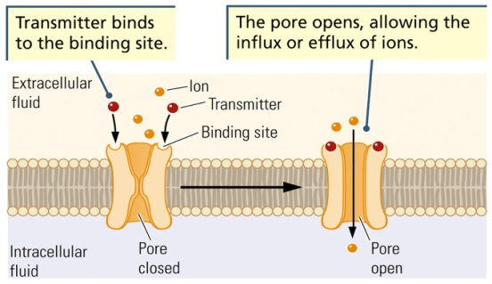
  - Metabotropic Receptor
    - Embedded membrane protein with a binding site for a neurotransmitter but no pore
    - Indirectly produces changes in nearby ion channels or in the cell’s metabolic activity
    - Linked to a G-protein that can affect other receptors or act with second messengers to affect other cellular processes
      - Consists of a single protein that spans the cell membrane, its binding site facing the synaptic cleft
      - Receptor proteins are each coupled to a G protein
    - G-protein
      - Family of guanyl nucleotide-binding proteins coupled to metabotropic receptors that, when activated, bind to other proteins
      - 3 parts: alpha, beta and gamma
      - Alpha detaches when a neurotransmitter binds to the G protein’s associated metabotropic receptor, and then the alpha can then bind to other proteins within the cell membrane or within the cytoplasm of the cell
      - If the alpha binds to a nearby ion channel in the membrane, the structure of the channel changes, modifying the flow of ions through it.
      - If the channel is open, it may be closed by the alpha or vice versa. These changes influence the membrane’s electrical potential
      - The alpha may also bind to an enzyme which activates a second messenger
    - Second Messenger
      - Activated by a neurotransmitter (the first messenger)
      - A chemical that carries a message to initiate a biochemical process
      - Carries instructions to other structures inside the cell
      - It can:
        - Alter ion flow in a membrane channel
        - Formation of new ion channels
        - Production of new proteins
    - Metabotropic receptors allow for the possibility that a single neurotransmitter’s binding to a receptor can activate an escalating sequence of events call an amplification cascade
      - This causes many downstream proteins to be activated or deactivated
    - Attaching to a metabotropic receptor generally causes an inhibitory effect
    - Each transmitter may bind with either a metabotropic or ionotropic receptor (ex. ACh has an excitatory effect on skeletal muscles, but a inhibitory one on the heart)
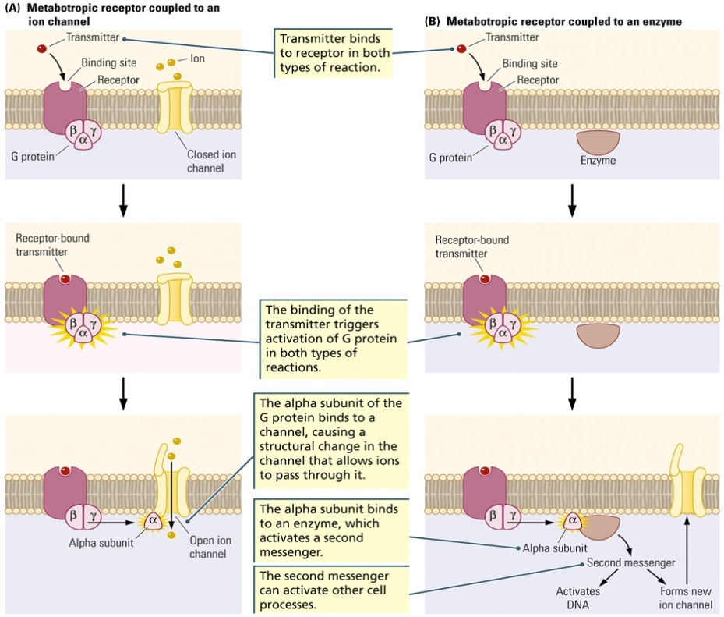

Neurotransmitter Systems and Behaviour
- Caution against the assumption of a simple cause-effect relation between a neurotransmitter and a behavior
- Neurotransmission can be simplified by concentrating on the dominant transmitter located within any given axon terminal
- Somatic Nervous System
  - Cholinergic Neuron (motor neuron)
    - Neuron that uses acetylcholine (ACh) as its main neurotransmitter
    - Excites skeletal muscles to cause contractions
  - Nicotinic ACh Receptor
    - Ionotropic receptor at which acetylcholine and the drug nicotine act as ligands to activate the flow of ions through the receptor pore
    - When ACh binds to this receptor, the receptor’s pore opens to permit ion flow, thus depolarizing the muscle fiber; large pore allows the simultaneous efflux of K+ and influx of Na
- Autonomic Nervous System
  - Cholinergic (ACh) neurons control both divisions
    - Sympathetic (fight-or-flight response) – ACh neurons in CNS synapse with NE neurons
    - Parasympathetic (rest-and-digest response) – ACh neurons in CNS synapse with ACh neurons
  - Norepinephrine is also involved in the fight-or-flight response
  - Whether neurotransmitters are excitatory or inhibitory depends on that organ’s receptors
- Central Nervous System
  - Activating System
    - Neural pathways that coordinate brain activity through a single neurotransmitter
    - Cell bodies are located in a nucleus in the brainstem and their axons are distributed through a wide region of the brain; coordinates wide areas of the brain to act in concert
    - Four Systems
      - Cholinergic, Dopaminergic, Noradrenergic, and Serotonergic
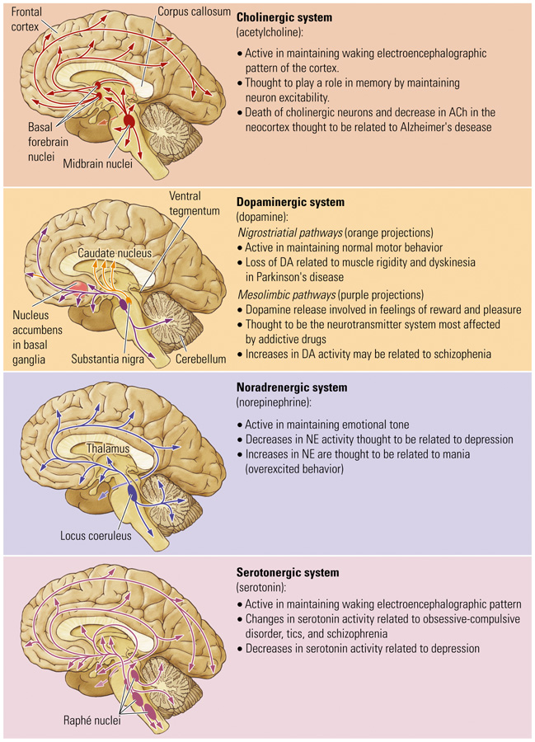
  - Alzheimer’s disease
    - Degenerative brain disorder that first appears as progressive memory loss and later develops into generalized dementia
    - Involves cholinergic system
  - Schizophrenia
    - Behavioural disorder characterized by delusions, hallucinations, disorganized speech, blunted emotion, agitation or immobility, and a host of other symptoms
    - Involves dopaminergic system
    - Excessive DA activity has a role
  - Obsessive-Compulsive Disorder
    - Behavioural disorder characterized by compulsively repeated acts (e.g., hand washing) and repetitive, often unpleasant, thoughts (obsessions)
    - Involves serotonergic system
    - Increased serotonergic activity is related to the symptoms

