Chapter 4 Continued

How Neurons Integrate Information

- Postsynaptic Potentials
  - Excitatory Postsynaptic Potentials (EPSP)
    - Brief depolarization of a neuron membrane in response to stimulation
    - Neuron is more likely to produce an action potential
    - They reduce the charge on the membrane toward the threshold level
    - If it is getting closer to the threshold (-50 mV), there will most likely be an action potential
    - Sodium coming in
  - Inhibitory Postsynaptic Potentials (IPSP)
    - Brief hyperpolarization of a neuron membrane in response to stimulation
    - Neuron is less likely to produce an action potential
    - Increase the charge on the membrane away from the threshold level
    - Chlorine goes in or potassium comes out
  - Last only a few milliseconds, and when they decay the neuron’s resting potential is restored
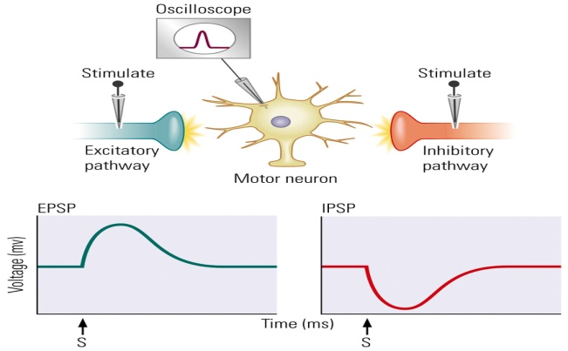
- Summation of Inputs
  - EPSPs and IPSPs Are Summated
    - Temporal Summation
      - Graded potentials that occur at approximately the same time on a membrane are summated
      - Increase the voltage closer to having an action potential
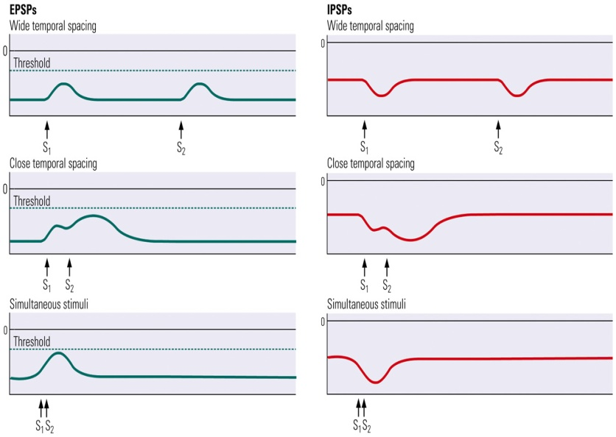
    - Spatial Summation
      - Graded potentials that occur at approximately the same location on a membrane are summated
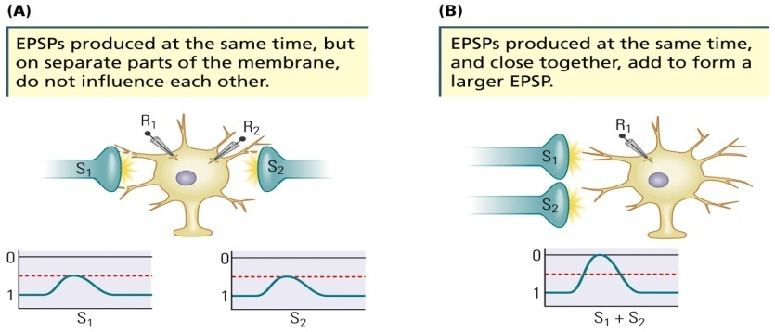
- The Axon Hillock
  - The Axon Hillock
    - Junction of cell body and axon
    - Rich in voltage-sensitive channels
    - Where EPSPs and IPSPs are integrated
    - Where action potentials are initiated
    - Open at a particular membrane voltage (assume -50 mV)
    - Inputs closer to the axon hillock are usually much more dynamic in their influence than those occurring some distance away
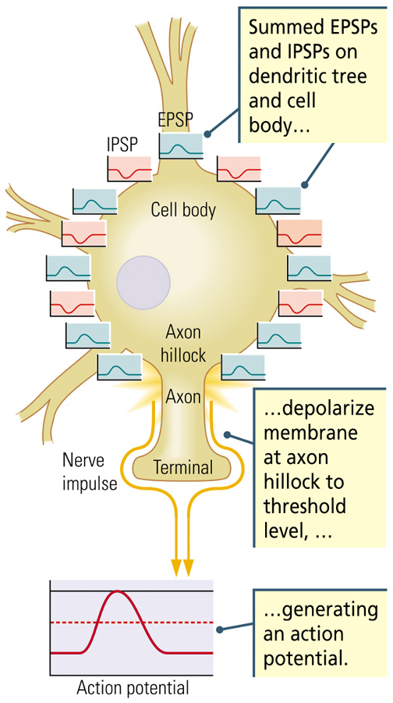

Into the Nervous System and Back Out
- How Sensory Stimuli Produce Action Potentials
  - Several different sensory modalities
    - Visual, auditory, tactile, chemical (taste and olfaction)
  - Many different types of sensory receptors
    - Ion channels on their cell membranes
    - Activity is based in ion channels
    - Example: Stretch-sensitive receptors
      - Ion channel on a tactile sensory neuron that activates in response to stretching of the membrane, initiating a nerve impulse
      - Example of how a sensory stimulus (touch) produces a nerve impulse
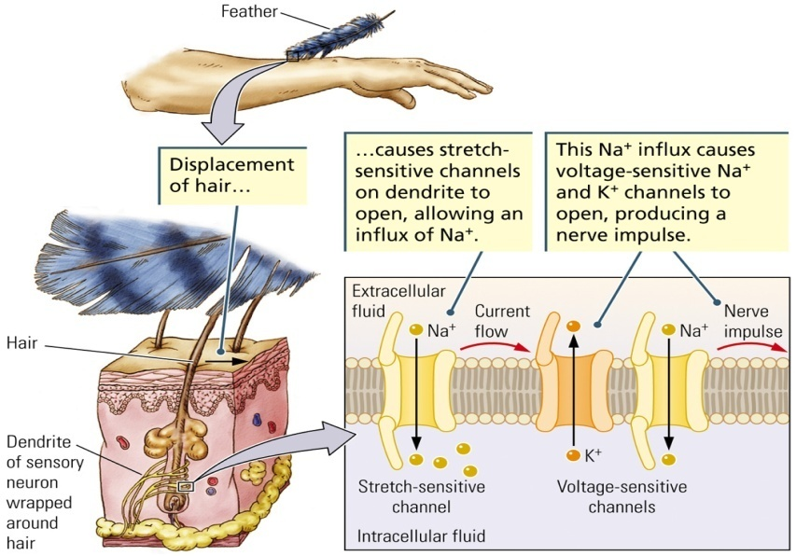
How Nerve Impulses Produce Movement
  - Motor neurons generate action potentials in muscle cells
  - Axon of each motor neuron makes one or a few contacts (synapses) with its target muscle, similar to those that neurons make with one another
  - End plate
    - Part of the muscle membrane that is contacted by the axon terminal
    - On a muscle, the receptor–ion complex that is activated by the release of the neurotransmitter acetylcholine from the terminal of a motor neuron
  - Acetylcholine
    - The first neurotransmitter discovered in the peripheral and central nervous systems
    - Activates skeletal muscles
    - Released by the axon terminal onto the end plate
  - Transmitter-sensitive channel
    - Receptor complex that has both a receptor site for a chemical and a pore through which ions can flow
    - When they open they allow a flow of ions across the muscle membrane sufficient to depolarize it to the threshold for its action potential. At threshold, adjacent voltage-sensitive channels open. They produce an action potential on the muscle fiber, which is the basis for muscular contraction.
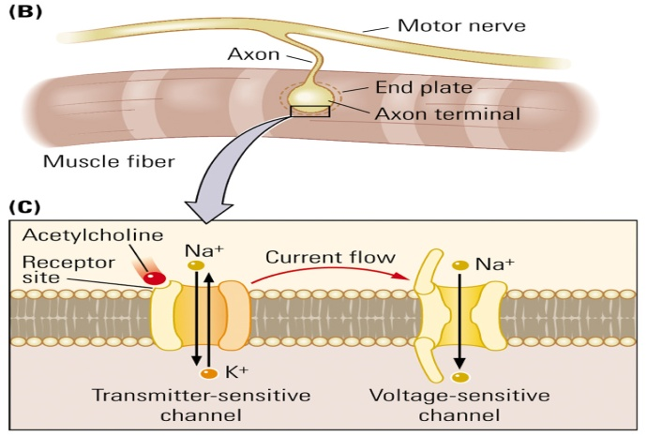

Studying the Brain’s Electrical Activity
- Single-Cell Recordings
  - Measuring action potentials in individual cells
  - Requires small insulated wire microelectrodes
  - Neurons fire in response to stimuli as simple as lights or tones, and as complex as the face of a particular person
  - Example: Head-direction cell
    - Neuron in the hippocampus that discharges when an animal faces a particular direction
    - There were only certain neurons that would fire depending on which direction the animal was looking
- EEG Recordings
  - Electroencephalogram (EEG)
    - Hans Berger in 1930s
  - Electrodes are placed onto the skull and record electrical activity of the brain
  - Often used to observe sleep, epilepsy, etc.
  - Each electrode has a name and the information that comes out of each one is recorded separately
  - Measures the summed graded potentials from many thousands of neurons, especially the neocortex
  - Three Important Features:
- The living brain’s electrical activity is never silent, even when a person is asleep or anesthetized
    - Amplitude (height of brain waves)
    - Frequency (number of brain waves per second)
- An EEG recorded from the cortex has a large number of patterns, some of which are rhythmic
- Example: Alpha rhythm
  - Rhythmic EEG wave with a frequency of 11 cycles per second
- The EEG changes as behaviour changes
- From alert to coma
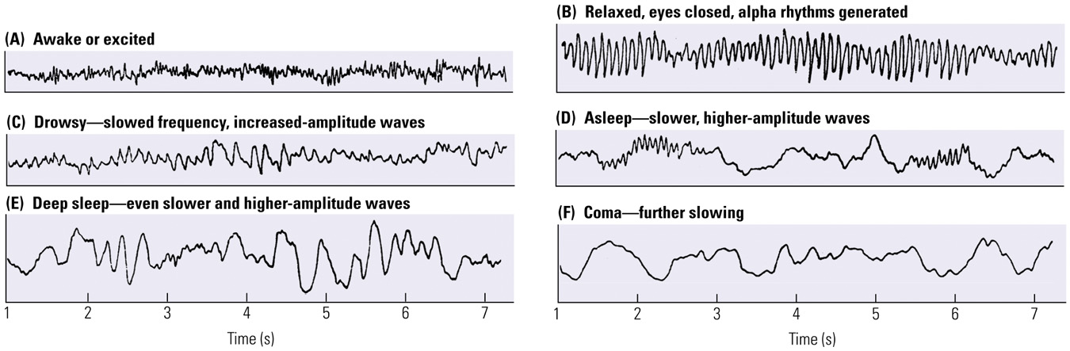
  - EEG is a reliable tool for
    - Monitoring sleep stages
    - Estimating depth of anesthesia
    - Evaluating severity of head trauma and searching for other brain abnormalities
  - Polygraph: A simple method for recording electrical activity of the human brain
- Event-Related Potentials
  - Event-Related Potential (ERP)
    - Brief change in slow-wave brain activity in response to a sensory stimulus
  - Stimulus is repeated many times and the recorded responses are averaged
  - Averaging cancels out any irregular or unrelated electrical activity and leaves only those potentials that were generated by the stimulus
  - Waves are numbered in relation to the time at which they occur
    - Example: N1 (N100) is a negative wave occurring about 100 ms after the stimulus; P300 is when you realize there was a change in stimulus (positive wave 300 ms after the stimulus)
  - Advantages
    - Noninvasive, relatively inexpensive

