Chapter 2 Continued

Organization of the Nervous System
- The Central Nervous System
  - The Spinal Cord
    - Controls most body movements
    - Can act independently of the brain
    - Spinal reflex:
      - Automatic movement
      - Hard to prevent (brain cannot inhibit)
      - Example: Knee-jerk reflex (patellar tendon)
  - The Brainstem
    - Begins where spinal cord enters the skull and extends upward to the lower areas of the forebrain
    - Receives afferent nerves from all of the body’s senses, and it sends efferent nerves to control all of the body’s movement except the most complex movements of the fingers and toes
    - Produces movement and creates a sensory world
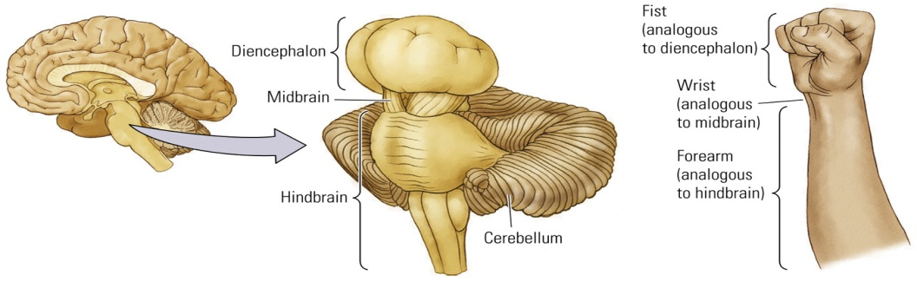
    - Three regions:
      - Hindbrain
        - Evolutionarily the oldest part of the brain
        - Control of movement
        - Controls various motor functions ranging from breathing to balance to fine movements
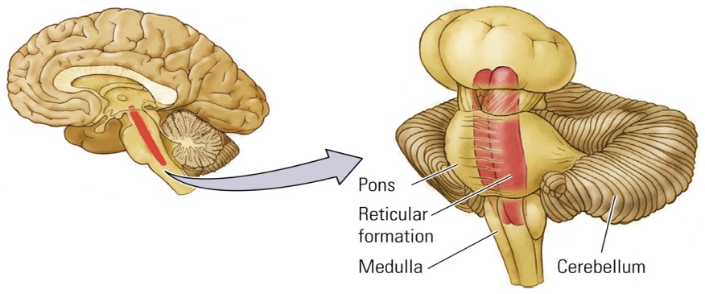
        - Contains:
          - Cerebellum
            - Controls complex movements and has a role in a variety of cognitive functions
            - Size of cerebellum increases with the physical speed and dexterity of a species
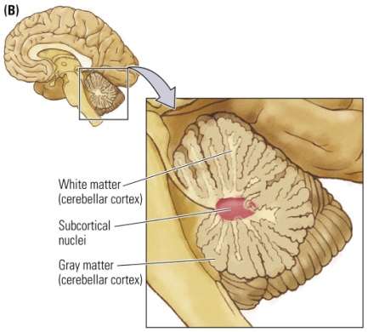
          - Reticular Formation
            - Netlike mixture of neurons (gray matter) and nerve fibers (white matter)
            - “Reticular activating system”
            - Stimulates the forebrain: Regulation of sleep-wake behaviour and behavioural arousal
          - Pons
            - Connects cerebellum to the rest of the brain
            - Controls important movements of the body
            - Nuclei within the pons receive inputs from the cerebellum and actually bridge it to the rest of the brain
          - Medulla
            - Rostral end of brain
            - Vital functions: Control of breathing and heart rate
      - Midbrain
        - Tectum (roof of midbrain) – located dorsally
          - Sensory processing (visual and auditory)
            - Receives a massive amount of sensory information from the eyes and the ears
          - Produces orienting movements
            - Related to sensory inputs, such as turning your head to see the source of a sound
            - The auditory and visual systems must share some sort of common map of the external world so that the ears can tell the eyes where to look
        - Tegmentum (floor of midbrain) – located ventrally
          - Composed of many nuclei, largely with movement-related functions
          - Eye and limb movements (red nucleus)
          - Species- specific behaviours
          - Perception of pain
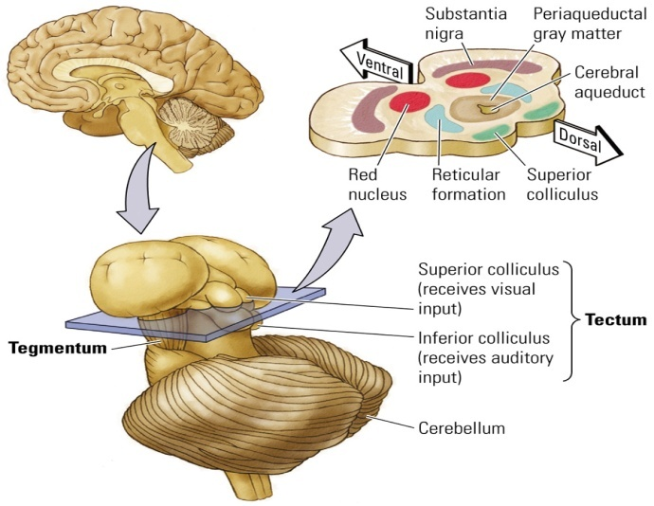
      - Diencephalon
        - Hypothalamus (0.3% of the whole brain volume) – to the left of the thalamus
          - Composed of 22 small nuclei
          - Feeding
          - Sexual behavior
          - Sleeping
          - Temperature regulation
          - Emotional behavior
          - Hormone function: through connections with the pituitary gland
          - A lesion in a specific part can affect behaviors – one can cause one to eat more, one can cause another to eat less
        - Thalamus – to the left of the tip of the brainstem, larger than the hypothalamus
          - 20 different nuclei, all connecting to different parts of the cortex
          - Information gets sent to the thalamus and then is sent to other parts of the cortex (“the gateway”, the reeling station)
          - Sensory processing
          - Motor processing
          - Integrative functions
          - Motivation
          - Memory
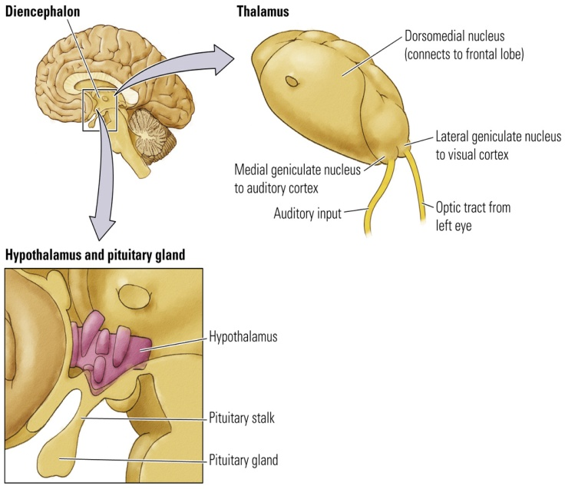
  - The Forebrain: Three Principle Structures
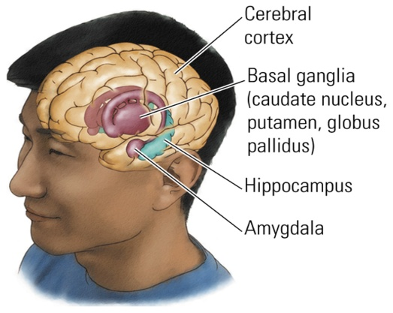
    - Neocortex: Regulates various mental activities (ranging from perception to planning)
      - Neocortex (“new bark”): 6 layers of gray matter on top of a layer of white matter; Creates and responds to a perceptual world
        - The outer part that you can see
      - Limbic Cortex: 3 or 4 layers of gray matter; Controlling motivational and emotional states; the older cortex
        - Play a role in controlling motivational states
      - The Cortex: Four Lobes; 80% of the brain overall (makes up most of the forebrain)
        - Occipital: Vision
        - Parietal: Tactile
        - Temporal: Visual, auditory, and gustatory
          - Wernicke’s area – understanding language
        - Frontal: Integrates sensory and motor functions; planning
      - The Cortex: Layers
        - Different layers have different cell types
        - Density of cells in each layer varies
        - Differences in appearance relate to function
        - Cytoarchitectonic Map: Map of neocortex based on the organization, structure, and distribution of the cells
        - Some regions are rich in one chemical whereas others are rich in another
        - The cortex is connected to virtually all other parts of the brain; it takes part in everything
        - It influences our cravings for food, our lust for things, how we interpret the meaning of abstract concepts, words and images.
        - Ultimate creator of our reality, because it is so well connected
    - Basal Ganglia: Control of voluntary movement
      - Collection of nuclei just below the white matter of the cortex (Key: caudate, putamen, and globus pallidus)
      - Controls voluntary movement
      - Related disorders: Parkinson’s, Tourette’s
      - Disorders of controlling movements
      - Must play a role in the control and coordination of movement patterns, not in activating the muscles
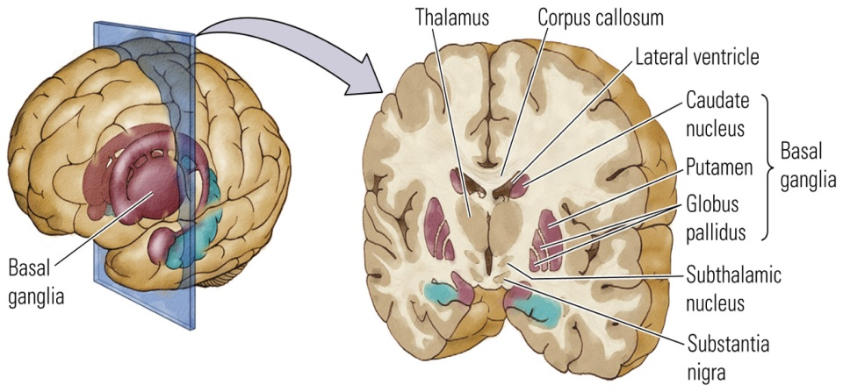
    - Limbic System: Regulates emotions and behaviours that create and require memory
      - Has major connections with prefrontal cortex
      - Group of structures between the neocortex and brain stem
        - Key: cingulate cortex, hippocampus (spatial navigation), and amygdala (emotion [anxiety])
          - Removing the amygdala produces truly startling changes in emotional behavior
          - Hippocampus and cingulate cortex have roles in certain memory functions, as well as in the control of navigation in space
      - Believed to be at least partly responsible for the rewarding properties of psychoactive drugs
      - Regulation of
        - Emotional and sexual behaviours
        - Memory
        - Spatial navigation
        - Motivation
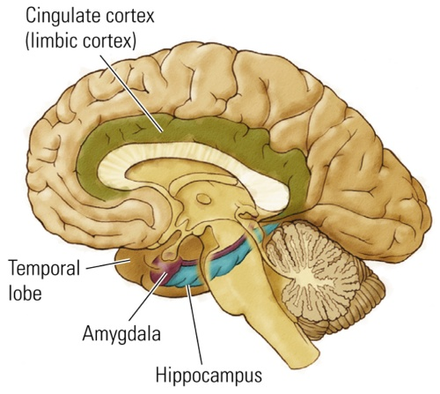
  - The Olfactory System
    - Very front of the brain
    - Responsible for sense of smell
    - Almost entirely a forebrain structure
    - Olfactory bulbs Pyriform Cortex Thalamus Neocortex
    - Can go directly to the hippocampus (direct connection)
    - Olfactory bulb is relatively small
    - It is still sensitive and plays an important role in various aspects of our feeding and sexual behaviour
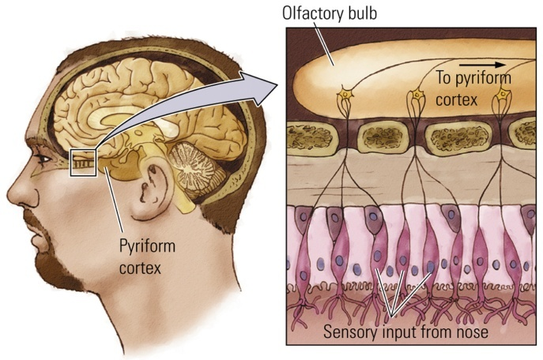

  - Cranial Nerves
    - 12 cranial nerves hugely associated with sensory connections
      - One set of 12 controls the left side of the head, whereas the other set controls the head’s right side
    - Can have afferent functions, such as sensory inputs to the brain from the eyes, ears, mouth and nose, or they can have efferent functions, such as motor control of the facial muscles, tongue and eyes
    - Examples:
      - Olfactory Smell
      - Optic Vision
      - Oculomotor Eye movement
    - Provide inputs to the brain from the head’s sensory organs and muscles and controlling head and facial movements
    - Contribute to maintaining autonomic functions by connecting the brain and internal organs and by influencing other autonomic responses (salivation)
- The Somatic Nervous System
  - Spinal Nerves
    - 5 regions
  - Dermatome
    - Area of the skin supplied with afferent nerve fibers by a single spinal-cord dorsal root
    - Segments of our bodies which correspond to segments of the spinal cord
    - Has a sensory nerve which sends information from the skin, joints and muscles to the spinal cord
    - Has a motor nerve which controls the movements of the muscles in that particular segment of the body
    - These spinal nerves receive information from sensory receptors in the rest of the body
  - Law of Bell and Magendie
    - The general principle that sensory fibers are located dorsally and motor fibers are located ventrally
    - Dorsal spinal cord is sensory and the ventral side is motor
    - Location of spinal-cord damage or disease on the basis of changes in sensation or movement that patients experience
    - Ex. Tectum and tegmentum
- The Autonomic Nervous System – regulates the internal organs and glands by connections through the SNS to the CNS
  - Sympathetic System
    - Directly linked with a surge of adrenaline
    - Arouses the body for action (e.g., increase heart rate and blood pressure)
    - Mediates the “fight or flight” response
  - Parasympathetic System
    - Opposite of sympathetic: prepares the body to “rest and digest”
    - Reverses the “fight or flight” responses

Eight Principles of Nervous System Function

- Principle 1:
  - The Sequence of Brain Processing Is:
“ InIntegrate Out”
- Ex. World Brain Behaviours
- The inputs to a neuron at any given moment are summed up, and the signal sent by that neuron to other neurons incorporates this summation
- Principle 2:
  - Sensory and Motor Divisions Exist Throughout the Nervous System
    - Periphery: Cranial and spinal nerves; either sensory or motor in function
    - Brain: All the way up the cortex; tectum is sensory, and tegmentum is motor
- Principle 3:
  - Many of the Brain’s Circuits Are Crossed
    - Ex. Left side of the body is connected to the right side of the brain
    - Innumerable neural connections link the left and right sides of the brain
    - Exceptions – olfactory and somatic systems; they directly link into the same side of the brain
- Principle 4:
  - The Brain is Both Symmetrical and Asymmetrical
    - Asymmetry is essential for certain tasks:
      - Language is usually on the left side
      - Spatial functions are usually on the right side
- Principle 5:
  - The Nervous System Works Through Excitation and Inhibition
    - Excitation: process by which the activity of a neuron is increased
    - Inhibition: process by which the activity of a neuron is decreased or stopped
    - Applies to individual neurons and to nuclei (either are on or off)
- Principle 6:
  - The Central Nervous System Functions on Multiple Levels
    - “Descent with Modification”
      - During evolution, new brain areas were placed on top of older ones
    - Newer brain levels added increased control and processing
    - Levels work together to produce behavior
    - Ex. Amygdala as emotional front humans can control their instincts better than animals
    - To move the arms, the brainstem must use circuits in the spinal cord
    - Each new level offers a refinement and elaboration of the motor control provided by one or more lower levels
- Principle 7:
  - Brain Systems Are Organized Both Hierarchically and in Parallel
    - More than one area may take part in a given function
    - Binding Problem: Because a single sensory event is analyzed by multiple parallel channels that do not converge onto a single brain region, there is said to be a problem in binding together the segregated analyses into a single sensory experience
      - How the brain ties together its various activities into a whole perception or behavior
    - Primary secondary tertiary
    - Multiple levels can exist in each of several processing streets, and areas at all levels interconnect
- Principle 8:
  - Functions in the Brain Are Both Localized and Distributed
    - Because functions (e.g., language) have many aspects, it is not surprising that these aspects reside in widely separated areas of the brain
    - Functions can be localized in specific parts of the brain
    - Small area of damage = focal symptoms
    - Large area of damage = remove entire function
    - Ex. Specific language-related abilities are found in specific locations, but language itself is distributed throughout a wide region of the brain

