Chapter 3

Cells of the Nervous System

- Debate in the Early 1900s
  - Golgi - The nervous system is composed of a network of interconnected fibers: a “nerve net”
  - Cajal - Nervous system is made of discrete cells that begin life with a rather simple structure that becomes more complex with age
    - When mature, these cells consist of a main body with extensions projecting from it
    - Neuron Hypothesis: Neurons are the units of brain function
- Glial Cells (“glue”) – 10x more than neurons
  - Help neurons, may bind them together (glue)
  - Multiple functions; provide structural support, nutrients, and protection
- Neurons
  - Functional units
  - Enable us to receive information, process it, and act
  - Three Basic Subdivisions
    - Dendrites: Gather information from other neurons; the more you have, the more information coming in
    - Cell Body or Soma: Core region; contains the nucleus, Integrates the information
    - Axon: Carries information to be passed on to other cells (neuron has only one axon)
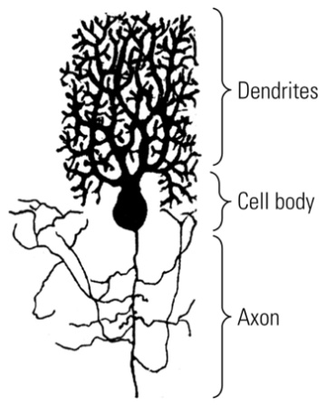
  - Most behaviours are produced by groups of hundreds or thousands of neurons – scientists think they work together in groups to produce some aspect of a behaviour
  - Acquire information from sensory receptors, pass that information on to other neurons, and make muscles move to produce behaviours.
  - Must encode memories and produce our thoughts and emotions as well
  - Must regulate all the many body processes such as breathing, heartbeat, etc.
  - Neurons continuously change their shape (grow and shrink)
    - The number of connections is changed
    - Physical changes result from coding and storing our experiences and memories
  - Most of your neurons are with you for life and are never replaced
  - Basic Structure and Function
    - Dendritic Spines
      - The more you have, the more information you’ll be able to process
      - Can have thousands per dendrite
      - Protrusion from a dendrite that greatly increases its surface area and is the usual point of contact with axons
    - Axon Hillock
      - Where the action potential starts; where the axon starts
      - Juncture of soma and axon where the action potential begins
    - Axon Collaterals
      - Branch of an axon
    - End foot
      - Knob at the tip of an axon that conveys information to other neuron; also called a terminal button
      - Almost touches the dendrites of another neuron
    - Synapse
      - Gap between one neuron and another neuron
      - Usually between an end foot of the axon of one neuron and a dendritic spine of another neuron
      - Cell body makes decision of whether or not there will be an action potential
    - Information Flow in a Neuron
      - Dendrite Cell body Axon End foot
      - Neuron must also act as a decision-making device – the message that it sends must be an averaged, or summary, response to all the incoming information
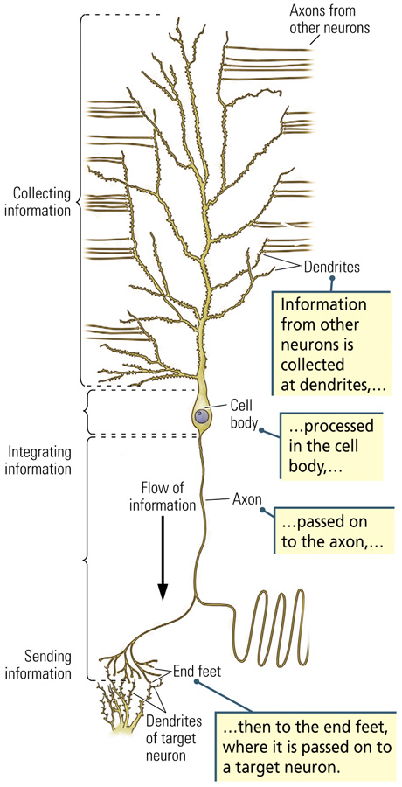
  - Different Types
    - Sensory Neurons
      - Bring information to the central nervous system
    - Interneurons
      - Associate sensory and motor activity within the central nervous system
      - Also called association nerons
      - Purkinje cell – carries information from the cerebellum to the rest of the brain and the spinal cord
    - Motor Neurons
      - Send signals from the brain and spinal cord to muscles
      - Have extensive networks of dendrites, large cell bodies, and long axons that connect to muscles
      - Located in the lower brainstem and spinal cord
      - All outgoing neural information must pass through them to reach the muscles
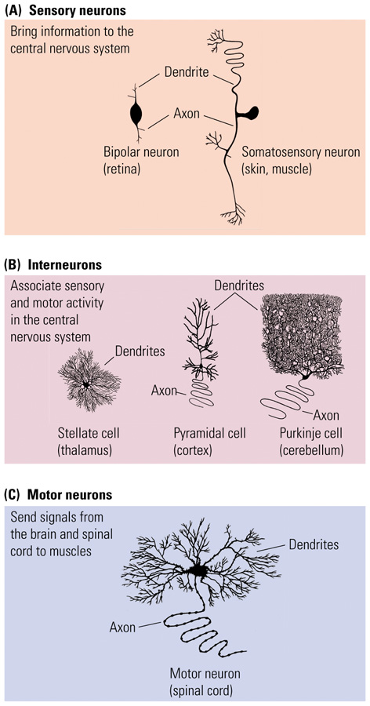
  - Neural Connections
    - The appearance of each neuron tells us something about the connections that it must make
    - In general, neurons with large cell bodies have extensions that are very long; neurons with small cell bodies have short extensions
    - Long extensions carry information to distant parts of the nervous system; short extensions are engaged in local processing
  - Excitation and Inhibition
    - “Language” of neurons
    - Neurons either excite other neurons (turn them on) or inhibit other neurons (turn them off)
    - Each neuron receives thousands of excitatory and inhibitory signals every second
    - Neurons “sum” these signals and respond accordingly: They become active or not
    - From the simple “yes-no” language of neurons emerges enormous possibilities for behavior
    - A neuron is spurred into action only if its excitatory inputs exceed its inhibitory inputs, and vice versa for not activating.
- Glial Cells – help neurons transmit information, provides insulation, nutrients and support, and aid in the repair of neurons; they constantly replace themselves
  - Ependymal Cells
    - Small, ovoid; found in the walls of the ventricles
    - Make and secrete cerebrospinal fluid (CSF)
    - CSF acts as a shock absorber when the brain is jarred, provides a medium through which wastes are elimnanted, may play a role in brain cooling, and may be a source of nutrients for certain parts of the brain adjacent to the ventricles
  - Hydrocephalus
    - Build-up of pressure in the brain and swelling of the head caused if the flow of CSF is blocked
    - In infants, this can lead to severe mental retardation and even death
  - Astrocyte (astroglia)
    - Star shaped, symmetrical
    - Structural support for neurons within the CNS
    - Attach to blood vessels and to the brain’s lining, creating scaffolding that holds neurons in place
    - Transports substances between neurons and capillaries (blood-brain barrier)
    - Blood-brain barrier – substances cannot get into the brain because of this structure; end feet of astrocytes attach to the cells of blood vessels, causing the blood-vessel cells to bind tightly together
    - Brain infections are difficult to treat because of this barrier
    - Convey signals from the neuron to the blood vessels, stimulating them to expand and so provide more fuel; enhance brain activity
    - Scar tissue formation – unfortunately acts as a barrier to the re-growth of damaged neurons
  - Tumor
    - Mass of new tissue that grows uncontrolled and independent of surrounding structures
    - Grow from glia or other supporting cells
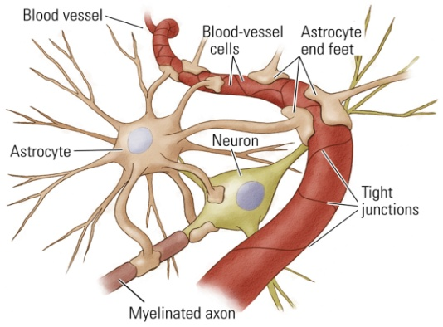
  - Microglia
    - Usually found in blood vessels
    - Originate in the blood vessels as an offshoot of the immune system and migrate throughout the brain
    - Monitor the health of brain tissue
    - If you see these densely populated, that means there has been brain damage
    - Phagocytosis: scavenge debris (e.g., dead cells)
      - They invade the area to provide growth factors that aid in repair and to engulf and remove foreign matter and debris
    - Microglia will be left where neurons were once located
  - Oligodendroglia Cell
    - Creates the myelin
    - Provide some nutrition to neurons
    - Glial cell in the central nervous system that myelinates axons
      - Do so by sending out large, flat branches that enclose and separate adjacent axons
  - Myelin
    - Glial coating that surrounds axons
    - Allows for faster propagation
  - Schwann Cell
    - Glial cell in the peripheral nervous system that myelinates axons
      - Wraps itself repeatedly around a part of an axon, forms a structure which resembles a bead on a string
    - Contribute to a neuron’s nutrition and function by absorbing chemicals that the neuron releases and releasing chemicals that the neuron absorbs
  - Multiple Sclerosis (MS)
    - Nervous system disorder that results from the loss of myelin around axons
  - Paralysis
    - Loss of sensation and movement due to nervous system injury
  - Peripheral Nervous System
    - Microglia and Schwann cells help repair neurons
    - Nerves can be repaired, there can be regrowth
    - Schwann cells serve as signposts to guide axons to their appropriate end points
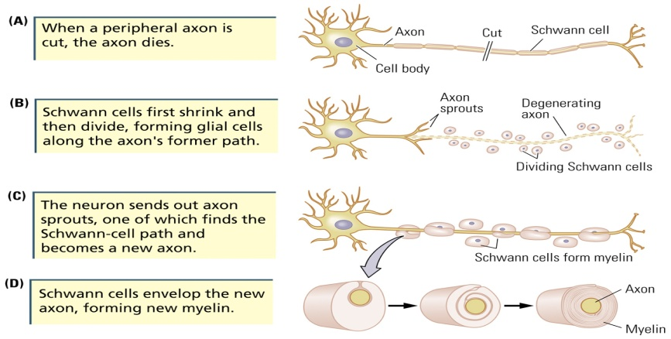
  - Central Nervous System
    - Repair does not take place, regrowth may even be inhibited
    - Function does not return

Internal Structure of a Cell
- Elements and Atoms
  - Elements
    - Naturally occurring substances
    - Three main ones: CHO – make up 96% of a cell’s composition
  - Atoms
    - Smallest quantity of an element that retains that element
    - Contain a nucleus
      - Neutrons: neutral in charge
      - Protons: carry a positive (+) charge
      - Electrons: carry a negative (-) charge
    - Ordinarily, it has an equal number of positive and negative charges and so it is electrically neutral
    - When an atom gives up an electron, it becomes positively charged
    - When an atom takes on an electron, it becomes negatively charged
    - Ion: A charged atom
      - Positive and negative charges of ions allow them to interact, a property that is central to cell function
- Molecules
  - Formed when atoms bind together
  - Smallest units of a substance that contain all of that substance’s properties
  - Salts (e.g., NaCl)
    - When formed, sodium (Na⁺) gives up an electron to chloride (Cl⁻)
    - Positively and negatively charged ions tightly held together by their electrical connection
  - Water (H₂0)
    - Atoms held together by shared electrons
    - Polar molecule: Opposite charges at opposite ends
    - Hydrophilic: “water loving”
- Parts of a Cell
  - Cell Membrane
    - Separates intracellular and extracellular fluid
    - Regulates movement of substances into and out of the cell: most cannot pass
      - Proteins embedded within membrane allow substances into and out of cell
      - Almost inpenetrable
      - Extracellular fluid – composed mainly of water with dissolved salts and many other chemicals; separates neurons and glia
- Phospholipids
  - Hydrophilic head: phosphorous; likes water
  - Hydrophobic tail: lipids (fat molecules); does not like water
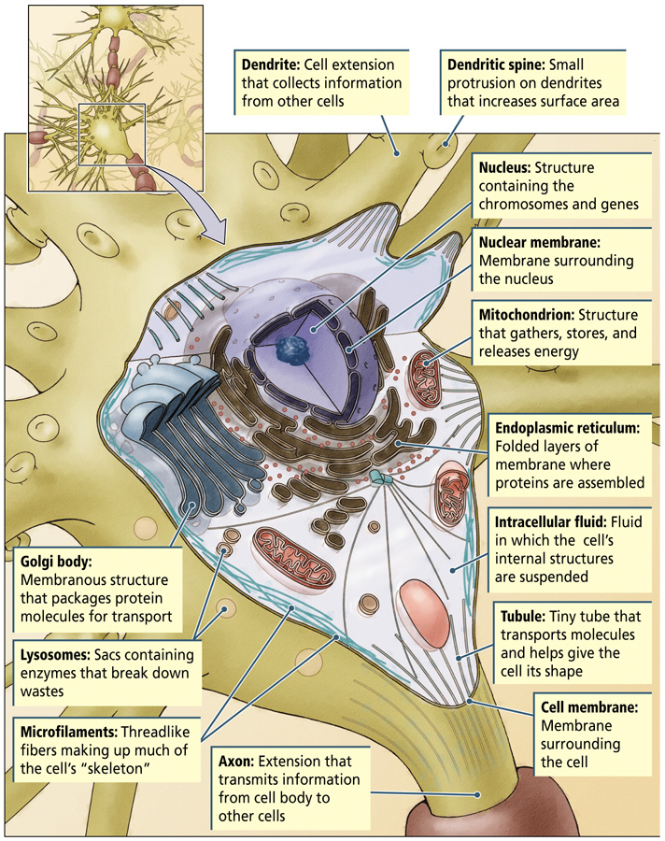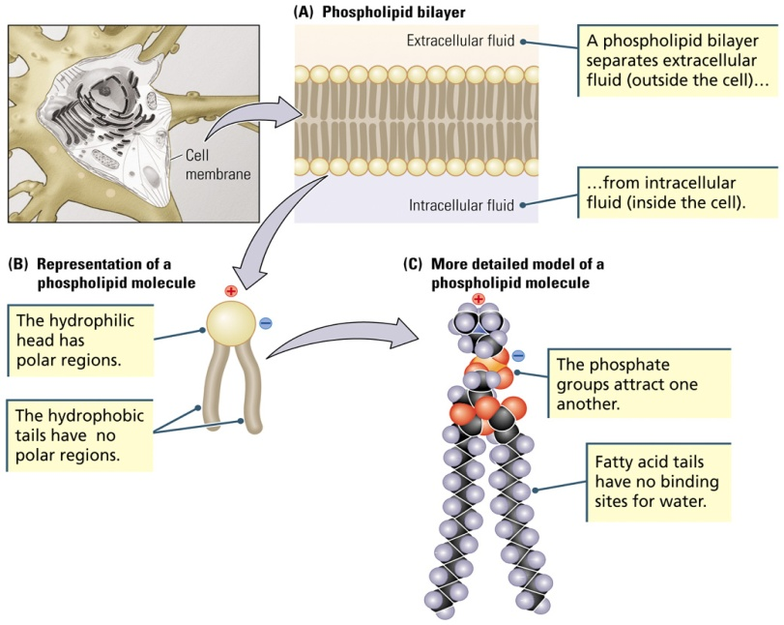
  - The Nucleus
    - Cell’s “executive office”
    - Chromosome
      - Double-helix structure that holds an organism’s entire deoxyribonucleic acid (DNA) sequence
      - Four nucleotide bases: Adenine (A), Thymine (T), Guanine (G), and Cytosine (C)
      - Human somatic cells have 23 pairs
      - Contain the genes – 20 000 genes, and half of them are for the brain
    - Gene
      - Contain segments of DNA
      - Blueprints for making proteins
      - Genes produce proteins that give you characteristics such as blue eyes and blonde hair
      - Sequences of nucleotides determine which amino acids are to be joined to form the particular protein
    - Transcription
      - Early phase of protein synthesis in which the DNA strands unwind and a complementary strand of messenger RNA (ribonucleic acid) is created
        - Messenger RNA copies the information
  - The Endoplasmic Reticulum (ER)
    - Ribosomes: Site of protein synthesis
    - Translation
      - Later phase of protein synthesis in which the messenger RNA (mRNA) travels from nucleus to the ER
      - mRNA is translated into a particular sequence of amino acids to form a protein
- Amino acids
  - Linked together by a peptide bond
  - Polypeptide chain: a series of amino acids
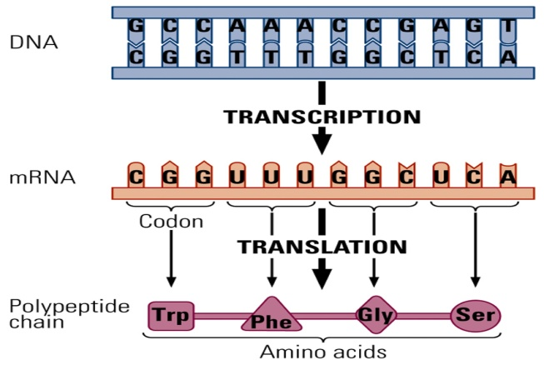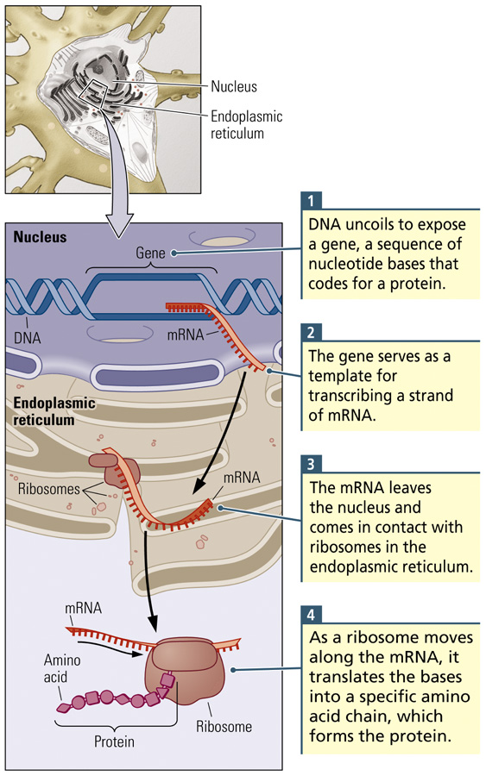
  - Golgi Bodies
    - Package proteins in membranes (vesicles) and give them a “label” indicating where they are to go

  - Microtubules
    - Transport the vesicles to where they need to go within the cell or outside of the cell
  - Cell Membrane, Revisited
    - Channel: Opening in a protein embedded in the cell membrane that allows the passage of ions
    - Gate: Protein embedded in a cell membrane that allows substances to pass through the membrane on some occasions but not others
    - Pump: Protein embedded in a cell membrane that actively transports a substance across the membrane
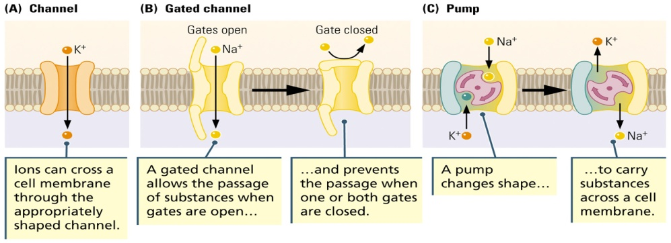

Genes, Cells, and Behaviour
- Chromosomes and Genes
  - Genes are chromosom segments that encode proteins, and proteins serve as enzymes, membrane channels, and messenger molecules.
  - Genes proteins cells behavior
  - Human somatic cells have 23 pairs of chromosomes
    - One copy from the mother (X) and one copy from the father (Y)
    - Autosomes: Pairs 1-22
    - Sex chromosomes: Pair 23
  - Allele
    - Alternate form of a gene; a gene pair contains two alleles
    - Matching copies of a gene
  - Homozygous
    - Having two identical alleles for a trait
  - Heterozygous
    - Having two different alleles for the same trait
  - Wildtype
    - Refers to a normal (most common in a population) phenotype or genotype
    - Ex. For eye colour, it would be brown
  - Mutation
    - Alteration of an allele that yields a different version of that allele
- Genotype and Phenotype
  - Genotype
    - The full set of all the genes that an organism possesses
  - Phenotype
    - The appearance of an organism that results from the interaction of genes with one another and with the environment
    - How the gene expresses themselves; what you see
- Dominant and Recessive Alleles
  - Dominant Allele
    - The member of the gene pair that is routinely expressed
    - Complete dominance – only the allele’s trait is completely expressed
    - Incomplete dominance – allele’s trait is partial expressed
    - Codominance – both the allele traits in the gene pair are expressed completely
  - Recessive Allele
    - The member of the gene pair that is routinely unexpressed
    - Can still be passed on to future generations and influence their phenotypes
- Genetic Mutations
  - Can have positive effects, neutral effects, or negative effects
  - Effects may be specific or wide spread
  - Most mutations have negative effects
  - Many have multiple symptoms
- Mendel’s Principles Apply to Genetic Disorders
  - Tay-Sachs Disease
    - Inherited birth defect caused by the loss of genes that encode the enzyme necessary for breaking down certain fatty substances
    - Build up of fatty tissue in the brain
    - It is a recessive disorder – two copies of the allele are needed for the disorder to develop
    - Appears 4-6 months after birth and results in retardation, physical changes, and death by about age 5
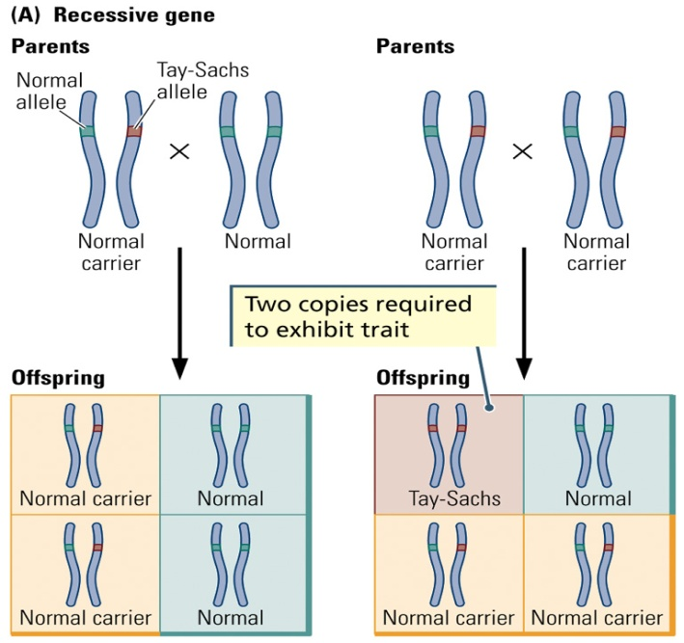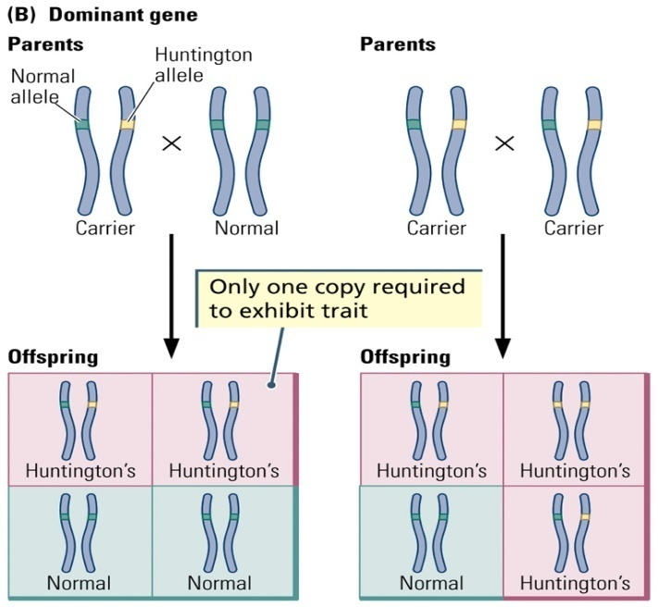
  - Huntington’s Chorea
    - Autosomal disorder that results in motor and cognitive disturbances
    - Caused by an increase in the number of CAG (cytosine-adenine-guanine) repeats on chromosome 4
    - Abnormal version of a protein known as hintingtin builds up in the nervous system cells
    - Most often starts in midlife
    - Only one defective allele is needed to cause the disorder
- Chromosome Abnormalities
  - Genetic disorders involve aberrations in part of a chromosome (or the entire chromosome) rather than a single defective allele
  - Down’s Syndrome
    - Chromosomal abnormality resulting in mental retardation and other abnormalities, usually caused by an extra chromosome 21 (trisomy)
- Genetic Engineering (not on exam)
  - Adding or removing genes from a genome
  - Transgenic animals
    - A gene is added to the genome and is passed along and expressed in subsequent generations
  - Approaches
    - Selective breeding
    - Maintaining spontaneous mutations
    - Directly manipulating genetic expression
  - Cloning (maybe on exam starting here)
    - Producing an offspring that is nearly genetically identical with another animal
  - Chimeric Animals
    - Have genes from two different species
  - Knockout Technology
    - Method used to inactivate a gene so that it is not expressed
    - Potential application to human genetic disorders

