Chapter 2

Overview of Brain Function and Structure

- The Brain’s Primary Functions
- Creating a Sensory Reality
- Evolution has equipped each species with a view of the world that helps it survive
- Dogs have better sense of smell than humans and humans see more colours than dogs
- The organs of the nervous system are designed to admit information from the world and convert this information into biological activity that produces subjective experiences of reality. The brain thus produces what we believe is reality in order for us to move.
- Without the nervous system, especially the brain, there is no such thing as sound. Rather, there is only the movement of air molecules.
- Integrating information
- Current knowledge can be compared with past knowledge
- To create knowledge that integrates information from different times and sensory domains and then use that knowledge to guide behavior
- Whenever the brain collects sensory information, it is essentially creating knowledge about the world, knowledge that it can use to produce more-effective behaviours.
- Producing Behavior
- Example: Movement
- Somatic nervous system (SNS) – all the spinal and cranial nerves to and from the muscles, joints, and skin, produces movement and transmits incoming sensory information, including the position and movement of body parts, to the CNS.
- Autonomic nervous system (ANS) – balances the body’s internal organs to rest and digest through parasympathetic nerves or to fight or flee or engage in vigourous activity through the sympathetic nerves.
- Many names for nervous system structures include information about anatomical location
  - Structures found toward the brain’s midline are medial, whereas those located toward the sides are lateral
    - Ex. Your heart is medial, while your hips are lateral
  - Structures located toward the front of the brain are anterior, whereas those located toward the back are posterior
  - Some may combine terms: example, dorso-lateral which means that it is located up and to the side.

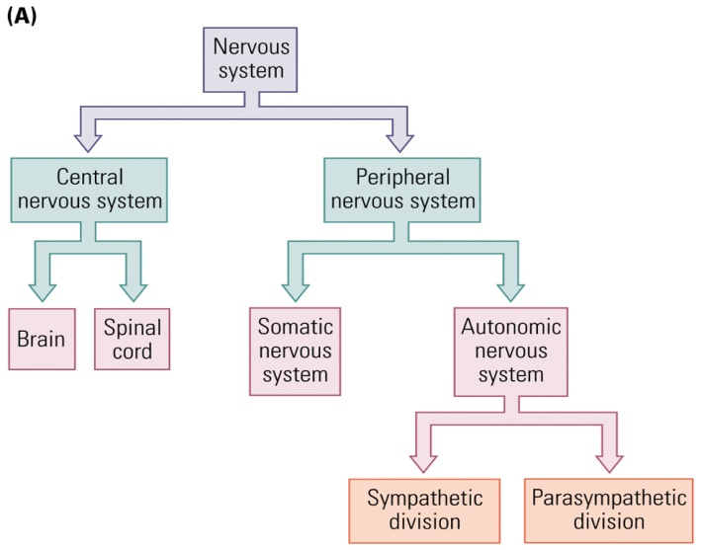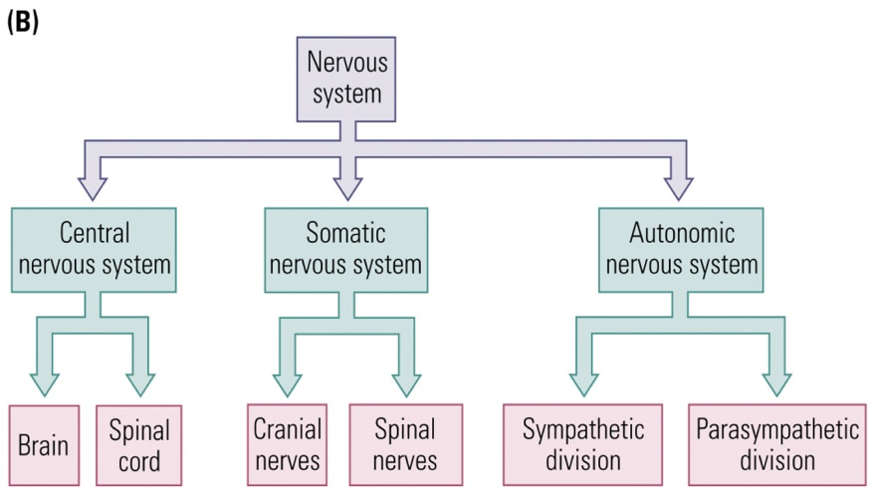

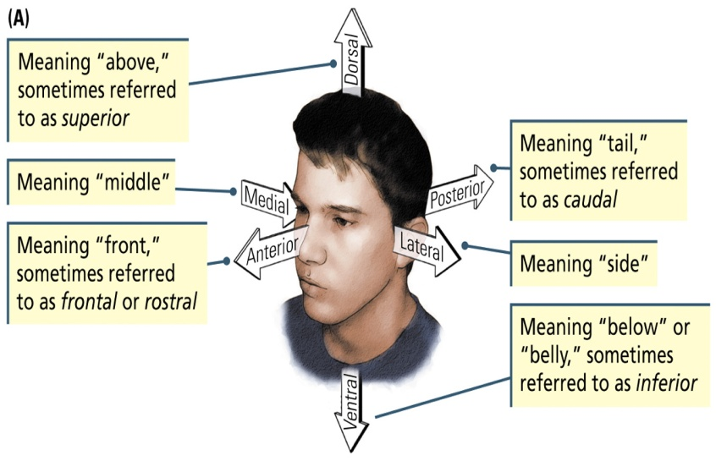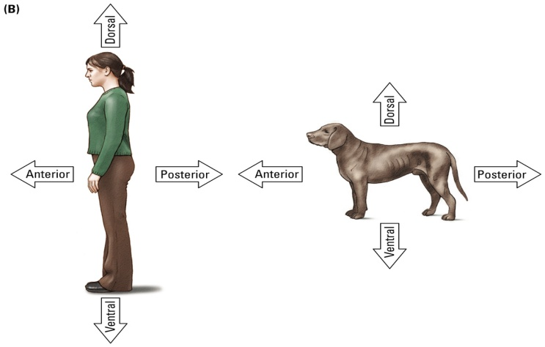
Dorsal View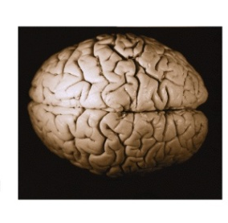Ventral View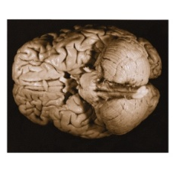Lateral View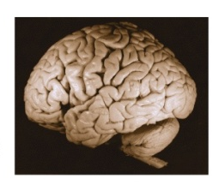
Medial View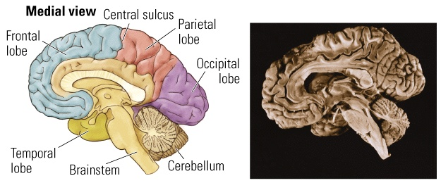

To and From the Brain

- To the brain Affarent – information coming into the CNS or one of its parts (sensory signals transmitted from the body into the brain)
- From the brain Efferent – information leaving the CNS or one of its parts (signals from the brain trigger some response)
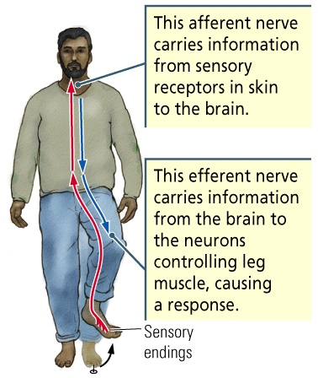

Planes (Slices)
- Refer to slides
Summary

- Top: dorsal or superior
- Bottom: ventral or inferior
- Front: anterior or rostral
- Back: posterior or caudal
- Middle: medial
- Side: lateral
- Afferent: information to the brain
- Efferent: information from the brain

Overview of Brain Function and Structure

- Surface Features
  - Meninges: Three layers of tough protective tissue
    - Dura: (hard) Tough double layer of Fibrous tissue enclosing the brain in kind of loose sack
    - Arachnoid: thin sheet of delicate connective tissue that follows the brain’s contours
    - Pia Matter: (soft) moderately tough membrane of connective tissue fibers that cling to the surface of the brain
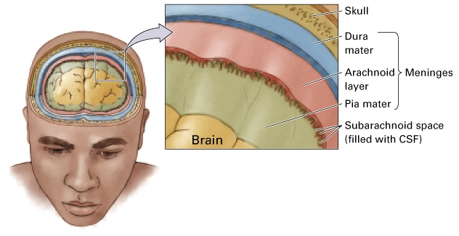
  - Cerebrospinal Fluid (CSF)
    - Colourless solution of sodium chloride and other salts
    - Fills the ventricles and circulates around the brain and spinal cord in the subarachnoid space (located between the arachnoid layer and the pia mater)
    - Cushions the brain so that it can move for expand slightly without pressing on the skull
    - Meningitis - Infection of the meninges and CSF
  - Meningitis
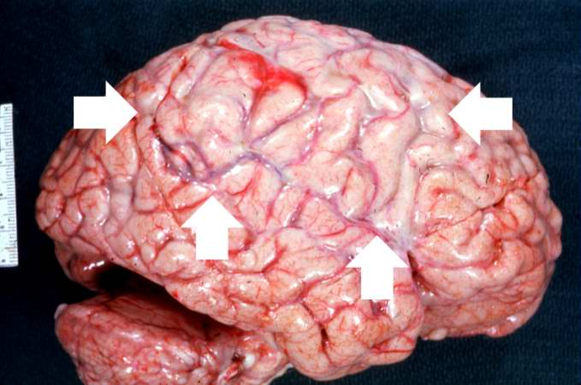
    - Caused by infections in the meninges (particularly in the pia matter and the arachnoid layer, and the CSF between them)
    - Can result in swelling of the brain
    - Sx include: headaches, cervical rigidity, drowsiness, stupor, coma
    - NOTE: there is a difference between meningitis and encephalitis. The latter refers to an infection to the brain itself
  - Refer to slides for cerebrum, cerebellum (little brain), gyri (bumps), sulci (cracks – some are so very deep that they are called fissures – longitudinal fissure between the cerebral hemispheres and the lateral fissure at the side of the brain), cortex
  - Dorsal View
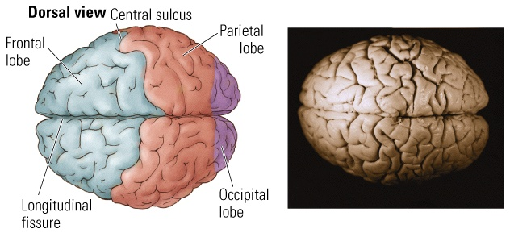
  - Ventral View
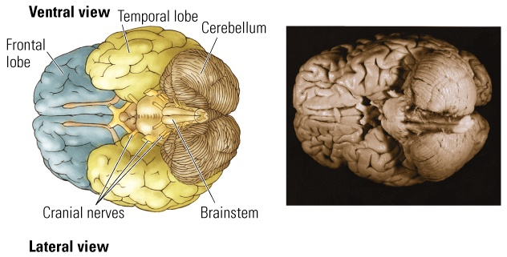

  - Medial View
  - Brainstem
    - Central structures of the brain, including the hindbrain, midbrain, and diencephalon
    - Smooth whitish structure with little tubes attached
  - Surface Blood Vessels
    - The brain receives blood through arteries and sends it back through veins to the kidneys and lungs for cleaning and oxygenation
    - Cerebral arteries emerge from the neck to wrap around the outside of the brainstem, cerebrum, and cerebellum, finally piercing the brain’s surface to nourish its inner regions
    - Anterior, middle, and posterior cerebral arteries
    - Stroke: Sudden appearance of neurological symptoms as a result of severe interruption of blood flow; a blockage or break in a cerebral artery is likely to lead to the death of the affected region
Major Arteries

- Brain Irrigation
  - Three major arteries:
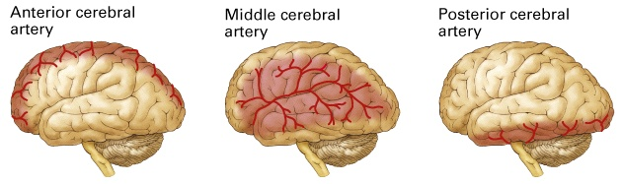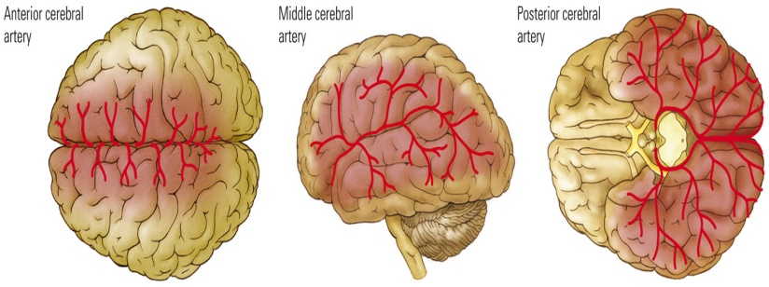
- Lateral View
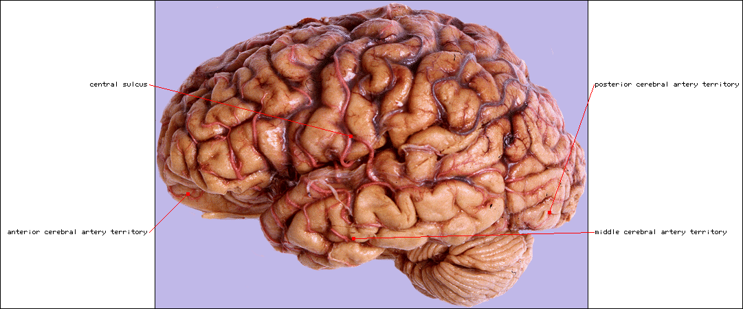
- Ventral View
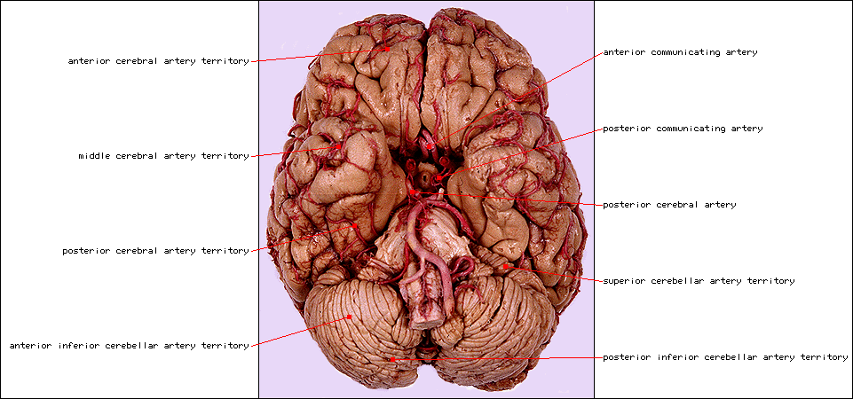
- Dorsal View
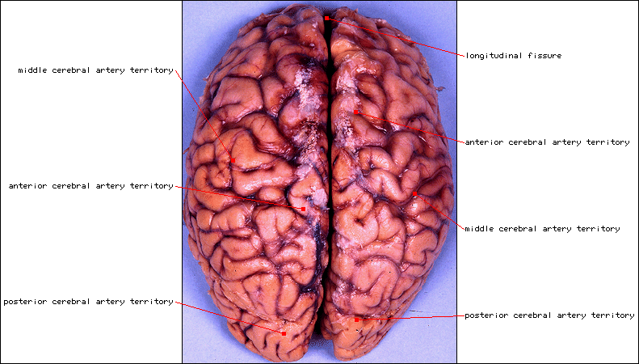
- Medial View
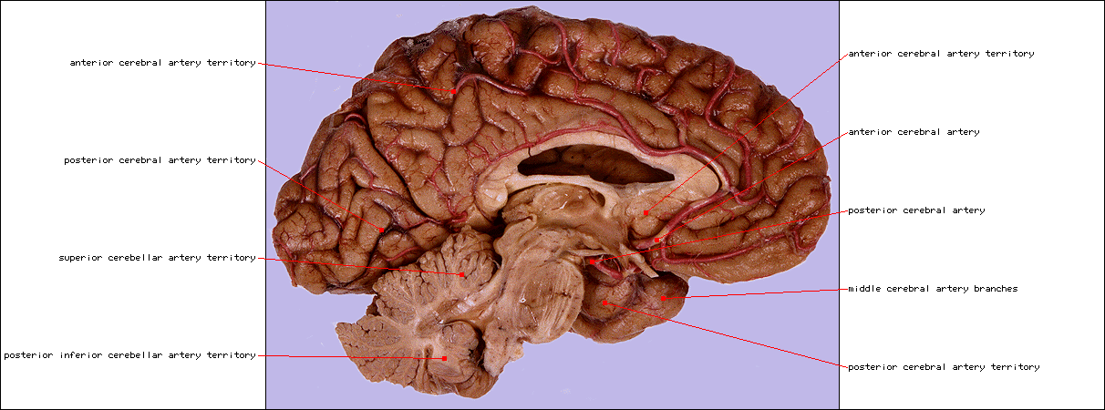
Overview of Brain Function and Structure

- Internal Features
  - White Matter - Areas of the nervous system rich in fat-sheathed neural axons
  - Gray Matter - Areas of the nervous system predominately composed of cell bodies and blood vessels
  - Ventricle - A cavity in the brain that contains cerebrospinal fluid (CSF)
    - Four ventricles: Two lateral ventricles (left and right), Third ventricle, Fourth ventricle
    - Cells that line the ventricles make the CSF that fills them. The ventricles are connected; so the CSP flows from two lateral ventricles to the third and fourth ventricles that lie on the brain’s midline and into the canal that runs the length of the spinal cord.
    - May play an important role in maintaining brain metabolism
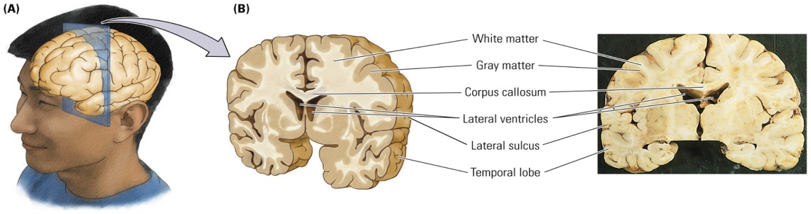
  - Corpus Callosum
    - Fiber system connecting the two cerebral hemispheres; long band of white matter
    - Cortex covers the cerebral hemispheres above the corpus callosum
    - Structures below the cortex are known as subcortical regions; these control basic physiological functions, and the newer cortical structures process motor, sensory, perceptual, and cognitive functions
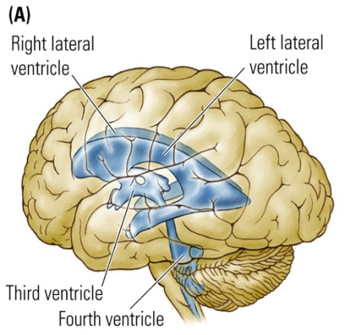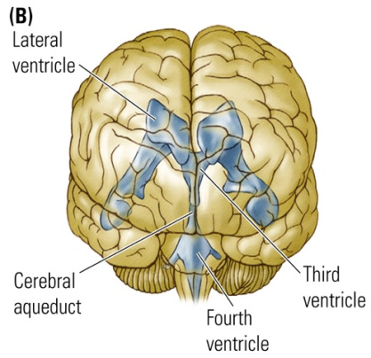
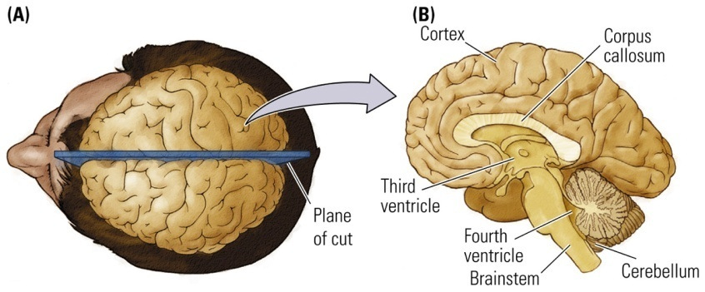
- Microscopic Inspection
  - Two main types of cells:
    - Neurons: Carry out the brain’s major functions; approximately 80 billion
    - Glia: Aid and modulate neurons’ activities; approximately 100 billion
      - Form the fatty covering, or insulation, over neurons
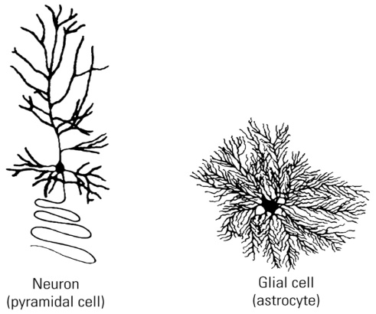
  - Nucleus (pl. nuclei)
    - A group of cells forming a cluster that can be identified with special stains to form a functional grouping; forms functional units within the brain
  - Nerve
    - Large collection of axons coursing together outside the central nervous system
  - Tract
    - Large collection of axons coursing together inside the central nervous system
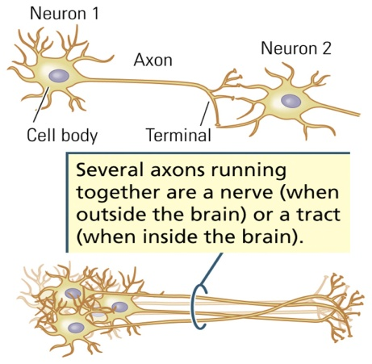
- Evolutionary Development
  - The brain of a young vertebrate embryo begins as a sheet of cells that folds into a hollow tube and develops into 3 regions: forebrain, midbrain, hindbrain
  - Human brain is a complex mammalian brain, yet it still retains most of the features of other less complex mammalian brains
  - Most behaviours are not the product of a single locus in the brain, but rather of many brain areas and levels
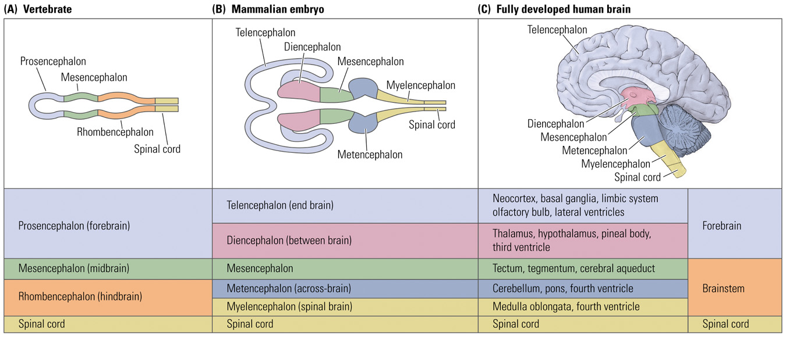
Organization of the Nervous System
- The Central Nervous System


