iTwo Main Tools: Confidence Intervals & Hypothesis Tests
- Confidence Intervals – give you an interval around your estimate within which you are confident (to some level of probability) that the true population parameter lies
- Hypothesis Tests – allow you to determine whether your sample estimate give you reason to believe that the population parameter is different from some assume value
A confidence interval is an interval around a statistic or estimate in which we have a certain confidence that the population parameter value we are estimating is likely to lie

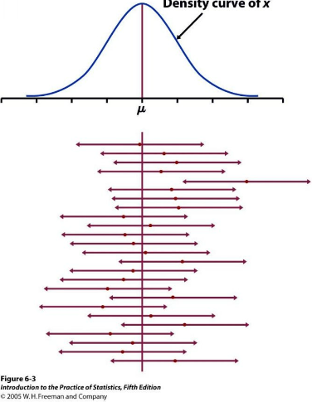

What happens to the C.I as n increases?
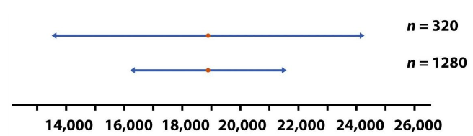

clearly, as n increases, the size of C.I needed to obtain the same level of confidence decreases

What happens as you increase the level of confidence?
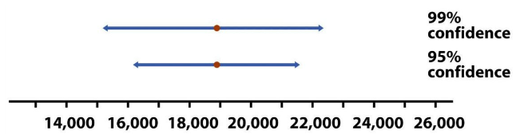

clearly, as you increase the level of confidence, you must expand the size of your interval

A 100(1 - α)% confidence interval always has the same form:
(estimate +/- z*(SD of estimate))

If you don’t know the SD then you replace it with the SE and get:
(estimate +/- t*(SE of estimate))

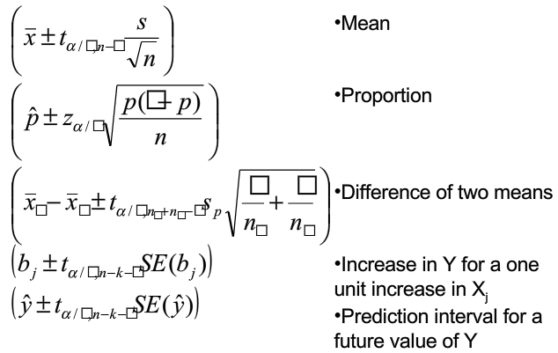

Process for Hypothesis Testing
- there is some existing theory, called the null hypothesis H₀, as to the value of some parameter that you wish to test against an alternative hypothesis, H_{A}
- formulate a test statistic that has a specific distribution if H₀ is true
- collect a random sample from your population
- compute a test statistic based on your sample
- if the value of your test statistic is sufficiently improbably, assuming H₀ is true, then we reject the H₀ in favor of H_{A}
What does “sufficiently improbably” mean?
- whatever value we get for our test statistic from our sample, it is always possible that H₀ is true – it just may be highly unlikely
- we need to decide ahead of time how unlikely our test statistic value needs to be before we are willing to reject H₀
- this value is called our significance level, α

Two Methods:
- Critical Region Approach: find a range of values such that if the test statistic falls into that range, reject H₀ in favor of H_{A}
- P-Value Approach: calculate probability of a test statistic as far from the population parameter specified in H₀ as the one we got: if low enough, reject H₀ in favor of H_{A}

Calculating the P-Value
- for H_{A} of the form ‘greater than’ (one sided), reject …
    - if Z_{stat} > Z_{α}
    - P-Value = Pr(Z>Z_{stat}) <= α
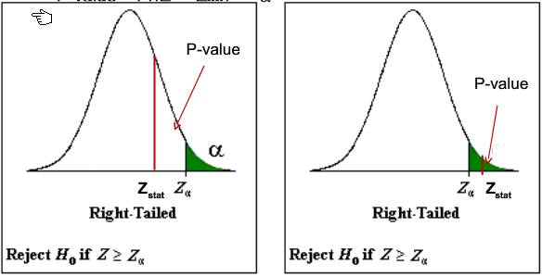

- for H_{A} of the form “less than” (one sided), reject …
    - if Z_{stat} < -Z_{α} or |Z_{stat}| > Z_{α}
    - P-Value = Pr(Z>= |Z_{stat}|) <= α

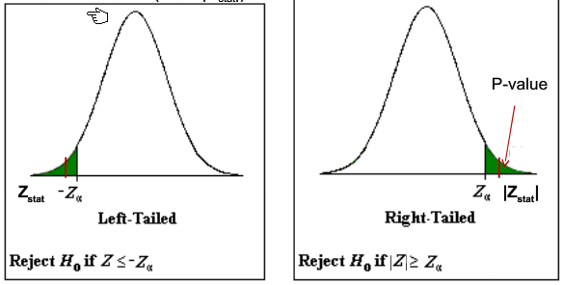

- for H_{A} of the form “not equal to” (two sided), reject …
    - if |Z_{stat}| > Z_{α/2}
    - P-Value = 2*Pr(Z>= |Z_{stat}| <= α
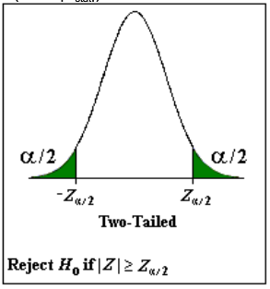

- for test statistics that have normal or t-distributions, all three forms of H_{A} are possible
- for test statistics that have a Chi-square or F-distribution it is only possible to have a two-sided test but you do not need to multiply by two to get the P-Value )they have done that for you already in the tables

Possible Errors
- there are two possible errors – falsely rejecting H₀ (type 1 error) or falsely accepting H₀ (type 2 error)
- by choosing α to be small we effectively keep the probability of falsely rejecting H₀ small
- however, that necessarily means that the probability of falsely accepting H₀ may be large
- thus what value of α you choose depends n which type of error you are more interested in keeping small – small α keeps Type 1 error down, larger α reduces Type 2 error
- generally speaking we set up the hypothesis test so that H_{A} is what we what to prove so the worse error is a type 1 error (i.e by keeping type 1 error small it means that is we do get a significant result we are really confident in having proved what we set out to prove)

What Differs Between Tests?
- type of data – measurement or categoric
- whether normality assumption holds – parametric vs. non-parametric tests
- number of samples (or populations) – one ,two, three, or more
- dependence or independence of samples – samples can be linked by some characteristics; samples can be linked by having two measurement on same individual
- known parameters values (specifically – is σ known?)
- what scenario you are dealing with affects what test statistic you will use, but not the analysis

Possible Scenarios …
- interested in the mean of a variable for a single population
    - σ known: one sample z-test
    - σ unknown: one sample t-test
- interested in the difference between the means of two independent populations
    - assuming equal variance: pooled two sample t-test
    - not assuming equal variance: un-pooled two sample t-test
- interested in the mean difference between matched data
    - matched pairs t-test
- interested in the proportion of individuals with a certain characteristic
    - one sample proportion test
- interested in comparing the proportion of individuals with a certain characteristic between two populations
    - two sample proportion test (or Chi-Square)
- interested in comparing the proportions from multiple populations
    - Chi-square
- Interested in comparing the means from multiple populations
    - Analysis of variance
- Interested in predicting a response variable based on one or multiple predictors
    - One predictor: simple regression
    - Two or more predictors: multiple regression

Tips for Choosing Between Tests
- Measurement or Categoric? – does is make sense to talk about means or proportions/percentages?
- How many populations? – do you have more than one set of individuals being sampled?
- What question are you being asked to answer? – should give you some idea as to the test
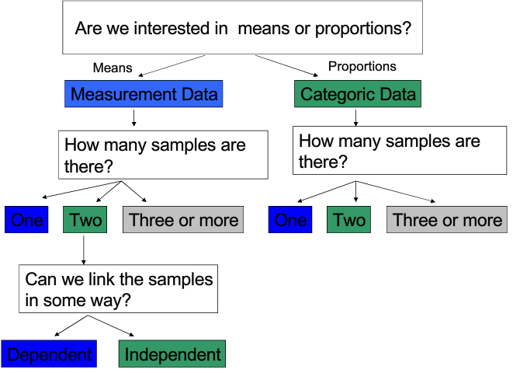
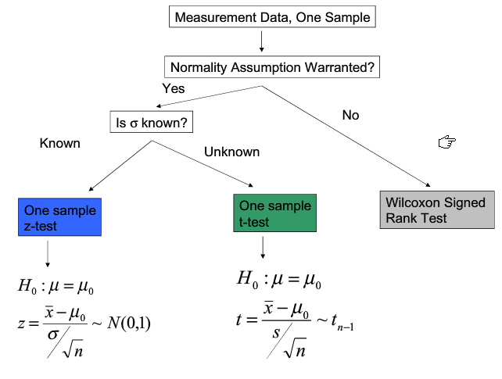
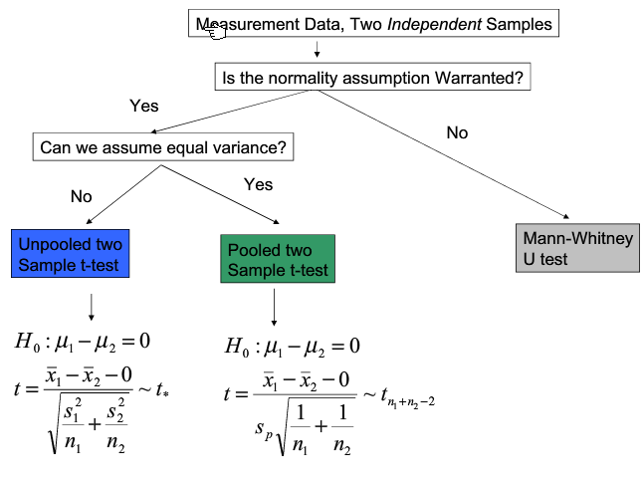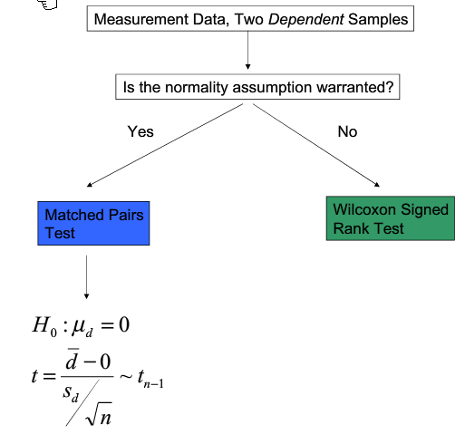

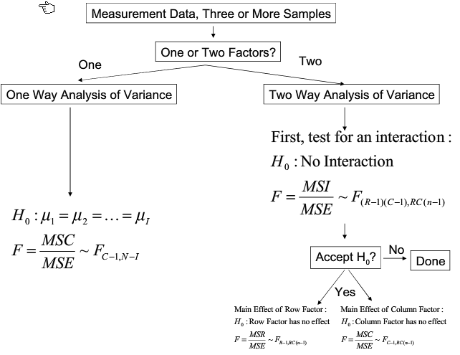
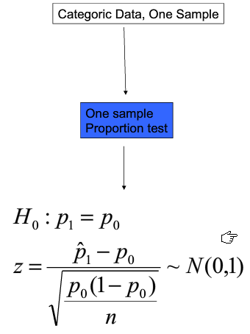
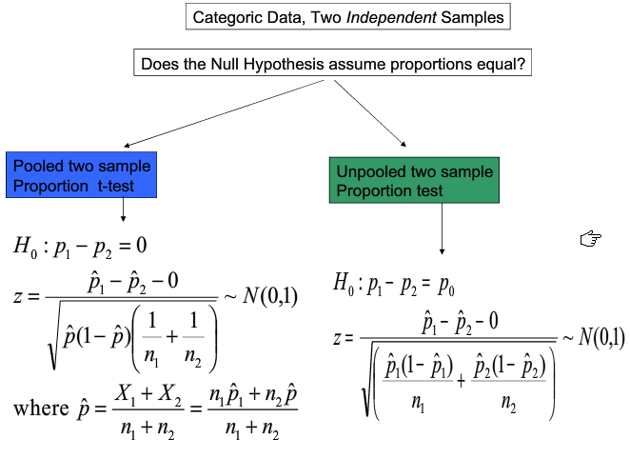
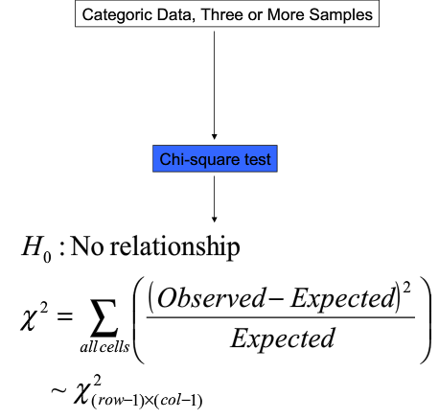
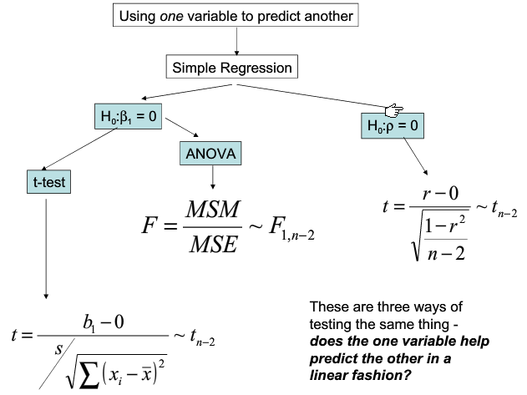

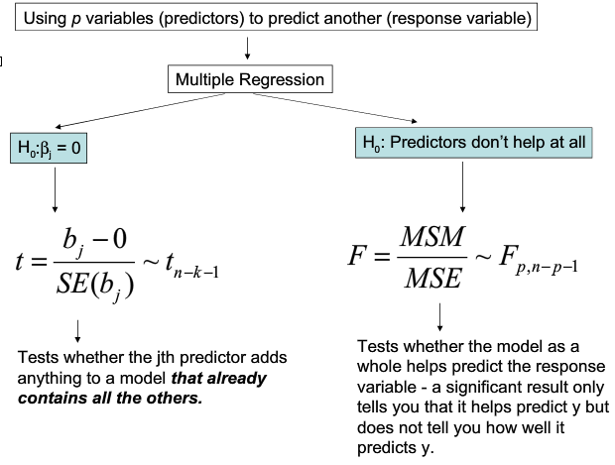

What Makes it Work
- what makes all the hypothesis testing and the confidence intervals work is that we know the distribution of the statistic
- from that, we derive the distribution of the test statistic

Distribution of Test Statistics
- all the test statistics for measurement data that have normal or t-distributions depends on the fact that …
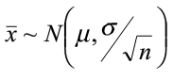
- all the test statistics for categoric data that have normal distributions depend on the fact that
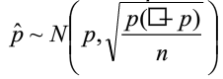
Distribution of Test Statistic for the One Sample Z and t-test
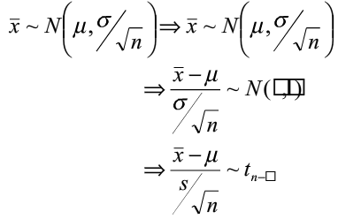
- using H₀ to give the assumed value of μ, you get the test statistics

Distribution of Test Statistic for Two Sample t-test
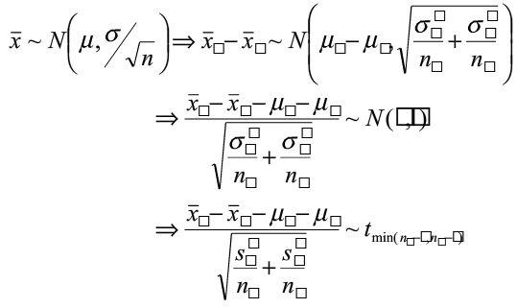
- using H₀ to give the assumed value of μ₁ - μ₂, you get the test statistic

Distribution of Test Statistic for Two Sample Proportion Test
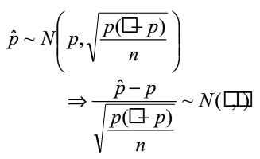
- using H₀ to give the assumed value of p, you get the test statistic

Distribution of Test Statistic for Two Sample Proportion Test
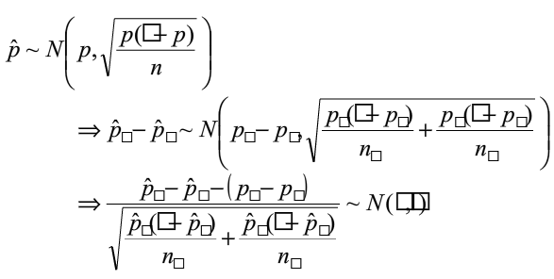
- using H₀ to give the assumed value of p₁ – p₂, you get the test statistic

