Geology Notes:

Chapter 1:

- Nebular Hypothesis (Huge rotating cloud of dust and gasses begin to contract. Most of the material is gravitationally swept to the center, producing the sun. Because of rotational motion, some dust and gas remain orbiting the central body as a flattened disk. The planets begin to accrete the material that is orbiting within the flattened disk. In time most of the remaining debris collects into the planets and moons).
- Earth begins to heat, which causes the iron and nickel to melt producing blobs that sank toward center to make the core.
- Formed buoyant masses, which moved to the surface, producing the crust (enriched in oxygen)
- Largest layer is the mantle (iron and magnesium)
- Continental drift, Pangaea. Continents fit together like puzzle.
- However shorelines aren’t accurate, so they looked at continental shelf.
- Fossil evidence (similar species found on continents that wouldn’t have been able to move.
- Rock type and structural similarities – match in mountain belts. Also match in types of rocks (Appalachian).
- Paleoclimatic evidence (similar climate changes happened in the areas, which would fit together.
- Lithosphere (crust and upper part of the mantle) is broken into more units called plates. Always moving and changing shape). Seven major plates.
- Movement is mostly caused by unequal distribution of heat, resulting in convection. This is the cycle of dense slabs sinking towards mantle and melting eventually move back towards the crust. This forms mountains, earthquakes and volcanoes.
- Plate boundaries – Outside of a plate where most of the deformation occurs.
- Internal structure of the Earth:
- Crust – Thin rocky outer layer, divided into Oceanic and Continental curst. Oceanic crust is thinner and denser. Continental crust is thicker, composed of many rock types and is less dense. Continental crusts are also much older, because it is hard to recycle them.
- Mantle – Largest part, with a dramatic change of chemical composition.
- Core – Iron and Nickel rich with extreme pressure.
- Layers based on physical properties:
- Lithosphere – thin brittle shell which contains the crust and upper mantle
- Asthenosphere – Weak, as it is not attached with the lithosphere. The lithosphere can move independently.
- Mesosphere – High temperature and pressure, rocks are still capable of gradual flow.
- Inner and Outer Core – Iron and Nickel. They exibit very different mechanical strengths. Outer is the liquid layer (flow of metallic iron) also generates Earths magnetic field. The inner core behaves like a solid, because of immense pressure and temperature.

The Rock System:
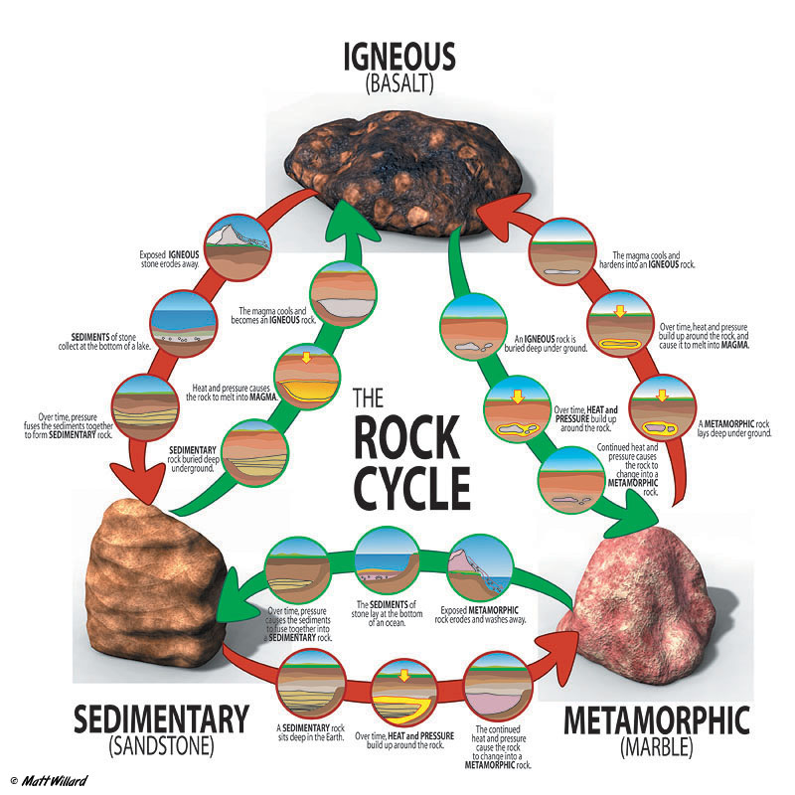
- Lithification – process of forming sediments into rock (sedimentary) because of layers, which compact.

Chapter 8:

- Law of Superposition – layers of rocks determines age. Developed by Steno.
- Rock masses that contain inclusions are YOUNGER. Enclosed rock unit in another rock.

Unconformities: (Gap produced by erosion and non-deposition which seperates layers of rocks)

Angular Unconformity- tilted/folded sedimentary rock that are overlaid with flatter and younger strata. This indicates that a period of deformation or erosion occurred.
Disconformity- The strata on either side are essentially parallel.
Nonconformity- Separates older metamorphic rock from younger sedimentary rock.

Chapter 12:

Paleomagnetism: Formation of minerals forms a needle like shape, which points to the magnetic poles at the time of formation. Because of plate movement or pole movement, these needle like structures will point in the same way they are formed originally.

