BUS 2302
ASSIGNMENT #1
WINTER 2013

DATE: January 18th, 2013

SUBMITTED BY: Ken Blair

STUDENT #: 040470019

Assignment 1

Step 1 – Make 3 predictions of what you expect your results to be. For example, how much time do you
expect to spend on your computer for the week? Or what will be the biggest time waster on your
computer? Save this for later reference.

I use my laptop for everything, from work- to watching TV. My biggest time waster would be Netflix, or Youtube (Movie streaming would also be included).

The video channel I use uses a VCL video format, so I’m not sure how that will be calculated.
In 1 week I would spend about 15-25 hours on my computer

Step 7 -

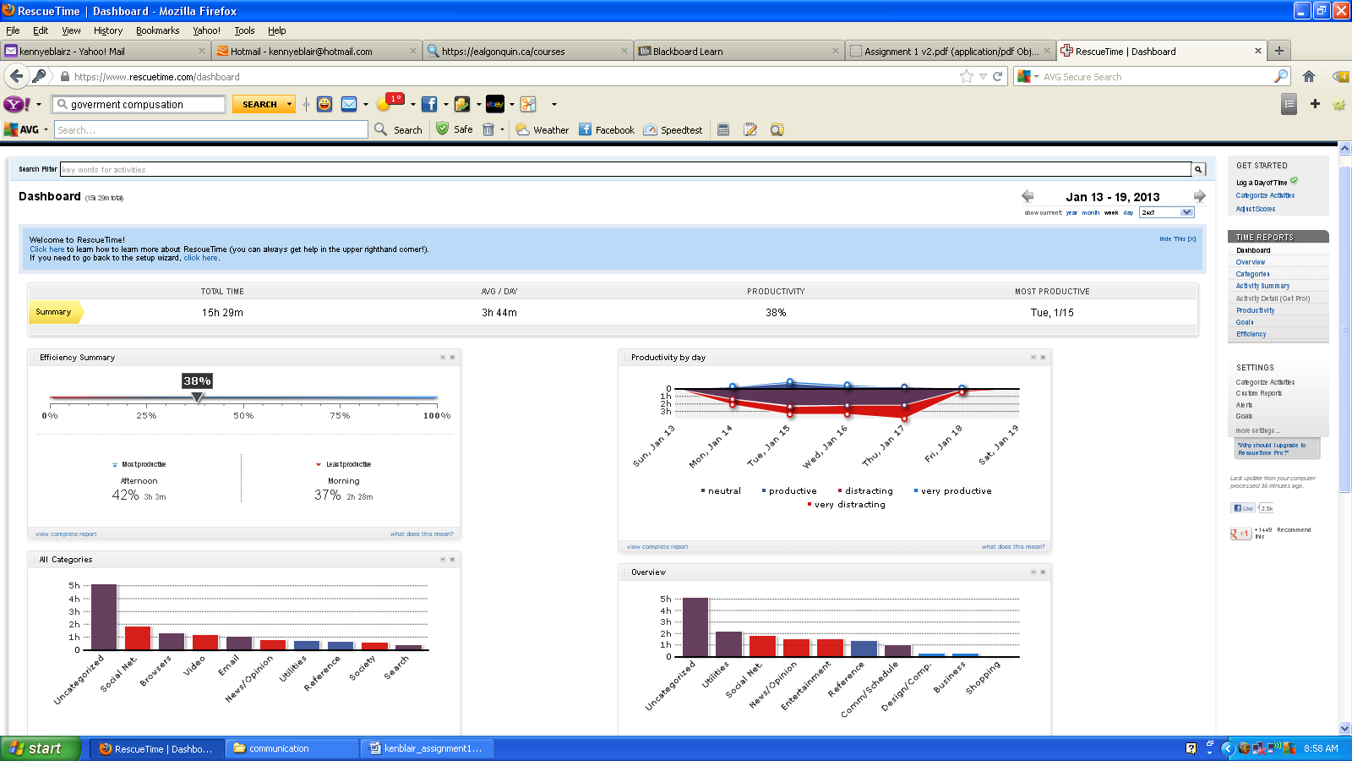

Step 8 - Underneath your screenshot, explain exactly what this is telling you about your habits and include the following:

Tracking how much time I’m spending doing different activities was really interesting, some of my predictions were right, however it seems I spend most of my time on youtube, and other video channels (Netflix etc). I spend a LOT of time dealing with email. This one wasn’t actually all that shocking to me. Although, I was a little sad to see that my top 5th activities were email and IM.

Overall I’d have to say I’m really happy with RescueTime, It shows me what I already predicted and some others I thought were not time wasters. I can use this knowledge to make changes for the better. After some research,

I found out that RescueTime will actually block certain sites from opening that are considered time wasters.

Internet usage polls and stats
http://news.cnet.com/8301-1023_3-10421016-93.html
http://www.comscoredatamine.com/2011/01/average-time-spent-online-per-u-s-visitor-in-2010/
http://www.statisticbrain.com/social-networking-statistics/
http://cn.nielsen.com/documents/Nielsen-Social-Media-Report_FINAL_090911.pdf This document was great! Social media report

After reading these articles I realized I spend more time on the internet then the average person. This could be due to many reasons. I work from home often, I do my school work online, I communicate with family overseas online.

http://www.go-gulf.com/blog/online-time/
According to these stats the average American is online about 32 hours a month or about 1.5 hours a day, while the average global internet usage is about 16 hours a month.
With my stats taken by RescueTime I’m spending almost 4 hours a day only, that’s almost 3 hours more than the average American.

Rescue Time tracks computer usage silently in the background and can be configured to block websites, I can use this tool to make more efficient use of the internet.

http://blog.timedoctor.com/2010/07/25/how-is-time-doctor-different-than-rescue-time
After reading this article I came to realise I can actually use RescueTime for and take advantage of everything it can offer. I can block sites such a facebook, Netflix, movie channels when I’m working. The program can also tell me if I’m actually working or cyber slacking.

To manage my time more effectively, I will need to cut down on browsing, and spending countless hours reading pointless articles.

http://ezinearticles.com/?Time-Management---7-Tips-to-Use-Your-Time-Wisely-and-Effectively-at-Home-and-at-Work&id=3450850
Here I found a list of ways I can manage my time more wisely.

1. Focus on one thing at a time
2. Prioritize your tasks in order of importance
3. Give yourself deadlines for each task
4. Change your behavior
5. Create a daily planning system that works
6. Set some valuable times to be with your family.
7. Exercising
I can keep looking back at these example to help manage my time online, and to be more productive.

Comparisons, S. (2012). Time Doctor different from Rescue Time? Retrieved from Time Doctor: http://blog.timedoctor.com/2010/07/25/how-is-time-doctor-different-than-rescue-time

Flosi, S. L. (2010). Average Time Spent Online per U.S. Visitor in 2010. Retrieved from http://www.comscoredatamine.com/2011/01/average-time-spent-online-per-u-s-visitor-in-2010/

go-gulf.com/blog. (2012, Febuary 2). Retrieved from How People Spend Their Time Online [Infographic] : http://www.go-gulf.com/blog/online-time/

nielsen. (2011). nielsen. Retrieved from THE SOCIAL MEDIA REPORT: http://cn.nielsen.com/documents/Nielsen-Social-Media-Report_FINAL_090911.pdf

Social Networking Statistics. (2012, November ). Retrieved from Social Networking Statistics: http://www.statisticbrain.com/social-networking-statistics/

Whitney, L. (n.d.). Average Net user now online 13 hours per week. Retrieved from CNET: http://news.cnet.com/8301-1023_3-10421016-93.html

