Porifera - Sponges
Porifera | [Sponges] Phylum of simple multicellular animals, with a simple body enclosing a single central cavity (in simple sponges) or penetrated by numerous interconnected cavities. The body wall consists of an outer layer of epithelium seprated from an inner layer of ciliated choanocytes (feeding cells) by a mesogleal layer. There are no nerve or muscle cells. Water is drawn into the internal cavities through pores (ostia), food particles are taken up by the choanocytes and the water flows out through a large pore (the osculum). There are three classes: the Calcarea, the calcareous sponges, which have spicules of calcium carbonate embedded in the mesoglea and projecting to the outside; the Hexactinellida, the glass sponges, with silica spicules; and the Demospongia, which includes some species with silica spicules and some species without, and which often have the body wall strengthened by a tangled mass of fibres (ex. The bath sponge)
Apopyle | Exhalent pore of sponges (leading from radial canal to spongocoel)
Archeocyte | Amoeboid cells found in the mesohyl of sponge
Choanocytes | Flagellated cell, with protoplasmic collar around base of the flagellum, lining body cavity of sponges. Involved in uptake of food particles from water drawn into cavity by the beating of the flagella
Dermal ostium | Skin ostium, present in leuconoid sponges
Incurrent canal | Ectoderm-lined canas which admit water into sponges (no choanocytes)
Mesohyl | [mesoglea] gelatinous, non-cellular layer between the inner and outer body wall in sponges and coelenterates.
Osculum | Large pore in body wall of sponge through which water flows out the body cavity
Ostium | Opening from exterior into body cavity of sponges through lateral wall, through which water is drawn in
Pinacocytes | Flattened plate-like cells of outer epithelium of sponges
Prosopyle | Inhalent pore of sponges
Radial Canal | [Coanocyte Chamber]
Spicules | Small needle-like structure or part, of silicate or calcium carbonate, providing structural integrity in sponges
Spongin | Fibrous protein component of the horny sponges, such as bath the sponge
Spongiocoel | The cavity, or system of cavities in sponges
Totipotency | Ability of forming any cell type

Overview of filter-feeders
- Cellular level of organization (no tissues/organs)
- Share few chars with metazoans (“Parazoans”)
- Sessile, aquatic filter feeders
- 09% marine (few freshwater ~10K species); free-living @ larval stage

*Table of Phyla*
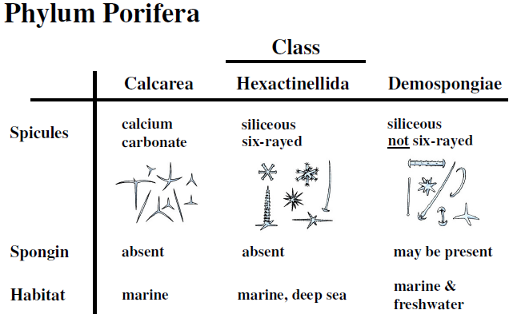

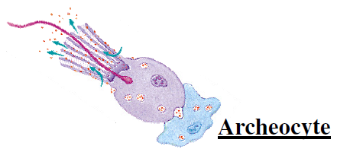

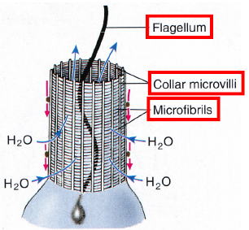
*These organisms work as a while Multicellular

Cells
- Choanocytes ovoid flagellated [pulsile] cells, line canal systems & chambers
  - Generate water current, capture small food particles, capture incoming sperm | exposed & embedded cells
  - Retain some food, rest passed along
- Archeocytes amoeboid, receive & digest food particles from choanocytes
  - Totipotent
- Sclerocytes spicules, Spongocytes spongin, Collenocytes/Lophocytes collagen

Canal Systems
- Asconoid [Calcarea ONLY] simplest, small & tube-shaped
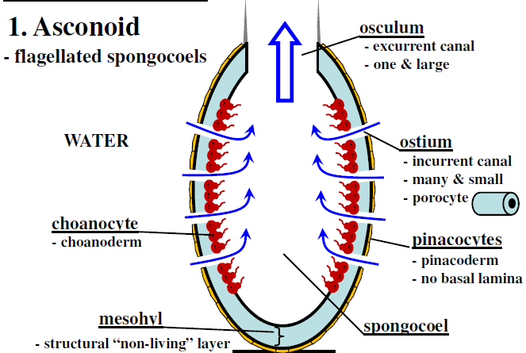
  - Pushes water through ostium [using choanocytes]; mesohyl has some living cells
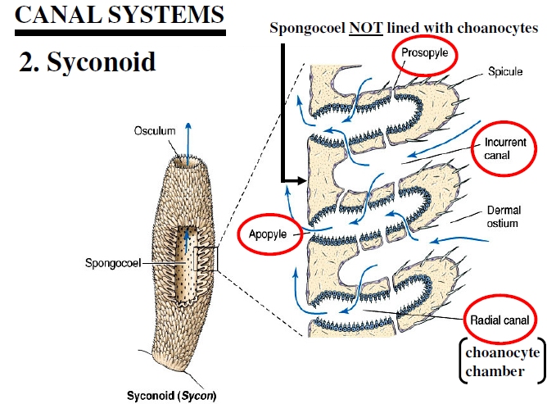

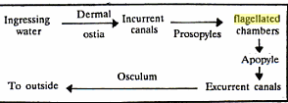
- Syconoid [Calcarea ONLY] larger, more complex than asconoid (tube-shaped] MORE SA! [ex. Sycon]
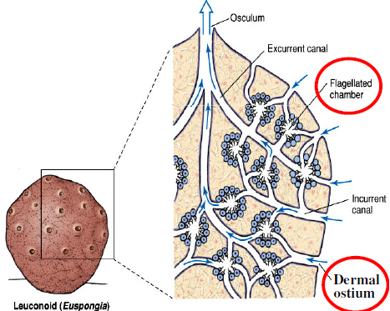
- Leuconoid most sponges: no spongocoel, >1 osculum; 2.4cm³ sponge 1M dermal ostia, 29M flagellated chambers
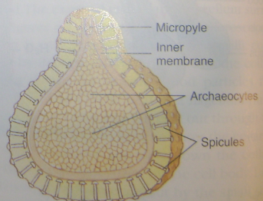

Gemmule: mech. For surviving harsh conditions; when favourable, archaeocytes exist through micropyle new sponge (all cells)

Reproduction/Development
- Sex/Asex reprod in all sponges [most monoecious]
  - Sperm from transofrmatino of choanocytes
  - Oocytes – Calcarea & some demosponges from choanocytes, other demo – archaeocytes
- Sperm released into water by 1 indiv, & taken into canal system of another (choanocytes phagocytize them, turn into carrier cells, which then carry sperm through mesohyl to oocytes
- Other sponges, oviparous (oocytes & sperm released into water); ova fertilized by motile sperm (no carrier cells) in the mesohyl; zygotes develop into flagellated larvae, break loose, and are carried away by water currents.
- Asexual: fragmentation/formation of external buds (which may or may not (then colonies) detach); internal buds gemmules may also form in unfavourable conditions to survive draught & freezing & >3 months in absence of oxygen

*copy-paste here photos from p118 6.10 & 6.11


