- Condensed version of all the notes (adms 4900):
1) Situational Analysis: 25marks
Review strategy: (4marks)
Goals =
Life Cycle ={ intro (products unfamiliar to consumers, market segments not well defined, product feature not specified, competition limited, their strat: develop product -> get users to try it, generate exposure -> become standard)
growth: characterized by strong increase in sales, attractive to some comp; eky to success here: build consumer prefrences for spec. brands, strat: brand recog, diff prod, fin. Resources to support value-chain activities}
mat: aggregate industry demand slows; market become saturated; few new adopters, direct comp -> predominant; marginal comp begin to exit; strat: efficient manu op/process engi; low costs customers become sensitive
Decline: industry sales profits go down; strat options become depdent on the actions of rivals. Strat = maintain, exit, harvesting, consolidation; to turn aroud…: asset cost surgery; selective product and market pruning, piecemeal productivity improvements}
product/market focus =
financial performance = see the back
application of diamond E = do you have an effective strategy? S,E,R,M, Org (are we structured to implement?)
Link S to (cost, diff, focus?) =
-> measurable, ST, LT, financial and non-financial
- Product market focus – nature of p/s, mkt segment and boundary, competitive promise – comp adv, business system focus – int and external, does S fit to env/values/resources/org capabilities?
E =marco conditions, industry env, competition,
- Porters 5 forces, is ind attractive?
- Trends, PEST
- Key success factors for ind and comp, and any gaps?
- Swot
- Does e fit with the strategy?
MP = mgmt. values – culture/preferences
-> basic needs of mngrs, beliefs, corp. culture
-> identify key values req to meet strategy and compare to actual
-> identify conflicts and how to resolve
-> identify org action to resolve ie training, persuasion, replacement
O = Org capabilities
- Is the ability to put resources to work
- What org cap needed to implement strat, hence identify req’d changes;
Culture, structure, systems, staffing, personal leadership
Assess feasibility of changes and time frame
Does O fit with Resources, Values and Strategy
R = identify res. Req’d to meet strategy (ie KSF and compare to actual)
- Resources are tech/hr/financial rep/brand/capabilities
- Identify gaps and actions to close the gaps
- Identify org cap to implement action closing gaps
- Does r fit the strategy and o?
- Current strategy: ( 5marks)
cost leadership/diff/focus C or D, or combine all three
(note on ‘combine all three’: for auto/flexible manu system, exploiting the profit pool concept comp adv, how 3 combi improves comp adv thru five forces)
Vision (definition: LR, inspiring, overarching, fundamental stmt of org’s v/aspiration/goals)
Mission (purpose of comp, basis of com adv, more spec than v)
Objectives/goals = operationize mission stmt, prov guidance on how org move to “higher goals”, quanti, yardstick for reward/incentives
Deliberate vs. emergent strategy
- External environment: (6 marks)
- PEST
- O/T
- 5 Forces
(Poten Entrants = profits eroded by new, high entry? Low threat thru econ of scale, product diff, cap req, switching cost, access to distr channel, cost disadv indep of scale
Suppliers = threaten to raise prise/reduce Q of purchased g/s. powerful when few/more concentrated than the industry it sells to, not obliged to contend w/ sub products for sale, industry = not imp customers, suppliers’ product = imp to buyers’, supplier group’s product = diff., or has built up switching cost, the group = threat of forward integ
Sub = celing prices, price/perf ratio
Rivalry among competitors = jockeying for posi, price compe, advertising battle, product intro, inc. cust. Service of warranties, slow ind. G, numerous comp., high fixed/sto cost, lack of diffswit cost, capacity in large increments, high exit barriers)
- Is the industry attractive?
- Internal Environment: (4 marks)
- S/W
- Resources
(tan = financial res (cash accounts/firm’s cap to raise equity/ firm’s borrowing cap), phy res (plant/facilities, fav. Manufac locations, machinery equip)
intan = tech res (trade secrets, innov pro process, patents/copyrights/trademarks), diff to imitate/unique, human (exp/cap of ee, trust, managerial skills, firm-spec practices/procedures), reputation ((strategic planning process, good evaluation, control system), innov/creativity (tech/science skills, inov cap)
org capabilities = competencies/skills that a firm employs to transform inputs to outputs, and cap to combine tangi/intangi resources to attain desired end (good cust service, excellent product develop cap, innovativeness of p/s, ability to hire/motive/retrain human cap)
- Capabilities: ability to undertake more coplex coordinated activity than just skilled work (i.e., /D, customer service, high quality manufacturing
- Core Competency: (1mark):
the glue that binds existing biz together; engine that fuels new biz growth; collective learning in a firm (how to coor div pro skills, how to integ multi estreams of tech, how to market diverse p/s)
3 criteria of core competency: 1. Difficult to imitate, 2. Superior customer value, 3. Different business must relate theirs into at least one core comp.
- Competitive Advantage: (1 mark)
-
- Sustainable Competitive Advantage: (2 mark)
- is the resource/cap: valuable, rare, diff to imitate, expoitable?
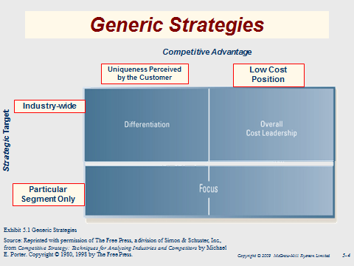
- Key Success Factors: (2 marks)
- Issues – (5marks)
- identity issues/ strategic (3marks)
- Operational strategic and strategical strategic, etc.
- Alternatives:
- Recommendation and Decision criteria:

- Feasibility Implementation ( 20 marks)
- Implementation of action plan for strategic recommendation
- McKinsey model addressed – staff, skills, systems, structure, style/culture
- Adress mgmt., financial/opera/marketing issues for Short/Medium/Long term
- Graphs, charts, timeline for implementation plans

Other notes:
- alternative routes to expansion: internal growth, acquisition, alliance, joint ventures -> details about JV and Alliance:
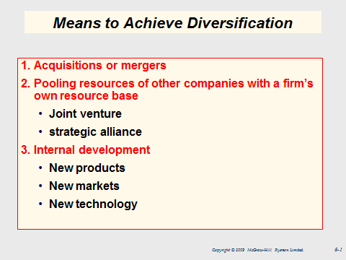
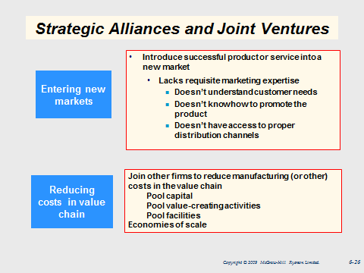
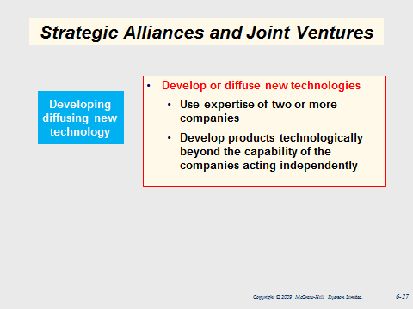
CONS = improper partner (ea. Partner must bring desired strengths to partnership; strenghs contributed by ea. Should be unique; partners must be compatible; there should be trust in one another)
- risk: strat decision are taken in the context of uncertainty and risk; decisions about future states of affairs are based on inc info; strat decision involve large opp costs
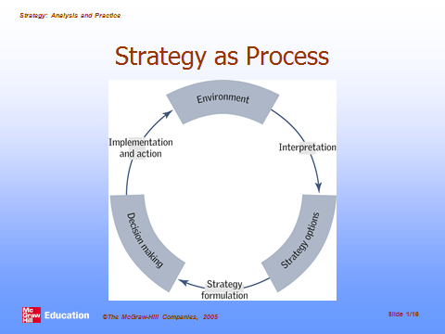
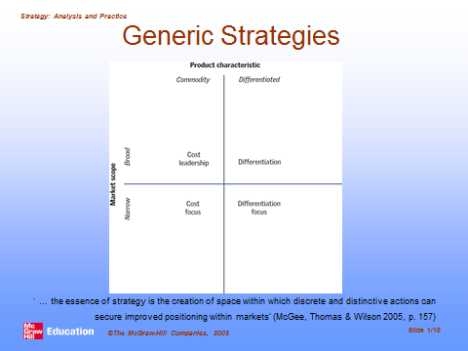
Financial performance measurement:
1) balance sheet
2) income statement
3) balanced scorecard (stakeholder perspective) -> for recommendation: 1. How do customers see us ? ( cust. Perspective) 2. What must we excel at? (internal perspective), 3. Can we continue to improve and create value? (innovation and learning perspective), 4. How do we look to shareholders? (financial perspective)
4) 5 types of finanacial ratios: 1. s/r solvency, 2. l/r solvency, 3. Asset management, 4. Profitability, 5. Market value (meaning ratios must include analysis of how ratios change over time, how ratios are interrelated)

