Fragile Systems Individual Quiz
1. Which is FALSE?

 |  | Value | Correct Answer
A. | The three phases of matter are solid, liquid, gas.
B. | Viscosity is a measure of how much fluids resist flowing.
C. | Strain is the change in shape, or deformation, of a solid object.
D. | Objects that are not very plastic are said to be ductile. | 100%
E. | Stress is a force per unit area parallel to a surface.

2. For most disaster scales, a disaster of magnitude 6 has _______ times greater energy than a disaster of magnitude 2.
 |  | Value | Correct Answer
A. | 3
B. | 4
C. | 5
D. | 10,000 | 100%
E. | 1,000,000

3. During a 300-day period, 900 earthquakes of magnitude 5 are typically observed. Thus, the return period for a magnitude 5 earthquake is _______.
 |  | Value | Correct Answer
A. | 900 years
B. | 300 years
C. | 5 years
D. | 3 days
E. | 1/3 of a day | 100%

4. Energy is diffuse if it ______.
 |  | Value | Correct Answer
A. | is concentrated in space
B. | is released over a short time
C. | happens gradually over time
D. | is spread out in space | 100%
E. | dissipates quickly

5. "Joule" is the unit for _________.
 |  | Value | Correct Answer
A. | pressure
B. | energy
C. | power | 0%
D. | force
E. | density

6. Most disaster scales are _______.
 |  | Value | Correct Answer
A. | logarithmic | 100%
B. | trigonometric
C. | algebraic
D. | linear
E. | isometric

7. Which statement is TRUE?
 |  | Value | Correct Answer
A. | Earth's carrying capacity increases as more people occupy our planet.
B. | You have almost no control over your own chances of surviving a natural disaster.
C. | The survivability rate of people in natural disasters will increase as population grows, due to better social networks.
D. | Population is self-limiting. Namely, the death rate increases when the carrying capacity is exceeded. | 100%
E. | The maximum population that can be carried by the earth is fixed.

8. "Order of magnitude" means
 |  | Value | Correct Answer
A. | somewhat larger
B. | factor of 2
C. | somewhat smaller
D. | factor of 10 | 100%
E. | factor of 1000

9. An object behaves elastically under strain if it_____.
 |  | Value | Correct Answer
A. | deforms easily and takes on a new shape after the strain is removed
B. | deforms easily and springs back to its original shape after the strain is removed | 100%
C. | is difficult to tear but easy to cut with scissors or a knife
D. | breaks easily when at a cool temperature, but flows under high temperatures.
E. | resists deformation and releases heat when the strain is removed

10. Consider the following three phenomena:
1) a flood caused by a thunderstorm
2) a storm surge caused by a hurricane
3) a tsunami caused by an underwater earthquake
These are ALL directly associated with ______.
 |  | Value | Correct Answer
A. | storms
B. | shorter return periods for more-intense phenomena
C. | solar energy
D. | geothermal energy
E. | both the concentration and dilution of energy | 100%

11. What is NOT a SIGNIFICANT source of energy for natural disasters?
 |  | Value | Correct Answer
A. | impacts from space
B. | gravity
C. | oil deposits | 100%
D. | earth’s internal heat
E. | the sun

12. Which form of energy is related to the distance an object moves times the force moving it?
 |  | Value | Correct Answer
A. | work | 100%
B. | latent heat
C. | potential energy
D. | power
E. | sensible heat

13. The energy released in disaster X is two orders of magnitude greater than that released in disaster Y. This means that X has ______ as much energy as Y.
 |  | Value | Correct Answer
A. | 10 times
B. | 100 times | 100%
C. | log(2) times
D. | half
E. | twice

14. What is scientifically wrong with this statement?
density = 1.2x10³
 |  | Value | Correct Answer
A. | for numbers in this range, it should be written as 1.2 kilo
B. | density can't be as large as 1.2x10³
C. | more significant digits are needed
D. | it is missing the units | 100%
E. | for numbers in this range, it should be written as 1,200

15. What is/are the main source(s) of energy fueling the motion of tectonic plates?
 |  | Value | Correct Answer
A. | the Sun
B. | radioactive decay and gravity
C. | heat and convection
D. | hot magma in the mantle
E. | all of the above | 0%

16. Which is NOT a primary energy source that makes the Earth an active body?
 |  | Value | Correct Answer
A. | electric power generated by the Earth’s rotating magnetic field | 100%
B. | impact of extraterrestrial bodies such as asteroids and comets
C. | gravity
D. | the Earth’s internal heat associated with natural radioactive decay
E. | the sun

17. Which statement is FALSE?
 |  | Value | Correct Answer
A. | A unit of force is the Newton.
B. | A unit of pressure is the kiloPascal.
C. | A unit of stress is the Pascal.
D. | The SI standard unit of time is the second.
E. | The SI standard unit of mass is the gram. | 100%

18. When twice as much force is exerted to move a mass over the same distance, the work done __________.
 |  | Value | Correct Answer
A. | is zero
B. | remains the same
C. | increases by 2 units
D. | is reduced by 2 units
E. | is doubled | 100%

19. Consider two countries, each with a population of 1 million in the year 2000. The annual population growth rate of Country X is 1% while that of Country Y is 2%. Assuming that the growth rates remain unchanged, which statement is FALSE?
 |  | Value | Correct Answer
A. | By the year 2070, Country X will have a population of 2 million and Country Y will have 4 million.``
B. | Both countries are experiencing exponential population growth. | 0%
C. | Over a period of 140 years, Country Y will have doubled its population 4 times.`
D. | The doubling time for the population of Country X is estimated as 1 million divided by 1%.
E. | The population of Country Y is increasing much faster that that of the world.

20. Which statement is FALSE?
 |  | Value | Correct Answer
A. | A sustainable society is resilient to natural hazards. | 0%
B. | Volcanoes, landslides, and earthquakes are natural disasters to the Earth.
C. | Energy can cause things to move or change.
D. | The unit of force is the Newton.
E. | Sensible heat is heat that you can feel.

Earthquakes Individual Quiz

1. Soil liquefaction occurs when ____________.
 |  | Value | Correct Answer
A. | the strength of soft ground is increased by the shaking of grains so that they settle into a stronger configuration
B. | earth dams are broken because of ground shaking, thus flooding or "liquefying" areas downstream of the dam
C. | ground shaking causes saturated loosely packed soil grains to lose strength and behave as a fluid | 100%
D. | earthquake motion releases water from faults
E. | shifts in the ocean floor cause large waves in the ocean

2. At a transform plate boundary ______.
 |  | Value | Correct Answer
A. | tensional stress builds up and produces a reverse fault
B. | shear stress builds up and produces a reverse fault
C. | tensional stress builds up and produces a normal fault
D. | shear stress builds up and produces a strike slip fault | 100%
E. | tensional stress builds up and produces a strike slip fault

3. Which statement about plate tectonics is TRUE?
 |  | Value | Correct Answer
A. | Spreading centres produce the largest number of great earthquakes (magnitude 8 or higher).
B. | Transform faults are where the world’s deepest earthquakes occur.
C. | Subduction zones are the source of heat that drives plate tectonics.
D. | Convection within the mantle helps drive the motion of plates. | 100%
E. | Gravity pulling on the roots of continents helps drive the motion of plates.

4. What happens to the different frequencies in a seismic wave as it travels long distances through the Earth’s mantle?
 |  | Value | Correct Answer
A. | high frequencies get amplified
B. | high frequencies disappear | 100%
C. | frequencies stay constant
D. | low frequencies disappear
E. | low frequencies are amplified

5. The primary cause of earthquake-related deaths in modern times is from ______.
 |  | Value | Correct Answer
A. | falling into the cracks that form when faults open
B. | being crushed by collapsing buildings | 100%
C. | drowning in liquefied soils
D. | becoming asphyxiated in dust created by all the shaking and falling buildings
E. | being shaken at their resonant frequency

6. At a collisional plate boundary, _____ faults are common.
 |  | Value | Correct Answer
A. | right-lateral
B. | transform
C. | normal
D. | strike-slip
E. | thrust (reverse) | 100%

7. Where do most large-magnitude earthquakes occur?
 |  | Value | Correct Answer
A. | in the interior of continental plates
B. | in the interior of oceanic plates
C. | along mid-ocean ridges
D. | near strike slip faults
E. | where plates converge | 100%

8. According to the latest renewal forecasts, the probability of a M9 Cascadia subduction zone earthquake in the next 50 years is _____.
 |  | Value | Correct Answer
A. | less than 1%
B. | 15% | 100%
C. | 35%
D. | 54%
E. | 100%

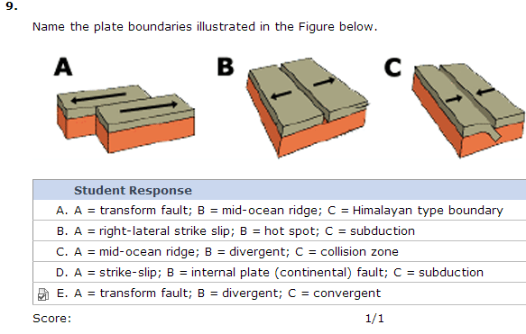

10. The energy sources currently driving tectonic plate motion are ___________.
 |  | Value | Correct Answer
A. | internal heat, solar influx, and external impacts
B. | gravity and external impacts
C. | gravity, internal heat, solar influx, and external impacts
D. | internal heat and solar influx
E. | gravity and internal heat | 100%

11. Five facts regarding earthquake physics are presented. All are true and interesting, but which one does NOT contribute directly to helping reduce the risk of living in Vancouver or any earthquake-prone region?
 |  | Value | Correct Answer
A. | We are now capable of monitoring actual plate motions in real time.
B. | With careful geological work, we can determine the times and magnitudes of earthquakes that occurred before written records were kept.
C. | Different soil types respond differently to seismic waves.
D. | Building behavior in response to actual ground motion can be very well characterized.
E. | We can study our planet's deep structure and composition using seismic waves. | 100%

12. Which factor is NOT used to estimate earthquake intensity?
 |  | Value | Correct Answer
A. | soil type
B. | type of fault | 100%
C. | distance to epicenter
D. | earthquake magnitude
E. | duration of shaking

13. Which of the following is the only type of seismic wave to reach Earth's solid inner core?
 |  | Value | Correct Answer
A. | P-waves | 100%
B. | S-waves
C. | Rayleigh waves
D. | Love waves
E. | Rogue waves

14. Which recent earthquake is MOST similar to the mega-earthquake that is predicted to occur along the Cascadia subduction zone?
 |  | Value | Correct Answer
A. | 2003 Bam, Iran
B. | 2004 Parkfield, California
C. | 2004 Sumatra, Indonesia
D. | 1999 Izmit, Turkey
E. | 2001 Pacific Northwest | 0%

15. You have just heard that a large earthquake occurred 320 kilometres below the surface of the Earth at a spreading zone. Why should you be skeptical?
 |  | Value | Correct Answer
A. | No earthquakes ever occur in spreading zones.
B. | Earthquakes only occur at less then 15 km depth.
C. | Only small earthquakes occur below 200km depth.
D. | Spreading zones are more likely to have shallow, weak earthquakes. | 100%
E. | Seismic energy can never escape a soft spreading zone where rocks are deforming plastically.

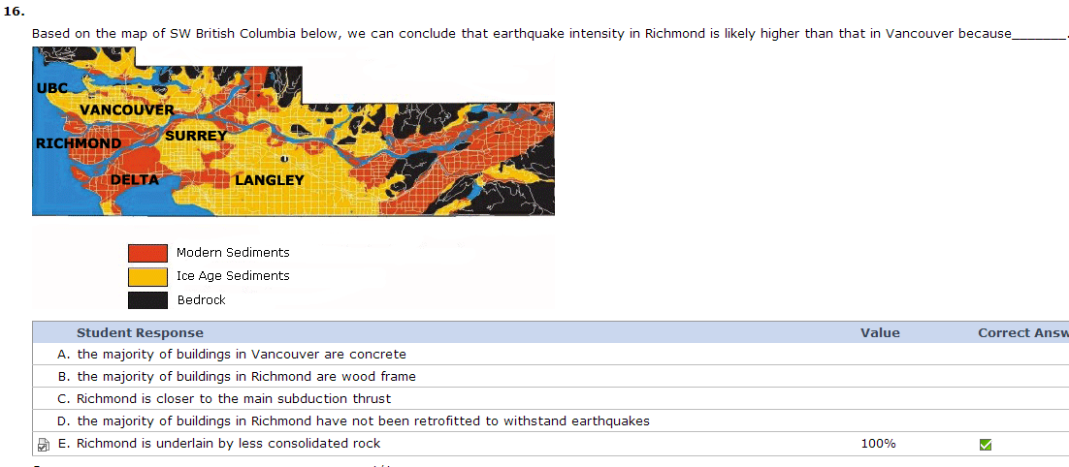
17. What type of motion occurs when a Rayleigh wave passes?
 |  | Value | Correct Answer
A. | forwards and backwards motion parallel to the direction of wave travel
B. | side to side motion parallel to the direction of wave travel
C. | sideways rotating motion parallel to the direction of wave travel
D. | purely up and down motion perpendicular (at a 90° angle) to the direction of travel
E. | backwards rotating motion parallel to the direction of wave travel | 100%

18. Which seismic wave would arrive first in Vancouver from an earthquake in California?
 |  | Value | Correct Answer
A. | P wave | 100%
B. | S wave
C. | shear wave
D. | Rayleigh wave
E. | Love wave

19. Which is most likely to damage a building?
 |  | Value | Correct Answer
A. | Vertical ground motion causing the building to move up and down at its resonant frequency.
B. | Vertical ground motion causing the building to move up and down more rapidly than its resonant frequency.
C. | Horizontal ground motion causing the building to move side to side at its resonant frequency. | 100%
D. | Horizontal ground motion causing the building to move side to side more rapidly than its resonant frequency.
E. | A vertical jolt, followed by a horizontal jolt, caused by a passing seismic wave.

20. After a fault ruptures (moves) ________.
 |  | Value | Correct Answer
A. | plastic deformation releases most of the stress
B. | stress is concentrated along the length of the rupture and released at the tips
C. | plastic deformation is the major cause of shaking in nearby cities
D. | stress increases along the fault
E. | elastic deformation concentrates stress at the ends of the fault that moved | 100%

Volcano Individual Quiz

1. Knowledge of the past eruptive history of a volcano is important for each of the following reasons EXCEPT ______.
 |  | Correct Answer
A. | the silica content of past eruptions helps indicate the potential explosivity of the volcano in the future
B. | a map of the volcano showing the distribution of vents and eruptive products tells us where eruptions may take place in the future
C. | volcanoes display consistent behavior over time
D. | a volcano is likely to have the same types of hazards in the future as it has had in the past
E. | the recurrence interval (return period) gives an idea of the magnitude (VEI) of eruptions

2. Mafic lava flows are dangerous because ______.
 |  | Correct Answer
A. | it can flow downslope at high speed
B. | of its low viscosity, thus high explosivity
C. | it can flow up and over hills to where people are hiding
D. | it can flow in lava tubes
E. | of its high maximum temperatures of 200 - 500 °C

3. All of the following are characteristics that make Mt. Rainier the most hazardous volcano in the Cascades arc EXCEPT ______.
 |  | Correct Answer
A. | produces pahoehoe lava
B. | generates earthquakes
C. | has great height and mass
D. | has a thick ice cap
E. | has active hot springs

4. Which is NOT a volcanic hazard or effect associated with large amounts of tephra/ash?
 |  | Correct Answer
A. | lahars
B. | an increase in global temperature
C. | disruption of airline flights
D. | an increase in respiratory problems
E. | destruction of agricultural land

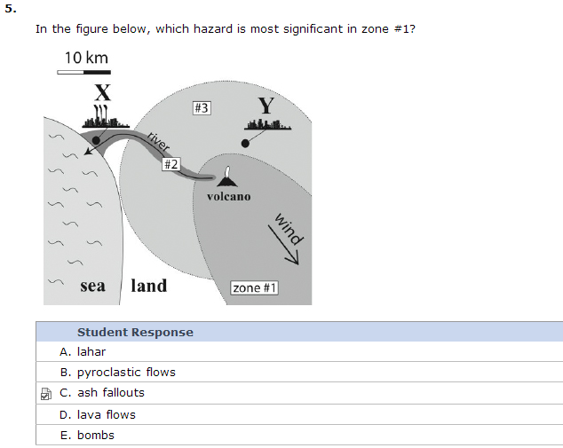

6. The difference between magma and lava is that magma _______.
 |  | Correct Answer
A. | has not erupted
B. | is cooler than lava
C. | is found on Earth’s surface
D. | has higher viscosity than lava
E. | is lava or tephra while it is beneath the Earth's surface

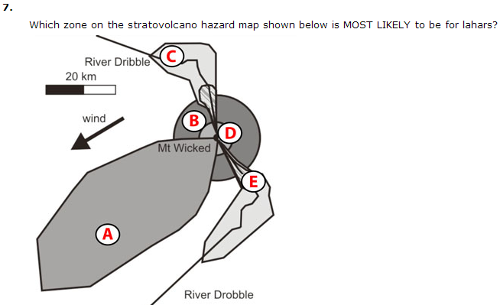
 | Student Response | Correct Answer
A. | A
B. | B
C. | C
D. | D
E. | E

8. How does a caldera form?
 |  | Correct Answer
A. | An extremely large eruption empties the magma chamber and the volcano collapses inwards.
B. | High volume felsic lava flows create a very large volcano.
C. | Alternating layers of magma and pyroclastic material build up a large volcano.
D. | Relatively short-lived eruptions of pyroclastic material build up a small volcano.
E. | Release of pressure causes a catastrophic lateral blast.

9. Which of the following correctly describes volcanism at a continental volcanic arc?
 |  | Correct Answer
A. | high viscosity dacitic lavas and explosive volcanism
B. | high viscosity dacitic to rhyolitic lavas and non-explosive volcanism
C. | high viscosity andesitic to dacitic lavas and non-explosive volcanism
D. | low viscosity basaltic lavas and non-explosive volcanism
E. | low viscosity rhyolitic lavas and explosive volcanism

10. A shield volcano such as Kilauea will most likely erupt ______.
 |  | Correct Answer
A. | pyroclastic flows, lahars, and scoria
B. | pumice and scoria
C. | pyroclastic flows and lahars
D. | huge quantities of ash
E. | lava flows and scoria

11. Tiltmeters and InSar can help DIRECTLY infer which of the following?
 |  | Correct Answer
A. | build-up of carbon dioxide in the lava dome
B. | earthquake distribution
C. | near-surface magma movement
D. | distribution of pyroclastic flow deposits
E. | plate movement

12. What was the volcanic hazard that caused the tragedy at Lake Nyos in Cameroon?
 |  | Correct Answer
A. | abundant acid rain from volcanic gasses
B. | CO₂ gas
C. | fast flowing basaltic lava flows
D. | volcanic landslide
E. | a lahar

13. Which of the following volcanic hazards is the LEAST hazardous to humans?
 | Student Response | Correct Answer
A. | lahars
B. | lateral blasts and explosive eruptions
C. | volcanic gases
D. | pyroclastic flows
E. | lava

14. Which volcanic hazard does hydrothermal alteration promote?
 |  | Correct Answer
A. | landslides
B. | lava flows
C. | pyroclastic flows
D. | tephra/ash
E. | lateral blasts

15. Some of the dangers associated with lahars from Mt. Rainier include all of the following EXCEPT ______.
 |  | Correct Answer
A. | lahars continuously release toxic gas as they flow
B. | lahars can occur with little warning
C. | lahars can occur in between times of volcanic activity
D. | lahars can travel long distances
E. | lahars can transport and deposit large quantities of material

16. Mount Rainier is dangerous for all of the following reasons EXCEPT ______.
 | Student Response | Correct Answer
A. | It has been more active than Mount St. Helens over the past 2000 years.
B. | It is the largest of the Cascade volcanoes.
C. | It has a history of producing large lahars.
D. | It is covered with a large volume of ice and snow.
E. | It has a history of erupting pyroclastic flows and lava flows.

17. Lahars, pyroclastic flows, and volcanic landslides are all hazards at ______.
 | Student Response | Correct Answer
A. | every volcano on Earth
B. | volcanoes above subduction zones
C. | volcanoes at spreading centres
D. | volcanoes at continent-continent collision zones
E. | hot spot volcanoes

18. Which statement is TRUE?
 | Student Response | Correct Answer
A. | An oceanic-oceanic convergent plate boundary will not produce explosive eruptions.
B. | Most non-explosive volcanoes are found at hot spots and located in plate interiors.
C. | Most explosive volcanoes are found at oceanic-continental convergent plate boundaries.
D. | Explosive volcanoes can be found at divergent plate boundaries.
E. | Continental-continental collisions result in both non-explosive and explosive volcanism.

19. According to the textbook, which of the following represents the most violent eruption style?
 | Student Response | Correct Answer
A. | VEI 3 Vulcanian
B. | VEI 1 Hawaiian
C. | VEI 9 Icelandic
D. | VEI 2 Strombolian
E. | VEI 6 Plinian

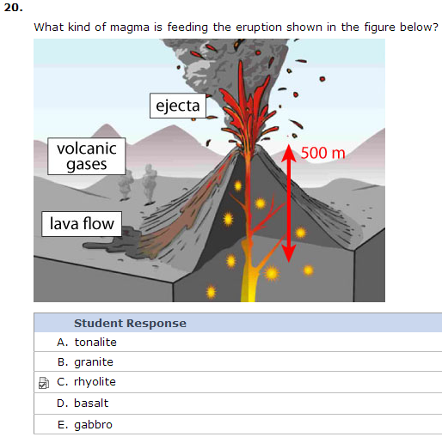
Landslides Individual Quiz

1. A _________ is a type of landslide described as the forward rotation of material about a pivot point on the hill slope.
 |  | Value | Correct Answer
A. | slide
B. | fall
C. | slump
D. | topple | 100%
E. | creep

2. The angle of repose is ______.
 |  | Value | Correct Answer
A. | the angle of a slope for which the factor of safety is a little greater than one
B. | the angle of a slope for which the factor of safety is less than one
C. | the angle of a slope for which the factor of safety is much greater than one
D. | an ideal that cannot be achieved
E. | the steepest angle a slope can hold before failure | 100%

3. Which of the following causes of landslides is LEAST important in British Columbia?
 |  | Value | Correct Answer
A. | climate
B. | slope angle
C. | quick clays | 100%
D. | removal of vegetation
E. | overloading

4. How does a debris slide differ from a debris flow? A debris slide _______.
 | Student Response | Value | Correct Answer
A. | does not contain as much water
B. | is not confined to a channel | 100%
C. | has a curved surface of failure
D. | is composed of different material
E. | moves more slowly than a debris flow

5. High pore water pressure can cause landslides by ____________.
 | Student Response | Value | Correct Answer
A. | reducing friction between adjacent grains | 100%
B. | affecting the rate of infiltration
C. | dissolving cement between adjacent grains
D. | increasing water surface tension
E. | decreasing the likelihood of liquefaction

6. Shear stress __________.
 | Student Response | Value | Correct Answer
A. | results from the force of gravity on a slope | 100%
B. | has 3 primary components
C. | is the internal resistance of a body to stress
D. | moves parallel and down the slope
E. | decrease as slope steepness increases

7. The fastest landslide type is a ______.
 | Student Response | Value | Correct Answer
A. | slump
B. | rockfall | 100%
C. | debris flow
D. | debris torrent
E. | mud flow

8. Lion’s Bay debris retention structure is designed to ______.
 | Student Response | Value | Correct Answer
A. | stop the water and debris in a debris flow
B. | stop the water in a debris flow
C. | slow the water in debris flow
D. | stop the debris in a debris flow | 100%
E. | lower property values downslope

9. According to the landslide classification, the term ‘earth’ is defined as ______.
 | Student Response | Value | Correct Answer
A. | sorted soil | 100%
B. | all unconsolidated sediment greater than 2 cm in diameter
C. | unsorted soil
D. | a combination of broken trees and earth
E. | a mixture of sand and clay

10. If a slope has a calculated factor of safety = 1.05 it means that a landslide ________.
 | Student Response | Value | Correct Answer
A. | has already occurred
B. | will happen within 24 hours
C. | is likely to occur in the future | 100%
D. | is highly unlikely
E. | will never occur

11. Which of the following was NOT a factor that contributed to the debris slide at Vaiont Dam, Italy in 1963?
 | Student Response | Value | Correct Answer
A. | anthropogenic (human) activity
B. | fractured bedrock
C. | an earthquake | 100%
D. | the presence of limestone and clay
E. | changes in water pressure due to filling/draining of dam

12. Suppose you are a geological engineer hired to deal with rockfall problems along new sections of the Sea-to-Sky Highway (Highway 99). You are asked to deal with large rockslides that may initiate along newly cut rock slopes blasted to widen the Sea-to-Sky Highway (Highway 99). To prevent massive blocks (>1000 m³) from sliding onto the road, which approach to mitigation would you take?
 | Student Response | Value | Correct Answer
A. | Prevention through rock bolts, anchors and drainage. | 100%
B. | Avoidance by selecting an alternative route for the highway.
C. | Protection by installing netting.
D. | Prevention by planting trees.
E. | Protection by building a containment channel.

13. A ______ makes a slope susceptible to movement without actually initiating it while a ______ initiates movement.
 | Student Response | Value | Correct Answer
A. | trigger… cause
B. | driver… trigger
C. | cause… trigger | 100%
D. | cause… driver
E. | driver… cause

14. Which of the following is NOT an anthropogenic trigger of landslides?
 | Student Response | Value | Correct Answer
A. | climate change
B. | glacial erosion | 100%
C. | deforestation
D. | irrigation
E. | mining

15. A landslide will MOST LIKELY occur in which of the following scenarios?
 | Student Response | Value | Correct Answer
A. | A hillside with a slope of 12° composed of a saturated soil layer with abundant vegetation.
B. | A hillside with a slope of 20° composed entirely of granite in an arid environment.
C. | A hillside with a slope of 12° composed of fractured sandstone in an arid environment.
D. | A hillside with a slope of 20° composed of fractured sandstone in a wet environment. | 100%
E. | A hillside with a slope of 20° composed of fractured sandstone with abundant vegetation.

16. Which of the following is NOT an approach to landslide mitigation?
 | Student Response | Value | Correct Answer
A. | prevention
B. | litigation | 100%
C. | protection
D. | avoidance
E. | relocation

17. In areas where loose soils are saturated with water, seismic shaking (i.e. from an earthquake) can _____.
 | Student Response | Value | Correct Answer
A. | trigger numerous rockfalls, endangering cars traveling on highways
B. | help to compact the soils, strengthening the slope
C. | transform the behaviour of a slope into one that begins to slowly creep
D. | cause water pressures to dramatically increase resulting in liquefaction | 100%
E. | help drain the soils thereby strengthening the slope

18. The strength of a slope is INCREASED by which of the following?
 | Student Response | Value | Correct Answer
A. | low shear resistance
B. | cohesion | 100%
C. | high shear stress
D. | high density of fractures
E. | high water content

19. Quick clays often lead to what type of landslide?
 | Student Response | Value | Correct Answer
A. | rotational slides
B. | translational slides
C. | spreads | 100%
D. | flows
E. | topples

20. The enormous 1980 Mount St. Helens rockslide _____.
 | Student Response | Value | Correct Answer
A. | was triggered by lahars that were flowing down the slope following the eruption
B. | triggered an earthquake which in turn triggered the volcanic eruption
C. | was triggered following the massive eruption of the volcano
D. | was triggered independently of the volcanic activity
E. | triggered the massive eruption of the volcano | 100%

Waves and Tsunami Practice Quiz

1. In their many attempts to help protect the coast from erosion, people have built the following structures EXCEPT __________.
 | Student Response | Value | Correct Answer
A. | groins
B. | bridges | 100%
C. | sea walls
D. | breakwaters
E. | coastal barriers

2. Which statement is FALSE?
 | Student Response | Value | Correct Answer
A. | The net distance traveled by water particles as a wave passes is zero.
B. | When a shallow water wave passes, water particles near the bottom of the ocean only move back and forth.
C. | When a deep water wave passes, water particles at the wave base "feel" the bottom. | 100%
D. | For a shallow water wave with wavelength=20 meters, orbitals at depth=0.5 meter are flattened.
E. | When a wave passes, water particles at the sea surface trace the largest orbitals.

3. Which of the following is FALSE about tsunami?
 | Student Response | Value | Correct Answer
A. | The trough of a tsunami can arrive first, sucking the ocean water out away from land.
B. | The crest of a tsunami can arrive first, giving little warning to people near the coastline.
C. | The second tsunami wave to arrive is larger than the first one. | 100%
D. | Tsunami are difficult to detect in water greater than 3000 meters depth.
E. | Tsunami can travel about the speed of a jet plane.

4. During the 1991 North Atlantic storm known as "The Perfect Storm", waves reached 25 m high and were breaking. Based on this information, we can infer that the wavelengths of those waves were ______.
 | Student Response | Value | Correct Answer
A. | less than 25 m
B. | between 25 and 150 m
C. | 175 m or less | 100%
D. | greater than 225 m
E. | greater than 500 m

5. A seiche generated by a landslide into Lake Ontario would have a resonance period __________ a seiche in your friend’s hot tub.
 | Student Response | Value | Correct Answer
A. | shorter than
B. | longer than | 100%
C. | the same length as
D. | more regular than
E. | less regular than

6. A wave with a period of 10 seconds per cycle has a frequency of ______ cycles per second.
 | Student Response | Value | Correct Answer
A. | 0.01
B. | 0.06
C. | 0.1 | 100%
D. | 1
E. | 6

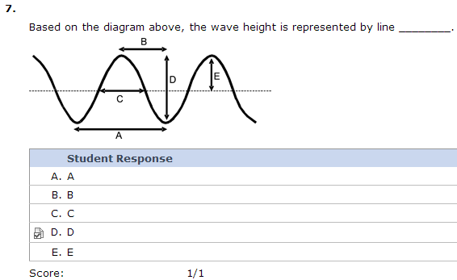

8. If you were sitting in a kayak (NOT paddling) in the middle of Burrard Inlet (average depth=25 m) on a day when the wind had generated 1-metre long waves, what motion would you and your kayak undergo as the waves pass by? Assume there is no current.
 | Student Response | Value | Correct Answer
A. | You would describe a circular orbital motion, slowly advancing in the direction of the wave.
B. | You would bob straight up and down.
C. | You would describe a circular orbital motion, without net displacement. | 100%
D. | You would move back and forth horizontally.
E. | You would move along in the same direction as the wave is traveling, at the same speed as the wave.

9. When waves approach shore where the bottom has a gentle slope, the WAVES will ___________.
 |  | Value | Correct Answer
A. | reflect
B. | plunge
C. | refract
D. | surge
E. | spill | 100%

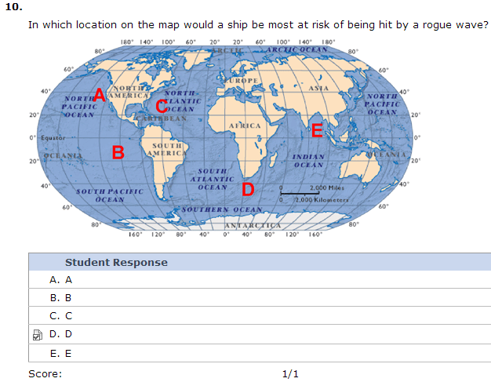

11. If you observe wave crests in the Pacific Ocean that are 60 meters apart and behave as deep water waves, you know that the water must be at least ______ meters deep.
 | Student Response | Value | Correct Answer
A. | 90
B. | 60
C. | 30 | 100%
D. | 15
E. | 5

12. If the waves are approaching Vancouver Island from the south and the Island lies on a northwest to southeast direction, the longshore transport will be directed from ______.
 | Student Response | Value | Correct Answer
A. | southwest to northeast
B. | northwest to southeast
C. | south to north
D. | north to south
E. | southeast to northwest | 100%

13. If you were the captain of a submarine, to what depth (at least) would you submerge your vessel in order to avoid the effects of waves with wavelengths of 100 m?
 | Student Response | Value | Correct Answer
A. | 5 m
B. | 10 m
C. | 30 m
D. | 50 m | 100%
E. | 100 m

14. Which of the following factors contributes the MOST to storm surge during a hurricane?
 | Student Response | Value | Correct Answer
A. | high tide
B. | shape of the coastline
C. | low atmospheric pressure under the eye
D. | high wind speed | 100%
E. | resonance (seiche) in semi-enclosed bays

15. Which of the following is TRUE about wave speed?
 | Student Response | Value | Correct Answer
A. | The speed of a shallow water wave depends on wavelength and period.
B. | The speed of a tsunami depends on wavelength only.
C. | At the same depth, shallow water waves with longer L are faster than those with shorter L.
D. | In deep water, longer wavelength waves travel faster than those with shorter wavelengths. | 100%
E. | Shoaling waves speed up as they approach shore.

16. Residents of Vancouver Island depend on the Pacific Tsunami Warning Center (PTWC) located in Honolulu, Hawaii to do all of the following EXCEPT _____.
 | Student Response | Value | Correct Answer
A. | predict tsunami behaviour and destruction in coastal towns and cities in the Pacific Rim | 100%
B. | use data from seismic stations from around the Pacific Ocean to make tsunami predictions
C. | gather data from tide stations around the Pacific Ocean to make tsunami predictions
D. | predict tsunami arrival times in coastal towns and cities in the Pacific Rim
E. | inform local/national/international agencies when to alert ships to move offshore in anticipation of a tsunami

17. In order to predict the wave heights of incoming surf, forecasters require information on all of the following EXCEPT _____.
 | Student Response | Value | Correct Answer
A. | local wind conditions
B. | waves that could interfere destructively
C. | air and sea surface temperatures | 100%
D. | waves that could interfere constructively
E. | swells from distant storms

18. Refraction causes waves to __________.
 | Student Response | Value | Correct Answer
A. | travel over a barrier
B. | bounce back towards its point of origin
C. | bend as much as 90º from the original direction | 100%
D. | become deep water waves
E. | converge in embayments and semi-enclosed water bodies

19. If your beachfront property has a steep, narrow, rocky beach year-round, it must be located in an area ______
 | Student Response | Value | Correct Answer
A. | where sediment deposition processes dominate
B. | with high population density
C. | with spilling waves
D. | with high wave energy | 100%
E. | protected by a breakwater

20. The tsunami that caused the most deaths in Canada in the past century occurred in ______.
 | Student Response | Value | Correct Answer
A. | Newfoundland | 100%
B. | Prince Edward Island
C. | British Columbia
D. | Yukon
E. | Nunavut

Storms Individual Quiz

1. In North America most thunderstorms form __________.
 | Student Response | Value | Correct Answer
A. | on the Canadian prairies
B. | in the southeast US
C. | near the east coast | 0%
D. | on the west coast
E. | in Oklahoma

2. Which of the following does NOT help to strengthen hurricanes?
 |  | Value | Correct Answer
A. | warm ocean water > 26 °C
B. | a large pressure gradient between the eye and the outer part of the storm
C. | ocean spray from waves increasing the humidity near the centre of the storm
D. | mixing of colder deep ocean water with surface water by strong waves | 100%
E. | condensation of water within the eye wall

3. The location in North America with the most thunderstorms is ___________
 | Student Response | Value | Correct Answer
A. | Florida | 100%
B. | Oklahoma
C. | Alberta
D. | Ontario
E. | Colorado

4. Arrange the 6 processes below in their order of occurrence during a thunderstorm:
(1) Air CIRCULATES outward between the top of the thunderstorm and converges near the ground.
(2) Air SPREADS OUT horizontally at the top of the thunderstorm.
(3) Sunlight ABSORBED at ground adds energy to boundary layer air.
(4) Air continues to RISE within the cloud, releasing latent heat.
(5) At the TOP OF THE STORM, the updraft hits the base of the stratosphere.
(6) Rising warm moist air COOLS and reaches saturation at cloud base (LCL).
 | Student Response | Value | Correct Answer
A. | 3…6…5…2…1…4
B. | 3…6…4…5…2…1 | 100%
C. | 3…4…6…5…1…2
D. | 1…3…4…5…2…6
E. | 1…3…6…4…5…2

5. Most thunderstorms are ______
 | Student Response | Value | Correct Answer
A. | supercell
B. | squall-line
C. | orographic
D. | multicell | 100%
E. | pulse

6. The TOP of thunderstorm clouds is lower to the ground when __________.
 |  | Value | Correct Answer
A. | the dew-point temperature is colder | 0%
B. | the near-surface air temperature is warmer
C. | the relative humidity is also low
D. | the dew-point depression is small
E. | not enough information to answer

7. The partial pressure exerted by water vapour in air is called __________.
 |  | Value | Correct Answer
A. | vapour pressure | 100%
B. | water pressure
C. | partial water
D. | pore pressure
E. | partial stress

8. The official name for thunderstorm clouds is _______.
 |  | Value | Correct Answer
A. | cirrocumulus
B. | nimbostratus
C. | mammatus
D. | stratocumulus
E. | cumulonimbus | 100%

9. Which statement is TRUE?
 |  | Value | Correct Answer
A. | A "tornado watch" means a tornado is happening now and heading in your direction.
B. | Most thunderstorms are short-lived because of the limited availability of boundary-layer fuel nearby. | 100%
C. | More intense tornadoes happen more frequently than weak ones.
D. | Tornado damage paths are usually wider than about 2 km.
E. | The official name for a thunderstorm cloud is "nimbostratus".

10. The greatest hazard to life AND property associated with hurricanes striking North America is/are the ______.
 |  | Value | Correct Answer
A. | storm surge
B. | low pressure in the eye
C. | thunderstorms
D. | strong winds
E. | loss of infrastructure | 0%

11. Which statement is FALSE?
 |  | Value | Correct Answer
A. | Lightning often ranks in the top two of weather-related killers in North America.
B. | Lightning can shoot out of the side of a storm and hit the ground ten miles away from the storm.
C. | Most lightning-caused forest fires are triggered by positive cloud-to-ground lightning.
D. | If you feel the hair standing up on your head or arms, there is a good chance that you are about to be struck by lightning in the next second or so.
E. | Some lightning occur with no thunder but where there is thunder, there must be lightning. | 100%

12. Which statement is FALSE?
 |  | Value | Correct Answer
A. | The Fujita scale for tornadoes is based on damage.
B. | The Torro scale for tornadoes is based on wind speed.
C. | The Saffir-Simpson scale for hurricanes is based on wind speed.
D. | The strongest observed tornado is F6 on the Fujita scale. | 100%
E. | Stronger hurricanes usually have lower sea-level pressures in the eye.

13. The process by which warm humid air moves horizontally toward thunderstorms is called ___.
 |  | Value | Correct Answer
A. | convection
B. | reflection
C. | transportation
D. | advection | 100%
E. | retention

14. Which of the following is NOT a type of supercell?
 |  | Value | Correct Answer
A. | classic
B. | low precipitation
C. | high precipitation
D. | multicell | 100%

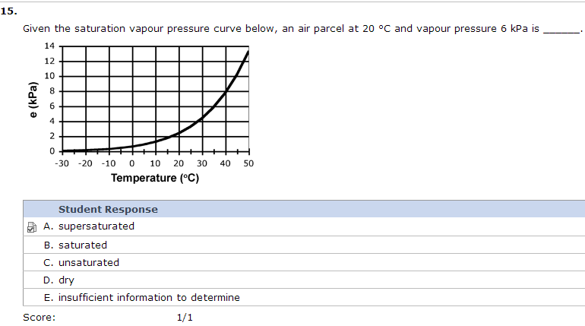

16. The official abbreviation for a thunderstorm cloud is __________.
 |  | Value | Correct Answer
A. | CB | 100%
B. | TS
C. | CN
D. | CU
E. | TC

17. Which phenomenon has the greatest rotation rate?
 |  | Value | Correct Answer
A. | hurricane
B. | supercell thunderstorm
C. | tornado | 100%
D. | derecho
E. | downburst

18. In Canada, hail is most frequent in __________.
 |  | Value | Correct Answer
A. | Ontario
B. | Manitoba
C. | Saskatchewan
D. | Alberta | 100%
E. | BC

19. Which statement is FALSE?
 |  | Value | Correct Answer
A. | Squall-line thunderstorms generally move to the northeast, the same direction as the individual storms within the line. | 100%
B. | Doppler radar can measure radial velocity inside storms
C. | Straight-line winds from thunderstorms can blow down tall trees.
D. | Vertically growing clouds are cumuliform.
E. | In the western North Pacific Ocean, hurricanes are called typhoons.

20. Towering cumulus clouds are officially known as _________.
 |  | Value | Correct Answer
A. | cumulus humilis
B. | cumulus mediocris
C. | stratocumulus
D. | cumulonimbus
E. | cumulus congestus | 100%

