Final Exam Questions
Energy of the sun is about 1000 W/m² and each square meter produces the equivalent of 1 barrel of oil per year or 4.2 kW hours of energy every day. All of the energy from the earth’s reserves is matched by the energy of 20 days of sunshine.
Solar Advantages
- Energy from sun is free after initial cost
- Short payback compared to the cost of common energy sources
- Can be stand alone systems
- Sun provides unlimited supply of solar energy
- Decrease in greenhouse gas
- Use of solar is an untapped market
- Ease of scalability – can easily add on
Most important components of a PV cell are two layers of P & N semiconductor material composed of silicon crystals. You cut silicon into wafers and stack them, and in between you have P-N junctions in parallel. The photons generate current, and by putting them in series, you can generate 25V. Standard solar panels give of 195 -225 W. Solar panels produce only DC.
Types of Cells
Single Crystal – has 25% efficiency but high cost
degrades quickly in performance due to Mother Nature
Has long cylinders sliced into hexagonal wafers
Accounts for 29% of global PV market
Sometimes used with concentrators or mirrors o boost efficiency to 30%
Polyscrystalline-has 15% efficiency, less expensive
Square cells can be packed closer together
Accounts for 62% of global PV market
a-Si has 5 % efficiency, least expensive
Amorphous silicon sprayed onto glass or metal in thin films making the whole module in one step
Appears to be most promising for future growth

Storage is a huge problem. If you can figure this out you will be a billionaire. You can use rechargeable batteries with an inverter and a charge controller, lead acid batteries, sent to the grid,.
Solar Thermal Energy – thermal collectors convert solar energy into heat energy. Classified as low (flat plates used to heat pool heaters), medium (flat plates used to create hot water) or high temperature collectors (use mirrors or lenses to produce power)
Solar Water heating – solar thermal collectors move fluid around and are stored in a reservoir tank for future use for pools, space heaters, and hot water. Large initial cost is recouped by savings
Heating cooling and Ventilation – Thermal mass materials ( stone, cement, water) store energy during the day and release it at night - Shouldice Clinic, Olympic Cube
Solar for the Home – while a basic package can cost you 10K, if you want a full solar system it will cost you $30K plus for every 3 KW it produces and most homes consume 20 to 30kWh per day. You also have to stay on the grid. You can also have solar powered water heaters. Governments offer contracts and incentives such as the GEA FIT programs
Net metering allows an individual to sell hydro back into the grid as well as use it for their own consumption. It will spin the meter backwards when it generates back into the grid
CST systems (Concentrating solar thermal) use lenses or mirrors and tracking systems to focus a large area of sunlight into a small beam. The main methods for providing the concentrated beam are the solar trough, solar power tower, and parabolic dish
Solar trough uses a parabolic shape to focus the sun at 30 to 60 times its normal intensity on a receiver pipe that has synthetic oil inside it which heats up, goes through a heat exchanger and produces steam to run a turbine and thus produce electricity
Parabolic Dish uses an array of mirrors to focus solar energy into a receiver where the fluid id heated
Solar Power Towers use flat reflectors that concentrate light on a central receiver atop a tower
There are also solar powered satellites which have an unobstructed view of the sun 24/7, no seasons or weather to contend with, solar lighting, solar vehicles
Solar must be used in conjunction with other reliable power sources. They will never be the only source.
The Environmental impact is next to nothing during operations apart from the vast areas of land they require and there are obviously employment opportunities

Wind Energy
Greenhouse gas emissions come from 35% fossil fuel use by cars and 35% power generation. As a result alternative energies are being sought; Wind turbines use wind to generate electricity. The wind turns the blades which spin a shaft that connects to a generator. The amount of power transferred to a wind turbine is directly proportional to the density of air, the area swept by the rotor and the wind speed.
The air is slowed down and spreads out. You want mosit air to get more power output. For a single cycle efficieny is 35% and for dual efficiency it is 59%. Therefore a can never be higher than 0.59 in the equation below
P=1/2 aρr²v³ although all books show this as ½ aρAv³
HAWT – horizontal axis Wind Turbine
Main motor shaft and electrical generator are at the top of the tower and must be pointed into the wind
HAWT Advantages
Blades at the side help center of gravity
Wing warp captures optimum wind energy
Rotor blades can pitch in storms to minimize damage
Tall tower allows you to access more wind
HAWT Disadvantages
Tall towers and long blades ( 90 meters) are difficult to transport
Difficult to install need special cranes and difficult to service.

VAWT – Vertical Axis wind turbine
Less popular, closer to the ground with main rotor shaft arranged vertically
VAWT Advantages
Easy maintenance as parts close to ground
Better aerodynamic coupling
No free standing tower required
No jitter – ideal in turbulent winds
VAWT Disadvantages
30% efficiency vs 59% in HAWTs
Need flat land
High inertia therefore might need a stator or exciting current to get it going
Maintenance is an issue due to weight above you
Disadvantages of Wind overall
Wind patterns are intermittent – when you have the most wind you need the least hydro
You need to either put friction on your blade or you need to store the energy because generation and consumption must remain balanced to maintain grid stability
Capacity Factor – the actual productivity of a turbine per year related to a theoretical maximum capcity factor. Therefroe you must intervonncet turbines to make them reliable
Windfarms usually produce 34.5KV sistribution level voltage. The medium voltage is stepped up by a transformer to the high voltage grid. Wind generators are practical where the average wind speed is 4,5 m/s
You have on shore wind farms(3km or more from nearest shoreline), or near shore windfarms ( within 3 km to the nearest shore or within 10km from shore if lying on water) or Off Shore ( 10 km or more from land) which is the best but most expensive
High start up costs
High capital cost
Environmental bird killing and blade noise
Far from distribution and transmission lines because otherwise building will interfere with wind
Safety issues due to falls
From week 8
Single phase motors can’t start on their own because the magnetic flux will lie up in a such a way that the rotor will jam. Therefore they need to overcome this friction and inertia by using a staring mechanism. There are two types – wither auxiliary winding or capacitive starter to start the motor . The auxiliary windings overcome the inertia and force and the switch in contact with the auxiliary windings drops the auxiliary circuit out once a certain speed is reached.
Single phase motors are better than dc because with dc you need a rectifier, they are bulky, they come with brushes which creates a spark, they are expensive , and there is a lot of maintenance cleaning the brushes etc
Right hand rule
The circle with the plus sign means going in to the page, circle with dot means ccw the opposition at the top and the bottom is what turns the motor

Final Exam Q for single phase Motors
Instantaneous currents and flux in a single-phase motor with the main winding excited. The duration of one cycle is T seconds, and conditions are shown at successive quarter-cycle intervals. a. Stator current I_{s} is maximum, rotor current I_{r} is zero. b. Stator current is zero, rotor current is maximum; however, F_{r} is smaller than F_{s}. c. Stator current is maximum, but negative. d. Rotor current is maximum, but negative. e. After one complete cycle (t = T) the conditions repeat. f. Resulting flux F in the air gap rotates ccw at synchronous speed. Its amplitude varies from a maximum of F_{s} to a minimum F_{r}.

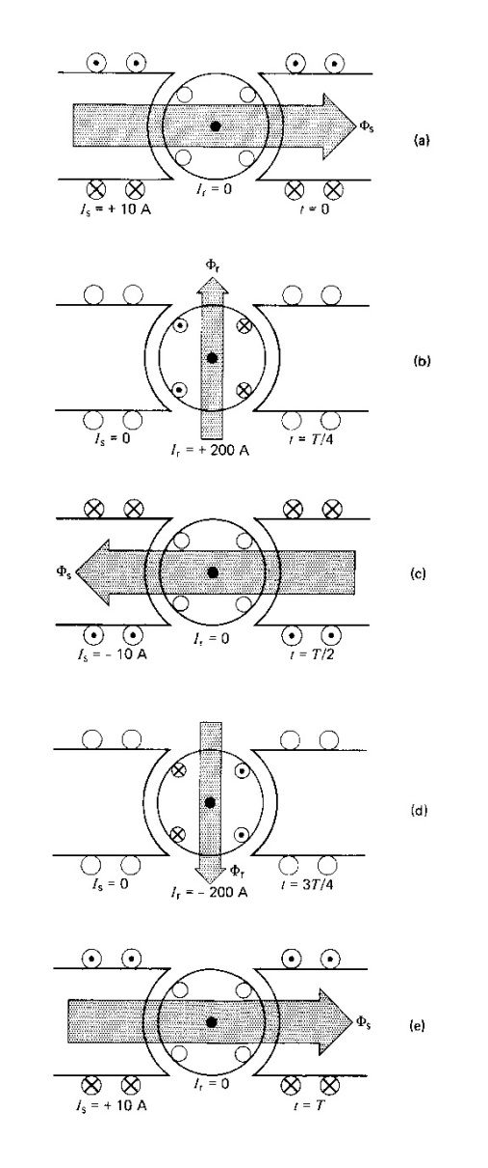

Induction Motor advantages
Simple design
Inexpensive
High power to weight
Easy to maintain
Direct connection to AC
Difference between motors and generators
For a motor you have 3 phase power out to the motor ( stator) 3 coils, phases ABC. When you pass current through the coils, you generate magnetic flux. The magnetic flux travels through the air gap between the rotor and the stator. The magnetic flux induces a voltage and a current. The current induced generates a magnetic flux opposite to the original field and the motor spins. The stator leads and the rotor lags and that difference is the slip.
For a generator, you have to make the rotor catch up with the stator so they run at the same speed. The dc flux does this. For an induction machine, you add dc flux and magnetic flux and you now have a generator. Change to the field in the pilot, excites to increase the dc flux to match the speed.
The equivalent circuit for a generator is the same as for a motor plus the exciter

What is the difference between synchronous motor and induction motor?
Synchronous and induction machines both produce torque through the interaction of a rotor magnetic field and a stator magnetic field. The differences between the two types of machines arise because of the differences in the way the rotor magnetic field is generated.
Synchronous machines have a stationary (relative to the rotor) magnetic field on the rotor. This field can be generated either by permanent magnets, or by a field winding powered through slip rings. The interaction of this field with the rotating field on the stator creates torque and causes the motor to rotate. A synchronous motor always rotates at some multiple, determined by the number of poles, of the line frequency. If a synchronous motor loses lock with the line frequency, e.g., by torque overload, it will stall. A synchronous motor cannot start by itself on a fixed frequency AC source. It either needs to be fed a variable frequency source, or it needs to be brought up to speed by an auxiliary motor, sometimes called a pony motor, so that it can generate torque. Synchronous machines usually require some form of control to keep the rotor speed locked to the line frequency.
Induction machines have a rotating (relative to the rotor) magnetic field on the rotor. In a squirrel cage motor, this field is created because the motion of the stator field relative to the shorted rotor cage induces currents in the rotor. These currents generate the rotor field, which interacts with the stator field to create torque. A wound-rotor induction machine has rotor windings similar to a synchronous machine, in which currents are induced by the rotating stator field. Induction motors always rotate in some narrow speed range that is less than synchronous speed. This speed difference, which is necessary to generate the rotor field, is called the "slip." Low slip machines, which turn at very near synchronous speed, are more efficient than high slip machines, but have lower starting torque. Induction machines can produce some torque at zero speed, so they are capable of starting themselves if the load torque is low enough at zero speed. The torque-speed characteristic of induction machines at rated speed has a negative slope (as speed decreases, torque increases). As a result, induction machines do not require controls to operate - the feedback mechanism is built into the machine.
The winding resistance a wound-rotor induction machine can be varyied by connecting resistors to the rotor windings via the slip rings. This allows the torque-speed characteristics of the wound-rotor machine to be varied as needed (e.g., high resistance (= high slip) for high starting torque and then low resistance (= low slip) for high efficiency at rated speed).
The absence of a rotor winding makes squirrel cage induction machines significantly cheaper to manufacture than synchronous machines (or wound-rotor induction machines). Squirrel cage machines are extremely rugged because of the lack of a wound rotor (the cage is usually cast right into the rotor laminations), and the lack of slip rings makes them more suitable for explosive environments because there is no arcing mechanism. The circulating currents in an induction machine rotor lead to resistive losses that make induction machines less efficient that synchronous machines.
Summary of differences:
Synchronous machines:
- Wound-rotor or permanent magnet to generate the rotor magnetic field.
- Rotor magnetic field is stationary with respect to the rotor.
- Always turn at synchronous speed.
- Require some form of control to operate.
- More expensive to produce than squirrel cage induction machines.
- Not self-starting.
- More efficient than induction machines.
Induction Machines:
- Wound-rotor or squirrel cage to generate the rotor magnetic field.
- Rotor magnetic field rotates with respect to the rotor.
- Always turn at less than synchronous speed.
- Do not require control.
- Much cheaper to produce (true for squirrel cage machines).
- Self-starting.
- Less efficient than synchronous machines.
- More suitable for explosive environments.
- No maintenance (for squirrel cage machines).
Synchronous Motor:
- Speed: Starting from its name ‘synchronous’, this motor runs at synchronous speed whatever the amount of load it may be. The speed of this kind of motor is not dependent on the load.
- Starting Torque: This motor does not have any self starting torque, so some other auxiliary means have to be provided for starting the synchronous machine.
- Excitation: Synchronous motor is a doubly excited machine. The field winding that is rotor is excited using DC source and its stator that is armature winding is excited using AC source. In addition to that it can be made to operate at leading power factor from lagging power factor just by changing its excitation.
- Efficiency: This is comparatively more efficient than induction motor.
- Cost: This kind of motor is much costlier that a similar rating induction motor.
Induction Motor:
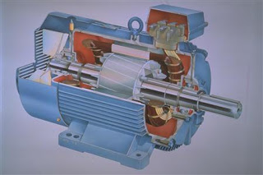
Induction Motor

- Speed: The speed of induction motor is always less than the synchronous speed and it is dependent on the load since the speed decreases with the increase in load.
- Starting Torque: This kind of motor has its own self starting torque.
- Excitation: It is a singly excited machine where its stator windings are excited using an AC source. Contrary to the case of synchronous motor, induction motor works only under lagging power factor.
- Efficiency: It is comparatively less efficient.
- Cost: The cost of induction machine is less when compared with a synchronous motor of same rating.
- CAPACITOR-START. - The first type of split-phase induction motor that will be covered is the capacitor-start type. Figure 4-11 shows a simplified schematic of a typical capacitor-start motor. The stator consists of the main winding and a starting winding (auxiliary). The starting winding is connected in parallel with the main winding and is placed physically at right angles to it. A 90-degree electrical phase difference between the two windings is obtained by connecting the auxiliary winding in series with a capacitor and starting switch. When the motor is first energized, the starting switch is closed. This places the capacitor in series with the auxiliary winding. The capacitor is of such value that the auxiliary circuit is effectively a resistive-capacitive circuit (referred to as capacitive reactance and expressed as X_{C}). In this circuit the current leads the line voltage by about 45° (because X_{C} about equals R). The main winding has enough resistance-inductance (referred to as inductive reactance and expressed as X_{L}) to cause the current to lag the line voltage by about 45° (because X_{L} about equals R). The currents in each winding are therefore 90° out of phase - so are the magnetic fields that are generated. The effect is that the two windings act like a two-phase stator and produce the rotating field required to start the motor.
- Figure 4-11. - Capacitor-start, ac induction motor.
- 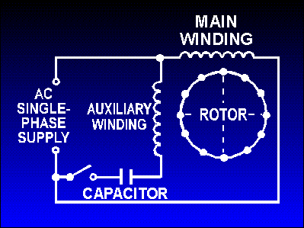
- When nearly full speed is obtained, a centrifugal device (the starting switch) cuts out the starting winding. The motor then runs as a plain single-phase induction motor. Since the auxiliary winding is only a light winding, the motor does not develop sufficient torque to start heavy loads. Split-phase motors, therefore, come only in small sizes.
Resistance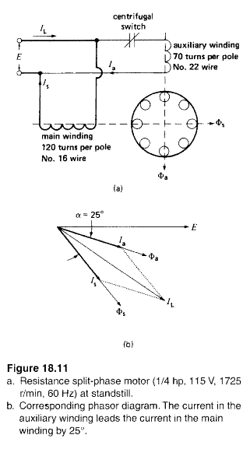 Split Phase
In a resistance .split-phase motor (often simply called split-phase motor). the auxiliary winding has
a relatively small number of turns of fine wire. Its resistance is higher and its reactance lower than that
of the main winding, with the result that the locked rotor current /" is more nearly in phase with £. The
resulting phase angle ex between (,and /,produces the starting torque. The line current, IL is equal to the phasor sum of I, and (,. At start-up. it is usually 6 to 7 times the nominal current of the motor.
Owing to the small wire used on the auxiliary winding. the current density is high and the winding heats up very quickly. If the starting period lasts for more than 5 seconds. the winding begins to smoke and may burn out, unless the motor is protected by a built-in thermal relay. This type of split-phase motor
is well suited for infrequent starting of low inertia loads.

The capacitor-start motor is identical to a split-phase motor, except that the auxiliary winding has about as many turns as the main winding has. Furthermore, a capacitor and a centrifugal switch are connected in series with the auxiliary winding (Fig. 18.12a). The capacitor is chosen so that Ia leads Is by about
80°, which is considerably more than the 25° found in a split-phase motor. Consequently, for equal starting torques, the current in the auxiliary winding is only about half that in a split-phase motor. It follows that during the starting period the auxiliary winding of capacitor motor heats up less quickly.
Capacitor-start motors are used when a high starting torque is required
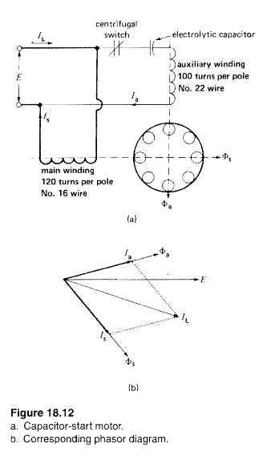
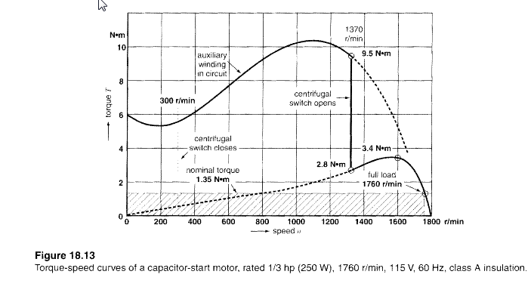
Currents induced in the rotor bars due to rotation produce a flux that acts at right angles to the stator flux. Using the right hand rule, going into the page, the flux cancels at the top and supports at the bottom causing the remaining lines to fight each other and produce a downward force. Same for the other side except for hand rule coming out of the page, except as soon as the flux tips, it starts the motor. The drawing shows how the magnetic rotating field wrt the (up-down) auxiliary, always the shorter vector is 90 degrees out of phase or perpendicular (Lto R) with the main.

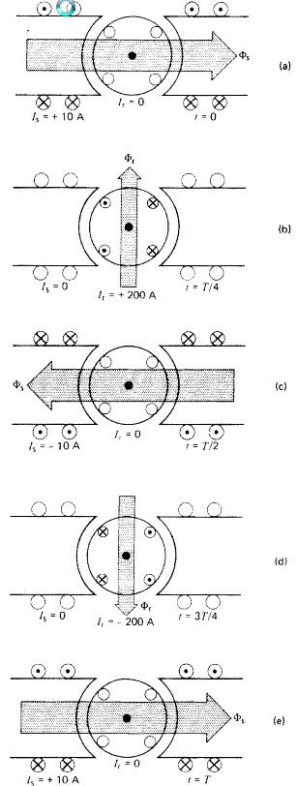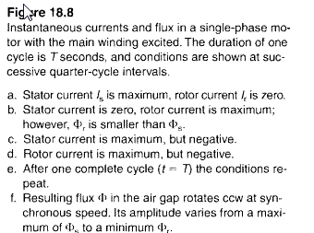
DC MOTORS
Difference between AC and Dc
Ac has slip rings, dc has commutator
Both have a coil that rotates between the poles of a magnet and an ac voltage is induced in the coil
In ac, the rotational part is called a rotor, in dc it is called an armature
For a generator you supply mechanical force, you get electrical energy
For a motor, you supply electrical energy, you get mechanical force
Dc motors are easy to control speed using a rheostat

Typical load characteristics of dc generators
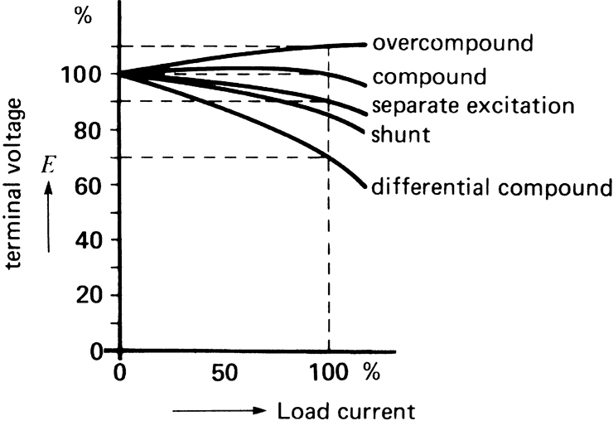

You can control the braking of a motor in two ways
Coasting – let it do nothing
Plugging – take a voltage and clip it
Dynamic brake – add a Resistor –low R means motor stops right away
Instrument Transformers Week 9
The main objective is to reduce the voltage to a safe level to work on. A safe voltage on the secondary side is 120V and the most common current is 5A
CT’s
high current CT’s use a donut shape where the primary goes through the donut shape and the secondary is in the coil. There for the primary has 1 turn for the coil and the secondary is multiple turns based on the amount of current you want to reduce
Np/Ns=a, and Ns/Np = 1/a
Primary has fewer turns based on Vp/Vs = Np/Ns = Is/Ip
Error rate 2.5% to 5 %
Must always terminate the secondary with either a short circuit or attach a device with low resistance like an ammeter or a relay coil because the di/dt is low duration where it switches from positive to negative
If you supply a CT with higher than rated ex2000 amps and it is rated for 1000:5, you won’t see 10A at the output because it saturates so maybe you will see 8A
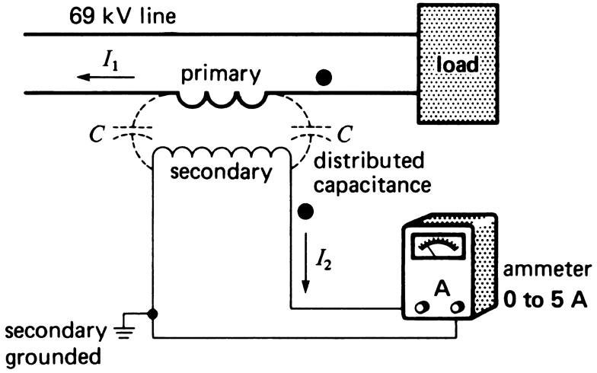
For a PT
Vs should always be 120V VP/Vs=Np/Ns
Whether is it a PT or a CT, they always operate based on the Voltage not the current
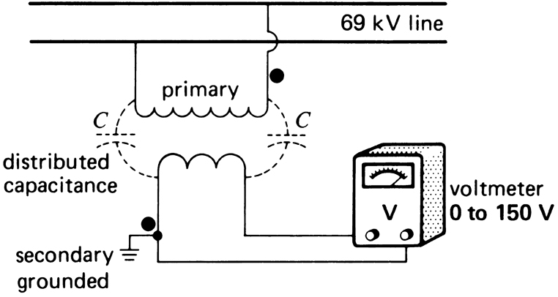
A CT is used to measure or monitor the current in the transmission lines and to isolate the metering equipment and relay connection to the secondary side. Common functions used for monitoring high voltage on the grid or inside a meter on the house
A PT is used to measure or monitor voltage on transmission lines and to isolate the metering equipment from the lines. Voltage conversion is constant and linear> The PT makes the measure of very high voltages much easier and its linearity ensures that the meter will scale accordingly

READ TRANSFORMER PROBLEMS FROM WEEK 9
After this there is Solar and Wind, Incremental; cost

Stopping
De-Energize/Coasting: The most common method of stopping a motor is to disconnect the supply voltage allowing the motor to coast to a stop. In some applications, however, the motor must be stopped more quickly or held in position by some sort of braking device.
Electrical Braking: Electrical braking uses the winding current of the motor to produce retarding torque. The kinetic energy of the rotor and load is dissipated as heat in the rotor bars of the motor. Two kinds of electrical braking are plugging and dynamic braking.
Plugging: Plugging brings an induction motor to a very quick stop by connecting the motor for reverse rotation while it is running. To prevent the motor from reversing again after it has come to a stop, the power is removed by means of a zero speed switch.
Dynamic Braking: Dynamic braking is achieved by removing the AC power supply from the motor and applying direct current to one of the stator phases. Neither plugging nor dynamic braking can hold the motor stationary after it has stopped.
Mechanical Braking: Mechanical breaking refers to the use of devices external to the motor to provide retarding torque. Most rely on friction in a drum or disc brake arrangement, and are set with a spring and released by a solenoid or motor. These devices have the ability to hold a motor stationary after it has stopped.
Mechanical braking packages usually include a fail safe stop and hold spring set. In the event of power failure, the brake sets, holding the load in position. These are commonly used on hoists and other lifting devices.

