Biology 111 Practice Final Exam Questions – December 2011

These questions are designed to illustrate the format of exam questions. We do not repeat in this final exam practice questions some of the chapter specific practice questions that are already posted in the course vista. Be sure to review them. You should also review the questions in the two mid-term exams, carefully reviewing the answer guides.

Spaces have been decreased for the purposes of this practice exam. During the exam you will be expected to provide answers that range from a few words to a few sentences.

1. One task that many boat owners hate is the chore of scraping the encrusting algae and animals that inevitably attach onto the hull of the boat. These organisms create drag that slows the movement of the boat through the water. Special paints that contain biocide compounds have been developed to prevent ‘fouling’ of the hulls. Compounds such as tributyltin (TBT) have been banned in many countries, because it is a non-specific toxin. These compounds dissolve very slowly in sea water and are eventually absorbed by marine producers through diffusion. (Total 3 marks)

a) As early as the 1970’s TBT was linked to a dramatic decline in the population of oysters in France. How would these filter feeding animals acquire TBT? (1 mark)

b) There has been further concern about the effect of this toxin on fish and marine mammals. Explain why. (1 mark)

c) What recommendations would you make to the Government of France regarding antifouling marine paints? (1 mark)

2. Rock pocket mice (Chaetodipus pernix) live in the deserts of the American southwest where the majority of the habitat is a light sand colour. The mice have sand-coloured fur allowing them some camouflage from predators like owls. One million years ago there were lava flows across parts of the desert creating regions of black-coloured rock. A black form of the mouse also exists, with the majority of the black mice living in the regions with black-coloured rock. The difference between the two types of mice is due to mutations in one gene. Scientists have been able to calculate that although mutations are rare, there has been enough time for the mutations causing black fur to arise independently many times. (Total 12 marks) | 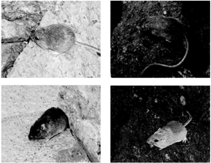

a) Did the lava flows cause the black mutation to occur in the population of mice? Explain your answer (2 marks)

b) To determine which allele is dominant you mate the two types of mice. You use a homozygous female with sandy coloured fur and a homozygous male with black coloured fur.
i) Write the genotypes of the two parent mice.

Use the symbols F^{s} =sandy fur, F^{b} = black fur. (We do not know which one is dominant and which one is recessive so we are not using the usual capital and lower case letters.) (1 mark)

Genotype of female mouse:________ Genotype of male mouse: __________ .

ii) In the circle below that represents the gamete of the female parent, draw one condensed chromosome and label it for the fur colour allele. (Although these mice have 2n = 38 chromosomes, just draw one chromosome.) Draw the corresponding chromosome from the gamete of the male mouse. (1 mark)

iii) Next draw a cell from the resulting offspring that is beginning to go through mitosis [show only the condensed chromosome(s) containing the fur colour gene labelled with the appropriate allele(s)].
(1 mark)

Female mouse’s gamete + Male mouse’s gamete

offspring

iv)what is the genotype of the offspring mouse:________ (0.5 marks)

v) Why does the phenotype of the offspring mouse allow you to tell which allele is dominant and which allele is recessive? (1.5 marks)

Below is a short sequence of DNA from the beginning of the fur colour gene. First transcribe this sequence into mRNA and then translate it using the codon table provided (next page). (2 marks)

CAAAGATGAGTAAAGGAGAAGAACTTTTC
GTTTCTACTCATTTCCTCTTCTTGAAAAG’ template strand

f) When the first underlined nucleotide is mutated from a T to a C, the colour of the pigment protein changes from sandy to black. Using the codon table provided explain why this may be the case. On the other hand, if the second underlined nucleotide is mutated from an A to a G instead (the first underlined nucleotide did not change), a normal (sandy) pigment protein is still made; explain why that occurs. (2 marks)

c) Explain how the presence of owls has acted to favour the black fur colour phenotype on the lava flows (1 mark)

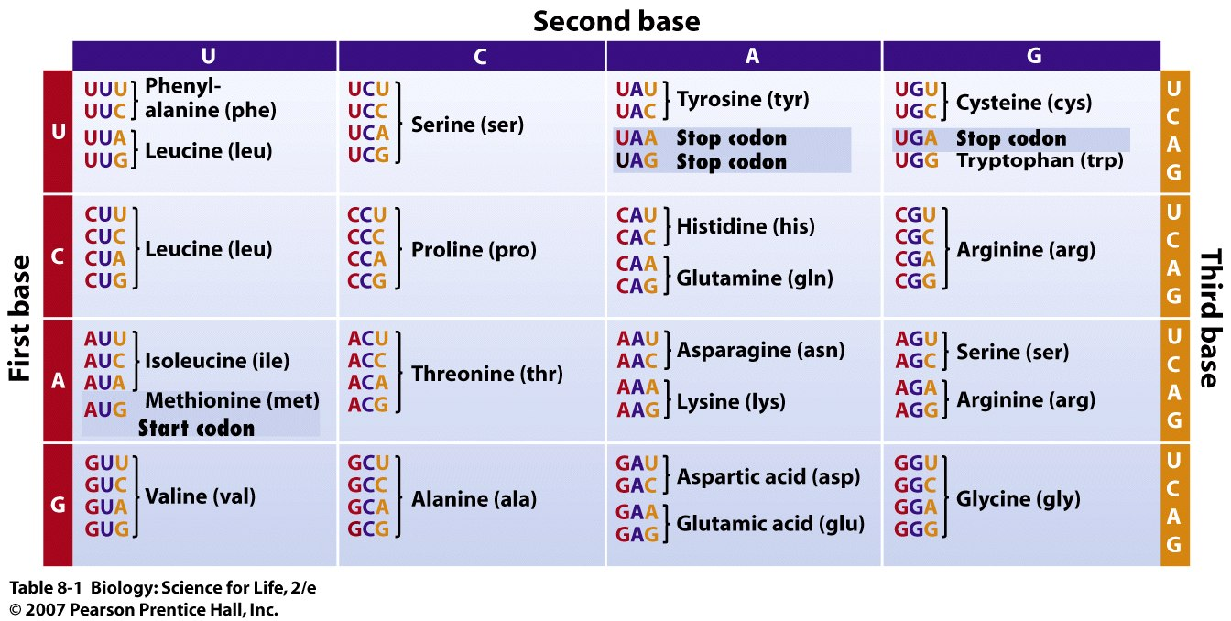

3. A tribe of indigenous Indians in a remote region of Papua New Guinea was isolated from the outside world. An exotic bacterial pathogen was accidently introduced to the tribe by a visitor. All individuals in the tribe were exposed to the bacteria; all were infected and fell ill (100% infection rate). Nobody died from the illness and everybody began to get better after 10 days and eventually recovered fully. Lacking susceptible hosts, the bacterial pathogen disappeared from the population. (Total 13 marks)

- Identify two types of immune components (e.g., cells or proteins) involved in fighting the pathogen during the infection and describe how each component fought the pathogen (4 marks)

(b) Ten years later the same pathogen was introduced to the same tribe of people. Only children under 10 got sick this time and the rest of the tribe was not affected. The infection rate in the entire Indian population was 20% this time. Has evolution through natural selection taken place in the population during the 10 year period between the two bacterial outbreaks? Explain your answer. Explain why the infection rate changed between the two invasions by the same bacterial pathogen. (3 marks)

c) Another viral pathogen was introduced shortly after the above episodes; many people became seriously ill and died of the viral infection. Some sick people eventually recovered fully. In the end, 80% of the population died of the virus. The same virus returned 50 years later. Although most people fell ill again, only 15% of the population died of the same viral disease.
i) Has evolution through natural selection taken place during the 50 years between the two viral invasion episodes? Explain your answer. Explain why the infection rate changed between the two invasions caused by the same viral pathogen. (3 marks)

ii) Of the people who the survived this second virus attack, some become ill with a rare type of cancer in old age. During the initial outbreak of the disease, the virus caused severe swellings of the lymph nodes in their necks. In the elderly survivors with cancer, cancer also seems to initially arise within the lymph nodes of their necks causing rapid cell division there. Explain why it is possible for viral DNA to still be present in cells of the lymph nodes so many years later. (1 mark)

d). Of the two disease outbreak scenarios above, at least one was an example of evolution. When do you think the gene(s) that helped certain individuals resist the pathogen appear in the population (before, during, or after the pathogen arrived)? Explain your reasoning. (2 marks)

4.
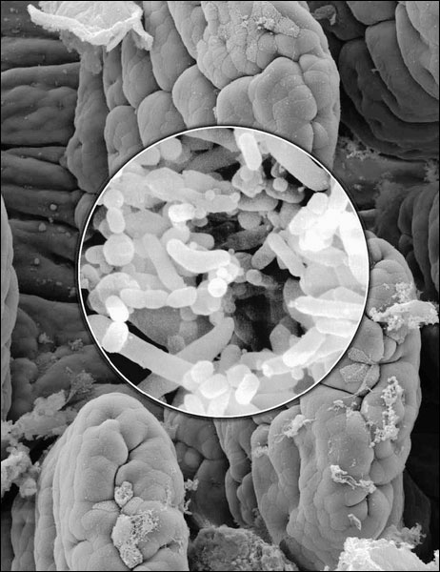 | 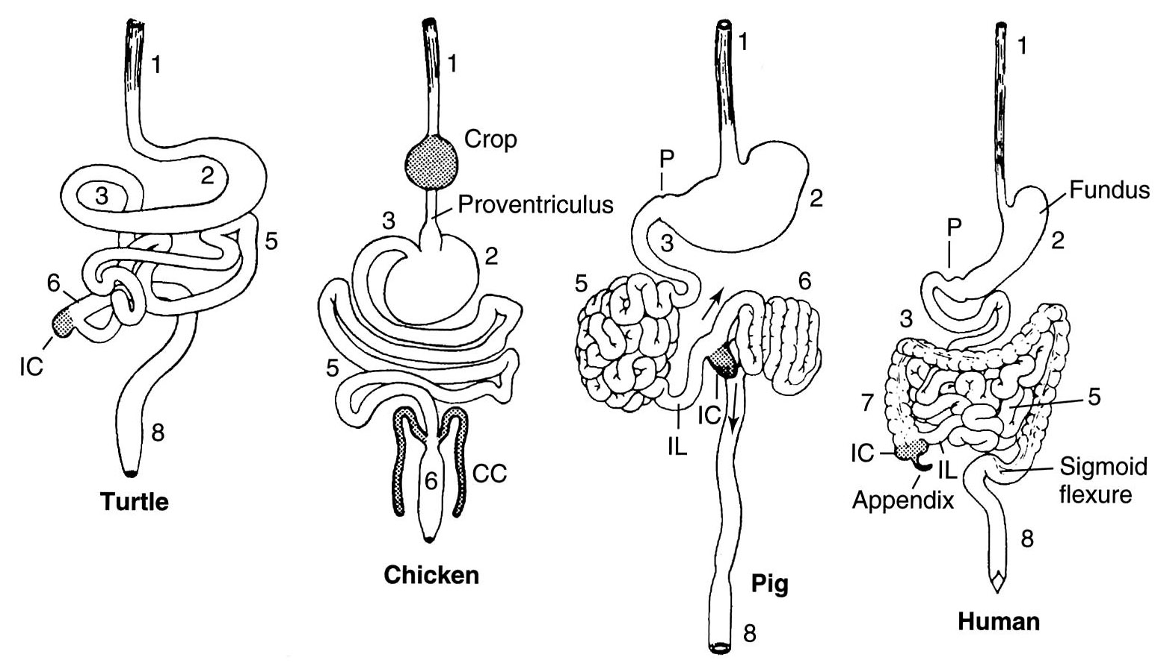 | Our ability to sequence entire genomes of different organisms has become very fast. Several ambitious projects are underway where all DNA from all the microorganisms inside the guts of various animals has been sequenced. A diverse array of genes has been found including genes which make enzymes for metabolizing amino acids,
carbohydrates, cellulose, lignin and other plant materials that animals themselves lack enzymes to metabolize. Genes have been found for synthesizing vitamins, produce methane etc. Although some genes are shared between microorganisms found in the guts of different animals, what is more noticeable is the many differences among them. (Total 9 marks)

a) One interesting discovery has been how different the microorganisms can be between different individuals of the same species. They even found great differences between the guts of two identical (human) twins. Considering the ecology you have learned in this course, describe two factors that could explain observed differences in the microorganisms (as measured by the presence of different genes) between different animals of the same species. (2 marks)

b) What two questions could you ask to help determine why there are different gut microorganisms in different species of animals? (2 marks)

c) Although we have many digestive enzymes to breakdown our food we still rely on microorganisms to do a lot of the work for us. When we pass gas (“farts”) this is the by-product of bacterial digestion of the foods we eat. Similarly cows expel a considerable amount of methane gas for the same reason. Do we also contribute to green house gases? (1 mark)

d) Explain whether you think carnivores (meat eaters) or omnivores (meat, plants, fungi etc eaters) would have a more diverse array of gut microorganisms. (1 mark)

e) Why would you have difficulty digesting your food after taking a full 2 week prescription of antibiotics? (1 mark)

f) When decomposers like bacteria and fungi decompose logs and dead plant matter in the forest they secrete enzymes outside of their cells to breakdown the organic matter and then they absorb the smaller molecules for their metabolism and growth. How do the activities of decomposers affect the growth of plants? Explain? (2 marks)

5.
a) The 4 diagrams below show the nuclei of 4 daughter cells from a mother cell that has gone through meiosis. The symbols represent the chromosomes. Draw the nucleus of the mother cell before DNA replication (before meiosis occurs). (1 mark)
b) Imagine a mutation arises to cause a disease such as cystic fibrosis. Cystic fibrosis causes difficulties breathing and most patient don’t live past 30 years old. This mutation prevents a functional protein from being made. People with heterozygous genotypes in this gene are normal and are carriers of the mutation. What must happen for us to actually see the disease manifested?

c) You have two butterflies one is pure white, the other is all black. One is male and the other is female. You know that one of the two phenotypes, white and black, is dominant and that the colour of butterflies is controlled by one single gene. You do not know the genotypes of these two individuals. How could you tell which is dominant? Describe what you would do and explain how that help you determine which trait is dominant (3 marks)

d) What is the ultimate source of genetic variability (genetic diversity) in eukaryotic organisms? Explain your answer (1 mark)

e) Cells spend most of their time in G1 of interphase. At this point the chromosome looks like a big mass of strings. Although the DNA is decondensed you can still say how many chromatids each chromosome has, even though you can’t see it.
- How many chromatids is each chromosome composed of at this point? (1 mark)

- So, imagine you have a cell with 4 chromosomes in G1. Even though the DNA is decondensed, imagine something happened to condense it during G1. Draw what the 4 condensed chromosomes inside the nucleus would look like. (1 mark)

- Is the DNA generally single-stranded or double stranded at this time? (Hint: to answer this question, ask yourself when the DNA is single-stranded) (1 mark)

f) Plant biologists have successfully bred many cultivar varieties of high yield crop plants, such as wheat. These crop plants allocate vast majority of the energy they harness from sunlight into producing grains or seeds suitable for human consumption. The cultivar varieties produce many more seeds per plant than their counter part, wild wheat that naturally grow in the wild, although both the cultivar and the wild wheat are actually the same species. If some of cultivar varieties of wheat plants escape the cultivated fields and move into the wild, will they change the gene frequencies of the wheat population in the wild over time? Explain your answer (2 marks)

g) Why do virus normally only attack certain kinds of cells within the body of a host? (1 mark)

h). People who drink large quantities of alcohol regularly often develop mutation in their liver cells, some of which eventually turn into liver cancer later in life. If two people, both drink heavily and have mutations in their liver cells during their late 20s, are married and then have children in their early 30s, will they pass on their mutated genes to their children? Explain your reasoning (2 marks)

6. Describe one aspect of biology that you learned in this course that was interesting to you and explain why you find it interesting. (2 marks)

