ADM1340 MIDTERM REVIEW
Chapter One
See pages 27-30 in the textbook for all needed theory.
Statements
The Income Statement: Revenues-Expenses= Net Income (Net Loss)
Statement of Retained Earnings: Beginning Retained Earnings+ Net income- Dividends= Ending RE
Balance Sheet: Assets = Liabilities + Owners’ Equity

Assumptions
The Entity Assumption: An accounting entity is an organization that stands apart as a separate economic unit.
The Going-Concern Assumption: The entity will continue to operate in the foreseeable future.
The Cost Assumption: Assets and services acquired should be recorded at their actual (historical) cost.
The Stable-Monetary-Unit Assumption: The dollar’s purchasing power is relatively stable.

Chapter 2
Normal Balances of the Accounts

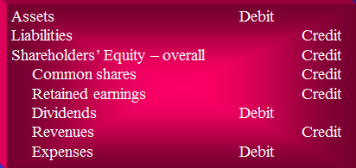

Chapter 3
See pages 118-122 in textbook for all needed theory and know accruals and deferrals.
Vocabulary
Accrual Accounting: recording cash transactions and noncash transactions (i.e. purchases on account).
Cash Basis Accounting: Revenue is recorded when case is received, expenses are recorded when incurred. Not GAAP.
Accrual Basis of Accounting: revenues are recorded when earned, expenses are recorded when incurred regardless of when cash is received or paid. GAAP.
The Time-Period Concept: Businesses need regular progress reports, so accountants prepare financial statements for specific periods and at regular intervals (i.e. monthly, quarterly, annually).
Revenue Principle: Governs when to record revenue and the amount of revenue to record.
Carrying Amount: The net amount of a capital asset (cost minus accumulated depreciation).
Accrued Revenue: Revenue that has been earned but not received in cash.

Closing the Books
Closing the Books means preparing the accounts for the next period’s transactions. Temporary accounts (revenue, expense, and dividends) are closed at the end of the accounting period. Permanent accounts (assets, liabilities, and shareholders’ equity) are not closed at the end of the period because their balances are not used to measure income.
Closing entries transfer the revenue, expense, and dividends balances to retained earnings.

Journalizing the Closing Entries:
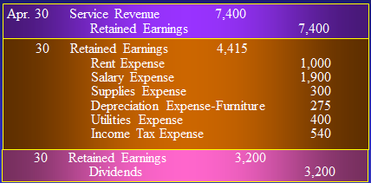
Posting the Closing Entries
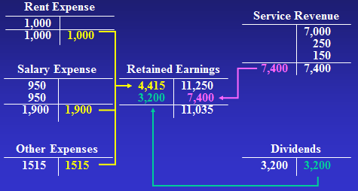

Ratios
The Current Ratio measures the company’s ability to pay current liabilities with current assets.
Current Ratio= Total current assets / Total current liabilities

The Debt Ratio indicates the proportion of assets that is financed with debt.
Debt ratio= Total liabilities / Total assets
This ratio measures a business’s ability to pay total liabilities.

Chapter 4
Internal Control
A plan of organization and system procedures designed, implemented and maintained by company management and board of directors to deal with risks relating to: reliability of financial records and reporting, ability to operate effectively and efficiently, and compliance with legal requirements.
There are five components to internal control:
- Control environment
- Monitoring of controls
- Risk assessment
- Information system
- Control procedures
Internal control Procedures:
- Smart hiring practices and separation of duties
  - Background checks, proper training, responsibilities clearly laid out.
- Comparisons and Compliance monitoring
  - Auditing.
- Adequate records
  - All major groups of transactions should be supported by hardcopy or virtual records.
- Limited access
  - Limit access to assets only to those persons or departments that have custodial responsibilities.
- Proper approvals
  - No transaction should be processed w/o management approval.
- Information technology
  - The basic attributes of internal control of IT does not change but the implementation procedures do.
- Safeguard controls
  - Burglar alarms, security cameras, job rotation, fireproof vaults (BADASS)…

Collusion
The act of two or more employees working together to defraud a firm.

Chapter 5
Separation of duties: separation of cash-handling and cash-accounting duties.

Accounting for Uncollectible Receivables
1. Allowance Method: records collection losses on the basis of estimates, not waiting to see which customers will not pay. The Allowance for Uncollectible Accounts (Allowance for Doubtful Accounts) is a contra account to Accounts Receivable.
Example of the Allowance Method:
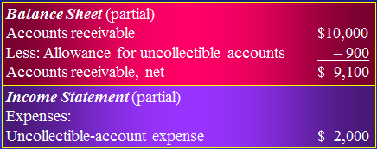
There are two methods for estimating uncollectibles: Percent-of-Sales and Aging-of-Accounts Receivable. Percent-of-Sales computes uncollectible-account expense as a percentage of revenue and is also called the income statement approach. Aging-of-Accounts Receivables analyses individual receivables from specific customers based on how long they have been outstanding and is also called the balance sheet approach.

Writing Off Uncollectible Accounts
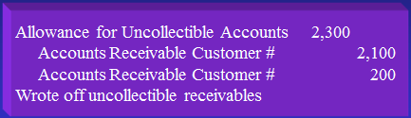

Direct Write-Off Method
Using this method, an account is written off only when it is decided that a specific customer’s receivable is uncontrollable. Not GAAP, not matching and does NOT use an allowance account. This method is defective for two reasons: since no allowance for uncollectibles is established, assets are overstated on the balance sheet, and it causes a poor matching of uncollectible-account expense against revenue and overstates net income.

Ratios
Acid Test (or Quick) Ratio: measures the company’s ability to pay its current liabilities immediately.
Acid Test Ratio= (Cash + Short-term investments + Net current receivables)/ total current liabilities.
The higher the acid-test ratio, the easier it is to pay current liabilities.

Days’ Sales in Receivables:
One day’s sales: Net sales/ 365 days
Days’ Sales in Receivables= Average net accounts receivable/ One day’s sales
A smaller number indicates a quick conversion to cash.

Chapter 6
Different types of Income Statements
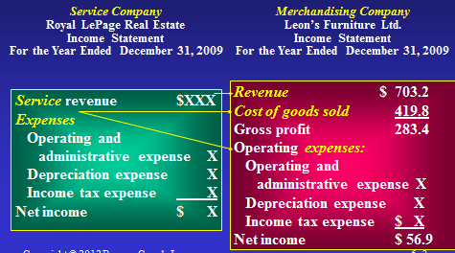
Different types of Balance Sheets
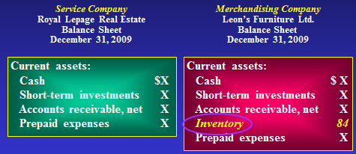

Accounting for Inventory
Balance Sheet: Cost of inventory on hand= Inventory (Asset on balance sheet).
Income Statement: Cost of inventory that’s been sold= Cost of Goods Sold (Expense on income statement).

Gross Profit (before operating expenses)= sales revenues - Cost of goods sold
Gross Profit – Operating Expenses = Net income

Inventory Accounting Systems
Periodic systems do not keep a continuous record of inventory on hand.
Perpetual systems maintain a running record to show the inventory on hand at all times.

Recording Transactions in the Perpetual System
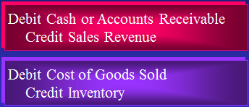

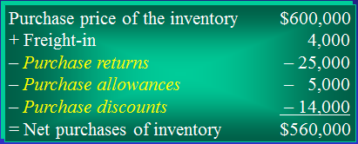

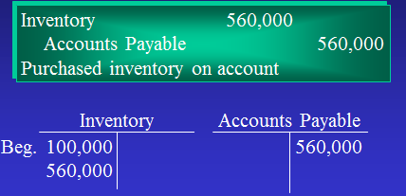
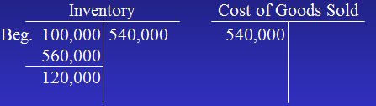

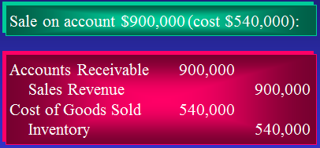

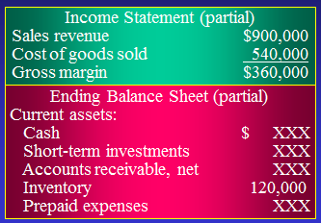

Various Inventory Costing Methods
Specific Unit Cost: Costing the inventory at the specific cost of the particular unit.
Weighted-Average and FIFO
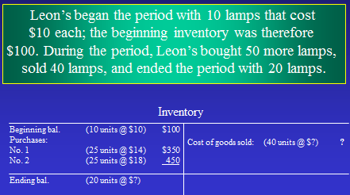
Using Weighted-Average:
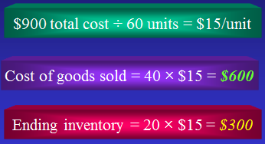

Using FIFO:
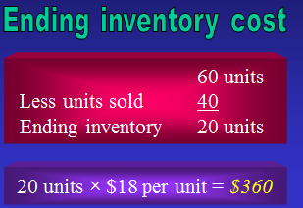
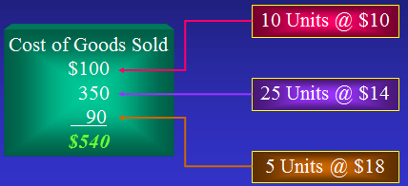

Accounting Standards and Inventories
Comparability sates that businesses should use the same accounting methods and procedures from period to period.
Disclosure Principle holds that a company’s financial statements should report enough information for outsiders to make informed decisions about the company.
Lower-of-Cost-and-Net-Realizable-Value (LCNRV) requires that inventory be reported in the financial statements at whichever is lower- inventory’s cost or its net realizable value.

Analyzing Financial Statements
Gross Profit Percentage= Gross profit/ Net sales revenue

Inventory Turnover= Cost of goods sold/ Average inventory = Cost of goods sold/( (beginning inventory+ ending inventory)/2)

The gross margin method of estimating ending inventory is based on the cost of goods sold model.
I.e. Beginning inventory + Purchases = Goods available for sale – Ending inventory = Cost of goods sold

By rearranging them we attain:
Beginning inventory+ Purchases = Goods available for sale – Cost of goods sold = ending inventory.

Effects of Inventory Errors
An error in the ending inventory creates errors for cost of goods sold and profit. The current year’s ending inventory is next year’s beginning inventory.
What are some possibilities? 1. Overstating ending inventory 2. Creating fictitious sales revenue.

Formulas
Review Barry Minkow and the ethical issue.

