Chapter 7
Healthy Relationships and Sexuality: Making Commitments
Communicating: Key to Establishing Relationships
- Communicating How You Feel
  - Being assertive (aggressive, passive). Differences in cultures.
- Improving Communication Skills
  - Awareness, self-disclosure: let others know about yourself & active listening: understand what people are feeling and thinking.
- Other considerations
  - Culture, age, gender, nonverbal cues, conflict

Characteristics of relationships
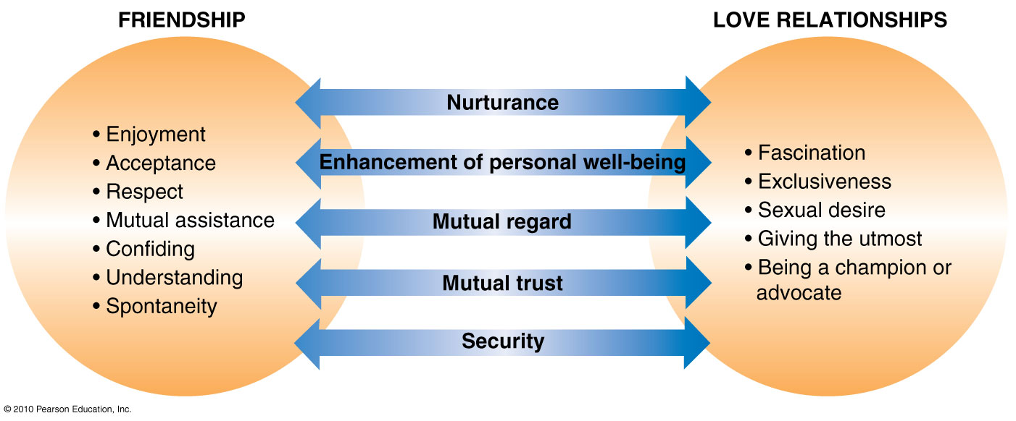

Committed Relationships: refers to act over time in a way that perpetuates the wellbeing of the other person, you and the relationship.
- Marriage “ultimate expression for an intimate relationship”
  - Legal agreement: shared finances, property, and children
  - Monogamy: sexual involvement with only one partner; serial monogamy: sexual relationship with one partner after the other; open relationships: partners agree that there can be sexual involvement outside the relationship.
- Cohabitation two unmarried people with an intimate connection who live together in the same household. Common-Law Marriage: more than 6 months.
- Gay and lesbian partnerships: they seek the same things in their primary relationship as heterosexual partners.
- Staying Single: 41.8% of population is single
- Having Children: consistency (time, energy, and money), affection, respect.

Success in Committed Relationships
- Partnering Scripts
  - Children raised with strong script of what is expected of them as adults
  - Society reinforces the traditional couples
  - Mixing of cultures is now more common
- The Importance of Self-Nurturance “you must first love yourself before you can love someone else”
  - Accountability: accepting responsibility for personal decisions, choices and actions.
  - Self-nurturance: realistic appreciation of self-worth (taking care of oneself as needed)

Barriers to Intimacy
- Dysfunctional Families
  - Negativity: inhibits psychological growth, self-love
  - Create obstacles to emotional and mental health
- Jealousy in Relationships
  - Low self-esteem
  - Overdependence on the relationship
  - Fear of losing control

Ending a Relationship
- Why Relationships End
  - Lack of communication, i.e. unmet expectations; severe financial difficulties, career failure, poor communication and cooperation, differences in sexual needs.
- Trial Separations
  - Moving apart for a period of time may allow some preliminary healing and an opportunity to reassess themselves and their commitment to the relationship. It does not mean that the relationship is ended nor it guarantees that it will improve.
- Deciding to Break Up
  - Potential feelings: anger, guilt, rejection, unworthiness.
- Coping with Loneliness
  - Reflection can help prevent the same mistakes.

World Divorce Rates
Country: Number of divorces:
- Sweeden 54.9
- US 54.8
- UK 42.6
- Germany 39.4
- France 38.3
- Canada 37.0
- Switzerland 25.5
- Greece 15.7
- Spain 15.2
- Italy 10.0
- Turkey 6.0
Gender Differences
- Social conditioning: Acceptable for women to show emotions but not men (?)
- Why the Differences?
  - Different development patterns for boys and girls
  - Different attraction criteria
- Picking Partners: Similarities and Differences between Genders
    - Proximity, Similarity, Physical Attraction
Your Sexual Identity: Our recognition of ourselves as sexual beings; determines by a complex interaction of genetic, physiological and environmental factors. Sex hormones gonads: testosterone (male) and progesterone and estrogen (female).
- Gender: sense of masculinity or femininity, defined by a given society
- Gender identity: one’s personal sense of masculinity or femininity
- Gender roles: expression of masculinity or femininity exhibited on a daily basis
- Gender role stereotypes: generalizations about how males and females should express themselves
Expressing Your Sexuality
- Developing Sexual Relationships
  - Learning to develop rewarding sexual relationships involves time, patience, family, friends, media and practice.
  - Limerence: the quality of sexual attraction based on chemistry and gratification of sexual desire
- Sexual Expression: What Are Your Options? Knowing yourself first as a sexual person and identify your desires and preferences to achieve sexual satisfaction.
  - Celibacy: not engaging in sexual activity
  - Autoerotic Behaviours: sexual fantasy, masturbation, sexual self-stimulation.
- Sexual Desire Disorders
  - Inhibited sexual desire (ISD) lack of sexual appetite or lack of interest in sexual activity.
- Sexual Arousal Disorders
  - Erectile dysfunction or impotence = impotence
- Drugs and Sex
  - Alcohol reduces inhibitions but inhibits sexual response, thus the mind may be willing but not the body.

