Chapter 4
Personal Fitness:
Improving Your Health Through Physical Activity: refers to all body movements produced by skeletal muscle resulting in energy expenditure. Vary by intensity. Three categories: 1. Physical activity for health, 2. Physical activity for fitness. 3. Physical activity for performance.
- Canada's Physical Activity Guide to Healthy Active Living: PHAC & CSEP
  - 60+ minutes of moderate intense activity, daily!
  - Participaction Canada health promotion
  - ~50% Canadians are physically inactive
- ~21% of teens sufficiently active for optimal growth and development. 27% boys vs. 14% girls.
Travel patterns, urban areas, between different industrialized countries (Pucher et al., 1996)
Transportation by car
Country: % of population:
Netherlands 44%
Canada 74%
USA 84%
Transportation by: 1) walking, 2) biking
Country: % of population:
Netherlands 21% 46%
Canada 10% 1%
USA 9% 1%
Improving Cardio-respiratory Endurance. It enables the heart to pump more blood with each stroke, thus lowering resting heart rate; it improves the body’s capacity to take in and distribute oxygen to working muscles, and it strengthens the muscles responsible for respiration.
- Cardio respiratory Endurance: ability of the heart, lungs and blood vessels to function efficiently. Max HR: (220-age) x %value. Heart rate: number of heart beat per unit of time, typically express as beats per minute bpm.
- Aerobic Power: current functional status of a person’s cardio-respiratory system, measured by VO₂max (maximal aerobic power) and referring specifically to the volume of oxygen consumed by the muscles during exercise. - VO2% and lactate threshold: (Lactic acid) The lactate threshold is a useful measure for deciding exercise intensity for training and racing in endurance sports, but varies between individuals and can be increased with training.
- Graded Exercise Test: a test of aerobic capacity administered by a physician, exercise physiologist or other trained person. Aerobic capacity: running speed and incline. Walk or run at ease pace, then at set time intervals gradually increase work load to arrive at your point of maximal exertion.
Sound Fitness Program
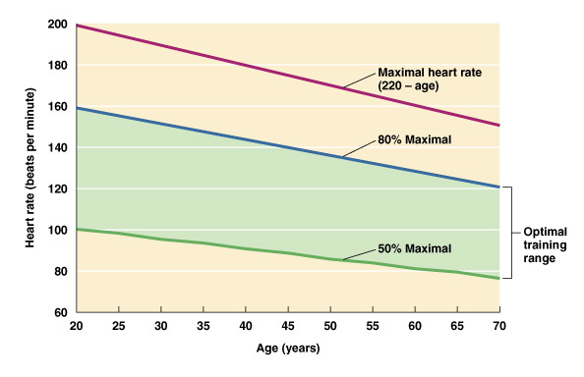
Cardiovascular Strength and Endurance - Strengthens the heart and lungs (circulatory, respiratory and immune systems) promoting efficient cooling, heating, and repair of the body.
Muscular Strength and Endurance - (Muscular, Skeletal, and Endocrine systems) Strengthens the muscles of the body increasing muscle mass, muscular stamina and definition.
Balance / Co-ordination (which includes agility). (Nervous system) Improves the tactile responsiveness of the body helping to make movement more natural. Increases the reliability of data received by the brain about stability and weight distribution making a person less likely to injury themselves in unstable situations. Very valuable for athletes and the elderly.
Flexibility - (Nervous system) the ability to move the body through its' fullest range of motion. Allows muscles to relax completely thus increasing the amount of muscle that can be used during exercise.
Core Conditioning - Understanding the connection between your abdominals and the rest of your body. This component connects all of the components of fitness together because all physical movement comes from the core.
The combination of these principles has a reciprocal effect on the body's remaining systems: reproductive, lymphatic, digestive and urinary.
- 3 factors to keep in mind:
1) Frequency: days per week, 2) Intensity: percent of HRmax during exercise, 3) Duration: length of exercise.
TIP 1: 1) Macro plan, 2) Micro plan
TIP 2: For healthy weight management and changes to body composition, anaerobic training is crucial

Improving Muscular Strength and Endurance. Musculoskeletal health = strength, endurance, flexibility.
- Muscular Strength and Endurance. Makes an impact on health and overall wellness: reducing coronary disease and osteoporosis.
    - Strength: maximal amount of force a muscle or group of muscles is capable of exerting in one contraction. Maximum amount of weight you can lift once, value called One repetition maximum (1RM)
    - Endurance: muscle or group of muscles ability to exert force repeatedly without fatiguing or the ability to sustain a muscular contraction. stamina
- Principles of Strength Development: Three key principles: tension, overload and specificity. Tension principle: Create sufficient tension/resistance within a muscle, weight lifting, lifting your own body weight
    - The Overload Principle: most important principle, overload forces muscle to adapt by getting larger, also known as Hypertrophy (increased sixe of a muscle).
    - The Specificity of Training Principle: manner in which a specific body system responds to the physiological demands placed upon it.

Health and performance components
- Performance components: agility: speed in changing direction or in changing body position, power: combination of strength and speed, coordination: ability to have things work together, balance: maintenance of a stable body position, speed: ability to move quickly, reaction time: ability to adjust or react to stimuli.
Types of Muscle Contractions
    - Isometric contraction: force is produced by the muscle without movement; do not create joint motion, acts to stabilize a particular body part while another part is moving. Concentric contraction: force is produced while the muscle shortens, joints movement is always produced. Eccentric contraction: muscle’s ability to produce force while lengthening, typically occurs when movement is in the same direction as the pull of gravity.
Types of Stretching Exercises: Flexibility refers to the range of motion, or the amount of movement possible at a particular joint or series of joints. Flexibility is enhanced by controlled stretching of muscles.
    - Static (isometric); technique that slowly and gradually lengthens a muscle or group of muscles. Repetition of a static stretch. Stretching position to the point of tension for 10 to 30 secs.
    - Ballistic (dynamic/sports-specific): Dynamic stretching involves moving parts of your body, using controlled bouncing or swinging movements, and gradually increasing reach and speed of movement. Ballistic stretching involves forcing your body beyond its normal range of motion.
    - PNF (contract-relax): proprioceptive neuromuscular facilitation stretching, are stretching techniques commonly used in clinical environments to enhance both active and passive range of motion with the ultimate goal being to optimize motor performance and rehabilitation
Types of Exercise
Cardio respiratory training (Aerobic):

Brisk walking
Jogging
Running
Swimming
Cross-country skiing
Interval training

Resistance training (Anaerobic):

Circuit-training
Calisthenics
Weightlifting
Power lifting
Bodybuilding
Plyometrics

Fitness injuries
- Causes
  - Overuse injuries: accumulative, day-after-day stresses placed on body parts (tendon, bones and ligaments) vs. traumatic injuries: occur suddenly and violently, typically by accident, second mayor type of fitness-related injuries.
- Common Overuse Injuries: ex. plantar fasciitis: inflammation of the plantar fascia, a broad band of dense, inelastic tissue that runs from the heel to the toe on the bottom of the foot, protects the nerves, blood vessels, and muscles from injury. “runner’s knee”: series of problems involving the muscles, tendons, and ligaments of the knee; most common problem is abnormal movement of the patella or kneecap (irritation to the cartilage on the back of the patella as well as to the nearby tendons and ligaments). Shin splint: any pain that occurs on the front part of lower legs.
- Treatment: Rest: eliminate risk of further irritation, ice: applied to relieve pain and constrict the blood vessels to reduce internal or external bleeding, compression: applies indirect pressure to damaged blood vessels to help stop bleeding , and elevation: elevation of the extremity above the level of the heart making the blood flow uphill to reach the injured area.
- Exercising in the Heat.
  - Avoid dehydration; appropriate clothing
  - Three heat stress illnesses
    - Cramps: muscle cramps that occur during or following exercise in warm/hot conditions, exhaustion: significant dehydration resulting from exercise in hor or humid conditions (precursor of heat stroke), and heat stroke: deadly heat illness resulting from dehydration and overexertion in hot conditions, cause body core temperature to rise rapidly from normal to 43 degrees in just a few minutes.
- Exercising in the Cold. Heat loss is greater than heat production, hypothermia (potentially fatal condition resulting from abnormally low body core temperature) may result.
  - Prevention: wear appropriate layers; hydrate

Energy Pathways
ATP - CP (alactic system: anaerobic)
Up to first 15 seconds
Glycolysis (lactic system: anaerobic)
15 – 90 seconds
Glycolysis (aerobic)
90 – 180 seconds
Fatty Acid Oxidation (oxidative: aerobic)
180 seconds+
Fuel for physical activity
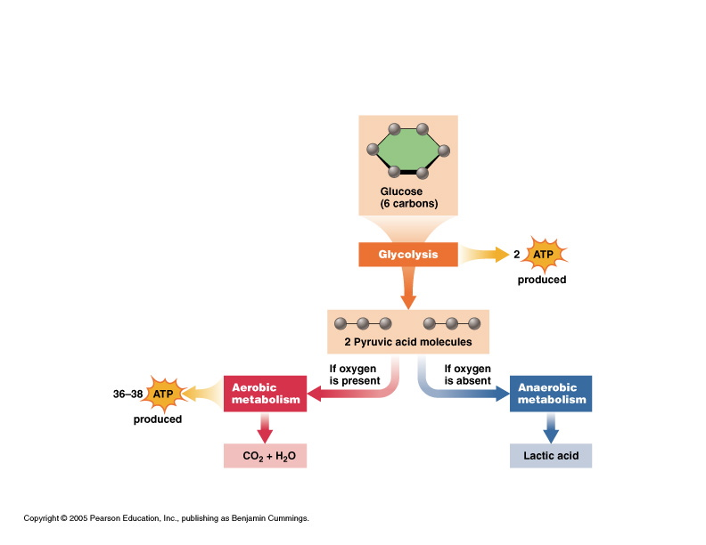
Scenario 1: Treadmill 30 minutes @ 40% VO2 Max
- Higher oxidative efficiency
- Percentage of calories from lipids: 80%
- 100 calories utilized
- Absolute calories from lipids: 80 calories
Scenario 2: Treadmill 30 minutes @ 80% VO2 Max
- Lower oxidative efficiency
- Percentage of calories from lipids: 40%
- 200 calories utilized
- Absolute calories from lipids: 80 calories

