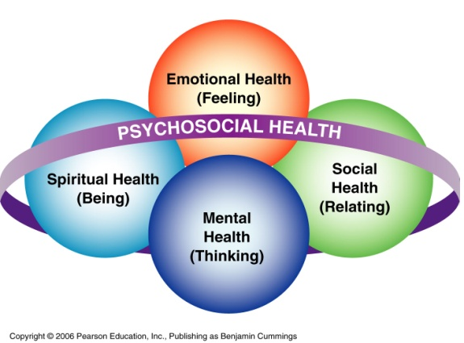
Chapter 2
Psychosocial Health:
Achieving Mental, Emotional, Social, and Spiritual Wellness
Psychosocial health: encompasses the mental, emotional, social and spiritual dimensions of health.
Is the result of a complex interaction of a person’s history and their conscious and unconscious thoughts about and interpretations of the past. There are some basic characteristics: * Feel good about themselves (virtues and flaws). * Feel comfortable with other people. * Control tension and anxiety. * Meet the demands of life (solve problems). * Curb hate and guild. * Positive outlook.
Mental health: “thinking” or “rational” part of psychosocial health. Is the ability to perceive things happening around in a realistic way, to use reasoning in problem solving, interpret situations, and to evaluate situations effectively and react appropriately.
Emotional health: “feeling” or subjective part of psychosocial health including the feeling reactions to life. Emotions are intensified feelings that we experience every day such as love, hate, hurt, despair, release, anxiety, fear, release, joy, frustration, anger. These are described as the interplay of four components: physiological arousal, feelings, cognitive processes (thinking), and behavioural reactions.
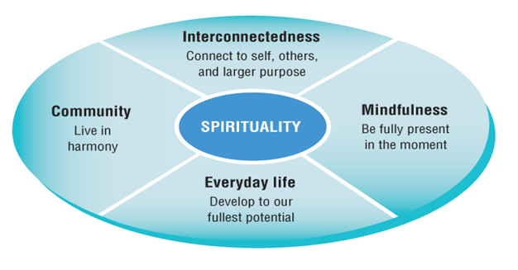
Social health: the part of PH dealing with our interactions with others on an individual and group basis, our ability to use and provide social resources and support, and our ability to adapt to a variety of social situations. There are 2 important factors: 1. Presence of strong social bonds: and 2. Presence of key social support: relationships that bring positive benefits to an individual.
Spiritual health: reflects our values, beliefs and perceptions of the world and all living things, a “search for meaning, connectedness, transcendence and energy”. It refers to the deepest and innermost part of us, the part that help us to make sense of the world and our part in it.
Seeking Professional Help
- Mental Health Professionals
  - Psychiatrist: licensed physician who specializes in treating mental and emotional disorders. A psychiatrist can prescribe medications and may have admitting privileges at local hospitals.
  - Psychoanalyst: A psychiatrist or psychologist with specialized training in psychoanalysis (type of therapy in which a person is helped to remember early traumas that block personal growth).
  - Psychologist: a person with a PhD and training in psychology “talk therapy”.
  - Social Worker: a person with a master’s degree in social work and experience in a clinical setting.
  - Counsellor: a person with a variety of academic and experiential training who deals with the treatment of emotional problems. A counsellor often has a degree in counseling, psychology, educational psychology or a related human service.

When You Begin Therapy
- Expect to:
  - not expect the therapist to give answers
  - participate actively and take responsibility
  - be honest to yourself
- Do Not Expect:
  - to be told what to do by your therapist

Being human
- Repression: is the psychological attempt by an individual to repel one's own desires and impulses towards pleasurable instincts by excluding the desire from one's consciousness and holding or subduing it in the unconscious
- Regression: is a defense mechanism leading to the temporary or long-term reversion of the ego to an earlier stage of development rather than handling unacceptable impulses in a more adult way. The defense mechanism of regression, in psychoanalytic theory, occurs when thoughts are pushed back out of our consciousness and into our unconscious.
- Displacement: is an unconscious defense mechanism whereby the mind redirects affects from an object felt to be dangerous or unacceptable to an object felt to be safe or acceptable.
- Transference: the unconscious tendency to assign to others in one's present environment feelings and attitudes associated with significance in one's early life, especially the patient's transfer to the therapist of feelings and attitudes associated with a parent.
- Projection: is a psychological defense mechanism where a person subconsciously denies his or her own attributes, thoughts, and emotions, which are then ascribed to the outside world, usually to other people. Thus, projection involves imagining or projecting the belief that others originate those feelings. Blaming another for self failure.

Overcoming conditioned and reflexive thoughts, feelings, and actions:
- Modeling: vicarious learning a method used in certain techniques of psychotherapy whereby the client learns by imitation alone, without any specific verbal direction by the therapist
- Conditioning: rewards and punishment
- Exposure: flooding, systematic desensitization. It is used to treat phobia and anxiety disorders including post-traumatic stress disorder. It works by exposing the patient to their painful memories,^{[1]} with the goal of reintegrating their repressed emotions with their current awareness.
- Relaxation techniques: arousal regulation.

Frequent beliefs:
- I must do well in life or I am inadequate and worthless
- Others must treat me well, under all conditions and at all times, or else they are horrible people
- My life must be comfortable and my living conditions must be advantageous or the world is a rotten place and life is not worth living
- Process of experience > content of an experience
- Positive worth of the person is held constant
- Positive intention motivates all behavior
- There is no such thing as failures, only experiences

