Organizational Behaviour Midterm 2 Review
Chapter 5

Performance = abilities + motivation

Characteristics of Motivation
- effort
- persistence
- direction
- goals

Intrinsic Motivation
- direct relationship between worker and task
- self applied
- manager has no control
Extrinsic Motivation
- stems from work environment external to task and is applied by others
- bonuses, promotion, vacay

Self Determination Theory
- Autonomous – self motivated by intrinsic factors
  - Facilitates effective performance, especially on complex tasks
- Controlled – motivated to obtain extrinsic rewards

Performance
- extent to which an org. member contributes to achieving the objectives of the org.
- not a one to one relationship

Factors contributing to individual job performance
- amount of effort
- persistence of effort
- direction of effort
  - motivation
  - cognitive ability
  - personality
  - task understanding
  - emotional intelligence
  - chance

3 Theories
- specify the needs of employees and try to satisfy the needs to inc. performance
- Maslow’s Heirarchy of Needs
- Alderfer’s ERG Theory
- McClelland’s Theory of Needs

Ex. 5.3

Higher Order Maslow’s Need Alderfer’s Intrinsic
Needs Hierarchy ERG Theory Motivation

Self Actualization Growth
Self Esteem
Belongingness Relatedness Safety
Physiological Existence
Basic Needs Extrinsic Motivation

McClelland’s Theory of Needs
- outlines when certain needs result in particular patterns of motivation
- behavioural consequences of 3 needs:
  - achievement
  - affiliation
  - power

ERG – flexible and simple, captures human need structure better

McClelland’s – supportive of data under right circumstances

Managerial Implication of Need Theories
- Diversity – incentives and goals that correspond
- Motivational potential on intrinsic motivators and higher order needs
- Higher order needs fail to develop unless lower level needs are gratified

Process Theories of Work Motivation
- expectancy theory
- equity theory
- goal setting theory

Goal Setting
- specific and challenging goals motivate
- need commitment to achieving goals
- SMART – specific, measurable, timely

Mechanisms of Goal Setting – exhibit 5.6
Goals Mechanisms Performance

Goals – specific, challenge, goal commitment, feedback
Mechanisms – direction, effort, persistence, task strategies

Equity Theory
- motivation stems from a comparison of the inputs one invests in a job and the outcomes one receives in comparison with the inputs and outputs of another person or group
- in what sense is equity theory a theory of motivation?
- Individuals are motivated to maintain an equitable exchange relationship.
- ex. Terry has an MBA, 5 yrs work experience, and works hard to maintain his $75 000 a year salary. Maxine has her bachelors degree, 1 yr work experience, and does adequate work.
  - In Terry’s view, he is underpaid and should be experiencing inequality.
  - He might resolve this inequality psychologically or behaviourally.
  - He needs to be paid less or put less into the job

Expectancy Theory: key terms
- instrumentality
  - perception by an individual that first-level outcomes (performance) are associated with second-level outcomes (rewards)
- valence
  - the preferences for outcome as seen by the individual
- expectancy

Chapter 6 - Motivations

Job design as a motivator
- the goal of job design is to identify the characteristics that make some tasks more motivating than others and to capture these characteristics in the design of jobs
- attempt to capitalize on intrinsic motivation

Job Rotation
- increasing the scope of an individuals job is job rotation
- employees are rotated to different tasks and jobs in the org.
- can involve working in different functional areas and departments
- provides a variety or challenging assignments, develop new skills and expertise, and prepare employees for future roles

Job Characteristics Model – exhibit 6.5
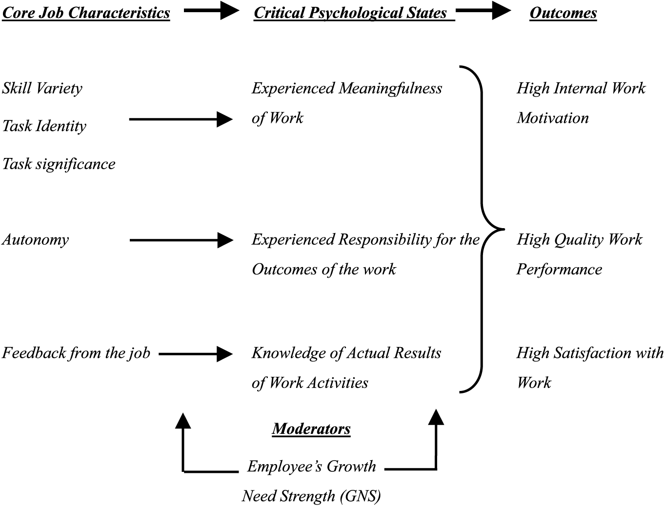

Autonomy – freedom about when to start the job and what to do

Job Enrichment
- design of jobs to enhance intrinsic motivation, quality of working like, and job involvement

Job Enrichment Procedures
- combining tasks
- establishing external and internal client relationships
  - internal – other departments , marketing, production, HR, finance
- reducing supervision or reliance on others
- forming work teams
- making feedback more direct

Potential Problems with job Enrichment
-poor diagnosis
-lack of desire or skills
-demand for rewards
- union resistance
-supervisory resistance

Management by Objectives Process
- the MBO process involves manager-employee interactions
  - Review every month
  - Develop and agree on employee objectives which can include job performance and personal development objectives
  - Appraisal meeting is help to evaluate the extent to which the agree objectives have been achieved
  - Cycle repeats

Research Evidence
- shows clear productivity gains associated with MBO

Factors associated with failure of MBO programs:
  - lack of commitment
  - overemphasis on measurable objectives at the expense of qualitative objectives
  - excessive short-term orientation
  - performance review become just an exercise or punishing employees for failure to achieve objectives

Chapter 7

Group
– 2 or more ppl interacting independently to achieve a common goal
Formal – established by an org. to facilitate org. goals
Informal – emerge naturally in response to common interest

Stages of Group Devlopment
- Forming – just got together, goals and roles are unclear
- Storming – problems emerge, some ppl control, high conflict
- Norming – things are clear, roles and responsibilities explained, functional
- Performing –
- Adjourning – disband group, go back to normal jobs
- not all groups go through all sages
- managers should step in from the beginning or storming stage

Group Structure
– characteristics of the stable social organization of a group
- how group is put together

Structural Characteristics
- size (3 to 20 ppl) and diversity
  - members in smaller groups are more satisfied
- norms, roles, status and cohesiveness
- member diversity – similar group members more cohesiveness
  - takes longer to become effective with a diverse group but they are more creative
- norm – way you dress, performance norms (no more than 100 cups/day)
- roles – tasks , responsibilities
  - role conflict – ambiguity, job description not clear
- Status – president vs. worker
  - Clear difference of status – demotivating
  - Avoid difference in things that ppl of different status receive
- Cohesiveness – how well ppl interact
  - Help ppl get along
  - Smaller groups – more chance to communicate
  - Make members spend time together
  - Make group unique and hard to get into
  - Reward group efforts not individuals
  - Encourage competition with other groups

Social Loafing
- tendency to withhold intellectual or physical effort in a group task
- motivational problem
- when one does this others lower efforts
Counteracting Social Loafing
- make indiv. performance more visible (smaller group)
- make work interesting
- increase performance feedback
- reward group performance

Team
- groups in organizational settings
- team = group
- improves efficiency and quality of work

Designing Effective Work Teams
- J. Richard Hackman
- Quality of output is good team is effective
- Group members must be satisfied
- Group experience enables members to continue to work together

Group Effectiveness Occurs When
- high effort is directed toward the groups task
- great knowledge and skill directed to task
- group adopts sensible strategies for accomplishing goals

Self Managed Work Teams – SMWTs
- challenging work under reduced supervision
- regulate their own members behaviour
- success factors
  - nature of task – challenging and enriching
  - composition of group – stability, size, expertise, diversity
  - various support mechanisms – training, reward, management

Cross-Functional Work Teams
- bring ppl together with different relevant specialties together to better invent, design, or deliver a product (finance, HR, IT, R&D)
- members must be experts in their own area but able to cooperate with others
- best known for success in product development

Principles of Effectiveness
- composition
- superordinate goals – don’t conflict original goals
- physical proximity – close to eachother
- rules and procedures
- leadership – good leadership skills
- autonomy – you decide how, what, when, to go things

Virtual Teams
- use technology to coordinate and communicate

- Advantages
  - Around-the-clock work
  - Less travel time and cost
  - Larger talent pool
- Problems
  - Miscommunication
  - Trust
  - Isolation
  - High costs – initial set-up expensive @ times
  - Management issues - motivation and direction

Chapter 8

Key to Power – make them dependent on you

Social Influence
- groups assert influence on their members b/c they want them to behave a certain way
- ppl are highly dependent on others

Information Dependence –

Effect Dependence
- rely on managers
- behave to confine with norms to avoid getting punished and we are looking for rewards

Motives for Social Conformity
- Compliance – we have to comply to norms
- Identification – imitate others you admire
- Internalization – when you feel what you’re doing is right

Socialization
- process by people learn attitudes, knowledge, and behaviours necessary to function in a group
- primary means organizations communicate their culture and values to new members
- new members acquire knowledge, change attitudes and behaviour

Exhibit 8.1 – socialization process

Person-job fit – values of org. meet values of person

Person-organization fit –
- less stress, less turnover

Stages
- anticipatory socialization
  - anticipation
  - socialization
- encounter
  - start work
- role management
  - already socialized
  - only behaviour modification

Key Issues in Process
- unrealistic expectations – inaccurate, when ppl enter they are shocked by reality and expectations are not met
- newcomers with higher met expectation have higher job satisfaction, organizational commitment, job performance, job survival, and lower intentions to quit

Psychological Contract (unwritten)
- beliefs held by employees regarding the reciprocal obligations and promises between them and their org.
- employee bonuses and promotions in return for hard work and loyalty

breach of contract = unsatisfied employee

Methods of Socialization
- who does the socialization, how is it done, how much is done
- realistic job previews – correct unrealistic expectations
  - balanced picture of positive and negative job aspects
- employee orientation programs
- socialization tactics

Exhitbit 8.3 – Traditional and Realistic Job Previews
Traditional
Set initial job expectations too high job is viewed as attractive high job acceptance work experience disconfirms expectations dissatisfaction and realization that job doesn’t match needs low job survival, dissatisfaction, frequent thoughts of quitting

Realistic
Set job expectations realistically job may or may not be attractive depending on indiv. Needs some accept, some reject offer work experience confirms expectations satisfaction; needs matched to job high job survival, satisfaction, infrequent thoughts of quitting

Realistic Job Previews
- reduce inflated expectations and turnover and improve job performance
- turnover reduction due to lower expectations and increased job satisfaction

Self Selection
- cause ppl not cut out for the job or who have low P-O and P-J fit perceptions to withdraw thom application process

Employee Orientation Programs
- introduce employees to job and ppl that they work with
- teach how to cope with stressful work situations
- more socialized employees have higher knowledge and understanding of org. and report higher org. commitment

Socialization Tactics (EX 8.4)
- Institutionalized
  - Context Tactics
  - Collective – large # of employees all together as a group, same experiences, same challenges
  - Formal – segregating newcomers from regular org. members and providing formal learning experiences
  - Content Tactics
  - Sequential – fixed number of steps leading to the assumption of a role
  - Fixed – timetable, specific time for things
  - Social Tactics
  - Serial- experienced member training newcomers
  - Investiture – affirms the incoming identity and attribute of newcomers rather than denying them and stripping them away
    - Careful selection of employees
- Individualized
  - Context Tactics
  - Individual – tactics tailor made for each new member
  - Informal – don’t distinguish a newcomer from more experienced members and rely on more informal and on-the-job learning
  - Content Tactics
  - Random – ambiguous or changing sequence
  - Variable – no time frame to indicate when the socialization process ends and the newcomer assumes his or her new role
  - Social Tactics
  - Disjunctive – role models and experienced organization members do not teach newcomers
  - Divestiture – debasement or hazing, strip away confidence so they can build them back, humble them

Institutionalized Socialization
- formal and structured
- reduces uncertainty
- encourages accepting norms and maintaining status quo
- promotes uniformity of behaviour

Individualized Socialization
- absence of structure
- creates ambiguity and encourages new hires to question status quo and develop own approach to the role
- take on particular style and characteristics of those socializing them
- no uniformity

Institutionalized is always followed by individualized as the person joins his or her regular work unit.

Organizational Culture
- style, atmosphere, personality of org.
- shared beliefs, values, assumptions that exist in an org.
  - determine norms that develop and the patterns of behaviour that emerge from these norms
- effects how we behave

CULTURE NORMS BEHAVIOUR

Strong Culture Concept
- org. culture intense and pervasive beliefs, values, and assumptions

Weak Culture – fragmented, have less impact on org. members

Strong Culture
- associated with great success (financial) and effectiveness
- do not always result in blind conformity
- doesn’t need to be big to have strong culture
- great consensus concerning “what the org. is about” and what it stands for

Assets of Strong Culture
- Coordination – facilitate communication, ppl get along
- Conflict Resolution – share core values
- Financial Success – culture, structure, strategy, culture supports the mission, strategies, and goals of org.

Liabilities of Strong Culture
- Resistance to Change – can damage a firms ability to innovate
- Culture Clash – mix badly in a merger

Contributors to Culture
- how cultures built, maintained, and changed
- The Founders Role – create it with a new org.
  - Build culture
- Socialization – maintain culture

