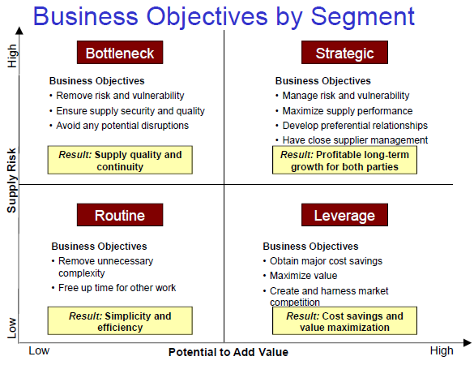
Modes of competitions: quality (Motorola), cost or price (Wal-Mart), service (Lands End), innovation (Honda, Intel).
Total Cost Measurement System
• Fundamental Objective: Carrier selection and utilization based on lowest total cost, not just lowest rates
• 4 critical areas measured:
Cost (claims), Quality (billing accuracy). Service (customer service), Delivery (On-time performance).
JOINT PROCESS IMPROVEMENTS
Share productivity gains, Re-engineer joint processes (VMR, JIT II), Optimize physical material flow, Integrate logistics, Use simultaneous engineering/concurrent joint product development, Support supplier operations improvement, Develop long-term mutually dependent contracts
The Role of Purchasing in an Organization
The primary goals of purchasing are:
1. Ensure uninterrupted flows of raw materials at the lowest total cost,
2. Improve quality of the finished goods produced, and
3. Optimize customer satisfaction.
Purchasing contributes to these objectives by:
– Actively seeking better materials and reliable suppliers
– Work closely with strategic suppliers to improve quality materials, and
– Involving suppliers and purchasing personnel in new product design and development efforts.
Sourcing Procurement Actions
º Increase supplier base – Global sourcing
º Best choice evaluation
º Volume leveraging
º Product design improvement
º Internal process improvement
º Joint process improvement
º Relationship restructuring
Supply management differs from
traditional procurement processes
in two major ways
º Supply management is a process that creates
strategies to manage the overall procurement and
use of materials or services.
º It is a process that enables the buyer to proactively
determine the values that best serve its needs in the
marketplace, which is radically different from issuing
bidding requests and reacting to marketplace
response as market leveraging does.

Supply Chain Management
It is the integration of key business processes from end user through original suppliers that provides products, services, and information that add value for customers and other stakeholders.
Customer Relationship Management, Supplier Relationship Management, Customer Service Management, Demand Management, Order Fulfillment, Manufacturing Flow Management, Product Development and Commercialization.
Good supply chain decisions
Lower the cost of inputs.
Increase productivity, lower final cost.
Increase service or quality, reduce internal waste, and reduce cost.
Increase customer service and product quality to customer, meet their needs.
Reduce assets and resources required to design, produce and deliver product.
All = Maximize rate of return on investment.
Take Aways
Supply chain management is not just another name for logistics, nor a combination of logistics, purchasing and operations.
º It is a way of doing business that is:
– Process-oriented
– Cross-functional
– Cross-firm
º Need to manage the tradeoffs that exist in every supply chain decision.

STRATEGIC SOURCING:
•Align competitive and functional area strategies
• Segment and classify purchasing/sourcing needs
• Select a strategic thrust appropriate to meet the sourcing need of each segment
• Select the mix of actions or tactics that support the strategic thrust chosen
• Use the appropriate tools to support and implement the tactics and actions chosen
Strategic sourcing is strategic because:
º It deals with the allocation of scarce resources, how much effort to expend?, What to focus on?
º It seeks to add value to product rather than just reduce its costs.
º Its horizon is the whole supply chain, how does the supplier/purchase decision affect total cost of the entire supply chain?

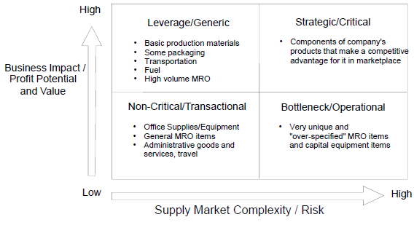

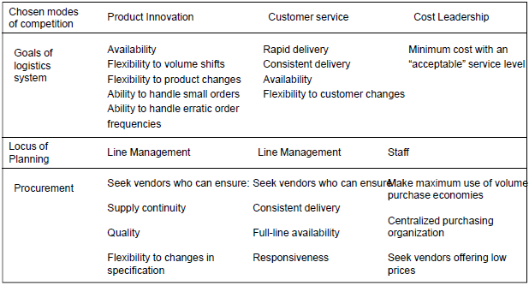
David Mondragón Rodríguez
SN:66823121
The Outsourcing and Third Party
Logistics Purchase Process
STEP 1: SET UP A CROSS FUNCTIONAL TEAM
STEP 2: THOROUGHLY KNOW YOUR OPERATION
STEP 3: DEVELOP AND DEFINE PROCESS, OBJECTIVES GAME RULES FOR OBJECTIVES, OUTSOURCING PROJECT OR ANALYSIS
STEP 4: DETERMINE WHICH LOGISTICS FUNCTIONS ARE CANDIDATES TO OUTSOURCING
STEP 5: DETERMINE SELECTION CRITERIA FOR A TPL
STEP 6: WRITE THE REQUEST FOR PROPOSALS (RFP)
STEP 7: LOOK FOR ALTERNATIVES, SEND RFPS
STEP 8: EVALUATE INITIAL PROPOSALS, CONTACT PROVIDERS FOR ADDITIONAL INFORMATION
STEP 9: MAKE THE DECISION
STEP 10: NEGOTIATE THE CONTRACT

John Deere Video
ºSite specific outsourcing at Waterloo complex
º Reasons for outsourcing: Production needs space over warehousing, Internal cost > external cost
º Outsourced warehousing., local intra facility, handling, not customer facing

Primary Reasons for Outsourcing
Outsourcing offered high cost savings or revenue enhancing potential: 41.0 %, The function(s) outsourced was not part of the company’s core business 26.5 %, the functions(s) outsourced was a major problem area for the company 10.9 %, The company was redesigning or reengineering its supply chain 9.4 %, Other 12.2 %.
Third Party Logistics Outsourcing
• The purchase of non-traditional logistics services often is the purchase of multiple logistics activities
• May be the purchase of bundled, integrated services
• Often involves the purchase of planning and control processes as well as implementation
• Often involves longer term relationships
WHY NOT USING
THIRD PARTY LOGISTICS
• Loss of control
• Fear of job loss/downsizing
• Existing obligations
• Logistics too important to outsource
• Uncertain benefits/risks
• Increased supplier dependence
• Loss of in-house expertise
• Customer non acceptance
Motorola
Corporate Goals
• Six Sigma Quality Program
• Active competition for Baldridge Award
• Company wide program
KEY OBJECTIVES
• Six Sigma Quality
• Total cycle time reduction
• Product/manufacturing leadership
• Profit improvement
• Participative Management
Transportation Management:
Corporate Organization
Decentralized Divisions
Transportation Management function in each
Division
Corporate Transportation Council
- Analysis, advice, coordination

Logistics Outsourcing
• Any external purchase of logistics services
• Includes traditional purchasing of transportation and warehousing services on transaction basis
• Includes purchase of third party logistics service

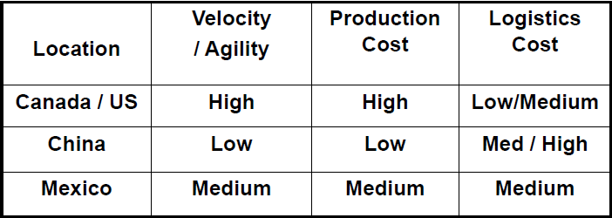
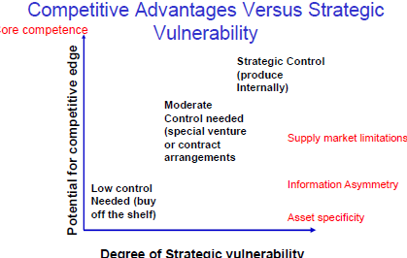
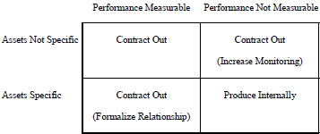
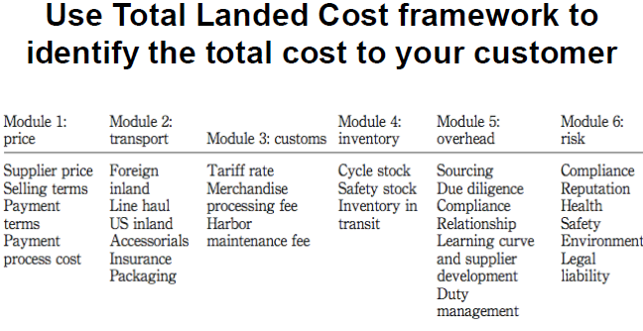
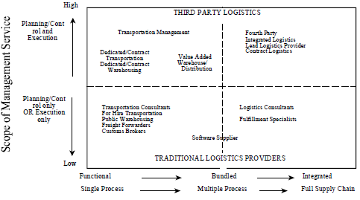
Off shore sourcing: 􀂉 Source a product intended for resale or use in N.A. or Canada or the U.S. or Mexico from Asia (off shore).
Near shoring: 􀂉 Source a product intended for resale or use in U.S. or Canada from Mexico. 􀂉 Source a product intended for resale or use in Canada from the U.S.
Re shoring: 􀂉 Bring back products sourced from off shore to domestic or continental supplier.
Off shore sourcing versus off shore manufacturing
􀂉 Often confusing, 􀂉 Off shore sourcing can be sourcing from a supplier that is off shore but …, 􀂉 It can also be sourcing from a firm’s manufacturing facilities or sub contracted manufacturing facilities which are located off shore.
Outsourcing versus off shore sourcing
􀂉 Outsourcing refers to whether the product is manufactured internally or externally
􀂉 You off shore source from your own plants or from an external plant, eg. Outsourced – off shore, insourced - off shore.
Bottom LINES
º Firms that off shore source to China today will still depend on China to some or perhaps a great degree in the near term future
º Alternatives to China each have their own advantages and unique risks
º There is volatility in demand and supply of everything
º Need to manage risk more than ever

Asset versus Non-Asset Based
• Asset based TPL relies on physical assets to provide services to clients.
• Non-asset or management based TPL utilizes expertise and systems to manage a business function.
• Hybrid or integrated TPL would utilize a combination of physical assets, systems and expertise to manage a business function, but it is usually free to ignore assets if internally controlled assets are not the best solution for clients.

Sourcing problems
º Supply language problems
first tier outsourcing to second tier - ended up overloading themselves with work from multiple 787 suppliers
º Production: Alenia, Italy: months of struggle to gain approval to build a factory on the site of an ancient olive grove. Once approved, they were already in "catch up mode". First few test-fuselage sections did not meet quality standards 􀂉 - Vought, US: designed the complicated carbon fiber exterior, but outsourced the building of the floor to an Israeli company. Again, a problem with quality. This can normally be solved with a review process, but due to distance and political reasons in Israel, it took a lot of time
º Delivery: Shortage of nuts and bolts that were needed to put the plane together. They had to use 1,000 temporary fasteners during the rollout ceremony of the Dreamliner. Some parts were not assembled to specifications; items that should have been installed were not. Some components came with no paperwork at all, or instructions required translation.

Evolution of the TPL relationship
From a major consultant’s point of view
• Consultants have the freedom to find BOB for each component while maintaining a single point of contact, • TPLs focus on one time improvement rather than continuous improvement Sept 2012, • TPLs do not focus on restructuring of the supply chain and material flows, • Therefor the next step in the evolution of TPLs…
• FOURTH PARTY LOGISTICS (AKA 4PL) 4PL is a supply chain integrator who assembles and manages resources, capabilities, and technology of its organization with those of complementary service providers to deliver a comprehensive supply chain solution.
LLP AND 4PL MODELS
• TPL can be the LLP – If it manages the resources of consultants and technology providers as well as other logistics service providers to provide the service
• Consultant can be the LLP – If it manages resources of 3PLs, technology providers as well as other logistics service providers to provide the service
• LLP can focus on narrow process or broad process but inherently has to plan and design (Northwest or Northeast Quadrant)
• 4PL – plan and design and execute and control, – Broad process (northeast quadrant) – COULD BE CONSULTING COMPANY OR TPL

