Cross Cultural Management / Comparative Management
May-04-11
7:00 PM

Introduction
May-04-11
7:01 PM
  - Reflective logs
    - 2 - 4 pages
    - Not a summary
    - More of a positive or negative
    - Argument and comments on the topic
    - What you would do to improve that
      - Why its good and why its bad
    - No references needed, just personal opinion
    - Include a title page, statement of academic integrity
      - One paragraph introduction
        - Why we registered for this course
        - What experiences you have
  - Case Study
    - Teams of 4
    - Case Studies are in the course pack
    - Questions are posted prior to class
    - Point form is preferred
      - Complete sentences
    - 10 mins prior to the end of class
    - Peer Evaluation form
      - One large envelope for the whole case
      - Small envelope for individual peer evaluation forms
    - Order of the case study is on the outline
  - Remarking
    - One week period
    - Write the concern and re-hand it in
  - Group Research Project
    - Worth 25%
    - Country must not be covered in the course
    - Focus on a specific industry
    - Presentation
      - More of a story or a structured process
    - Group list due Friday
  - Video - Globalization Winner and Losers
    - WTO - Seattle
      - More emphasis on free then fair trade
      - International monetary fund
        - Had to bail out the Asian countries as foreign investors back out
    - Globalization has brought many people out of poverty
    - India is booming in the industry of IT
    - Internet has created many millionaires
    - Infosys
      - Once your online you will be tied in
    - Internet has allowed for NGOs and activities to gain strength
    - GM foods
      - Believed that corporations would put profits over the safety
      - International law was not ready for GM food
        - Some believed it should be tested like a pharmaceutical
    - Fishing industry
      - Africa vs. EU
      - Fish as a sustainability for local villages are being threatened
      - International law lagged behind and these resources are only managed by goodwill of nations
    - IMF
      - United states is using the IMF a tool
        - The United States is the greatest shareholder
      - The WTO has been blamed for ruling in the favour of the USA
    - NAFTA
      - Can move work to Mexico for the cheaper labour
      - Originally was to build more jobs
      - The salary is predetermined by the Mexican government
        - Most are not considering the ability to live
      - The free market does not reduce the number of people that cross the border
    - Production can shift towards the countries that have lax environmental regulation
      - Most of the local communities would suffer
        - Shell and Nigeria
      - It is best if all businesses should be
    - China
      - Fastest growing economy in the world
      - Adopted capitalism
      - Globalization has put pressure towards Political reform
      - Problems with rural areas and state owned
      - A lot of city workers are not protected by any unions or any policies
    - Gold
      - Used by central banks to hold value but are now using insurance and stocks
      - Britain central bank sold off gold reserves and resulted in a plummeting gold prices
      - In south Africa there was upwards to 40% as Gold stabilized
    - WTO Activists
      - Continues to fight for fair trade

How cultural differences affect organization
May-11-11
7:02 PM
  - Management, Globalization, Global management and its challenged
    - Managing in the global economy involves understanding the following inter-related themes:
      - Management involves getting things done through other people
        - Utilize people
        - Challenge is the cultural differences
        - Diversity also includes any kind of differences we see in ourselves and other people
          - Political beliefs, languages
      - Globalization represents the emerging of a single global economic system in which the creation of economic value is shared by a mix of stakeholders from a range of economic, social, and cultural unique countries
        - Globalization
        - Disadvantage
          - has polarized the difference between developing and developed countries and what they have
          - Another disadvantage is the environmental and political mess
            - IMF and WTO have power, no representation from developing countries
          - A lot of cultural diminishes developing countries reduce culture
      - Global management involves getting things down through other people who are part of a national economic that can often be expected to differ economically, socially and culturally.
  - Going Global: Phases of Development
    - Domestic phase
      - Also called product oriented phase
      - Created a product or service and how we can market better
      - Is a starter business and doesn't look to integrate cultural difference
      - Still would want to be culturally sensitive
      - Generally people would have a view of my way is the proper way
    - Multi-domestic phase
      - Also market oriented phase
      - Sensitivity to cultures are important
      - Translation of products or services
      - HR policies are clear and people are on the same page
      - Look into many options and have different ways of managing
      - Consider expanding past national boundaries
    - Multinational phase
      - Price sensitive phase
        - How to save costs and save money, where there are less risks
        - No definite framework and use the local headquarter's culture
        - More benefits and less risks to make decisions
      - Assume the company has manufacturing or other business in other countries
      - Has a strong tie to headquarters and continue to keep core values and visions
      - Decentralize, this is how the company works and here are the core values
        - Ex - Canadian individualistic vs. country in collective
    - Global phase
      - Aka Transnational phase
      - Totally independent and a lot of freedom
        - Contingency approach
        - What will give you the best results and how complex it is
      - International firms completely independent
        - Same company but all operations are done locally
        - Each local part have their own values
  - Multiple Management Perspectives
    - Parochial managers
      - Management practices and the world is viewed from the point of view of their OWN cultural perspective only.
        - Ignore diversity and do not see it to exist
      - Polycentric hiring
        - Hire local
    - Ethnocentric managers:
      - Acknowledge cultural differences, but believes that their culture, value system, and ways of doing things is best. Diversity is resisted.
      - Resist diversity and believes that their own culture is the best
      - D
        - Hire home country
    - Geocentric Managers:
      - Acknowledge diversity and listen to other people as well
      - Best fit approach
      - Best approach is Geocentric
        - Send a person who has international experience
  - Organizational Culture vs. National Culture
    - The collective mental programming of the people of any particular nationality
      - Culture is a collective mental programming of people
    - Organizations operate within a national culture context and national culture influences organizational culture
      - Organizations would usually have a national culture
      - National culture overrule
      - organizational culture
  - Models of National Culture
    - Single Dimension models
      - Context: how culture perceive information
        - High and low context cultures (Hall)
        - High context is more body language and what others think
          - Developing and collective
          - Will require more time, to verify data and seek additional information
        - Low context is the facts and figures
          - Most developed countries
      - Time: (Lewis)
        - Monochromic culture
          - Time is money
          - Does one thing at a time
          - Focused on deadlines
          - Show up on time
          - Ex- German
        - Polychromic Culture
          - More relaxed
          - Do many things at the same time
          - More likely to be late
          - Ex- Italian
      - Trust: Fukuyama's Analysis of Trust
        - Looked at the relationship between trust, social capital and management
          - High trust
            - Low guidelines and rules
            - Respect and hierarchy
            - Ex - Family Businesses
          - Low Trust
            - High guidelines and rules
    - Historical Social Models
      - Look into how there is different management styles in
        - Europe – Euromanagement Study
          - Better ability and socially responsible behaviour
          - Have a more democratic leader
          - Have a higher ability to adapt to cultures
        - South East Asia Management
          - Religion plays a large role
          - Bosses have a lot of power
            - Supreme power
          - If you ask others to contribute ideas it shows weakness
            - If you’re the leader you know everything
          - Everything is connected
      - The Euro management Study
      - South East Asian Management
    - Multiple Dimension Models
      - Hofstede
        - Study of work related values are in different countries
          - Collectivism vs individualism
            - Autonomy compared to being in a group
            - Individualistic
              - Self focus
              - Individual initiative and compete vs. others
            - Collectivism
              - Focus on we
              - How relationships affect other people
          - Power Distance
            - Tolerance of unequal distraction of power
              - High power
                - Typically in collectivism
                - Higher roles
              - Low Power
                - Individualistic
                - Do not like having a high power distance
          - Uncertainty avoidance
            - High tolerance
              - Do not want ambiguity
              - Clear objectives
            - Low
              - Communicating in different channels
          - Feministy vs masculinity
            - Masculine
              - Materialistic society
              - More aggressive
              - Assigned gender roles
              - Most are collective
              - Tightly centralized
            - Feminine society
              - Individualistic and equal rights
              - Trusting, and forgiveness
          - Time Orientation
            - Past oriented
            - Future oriented
              - More flexible and well at adapting and changing
              - Change is apart of natural life and value improvement through change
      - Kluckhohm and Strodtbeck
        - How people see themselves
          - Good vs. bad
          - Have the ability and confidence in cooping with differences
        - People's relationship to the world
          - The culture is dominate
            - Individualistic have the idea of controlling their own destiny
            - Collectivism see more of God and a greater power
        - Human relationships: individualism or collectivism
        - Activity: Doing or Being
          - Doing - a lot of culture have respect on people who did

  - Being - who you are, age, gender, past
    - Ascribed culture
    - Time: Present, Past, & Future
    - We need clear plans leading from current competencies to new vision
    - Sequential
      - Monochromic
      - Everything has its time and place
      - Schedule very tightly
      - Time is money
    - Synchronic
      - Polychromic
      - Track various activities in parallel
      - Giving them time
      - Less insistent upon punctuality
    - Space
    - How people use their space
    - Privacy and physical distance
      - Individualistic have a greater space
      - Collectivism
  - Trompenaars: The seven Dimensions of Cross-Cultural Management:
    - One of the most important models
    - Three Universally shared social problems addressed by seven fundamental dimensions of culture
      - 1.Relationship with other people
        - 1. Universalism vs. particularism
          - Focus on rules or relationships
          - Universalism - more of rules, law and regulations
            - Contract
              - Legal contracts are readily drawn up
              - A trustworthy person as the one who honours this word or contract

  - Particularism - more of the relationship
    - Contract
      - Legal contract
  - 2. Collectivism vs. individualism
    - Self oriented or community oriented
    - Decision making
      - Individualism
        - Decisions are made on the spot by an individual
        - Disparity between decision and implementation
      - Collectivism
        - Takes much longer and goes through
        - Decisions are referred back to the organization
        - Implementation phase proceeds smoothly
    - Role of the translator
      - Collectivism
        - More of a interpretation and relationship
      - Individualism
        - More direct
  - 3 Neutral vs. affective
    - Guided by reason, logic or emotion
    - Neutral culture
      - Oriental culture there many be low emotional and neutral
    - Affective cultures
      - More emotional cultures
  - 4 Diffuse vs. specific
    - Treat public vs private area
    - Diffuse
      - Larger public area
    - Specific
      - Larger private area
  - 5 Achievement vs. ascription
    - Doing vs. being culture
    - Achievement - what you did
      - individualistic
    - Ascribed - more of who you are
  - 2 - 6 Relationship to time
    - Monochromic
      - View time as money
    - Polychromic

  - 3 – 7 Relationship with nature
    - Inner-directed
      - Controlled destiny
      - Have the ability to control nature
      - Traditional (sticks with status quo)
      - No other languages
      - Asian still our ideas
    - Outer -directed
      - Go along, product of nature
      - Very open and goes with the flow
      - Evolution is apart of life
      - Oriental culture
      - Celebrating
- Lessem & Neubauer (European management systems)
    - Pragmatism
      - More hands on
      - Experientially oriented
      - Practical, firm, decisive
      - Detail oriented
      - Individualistic
      - Ex - Swiss, German
    - Idealism
      - Holistic (ideal goals)
      - Perfection and unrealistic goals
      - General management style
      - Open minded and high hopes
    - Rationalism
      - More reason
      - Regard to reason
      - Hand on and scientific with facts and figures
      - Ex - French
    - Humanism
      - Social life and flexibility
      - Focus on the person
      - Ex - Greek and Spanish
  - Work Behaviours varies across cultures
    - McGregor's Theory X and Y
      - Theory X
        - Negative thought on employees
        - Employees are lazy
      - Theory Y
        - Positive and optimistic views
      - The management's approach will result in the performance of employees
      - Manager can have different kinds of assumptions about workers that will influence managerial behaviours.
        - Task and Relationship Oriented cultures
          - Focus on the tasks and remove any hierarchy, tasks are given based on who can complete that task
          - Relationship culture needs hierarchy, usually has a
          - Ideal is a balance
        - Managers experts or problem solvers
          - Collective society, managers know all the answers
          - Individualistic they are more of problem solvers and require people to work together to get things solved
        - Individualism and Collectivism
        - Rules and Relationships
  - No one is superior, no one is
  - Culture classification
    - Never ignore situational variables

Video-Cross Culture
May-11-11
8:41 PM
  - Different cultures may use products and services in a different way
    - Ex - Walkman
      - Japanese to not disturb
  - Norm is a groups of definitions of right and wrong
  - Values refer to definition of good and bad
  - Cultivate to act upon nature
  - Basic assumptions are assumptions of solution to survival problems
  - Culture is a shared system of meaning a process leading …

Neutral and affective
  - The role of humour
    - Neutral
      - Understatement
    - Affective
      - Overstatement
  - Diffuse vs.
    - Specific
      - American, Dutch
    - Diffuse
      - Asian, East european
    - Criticism and losing face
      - Specific
      - Diffuse

Intercultural Communication
May-18-11
7:05 PM
  - Communication is
    - The ability to share ideas and feelings
    - A two-way process in which the communicators try to achieve a shared meaning
      - We make sense our of the words and share that idea
      - Not a linear process, may be a technical or Symantec problem (not able to influence)
    - Different communication styles
      - Direct vs. Indirect communication
        - Direct communication
          - Yes or no answer, typically not open ended or story style
          - Low context culture
        - Indirect communication
          - Close ended answer less typical
          - More of a longer answer
          - Ex - Latin culture
      - Elaborate vs. Specific
        - Elaborate
          - More detailed and repetition
          - No uncertainty
          - Ask a lot of questions
          - High context and high avoidance of uncertainty
        - Specific
          - Save times, lower quantity of talking
          - More precise
      - Personal vs. contextual
        - Personal
          - Treat as a unique individual
          - Individualistic
          - Looking for the person
        - Contextual
          - Ascribed society
          - Context matters (Status)
      - Instrumental vs. Effective
        - Instrumental
          - Individualistic society
          - Center focused
          - What he or she wants to say
          - The message
        - Effective
          - Collective society
          - More of a process oriented
          - Receiver focused
          - Relationship based
    - The effect of the listening style also affects communications
      - People oriented listeners
      - Content oriented listeners
        - What people said
        - Takes word literally
      - Evaluative Listeners
        - Active listening style
        - Deliberate listening style
    - The process that occurs between individuals, via behaviour (Verbal or nonverbal) that is perceived by another
  - Communication Process
    - Transmission phase - Information is shared
    - Feedback Phase - assurance of a common understanding
    - Encoding - translating the message into symbols or words
    - Decoding - the interpretation of the message
    - Medium - The pathway: telephone, letter, email, face-to-face
    - Noise - Anything that hampers any stage of the communication process
    - 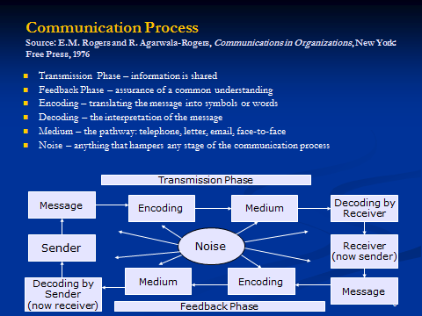

  - Importance of Communication to Management
    - "Management is essentially getting things done through other people"
      - Managers have many different roles
        - Relational, decisional, interpersonal roles
      - Minceburg
      - Must be an effective communicator, very important skill
    - For the manager, communication facilitates:
      - Control
      - Motivation
      - The expression of emotions
      - The transfer of information/meaning
  - Verbal vs. Nonverbal communication
    - Verbal Communication
      - Based on culturally agreed upon set of symbols
      - Usually deliberate
        - Can be planned
      - Learned later in life
      - Come in an orderly sequential way
        - Have structured way
        - Introduction, information, etc
      - Has a definite ending point
    - Nonverbal Communication
      - Based on culturally agreed upon set of symbols
      - Often governed biologically/involuntarily
        - Cannot be planned, just happens
      - Learned earlier in life
      - Do not come in an orderly sequential way, but simultaneously from a multiple of channels
      - Emotional stability scale
        - Being able to control emotions
        - Are able to manage others and help control their emotions
        - 5 ways of having a emotionally stable charactor
          - Self-monitoring
          - Self-esteem
            - How one views themselves
          - Empathy (understanding)
          - Motivation
          - Willingness to learn
      - Continuous process, never ending
      - Ex -
        - How people dress, act and many other actions are non verbal
    - Verbal and non-verbal should be consistent
      - Ex- Context and body language should be the telling the same message
  - Obstacles to intercultural Communication
    - Pragmatic:
      - Language-issues
        - Can learn a learn the language
    - Value-Driven:
      - Ideological differences
        - The cultural dimensions
      - Cultural Values (as per framework)
      - Materialism
        - Importance placed on material acquisitions
      - Religion
        - How to communicate with different types of people
          - Elders and seniors
    - Perceptual:
      - How people view the world
      - Individual experience and status
      - Ethnocentrism
        - Having the definite answer
        - Accept difference between people
      - Stereotyping
        - Applying generalization to an individual or group
      - Prejudices
      - Perception
        - How we see others and ourselves
      - Misinterpretation
      - Misevaluation
  - Intercultural Communication Competence
    - An effective communicator:
      - Sees people first and representatives of cultures second
        - Not treat people as objects
      - Knows people are basically good
      - Knows the value of other cultures as well as that of his own
      - Has control over reactions
      - Speaks with candour
      - Has inner security and is comfortable being different from people
  - Culture Shock: The U-Curve of Adjustment
    - Describes the stages of people adjusting to the culture
      - Networking and connecting with people is important
      - Do not take too many assignments
    - Initial Contact
      - Failure to recognize new realities with an continuation of the "home" culture perceiving the new culture from the point of view of one's own culture
    - Initial Culture Shock
      - Disorientation experienced because of lack of familiarity with day to day cues a disintegration stage
    - Superficial Adjustment
      - Learning to cope, survive, overcoming the negative effects of culture shock (but only in a temporary way)
    - Depression/isolation
      - A growing awareness of deep cultural differences, a feeling of alienation, lack of "Fit-in"
    - Reintegration/Compensation
      - Development of coping mechanisms and behaviour
    - Autonomy/Independence
      - An acceptance of a recognition of the value of the differences between home/host culture
  - Theories on the Development of Intercultural Communication Competence (Not on Exam)
    - Psychological Theories
      - Individuals control
      - General System Theory
        - How people adapt and how people change and learn Cross Cultural
        - What kind of culture and information about it
        - People who have the ability to observe, people maybe able to deal with the culture shock well

  - Uncertainty Reduction Theory
    - Two types of uncertainty
      - No way to accurately predict and explain
      - Communication will not be easy
      - Predictive
      - Explanatory

  - A primary motivation for communication (for striving to develop trust) is the need to reduce uncertainty & its emotional equivalent (anxiety). Here are 8 variables that can help
    - Pragmatic:
      - Second language competence
    - Establishment of Common Cultural Values:
      - Shared networks
      - Inter-group attitudes
      - Favourable contact
    - Perceptions
      - Knowledge of the host culture
      - Stereotypes
      - Cultural identity
      - Cultural similarity
  - Sociological Theories
    - Focus on social systems
    - Society and cultures help adapt
      - Know yourself
      - Stay open to new info
      - Develop trust
    - Convergence Theory
      - Principle of convergence: if two or more individuals share information with one another, then over time, they will tend to converge toward one another, leading to a state of greater uniformity (divergence, on the other hand, leads to cultural diversity that leads to disorder within interpersonal systems)
        - Technology
        - English
      - Communication creates a network of relations among people that makes up the structure of society
      - If communications in a society is unrestricted, then convergence among member in terms of beliefs will be evident
    - Interpersonal Theory
      - Increased closeness (intimacy)
        - Interest in openness, authenticity, honesty, trust, & empathy
      - Improve performance
        - Interest in communication & relational competency
  - Selecting Employees in a Global Labour Market
    - Basic principles for selection of employees for international assignments:
      - Competency in the employee's area of expertise
        - Technical ability main focus
      - Ability to communicate
        - Another main focus
      - Flexibility and tolerance for ambiguity
      - Sensitivity to cultural differences
        - Need to know basic knowledge of the culture
      - Motivation to succeed
      - Enjoyment to challenges
      - Willingness to learn
      - Support from family members
    - When an international assignment fails its called an experimental failure
    - Should have a strong character that can handle the culture shock
  - Improving Intercultural Competence
    - Develop knowledge: strategies to understand others who are different from us
      - Ask questions and seek information
    - Develop motivation: strategies to accept others who are different from us
    - Develop skill: strategies to adapt to others who are different from us
    - Understand others who are different than us
      - Seek information about the culture: Learn about a culture’s world view.
      - Ask questions and listen effectively: Reduce uncertainty by asking for clarification and listening to the answer.
      - Develop a “third culture”: Create common ground.
    - Accepting Others Who Are Different From Us
      - Tolerate ambiguity: Take your time and expect some uncertainty.
      - Develop mindfulness: Be conscious of cultural differences rather than ignoring the differences.
      - Avoid negative judgments about another culture: Resist thinking your culture has all the answers.
    - Strategies to Adapt to Others Who Are Different from Us
      - Develop flexibility: Learn to “go with the flow.”
      - Become other-oriented: Put yourself in the other person’s mental and emotional mindset.
      - Adapt your communication to others: Adjust your behaviour to others to accommodate differences and expectations.
  - Policies for Assigning Expatriates
    - Training
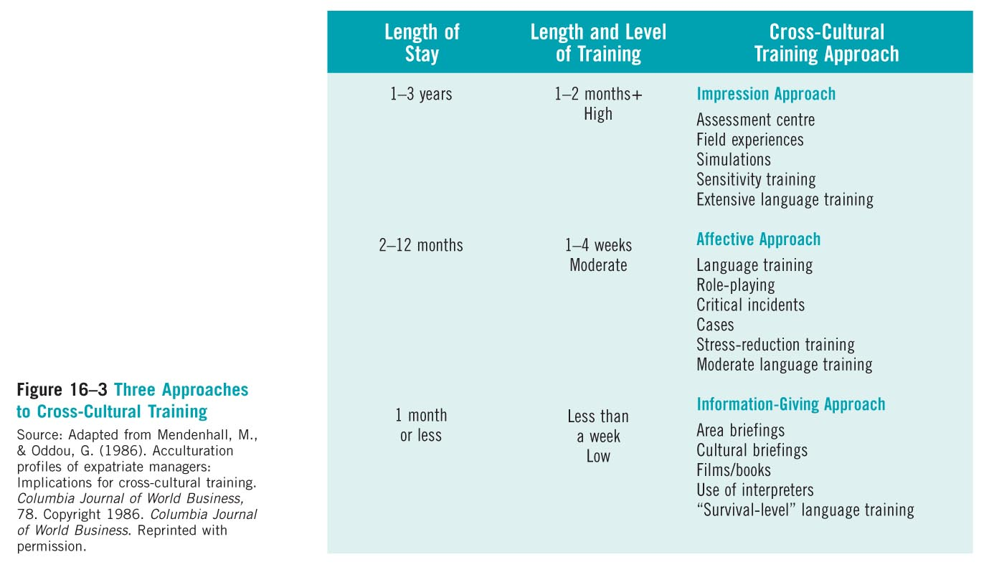
  - Basic Rules for Negotiation (*Important)
    - Do not think of negotiation as a game
      - Games have winners and losers, game spirit is to adopt win/lose approach. Played by prescribed rules, usually includes referees and judges.
      - No direct path to winning
      - More of both parties agreeing
      - No specific goals and must make sure that both parties leave happy
    - Be prepared (spend time in gathering knowledge)
      - Preparing includes gathering, analyzing information, selecting and developing strategy to prepare for specific negotiation.
      - Know what is happening and the situation
    - Know yourself and our counterpart
      - assess personality, temperament, behavioural tendencies, needs, power.
      - Know your and their position, personality, and temperament
    - Always look for common ground and common goals (explore options)
      - know when to hold them and when to fold them.
      - Know how to hold on to your goals and when to put them aside
      - Gain feedback on your goal from the negotiation
    - Follow basic communication rules
      - listening, speaking, filtering and watching.
    - Maintain emotional stability, personal integrity, and trust
      - personal integrity, and trust don’t trust the other party too much, apologize for errors, use persuasion techniques to maintain trust.
      - Persuasion
        - Inform the counterpart
        - More information for a better decision
        - Create a trust worthy decision
        - What your goals are and why
    - Know when to continue and when to walk away (in response to dirty tricks)
      - sometimes quitting is success.
        - When you see there is significant differences
        - Know your weaknesses and see if your comfortable with losing the time for negotiating
      - Don’t think your target was wrong just because you succeed in getting it accepted
      - Prepare for bad luck
      - Anticipate the counterparts decisions
    - Negotiate with someone who had the authority to commit
      - Collectivist culture - Take to the person who has power
    - Focus on long term issues
      - Consider the issues
    - Set limits for bargaining flexibility
      - Know your limits, minimum standard and your maximum
      - Bargaining zone
    - Ask for written agreement
      - Some are not comfortable
      - Something in writing to remind what they agreed to (informal, non binding)
      - Collectivism
        - Trust is high
  - Common Mistakes in negotiation
    - Make assumptions
      - for what other party wants and feels.
    - Overestimating or underestimating
      - your own and your counterpart’s weaknesses or power. Accepting the very first offer- hide your enthusiasm, take your time to evaluate the offer, allow the other side the opportunity to get something in return.
    - Too optimistic or pessimistic goals without factual data
    - Letting counterpart know your time and deadline
    - Accepting the very first offer
      - You know your bargaining zone well
      - Sometimes you may need to move ahead
    - Focusing on what other party gets
      - Focusing on what the other party gets does not mean that you lost something
      - Focus on your goals
    - Not saying no in an acceptable manner
      - Not saying no in an acceptable manner is the final common mistake. Be form and give explanation for your rejection.
      - When you do not agree, give reasons
  - Characteristics of strategic negotiation
    - Preparation
    - …
  - Negotiation Successfully: from book "getting to Yes"
    - The seven segments
      - Interest Options
      - Standards
      - People
      - Alternatives
      - Closure
    - Discover interests beneath positions. Not only what people say they want, they wont do, will do, or demands. Also focus on underlying motivation, needs, concerns, fears, and aspirations through empathy and by asking ‘why not what's wrong with…”
    - Generate multiple options by brainstorming. Not deciding, committing, judging or arguing, evaluating but inventing, improving, generating, without criticism. Dovetail differing interests for mutual gains.
    - Utilizing objective Standards will help parties search an agreement where options won’t. pick appropriate, relevant to time, place or circumstances. Law, equal treatment, market value.
      - Ex. Buying house, what current owner paid+ inflation, average increase, assess value of the house, price of sold houses in the area. Reason and be ready to reason.
    - Separate people issues from the substantive problems. acknowledge emotions perceptions without blaming, ease and improve communicating (listening), degree of trust and reliability.
      - Be able to focus on the issues
    - Alternatives (BATNA) that satisfies your interests in the event of no agreement. Always look for ‘walk away’ alternative and improve them. Preparation is the key.
      - What your best alternatives are
    - Closure (move systematically) picture before u begin, don’t lock anything but work with a framework agreement from the beginning, and be generous at the end and agree on what satisfies both parties.
      - Develop what type of framework on what you see the results

Video - International Negotiations
May-18-11
8:49 PM
  - International Negotiations has higher stakes and investments
    - Longer term
    - Difficulties with home office
      - Difficult for a western firm to understand why it takes a long time to negotiate with international negotiators
      - Ask for time and patience
  - The Team
    - Comfortable with other cultures
    - Dealing with the unpredictability
      - Get someone with experience of the culture
      - Local Associate
        - Get someone who is of the culture and contracts of the local
        - Introductions
        - Navigate bureaucracy
    - Seniority demands respect
    - Match positions with positions
      - High titles (Manager vs. Director)
    - Long term operation
      - The people that runs the business
      - Develop relationships and respect
      - One team from start to finish
    - Should have the right size
      - Smaller group has cost savings
      - Larger group allows for greater accuracy and safety
        - Collective society works in a group
    - Overview
      - Senior Exec and day to day
      - One team start to finish
      - Proper size of the team

  - Proper Preparations
    - Cooperative cultures
      - Win-win
    - Competitive
      - Winner - loser
      - Does not believe both can benefit
      - Must appear clearly both win with something tangible
    - Business Objectives
      - USA - Maximize profit and shareholder value
      - Europe- Protect and create jobs
      - Japanese - Gain access to technology
    - Over prepare
      - Be able to answer any type of question
    - Keep some information
    - Overview
      - Win-win situations
      - Prepare detailed information
      - Ask questions
      - Safeguard strategic information
  - Relationships
    - Overview
      - Spend time on relationships
      - Confirm that the counter part has authority
      - Build trust
  - Time
    - Overview
      - Cultural difference affect pacing
      - Bureaucracy can slow down processes
      - Budget your time and be relaxed with your counterparts
  - Opening
    - Overview
      - Decide where the talks should be
      - Create flexible agenda
      - Create creative pitch to the culture
      - Build room for bargaining
  - Discussions
    - Overview
      - Different styles and tactics
      - People deal with Compromise differently
      - Note agreements and change settings
      - Know your bottom line and walk out
  - Agreements
    - Overview
      - Be patient
      - Focus on the relationship
      - Short key point documents
      - Anticipate contractual deviations, use relationship

Creating Cultural Synergy and Motivation
May-25-11
7:11 PM

Diversity
  - Anything that makes us different
    - Demographics

  - Potential advantages and disadvantages of diversity
    - Synergistic
      - advantages
        - Greater openness to ideas
        - Multiple perspectives and interpretations
        - Increased creativity, flexibility, and problem-solving skills
      - Disadvantages
        - Cost, time, ambiguity complexity and confusion, and miscommunication
        - Difficult to reach agreement
    - Culture specific
      - Advantages
        - Better understanding of cultural dynamics
        - Better understanding of local HR and customers
        - Effective marketing
      - Disadvantages
        - Policies, strategies, practices and procedures
        - Ethnocentrism
    - Developing Diversity
      - Requires training
      - Organizational culture, where diversity is appreciated
      - Create an environment that accepts diversity
        - Doing different things
        - Encourage asking questions
        - Seek information
        - Expect the unexpected
        - Accept that no one is superior or inferior
  - Cultural Assumptions and their implications for management
    - Acculturation two cultures will try to resolve cultural differences
    - Create cultural synergy
      - Culture separatism
        - Only minority groups adapt and follow the norms and regulations of the culture
        - Assimilate one's self
      - Cultural assimilation
        - Minority groups would do this
        - Believe it’s a melting pot
      - Cultural pluralism
        - Must recognize that all are different
        - Everyone is trying to work on making everything work (accommodating and working together)
    - Common but misleading assumptions
      - Homogeneity
        - We are all the same
        - Ex - American (we are all American)
      - Similarity
        - Everyone is just like me
        - Everyone has the same culture
      - Parochialism
        - Think there is only one best way to do thing
        - Do not recognize other ways
      - Ethnocentrism
        - One way is superior
        - The sense of superiority compared to other cultures
    - Less common but appropriate assumptions
      - Heterogeneity
        - Accept diversity
        - Find a way to work together
      - Similarity and differences
        - Some similarities but there are differences too
      - Equifinality
        - Multiple good ways to do thing to achieve a similar result
        - Talking others and decide what should be done
      - Cultural contingency
        - Acknowledge difference but everyone is equal
  - Cultural Synergy
    - Cultural synergy recognizes both similarities and differences among the cultures that compose a global organization and suggests that we neither ignore nor minimize cultural diversity, but rather view it as a resource in designing and developing organizational system
      - Manager can be accepted in a new culture
      - Centralize the mission and vision
  - Steps to create Cultural Synergy
    - Describing the situation
      - Accommodate if possible
      - Being able to create a solution that people will accept
    - Interpreting the culture
    - Increasing cultural creativity
    - Creating cultural synergy

  - Strategies that include Synergy
    - Conflict management
    - Cultural dominance (shark image)
      - Applying your authority
      - In a cross cultural management you need more flexibility and this strategy is ineffective
      - Ultimate power and facts and figures
      - Can enforce any policy or plan
      - Many large companies use this approach
        - Affects relationships negatively
        - Ex- Walmart
    - Cultural accommodation (teddy bear image)
      - Appeasing style
      - Companies would adopt the new culture
      - What can be done to accommodate others
      - Not very effective
        - Always having to accommodate even though it may be less efficient
    - Cultural compromise (fox image)
      - Looks for a trade off
      - Give up something to get something back in value
      - May not be affective as it build that idea that in order to get something you must lose something

  - Cultural avoidance (Turtle Image)
    - Ignoring an issue or not talking about it
    - Works better in personal relationships when emotions are involved or when you know you are wrong or do not have all the facts (sometimes good)
    - Evaluate priorities and consequences
      - Not having all the facts
      - Being wrong

  - Cultural Synergy (Owl Image)
    - Collaborative approach, not having to give up something but creating mutual agreements
    - Increase creativity and keeps value in the relationship
    - Not always having a goal of winning
    - Works in most cases, but sometimes it may not work
    - When communicating should be very neural

  - Motivation
    - The process through which behaviour is mobilized to reach certain goals
    - Process which energizes and directs behaviour
    - As a manager, can I actually motivate a individual from another culture?
    - Need theories and process theories
      - Need if you help them satisfy the needs
        - Conclusive
      - Process Theories
        - Inclusive
      - Should have a mix of the two theories
  - Prominent Need Theories of Motivation
    - Maslow:
      - Different cultures have different priorities and different needs hierarchies
    - McClelland
      - These needs have not been shown to be universal
      - types of need
        - Pleasure and avoid pain
        - Need for power and affiliation
        - Achievement
    - Herzberg:
      - Presumes that the motivators are the same for everyone - Ignores values and preferences
  - Process Theories of Work Motivation
    - Motivation theories that specify the details of how motivation occurs
    - Three Important process theories:
      - Expectancy theory
        - Social Contract
        - Looks at the result and outcome
        - Get what they expect
      - Equity theory
        - Deals with fairness
        - Treating people know how much time and energy people are putting into their work
        - Incentives should be given based on the level of work (Fair reward for the input)
        - 3 goals of an organization
          - Efficiency
          - Fairness
          - Legal compliance
      - Goal setting theory
        - SMART criteria
  - The inter-cultural effectiveness of 'Other motivators'

Potential motivators | Where the motivator would likely work
Monetary incentives | Not particularly useful in collectivist cultures
Job rotation | Unlikely to succeed in cultures with high uncertainty avoidance, high power distance or collectivist cultures
Job enrichment | Unlikely to succeed in collectivist cultures
Job design | - Unlikely to succeed in cultures demonstrating high power distance, strong uncertainty avoidance and collectivist cultures  - How to make the job much more flexible
Performance Evaluation | - Unlikely to succeed in collectivist cultures
    - Collectivist culture
      - Group based incentives
      - Job security
      - Good supervision
      - Job sharing
      - Flexible working arrangements
  - Most important facet of work like, by culture

Work Goal | Cultures ranking this goal as being MOST important
Interesting Work | Belgium, Great Britain, Israel, United States
Pay | Germany
Autonomy | Netherlands
Match Between person and job | Japan
  - Do Motivation Theories Translate Across Cultures?
    - Equity theory will be constrained by what is considered "fair" in a particular culture.
      - Different cultures have different fairness
        - Ex - Gifts - Respect (care) vs. bribery
      - Most individualistic societies
        - Structures and rule are fair
      - Most collectivist cultures
        - Relationships are fair
    - Expectancy is very effective when applied cross-culturally.
      - Know the social contract makes thing easier
    - Setting specific and challenging goals in motivational when applied cross-culturally. The goal setting process must be adjusted to the culture (e.g. individual verses group goals).
      - Works everywhere, since employees have something to focus on
      - Adjusting goals based on the culture
    - Appreciating cultural diversity in critical for maximizing motivation.
  - Motivation Checklist
    - Should have a combination of motivation packages
    - Cafeteria menu
      - Create a combination for employees to choose
      - Employees have different values and they may choose a combination of benefits that encourages them to stay with the company
    - Materialistic & other incentives
      - Consider what different cultures values as a starting point
    - Recognized individual differences
    - Match people to jobs
      - Let them do thing they are comfortable
      - Productivity and motivation will be higher if they know what they are doing
    - Set practical and realistic goals
      - 3 goals of an organization
        - Efficiency
        - Fairness
        - Legal compliance
      - Evaluate your resources
    - Link rewards to performance
    - Check the system for equity
      - Check who people are using for their 'referent other'
      - Refine strategy
  - Cultural Intelligence
    - But ultimately, the balanced motivational systems used by an organization should fit the strategic goals of the organization, and Cultural intelligence is needed, sometimes simply being creative & sincere & INSPIRING others can work.
    - Using your 'cultural' common sense:
      - Cognitive
        - Thinking, learning, strategizing
      - Motivational
        - Confidence, persistence, value congruence, affinity/attraction toward new culture)
      - Behavioural
        - Repertoire of previously learned intercultural effective behaviours + ability to acquire new behaviours when needed)

Managing Multi-Cultural Teams & Leading Globally
June-01-11
6:57 PM
  - Leadership Review
    - A leader is
      - "Someone you choose to follow to a place you wouldn’t go by yourself"
      - "The incremental influence or additional influence that a person has beyond his or her formal authority
      - Use charisma to maintain loyalty and respect
      - Leadership is about ordinary skills to achieve extraordinary things
      - Can learn to be an effective leader
        - The roles are different from manager, they are vision builders oppose to just budgeting and such.
      - The factors that affect leadership
        - Cultures
  - Leadership Theories: Cultural Constraints
    - Despite the different cultures the underlying concepts are similar
    - McGregor's Theory X (evil) and Y (good)
      - Cultural limitations?
        - Dichotomous view of human nature (MGT's conception)
        - Y appropriate for low power distance cultures
      - Theory X - Employees are lazy and require management and supervision to be effective
        - View people that are irresponsible
      - Theory Y - People are more capable and just need motivation
        - Instilling a sense of energy by creating the proper environment
    - Misumi's PM Leadership theory (Japan)
      - P (Performance) + M (Maintenance ) are greater than sum of their parts, and being high on both leads to higher leader effectiveness rating (US, UK, HK support this)
        - Performance - Task accomplishments
        - Maintain - Strong concern for the people
      - But leader behaviours only acquire meaning through context
        - Need to be high on task accomplishment and people skills
        - Respect people by having a good environment with all the resources
      - Japanese managers value the most is the loyalty to the company, in group collectivism
    - Singha's NT leadership (India)
      - NT Stands for
        - Nurturance
        - Task
      - Indian leaders largely Task-oriented and direct reports proper it; but when participative approach succeeds (combined with nurturing simultaneously) overall result is better (in collectivist contexts)
        - High power distance and collectivist
          - Leader should have all the answers
          - Autocratic society
        - What kind of needs the employees have
        - Use more of a goal setting theory
      - To succeed in India you must be very knowledgeable and always there to support your subordinates
    - Transformation Leadership
      - Weber distinguishes charismatic authority from rational and traditional authority, & note that empowerment less likely in high power distance societies
      - A leader that has the ability to transform employees
        - Instil a kind of vision in employees
      - So again, context determines the success/failure of any particular style
      - Three types of leadership to change and transform
        - Charismatic authority
          - Not a very stable form of authority
          - Individualistic societies appreciate
        - Rational Authority
          - Better transform people by creating rules and regulations using rational and logical justifications
          - Ideal type of authority
        - Traditional Authority
          - Most collectivist societies would appreciate
          - Use resources and power in transforming
  - Cultural Relativity of Leadership: Managing and leading in…
    - In overseas Chinese cultures:
      - Much business practice is centred around Confucian social policy:
        - Leadership makeup includes virtuous behaviour, protection of the weak, harmony, loyalty, moderation, calmness, conflict avoidance, face-saving, consensus
        - Leadership is expected to demonstrate humanity, patience, integrity, compassion, humility
        - Authority is sanctioned by becoming worthy of respect and providing a good role model for subordinates
      - It thus relies on the traditional form of authority
    - In France:
      - Individual respect/demand for authority creates tension with strong belief in individualism
      - High tolerance of blunders on the part of management
      - Management system is elitist and autocratic, but not familial (there is a merit based element to it)
      - Organizations are highly centralized and hierarchical with decisions made at the top
      - Information is not allowed to filter down below certain levels of the organization
      - The president of a French company is not answerable to anyone and status is attributed on the grounds of family, age, education, and professional qualifications
    - In the United States
      - Efficiency is paramount; American managers are very time conscious and possess a strong work ethic
      - Managers are competitive, assertive, goal and action oriented, friendly and informal, and value innovation => Status is based on demonstrable achievement
      - A democratic leadership style prevails within American organizations; Individual freedom is deeply valued – above the welfare of the company
  - The GLOBE Project
    - 150 Researchers worldwide
      - Data collected from 15,000 middle managers
        - From 875 organizations
        - 3 industries (financial services, food services, and telecommunications)
        - 61 nations
      - Identified 6 global leader behaviour dimensions and 9 cultural dimensions
      - Found that the 61 countries grouped into 10 clusters, of which 4 (southern Asia, Anglo, Arabic & Latin European) will be discussed today).
  - Work on improving emotionally intelligent
    - Self awareness
    - Self regulation
      - Monitor behaviour
    - Motivation
    - Empathy
    - Social Skills
  - Implications
  - Global leadership Study
    - Multiphase and multi-lateral
      - Most participants are middle to lower management
      - Used Hofstede's theories to measure leadership
        - How leaders behaviour leads to a certain success
    - The 6 Global Leader Behaviour Dimensions
      - Started with 23 styles and ended with 6
      - Based on how styles can lead to a certain goal
      - Transformational - Charismatic
        - Were successful due to achievement oriented and visionary
        - Willing to sacrifice for the employee
      - Team-oriented
        - Good at maintaining stakeholder relationships
        - More diplomatic and collaborative in their approach
      - Self-protective
        - Self centered
        - Only one way towards a solution
        - Procedural and controlling
        - More in the middle eastern styles and eastern Asia
      - Participative
        - More a democratic style and empowering employees
        - Consensus and relationship building
      - Humane
        - Modest behaviour
        - Strong concern for their employees
        - High on maintenance scale
      - Autonomous
        - Individualistic orientation
        - Make decision by themselves and more of tactics
        - Uniqueness

    - The 9 Cultural dimensions based on Hofstede's work:
      - Uncertainty avoidance
        - Tolerance for ambiguity
        - Require of higher structure
        - Not very certain based on the culture
          - Individualistic - low uncertainty avoidance
          - Collectivism - High uncertainty avoidance
      - Power distance
        - Tolerance of unequal distribution of power
      - Collectivism I: Societal Collectivism
        - Concern for society
      - Collectivism II: In-group Collectivism
        - Concern for more of a immediate family, group or company wide
      - Gender Egalitarianism
        - Minimizing gender roles
        - Collectivist (Masculine)
          - Structured roles
        - Individualistic (Feminine)
      - Assertiveness (directness)
        - Latin american and south eastern (Not really assertive)
        - Individualistic (more assertive)
        - Collectivist (more assertive when it comes to society)
      - Future Orientation
        - Preference towards path oriented and future planning
        - Most organizations are past oriented
          - Keeps towards traditions and resist change
        - Present oriented
          - What we can do now and what is possible
          - Most middle eastern cultures
        - Future oriented
          - Individualistic
      - Performance Orientation (need for achievement)
        - Strong need to achievement
        - Typically more rationalist and competitive
      - Humane Oriented
        - Appreciation towards caring environment
    - The societal Clusters (4 of them)
      - There are forces of convergance (Language and technology)
      - Divergance (Traditionalist and fundamentalist) Social group that
      - Southern Asia
        - High on human orientation, collectivism
        - Leadership style autocratic and showed a strong for a humane leadership style and visionary
        - Male leadership and precise and decisive
        - Diplomatic as they are hieratical
      - Anglo
        - Mid-range on all the dimensions
        - Leadership
          - Charismatic leadership
          - Team oriented
          - participative oriented style
        - Collectivist society
      - Arabic
        - Leadership
          - Same as Anglo leader
          - Charismatic leadership style
          - Team oriented
          - Participative
        - Low on gender and future oriented (Destiny)
        - High in other dimensions
        - Trust building
      - Latin Europe
        - Leadership
          - Team oriented leadership and charismatic
        - High on power distance
        - strong collectivism (in-group)
        - Midrange on future oriented
      - The 6 other clusters included: Nordic Europe, Germany Europe
    - Universal FACILITATORS of Leadership Effectiveness
      - Integrity (being trustworthy, just, & honest)
      - Charismatic-visionary (Having foresight/planning ahead)
      - Charismatic-inspirational (Being positive, dynamic, encouraging, motivating, and building confidence)
      - Team-Builder (being communicative, informed, a coordinator, and team integrator)
    - Universal IMPEDIMENTS (Avoid) to Leadership Effectiveness
      - Self-Protective (being a loner & asocial)
      - Malevolent (being non-cooperative & irritable)
      - Autocratic (being dictatorial)
    - Culturally-Contingent Leader Attributes (might work)
      - Autonomous (being individualistic)
      - Status-Conscious
      - Charismatic III: Self-Sacrificial (being a risk-taker)
  - Globe Project: Implications
    - When in Rome…don’t just do as they do but also be aware of what they Want to do (how they want to move forward)
    - Universal desire for charismatic/transformational leaders (heroes?). Not easy for many managers.
      - Appreciate transformational leadership style
    - Universal desire for integrity: But ethics has culturally-specific connotations too
      - All wanted fair system in place with cultural specific way of solving them
    - Most countries scored low on gender egalitarianism
      - Human rights improvement
  - Managing a multicultural workforce
    - Different stages of the firm
    - Domestic firms
      - Domestic multiculturalism
      - Very important focus on multicultural managing
      - Does not have to go anywhere for multiculturalism
      - Everything will deal with how diversity the labour force is
    - Multi-domestic firms
      - How can firms adapt their good or services to the local culture and differences
    - Multi-national firms
      - The firm will not have that much concern on the culture management
      - More focus on the price and costs
    - Global firms
      - More culturally responsible, more of a global system and make more culturally appropriate strategies
  - Types of diversity in teams & Advantages and Disadvantages of Multicultural teams
    - Team refer to as a cooperate, positive interdependence through promotive interaction
    - Reasons to form a team:
      - Teams are used to combine talents to accomplish tasks
      - Create better innovative solutions
      - Motivational aspect
      - Lower stress

  - Homogenous teams
    - Team has a similar background and demographic
    - Similar abilities, experience and education
  - Heterogeneous teams
    - The team members are different
    - Different attitude
  - Token Teams
    - One member from a different culture or a single representative of a culture
  - Bicultural teams
    - Teams that are from 2 cultures
  - Multicultural teams
    - Teams with more than 2 cultures
    - More challenging to manage

  - Group think and its symptoms:
    - Use multicultural teams to avoid group think
    - Group think
    - Illusion of invulnerability
    - Rationalization
    - Illusion of morality
    - Stereotypes of outsiders
    - Pressure for conformity
    - Self-censorship
    - Illusion of unanimity
    - Mind guards
  - Effective Team processes for Global Teams
    - How teams are created and what are the conditions that evolve
    - Cross cultural is a applied science
    - Basic Elements of Team Dynamics
      - Task & Social Processes
        - Task what people have to work on and their responsibility
        - Social the quality of relationship
        - Need a balance between the two
          - Intellectual and physical ability and social task
      - Emergent States
        - As events that evolve
      - Coordinating Mechanisms
    - Team Process Flows
      - Differentiation/Integrating
        - Identify how people are different and use that towards integrating towards the solution
      - Face-to-face and virtual
        - Look at channels
          - Lean or rich mediums
      - Phases and Transitions
        - Forming - come together to complete a task
        - Storming - Conflicts will arise due to differences.
        - Norming - Can create norms to
        - Performing - once a task is accomplished
        - Closure - no need for team to work together
    - Team Process Building Blocks
      - Building Trust
      - Differentiating
      - Integrating and decision making
      - Managing Conflict
      - Creating/Sharing Knowledge
  - Managing Culturally diverse teams
    - Task-related selection
      - Discover skills specialization
    - Recognizing differences
      - Do not ignore differences
    - Establishing a vision of superordinate goal
    - Equalizing power
      - Take turns and be leaders
    - Creating mutual respect
    - Giving feedback

Cross-Cultural Ethics in International Business Context
June-08-11
7:08 PM
  - Ethics
    - Business Ethics are humanely based not culturally specific
    - The knowledge is culturally specific
  - Common Ethical Dilemmas in International Business
    - False Information
      - Falsifying reports, abusing expense accounts
    - Dealing with Competitors
      - Industrial Espionage
    - Gender Equality / Human Rights
      - Differences in the way women & minorities are treated in the workforce
    - Environmental and Ecological Concerns
      - The ecological impact of business operations
    - Bribery & Extortion
      - White mail bribery
        - Pay an official to get any entitlement or resource, it is illegal and the payments are usually really high
      - Lubrication bribes

        - Speed up the process, usually not illegal
      - Extortion
        - A lot of bureaucratic and masculine cultures
    - Social Responsibility
      - Can include all the dilemmas
      - How a company can operate in a socially accepted way and how it can return the welfare of the community
      - Organization's obligation to conduct business in such a way that safeguards the welfare of society. (Note: much of above categories could fall within this category)
    - Resolving Ethical Dilemmas in International Business
      - Universalistic approach
        - Equal and fair
        - Look into different rules and regulations in place
        - Law and rules apply to everyone (Home or host country)
        - Universal and fair rules apply
      - Particularistic approach
        - Specific obligation to a few people
        - Collectivist society
      - Compromise approach
        - Give and take
        - Managers accommodate some local demand
        - Acknowledge the local pressures
        - Find a balance
      - Reconciliatory approach
        - Collaborative or balances approach
        - Personal values are not superior
        - Working together with locals
        - Ideal collaborative approach
    - Countries practice the highest ethical standards
      - A lot of researcher has found that the most ethical standards are higher in developed countries
    - Source of Ethics
      - Ethics are learned through a variety of channels:
        - Reflections of social values (as expressed hrough the media, for example) reinforce cultural beliefs of right and wrong that were first addressed through the following three channels:
        - Family groups
        - Educational insitutions
        - Religious beliefs
    - Why do Cultures differ in Ethical Response?
      - ….
      - Teleology/ Utilitarianism
        - The theory of consequences
        - Manager would look at the different alternatives
        - Make the decision with the result of the maximum benefit for the maximum amount of people
        - Disadvantage is the accuracy of the forecast
      - Deontology
        - The theory of moral duty
        - Ethics are guided by duty not the consequences
      - Justice
        - The theory of fair rules
        - Establish rules and regulations that re equity based (Fair) and transparent and that apply to everyone
        - Models

          - Interactional justice
        - Three guiding principles:
          - Be equitable (outcomes)
          - Be fair (process)
          - Be impartial
      - Ethical (cultural) Relativism
        - Situational, no best right way
        - Should they trust home culture or host culture
        - No single right way because all cultures are different and no culture is any better or any worse than another
          - What is unethical and even illegal in some countries is accepted and indeed expected ways of doing business in others -> must look at the circumstances
        - Should managers base their ethical standards on those of the host country or those of the home country or some reconciliation of the two?
    - Code of Ethics
      - Professional standards
      - Brief description of the company's values
      - A code of ethics is a formal statement of an organization's primary values and the ethical rules it expects its employees to follow
      - Code of ethics are designed to perform one or more of the following four functions:
        - Increase public confidence
        - Decrease government regulation
        - Improve internal operations by providing consistent standards of both ethical and legal conduct
        - Assist managers in responding to issues arising from unethical or illegal behaviour
  - World Views: Focus Religion
    - Monotheistic - Belief in one supreme power
      - Christianity
      - Islam
        - Condemns materialism / commerce
      - Judaism
    - Polytheistic - Belief in many supreme powers
      - Hinduism
      - Buddhism
      - Confucianism
        - More of a code of ethics and rules

Multinational Decision Making Managing Cross-Cultural Transitions: managing Abroad and coming back home
(Ch. 8 + Ch. 10)
June-22-11
7:04 PM
  - Three basic management roles
    - Information roles
    - Interpersonal roles
    - Decision roles
      - Daily routine decisions
      - Strategic decision making
      - Factors to make decision
        - Well structured problem
          - Existing solutions are there
          - Ideal situation toward dealing with organizational problems
        - Ill structured problem
          - Problem is not clear
          - Not sure of what the alternatives
          - Cannot say one is perfectly informed, perfectly rational and never accurately make a decision
  - Traditional/ rational decision making process
    - Often people who makes rational decisions some do not have the time to go through the process, but it is ideal
    - Some have problem solving approach vs. situation acceptance approach
      - Problem solving - Individualistic
      - Situation acceptance - Collectivism
        - Accept a situation as it is and not resolve the issue
    - Problem recognition
    - Information search
      - What are some of the factors of the problem and how to we gather and process information
      - Why are we dealing with the situation
      - Feelers vs. Sensor
        - Feeler - generalization, judgement, use informal channels
        - Sensor - Facts and relay on more of the tangible cues
    - Construction of alternatives
      - How we can generate different alternatives
      - Ask other decision makers
      - Look at various options
      - Traditionalist
        - France, Britain, Latin American
        - Look at traditions and norms oppose to innovative ideas
      - Future oriented
        - Oriental Cultures
        - Creative and take risks
    - Choice
      - Make a selection which option is better
      - More positive outcomes with lower risk and higher reward
      - Who makes the decision
        - Individualistic - Democratic
        - Collectivist - From the top
    - Implementation
      - How we are making the decision
      - Gradual or
      - Future oriented
        - Fast implementation
      - Past oriented
        - Slow implementation
  - Alternative to Rational Models
    - Maximization or Optimization
      - Selection of the alternative they expect the greatest value or serve the most
      - Using your resources most effectively
    - Anchoring Effect
      - Rely on initial estimates and impressions
      - What we think
      - Action Theories
        - Our understanding
        - If and then approach
    - Satisfying Process
      - Use my own standard toward evaluating something
      - Based on education and experience create a standard an value each alternative to that standard
    - Intuitive Process (Experientially based process)
      - When people make decision use experiences and use subjective perception (Gut feeling)
  - Common decision making techniques
    - Delphi technique
      - Get opinion from other people
      - The process of Delphi
        - Use a set of questionnaires and collect answers from different participant
        - Sit with other decision makers to refine the questionnaires
      - Can use quantitative tools
    - Nominal group techniques
      - One of the more useful techniques
      - Invite people to discuss an issue and resolve the issue
        - Write down the problem and solutions
        - Moderators will present it and the group will evaluate the different options
        - No one knows who presented the idea
      - Giving everyone the opportunity to propose a solution
    - Brainstorming
      - Quantity of ideas over quality
      - Do not use if you have a rigid organization culture, should only be used for innovative
      - Focus group like
        - As many ideas as possible
        - No criticism
    - Pareto analysis
      - Inefficient but more for a long-term
      - Oppose to dealing with individual problems but more for key vital factors that is creating those issues
    - Decision trees
      - Plus - minus decisions
      - Talk about an issue or a problem with other people who makes decision and evaluate the end results
    - PMI
      - Plus-minus
      - Same as decision
    - Cost-Benefit analysis
      - How much money a decision costs and its result
      - Not all can be valued as a dollar
    - Experientially-based processes
      - Acknowledge on past experiences and subjective evaluations
  - Influences on decision-making
    - National culture
      - Have an influence on the quality of the decision
      - Must have a basic knowledge of the national culture
    - Organizational culture
      - Innovation vs. bureaucratic culture
    - Nature of the problem
      - How simple or complex the problem is
      - How well everyone knows the problem
        - Some views it as a problem others view it as a situation
    - Competencies and skills
      - How much decision makers have skills or knowledge on solving problems
    - Process issues
      - Can affect quality of decision
      - Ex- poor leadership
        - Lack of commitment
        - Group thinking
    - Selected technique/methods
      - Different approaches towards solving the issue

Chapter 10 -
  - International Workforce *Important*
    - Host country national (locals)
      - Citizen of country where working
    - Home-County national
      - Citizens of home/parent county
      - Ex - Canadian company employs a Canadian citizen for international
    - Third-country nationals:
      - Non-citizen of parent of host
    - Expatriates
      - Non-citizen of country where working
      - Anyone who is not in their home country
  - Staffing policy
    - Polycentric
    - Ethnocentric
    - Geocentric
  - Global Manager Myths
    - There is a universal approach to management
    - People can acquire multicultural adaptability and behaviours
    - There are no impediments to mobility
      - Not easy for people to move to new places
    - There are common characteristics shared by successful international managers
      - Some leadership styles fit in certain societies
      - One size does not fit all
    - MNCs will do everything they can to ensure that any international assignment goes smoothly
      - Not all companies carefully plan
      - Some do not know what to do when they come back
      - Difference between personal goals vs. company goals
  - Expatriates Assignments
    - Fail due to
      - Premature return and not completed
      - Underperformance
      - Do not have the ability to retain the employee
    - Why they fail
      - Career Blockage
        - Not enough contact with the company
      - Culture shock
        - Disillusion of new culture
      - Lack of training
      - Technical Emphasis
        - Has the basic know-how but working in an international assignment it requires a lot more
      - Poor selection
      - Family problems
    - Difficulties upon return
      - Downplaying skills
      - Loss of status
      - Poor planning
      - Reverse Culture Shock
        - (Professional re-entry)
        - Re-socialized returning
          - Do not recognized that they learned something
        - Alienated return
          - Know they have learnt something
          - Use what they did in the host country culture
        - Proactive returning
          - Balance the culture difference from home and host cultures
          - Good sense of humour and know what is socially appropriate
  - Selecting employees in a global labour market
    - Basic principles for selection of employees for international assignments:
      - Competency in the employee's area of expertise
        - Should have technical competence
      - Ability to communicate (including language)
        - Have the willingness to learn or know the language
      - Flexibility and tolerance for ambiguity
        - Have the ability to assimilate in the new culture
      - Sensitivity to cultural differences
      - Cultural requirements
      - Motivation to succeed
      - Enjoyment of challenges
      - Willingness to learn
      - Support from family members
      - Other-oriented behaviours
  - Cross-Cultural Preparation and Performance Management
    - Departure preparation
    - Assignment preparation
    - Return home preparation
  - Cross-Cultural Training Approach
    - Impression Approach
      - 1 - 3 year length of stay
      - 1 month + length of training
      - Field experience
      - Extensive language training
    - Affective Approach
      - 2 - 12 months
      - 1 - 4 weeks training
      - Moderate language training
    - Information-giving Approach
      - 1 month or les
      - Less than a week of training

  - Dimensions of Cross-Cultural Adjustment
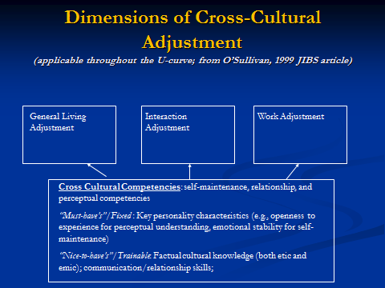
  - Managing re-entry
    - Communicating with expats while abroad
      - Keep in touch with employees
      - Send them emails, memo and keep them informed
    - Validate the experience of expats at re-entry
    - Utilize the experience of expats at re-entry
    - Coach and assist where needed

  - 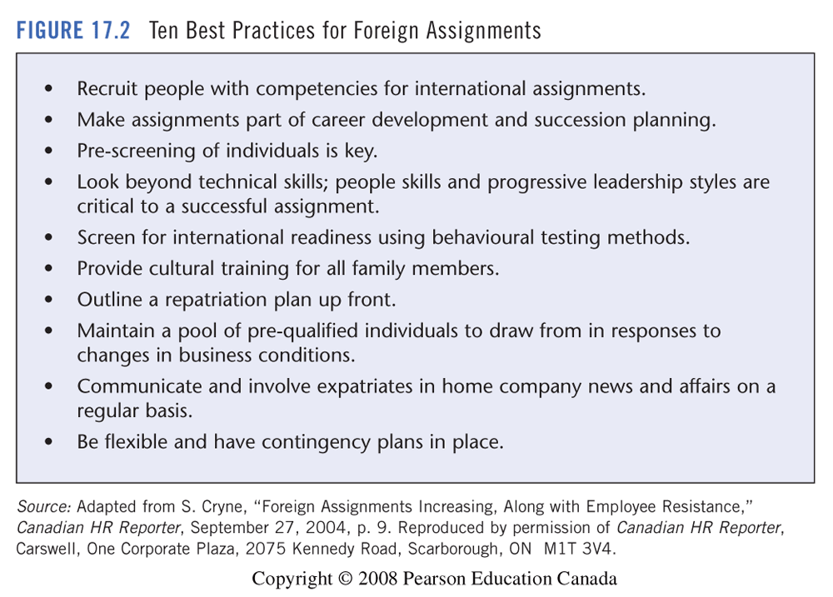

Lecture 7 - The Expatriate Spouse
June-29-11
7:18 PM

  - (Important)
  - Single Career Couple
    - Moving aboard: pre-made decisions
    - Cross-cultural transitions: the arrival
    - Culture Shock: the initial period abroad
    - Returning Home
      - Life was more challenging since everything changes

  - Dual Career Couple
    - Trailing spouse should consider number of options
      - Turn down the assignment
        - If the couple feels its too difficult to take the assignment since one person has to sacrifice more.
        - Negative consequences if the assignment is related to their career plan
      - Negotiate before accepting the assignment
        - Expatriate can negotiate if one is a valuable resource or only option
        - 5 - 10% of companies help the spouse find a job
      - Trailing spouse can remain in his/her current position at home
        - Long distance relationship
      - Trailing spouse can take sabbatical or continue his/her career
        - Either change their career or take a temporary career.
      - Create other options

Chapter 12 - Global Careers - Succeeding in the 21st century
  - Three aspects to the success of working abroad
    - Personality - Being adventurous, good networking skills, technical skills, ambition and eager to learn
    - Family - Supportive family
    - Compatibility between the home culture and the host culture
  - Is the traditional expatriate manager extinct?
    - What is a traditional expatriate manager look like?
      - Spends his time between 3 to 5 years working abroad
      - Younger (30s)
    - More geocentric with a global mindset
    - Assignments with short durations
    - Increasing number of women
    - Similar educational background
    - Willing to move abroad is higher
  - Reasons future managers accept global assignments
    - Cross-cultural experience and personal growth
      - They will see that they will learn a lot
      - Learn the new language and expand their horizon
    - The job itself
      - Challenging
    - Compensation
      - A lot of benefits and return but the salary is usually the similar to that of the home country
    - Career advancement
      - Feel that if they take an international opportunity they will have greater opportunities in the future
    - Good location
      - Good social living conditions to encourage people to take the assignments
    - Satisfying or unique lifestyle
      - Change and variety in lifestyle
    - Spouse and family
      - Children at a critical age (Younger childern) have a greater change of adapting
    - Lack of domestic opportunities
    - Host country acceptance
  - Reasons future mangers reject global assignments
    - Location
    - Job and career
      - If the job is not challenging and is boring
      - No proper career planning
    - Spouse and family
      - Family not supportable or have poor education facilities
    - Money
      - Compensation is poor and may be in a losing situation
    - Unpleasant life aboard
      - Require to learn new languages and way too much change
    - Disruption to life in home country
      - See their commitment to family relations
    - Long contract
      - Most new assignments are usually shorter contracts
    - Good current position at home
    - Too much travel
  - Global Managers: no longer men alone
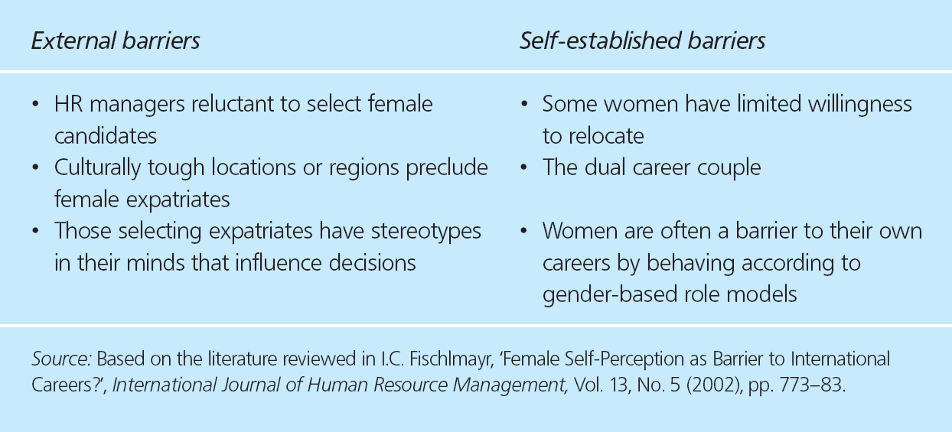

Final Exam
June-29-11
7:50 PM

5 questions pick 3 for short answer
Half of the questions are m/c

Lecture 8 - Knowledge Management
July-06-11
7:13 PM

  - Key Dimensions of a Learning Organization
    - Vision
      - Clear vision
    - Culture
      - Proactive culture
      - Appreciate knowledge sharing
      - Need to take initiative to learning
    - Learning Systems/Dynamics
      - Collaborative problem solving
      - Use total department resources toward solving a problem
      - Sharing tools between departments
      - Have different systems in place for employees to find information that is needed
    - Knowledge Management/Infrastructure
      - Cannot expect that the company would have all the systems in place

  - The Learning Organization
    - Five Disciplines: (conference board of Canada research)
      - Personal Mastery
        - Employees should be willing to learn and improve themselves
        - Create an environment to encourage others to have personal mastery
      - Building a shared Vision
        - A vision of the future to which everyone have a clear and shared vision
        - As a manager you want to make sure the expectations and vision is clear.
      - Mental Models
        - Assumptions and images
        - Optimistic and positive image they are more willing to promote a learning environment
      - Team Learning
        - People actually know how to cope with individual differences and have the ability to
      - Systems Thinking
        - When people work together and view issues they have the ability to connect the system together to solve the issue
        - There are great interdependency
      - Management Practices
        - Good role model and have the charismatic
  - International Management Challenges
    - Knowledge transfer is a challenge for international managers
      - Transfer local knowledge
    - Sense making
      - Share an understanding
      - If you are a rationalist, you should ignore the experience
      - If you are an imperialist, you should ignore the gut feeling
    - Types of organizational learning
      - Positivist (Quantitative)
        - Gain information but may not be accurate information
      - Narrative (Qualitative) approach
        - What people will tell you and ...
        - You must have emotional stability
    - How can you:
      - Acquire potential high-grade knowledge from unfamiliar environments?
      - Manage knowledge in a single administrative system that resides in disperse and differentiated locations?
      - Manage cross-organizational and cross-cultural teaming?

  - Knowledge management
    - Explicit knowledge
      - Can be expressed through summary or any knowledge that can be easily transferred
      - Ex - Policy rule or company info
    - Tacit knowledge
      - Technical dimension
        - What they have to do for their job
        - Basic know how
      - Cognitive dimension
        - Acquired through experience
        - Evaluate quality of work
        - Decision making
    - Knowledge stickiness
      - Sending problem
    - "Absorptive Capacity" for Knowledge
      - Receiving problem
      - A receiver is not receiving the knowledge properly
  - Knowledge Management Practices
    - A knowledge acquisition
      - Environment Scanning
        - Analysis of the internal aspects
        - What do you want to teach people and available for employees
        - External analysis
          - How you are different compared to others
          - Use market research, customer feedback
      - Formal Learning (training & Development)
        - Any structured ways of learning

      - Informal Learning
        - Anything that you learn on your own with no structure

  - Comparing Formal and Informal Learning
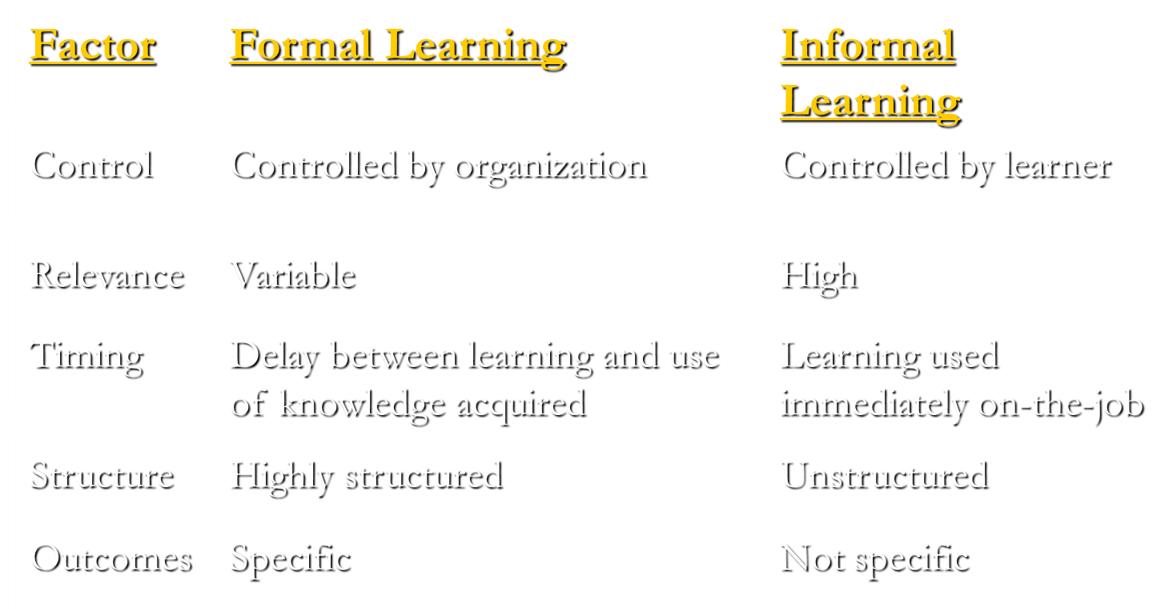
  - How people acquire knowledge
    - Knowledge is social and must have a shared and mutual understanding of the knowledge
    - Mental Models
      - Communities of practice
        - Networks of people and how they learn and interpret
        - Social learning theory
      - How people process information

  - Knowledge Interpretation
  - Knowledge Dissemination
    - Knowledge sharing, any channels or mediums to share information
    - Ex - intranet, email, or face - to - face
  - Knowledge Retention
    - Have an inventory of information for future use
    - Stored in organized systems

  - Knowledge Management Principles
    - Knowledge resides in people's minds
      - Tacit knowledge
        - Transfer information to help train new employees

  - Knowledge-sharing requires trust
    - Create an environment of trust to allow knowledge sharing
  - Technology enables new knowledge behaviours

  - Knowledge-sharing must be encouraged and rewarded
    - Reward individuals that create and share the knowledge

  - Management support and resources are essential

  - Knowledge initiatives should begin with pilot programs
  - Multiple methodology is needed to evaluate initiatives
  - Organizations should encourage learning and creativity for development
  - Knowledge work - the process
    - Knowledge creation - Continuous innovation --> Competitive advantage
      - How does knowledge get generated
      - Knowledge codified
      - Knowledge Transfer
        - Serial Transfer
        - Near transfer
          - Another team within the same department and utilize the knowledge to do something better
        - Far transfer
        - Strategic transfer
  - Multilevel system model
    - Organizational level learning
      - Require an environment where learning is important
      - Encourage learning and knowledge transfer
    - Group level learning
    - Individual level learning
      - In learning organizations there will be opportunities for individuals to learn and experience

*Movie* - Doing Business in Chile
July-13-11
7:29 PM

  - Orientation
  - History
    - Weak Spanish rule - independence
    - Instability, military in 1800
    - Redistribution of power lead to communism

