Midterm Notes Ecology

Lec 1 – Ecology
- 1. the scientific study of interactions between organisms and their environment
- 2. the scientific study of interactions that determine the distribution (geographic location) and abundance of organisms
- Ecological maxims (guiding principles):
  - 1. Organisms interact and are interconnected
  - 2. Everything goes somewhere
  - 3. No population can increase in size forever
  - 4. Finite energy and resources result in tradeoffs
  - 5. Organisms evolve
  - 6. Communities and ecosystems change over time
  - 7. Spatial scale matters
- Ecological Hierarchy
  - Population: Group of individuals of a species that are living and interacting in a particular area.
  - Community: Association of populations of different species in the same area.
  - Ecosystem: Community of organisms plus the physical environment.
  - Landscapes: Areas with substantial differences, typically including multiple ecosystems.
- Net primary productivity (NPP): Energy captured by producers, minus the amount lost as heat in cellular respiration.
- Scientific method:
  - 1. Make observations and ask questions.
  - 2. Use previous knowledge or intuition to develop hypotheses.
  - 3. Evaluate hypotheses by experimentation, observational studies, or quantitative models.
  - 4. Use the results to modify the hypotheses, pose new questions, or draw conclusions about the natural world.
- Deformity and Decline of amphibians – a case study
  - High incidence of deformities in amphibians
  - Declining populations of amphibians worldwide
  - Amphibians are “biological indicators” of environmental problems.
  - Skin is permeable; pollutant molecules can pass through easily.
  - Eggs have no protective shell.
  - They spend part of life on land and part in water—exposed to pollutants and UV in both environments.
  - Population decline in frogs is hypothesized to be happening for a number of reasons
    - Fertilizer in runoff to ponds increases algal growth.
    - Snails that harbor Ribeiroia parasites eat algae.
    - Rebeiroia parasites cause deformities in tadpoles
    - Greater numbers of snails result in greater numbers of Ribeiroia parasites
    - Hatch and Blaustein (2003) studied the effects of UV light and nitrate on Pacific tree frog tadpoles.
      - At high elevation sites, neither factor alone had any affect. But together, the two factors reduced tadpole survival.
      - At low elevation sites, this effect was not seen.
Lec 2 – The Physical Environment

- Potential causes of salmon declines in the North Pacific Ocean:
  - dam construction
  - sediment from logging operations
  - water pollution
  - overharvesting
  - But the conditions of oceans, where salmon spend most time as adults, have also been implicated.
  - Hare and Francis (1994) studied fish harvest records and showed alternating periods of high and low production associated with climatic variation in the North Pacific.
  - Mantua et al. (1997): Periods of high salmon production in Alaska corresponded with periods of low production in Oregon and Washington.
  - They also found a correlation between salmon production shifts and sea surface temperatures.
- Weather: Current conditions—temperature, precipitation, humidity, cloud cover.
- Climate: Long-term description of weather, based on averages and variation measured over decades.
  - Climatic variation includes daily and seasonal cycles, as well as yearly and decadal cycles.
  - Long-term climate change results from changes in the intensity and distribution of solar radiation.
  - Current climate change is due to increased CO₂ and other gases in the atmosphere due to human activities.
  - Climate determines the geographic distribution of organisms.
- The sun is the ultimate source of energy that drives the global climate system.
  - Energy gains from solar radiation must be offset by energy losses if Earth’s temperature is to remain the same.
  - A lot of radiation is emitted by the surface of the earth
  - A lot of this radiation is reflected back down to the earth from the greenhouse gases.
  - Greenhouse Gases:
    - Water vapor (H₂O).
    - Carbon dioxide (CO₂).
    - Methane (CH₄).
    - Nitrous oxide (N₂O).
    - Without greenhouse gases, Earth’s climate would be about 33°C cooler.
- Energy is spread over less area at the equator so it is more concentrated so it remains hotter there.
  - Solar radiation heats Earth’s surface, which emits infrared radiation to the atmosphere, warming the air above it.
  - Warm air is less dense than cool air, and it rises—this is called uplift.
  - Air pressure decreases with altitude, so the rising air expands and cools.
- Tropical regions receive the most solar radiation and the most precipitation.
  - Uplift of air in the tropics results in a low atmospheric pressure zone.
  - When air masses reach the troposphere–stratosphere boundary, air flows towards the poles.
- Hadley cells(equator to 30°), Ferrel Cells(30 to 60) and Polar cells(60 to 90)result in the three major climatic zones in each hemisphere—tropical, temperate, and polar zones respectively.
- Areas of high and low pressure created by the circulation cells result in air movements called prevailing winds.
  - The winds appear to be deflected due to the rotation of the Earth—the Coriolis effect.
- Water has a higher heat capacity than land—it can absorb and store more energy without changing temperature.
  - Summer: Air over oceans is cooler and denser, so air subsides and high pressures develop over the oceans.
  - Winter: Air over continents is cooler and denser; high pressure develops over continents.
- Major ocean surface currents are driven by surface winds, so patterns are similar.
  - Speed of ocean currents is about 2%–3% of the wind speed.
  - Ocean currents affect climate.
  - The warm Gulf Stream warms the climate of Great Britain and Scandinavia.
    - At the same latitude, Labrador is much cooler because of the cold Labrador Current.
- Altitude and Climate
  - Himalyas in Asia have an average cooler temperature than its surroundings because of altitude.
- Upwelling and Downwelling
  - Downwelling: Where warm tropical surface currents reach polar areas, the water cools, ice forms, the water becomes more saline and more dense and sinks
  - Upwelling is where deep ocean water rises to the surface.
    - Upwelling occurs where prevailing winds blow parallel to a coastline. Surface water flows away from the coast and deeper, colder ocean water rises up to replace it.
    - Upwellings influence coastal climates.
    - Upwellings bring nutrients from the deep sediments to the photic zone—where light penetrates and phytoplankton grow.
      - This provides food for zooplankton and their consumers. These areas are the most productive in the open oceans.
- Latitude and Climate
  - Sahara desert in northern africa is about 30 degrees north of the equator, which is high pressure, so they get almost no precipitation.
- Rain shadow
  - North–south trending mountain ranges create a rain shadow
    - The slope facing prevailing winds (windward) has high precipitation, while the leeward slope gets little precipitation.
- Vegetation can also influence climate.
  - Albedo—capacity of a land surface to reflect solar radiation—is influenced by vegetation type, soils, and topography.
    - For example, a coniferous forest has a darker color and lower albedo than bare soil or a dormant grassland.
  - Loss or change in vegetation can affect climate.
    - Deforestation increases albedo of the land surface: Less absorption of solar radiation and less heating.
    - Lower heat gain is offset by less cooling by evapotranspiration, due to loss of leaf area.
    - Decreased evapotranspiration results in less moisture in the atmosphere and less precipitation.
    - Deforestation in the tropics can lead to a warmer, dryer regional climate.
    - Since there is such a big shift in latent heat loss in deforested areas, we lose less heat and get less precip, so it is hotter even though there is higher albedo.
- Climatic variation over time
  - Earth is tilted at an angle of 23.5° relative to the sun’s direct rays.
  - The angle and intensity of the sun’s rays striking any point on Earth vary as Earth orbits the sun, resulting in seasonal variation in climate.
- Temperate – zone lakes
  - In temperate-zone lakes, stratification changes with the seasons.
  - In summer, the warm epilimnion lies over the colder hypolimnion. The thermocline is the zone of transition.
  - Complete mixing (turnover) occurs in spring and fall when water temperature and density become uniform with depth.
  - Epilimnion is warm part of lake, hypolimnion opposite.
- El Niño/La Niña
  - El Niño events, or the El Niño Southern Oscillation (ENSO), are longer-scale climate variations that occur every 3 to 8 years and last about 18 months.
  - The positions of high- and low-pressure systems over equatorial Pacific switch, and the trade winds weaken.
  - Upwelling of deep ocean water off the coast of South America ceases, resulting in much lower fish harvests.
- Long term Earth’s average temperature
  - Over the past 500 million years, Earth’s climate has alternated between warm and cool cycles.
  - Warmer periods are associated with higher concentrations of greenhouse gases.
  - Earth is currently in a cool phase characterized by formation of glaciers (glacial maxima), followed by warm periods with glacial melting (interglacial periods).
    - These glacial–interglacial cycles occur at frequencies of about 100,000 years.
    - We are currently in an interglacial period; these have lasted about 23,000 years in the past.
    - The last glacial maximum was about 18,000 years ago.
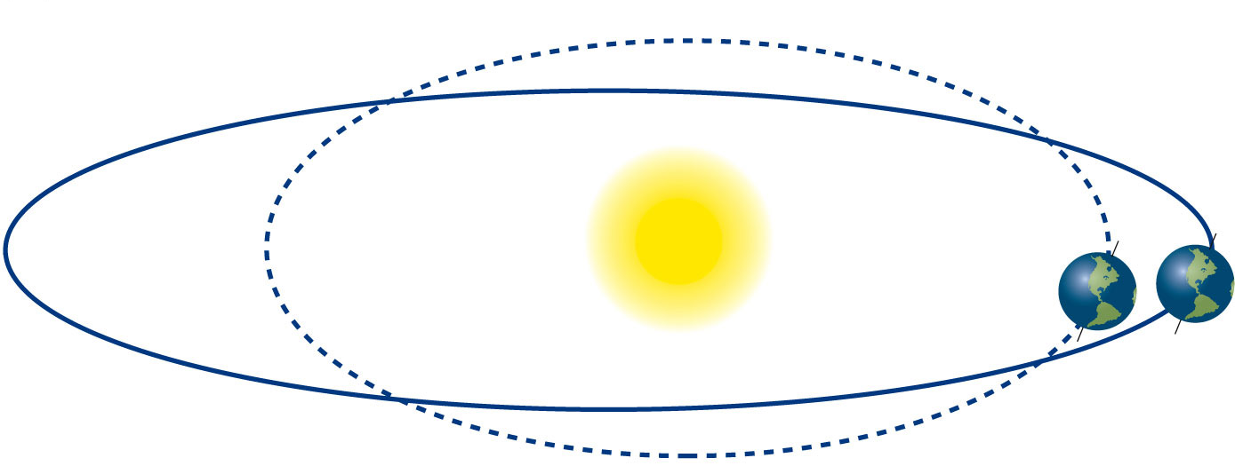
    - The glacial–interglacial cycles have been explained by regular changes in the shape of Earth’s orbit and the tilt of its axis—Milankovitch cycles:
    - The intensity of solar radiation reaching Earth changes, resulting in climatic change.

Lec 3 – Biosphere

- The biosphere is the zone of life on Earth
- Biomes are large-scale biological communities shaped by the physical environment, particularly climate. (e.g tundra, grasslands etc.)
  - Biomes are categorized by dominant plant forms, not taxonomic relationships.
- Convergence: Evolution of similar growth forms among distantly related species in response to similar selection pressures.
- Water availability and soil temperature determine the supply of nutrients in the soil.
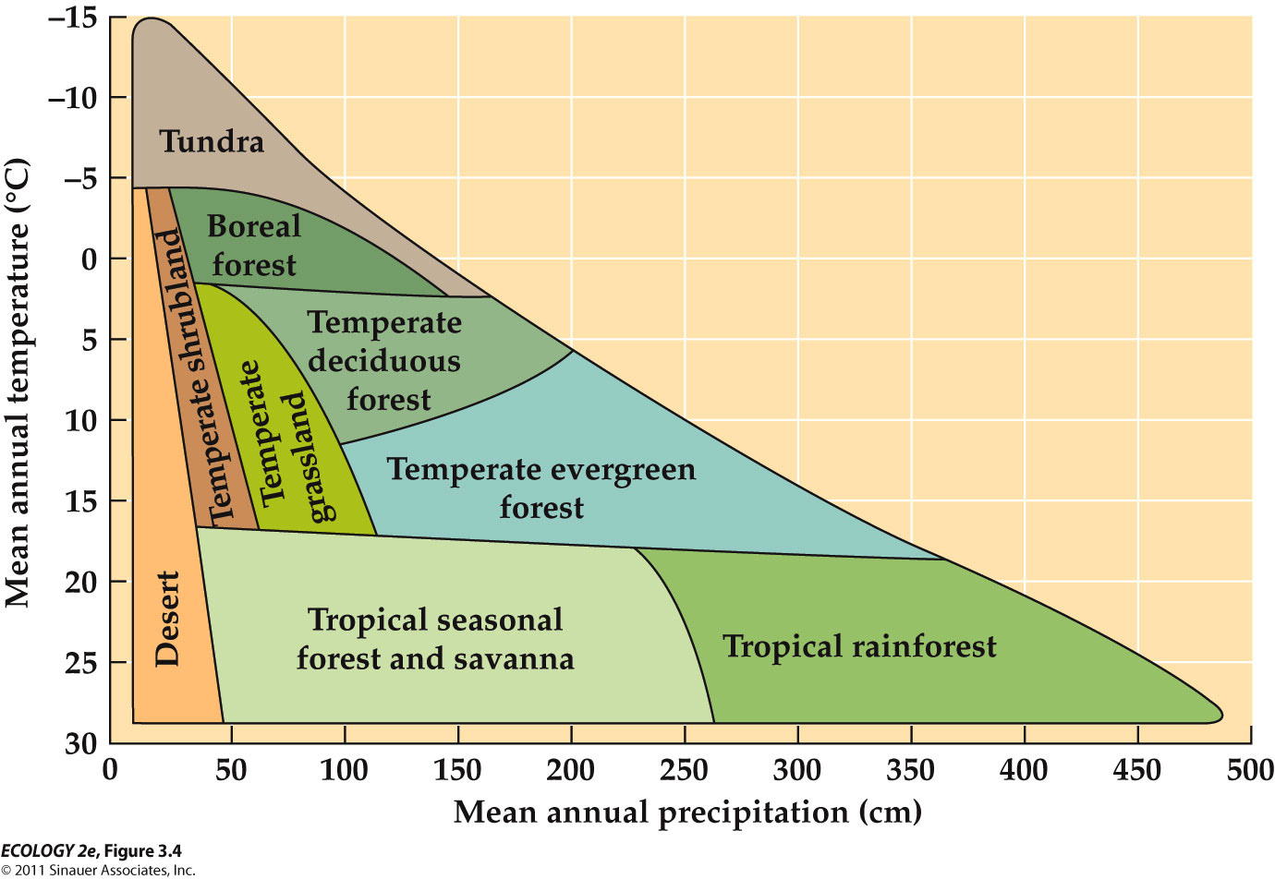
- Biomes Vary with Mean Annual Temperature and Precipitation
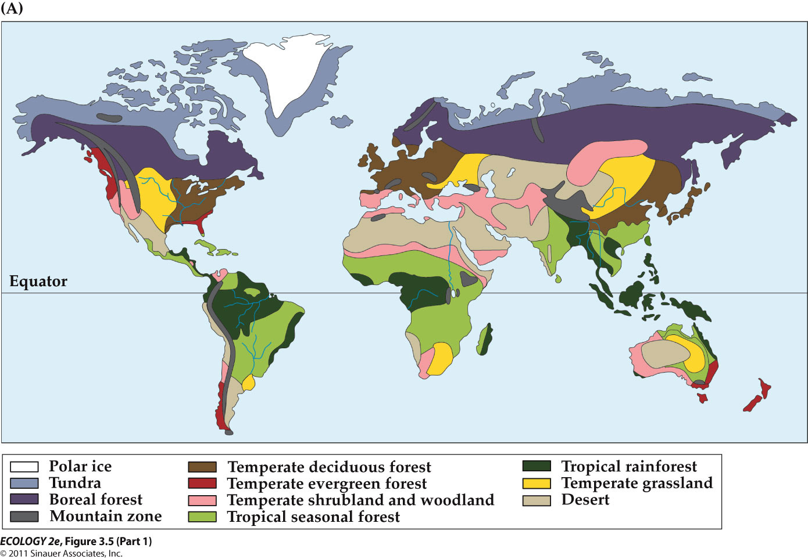

- Human activities influence the distribution of biomes.
  - Land use change: Conversion of land to agriculture, logging, resource extraction, urban development.
- There are nine major terrestrial biomes: Tropical Rainforests, Tropical Seasonal Forests/Savannas, Hot Deserts, Temperate Grasslands, Temperate Shrublands/Woodlands, Temperate Deciduous Forests, Temperate Evergreen Forests, Boreal Forests, Tundra
  - Tropical Rainforests:
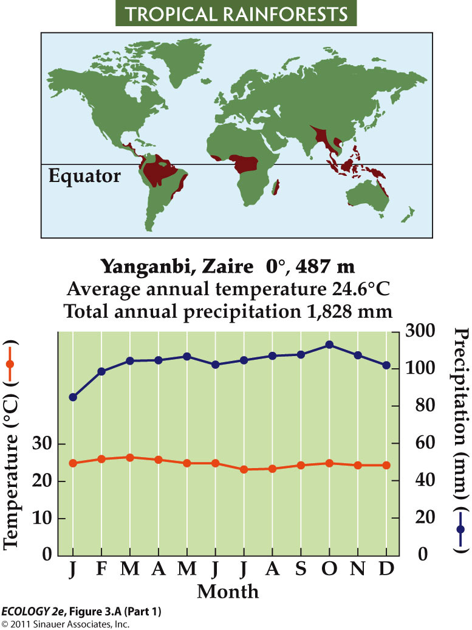
- High biomass, high diversity—about 50% of Earth’s species.
- Light is a key factor—plants must grow very tall above their neighbors or adjust to low light levels.
- About half of the tropical rainforest biome has been altered.

  - Tropical Seasonal Forest/Savannas
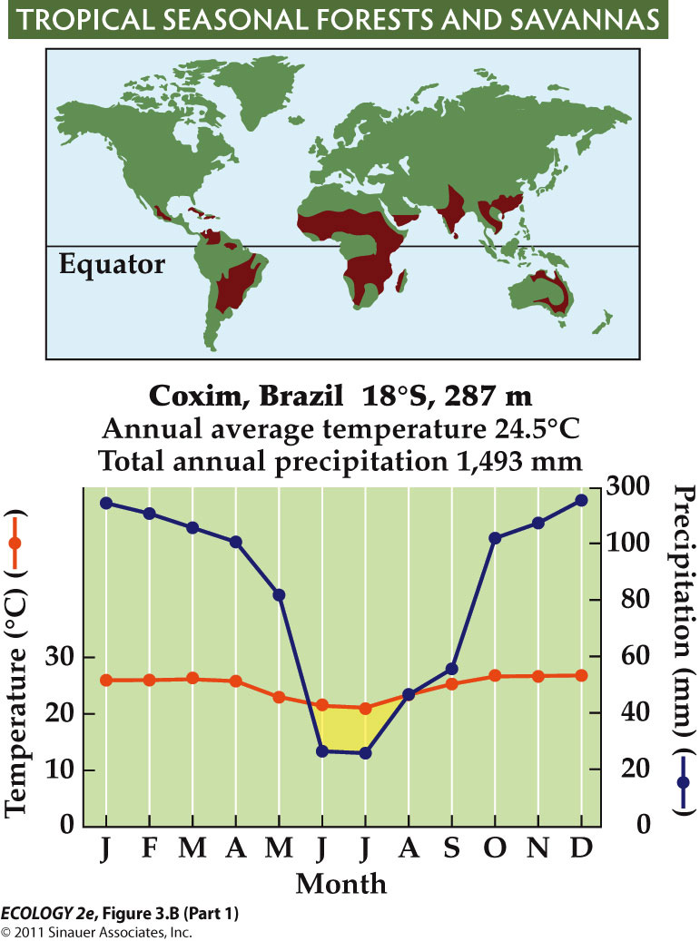
- Fires promote establishment of savannas; some are set by humans.
- In Africa, large herbivores—wildebeests, zebras, elephants, and antelopes—also influence the balance of grass and trees.
- On the Orinoco River floodplain, seasonal flooding promotes savannas.
- Less than half of seasonal tropical forests and savannas remain.
- Human population growth in this biome has had a major influence.

  - Hot Deserts
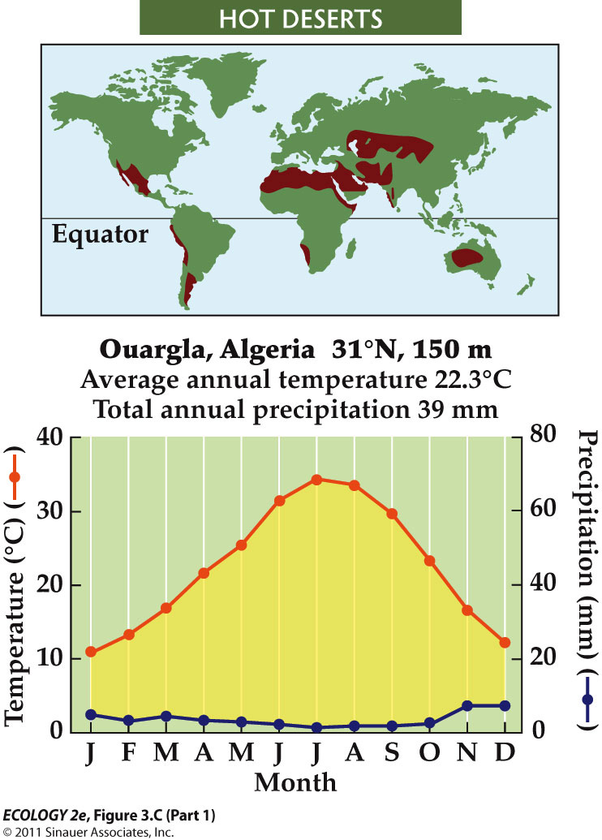
- Many plants have succulent stems that store water.
- Convergence of this form is shown by cacti (Western Hemisphere) and euphorbs (Eastern Hemisphere).
- Long-term droughts and unsustainable grazing can result in desertification—loss of plant cover and soil erosion.

- Temperate Grasslands
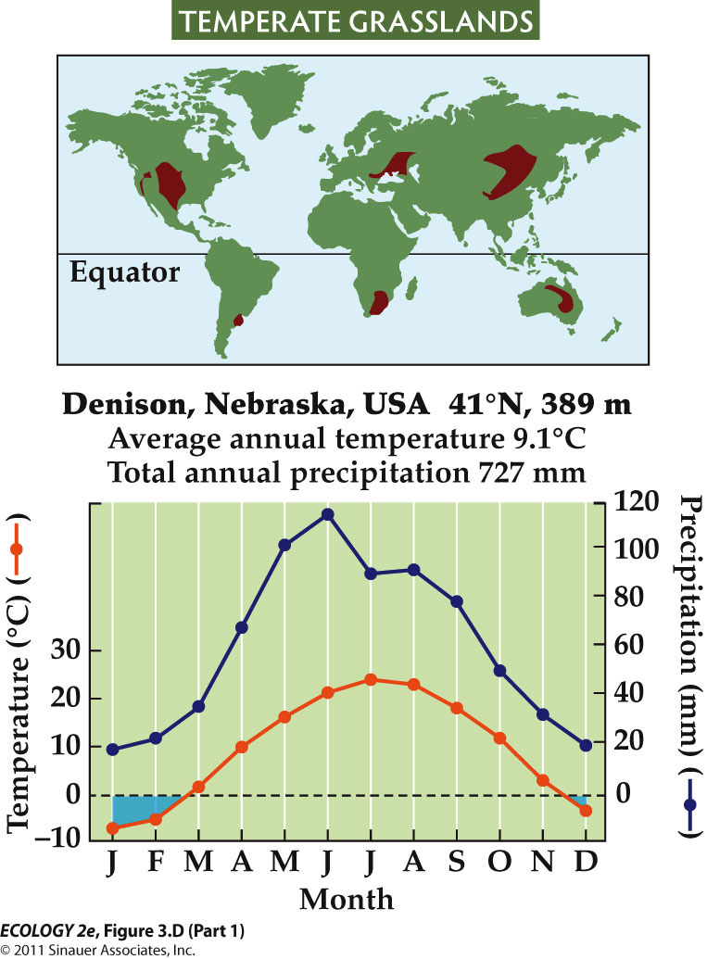
- Grasses dominate; maintained by frequent fires and large herbivores such as bison.
- Grasses grow more roots than stems and leaves, to cope with dry conditions.
- This results in accumulation of organic matter and high soil fertility.
- Most fertile grasslands of central North America and Eurasia have been converted to agriculture.
- In arid grasslands, grazing by domesticated animals can exceed capacity for regrowth, leading to grassland degradation and desertification.

- Temperate Shrublands/Woodlands

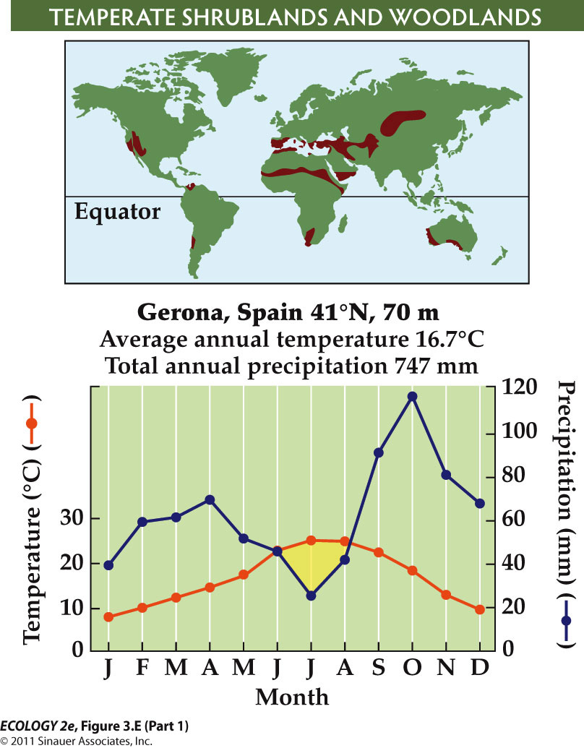
- Oddly green in the winter, and brown in the summer. Driest is summer, wettest is winter, opposite of every other biome
- Evergreen leaves allow plants to be active during cooler, wetter periods.
- They also lower nutrient requirements—the plants don’t have to develop new leaves every year.
- After fires, shrubs sprout from underground storage organs, or produce seeds that sprout and grow quickly.
- Without regular fires at 30–40-year intervals, shrublands may be replaced by forests.

- Temperate Deciduous Forest
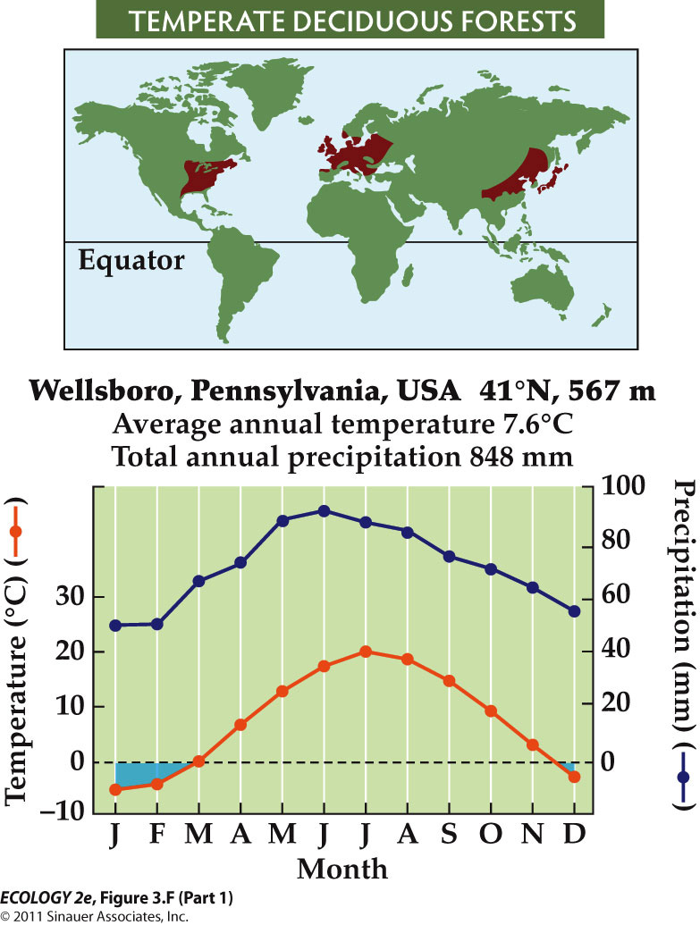
- Deciduous leaves in response to extended periods of freezing
- Fertile soils and climate make this biome good for agriculture. Very little old-growth temperate forest remains.
- As agriculture has shifted to the tropics, temperate forests have regrown.

- Temperate Evergreen Forests
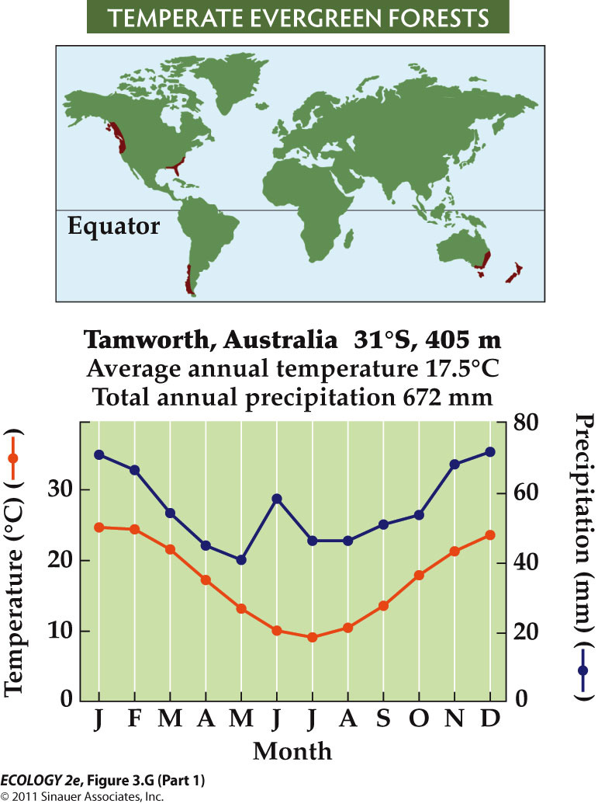
- Commonly found on nutrient-poor soils
- Evergreen trees are used for wood and paper pulp, and this biome has been logged extensively.
- Very little old-growth temperate evergreen forest remains.
- Suppression of fires in western North America has increased the density of forest stands, which results in more intense fires when they do occur.
- It also increases the spread of insect pests and pathogens.

- Boreal Forests
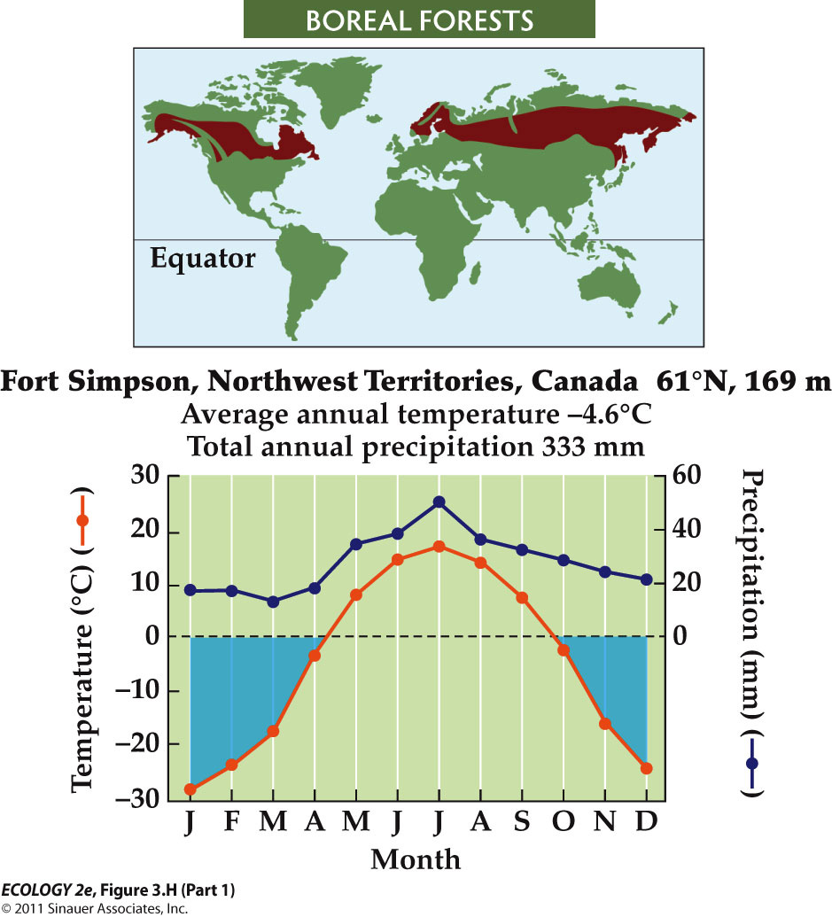
- Long, severe winters.
- Permafrost (soil that remains frozen year-round) prevents drainage and results in saturated soils.
- Trees are conifers—pines, spruces, larches.
- Cold, wet conditions in boreal soils limit decomposition, so soils have high organic matter.
- In summer droughts, forest fires can be set by lightning, and can burn both trees and soil.
- In low-lying areas, extensive peat bogs form.
- Boreal forests have not been as affected by human activities.

- Tundra
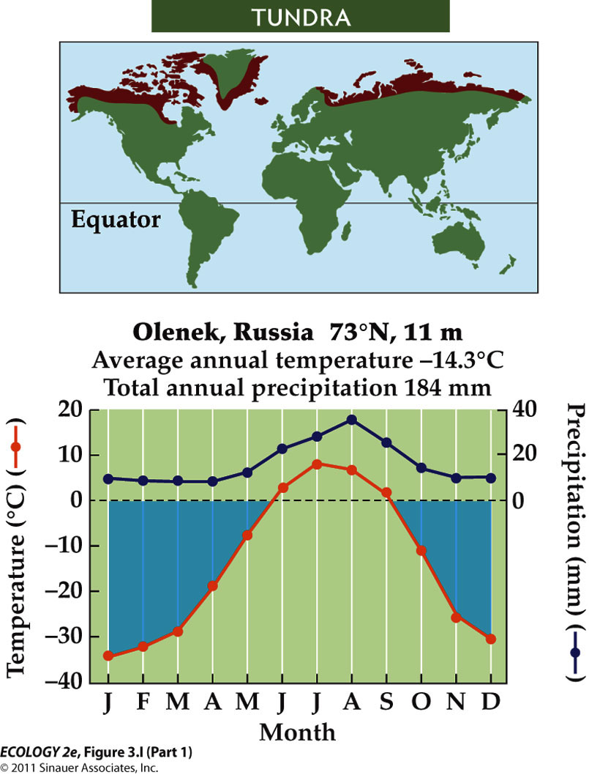
- Characterized by sedges, grasses, forbs and low growing shrubs
- The Arctic has experienced significant climate change, with warming almost double the global average.

- Mountain Biological Zones
  - On mountains, temperature and precipitation change with elevation, resulting in zones similar to biomes.
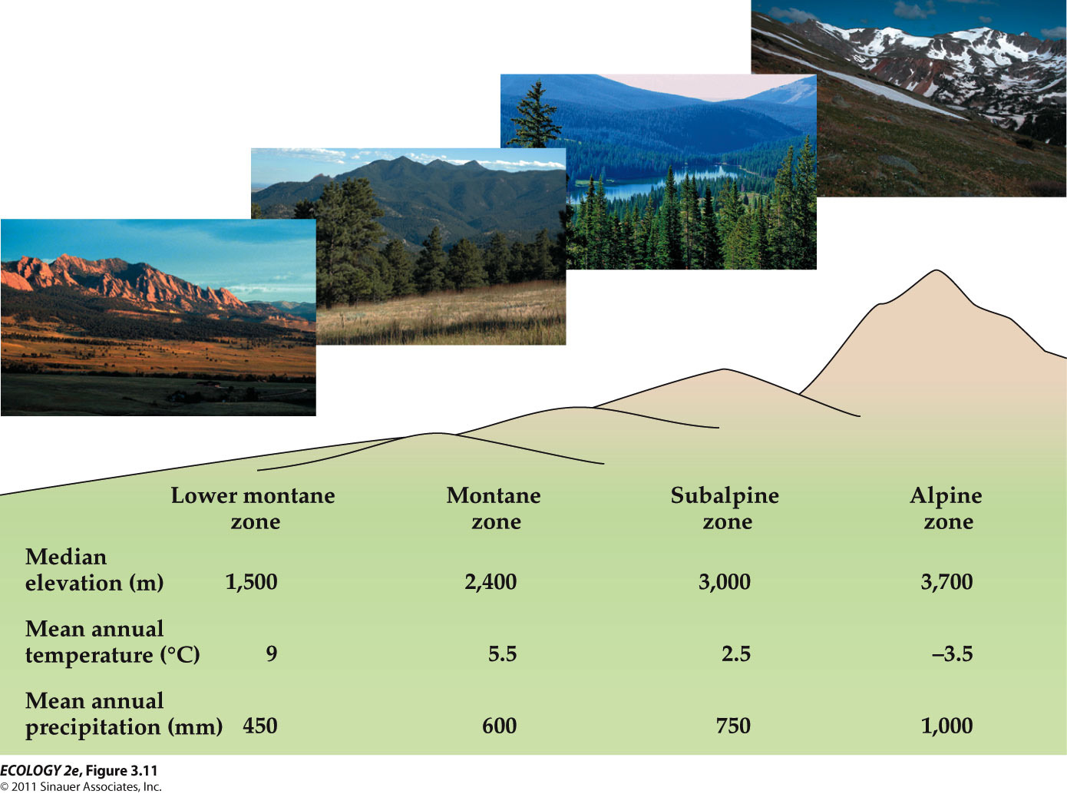
  - Smaller scale variations are associated with slope aspect, proximity to streams, and prevailing winds.

- Streams and rivers
  - Streams and rivers are lotic (flowing water) systems.
  - Benthic organisms are bottom dwellers, and include many kinds of invertebrates.
    - Some feed on detritus (dead organic matter), others are predators.
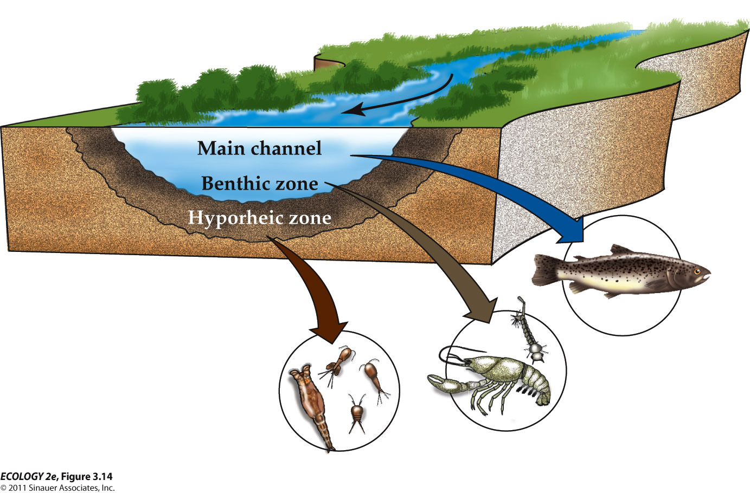
    - Some live in the hyporheic zone—the substratum below and adjacent to the stream.
  - Spatial Zonation of a Stream

  - Lakes and still waters (lentic) occur where depressions in the landscape fill with water.
    - The littoral zone is near shore, where the photic zone reaches the bottom. Macrophytes occur in this zone.
    - Pelagic zone: Open water; dominated by plankton (small and microscopic organisms suspended in the water). Open ocean beyond the continental shelves.
      - Phytoplankton are photosynthetic, restricted to the upper layers through which light penetrates (photic zone).
      - Zooplankton are non-photosynthetic protists and tiny animals.
    - The photic zone, which supports the highest densities of organisms, extends to about 200 m depth.
      - Below the photic zone, energy is supplied by falling detritus.

Lec 4 – Coping with Environmental Variation: Temperature and Water

- The physical environment influences an organism’s ecological success in two ways:
  - Availability of energy and resources—impacts growth and reproduction.
  - Extreme conditions can exceed tolerance limits and impact survival.
- Because plants don’t move, they are good indicators of the physical environment.
  - Example: Aspen distribution can be predicted based on climate. Low temperatures and drought affect reproduction and survival.
- Physiological ecology is the study of interactions between organisms and the physical environments that influence their survival and persistence.
- Physiological processes have optimal conditions for functioning.
  - Deviations from the optimum reduce the rate of the process.
  - Stress—environmental change results in decreased rates of physiological processes, lowering the potential for survival, growth, or reproduction.
- Acclimatization: Adjusting to stress through behavior or physiology.
  - It is usually a short-term, reversible process.
  - Acclimatization to high elevations involves higher breathing rates, greater production of red blood cells, and higher pulmonary blood pressure.
- Over time, natural selection can result in adaptation of a population to environmental stress.
  - Individuals with traits that enable them to cope with stress are favored. Over time, these genetic traits become more frequent in the population.
- Acclimatization and adaptation require investments of energy and resources, representing possible trade-offs with other functions that can also affect survival and reproduction.
- Ecotypes: Populations with adaptations to unique environments.
  - Ecotypes can eventually become separate species as populations diverge and become reproductively isolated.
- Temperature
  - Survival and functioning of organisms is strongly tied to their internal temperature.
  - Some archaea and bacteria in hot springs can function at 90°C.
  - Lower limits are determined by temperature at which water freezes in cells (–2 to –5°C).
  - Some species produce different forms of enzymes (isozymes) with different temperature optima that allow acclimatization to changing conditions.
  - Temperature also affects the properties of cell membranes, which are composed of two layers of lipid molecules.
- Ectotherms: Regulate body temperature through energy exchange with the external environment.
  - Ectotherm surface area-to-volume ratio of the body is an important factor in exchanging energy with the environment.
    - A larger surface area allows greater heat exchange, but makes it harder to maintain internal temperature.
    - Many insects and reptiles bask in the sun to warm up after a cold night. Because this increases risk from predators, many are camouflaged and can change coloration to match backgrounds.

- Endotherms: Rely primarily on internal heat generation—mostly birds and mammals.
  - Endotherms can remain active at subfreezing temperatures.
  - The cost of being endothermic is a high demand for energy (food) to support metabolic heat production.
  - Metabolic rates are a function of the external temperature and rate of heat loss.
  - Rate of heat loss is related to body size and surface area-to-volume ratio.
  - Small endotherms with large surface area-to-volume ratio have higher metabolic rates, and require more energy and higher feeding rates than large endotherms.

- Internal heat generation as defense
  - Bees can swarm a hornet and beat their wings to raise body temp, so inside the dome the hornet dies from overheating.
- A smaller surface area relative to volume decreases the animal’s ability to gain or lose heat.
  - As body size increases, surface area-to-volume ratio decreases, and large ectotherms are thus improbable.
    - This led to speculation that large dinosaurs may have had some degree of endothermy.
- In most organisms, freezing results in tissue damage as ice crystals perforate cell membranes and organelles.
  - *In animals that withstand freezing, the freezing water is limited to the space outside the cells.
    - Ice-nucleating proteins outside cells serve as sites of slow, controlled ice formation.
    - Additional solutes, such as glucose and glycerol are made inside the cells to lower the freezing point.
- Thermoneutral zone: The range of environmental temperatures over which a constant basal metabolic rate can be maintained.

- Lower critical temperature: When heat loss is greater than metabolic production; body temperature drops and metabolic heat generation increases.
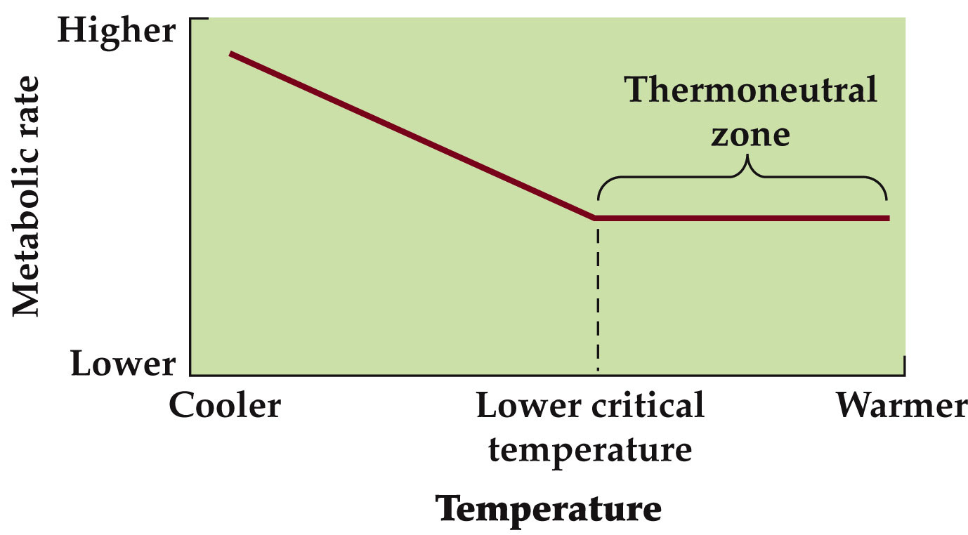
- Mammals in the Arctic have lower critical temperatures than mammals in tropical regions.
- The rate of metabolic activity increases more rapidly below the lower critical temperature in tropical mammals as compared to Arctic mammals.
- Some organisms can survive periods of extreme heat or cold by entering a state of dormancy, in which little or no metabolic activity occurs.
  - Small mammals have thin fur and not much fat for energy storage, but high demand for metabolic energy below the lower critical temperature.
    - They survive in cold climates by entering a dormant state called torpor. Body temperature and basal metabolic rates are low, which conserves energy.
    - Energy reserves are needed to come out of torpor. Small endotherms may undergo daily torpor to survive cold nights.
    - Longer periods of torpor, or hibernation, are possible for animals that can store enough energy.
- Heat stress in animals
  - Some organisms use behavioral changes to control exchange of energy with the environment.
  - Examples: Elephants swim and spray water onto their backs with their trunks to cool their bodies.
  - Ectotherms in hot environments can gain too much heat from the environment and body temperature can reach lethal levels.
- Water stress
  - Arid conditions are a widespread challenge for organisms.
  - Some tolerate dry conditions by going into suspended animation. Many microorganisms do this, as do some multicellular organisms
  - Reptiles are very successful in dry environments. They have thick skin with layers of dead cells, fatty coatings, and plates or scales.
  - Mammals and birds have thick skin plus fur or feathers to minimize water loss.
  - Sweat glands in mammals are a trade-off between water loss resistance and evaporative cooling.
- Energy Exchange in Terrestrial Plants
  - Conduction—transfer of energy from warmer to cooler molecules.
  - Convection—heat energy is carried by moving water or air.
  - Plants can adjust energy inputs and outputs.
    - Transpiration rates can be controlled by specialized guard cells surrounding leaf openings called stomates.
    - Variation in degree of opening and number of stomates control the rate of transpiration and thus leaf temperature.
  - Some plants shed their leaves during dry seasons.
  - Other mechanisms include pubescence—hairs on leaf surfaces that reflect solar energy. But hairs also reduce conductive heat loss.
  - If air temperature is lower than leaf temperature, heat can be lost by convection.
    - Convective heat loss is related to speed of air moving across a leaf surface.
    - Boundary layer: A zone of turbulent flow due to friction, next to the leaf surface.
      - The boundary layer lowers convective heat loss.
      - Boundary layer thickness is related to leaf size and surface roughness.
      - Small, smooth leaves have thin boundary layers and lose more heat than large or rough leaves.
    - In cold, windy environments, convection is the main heat loss mechanism.
    - Most alpine plants hug the ground surface to avoid high wind velocities.
    - Some have a layer of insulating hair to lower convective heat loss.

Lec 5 - Coping with Environmental Variation: Energy

- Some heterotrophs consume non-living organic matter.
- Parasites and herbivores consume live hosts, but do not necessarily kill them.
- Predators capture and consume live prey animals.
- Some plants are holoparasites: They have no photosynthetic pigments and get energy from other plants (heterotrophs).
  - Dodder is a holoparasite that is an agricultural pest and can significantly reduce biomass in the host plant.
- Mistletoe is a hemiparasite—it is photosynthetic, but obtains nutrients, water, and some of its energy from the host plant.
- Chemosynthesis (chemolithotrophy): Energy from inorganic compounds is used to produce carbohydrates.
  - Chemosynthesis is important in nutrient cycling bacteria, and in some ecosystems such as hydrothermal vent communities.
- Photosynthesis has two major steps:
  - Light reaction—light is harvested and used to split water and provide electrons to make ATP and NADPH.
  - Dark reaction—CO₂ is fixed in the Calvin cycle, and carbohydrates are synthesized.
  - Light response curves show the influence of light levels on photosynthetic rate.
  - Light compensation point: Where CO₂ uptake is balanced by CO₂ loss by respiration.
  - Saturation point: When photosynthesis no longer increases as light increases.
  - 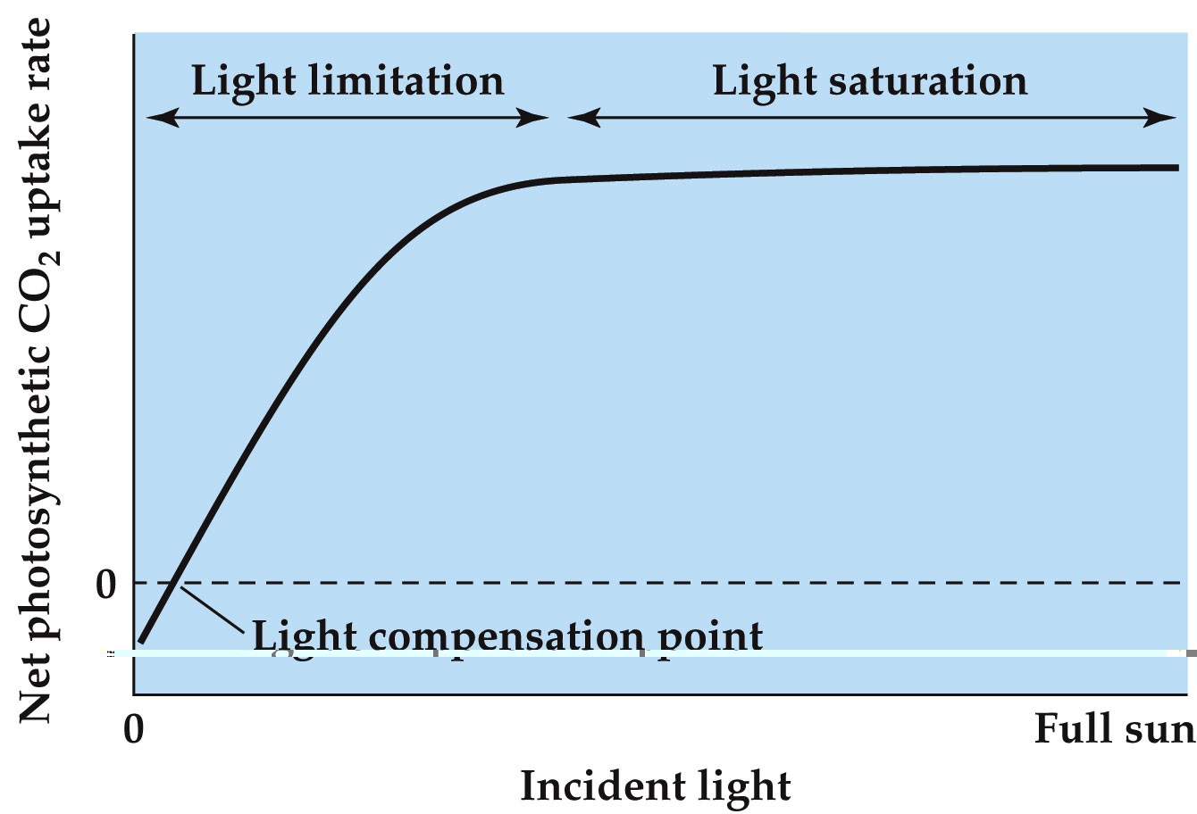
  - Plants can acclimatize to changing light intensities with shifts in light response curves.
  - Shifts in light saturation point involve morphological and physiological changes.

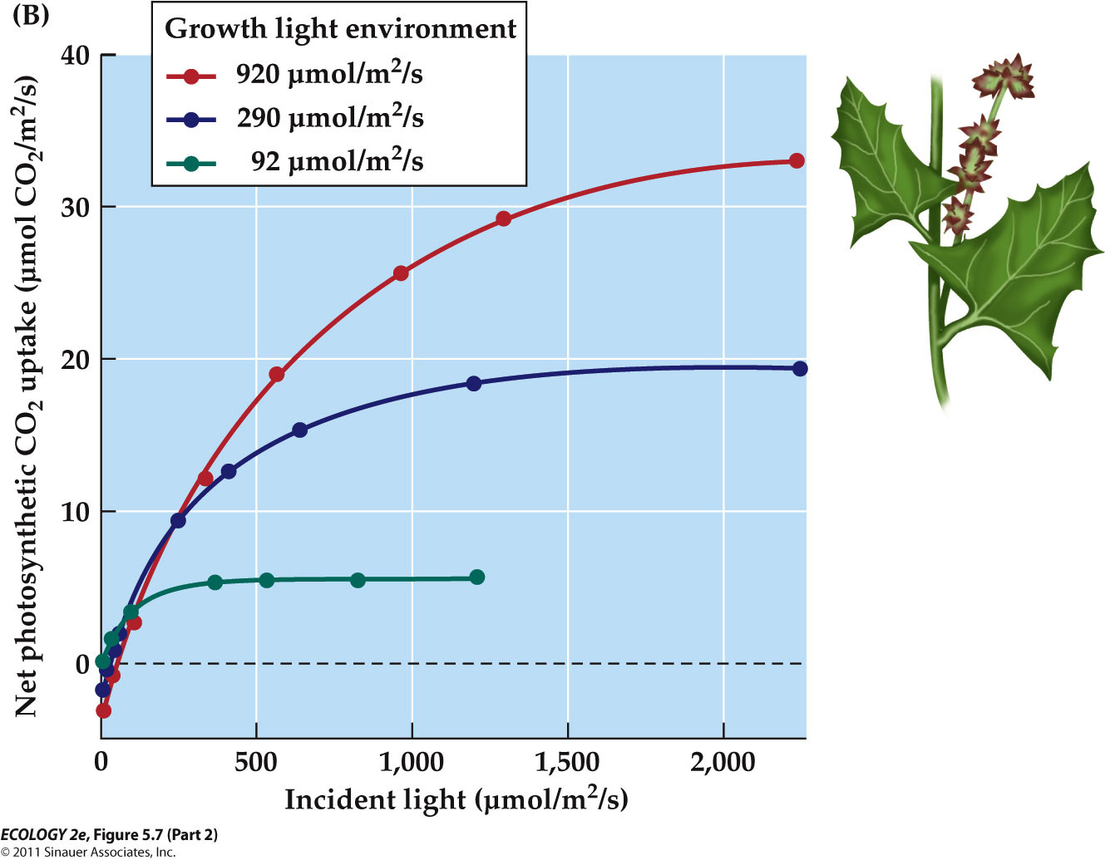

- Leaves at high light intensity may have thicker leaves and more chloroplasts.
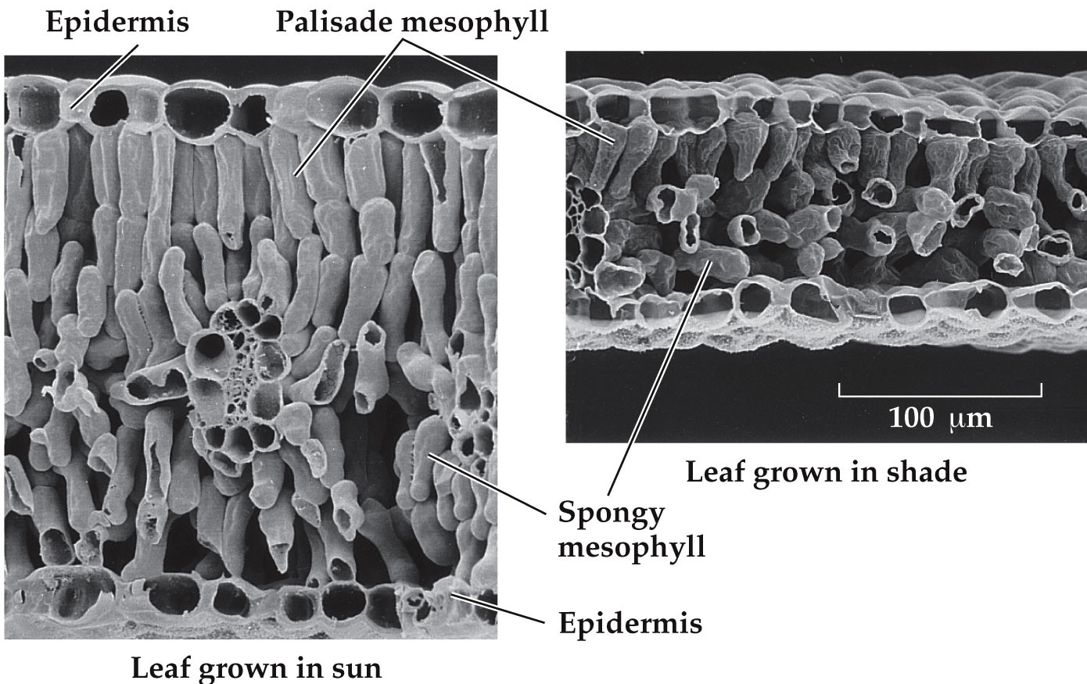

- Water availability influences CO₂ supply in terrestrial plants.
  - Low water availability causes stomates to close, restricting CO₂ uptake.
  - Closing stomates increases chance of light damage: If the Calvin cycle isn’t operating, energy accumulates in the light-harvesting arrays and can damage membranes.
  - Plants have various mechanisms to dissipate this energy, including carotenoids.
  - Plants from different climate zones have enzyme forms with different optimal temperatures that allow them to operate in that climate.
  - 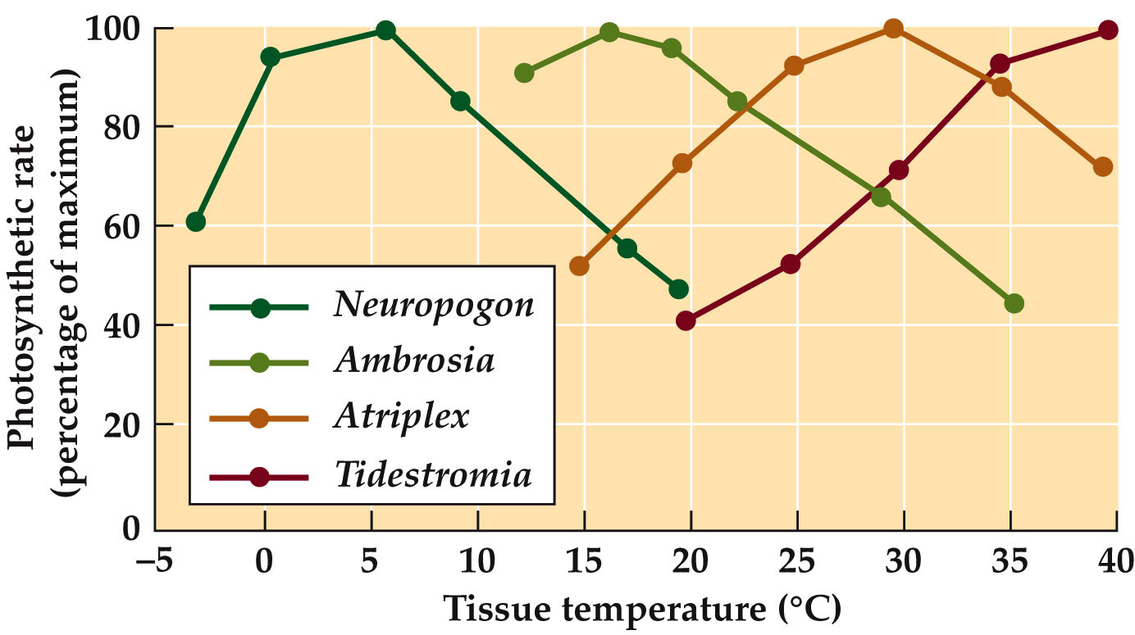
  - Nutrients can also affect photosynthesis:
    - Most nitrogen in plants is associated with rubisco and other photosynthetic enzymes.
    - Thus, higher nitrogen levels in a leaf are correlated with higher photosynthetic rates.

- Does photorespiration have any benefits?
  - Experiments with Arabidopsis thaliana plants with a mutation that knocks out photorespiration:
- These plants die under normal light and CO₂ conditions.
  - Altered tobacco plants with high rates of photorespiration showed less light damage than plants with normal or lowered photorespiration rates (Kozaki and Takeba 1996).
    - But photorespiration is not advantageous if CO₂ is low and temperatures high.
    - Such conditions existed 7 million years ago, when C₄ photosynthesis first appeared.
      - The C₄ photosynthetic pathway reduces photorespiration, and evolved independently several times.
        - Many grass species use this pathway, including corn, sugarcane, and sorghum. It involves biochemical and morphological specialization.
        - CO₂ uptake and the Calvin cycle occur in different parts of the leaf.
        - CO₂ is taken up in the mesophyll by PEPcase, which has greater affinity for CO₂, and does not take up O₂.
        - CO₂ concentration is increased in bundle sheath cells where rubisco is operating in the Calvin cycle, which reduces O₂ uptake by rubisco.
        - More ATP is required for the C₄ pathway, but higher photosynthetic efficiency gives these plants an advantage at high temperatures.
        - Transpiration losses are minimized because PEPcase can take up CO₂ even when stomates are not fully open.
        - If photosynthetic rates determine ecological success, climatic patterns should predict regions where C₄ plants will dominate.
        - There is a close correlation between temperature and the proportion of C₄ species in the community.

    - Crassulacean acid metabolism (CAM) minimizes water loss.
      - CO₂ uptake and the Calvin cycle are separated temporally.
      - CAM plants open their stomates at night when it’s cooler and humidity is higher, and close them during the day.
- Heterotrophs consume energy-rich organic compounds (food) and convert them into usable chemical energy (ATP).
  - Soil microorganisms that feed on detritus invest little energy to find food, but the food has low energy content.
  - A cheetah hunting a gazelle invests a lot of energy to find, chase, and kill its prey, but it gets an energy-rich meal.
- Humans view toolmaking as something that differentiates us from other animals.
  - But toolmaking in chimpanzees has been known since the 1920s.
  - Jane Goodall observed chimps in the wild using plant stems to retrieve termites from a mound.
  - Some birds also make tools.
    - Crows on South Pacific islands use tools to snag insects from decomposing trees (Hunt 1996).
    - The crows make two different kinds of tools from plant materials.
- Optimal foraging theory:
  - Animals will maximize the amount of energy gained per unit time, energy, and risk involved in finding food.
  - It assumes that evolution acts on the behavior of animals to maximize their energy gain.
  - Profitability of a food item (P) depends on how much energy (E) the animal gets from the food relative to the amount of time (t) it spends finding and obtaining the food:
  - Optimal foraging theory considers habitat to be heterogeneous—patches have different amounts of food.
  - To optimize energy gain, an animal should remain in a patch with the highest food density, until it becomes equal to nearby patches.

- Marginal value theorem (Charnov 1976):
  - An animal should stay in a patch until the rate of energy gain has declined to match the average rate for the whole habitat (giving up time).
  - Giving up time is also influenced by distance between patches.
  - The longer the travel time between food patches, the longer an animal should spend in a patch.
- Optimal foraging theory does not apply as well to animals that feed on mobile prey.
  - The assumption that energy is in short supply, and this dictates foraging behavior, may not always hold.
  - Resources other than energy can be important, such as nitrogen or sodium content of the food.

Lec 6 – Evolution and Ecology

- Trophy Hunting and Inadvertent Evolution: A Case Study
  - Bighorn sheep populations have been reduced by 90% by hunting, habitat loss, and introduction of cattle. Hunting is now restricted; permits for a large “trophy ram” cost over $100,000
  - Trophy hunting removes the largest and strongest males—the ones that would sire many healthy offspring.
  - In one population, 10% of males were removed by hunting each year, the average size of males and their horns decreased over 30 years of study.
  - African elephants are poached for ivory; the proportion of the population that have tusks is decreasing.
  - Rock shrimp are all born male, and become females when they are large enough to carry eggs. Commercial harvesting takes the largest individuals, which are all females.
    - Genes for switching sex at a smaller size became more common, resulting in more females, but smaller females lay fewer eggs.
- Mechanisms of Evolution
  - Natural selection, genetic drift, and gene flow can cause allele frequencies in a population to change over time.
  - Three types of natural selection:
    - Directional selection: Individuals at one phenotypic extreme (e.g., large size) are favored.
      - Example: Drought favored large beak size in medium ground finches.
    - Stabilizing selection: Individuals with an intermediate phenotype are favored.
      - Example: Parasitic wasps select for small gall size of Eurosta flies; while birds select for large gall size.
    - Disruptive selection: Individuals at both phenotypic extremes are favored.
      - Example: African seedcrackers (birds) have two food sources—hard seeds that large beaks are needed to crack, and smaller, softer seeds that smaller beaks are more suited to.
  - Genetic drift occurs when chance events determine which alleles are passed to the next generation.
    - It is significant only for small populations
    - Genetic drift has four effects on small populations:
      - It acts by chance alone, thus causing allele frequencies to fluctuate at random. Some may disappear, other may reach 100% frequency (fixation).
      - Because some alleles are lost, genetic variation of the population is reduced.
      - Frequency of harmful alleles can increase, if the alleles have only mildly deleterious effects.
      - Differences between populations can increase.

  - Gene flow: Alleles move between populations via movement of individuals or gametes.
    - Gene flow has two effects:
      - Populations become more similar.
      - New alleles can be introduced into a population.
    - In the 1960s, new alleles that provide resistance to insecticides arose by mutation in mosquitoes in Africa or Asia.
    - Mosquitos with the new alleles were blown by winds or transported by humans to new locations.
    - The allele frequency increases rapidly in populations exposed to insecticides.
  - Natural selection is the only evolutionary mechanism that consistently causes adaptive evolution.
    - Adaptations are features of organisms that improve their ability to survive and reproduce.
    - By consistently favoring individuals with certain alleles, natural selection causes adaptive evolution—traits that confer advantages tend to increase in frequency over time.
    - There are many examples of rapid adaptive evolution:
      - Antibiotic resistance in bacteria.
      - Insecticide resistance in insects.
      - Drab coloration in guppies, which makes them harder for predators to see.
      - Increased beak size in Geospiza finches.
      - Rapid adaptive evolution can happen on a continental scale.
        - Clines are patterns of change in a characteristic over a geographic region.
        - In Drosophila, the Adh^{S} allele of the alcohol dehydrogenase gene decreases in frequency as latitude increases.
          - Adh^{S} is less effective in colder temperatures, so natural selection resulted in this cline with latitude.

    - Gene flow can limit adaptation to local conditions.
    - Adaptive evolution can occur in a population if the natural selection forces are strong enough to overcome gene flow.
      - Bentgrass can grow in soils that are contaminated with heavy metals.
      - At former mine sites, the tolerant genotypes were dominant, but also occurred in populations growing in normal soils.
      - Bentgrass is wind-pollinated, so alleles are easily carried to other populations.
      - Plants at the mine site also received pollen (alleles) from the population on normal soils, but allele frequencies didn’t change—at the mine site there was very strong selection against plants without tolerance to heavy metals.
      - Natural selection was strong enough to overcome the effects of ongoing gene flow.
    - Natural selection does not result in a perfect match between organisms and their environments; environments are constantly changing, and there are constraints on evolution:
      - Lack of genetic variation: If there is no beneficial allele, adaptive evolution at that gene can not occur.
        - Example: Initially, mosquito populations lacked alleles for pesticide resistance so the pesticides were effective.
      - Evolutionary history: Natural selection works on traits that already exist.
        - Organisms have certain characteristics and lack others because of their ancestry.
        - Example: Dolphins evolved from terrestrial mammals; they have lungs and cannot “breathe” underwater.
      - Ecological trade-offs: The ability to perform one function may reduce the ability to perform another function.
        - Adaptations represent compromises in the abilities of organisms to perform different and sometimes conflicting functions.
  - Speciation: The process by which one species splits into two or more species.
    - Speciation most commonly occurs when a barrier prevents gene flow between two or more populations of a species.
    - Barriers can be geographic or ecological. The populations then diverge genetically over time.
    - The key step in speciation occurs when a population accumulates so many genetic differences that they cannot produce viable, fertile offspring if they mate with the parental species.
      - In some cases, a trait favored by selection is the same trait that drives speciation.
        - Example: Mosquitofish in pools with fish predators have evolved a body shape for high-speed escape swimming.
        - Female mosquitofish prefer to mate with males that have the same body shape as they do.
    - Genetic drift can also lead to evolution of reproductive barriers.
      - But gene flow slows down or prevents speciation.
      - Populations that exchange alleles tend to remain genetically similar, making evolution of reproductive barriers less likely.
    - The rise of new species in one group can lead to increased diversity of other groups.
      - Example: When apples were introduced into North America, some apple maggot fly populations switched to eating apples. These populations are probably forming a new species.
      - Populations of parasitic wasps that feed on apple maggot flies have also diverged and become reproductively isolated from the parent species.

  - Human actions can alter the course of evolution. Habitat fragmentation leaves isolated patches, which can affect evolutionary processes.
  - 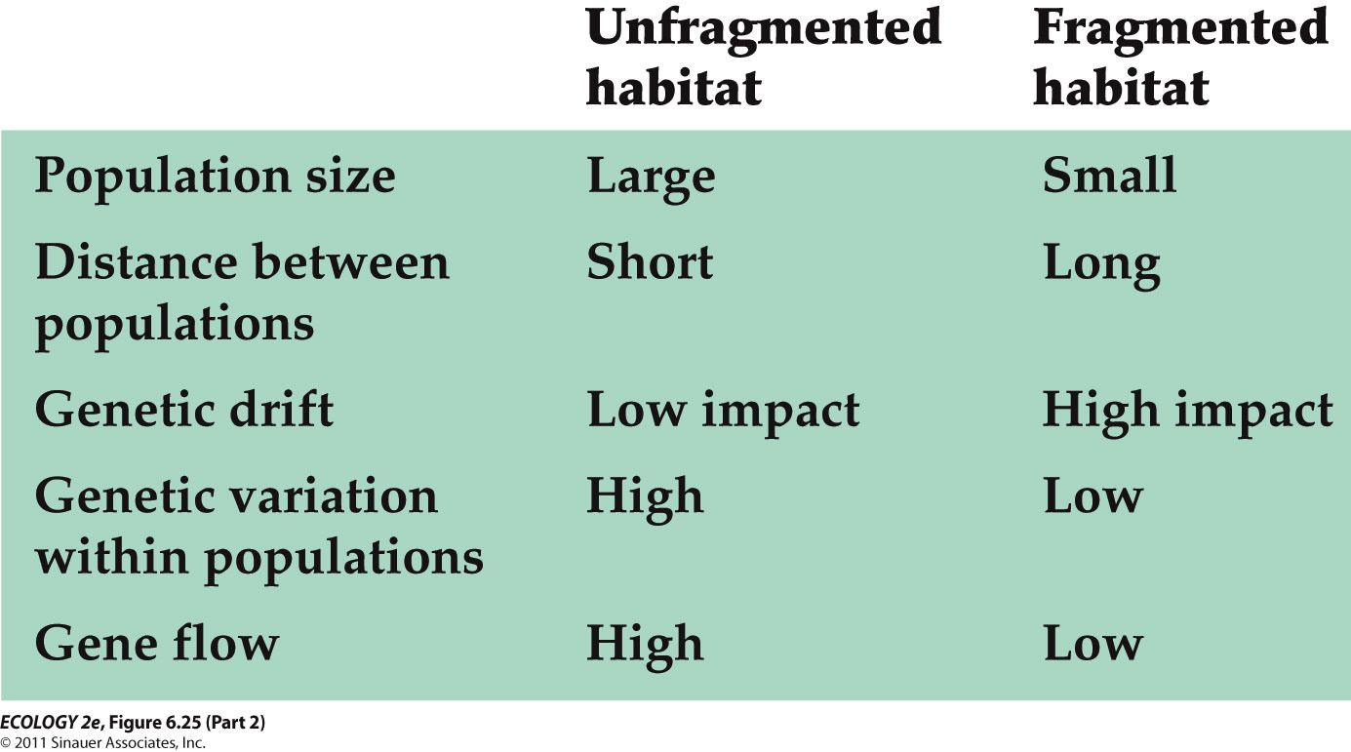

Lec 7 – Life History

- An organism’s life history is a record of events relating to its growth, development, reproduction, and survival.
- Life history characteristics include:
- Age and size at sexual maturity.
- Amount and timing of reproduction.
- Survival and mortality rates.
- Nemo Grows Up: A Case Study
  - In real life, two to six clownfish spend their entire adult lives within one sea anemone, but are not usually related.
  - The largest fish is a female; the next largest is the breeding male. The remaining fish are immature nonbreeders.
  - There is a strict pecking order in the group, based on body size.
  - If the female dies, the breeding male becomes a female, and the next largest fish becomes the breeding male.
  - Hatchlings move out of the anemone, and juveniles must find a new anemone to inhabit.
  - Experiments with clownfish show that hierarchy is maintained by regulating growth rates (Buston 2003).
    - If two fish become similar in size, a fight results and one is expelled from the anemone.
    - They are completely dependent on protection by the sea anemone.
    - They are easy prey outside the anemone.
    - Conflicts result in expulsion and death, probably without having reproduced.
    - So there is strong selection pressure to avoid conflict. Sea anemones are a scarce resource for clownfish.
    - Growth regulation mechanisms have evolved because individuals that avoid growing to a size that necessitates conflict are more likely to survive and reproduce.
- Life history strategy
  - overall pattern in average timing and nature of life history events.
  - It is shaped by the way the organism divides its time and energy between growth, reproduction, and survival.
  - Ideal or optimal life histories maximize fitness (genetic contribution to future generations).
    - But none are perfect; all organisms face constraints and ecological trade-offs.
  - Phenotypic plasticity: One genotype may produce different phenotypes under different environmental conditions.
    - For example, growth and development may be faster in higher temperatures.
    - Phenotypic plasticity may result in a continuous range of sizes; or discrete types called morphs.
    - Polyphenism—a single genotype produces several distinct morphs.
      - Spadefoot toad tadpoles have small omnivore morphs and larger carnivore morphs.
      - Carnivore tadpoles grow faster and metamorphose earlier. They are favored in ephemeral ponds that dry up quickly.
      - Omnivores grow more slowly and are favored in ponds that last longer; they metamorphose in more favorable conditions and have more chance of survival.
      - Different body morphology results from different growth rates of body parts in both the Ponderosa pines and spadefoot toads.
        - Allometry: Different body parts grow at different rates, resulting in differences in shape or proportion.
- Modes of Reproduction
  - Asexual reproduction: Simple cell division (binary fission)—all prokaryotes and many protists.
  - Benefits of sexual reproduction: Recombination promotes genetic variation and increased ability to respond to environmental challenges.
    - Disadvantages: An individual transmits only half of its genome to the next generation; population growth rate is slower.
  - Isogamy: Gametes are equal in size.
  - Anisogamy: Gametes of different sizes. Usually the egg is much larger and contains nutritional material.Most multicellular organisms produce anisogametes.
  - Some species have direct development—the fertilized egg develops into a juvenile without passing through a larval stage.
- Most vertebrates have simple life cycles without abrupt transitions. But complex life cycles are common in insects, marine invertebrates, amphibians, and in some plants, algae, protists and fishes.
  - Complex life cycles have at least two stages, with different body forms and that live in different habitats.
  - Metamorphosis: Abrupt transition in form between the larval and juvenile stages.
- Reproduction Amounts
  - Semelparous species reproduce only once. Including:
    - Annual plants.
    - Agave—vegetative growth can last up to 25 years (but also produces clones asexually).
  - Iteroparous species can reproduce multiple times. Including:
    - Trees such as pines and spruces.
    - Most large mammals.

- r-selection and K-selection describe two ends of a reproductive strategy continuum.
  - r is the intrinsic rate of increase of a population.
  - r-selection: For high population growth rates; an advantage in newly disturbed habitats and uncrowded condition.
  - r-selected (“live fast, die young”):
    - Short life spans, rapid development, early maturation, low parental investment, high reproduction rates.
    - Most insects, small vertebrates such as mice, weedy plant species.
  - K is the carrying capacity for a population.
  - K-selection: For slower growth rates in populations that are at or near K; this is an advantage in crowded conditions; efficient reproduction is favored.
  - K-selected (“slow and steady”):
    - Long-lived, develop slowly, late maturation, invest heavily in each offspring, low reproduction rates.
    - Large mammals, reptiles such as tortoises and crocodiles, and long-lived plants such as oak and maple trees.
- Stress vs. Disturbance
  - Stress—any abiotic factor that limits growth.
  - Disturbance—any process that destroys plant biomass.
  - Four habitat types possible:
    - Low stress, low disturbance.
      - Competitive plants with superior ability to acquire light, minerals, water, and space—have a selective advantage.
    - High stress, low disturbance.
      - Stress-tolerant plants with phenotypic plasticity, slow rates of water and nutrient use—not palatable to herbivores.
    - Low stress, high disturbance.
      - Ruderal plants with short life span, rapid growth rates, heavy investment in seed production.
      - Can exploit habitats after disturbance has removed competitors.
      - Seeds can survive a long time until conditions are right for rapid germination and growth.

    - High stress, high disturbance—not suitable for plant growth.
- Trade-Offs
  - Trade-offs: Organisms allocate limited energy or resources to one function at the expense of another.
  - Trade-offs between size and number of offspring:
    - The larger the investment in each individual offspring, the fewer offspring can be produced.
    - Investments: Energy, resources, and loss of time for other activities such as foraging.
  - “Lack clutch size”: Maximum number of offspring a parent can successfully raise to maturity.
    - Named for David Lack (1947) who noticed that bird’s clutch size increases with latitude; longer daylight hours may allow parents more time to forage and feed more offspring.
    - Experimental manipulation of clutch size in lesser black-backed gulls showed that in larger clutches, offspring have less chance of survival.
  - In species without parental care, resources are invested in propagules (eggs or seeds). Size of the propagule is a trade-off with the number produced.
  - Experiments by Sinervo (1990) on lizard eggs showed that smaller eggs developed faster and produced smaller hatchlings, but small hatchlings were not able to sprint as fast to escape predators.
    - Selection may favor early hatching in northern populations, because of shorter growing seasons. Faster sprinting speed may be favored in southern populations where there are more predators.
  - Trade-offs between current and future reproduction:
    - For an iteroparous organism, the earlier it reproduces, the more times it can reproduce over its lifetime.
    - But the number of offspring produced often increases with size and age of the organism.
    - Atlantic cod females produce more eggs as they grow larger. Commercial fishing removes older, larger fish, favoring fish that reproduce earlier at smaller sizes (evolutionary change)
      - It may be advantageous to delay reproduction and invest more energy in growth and survival in order to increase lifetime reproductive output.
      - Example: A fish with a 5-year lifespan can increase its total reproductive output by delaying maturation by one year.
    - If adult survival rates are low, future reproduction may never occur, so early reproduction rather than growth would be favored.
    - If adult survival rates are high with long life spans, or fecundity increases with body size, it makes sense to allocate energy to growth rather than reproduction.
    - Senescence: Decline in physiological function with age.
      - Onset can set an upper age limit for reproduction.
      - Semelparous species undergo very rapid senescence and death following reproduction.
      - In some large social mammals, such as humans and elephants, senescence is long.
        - But, postreproductive individuals contribute to the group’s welfare by parental and grandparental care and other ways.
      - Senescence may occur earlier in populations with high mortality rates or predation.
        - In guppy populations with high mortality rates, they may be investing less energy in immune system development, resulting in higher rates of senescence due to disease.

- Life Cycle Evolution
  - As selection pressures change, different morphologies and behaviors are adaptive at different life cycle stages.
  - Small early life stages can be vulnerable to predation and competition for food.
    - But small size can allow early stages to do things that adult stages can’t.
    - Organisms have various mechanisms to protect the small life stages.
      - Parental Investment:
Provisioning eggs or embryos—yolk and protective coverings for eggs, nutrient-rich endosperm in plant seeds.
      - Parental care—invest time and energy to feed and protect offspring.
  - Dispersal and Dormancy:
    - Small offspring are well-suited for dispersal.
    - Dispersal can reduce competition among close relatives, allow colonization of new areas, and allow escape from areas with diseases or high predation.
    - Sessile organisms such as plants, fungi, and marine invertebrates disperse as pollen, seeds, spores, gametes, or larvae
    - Dormancy: State of suspended growth and development in which an organism can survive unfavorable conditions.
      - Small seeds, spores, eggs, and embryos are best suited to dormancy—less metabolic energy is needed to stay alive.
      - But some larger animals also enter dormancy.
  - Complex life cycles may result from stage-specific selection pressures, and help minimize the drawbacks of small, vulnerable early stages.
    - Functional specialization of stages is a common feature of complex life cycles.
    - In many insects the larval stage stays in a small area, such as on a single plant.
    - The larvae are specialized for feeding and growth. The adult is specialized for dispersal and reproduction.
      - In marine invertebrates, larvae are specialized for both feeding and dispersal in ocean currents. Many larvae have specialized ciliated bands for feeding, or they may also have spines, or other structures to deter predators.

Lec 8 – Population Distribution and Abundance

- Population: Group of interacting individuals of the same species living in a particular area.
  - Interactions within populations include sexual reproduction and competition.
- Distribution: Geographic area where individuals of a species occur.
- Abundance: Number of individuals in a given area.
  - Abundance can be reported as population size (# of individuals), or density (# of individuals per unit area).
- Species vary in their ability to disperse.
  - In plants, dispersal occurs by seed movement. The distance moved can be very small.
  - Other species, such as whales, can move thousands of kilometers in a year.
- For some species, it’s hard to determine what an individual is.
  - Individuals can be defined as products of a single fertilization: The aspen(tree) grove would be a single genetic individual, or genet.
  - If members of a genet are independent physiologically, each member is called a ramet.
- The distributions and abundances of organisms are limited by habitat suitability, historical factors, and dispersal.
  - Habitat Suitability
    - Abiotic features: Moisture, temperature, pH, sunlight, nutrients, etc.
    - Some species can tolerate broad ranges of physical conditions, others have narrow ranges.
    - Biotic features: Organisms are affected by herbivores, predators, competitors, parasites, and pathogens.
      - In Australia, an introduced cactus became a pest species, spreading over vast areas.
      - A moth that feeds on cactus was then released, and distribution and abundance of the cactus has been greatly reduced.
  - Some species distributions depend on disturbance—events that kill or damage some individuals, creating opportunities for other individuals to grow and reproduce.
    - Example: Some species persist only where there are periodic fires.
  - Historical Factors
    - Evolutionary history and geologic events affect modern distribution of species.
    - Example: Polar bears evolved from brown bears in the Arctic. They are not found in Antarctica because of an inability to disperse through tropical regions.
  - Dispersal
    - Dispersal limitation can prevent species from reaching areas of suitable habitat.
    - Example: The Hawaiian Islands have only one native mammal, the hoary bat, which was able to fly there.

- Geographic range—the entire geographic region over which a species is found.
  - Few species are found on all continents except humans, Norway rats, and the bacterium E. coli.
- Dispersion: Spatial arrangement of individuals within a population:
  - The dispersion of individuals within a population depends on the location of essential resources, competition, dispersal, and behavioral interactions
  - Regular—individuals are evenly spaced.
  - Random—individuals scattered randomly.
  - Clumped—the most common pattern.
    - In high quality territories, cooperative breeding occurs—young birds postpone breeding and instead help their parents raise more offspring.
    - The high quality sites attract more birds and can result in clumped dispersions.
      - Cooperative breeding is advantageous when high-quality territories are scarce.
      - A young bird will survive and produce more offspring over its lifetime if it stays to help the parents, and delays breeding.
      - If high-quality territories are abundant, cooperative breeding is not favored.
- Estimating Abundances and Distributions
  - Population abundances and distributions can be estimated with area-based counts, distance methods, mark–recapture studies, and niche modeling.
  - Complete counts of individual organisms in a population are often difficult or impossible.
  - Several methods are used to estimate the actual abundance or absolute population size.
    - Relative population size: Number of individuals in one time period or place relative to the number in another.
      - Estimates are based on data presumed to be related to absolute population size.
      - Examples: Number of cougar tracks in a given area, or number of fish caught per unit of effort.
      - Interpretation of relative population size can be tricky.
      - Example: Number of cougar tracks is related to population density, but also activity levels of individuals.
    - Area-based counts
      - Used most often to estimate abundance of immobile organisms.
      - Quadrants: Sampling areas of specific size, such as 1 m².
        - Individuals are counted in several quadrants; the counts are averaged to estimate population size.
    - Distance methods
      - Distances of individuals from a line or point are converted into estimates of abundance.
    - Line transects:
      - Observer travels along line and counts individuals and their distance from the line.
    - Mark–recapture studies:
      - Used for mobile organisms.
      - A subset of individuals is captured and marked or tagged, then released.
      - At a later date, individuals are captured again, and the ratio of marked to unmarked individuals is used to estimate population size.
- Niche Modeling
  - Ecological niche: Physical and biological conditions that a species needs to grow, survive, and reproduce.
  - A niche model predicts a species’ distribution based on conditions at locations the species is known to occupy.
  - A computer program (GARP) compared grid cell data with habitat rules for each species. Predictions of species occurrences were correct 75–85% of the time.
  - In areas where predictions were not correct, researchers found seven previously unknown chameleon species.

Lec 9 - Population Growth and Regulation

- Human Population Growth: A Case Study
  - Humans have a large impact on the global environment: Our population has grown explosively, along with our use of energy and resources.
  - Human population reached 6.8 billion in 2010, more than double the number of people in 1960.
  - For thousands of years our population grew relatively slowly, reaching 1 billion for the first time in 1825. Now we are adding 1 billion people every 13 years since the Industrial Revolution.
  - Growth rate has slowed recently, to about 1.18% per year, and continues to slow.
  - By 2080, it is predicted there will be roughly 9–10 billion people on Earth.
  - Is 10 billion above the carrying capacity of the human population?
    - Many people have tried to estimate human carrying capacity.
    - Researchers must make assumptions about how people would live and how technology would influence our future.
    - Estimates range from fewer than 1 billion to more than 1,000 billion.
  - Ecological footprint:
    - Total area of productive ecosystems required to support a population.
    - In 2006:
      - 11.9 billion hectares of productive land available globally.
      - Average ecological footprint: 2.6 hectares.
      - Suggests a carrying capacity of 4.6 billion.
      - Population: 6.6 billion, a 40% overshoot of carrying capacity.
      - If everyone in the world used resources at the same rate as:
        - U.S. citizens in 2006, carrying capacity would be 1.3 billion people.
        - Indian citizens in 2006, carrying capacity would be 14 billion people.
      - One of the ecological maxims is: “No population can increase in size forever.”
        - The limits imposed by a finite planet restrict a feature of all species: A capacity for rapid population growth.

  - Life table
    - A summary of how survival and reproductive rates vary with age.
    - Information about births and deaths is essential to predict future population size.
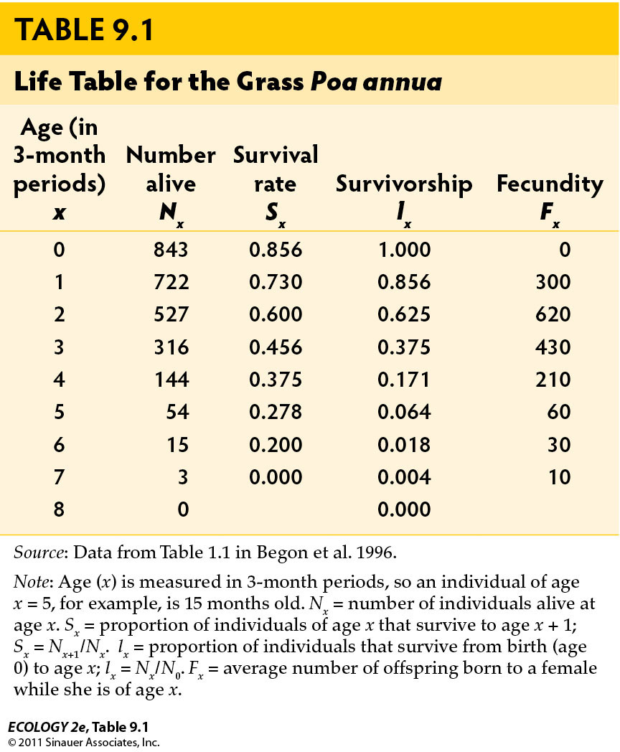

- Sx = survival rate: Chance that an individual of age x will survive to age x + 1.
- lx = survivorship: Proportion of individuals that survive from birth to age x.
- Fx = fecundity: Average number of offspring a female will have at age x.
- Birth and death rates can vary greatly between individuals of different ages.
  - Gambians’ survivorship depends on the season of birth.
  - Gambians born during the “hungry season” (when food stored from the previous year is depleted) had lower survivorship than those born at other times of the year.
- In some species, age is not important, e.g., in many plants, reproduction is more dependent on size (related to growth conditions) than age.
- Life tables can also be based on size or life cycle stage
- Survivorship curve:
  - Plot of the number of individuals from a hypothetical cohort that will survive to reach different ages.
  - Survivorship curves can be classified into three general types.
  - Type I: Most individuals survive to old age (Dall sheep, humans).
  - Type II: The chance of surviving remains constant throughout the lifetime (some birds).
  - Type III: High death rates for young, those that reach adulthood survive well (species that produce a lot of offspring).
- A population can be characterized by its age structure
  - the proportion of the population in each age class.
  - Age structure influences how fast a population will grow.
    - If there are many people of reproductive age (15 to 30), it will grow rapidly.
    - A population with many people older than 55 will grow more slowly.
  - Growth rate (λ): Ratio of population size in year t + 1 (N_{t+1}) to population size in year t (N_{t}).
    - If survival or fecundity rates change, population growth rate will change.
    - Example: If F₁ changes from 2 to 5.07 (and other values stay the same), λ increases to 2.0.
      - Age distribution would also change.
- Geometric growth and exponential growth can lead to rapid increases in population size.
  - Geometric growth: If a population reproduces in synchrony at discrete time periods and growth rate doesn’t change.
    - The population increases by a constant proportion: The number of individuals added is larger with each time period.
  - Exponential growth: When individuals reproduce continuously, and generations can overlap.
    - If a population is growing geometrically or exponentially, a plot of the natural logarithm of population size versus time will result in a straight line.
  - In natural populations, favorable conditions result in exponential growth, but it cannot continue indefinitely.
    - There are limits to population growth.
- Effects of Density
  - Population size can be determined by density-dependent and density-independent factors.
    - Density-independent factors
      - Effects on birth and death rates are independent of the number of individuals in the population:
      - Temperature and precipitation, catastrophes such as floods or hurricanes.
    - Density-dependent factors
      - Birth, death, and dispersal rates change as the density of the population changes.
      - As density increases, birth rates often decrease, death rates increase, and dispersal (emigration) increases, all of which tend to decrease population size.

- Population regulation
  - Density-dependent factors cause population to increase when density is low and decrease when density is high.
  - Ultimately, food, space, or other resources are in short supply and population size decreases.
  - Density-independent factors can have large effects on population size, but do not regulate population size.
- Logistic growth: Population increases rapidly, then stabilizes at the carrying capacity (maximum population size that can be supported indefinitely by the environment).
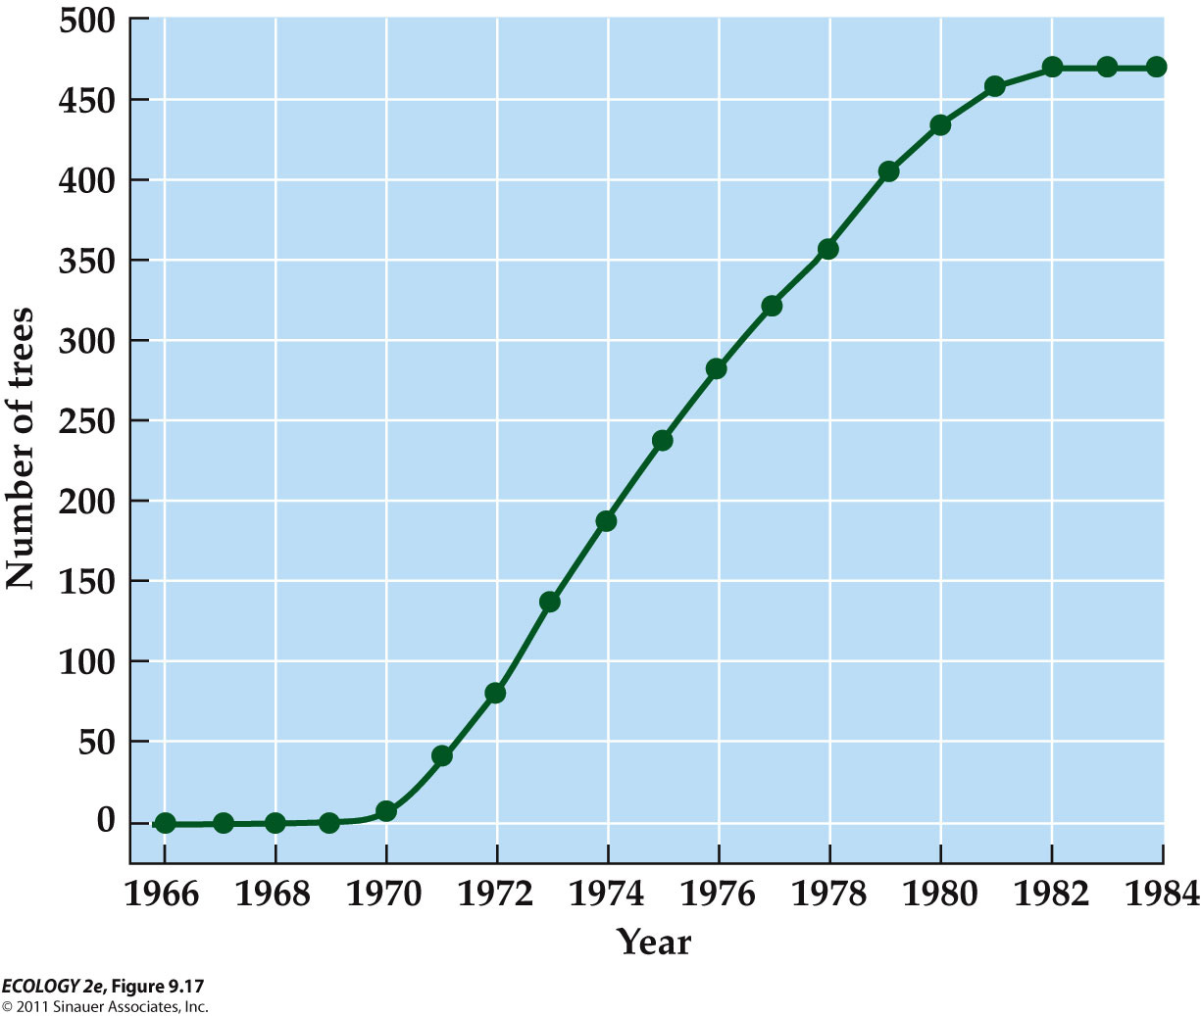

- The growth rate decreases as population nears carrying capacity because resources begin to run short.
- At carrying capacity, the growth rate is zero, so population size does not change.
- When densities are low, logistic growth is similar to exponential growth.
- As density increases, growth rate approaches zero as population nears K(carrying capacity).

Lec 10 - Population Dynamics

- Population dynamics: The ways in which populations change in abundance over time.
- Population size changes as a result of four processes: Birth, death, immigration, and emigration.
- Patterns of Population Growth
  - Populations exhibit a wide range of growth patterns, including exponential growth, logistic growth, fluctuations, and regular cycles.
    - These four patterns are not mutually exclusive. A single population can experience each of them at different times.
    - Exponential Growth
      - Population increases by a constant proportion at each point in time.
      - When conditions are favorable, a population can increase exponentially for a limited time. When a species reaches a new area, exponential growth can occur if conditions are favorable.
      - The population may grow exponentially until density-dependent factors regulate its numbers.
      - Species such as the cattle egret colonize new regions by long-distance or jump dispersal events.
      - Local populations then expand by short-distance dispersal events.
    - Logistic Growth
      - These populations first increase, then fluctuate by a small amount around the carrying capacity.
      - Plots of real populations rarely match the logistic curve exactly.
      - “Logistic growth” is used broadly to indicate any population that increases initially, then levels off at the carrying capacity.
      - For K (carrying capacity) to be constant, birth rates and death rates must be constant over time at any given density.
        - This rarely happens in nature. Birth and death rates do vary over time, thus we expect carrying capacity to fluctuate.
    - Population Fluctuations
      - In all populations, numbers rise and fall over time.
      - Fluctuations can be deviations from a growth pattern, e.g., the Tasmanian sheep population
      - or erratic - In Lake Erie phytoplankton populations, fluctuating abundance could reflect changes in environmental factors such as nutrient supplies, temperature, or predator abundance.
    - Population outbreak - # of individuals increases rapidly
      - An ongoing outbreak of the mountain pine beetle has killed hundreds of millions of trees across British Columbia. This has altered forest composition, and CO₂ is released as the trees decay—17.6 megatons every year.
    - Population Cycles
      - Some populations have alternating periods of high and low abundance at regular intervals.
      - Populations of small rodents, such as lemmings and voles, typically reach a peak every 3–5 years.
      - Different factors may drive population cycles in rodents.
      - Some population cycles may stop if certain environmental factors change.
      - Warmer winter temperatures affect snow conditions at high latitudes, making it more difficult for lemmings to feed and avoid predators. Their populations have stopped cycling every 3 to 4 years.
        - Subnivian environment is between snow and ground, lemmings can hide there and feed there, so it keeps them safe in mild winter.
- Delayed density dependence:
  - Delays in the effect that density has on population size.
  - Commonly, the number of individuals born in a given time period is influenced by population densities that were present several time periods ago.
  - Delayed density dependence can cause populations to fluctuate in size.
  - Example: A predator reproduces more slowly than its prey.
    - If predator population is small, prey population may increase, then the predators will increase, but with a time lag.
    - Many predators may reduce the prey population, and then the predator population will decease again.
  - The logistic equation can be modified to include time lags
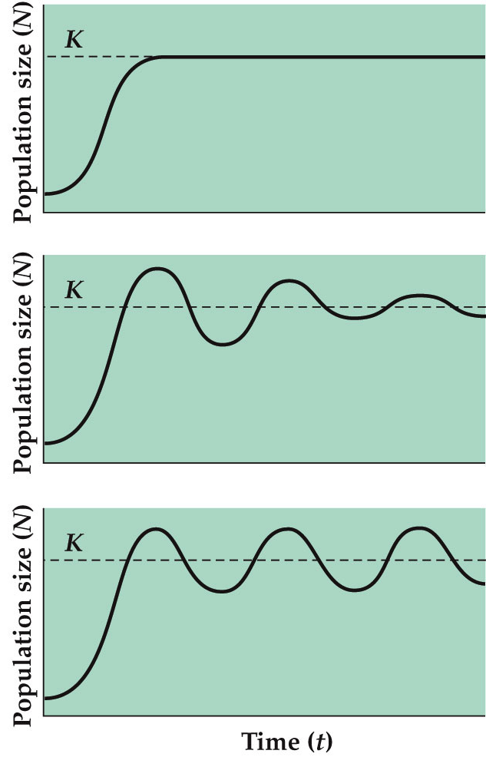
damped
oscillations
stable limit
cycle

- Population Extinction
  - The risk of extinction increases greatly in small populations.
  - Fluctuations in growth rate, population size, and chance events can affect a population’s risk of extinction.
  - When variable environmental conditions result in large fluctuations in growth rate, the risk of extinction increases.
    - If the simulations are repeated using larger initial population sizes, there are fewer extinctions.
  - Chance events—genetic, demographic, and environmental events—can play a role the extinction of small populations.
    - Genetic drift
      - chance events influence which alleles are passed on to the next generation.
      - Allele frequencies can change at random from one generation to the next and genetic variation is reduced
    - Demographic stochasticity
      - chance events affect survival and reproduction of individuals.
        - Example: In a population of ten individuals, a storm wipes out six.
        - The 40% survival rate may be much lower than the average rate for that species.
    - Allee effects:
      - At low densities, individuals have difficulty finding mates, so growth rate decreases as population density decreases.
      - Allee effects can reduce small population size even further.
    - Environmental stochasticity
      - Unpredictable changes in the environment that can cause extinction of small populations.
      - Yellowstone grizzly bear population is at risk of extinction from random environmental variation, if the number of females drops to 30–40.
    - Environmental vs Demographic stochasticity
      - Environmental stochasticity—change in average birth or death rates from year to year because of random changes in environmental conditions.
      - Demographic stochasticity—birth and death rates are constant, but the actual fates of individuals differ.
  - Natural catastrophes
    - can eliminate or greatly reduce even large populations, and play a role in extinctions.
    - Heath hens were reduced to one population of 50 on Martha’s Vineyard when a series of bad weather, fires, diseases, and predators drove the population to extinction.

- Metapopulation:
    - A set of spatially isolated populations linked by dispersal of individuals or gametes.
    - Characterized by repeated extinctions and colonizations of the small individual populations, but the metapopulation persists.
    - Some patches will be occupied as long as colonization rate is greater than extinction rate; otherwise, all populations in the metapopulation will become extinct.
    - Habitat fragmentation
      - Large tracts of habitat are converted to isolated patches, resulting in a metapopulation structure.
      - As patches get smaller and more isolated, colonization decreases and extinction rate increases.
    - Isolation by distance
      - when patches are too far apart hard to colonize.
      - Isolation by distance can affect the chance of extinction—a patch that is near an occupied patch may receive immigrants repeatedly.
      - High rates of immigration that protect a population from extinction is known as the rescue effect.
    - Patch size
      - small patches may be hard to find and have high extinction rates.
- Runaway Jellyfish population in Black Sea
  - Events in the Black Sea ecosystem illustrate two types of causation in ecological communities:
    - Bottom-up control—increased nutrient inputs caused eutrophication and increased phytoplankton biomass, decreased oxygen, fish die-offs, etc.
    - Top-down control—top predators control the abundance of populations.

Lec 11 – Competition

- Competition: An interaction between individuals in which each is harmed by their shared use of a limiting resource.
  - Competition occurs between species that share the use of a resource that limits the growth, survival, or reproduction of each species.
  - Interspecific competition: Interaction between two species in which each is harmed when they both use the same limiting resource.
  - Intraspecific competition: Between individuals of a single species.
  - Competition for Resources
    - Resources are features of the environment required for growth, survival, or reproduction, and which can be consumed to the point of depletion.
  - Species are also influenced by physical factors (abiotic) that are not consumed, such as temperature, pH, salinity.
    - These factors are not considered to be resources.
  - Competition reduces availability of resources.
  - General Features of Competition
    - Competition, whether direct or indirect, can limit the distributions and abundances of competing species.
    - Exploitation Competition—Species compete indirectly
      - Individuals reduce the availability of a resource as they use it.
    - Interference competition: Species compete directly for access to a resource.
      - Individuals may perform antagonistic actions (e.g., when two predators fight over a prey item, or voles aggressively exclude other voles from preferred habitat).
  - Competitive Exclusion
    - If the ecological niches of competing species are very similar, the superior competitor may drive the other species to extinction.
  - Competitive exclusion principle:
    - Two species that use a limiting resource in the same way cannot coexist.
  - Resource partitioning: Species using a limited resource in different ways.
    - Stomp et al. (2004) studied two cyanobacteria species in the Baltic Sea.
    - BS1 absorbs green wavelengths most efficiently; BS2 absorbs red most efficiently.
    - When grown together, one drove the other to extinction, depending on the wavelength used.
    - Under white light (all wavelengths) they both persisted.

- Altering the Outcome of Competition
    - The outcome of competition can be altered by environmental conditions, species interactions, disturbance, and evolution.
      - Environmental conditions can result in competitive reversal—the inferior competitor in one habitat becomes the superior competitor in another.
  - Character displacement
    - Natural selection can influence the morphology of competing species and result in character displacement.
      - The phenotypes of competing species become more different over time.
      - In two species of Galápagos finches, beak sizes, and hence sizes of the seeds eaten, are different on islands with both species.
      - On islands with only one of the species, beak sizes are similar.

