- Blood Vessel Structure and Function

  - 3 major types:
    - arteries
    - capillaries
    - veins
      - as heart contracts it forces blood into the large arteries leaving the ventricles
        - ⬇
      - then blood moves into arteries that get smaller and smaller, finally reaching smallest branches ➔ the arterioles, which feed into the capillary beds of body organs and tissues
        - ⬇
      - blood drains from capillaries into venules, which are the smallest veins.
        - ⬇
      - then on to the larger veins that merge to form the large veins that empty into the heart
      - arteries➔ arterioles ➔ capillaries ➔venules ➔ veins
  - BV stretch for about 100,000 km through the internal body
  - Arteries carry blood away from the heart
    - Branch and fork as they form smaller and smaller divisions
  - Veins carry blood towards the heart
    - Join/ merge together into larger vessels approaching the heart
  - In systemic circuit
    - Arteries carry oxygenated blood
    - Veins carry deoxygenated blood
  - In pulmonary circuit
    - Arteries carry deoxygenated blood to the lungs
    - The veins carry oxygenated blood from the lungs to the heart
  - Umbilical vessels of a fetus also differ in the roles of veins and arteries
  - Only capillaries have intimate contact with tissue cells and directly serve cellular needs
    - Exchanges between blood and tissue occur primarily through the gossamer-thin capillary walls

- Structure of Blood Vessel Walls
  - 3 distinct layers/ tunics (covering)that surround a central blood-containing space> lumen
    - Tunica intima
      - Innermost tunic
        - Tunic is in intimate contact with the blood in the lumen
      - Contain simple squamous epithelium that lines the lumen of all vessels
        - Endothelium is continuous with the endocardial lining of the heart and its flat cells fit closely together> forming a slick surface that minimizes friction as blood moves through the lumen
          - In vessels larger then 1 mm a sub endothelial layer> consisting of basement membrane and loose CT > supports the endothelium
      - Arteries have an internal elastic membrane > VEINS DON’T
    - Tunica media
      - Mostly circularly arranged smooth muscle
      - Sheets of elastin
        - Contains the most elastin
      - Activity of the smooth muscle is regulated by sympathetic vasomotor nerve fibers of the autonomic nervous system & chemicals
        - Depending on body’s need at any given moment regulation causes:
          - Vasoconstriction
            - Lumen diameter decreases as smooth muscle contracts
          - Vasodilation
            - Lumen diameter increase as SM relaxes
      - Activity is critical in regulating circulatory dynamics because small changes in vessel diameter greatly influence blood flow and pressure
      - Bulkiest layer in the arteries
        - Bear the chief responsibility for maintaining blood pressure and circulation
    - Tunica Adventitia/ Externa:
      - Outer most layer
      - Composed largely of loosely woven collagen fibers that protect & reinforce the vessel & anchor it to surrounding structures
      - Is infiltrated with nerve fibers, lymphatic vessels and in larger veins> a network of elastic fibers
      - In larger arteries> it contains a system of tiny BV, the vasa vasorum
        - vessels of vessels
        - nourish the more external tissues of the blood vessel wall
          - the innermost (luminal) portion of vessels obtain their nutrients directly from blood in lumen.
  - The 3 vessel types vary in length, diameter, wall thickness and tissue make up

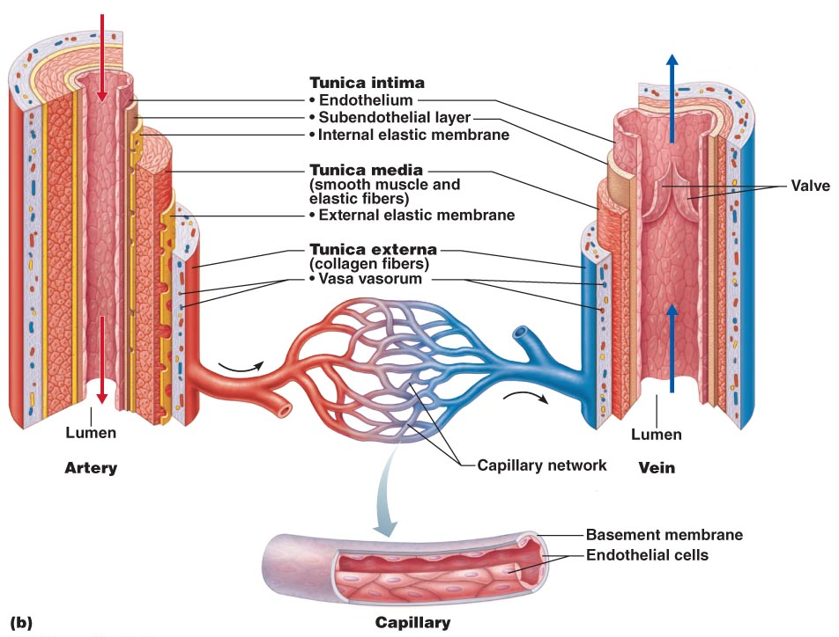

- Arterial System
  - 3 groups:
    - elastic
    - muscular
    - arterioles

Elastic Arteries / Conducting Arteries
    - thick-walled arteries near the heart
      - aorta and its major branches
    - longest in diameter
      - 2.5 cm- 1 cm
    - the most elastic > highest portion of elastin
      - their large lumens make them low-resistance pathways that conduct blood from the heart to medium sized arteries
        - arteries are sometimes called conducting arteries
      - pressure reservoirs
        - expanding and recoiling as the heart ejects blood
          - blood flows fairly continuously rather than starting and stopping with pulsating rhythm of heart beat
    - atherosclerosis
      - BV become hard
        - Blood flows more intermittently
    - Smooth out pressure fluctuations
      - Recoil helps maintain pressure & flow of blood

Muscular Arteries/ Distributing Arteries
    - Deliver blood to specific organs
      - .3mm- 1cm diameter
    - Have the thickest tunic media of all vessels
      - Contains more smooth muscle and less elastic tissue
        - More active in vasoconstriction and less capable of stretching
    - There is an elastic membrane on each face of tunica media

Arterioles
    - Smallest of arteries
      - have a lumen diameter of 10um - .3mm
    - larger arteries have all 3 tunics
      - but tunica media is chiefly smooth muscle with a few scattered elastic fibers
    - smaller arteries> lead into capillary beds
      - a little bit more then a single layer of smooth muscle cells spiraling around endothelial lining
    - minute-to-minute blood flow into capillary beds is determined by arteriolar diameter
      - varies in response to changing:
        - neural
        - hormonal
        - local chemical influences
    - when arterioles constrict > the tissues served are largely bypassed
    - when arterioles dilate> blood flow into the local capillaries increases

- Capillaries
  - Microscopic capillaries are the smallest BV
    - Exceedingly thin walls consist of just a thin tunica intima
  - Length = 1mm
  - Lumen diameter = 8-10 um
    - Just large enough for RBCs to slip through single file
  - Function= exchange
  - Pericytes
    - At strategic locations along the outer surface of some capillaries
    - Smooth muscle like cells that stabilize the capillary wall & help control capillary permeability
  - Most tissues have a rich capillary supply
    - Exceptions:
      - Tendon & ligaments= poorly vascularized
      - Cartilage & epithelial lack capillaries
        - Receive nutrients from BV in nearby CT
      - Avascular cornea & lens of eye
        - receive nutrients from aqueous humor
  - capillaries= back alleys & driveways that provide direct access to nearly every cell in the body
    - ideal suited for their role of exchange between blood and interstitial fluid.
      - gases
      - nutrients
      - hormones

Types of Capillaries
    - 3 types:
      - continuous
      - fenestrated
      - sinusoidal

Continuous Capillaries
        - abundant in skin and muscles
        - continuous
          - endothelial cells are joined by tight junctions
            - providing an uninterrupted lining
            - these junctions are usually incomplete & leave gap of unjoined membrane
              - called intercellular clefts
                - large enough to allow limited passage of fluids and small solutes

Fenestrated Capillaries
        - similar to continuous capillaries except:
          - endothelial cells are riddled with oval pores/ fenestrations
        - delicate membrane covers the fenestrations
        - much more permeable to fluids and small solutes than continuous capillaries
        - found wherever active capillary absorption or filtrate formation occurs
          - in small intestine
            - receive nutrients from digested food
          - endocrine organs allow homes rapid entry into blood
        - fenestrated capillaries with perpetually open pores occur in kidneys
          - where rapid filtration of blood plasma is essential
          - areas of active absorption or filtration

Sinusoidal Capillaries
        - highly modified, leaky capillaries
        - found in
          - liver
          - bone marrow
          - spleen
          - adrenal medulla
        - have large irregular shaped lumens
          - are usually fenestrated
        - endothelial lining has fewer tight junctions & larger intercellular clefts than ordinary capillaries
          - structural adaptations allow large molecules, proteins and even blood cells to pass between the blood and surrounding tissues
        - most permeable

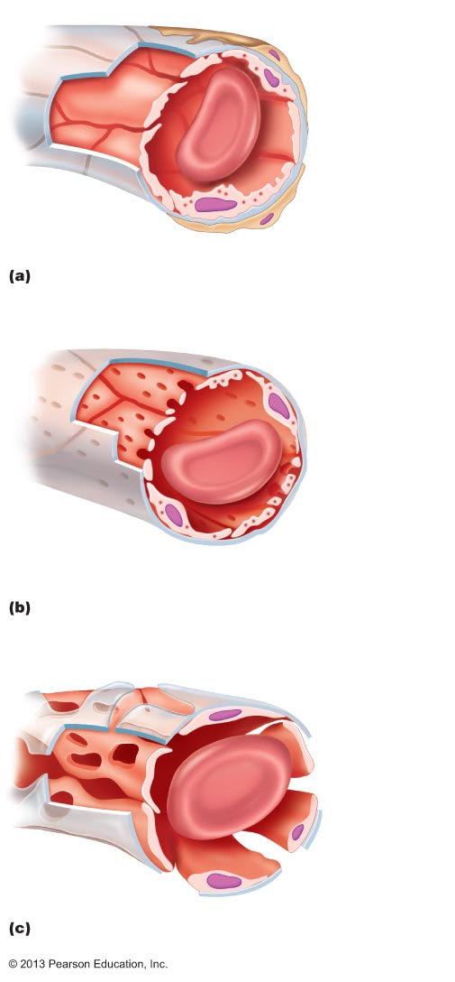

Capillary Beds
    - do not function independently
      - they form capillary beds
        - interweaving network
    - microcirculation
      - flow of blood from an arteriole to a venule through a capillary bed
    - consists of 2 types of BV
      - vascular shunt
        - metarteriole + throughfare channels
          - short vessel that directly connects the arteriole and venules at opposite ends of the bed
      - true capillaries
        - actual exchange vessels
        - 10-100 per bed
        - usually branch off the metarteriole end (proximal end of the shunt) and return to the thoroughfare channel (distal end)
          - occasionally they spring from the terminal arteriole and empty directly into the venule
            - the terminal arteriole feeding the bed leads into a metarteriole
              - a vessel that is structurally intermediate between an arteriole and a capillary

⬇
            - metarteriole is continuous with the thoroughfare channel
              - intermediate between a capillary and a venule

⬇
            - thoroughfare channel joins the postcapillary venule that drains in the beds.
    - Precapillary sphincters
      - Cuff of smooth muscle
      - Surrounds root of each true capillary at metarteriole
      - Acts as a valve to regulate blood flow into the capillary
        - Blood flowing through a terminal arteriole may go either through the true capillaries or the shunt
      - When relaxed/ open
        - Blood flows through the true capillaries and takes part in exchanges with tissue cells
      - When contracted/ closed
        - Blood flows through shunts and bypasses the tissue cells
    - Local chemical condition and arteriole vasomotor nerve fibers regulate the amount of blood entering a capillary bed
      - A bed may be completely flooded with blood or bypassed depending on the condition
        - Vigorous exercise
          - Blood is rerouted from your digestive organs to the capillary beds of your skeletal muscle where it is more immediately needed
          - Helps explain why vigorous exercise right after a meal can cause indigestion/ abdominal cramps

- Venous System
  - Carry blood from the capillary beds toward the heart
  - along route, the diameter of successive venous vessels increases
    - walls gradually thicken as progress from venules to larger and larger veins

Venules
    - capillaries unit to form venules
      - range from 8-100 um diameter
    - smallest venules> the post capillary venules > consist entirely of endothelium around which pericytes congregate
      - extremely porous
        - fluid and WBCs move easily from the bloodstream through their walls
    - just endothelium & a few fibroblasts
    - larger venules have one or two layers of SM cells ( a scanty tunica media) and a thin tunica externa/ adventiitia

Veins
    - venules join to form veins
    - usually have 3 distinct tunics
      - but walls are always thinner & lumen are larger then corresponding arteries
    - little smooth muscle or elastin in the tunica media
      - poorly developed and tends to be thin even in largest veins
    - tunica externa is the heaviest wall layer
      - consisting of thick bundles of collagen fibers & elastic networks
    - can accommodate a fairly large supply at any time because of their large lumens and thin walls.
    - Are capacitance vessels and blood reservoirs
      - Can hold up to 65% of the body’s blood supply at any time.
      - Normally only partly filled.
    - Walls can be much thinner then those of arterial walls without danger of bursting because the blood pressure in veins is low.
      - Low-pressure condition demands several structural adaptations to ensure veins return blood o the hear at the same rate it was pumped into the circulation
        - One adaptation:
          - Large-diameter lumens
            - Offer relatively little resistance to flow

Venous Valves
    - Another adaptation is valves that prevent blood from flowing backward
    - Venous valves
      - Formed from folds of the tunica intima
        - Resemble the SL valves in both structure and function
      - Most abundant in veins of limbs where gravity opposes the upward flow of blood
      - Absent in veins of the thoracic and abdominal body cavities
    - Effectiveness is demonstrated by ability for the vein to remain flat/ collapsed despite the pull of gravity

Homeostatic Imbalance
      - Varicose veins
        - Veins that are tortuous and dilated because of incompetent/ leaky valves
        - Adults usually suffer in lower limbs
        - Factors :
          - Hereditary
          - Age
          - Conditions that hinder venous return
            - Prolonged standing in one position
            - Pregnancy
            - Obesity
          - Elevated venous pressure

Venous Sinuses
    - Such as:
      - Coronary sinuses of heart
      - Dural venous sinuses of the brain
        - Receive cerebrospinal fluid and blood draining from the brain
        - Reinforced by the though dura matter that covers brains surface
    - Highly specialized, flattened veins with extremely thin walls
      - Composed of only endothelium
    - Supported by tissues that surround them
      - Rather then tunics

- Vascular Anastomoses
  - BV form special interconnections called vascular anastomoses
  - Most organs receive blood from more than one arterial branch and the arteries supplying the same territory often merge forming> arterial anastomoses
    - Provide alternate pathways called collateral channels for blood to reach a given body region
      - If one branch is cut or blocked by a clot this channel can provide sufficient blood to area
  - Occur around joints where active movement may hinder blood flow through one channel
    - Also common in abdominal organ, heart and brain
  - Arteries that supply the retina, kidneys and spleen either do no anastomose or have a poorly developed collateral circulation
    - If blood flow is interrupted> cells supplied by such vessel die
  - Arteriovenous anastomoses
    - Ex: The metarteriole-thoroughfare channel shunts of capillary beds that connect arterioles and venules
  - Veins interconnect much more freely then arteries
    - Venous anastomoses are common
      - Are abundant so on occluded vein rarely blocks blood flow or leads to tissue death

- Part 2
- Physiology of Circulation

- Introduction to Blood Flow, Blood Pressure and Resistance

Blood Flow (BF)
    - The volume of blood flowing through a vessel, an organ or the entire circulation in a given period
      - ml/min
    - considering entire vascular system
      - blood flow is equivalent to CO
      - under resting conditions its relatively constant
        - at any given moment blood flow through individual body organs may vary widely according to their immediate needs
          - can be regulated independently for various tissues & organs

Blood Pressure (BP)
    - force per unit area exerted on a vessel wall by the contained blood
      - expressed by mm Hg
    - refers to systemic blood pressure in the largest arteries near the heart
      - average aortic bp= 90mm Hg
    - the differences in bp within the vascular system
      - pressure gradient
        - provides driving force that keeps blood moving from high pressure to low pressure through the body
      - 90> 90 = no flow!
- F = P₁ - P₂
- R
      - 90>30= flow!

Resistance
    - opposition to flow/ inversely related
    - is a measure of the amount of friction blood encounters as it passes through the vessels
      - measure of total frictional forces that impede flow

generally use the term
          - peripheral resistance
            - most friction is encountered in the peripheral/ systemic circulation
              - well away from the heart
    - major determinant of BF because a change in blood vessels radius increases resistance to the 4th power.
Resistance varies inversely with (radius)⁴!!
    - 3 important sources of resistance:
      - blood viscosity
      - vessel diameter
      - vessel length

Blood Viscosity
        - viscosity
          - internal resistance to flow that exists in all fluids
          - related to the thickness/ stickiness of fluid
          - the great the viscosity
            - the less easily molecules slide past one another & the more difficult it is to get and keep the fluid moving
        - BV is fairly constant
          - Conditions such as polycythemia (excessive RBCs) can increase blood viscosity
            - Resistance
          - If RBC is low
            - Anemia’s
            - Blood is less viscous
              - Peripheral resistance declines
        - Due to formed elements, plasma proteins

Total Blood Vessel Length
        - Relationship between total BV length + resistance is straight forward:
          - Longer vessel= greater resistance

BV Diameter
        - Changes frequently & significantly alters peripheral resistance
          - Blood viscosity and vessel length are normally unchanging
        - How?
          - Principles of fluid flow
            - Fluids close to the wall of a tube/ channel is slowed by friction as its passes along the wall
            - Fluids in the center flows more freely and faster
        - Laminar flow / streamlining
          - In a tube of any given size the relative speed and position of fluid in the different regions of the tubes cross section remain constant
            - The smaller the tube= the greater the friction
              - Relatively more fluid contacts the walls
        - Resistance varies inversely with the 4th power of the vessel radius
          - If the radius of a vessel doubles, the resistance drops to 1/16 of its original value
            - Large arteries close to the heart which do not change dramatically in diameter contribute little to peripheral resistance
              - Small-diameter arterioles are major determinants of peripheral resistance
                - Because they can enlarge or constrict in response to neural and chemical controls
        - When blood encounters an abrupt change in vessel diameter or rough or protruding areas of the tube wall (fatty plaque)> the smooth laminar blood is replaced by turbulent flow
          - Irregular fluid motion where blood from the difference lamina mixes
        - Turbulence dramatically increases resistance

Relationship Between Flow, Pressure, and Resistance
    - Blood flow (F) is directly proportional to the difference in BP (ΔP) between two points in the circulation that is blood pressure or hydrostatic pressure gradient
      - When ΔP ⬆
        - Blood flow speeds up
      - ΔP ⬇
        - Blood flow declines
    - BF is inversely proportional to the peripheral resistance (R) in the systemic circuit
      - If R ⬆ ➔ BF⬇
        - F= ΔP/ R
      - R is far more important than ΔP in influencing local BF because R can easily be changed by altering blood vessel diameter
        - Arterioles dilate> ⬇ resistance= BF to that area ⬆
          - Even though systemic pressure is unchanged or may actually be failing

- Systemic Blood Pressure
  - Any fluid driven by a pump through a circuit of closed channels operates under pressure
    - The nearer the fluid is to the pump > the greater the pressure exerted on the fluid.
      - BF in BV is the same
        - Blood flows through the BVs along a pressure gradient
          - Always moving from higher > lower pressure areas
  - The pumping action of the heart generates blood flow
    - Pressure results when flow is opposed by resistance
  - Systemic blood pressure= highest in aorta
    - Declines through pathway to finally reach 0 mmHg in the right atrium
  - The steepest drop in BP occurs in the arterioles
    - Offers the greatest resistance to BF
  - As long as pressure gradients exist, no matter how small, blood continues to flow until it completes the circuit back to the heart

Arterial Pressure
    - 2 factors:
      - How much the elastic arteries close to the heart can stretch
        - compliance/ dispensability
      - The volume of blood forced into them at any time
        - If amounts of blood entering and leaving the elastic arteries in a given period were equal, arterial pressure would be constant
          - Instead BP is pulsatile in the elastic arteries near the heart
            - It increases and decreases with rise and fall

      - Systolic Pressure
        - As L ventricle contracts/ systole & expels blood into the aorta > it imparts kinetic pressure energy to the blood
          - Stretches the elastic aorta as aortic pressure reaches its peak
        - Averages 120 mm Hg in healthy adults
        - Blood moves forward into arterial bed bc pressure in aorta is higher than the pressure in the more distal vessels

      - Diastolic Pressure
        - During diastole> the aortic valve closes> preventing blood from flowing back into the heart
          - Walls recoil
            - Maintaining sufficient pressure to keep the blood from flowing forward into the smaller vessels
              - During this time aortic pressure drops to its lowest levels
        - Elastic arteries = pressure reservoirs that operate as auxiliary pumps to keep blood circulating throughout the period of diastole/ relaxation
          - The volume and energy of blood stored in the elastic arteries during systole are given back during diastole

Pulse pressure
        - Difference between the systolic and diastolic pressures
          - systolic bp - diastolic bp
        - felt as a pulse during systole, as ventricular contraction forces blood into the elastic arteries and expands them
          - indicates a vigor contraction of ventricle
          - provides info on elasticity of aorta & major arteries
        - ⬆ stroke volume & faster blood ejection from heart (result of increased contractility) raises pulse pressure temporarily
        - atherosclerosis chronically increases pulse pressure because they elastic arteries become less stretchy

Mean Arteriole Pressure (MAP)
        - pressure that propels the blood to the tissues
        - diastole lasts longer then systole
          - so MAP is not simply the value halfway between systolic and diastolic pressures
            - its roughly equal to the diastolic pressure pulse 1/3 of the pulse pressure.
              - MAP= diastolic pressure + pulse pressure/3
              - Systolic bp = 120 mmHg
              - Diastolic bp= 80 mmHg
                - MAP= 80 mmHg + (120-80= 40mm Hg)/ 3= 93 mm Hg
        - MAP & Pulse pressure both decline with increasing distance from the heart
          - MAP loses ground between the blood and vessels walls
          - Pulse pressure is gradually phased out in the less elastic muscular arteries
            - Elastic rebound of vessels ceases to occur
        - At end of arterial tree
          - Blood flow is steady and the pulse pressure has dissipated

Capillary Blood Pressure
    - by time blood reaches capillaries
      - blood pressure has dropped to approximately 35 mm Hg and by the end of the capillary beds is only around 17 mm Hg
    - low capillary pressures are desirable because:
      - Capillaries are fragile and high pressures would rupture them
      - Capillaries are extremely permeable and thus even the low capillaries pressure can force solute-containing fluids (filtrate) out of the blood stream into the interstitial space
        - Fluids are important for continuously refreshing the interstitial fluid
        - Lost of exchange at low bp

Venous Blood Pressure
    - Steady and changes very little during the cardiac cycle
    - The pressure gradient in veins, from venules to the termini of the vena cavae, is only about 15 mmHg
    - Difference in pressure between an artery and a vein becomes very clear when the vessels are cut
      - The blood flows evenly from the wound, but a lacerated artery spurts blood
    - The very low pressure in the venous system reflects the cumulative effects of peripheral resistance
      - Dissipates most of the energy of blood pressure as heat during each circuit
    - Despite the structural modifications of veins > large lumens and valves > venous pressure is normally too low to promote adequate venous return.
      - 3 functional adaptations are critically important to venous return:
        - the muscular pump
          - consists of skeletal muscle activity
          - as the muscles surrounding the deep veins contract and relax, they “milk” blood toward the heart
            - once blood passes each successive valves > it can’t flow back
          - standing professions such as hairdressers and dentists often have swollen ankles> blood pools in their feet and legs
          - skeletal muscle inactivity reduces venous return
        - the respiratory pump
          - moves blood upward toward the heart as pressure changes in the ventral body cavity during breathing
            - as we inhale > abdominal pressure increases, squeezing local veins and forcing blood towards the heart
            - at the same time, the pressure in the chest decreases allowing thoracic veins to expand and speeding blood entry into the right atrium
        - Sympathetic venoconstriction
          - Reduces the volume of blood in the veins
            - The capacitance vessels
          - As layer of smooth muscle around the veins constricts under sympathetic control, venous volume is reduced and blood is pushed toward the heart
      - All 3 functional adaptations increase venous return > which increases stroke volume (by Frank sterling law), therefore increases cardiac output.

- Maintaining Blood Pressure
  - Homeostatic mechanisms that regulate cardiovascular dynamics are those that maintain BP
    - Cardio output
      - Blood flow of entire circulation
    - Peripheral resistance
    - Blood volume
  - Homeostatic mechanisms in place to maintain adequate flow to tissues under a variety of circumstances
    - Keeps us from keeling over when we get up too quickly etc.
  - CO and peripheral resistance relate to blood pressure:
    - F= ΔP/R
    - CO= ΔP/R
    - ΔP= CO X R
  - BP varies directly with CO and R
    - Also with blood volume because CO depends on blood volume
      - Heart cant pump out what doesn’t enter the chambers
    - In theory, a change in any of these variables would cause a corresponding change in blood pressure
  - What really happens:
    - Changes in one variable that threaten blood pressure homeostasis are quickly compensated for by changes in the other variables
  - CO is equal to stroke volume ml/beat times HR beats/min
    - Normal CO is 5- 5.5 L/min
    - Main factors determining cardiac output:
      - Venous return
        - SV
      - Neural and hormonal controls
        - HR
          - Medulla is in charge of heart rate most of the time
          - Parasympathetic vagus nerves maintains the resting heart rate
            - During resting conditions venous return (end diastolic volume) largely controls SV
            - During stress the cardio acceleratory center takes over
              - activating sympathetic NS increasing:
                - HR
                - By acting on SA node
                - SV
                - By enhancing cardiac muscle contractility, which decreases end systolic volume
    - Enhanced CO increases MAP

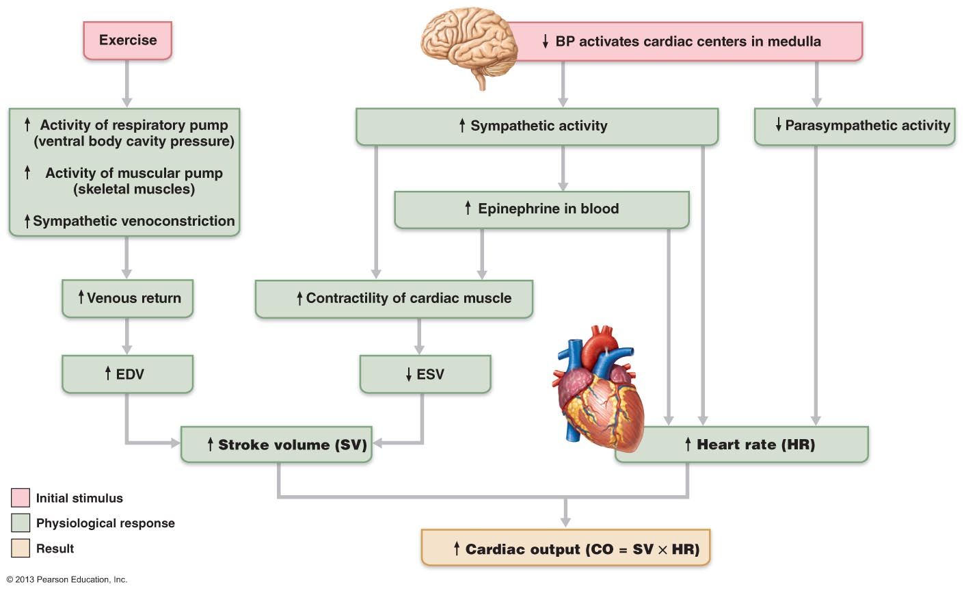

Factors that regulate Blood Pressure:
    - Short-term Regulation
      - By the nervous system and blood borne hormones alters blood pressure by changing peripheral resistance and CO
    - Long-term resistance
      - Alters blood volume via the kidneys

Short-Term Regulation: NEURAL CONTROLS
    - Alter both CO & peripheral resistance
    - Neural controls of peripheral resistance are directed at 2 main goals:
      - Maintaining adequate MAP
        - By altering blood vessel diameter on a moment-to moment basis
          - Very small changes in blood vessels diameter cause substantial changes in peripheral resistance
            - Systemic blood pressure
        - Under conditions of low volume
          - All vessels except those supplying the heart and brain are constricted to allow as much blood as possible to flow to those two vital organs
      - Altering Blood distribution
        - To respond to specific demands of various organs
          - During exercise blood is shunted temporarily from the digestive organs to the skeletal muscles
    - Most neural controls operate via reflex arcs involving baroreceptors & afferent fibers
      - Reflexes are integrated in the cardiovascular center of the medulla
        - Their output travels via autonomic fibers to the heart and vascular smooth muscles
    - Inputs from chemoreceptors & higher brain centers also influence the neural control mechanism

Role of the Cardiovascular Center
      - Clusters of neurons in the medulla oblongata act together to integrate BP control by altering CO & blood vessel diameter
      - Cardiovascular center
        - Consists of:
          - Cardiac centers
            - Cardioacceleratory and cardioinhibitory centers
          - Vasomotor center
            - Controls diameter of BVs
            - Transmits impulses at a fairly steady rate along sympathetic efferent called vasomotor fibers
              - Exit from T1 through L2
              - Innervate the smooth muscle of BV, mainly arterioles
                - Arterioles are almost always in a state of moderate constriction called vasomotor tone
                - Constant input, especially to arterioles (NE)
            - Degree of vasomotor varies from organ to organ
              - Arterioles of the skin & digestive viscera receive vasomotor impulses more frequently & tend to be more strongly constricted than skeletal muscles
              - Any increase in sympathetic activity produces generalized vasoconstriction & raises BP
              - Decreased sympathetic activity allows the vascular muscle to relax somewhat + lowers BP to basal levels

        - Modified by inputs from:
          - Baroreceptors
          - Pressure-sensitive mechanoreceptors that respond to changes in arterial pressure and stretch)
          - Chemoreceptors
          - Receptors that respond to changes in blood levels of CO2, O2, H+
          - Higher brain centers

Baroreceptors Reflexes
      - When arterial BP rises it activates Baroreceptors
        - Stretch receptors located in the
          - carotid sinuses
            - dilations in the internal carotid arteries which provide the major blood supply to the brain
          - aortic arch
          - walls of nearly every large artery of the neck and thorax
      - when stretched
        - baroreceptors send a rapid stream of impulses to the cardiovascular center
          - inhibiting the vasomotor and Cardioacceleratory centers & stimulating cardioinhibitory center
            - result is a decrease in BP
      - increasing MAP stretches receptors
        - response via vasomotor center is:
          - 3 mechanisms bring this about:
            - Arteriolar Vasodilation
              - Decreased output from the vasomotor center allows arterioles to dilate
              - As peripheral resistance falls> so does MAP
            - Venodilation
              - Decreased output from the vasomotor center also allows veins to dilate
                - Shifts blood to the venous reservoirs
                - Decreases venous return & CO
            - Decreased CO
              - Impulses to the cardiac centers inhibit sympathetic activity and stimulate parasympathetic activity
                - Reducing HR and contractile force
                - As CO falls> so does MAP

      - In opposite situation:
        - A decline in MAP initiates reflex vasoconstriction and increases CO
          - Bringing BP back up
            - Peripheral resistance and cardiac output are regulated in tandem to minimize changes in blood pressure
      - Goal
        - Rapidly responding baroreceptors protect the circulation against short-term/ acute changes in BP
          - Ex: when you stand up after reclining blood pressure falls
          - Baroreceptors take part in carotid sinus reflex
            - Protect the blood supply to your brain
          - Whereas those activated in the aortic reflex
            - Help maintain adequate blood pressure in your systemic circuit as a whole
      - They are relatively ineffective in protecting us against sustained pressure changes
        - Development of chronic hypertension
          - Baroreceptors adapt to monitor pressure changes at a higher set point

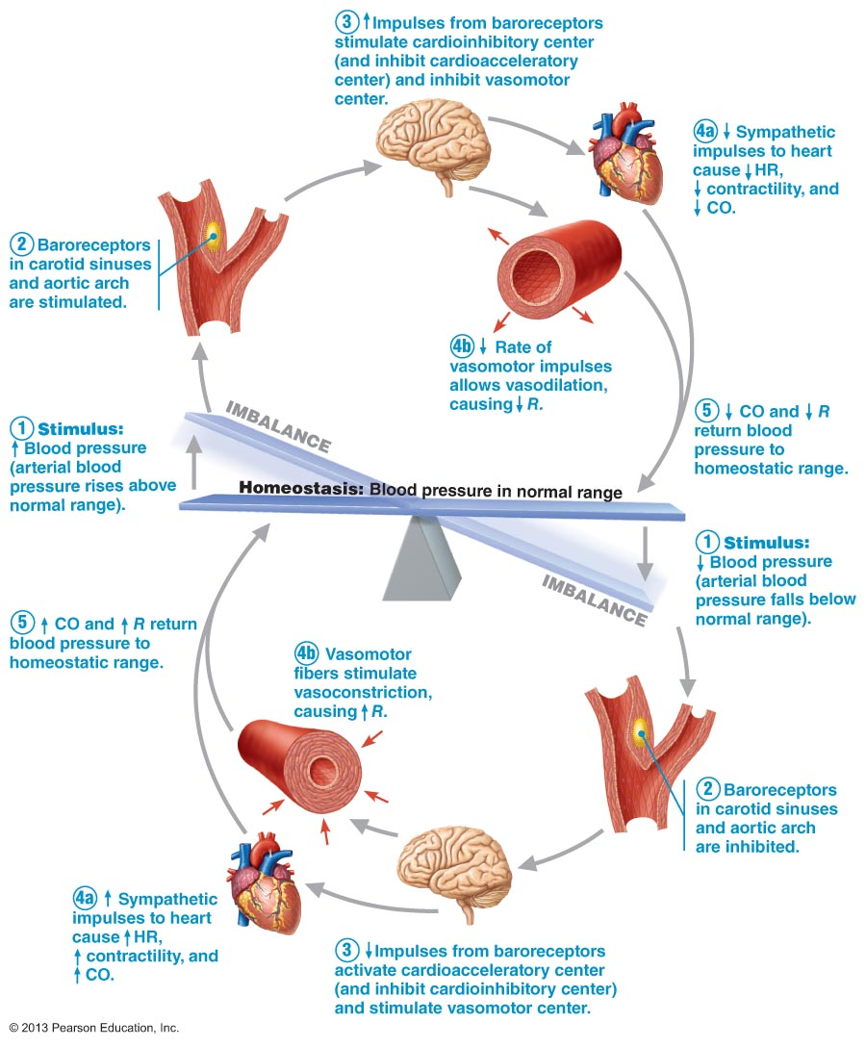

Chemoreceptor Reflexes
      - when CO2 levels rise or pH levels falls or O2 content of the blood drops sharply chemoreceptors in the aortic arch and large arteries of the neck transmit impulses to the Cardioacceleratory center
        - which then increases CO
      - & to the vasomotor center
        - which causes reflex vasoconstriction
      - rise in blood pressure that follows speeds the return of blood to the heart and lungs
      - most prominent chemoreceptors are the carotid and aortic bodies located close by the baroreceptors in the carotid sinuses and aortic arch
      - chemoreceptors play a larger role in regulating respiratory rate than BP

Influence of Higher Brain Centers
      - reflexes that regulate BP are integrated in the medulla oblongata of the brain stem
        - fight-or-flight response mediated by hypothalamus
          - also mediates redistribution of blood flow and other cardiovascular responses that occur during exercises and changes in body temp, stress

Short-Term Regulation: HORMONAL CONTROLS
    - help regulate BP
      - in short-term regulation
        - by changes in peripheral resistance
      - in long-term regulation
        - by changes in blood volume
    - Paracrines (local chemicals)
      - Primarily serve to match blood flow to the metabolic need of a particular tissue
      - Massive release of paracrines can affect BP
    - Short-term effects of hormones:
      - Adrenal Medulla Hormones
        - During periods of stress
          - Adrenal gland release epinephrine and NE to the blood
          - Fight-or-flight
            - Enhance sympathetic NS response by ⬆ CO and promoting generalized vasoconstriction
        - Nicotine mimics effects of catecholamines
          - Amino acid hormones??
      - Angiotensin II
        - When BP or Blood volume are low
          - Kidneys release renin
            - Acts as an enzyme, ultimately generating angiotensin II
              - Stimulates intense vasoconstriction> promoting rapid rise in systemic BP
              - Also stimulates release of aldosterone & ADH
                - Act in long-term regulation of BP by enhancing blood volume
      - Atrial Natriuretic Peptide (ANP)
        - Atria of the heart produces ANP
          - Leads to reduction in blood volume and BP
        - Antagonizes aldosterone and prods the kidneys to excrete more Na & water from the body
          - Reducing blood volume
        - Also causes generalized vasoconstriction
      - Antidiuretic Hormone (ADH)
        - Produced by hypothalamus / posterior pituitary
          - Stimulates kidneys to conserve water
            - Not usually important in short-term BP regulation > therefore long-term effect
          - When BP falls to dangerously low levels (during hemorrhage) much more ADH is released and helps restore arterial pressure by causing intense vasoconstriction
      - Endothelium-derived factors:
        - Endothelin
          - is a potent vasoconstrictor
        - Platelet-derived growth factor
          - vasoconstrictor
        - Nitric oxide (NO)
          - Induces brief vasodilation
      - Inflammatory chemicals:
        - Histamine, prostacyclin
          - Release during inflammatory response
            - Potent vasodilators
      - Alcohol
        - Inhibits ADH release
        - Depresses vasomotor center
        - Promotes vasodilation
          - Especially skin

Long- Term Regulation: RENAL MECHANISMS
    - Unlike short-term controls of BP that alter peripheral resistance and CO
      - Long-term controls alter Blood Volume
        - Renal mechanisms mediate long-term regulation
    - as well as responding to short-term changes in blood Baroreceptors quickly adapt to prolonged chronic episodes of high or low pressure
      - this is where the kidneys step in to restore and maintain BP homeostasis by regulating blood volume
        - blood volume varies with age, body size and sex but renal mechanisms keep it close to 5L
    - anything that changes blood volume will change BP
      - blood volume= major determinant of CO
      - excessive salt intake> promotes water retention
        - an increase in blood volume is followed by a increase in BP
          - anything that increases blood volume raises MAP because of the greater fluid load in the vascular tree
          - also stimulate the kidneys to eliminate water
            - this reduces blood volume & BP
        - a decrease in blood volume = a fall/ decrease in BP
          - blood loss & dehydration that occurs during vigorous exercise are causes of reduced Blood volume
          - a sudden drop in pressure signals internal bleeding and blood volume to low to support normal circulation
          - triggers renal mechanisms that increase blood volume and BP
      - blood volume can be stabilized or maintained within normal limits only when blood volume is stable
    - kidneys act both directly & indirectly to regulate arterial pressure and provide the major long-term mechanisms of BP control

Direct Renal Mechanism
      - alters blood volume independently of hormones
      - when either blood volume or BP is increase ➔ increases the rate at which the fluids filter from the blood stream to the kidney tubules = insufficient time to reclaim water, not enough time to absorb ➔ more of it leaves the body as urine
        - BP and blood volume decrease
          - Therefore water is conserved and returned to the blood stream and blood pressure rises.
            - As BV go ⬆ so does arterial blood pressure

⬇ Arterial Pressure

⬇ Filtration by Kidneys

⬇ Urine Formation

⬆Blood Volume

⬆ Mean Arterial Pressure

Indirect Renal Mechanism
      - Regulate BP indirectly via the renin-angiotensin-aldosterone mechanism
      - When arterial BP ⬇
        - Certain cells in kidneys release then enzyme renin into the blood
          - Renin enzymatically cleaves angiotensin
            - a plasma protein made by the liver
            - converting it to angiotensin I
              - angiotensin converting enzyme (ACE) converts angiotensin I ➔ angiotensin II
                - ACE activity is associated with the capillary endothelium in various body tissues > particularly the lungs
      - Angiotensin II acts in 4 ways to stabilize arterial BP & extracellular fluid volume:
        - Stimulate adrenal cortex to secrete aldosterone
          - Enhances renal reabsorption of Na
            - As Na moves into blood stream➔ water follows
              - conserves blood volume.
          - Also it directly stimulates Na reabsorption by kidneys
        - Prods the posterior pituitary to release ADH
          - promotes more water reabsorption by the kidneys
        - Triggers the sensation of thirst by activating the hypothalamic thirst center
          - Encourages water consumption, ultimately resorting blood volume and so BP
        - Is a potent vasoconstrictor
          - Increasing BP by increasing peripheral resistance.
      - MAP ⬆

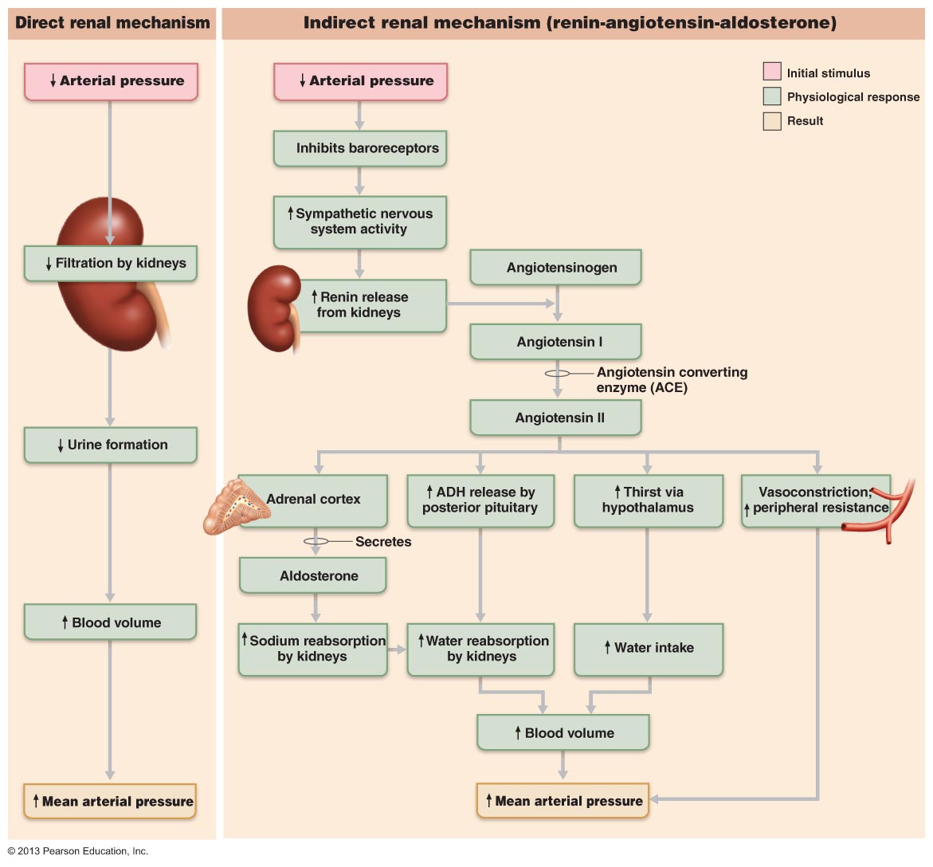

Clinical Monitoring of Circulatory Efficiency
    - Measuring pulse and blood pressure
    - Vital signs
      - Pulse
      - BP
      - Body temp
      - Resp rate
        - Measured by:

Taking a Pulse
      - Alternating expansion and recoil of arteries during each cardiac cycle allow us to feel a pressure wave > pulse
        - Is transmitted through the arterial tree
      - Can feel it in any artery that lies close to the surface
        - Push surface artery against firm tissue
          - Usually radial pulse is used to measure pulse
          - Many more spots to take pulse
            - Pressure points
              - Pulse points
              - Compressed to stop blood flow into distal tissues during hemorrhage
      - Activity, postural changes and emotions effect pulse rates
        - Normal healthy man:
          - sitting down pulse = 70
          - Lying down = 66
          - Suddenly stands= 80
          - Vigorous exercise or emotional upsets= 140-180
            - Sympathetic NS effects on heart

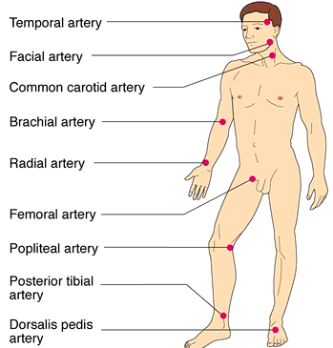

Measuring Blood Pressure
      - most often you measure systemic arterial blood pressure indirectly in the brachial artery of the arm by the auscultatory method
        - steps:
          - wrap the blood pressure cuff/ sphygmomanometer snuggly around the person’s arm superior to the elbow
          - inflate cuff until the cuff pressure exceeds systolic pressure
            - blood flow into the arm stops and a brachial pulse cannot be felt or hear
              - artery fully collapsed> no flow
          - reduce cuff pressure gradually and listen (auscultate) with a stethoscope for sounds of brachial artery
      - systolic pressure
        - the 1st soft tapping sounds are heard> first point at which a small amount of blood is spurting through the constricted artery

⬇
      - as pressure cuff is reduced further, sounds called the sounds of Korotkoff become louder and more distinct

⬇
      - when artery is no longer constricted and blood flows freely
        - the sounds can no longer be heard
          - diastolic pressure
            - pressure at which the sounds disappear

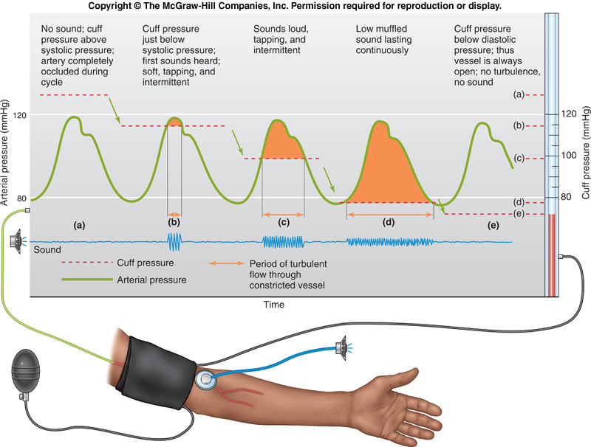

Homeostatic Imbalances in Blood Pressure
      - normal adult at rest:
        - SP= 110-1140
        - DP= 75- 80
      - Elevations in BP occur as normal adaptations during changes in
        - Posture
        - Physical exertion
        - Emotional upset
        - Fever
        - Age
        - Sex
        - Weight
        - Race

Hypertension
        - Chronically elevated BP, characterized by a sustained increase in either SP (above 140) or DP (above 90)
        - Prehypertension
          - If BP valves are elevated but not yet in hypertensive range
            - High risk individuals
        - Common and dangerous disease
        - Primary Hypertension
          - Hereditary
          - Diet
          - Obesity
          - Age
          - Diabetes
          - Stress
          - Smoking
            - Can be cured
        - Secondary Hypertension
          - Obstructed renal arteries
          - Kidney disease
          - Endocrine disorders

Hypotension
        - Low blood pressure
          - Below 90/60 mm Hg
        - No cause for concern

      - Look in text book for more information pg. 711

- Blood Flow Through Body Tissues: Tissue Perfusion
  - Blood flow through body tissue> tissue perfusion is involve in:
    - Delivering O2 and nutrients to tissue cells & removing wastes from them
    - Exchanging gases in the lungs
    - Absorbing nutrients from the digestive tract
    - Forming urine in the kidneys
  - The rate of blood flow to each tissue and organ is almost exactly the right amount for proper function
  - At rest :
    - brain receives 13% of total BF
    - heart 4%
    - kidneys 20%
    - abdominal organs 24%
    - skeletal muscles 20%
  - during exercise nearly all of the increased CO flushes into the skeletal muscles and bf to the kidneys and digestive organ declines

Velocity of BF
    - inversely related to cross sectional area
    - speed/velocity of BF changes as blood travels through the systemic circulation
      - fastest at the aorta & other larger arteries
        - like a river
        - total cross sectional area is least
      - slowest in capillaries
        - large total cross sections
          - like a lake
      - picks up speed again in veins
        - river again
    - as arteriole system branches→ total cross sectional area of vascular bed increases= velocity of blood flow proportionately
      - even though individual branches have smaller lumen > their combined gross sectional areas, therefore the volume of blood they can hold, are much greater then that of aortas
        - aorta 2.5cm squared
        - combined cross-section 4500 cm squared
          - this difference results in fast blood flow in aorta
          - slow blood flow in capillaries
            - beneficial because it allows adequate time for exchanges between blood and tissue cells
    - as capillaries combine to form 1st venules and then veins, total cross sectional area declines and velocity increases
    - cross sectional area of vena cava is 8cm squared
      - velocity of bf varies from 10 to 30 cm/s in those vessels
        - depending on activity of skeletal muscle pump

Autoregulation: Local Regulation of Blood Flow
    - Autoregulation
      - Automatic adjustment of bf at any instant
      - Local conditions regulate this process independently of any control by nerves or hormones
      - MAP is the same everywhere in the body & homeostatic mechanisms adjust CO as needed to maintain that constant pressure
      - Changes in bf through individual organs are controlled intrinsically by modifying the diameter of local arterioles feeding the capillaries
    - Local conditions in the arterioles feeding the capillaries beds of an organ have little effect on pressure in the muscular artery feeding that organ or in the large elastic arteries
      - As long as the circulatory feedback mechanisms maintain a relatively constant MAP
        - Local demand regulates the amount of blood delivered to various areas
    - Summary:
      - Organs regulate their own bf by varying the resistance of their arterioles
        - Classed as
          - Metabolic
            - Chemical
          - Myogenic
            - Physical

Metabolic Controls (Local)
      - When BF is too low to meet a tissue’s metabolic needs> oxygen levels ⬇ and metabolic products accumulate
        - Metabolic products act as paracrines
      - Changes serve as Autoregulation stimuli that lead to autonomic increases in tissue bf
      - Metabolic factors that regulate bf:
        - Low O2
        - ⬆ in H+
          - from CO2 & lactic acid
        - K+
        - Adenosine
        - Prostaglandins
          - Inflammatory chemicals
      - Many act directly to relax vascular SM
        - Some may act by causing vascular endothelial cells to release nitric oxide
      - Nitric Oxide (NO)
        - Powerful vasodilator
          - Acts via a cyclic GMP second-messenger system
        - Quickly destroyed
        - Potent vasodilator effects are brief
        - Major player in controlling local vasodilation
          - Often over-riding sympathetic vasoconstriction when tissues need more blood flow
      - Endothelium also releases potent vasoconstrictors , including endothelins, are among the most potent vasoconstrictors
      - Net result of metabolically controlled Autoregulation is immediate vasodilation of the arterioles serving the capillary beds of the “needy” tissues and dilation of their pre capillary sphincters
        - Bf to the area rises temporarily
          - Allowing blood to surge through the true capillaries and become available to the tissue cells
      - Inflammatory chemicals (histamine, kinins and prostaglandins) released in injury, infection or allergice reactions also cause local vasodilation
        - Helps defense mechanisms clear microorganisms and toxins from the area
        - Promotes healing

Myogenic Controls
      - Fluctuations in systemic blood pressure would cause problems for individual organs if it were not for the myogenic responses of vascular SM
        - Myo= muscle
        - Gen= origin
      - Inadequate blood perfusion through an organ is quickly followed by decline in organs metabolic rate and possible organ death if prolonged
      - Excessively high arterial pressure and tissue perfusion can be dangerous > combination can rupture more fragile BVs
        - Vascular SM prevents these problems by responding directly to passive stretch (caused by increased intravascular pressure) with increased tone
          - Tone resists the stretch > causes vasoconstriction
      - Reduced stretch ➔ vasodilation ➔ increased blood flow into tissue
        - Keep tissue perfusion fairly constant despite most variations in systemic pressure

    - Both metabolic and myogenic factors determine the final auto regulatory response of a tissue
      - Reactive hyperemia
        - Increased bf into a tissue that occurs after the blood supply to the area has been temporarily blocked
          - Headstand
        - Results from both myogenic response and metabolic wastes that accumulated in that area when blocked

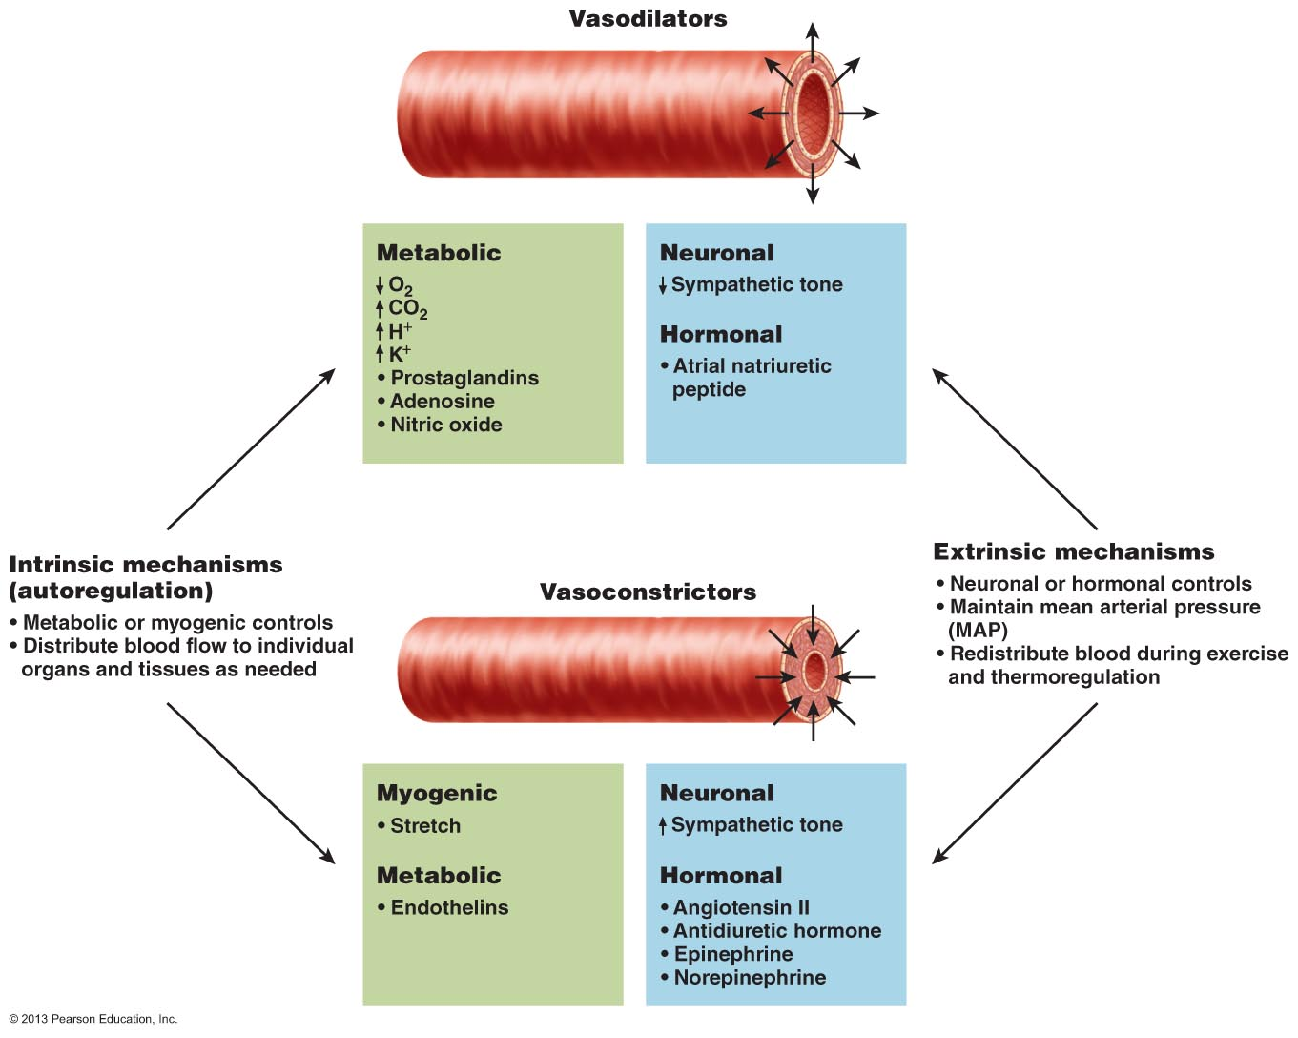
    - Active Hyperemia
      - Increased accumulation of waste products due to increased O2
        - Result of increased activity of tissues
        - Stimulation of vasodilation

    - Reactive Hyperemia
      - Due to blockage of bf to an area of tissue for a period of time (i.e sitting in one position for long period of time)
        - Still generates waste products and uses oxygen
          - Not able to get rid of waste products
        - As soon as we change position bf will increase in that area to get rid of waste product

Blood Flow in Special Areas
    - Each organ has special requirements and functions that are revealed in its pattern of Autoregulation
    - Autoregulation in the brain, heart and kidneys is extraordinarily efficient
      - Maintains adequate perfusion even when MAP fluctuates

Skeletal Muscles
      - Bf varies with fiber type and muscle activity
      - Capillary density and bf are greater in red/slow oxidative fibers than in white/ fast glycolytic fibers
      - Resting skeletal muscles receive about 1L of blood/ minute
        - Only about 25% of their capillaries are open
        - Myogenic and general neural mechanisms predominate
      - Active muscles> bf increases (hyperemia) in direct proportion to their greater metabolic activity
        - Called active hyperemia
          - Occurs mostly in response to the decreased oxygen concentration and accumulated metabolic factors that result from the “revved-up” metabolism of working muscles
      - Systemic adjustments mediated by the vasomotor center must also occur to ensure that blood delivery to the muscle is both faster and more abundant
        - During exercise
          - Sympathetic NS system activity increases, releases:
            - NE > causes vasoconstriction of the vessels of blood reservoirs
              - Digestive viscera and skin
                - Therefore more blood goes to the muscles working
      - SNS and local metabolic controls have opposing effects on arteriolar diameter
        - During:
          - Local controls override sympathetic vasoconstriction
            - Blood flow to skeletal muscles can increase tenfold
            - Virtually all capillaries in the active muscles open to accommodate the increased flow
      - Factor determining how long muscles can contract vigorously is the ability of the CVS to deliver adequate O2 & nutrients & remove waste products

The Brain
      - Blood flow is maintained and constant
      - Brain is unable to store essential nutrients
      - Metabolic Controls:
        - Cerebral bf is regulated by one of the body’s most precise autoregulatory system & is tailored to local neural need
          - Ex: Make a fist with your right hand > the neurons in the left cerebral cortex controlling that movement receive more blood than the adjoining neurons
        - Very sensitive to declining pH & increased CO2 levels cause vasodilation
          - Resulting in acidic conditions in brain tissue
        - Low levels of O2 are a much less potent stimulus for Autoregulation
          - Very high levels of CO2 abolish autoregulatory mechanisms & depress brain activity
      - Myogenic mechanism
        - Protects it from possibly damaging changes in bp
          - When MAP ⬇
            - Cerebral vessels dilate to ensure adequate brain perfusion
          - When MAP ⬆
            - Cerebral vessels constrict to protect the small more fragile vessels father along the pathway from excessive pressure
          - During special cases:
            - Brain ischemia > rising intracranial pressure (as with brain tumors)
              - Brain regulates its own bf by triggering a rise in systemic bp
          - However, when systemic bp changes are extreme:
            - Brain becomes vulnerable
              - Fainting occurs when MAP falls below 60mm Hg

The Skin
      - Bf through skin
        - Supplies nutrients to cells
          - Autoregulation
        - Helps regulate body temp
          - neural intervention
          - primary function of the cutaneous circulation
        - Provides blood reservoir
          - Neural intervention
      - Body temp
        - Bf can change from 50 ml/min to 2500ml/min
          - Capability reflects neural adjustments of bf through arterioles and arteriovenous anastomoses (richly supplied with sympathetic nerve endings)
            - Controlled by reflexes initiated by temperature receptors or signals from higher CNS centers
          - Exposure to heat/ body temp ⬆= hypothalamic “thermostat” signals for ⬇ vasomotor stimulation of skin vessels
            - Result: warm blood flushes into the capillary beds and heat radiates from the skin surface
          - When cold/ body temp ⬇= superficial skin vessels strongly constrict
            - Blood almost entirely bypasses the capillaries associated with the arteriovenous anastomoses > diverting warm blood inward to organs

The Lungs
      - Unusual
        - Relatively short pathway
        - Pulmonary arteries and arterioles are structurally like veins and venules
          - Thin walls & large lumens
            - Resistance to bf is low > less pressure is needed to propel blood through those vessels
              - Therefore pressure is much lower then systemic
                - 24/10 vs. 120/80
      - in pulmonary circulation:
        - autoregulatory mechanism is opposite:
          - low pulmonary O2 levels cause local vasoconstriction
          - high levels of O2 promote vasodilation
      - persistent with gas exchange role in this circulation
        - when air sacs are flooded with O2-rich air ➔ the pulmonary capillaries become flushed with blood and are ready to receive the O2 load
        - if air sacs are collapsed or blocked with mucus> the O2 content in those areas is low> blood largely bypasses those nonfunctional areas

The Heart
      - pumping action of ventricles influences movement of blood through smaller vessels of the coronary circulation
        - contraction= compression of coronary vessels
          - bf through myocardium stops
        - relaxation= high aortic pressure forces blood through the coronary circulation
      - myoglobin in cardiac cells store sufficient O2 to satisfy the cell’s O2 needs during systole
        - abnormal/ rapid heartbeat reduces the ability of myocardium to receive adequate O2 and nutrients during diastole
      - resting conditions:
        - bf= 250 ml/min controlled by myogenic mechanisms
        - cardiac cells use as much as 65% of the O2 carried to them in blood
        - bf remains fairly constant despite wide variations in coronary perfusion pressure
      - strenuous exercise:
        - coronary vessels dilate in response to local accumulation of vasodilators (adenosine)
        - bf may ⬆ 3-4 X
        - any event that decreases the O2 content of the blood releases vasodilators that adjust the O2 supply to the O2 demand
          - enhanced bf is important bc it’s the only way to provide more O2 to a vigorously working heart

Blood Flow Through Capillaries and Capillary Dynamics
    - Capillaries
      - major point of communication between interstitial fluid & blood
      - bf through capillary networks is slow and intermittent
        - due to vasomotion
          - the on/off opening and closing of precapillary sphincters in response to local autoregulatory controls

Capillary Exchange of Respiratory Gases and Nutrients
      - Diffusion is how O2, CO2, most nutrients and metabolic wastes pass between blood and interstitial fluid
        - Net movement always occurs along a concentrated gradient
          - Moving from an area of its higher concentration to lower concentration
            - O2 and nutrients pass from the blood> high concentrations➔ through interstitial fluid to tissue
            - CO2 and metabolic wastes leave the cells> high concentration ➔ diffuse into the capillary blood
      - 4 different routes across capillaries for different types of molecules
        - Diffuse through membrane/ lipid bilayer of endothelial cell plasma membranes.

Lipid soluble ➔respiratory gases
        - Movement through intercellular clefts ➔ small water-soluble solutes> amino acids & sugars
        - Fenestrations/ pore ➔ water soluble substances
        - Transported in vesicles or caveolae➔ large molecules > proteins
      - Capillaries differ in their leakiness

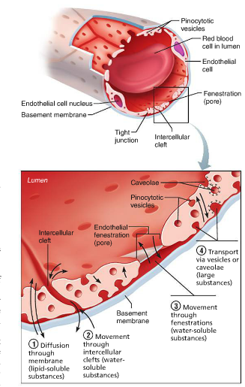

Fluid Movements: Bulk Flow
      - Nutrient gas exchanges = across the capillary walls by diffusion
      - Bulk fluid flows are also going on
      - Fluid is forced out of the capillaries through the clefts at the arterial end of the bed
        - Most of it returns to the bloodstream at venous end
      - Important in determining the relative fluid volumes in the bloodstream and the interstitial space
        - Aprox. 20L of fluid filter out of the capillaries each day before being returned to the blood
      - The direction and amount of flow across capillary walls reflects the balance between two dynamic and opposing forces:
        - Hydrostatic & osmotic pressure

Hydrostatic Pressure (HP)
        - The force exerted by a fluid pressing against a wall
        - In capillaries- HP is the same as capillary blood pressure
          - Pressure exerted by blood on capillary walls
        - Capillary Hydrostatic Pressure (HPC)
          - Forces fluids through capillary walls = filtration
            - Leaving behind cells and most proteins
        - BP drops as bfs along a capillary bed
          - HPC is higher at arterial end (35mm Hg) then at venous end (17 mm Hg)
        - BP which forces fluid out of the capillaries is opposed by the interstitial fluid hydrostatic pressure (HPif) acting outside the capillaries and pushing fluid in
          - Usually very little fluid in the interstitial space
            - Lymphatic vessels constantly withdraw it
          - May vary from slightly – to +, traditionally it is assumed to be 0

Colloid Osmotic Pressures (OP)
        - The force opposing HP
        - Created by large nondiffusible molecules
          - Plasma proteins
            - Unable to cross the capillary wall
        - These molecules draw water toward themselves
          - Encouraging osmosis bc the water concentration in their vicinity is lower than it is on opposite side of capillary walls
            - *”HP pushes & OP pulls/sucks”
        - capillary colloid osmotic pressure (OPc)/ oncotic pressure
          - developed by the abundant amount of plasma proteins, primarily albumin molecules
          - OPc is 26mm Hg
        - Interstitial colloid osmotic pressure (OPif)
          - Is lower
            - .1- 5 mm Hg
        - unlike HP> OP doesn’t vary significantly from one end of the capillary to the other

Hydrostatic-Osmotic Pressure Interactions
        - net filtration pressure ( NFP)
          - considers all the forces acting at the capillary bed
        - while net filtration is occurring at the arteriole end ➔ a – value for NFP at the venous end of the capillary indicates that fluid is moving into the capillaries (called reabsorption)
          - result:
            - net fluid flow is out of the circulation at the arterial end of capillary beds and into the circulation at the venous end
              - more fluid enters the tissue spaces than return to the blood
                - result: a net loss of fluid from the circulation of about 1.5 ml/min
                - lymphatic vessels pick up this fluid and any leaky proteins and return it to the vascular system > account for the relatively low levels of both fluid and proteins in the interstitial space

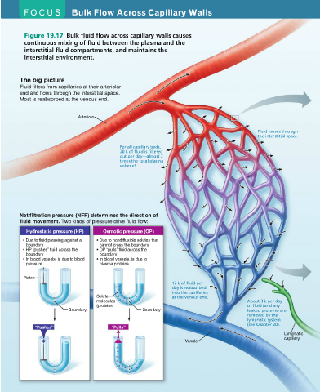

- 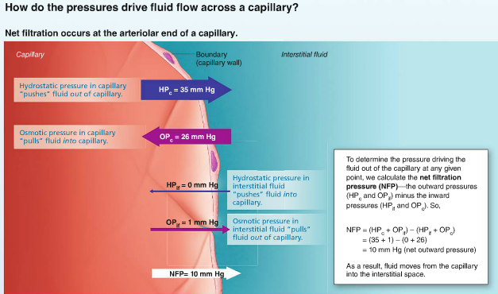
- 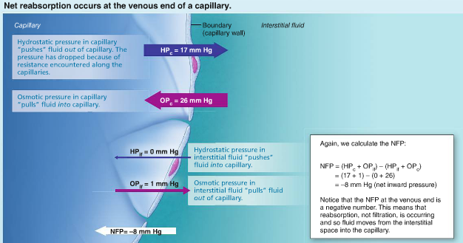

- 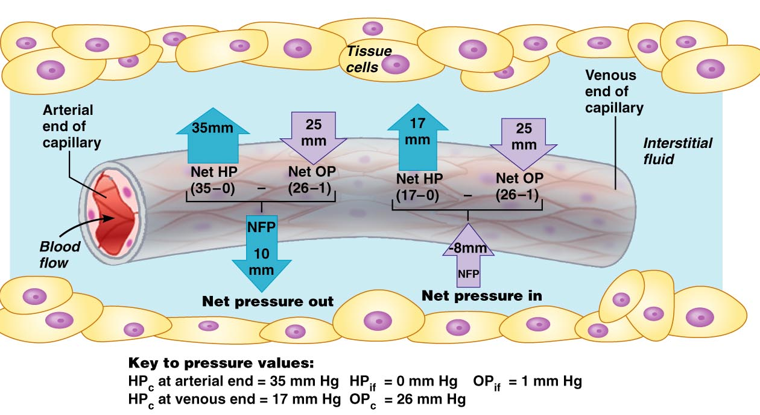

- Circulatory Shock
  - Any condition that blood vessels are inadequately filled and blood cannot circulate normally
    - Cells die> organ dies

Hypovolemic Shock
    - Most common form
    - Low blood volume
      - Results from large-scale blood or fluid loss
        - Acute hemorrhage
        - Sever vomiting or diarrhea
        - Extensive burns
    - If blood volume drops rapidly = HR increase in attempt to correct problem
      - Weak “thread pulse” is first sign
    - Intense vasoconstriction also occurs
      - Shifts blood from the various blood reservoirs into the major circulatory channels & enhances venous return
    - BP is stable at 1st then eventually drops if blood loss continues
      - Replace fluid volume as quickly as possible

Vascular Shock
    - Blood volume is normal
      - Circulation is poor as a result of extreme vasodilation
      - Huge drop in peripheral resistance follows because of rapidly falling BP
    - Loss of vasomotor tone
      - Due to anaphylactic shock
        - Massive release of histamine triggers body-wide vasodilation
      - Neurogenic shock & septic shock

Cardiogenic Shock / pump failure
    - Occurs when heart is so inefficient that it cannot sustain adequate circulation
      - Myocardial damage after numerous heart attacks

