- A) Olympia b) Delphi c) Corinth d) Nemea e) Dodona

- Games for Poseidon >> Corinth
- First panhellenic games >> Olympia
- Oracle of Zeus >> Olympia
- Oracle of Apollo >> Delphi
- Baby eaten by a snake here >> Nemea
- Pythia lived here >>

- MUSEUM ASSIGN DEADLINE NOV 19TH NO OUTSIDE RESEARCH

- Λ λ (lambda) pg.61

- Phoenician Influences
- -alphabet (Cadmus)
- -athletic competitions
- -symposion

- The Symposion: another Phoenician idea?
- (Pg.106) male dinner with drinking competitions

- Playing kottabos with a kylix (drinking cup called skyphos, holds most wine)

- At the end of the LDA
- -Panhellenic games began
- -return of writing leads to Archaic Age

- Hesiod (pg.75)
- Early Archaic Age epic poet

- -Theogony
- -Works and Days

- Muses: daughters of Mnemosyne
- -Kalliope: epic
- Klio: history
- Erato: love poetry
- Melpomene: tragedy
- Polyhymnia: sacred song
- Terpsichore: dance
- Thalia: comedy
- Urania: astronomy

- Archilochos of Paros
- Early Archaic lyric poet
- (pg.74)

- Age of Colonization (archaic age) 2nd expansion of Greek
- migration occurred in early dark age. Colonization began in late and continued onto Archaic. differed in TIME^, DIRECTION where? In to the west, south and north. REASON a deliberate and organized act

- Metropolis: mother city
- Oikistes: leader of colonists

- Moved to find more fertile land, traded tin, iron, etc. Colonized bcz they could make money—dominated locals and inslaved them, sold them and made money. Also made $$ from piracy. Political reasons etc

- 1.) PICK A SPOt: Good harbor, fertile land,
- water supply. Islands are ideal.
- 2.) Consult oracle of Apollo in Delphi.
- 3.) Appoint your leader (oikistes)
- 4.) Metropolis would require fire be carried in

- Each colony used same version of alphabet metropolis used—and everything else. Exact replica
- Once established, they could have individual gov’t and change things

- Pithekoussai (Italy)
- 1st western colony

- -metropolis: Chalcis
- -trade with Etruscans
- -Euboian version of alphabet

- Pithekoussai: Why we have ABC not ABgamma:

- Etruscan Roman

- Metropoleis & Western Colonies
- -Euboia: Naxos (Sicily), Pithekoussai
- -Corinth: Syracuse
- -Phokaia (Ionia): Massalia

- Metropoleis & Northern Colonies

- -Thrace, Hellespont, Black Sea
- -Megara: Byzantium
- -Miletos: Black Sea

- Why not the rest of the Mediterranean?

- Emporia
- Egypt: Naukratis
- Phoenicia

- Results of Colonization
- -increase in trade
- -Hellenization spread of Greek culture

- Orientalizing: Phoenician influence
- Pg.71

- Orientalizing Style w/ harpies & panthers from Corinth

- Egypt: Abu Simbel
- >Greek Mercenaries leave graffiti on statue of Ramses II (pg.71)

- Egypt: Karnak: monumental architecture

- Greek Temple

- Corinth: monolithic temple of Apollo (pg.91)

- Doric Order (pg.168)
- Columns: shaft + capital
- Frieze = metopes + triglyphs

- Corinth re-invents clay tile.

- Egyptians used granite for sculptures
- Greeks used limestone, marble KOUROS (pg.70)

- Kouroi: symmetrical, parallel planes, Archaic smile, painted, viewed from all sides.

- Egyptians inspired Greeks to do monumental ANIMALISTIC sculptures (lions, etc)

- Bronze Age Wealth: copper ingots

- Dark Age Obeliskoi: iron spits (pg.72)
- 6 obols = 1 drachma

- Lydia (Asia Minor) capital: Sardis

- -electrum
- -first coinage
- -Croesus
- (pg.91)

- What is a Polis? (plural: poleis)?

- Pausanians: pg.78 (travel writer):
- Apolis consists of: (physical things)
- Government buildings, gymnasium, theatre, agora, public water supply.

- 2. Alkaios: song writer from Lesbos
- Apolis is
- NOT houses, walls, etc BUT people.

- 3. Aristotle: Athenian philosopher
- Apolis is: a partnership of several villages (big enough to be sufficient)

- Each Polis has its own version of architecture, dialect of Greek, but still have same beliefs in Gods.

- Polis = 2 parts

- 1. Asty = urban centre
- -fortified acropolis
- -fortified lower town
- --^agora (marketplace), religious spaces

- 2. Chora

- -chora=countryside
- -synoicism (amalgamation)

- asty = Athens + chora = Attica = polis of the Athenians

- Priene (Ionia), Orthogonal Plan:
- Hippodamus of Miletus
- ^
- -prytaneion (town hall)
- -gymnasiums
- -theatre
- -agora

- Each polis had its own distinctive:

- -laws, constitution, government
- -coinage
- -weights & measures
- -version of the alphabet
- -art & architecture
- -customs
- -army
- -calendar

- Polis Calendar
- -year named after annual official
- -year began in July
- -names of months differed from polis to polis

- Oikos = household
- -stone foundation
- -walls: mud brick
- roof: tile or thatch
- cistem
- altar (biggest difference between our houses and theirs)

- Boiotia

- -Dionysius from here.
- -Kantharos: handles go up above rim of cup (pg. 89)
- - home of Pesiod

- Thebes: founded by Cadmus
- (after he follows a cow and kills a giant snake)

- Apollo Ptoos
- -sanctuary near Thebes
- -100+ kouroi found

- Boiotian shield on Theban coin (pg.88)

- Theban army was excellent, known for military flute players
- -the “scared band”
- -destroyed Spartans at Leuktra (371 BCE)

- Lion of Chaironeia

- -grave of Sacred Band?
- Philip ll & Alexander

- PINDAR OF THEBES (songwriter)

- -house spared by Alexander
- -epinician odes (victory songs_
- -source of mythology

- Cornith (Korinthos)
- -destroyed by Romans (146 BCE)

- Sisyphus: mythical founder of Corinth
- (first rock ‘n’ roller)

- punishment: push boulder up the hill (couldn’t as it would always roll down)

- Early Archaic Age Government

- -Oligarchy
- -oligos = few
- -land owning aristocrats

- Corinthian perfume containers [aryballoi (small ones) alabastron (bigger)]
- ^Orientalizing style

- Archaic Age
- Age of Tyranny

- -tyrant (Lydian word)
- -illegal ruler who seizes power from ruling aristocratic oligarchy

- Periander: tyrant of Corinth (625-585 BCE)

- -Kypselid tyranny
- -Kypselos
- -made Corinth the commercial centre of Hellas

- Diolkos in operation

- Corinthian Coin with Pegasus (pg.91)

- Periander – associated with Corinth (he was a Tyrant)
- Cadmus – associated with Thebes (father of alphabet)
- Sacred Band – associated with Thebes (responsible for defeat of Sparta)
- Diolkos – associated with Corinth (road for dragging boats)
- Oedipus – associated with Thebes (king of Thebes)

- Xenophon
- -soldier
- -historian
- -how-to books (manuals)
- -pupil of Socrates

- Did the Greeks have Halloween?

- Anthesteria: 3 day festival where people wore masks and drink. The dead “came back to life”
- 1.) “Pithos” Day –day new wine is opened and samples
- 2.) “Wine Jug” Day > Diplyon jug (pg.65) : parades, bring your own jug of wine
- 3.) “Cooking Pot” Day : the dead came to life for 1 day : veggies cooked in pots, set outside doors as offering to the dead

- EDA Migrations to Asia Minor

- The Eastern Hellenes
- -Greeks: Aeolia, Ionia, Caria
- -non-Greeks: Phrygia
- -Cimmerian invaders
- -King Midas (Phrygia)
- -Lydia defeats Cimmerians:
- -King Alyattes destroyed
- -Smyrna

- Smyrna: asty
- -settled by Aeolians
- -orthogonal plan
- -captured by Ionians
- -destroyed by Lydians

- Croesus of Lydia (pg.72)
- -completed conquest of eastern Greeks
- -oracle at Delphi
- -defeated by Persians
- Persians rule: 550-479 BCE

- Ionian Dodekapolis
- -listted by Herodotus
- -12 poleis include
- -2 islands

- Panionian: (Poseidon Helikonios)
- Mt. Mykale

- Priene: “most complete archaeological picture of a Hellenistic Greek city”

- Priene (pg.80)

- -prytaneion
- -gymnasiums
- -theatre
- -agora
- -public water supply
- (criteria for what a city is)

- Priene: temple of Athena (pg.80)

- SEE PG. 168-9

- Priene: theatre

- Polykrates of Samos
- “was the first Greek we know of to establish a thalassocracy, unless we count Minos of Knossos”

- thalassos = sea
- -cracy = rule

- Polykrates is famous for his public works (sponsored by Tyrants)
- - list of these is a tunnel-- went through a mountain

- Samos: Harbour Breakwater: oldest manmade port in world

- Samos
- -birthplace of Hera
- -site of wedding of Hera to Zeus

- Samos: dipteral Heraion

- -Ionic order (pg.94)

- Samos: dedications to Hera

- Kouros (3x size of ave man)

- Samos: ivory figure from a lyre –pg.97

- Miletus on the Meander R.

- Black Sea metropolis
- -destroyed by Persians
- -orthogonal plan
- -home of Hippodamus

- Miletus: theatre (significance)

- Miletus: Home of the Pre-Socratic Philosophers of Miletus

- -Thales: father of science
- -predicted a solar eclipse

- Thales of Miletus

- -calculated height of pyramids
- -rejected mythological explanations

- Anaximander of Miletus:
- “the indefinite” or “the infinite”

- Anaximander’s Map of the World
- -1st western geographer
- -1st sundial
- -1st prose writer

- Anaximenes of Miletus
- -air: the ultimate source
- 1st scientific experiment which had to do with the theory of condensation

Thales, Anaximander, Anaximenes=

Milesian School of natural philosophers

-mid 6th century BCE (archaic age)

Didyma: Oracle of Apollo

administered by Miletus

- Didyma: Ionic, dipteral, hypaethral

- Ephesus: Heracleitus

- Pre-Spcratic Philospphers
- Monists/Natural/Material Philosophers

- Miletus
- -Thales: water
- -Anaximander: indefinite or infinite
- -Anaximenes: air

- Ephesus
- Heracleitus: fire

- Artemision
- -dipteral, Ionic
- -earthquake proof
- -Croesus: donated columns

- East Greek Poleis Commonalities

-results of EDA migrations

-sites of monumental architecture

-wealthy through trade

-destroyes and rebuilt w/ orthogonal plans

- O for Omphalos (pg.69) belly button for centre of the earth, Delphi.

- Expansions of the Greek World:
- 1. Early Dark (Iron) Age: Migrations
- 2. Archaic Age = Age of Colonization

- Euboia
- #1st to recover from Dark Age recession

- Magna Graecia
- 1st Metropolis: 2 poleis on Euobia
- -motive to export trade

- Colonization: deliberate act of polis
- -motivation
- -suitable site chosen
- -consulted with oracle of Apollo @ Delphi
- -sent oikistes in charge of colonists

- Etruscans in Etruria (Tuscany) became Hellenized

- Fibula- dress worn by Greek

- Pithekoussai founded by Cumae
- Cumae founded Neapolis (Naples)

- Metropolis of Western Colonies

- Sicily: fertile land
- Site of abduction of Demetres (his son?)

- Euboian Zankle & Rhegion:
- Straits of Messina

- Zankle = ‘sickle’
- SICILY Coins that say name of place where used

- Syracuse: Fountain of Arethusa (pg.105)
- -Doric Temple of Apollo
- -Doric Temple of Athena
- Medusa: popular Sicilian monster

- Archimedes of Syracuse. EUREKA !
- Selinus: most western Sicilian colony
- Selinus: metope
- (Athena, Perseus, Medusa) –pg.103

- 2 Sicilian Charioteers

- Motya: marble
- Delphi: bronza –pg 103, 158

Akragas (Agrigento)

Telemons: statues built like columns

Poseidonia/Paestum

Metropolis: Sybaris

(PG.106 & 146)

Innovation #1: interior colonnade

Temple of Hera I

Innovation #2: combine orders

Temple of Athena

Inovation #3: double interior columns ??

Tomb of the Diver: monumental Greek painting

Poseidonia: heroon of Oikistes?

Phokaia: metropolis of Massalia (Marseille)

Massalia: metropolis of Nikaia (Nice)

Monoikos (Monaco), Antipolis (Cap d’Antibes)

Pytheas of Massalia

Thera: metropolis of Cyrene

King of Cyrene: descendant of oikistes

Cyrene: grain, horses, silphium

Advertise temples, advertise success with treasuries, spread greek culture beyond the Ageian, celebrate growing of grapes, olives, mythology, writing.

- Cyrene found in Libya
- Syracuse – Silicy
- Massalia – France
- Pithkoussai – Italy
- Poseidonia - Italy
- Selinus – Sicily

- SPARTA!
- -best warriors in Greece until 371 BCE
- -Dorian (Spartans descendant from Dorians)

- Sparta: Menelaion (pg 84)
- Mt. Taygetos & Mt. Parnon
- Sparta: NOT like other poleis

- Sparta/Laconia/Lacedaimon

- -asty: 5 villages
- -chora: Eurotas River valley
- -unfortified until after 371 BCE
- -no monumental buildings
- -houses built from wood

- 3 Spartan Social Classes
- Citizens:
- -Spartiates: had a right to vote, male citizens, the minority of population
- -Non-Citizens: females, Perioikoi (neighbours) of the 5 original villages, no cultural, linguistic differences from Spartiates, paid taxes, could NOT vote, could serve part-time in the army, craftsmen
- -Helots: (slaves), state-owned slaves not to individuals, more numerous than above, others taught to see Helots as sub-humans

- Spartiate Warrior
- -only Greek warriors with longhair
- -perioikoi-made weapons & armour
- -red himation

- murex ^(pg.85)

- Archaic Laconian Hydria
- Vix Krater: made by perioikoi
- Laconian Marble Perirrhanterion

- ^examples of types of vases they made

- Laconian Ivories
- Tondo of Archaic Laconian Kylix

- Sparta conquered Messenia: early Archaic Age
- -control 2/5 of Peloponnese
- -agricultural self-sufficiency
- -inequality
- -helots (huge supply of agricultural flakes)

- Taras: founded by Spartan partheniai

- Lykourgos
- The Great Rhetra

- -maintain Spartiate superiority over helots
- -prevent outside interference
- -avoid tyranny

- The Greek Rhetra made Sparta different:
- -politically
- -militarily
- -socially
- -economically

- Potitical reform: “Mixed” Constitution
- -2 hereditary kings
- -Gerousia (28): Council of Elders
- -5 ephors –most power: they declared annual war on helots as a way of keeping them under control
- assembly –at least 30 yrs old, no debate could only vote yes or no and their decision could be rejected

- Military reform:
- -full time, professional, citizen soldiers
- Qualifications:
- -> Spartiate parents
- -> 13 years of training
- -> have to be elected to army dining barracks

- -only polis with year-round warriors

- Military Training
- -unfit infants were disposed
- -determined fitness for becoming Spartiate
- -selected at birth
- -training began at age 7
- -boot camp age 12-20 yrs

- Festival of Artemis Orthia
- -progress measured by tests linked to religion
- -ritualized theft of cheese
- ->from altar in front of temple of Artemis Orthia
- ->impossible to avoid being whipped

- Tyrtaios
- -warrior poet
- -wrote marching songs
- -themes: how beautiful to die for Sparta!
- -poetry of Archilochus of Paros banned
- -long hair made a man look taller, fierce.

- ‘Dress like a Dorian’
- Spartan Women
- -could own property
- -married late
- -brides head shaved from bridesmaid, after that it’d be kept long
- -women became head of household
- -raised the children
- -educated like males

Runner or Dancer? pg.86

-women trained physically as much as men, were expected to be good singers and dancers

Gorgo, wife of Leonidas, gave her father, the king, advice

-don’t accept the bride

-send the man away

- illustrates Spartan female power

- and Spartan xenophobia –fear of strangers

Success of Lykourgos’ Great Rhetra

-no helot revolts

-no tyranny

-deterred outsiders

-Sparta became dominant force in Peloponnese

Sparta vs. other Hellenes

-politically

-militarily

-socially

-economically

-equality & uniformity = 1st effort in communism

- Warfare in the Archaic Age (750-480 BCE)
- “Chigi Vase” (pg.114-5) for pouring wine
- ^evidence of trade, earliest representation of archaic warfare

- WHY DID THE GREEKS FIGHT
- to gain:
- individual or group prestige OR
- territory

- WHEN DID THE GREEKS FIGHT
- duration: usually 1 day
- March – October
- daylight

- Prisoners of War
- -source of income
- Greeks: freed or held for ransom
- non-Greeks: kept or sold as slaves

- War Casualties:
- equipment stripped for
- personal use or
- trophy display
- bodies returned unmutilated
- truce for burial

- WHO???
- -land-owning, citizen farmers
- NO mercenaries
- -3 categories for fighting men:

- Archaic Age Cavalry
- -Dark Age innovation
- -small horses
- -no stirrups
- -minority of troops, lightly used (5% of total numbers in battle)
- -(no chariots)—because of landscape

- Hoplite: heavy-armed infantryman (soldier)
- Panoply: equipment (hoopla) weight:50 pounds
- -helmet (made of bronze, no neck protection, hard to hear)
- -cuirass (body piece, could be pierced with spear, very hot) linen at times
- -greaves
- -hoplon (shield) heavy, 1m, bronze covered wood pg.114-5
- hoplite phalanx: musical instrument (keeps everyone marching in unison)

- Light-armed Troops
- -slingers & archers
- -not land-owners
- -rarely used (had nothing to lose or protect anyways)

- Archaic Age = Age of Colonization

- =development of piracy & naval warfare
- =thessocracies in
- -Phokaia
- -Samos
- -elsewhere (pg.111)

- Trireme: basic fighting ship
- tri = 3; reme = rowers

- (Land) Battle at Himera:

AKRAGAS & SYRACUSE VS. HIMERA & CARTHAGE

480 BCE

Results of Himera

-Greeks won! Greek victory over Carthage

-Akragas got slaves for projects

Syracuse gained control of 2/3 of Sicily

- More Conflict in Sicily
- -Carthage destroys Selinus
- -Syracuse destroys Motya

- tensions between eastern and wester Sicily

- (Naval) Battle of Cumae: 474 BCE
- Syracuse vs. Etruscans

- Dedication to Zeus at Olympia
- -captured Etruscan helmet
- pg.113

- Persian Empire in 490 BCE
- -Darius
- -satrapy (name for province)
- -satrap (name for governor) responsible for collecting taxes, sending troops
- -Lydia (Sardis) being the capital

- Persian Forces of Darius

- -light infantry:arrows/battle axes; smaller, lighter shields; little body armour
- -chariots
- -cavalry: armour for horse & rider
- -navy: Phoenicians & Ionians

- PERSIAN WARS
- 499: Ionian Revolt led by Miletus
- Athens & Eretria (Euboia) help burn Sardis
- 494: Persians quell revolt, destroy Miletus,
- decide to punish Hellenes (Athens, Eretria)

- Persian Wars:
- Phase 1: 492: Mardonius marches on Hellas storm off Mt. Athos
- Phase 2: 490: attack across Aegean

- Cont’d Phase 2: Marathon: 490 BCE

- Persians destroy Eretria, cross to Marathon
- Athenians send runner to Sparta
- Plataia helps Athens but BOT Sparta (too busy with religious festival)

- Herodotus: 1st historical account in European history of large pitched battle

- Only 192 casualties for Greeks, 7000 Persians doee.

- ‘Miltiades dedicated this helmet to Zeus’
- (at Olympia)

- Marathon: soros of 192 Athenians

- Phase 3: Xerxes invades (480 BCE)
- largest invasion force of Europe until D Day in World War 2
- canal at Mt. Athos dug in meantime

- Themistokles:
- ‘father’ of the Athenian Navy
- -use Athenian silver for triremes
- -opponents exiled
- -200 triremes for Athens
- -defensce league of 31 poleis

- Thermopylai: 480 BCE
- -Leonidas of Sparta
- -delay Persians
- -more than 300

- Leonidas, king of Sparta

- Response of Leonidas to Persian Ultimatum
- “Come and get ‘em”

- soros: memorial tumulus

- Persians destroy Athens
- Korai (statues of women) on acropolis thrown down wells

- Battle of Salamis
- -Xerxes watches the Greek victory

- 479: Battle of Plataia
- last battle of the Persian Wars = end of the Archaic Age
- ^Greeks won, save Hellas from Barbarian rule
- Persians were slaughtered!

- Serpent Column:
- monument to Greek victory
- -names all 31 allied poleis
- -dedicated to Delphi
- -now in Istanbul, Turkey
- (pg.112)

Importance of Persian Wars

-major turning point in western history

-2 Hellenic superpowers emerge

- Lecture 16:Athens I: Agora & Democracy

- Σ ς/σ Sigma is for soros = burial tumulus, they are heroes generally buried here.

- Classical Age (480/79-323 BCE)
- Democracy- greek word literally means power for the people to govern themselves. T flourished in Greece for 200 years, afterwards forgotten. Our democracy today is different, but they are based on the same principles : liberty, equality and freedom of speech.
- meaning
- basis
- Polis of the Athenians: Occupied the land of Attica
- Theseus: synoicism = he is responsible for this, Athens is the fortified center.
- asty + chora The asty is a fortified urban center, in the Early Archaic Age they had a demo = 4 tribes.
- Early Archaic Political Structure
- archons: Archon Basileus (king)- responsible for things related to religious ceremonies and religion in general and legal matters
- , Polemarch (military leader)
- , eponymous Archon in charge of civil affairs, the year that you were in that position, that year would be named after you. Held power for one year
- + 6 thesmothetes = leaders, the Demos was governed by then.
- Areopagus Council met on the hill of Ares, consisted of Archons that were previously in power.
- Ekklesia (assembly) consisted of aristocrats, farmers and craftsmen. The poor were not part of this assembly. Their job was to elect the Archons.
- How to achieve rule by the people (democracy):
- reduce control of aristocratic oligarchy
- legally, politically & economically
- Drako: legal reforms/Draconian
- first written law code in Athens
- Wide use of the death penalty
- Draconian : excessively harsh
- Solon:
- legal reform: Heliaia,
- Poet, aristocrats and a poet.
- He softened the Draconian laws
- Created kaw courts (Heliaia)
- political reform
- Ekklesia, =new members, the poor.
- qualification for office, now only wealth (not birth)
- economic classes, 4 economic classes
- Council of 400= new boule (4 tribes x 100)
- economic reform
- debt- he made slavery for debt forbidden
- debts were cancelled
- commercial base established = offered foreign craftsmen citizenship and to set up their business.
- Peisistratos: typical tyrant
- Temples, public buildings, water supply, festivals, arts , employement (improved, created or helped these certain things)
- Tyrannicides: Harmodius, Aristogeiton (p.118 picture of them)
- Hipparchos assassinated by the Turannicides.
- Hippias last mainland Greek tyrant
- Why did they assassinate him? Personaly reasons not political. He put the moves on him, but he already had a bf. He then insulted his sister publically, so they killed him.
- Kleisthenes: political reforms- Father of Democracy
- Tribes 10 new tribes, each were named after a mythical Athenian hero
- council of 500 – they could only serve twice in their lifetime, and have to be over 30
- lottery basically picked named out of a hat.= biggest difference between ancient and modern Greece
- ekklesia: Pnyx = meeting place for ekklesia, now 18year olds can be members of the assembly This assembly can amend, reject or give advice for resolutions.
- ostracism: Ostraka = a way of preventing tyranny, a negative popularity hole, to check anyone from gaining excessive power. Annual vote if anyone was aiming at becoming a tyrant. (p.122) If your name showed up 6,000 times, you got invited to leave Athens for 10 years, exiled. You could be recalled by the ekklesia.
- Themistokles: political reforms (p.120) father of the Athenian navy
- ostracism first to used ostracism, but still Kleisthenes idea. He won one time
- lottery for selection of the archon, now everybody can be an archon. Had to pick between 500 names
- Perikles: political reform made it possible for the poor to attend court etc
- pay for performing public duties – jury duty in Heliai, attending meetings of the boule and ekklesia.
- Democracy: participatory, direct, disadvantages
- 5 Athenian Reforms
- -Draco
- -Solon
- -Kleisthenes
- -Themistokles
- -Perikles
- The Agora and Democracy
- Overview: asty: acropolis, Areopagus, Pnyx, Panathenaic way, agora
- Gates: Dipylon & Sacred, Piraieus
- Agora:
- multi-purpose
- Buildings
- altar of the 12 gods (from mount Olympus)
- Stoa Basileus
- Stoa Poikele meeting place of the Stoic philosophers.
- fountain house
- Hephaestion
- Old Bouleterion
- New Bouleterion
- prytaneion (tholos)
- shrine of the Eponymous Heroes –each tribe had a statue
- Strategeion: military HQ: strategoi 10 elected strategoi, no limit to number of times they can rule, NOT paid. They make military strategies.
- mint
- Athenian finance
- Treasures were elected, the taxes payed for their income, the ax payers were the aliens, the non Greeks, They kept records of public money being spent (howmuch money it cost to build the Parthenon for example)
- Attic owls, mint in the agora (mint=coins money) bronze silver or golf. Oldest Europeans currency. Worth their weight.
- Heliaia
- trials
- klepsydra water clock to time legal speeches (6 minutes)
- Antiochis – an eponymous hero, name of 1 of 10 tribes p.125
- Anybody could prosecute, citizens were the ones that charged people, they had no police and no judge, no lawyers, it was your job to bring the criminal in.
- Ballots made of bronze, p.123.

- Words to Remember
- People: Theseus, Draco, Solon, Peisistratos, Tyrranicides, Hippias, Hipparchos, Themistokles, Perikles
- Places: asty, chora, Pnyx, altar of the 12 gods, Stoa Basileus, Stoa Poikele, Hephaestion, Old Bouleterion, New Bouleterion, prytaneion (tholos), shrine of the Eponymous Heroes
- Terms: synoicism, demos, archons, Archon Basileus, Polemarch, Eponymous Archon, thesmothetes, Areopagus Council, Ekklesia, Heliaia, Council of 400, Council of 500, strategoi, klepsydra

- See attached plan of the Athenian Agora (from http://plato-dialogues.org/tools/agora.htm)

- Points to Ponder
- In what ways does ancient Athenian democracy differ from Canadian democracy? How is it the same?
- Do you think Athenian democracy would work in Canada? Explain.
- In what ways does the Athenian agora resemble downtown Ottawa? How does it differ?

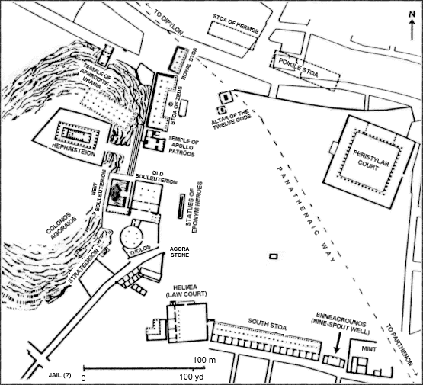

- Lecture 17:
- Letter of the day
- Tt (tau)
- for tyrannicides
- murder of hippokris

- The Agora:
- stoa
- socialize centre for men
- building keep you in shade
- long building with deep porch
- political centre
- administrative centre
- legal centre
- law courts
- military centre
- military head quarters
- religious centre
- alter of 10 gods
- sacrifices made to Olympian Gods
- financial centre
- mint in Agora

- Industrial Sectors in Athens
- metal workers one side of drag
- temple of hephaistos here (GOD OF METAL WORK)
- on other side of drag clay workers
- made pottery, figurines
- Illegal to have no crafts
- Gave citizenship to craft workers
- Athens is major exporter of worked silver, pottery and olive oil
- equality in work
- a citizen, slave, and resident alien all got payed the same for the same type of work being done)
- this means how good you worked meant how much made

- Slaves
- slaves in Athens (individually owned privately)
- slaves bought in slave market
- slaves from pirates
- from revolts
- slaves are non Greek
- could not marry
- cannot own property
- can buy freedom but could not buy citizenship
- hired out in slave farming to do various jobs
- slaves can become doctors, metal workers...
- slaves can become very wealthy
- slave are fed, clothed, housed, and payed for work and never unemployed
- without slavery, direct democracy impossible
- principle of freedom and equality, citizens depended on slaves while they participated in government

- Peraieus: harbour area of Athens
- Peisistratos improved harbour of Athens
- fortified by Themistokles
- 3 harbours and 2 agoras
- 1 harbour calld kanthoras= biggest of 3 containers at the symposium thus harbour biggest of the other two
- Bay of phaleron had religious associations had to do with the Eleusinian Mysteries

- Economic centers in Athens
- 3 Harbours and 2 Agoras
- 2 agora (import and export near the harbour) mostly economic
- agoras imported grain (from black sea)
- Peiraieus: harbour area of Athens made by peisistratos

- Peiraieus
- Harbour area of Athens built by Peisistratos
- themistokles
- (fortified it)
- had an orthogonal plan
- Kantharos
- biggest of 3 harbours
- was commercial harbour
- other two are naval based harbours

- Eleusinian Mysteries
- Demeter (initiation ceremony)
- plant in fall harvest in spring
- Greek speakers only can be initiated
- free/slaves, males/ females (all can be initiates of Demeter at ceremony)
- Most common animal sacrificed in honour of Demeter is baby piglet
- take piglet to the bay of phaleiron
- wash and purify piglet in the bay
- take it back to asty for scarification
- Initiation
- priests would start at alter go through sacred gated then proceed all the way to Eulusis (on way to attica)
- Follow the cista= container on top of the head of woman contained religious objects
- 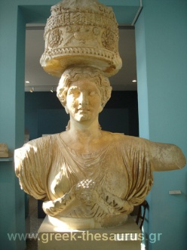
- 22 km hike
- at Eleusis is Demeter sanctuary, it is fortified
- Telesterion = hall of mysteries

- Telesterion (Interior)
- Site of Eleusinian Mysteries
- secret nocturnal rites (ceremony)
- death penalty for revealing the rites (ceremony)
- objects taken from cista and shown to initiates
- sacred objects connected with fertility of crops (take place in fall)
- it`s thought that they had something to do with belief in life after death
- very important religious ceremony in Athens

- Panathenaia
- birthday of Athena
- big religious festival
- mostly for Athenians but some things were open to non Athenians

- Panathenaic Way:
- Processional Route for Panathenaia
- route followed by people celebrating the panathenaia (birthday party for Athena)
- procession was to deliver present to Athena
- present was a new dress called Peplos
- weavers of peplos are aristocratic young women

- Panathenaic Procession
- procession on way to deliver present shown on Elgin Marbles: British Museum
- 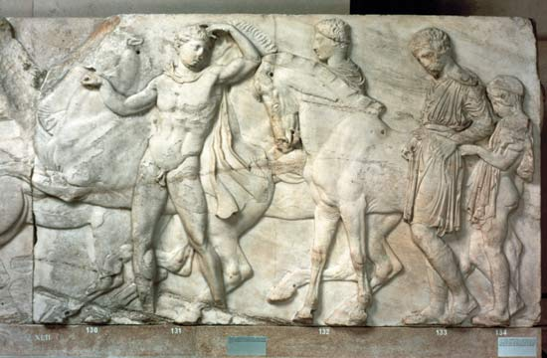
- Figure: the procession to deliver Athena's birthday present

- procession consisted of lots of people (the women who made the peplos, horsemen, priests cult members and animals
- including 100 bulls sacrificed to Athena
- every 4 years they have a grand version of this lasts 1 week

- Great Panathenaia (mostly Athenians)
- contests and religious ceremonies
- Hipparchos
- introduced Great Panathenaia
- introduced Homer contests
- Odeion
- building built by Perikles
- built for contest of Great Panathenaia
- The first 4 days of their events open to everybody but last 3 days are for Athenians only
- common prizes black amphora filled with olive oil

- Panathenaic Amphora
- 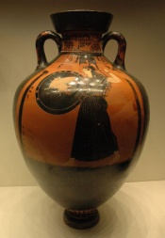
- always black figure
- Athena on one side
- on the other side depiction of event
- For the games of Athens written on it
- unlike Pan-Hellenic, awarded for more than 1st place
- 40 litres capacity
- sell the Amphora
- multiples given
- other prizes too

- Anthippasia : for Athenians only (lasted 4 days)
- Competition for Athenians only
- last 3 days team event for 10 tribes
- winner gets to erect statues, got money, 3 bulls, 200 free meals
- Competitions included military training:
- Calvary display
- dancing in armour important for phalanx
- 2 horse chariot racing
- javelin throw from horseback
- boat races important for trireme

- 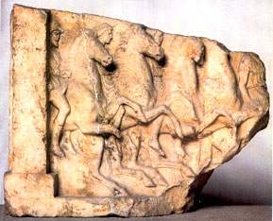

- Panathenaic Torch Race
- carry torches in relay race must remain lit
- Went through the Acropolis
- Also went through the Propylaia = Entrance gate
- 40 runners all together, 10 tribes, 4 per tribe participate
- prize for winning tribe and prize for winning individual
- occurred night before Panathenaia
- King Archon (basileus) stands at the altar holds branch of olives in front hydria may have been prize

- Acropolis:
- Focus of Panathenaia
- Re- built acropolis under Perikles
- pg.126

- Propylaia: Entrance gate
- Mnesikles architect
- on left picture gallery
- on right temple of Athena Nike
- Propylaia= five passage ways
- order of structure exterior= doric
- ionic interior

- Temple of Athena Nike
- Monolithic columns
- ionic
- frieze continuous = subject war
- only one room held bronze statue of Athena
- Athena Nike (wingless)
- 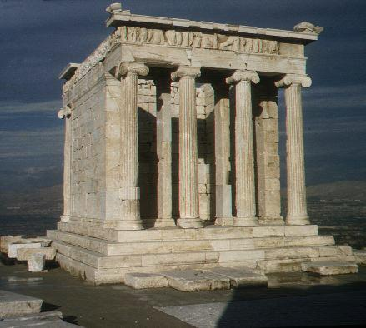

- Bronze Athena
- Promachos (Athena the Champion) by Pheidias
- Bronze figure of Athena
- located in the acropolis
- one of the ancient wonders

- Parthenon:
- largest Doric temple in mainland Hellas
- doric exterior
- ionic interior
- dedicated to Athena
- west pediment mythical contest between Athena vs Poseidon
- fight to see who got Athens
- Athena won by giving Athenians olive tree
- east pediment depicts birth of Athena
- pediment= large triangle at the top
- Metope Theme: triumph of Greek civilization over barbarians (people did not speak Greek)
- One side= Theseus versus Amazons
- North side: Greeks versus Trojans
- Giants, Lapiths vs Centaurs

- Parthenon: Ionic Elements
- continuous frieze (Elgin Marbles)
- 4 ionic columns in treasury (back room)
- double row interior column
- Athenians died 192= same number of people depicted on the continuous frieze

- Athena Parthenos
- chryselephantine statue (made of gold and ivory)
- a ton of gold
- Sculptor= Pheidias
- 9m high
- Athena dressed as warrior carrying shield
- On shield portrayed Greeks fighting Amazon
- Pheidias and Perikles depicted on there too
- pheidies had to leave Athens since not supposed to put living Greeks on ancient statues so he went to Olympia

- Athena and Ereschtheus
- Erectherus: early mythical King of Athens
- Raised by Athena
- 1 of 10 eponymous heroes of Athens
- 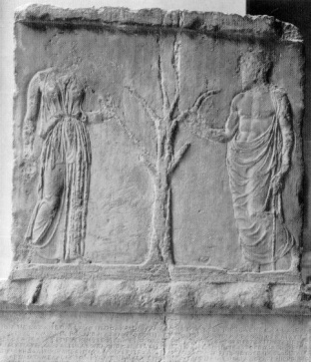
- Figure: inscription recording treasurers kept in Parthenon crowned by relief showing Athena and Erectheus either side of the olive tree
- worshiped in building called Erechtion

- Erechtheion
- Sacred to :
- Erectheus
- Athena
- Poseidon
- Hermes
- Dione: Mother of Aphrodite
- Zeus
- Butes: twin brother of Erechtheus
- Hephaestus
- in sanctuary wooden statue of Athena
- caryatid (column in the shape of draped female figure) porch
- the sacred olive tree was outside
- olive tree was hacked by Persians but grew back
- Hermes also had wooden statue outside
- Altars for Butes, Hephaestus, and Zeus
- Temple was designed on two levels

- Erectheion: Caryatid porch
- 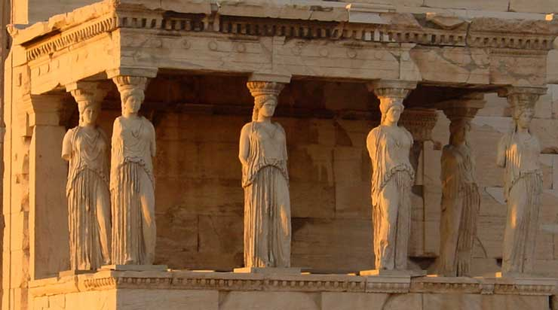
- faces the Parthenon
- women figures holding up the building
- Erechtheion
- James Stuart
- painting of Erechtheion
- painted the Parthenon (became Christian church then mosque and finally smaller mosques built inside the shell)
- Neo Classical architecture
- then became famous

- Words to Remember
- People: Peisistratos, Themistokles, Demeter, Athena, Athena Promachos, Pheidias, Athena Parthenos, Erechtheus
- Places: Peiraieus, Kantharos, Eleusis, Telesterion, Odeion, Panathenaic Way, Propylaia, Athena Nike, Parthenon, Erechtheion
- Terms: obols, cista, caryatid, peplos, Elgin Marbles, Panathenaia,, Panathenaic amphora, Anthippasia, pediment, chryselephantine, neo-classicism

- Section 12
- November-22-12
- 3:54 PM
- Propylaia Parthenon Erechthoion Temple of Athena Nike

- Dedicated to many gods (Erechtheion)
- Small ionic temple (Temple of Athena Nike)
- Combined Doric & Ionic orders (Parthenon)
- Entrance gate to the acropolis (Propylaia)
- Chryselephantine statue here (Parthenon)

- Y (upsilon) is for "naked" u
- Increase in trade led for more need to adopt the Phoenician letter

- Some Archiac Authors
- Hesiod of Askra (Boiotia) - epic poetry, how to manuals for farming, origin of gods
- Homer - we don't know exactly where he came from or who his father was, Odyssey and Iliad (great works of literature, part of education of young Greeks, competitions at religious festivals)
- Tyrtaios of Sparta - wrote marching songs about courage, how good it was to die for Sparta, soldiers sang his songs)
- Archilochus of Paros - lost his shield in a battle and wrote a song about it, not very courageous fighter, wrote personal poetry, often with a military theme
- Solon of Athens - Great Athenian reformers, cancelled debts, introduced law courts, commercial basis for Athens, wrote about his accomplishments, patriotic literature as well
- Anaximander of Miletus - Pre-Socratic philosopher, first western geographer, anticipated Darwin's theory of Evolution, indefinite is the root of all things

- Classical Historians
- Herodotus of Halicarnassos - lived and wrote in Athens, wrote about history of the Persian wars after 50 years, works called : Histories (Persian Wars)
- Thucydides - lived in Athens, military man, wrote about the Peloponnesian War, chronological history
- Xenophon - Hellenica =(ends talking about the Peloponnesian war, left Athens for Sparta, wrote not just history but also how to books, history of Cyrus the Great, proliphic writer

- Athens: birthplace of drama (page 126)
- Where drama began (Athens) biggest influences on our daily lives
- Athens: Theatre of Dionysis (page 136)
- Movies, plays, operas, performances that are acted by scripts, music
- Began in the time of the tyrant Peisistratos
- Word drama means to do something great
- Written to be performed by actors
- Theatre all around : Amphitheatre (CHECK SPELLING ) - gladiator games
- It's outside, open to the sky, the seats are like benches made of stone

- Ideal plan of theatre of Epidauros
- Theatron (where the audience sat) - the watching place
- Orchestra (where shit's going down)
- Behind the orchestra, there is a slightly raised platform called Proskena

- City Dionysia in honour of Dionysus
- Held in MARch
- Promoted by Peisistratos (art, drama because it encrouaged pride and establish identity)
- Encouraged polis pride and identity
- Religious rites (sacrifices, bbqs)
- Competitions (as important as the Panathenaia)
- State holiday (prisoners released on bail)

- Drama contests
- Judged: one judge per tribe, sat in front row
- Selected by: lottery (picked name out of hat)
- Prizes for actors, writers and producers
- Selected by: listened to the audience (applause meter)
- More than one prize for a winner
- The academy awards are around the same time………….

- City Dionysia
- Day 1: ended with a komos (party in the streets) (page 134)
- Days 2-4: contests for tragedy and satyr plays
- Day 5: contests for comedy

- Athens: City Dionysia: Day 1 (Fertility Festival)
- God of Fertility
- Feasting
- They paraded huge dicks
- Competition (tribal chorus contests - group of men that sing and dance)
- Komos

- What is Drama?
- Dithyrambs (chorus - song and dance by group of men)
- Tragedy
- Satyr plays
- Comedy

- Drama Begins - Dithyrambs
- chorus of male citizens
- Chorus - sing and dance
- Man who stepped away from chorus
- Thespis 534 BCE (during the tyrany of peisistratos)
- Thespians are now called after him
- Chat and dance with the aulos (double flute)
- Chorus is there to unify the play
- Provide background information
- As drama develops, less chorus, more actors
- Orchestra means : dancing floor
- In the middle of the circular area, there was an altar for Dionysus
- Before performance began, one of the 10 elected Generals would make a sacarifice to Dionysus - religious festival

- Actors
- Played parts for both sexes
- Always male citizens
- Played multiple parts
- Only 3 actors allowed in Tragedy in Athens
- Only 4 actors in comedy
- Paid by the Polis of Athens

- Tragedy (page 134)
- Days 2-4
- based on myths (changeable)
- Poetry forms
- Theme: struggle/conflict
- NO on-stage violence
- Off stage violence: obscene (obskene)
- Ekkyklema: bodies rolled out in a cart

- Tragic Form and Structure
- Kosmos
- Prologue: introduction
- Parados: chorus enters
- Interaction: episode and stasimon
- Exodos (chorus and actors leave)

- 3 actors per Tragedy page 134
- Masks (audience can see the faces/characters better)
- Masks made of linen
- Sounds will be funneled up and acoustics are amazing
- Contemporary clothing: himation (coats), long or short chiton (dress)
- Kothornoi (platform boots)
- Chorus dressed according to what they were playing

- Satyr Plays
- Relief from tragedy
- Dionysiac element
- Not satire!
- Actors dressed same as actors in tragedies

- Chorus in a Satyr Play
- Masks
- Loin cloths
- Leather phalloi (penises)
- Tails
- Pointed ears
- Imitating the attendance of Dionysus basically
- Only one Satyr play survives

- Comedy
- Contemporary fantasy
- Funny, crude, body parts
- Grotesque
- Lampoon
- Ludicrous predicaments (sex strike by the women to stop the Peloponnese War)

- 4 actors per Comedy
- Grotesque masks
- Padded costumes (huge butt)
- Flat slippers
- Leather phalloi (penises)
- Greek's found it funny
- Choruses in Comedy dressed in accordance with the comedy (Frogs = green)

- Who paid?
- Drama controlled, financed and organized by polis
- Polis paid actors
- Polis paid the poor to attend
- Polis "appointed" the producers and writers

- Who paid (2)?
- Choregos: producer (wealthy men)
- Appointed by eponymous archon
- Form of taxation
- Compete for status
- Prize: tripod and erected monuments to themselves (Choregic Monument of Lysikrates page 137)

- Audience
- Citizens and resident aliens
- Poor who were paid to attend (Perikles)
- Women? Ehhhhhh not sure

- Writers:
- Selected by the eponymous archon
- Tragedy writers: 3 tragedies and 1 satyr play
- Comedy writers: 1 play

- 3 Attic Tragedians:
- Aeschylus (earliest)
- Sophokles
- Euripides

- Aeschylus:
- Fought at Marathon (490) and Salamis (480)
- Death
- Went to Sicily to write plays on the tyrant, while he was there, he lost his hair, shiny bald head, an eagle is carrying a tortoise on the beach, the eagle needs to drop it to eat it and drops it on Aeschylus' head and drops dead
- Innovations
- Earliest tragedy writer so chorus is important
- Introduced props
- Based on Myths
- But this on actual event: "The Persians" (Salamis)
- Producer was Perikles
- Responsible for the trilogy: Oresteia

- Oresteia: trilogy by Aeschlyus
- Orestes, son of Agamemnon
- Play 1: return of Agamemnon, greeted by his lovely wife
- been fooling around with another man while he was at Troy, Agamemnon bought back a Trojan princess, and Agamemnon sacrificed his daughter to get good wind 10 years prior so his wife isn't happy to see him)
- So she kills him, but not on stage, in the back and comes back out and says I did it and why I did it and im glad I did it!
- Play 2: Orestes kills mother
- because mom killed dad
- Play 3: Justice from Areopagus Council
- For killing mother, by then the Council was only responsible for murder justice and taking care of the olive tree

- Sophokles
- Friend of Herodotus
- Died at 90
- Spartans declared a truce in the Peloponnese war to bury him
- 103 tragedies he wrote but 7 survive
- Into politics
- 2 Oedipus plays
- Oeudipus Tyrannos
- Innovations
- Introduced the 3rd actor
- Back drops, scenery
- He didn't act in his own plays

- Europides
- Salamis
- Only won first place 5 times
- Tragic death in Macedonia
- Went hunting and the hunting dogs ripped him to pieces
- To write plays for the King of Macedonia
- Focus on female heroines
- Murderess, witches, liars, adulteresses, sluts

- "Medea" by Euripides
- Wife of Jason and had two kids with Jason
- Wife murdered their children
- Use of : ekkyklema and mechane (crane to be lifted off)
- Only won 3rd prize

- Both Sophokles and Euripides wrote during the Peloponnese war so comedy was very popular

- Aristophanes: Old Comedy
- Limited to 4 actors
- Main actor is in every single scene and 19 parts, sometimes
- Aristophanes is only comedy writer to survive
- To make people laugh and get comedy prizes
- Visual comedy: on the container
- Zeus on the left looking at the lovely ladies up above and Hermes on the right
- Political satyrs were his big strength
- Perikles' mistress
- Socrates
- Aristophanes is the best source to get information on the people he makes fun of

- 100 years later:

- Menander: New Comedy
- Hellenistic period
- Origin of the modern sitcom
- Wrote over 100 plays but one survives

- Theatre at the sanctuary of Asklepios
- Built into hillside
- For Epidauros
- Best preserved theatre
- Held 16,000-17,000 people

- Lecture 18:
- 1. place for chorus =orchestra
- 2. producer of a play= choregos
- 3. first actor= Thespis
- 4. Writer of tragedies about women = Euripides
- 5. Where the audience sat = theatron
- 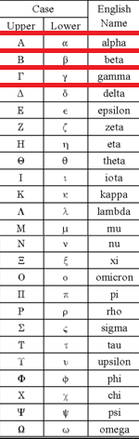
- Letter of the Day
- ϕ phi
- phi for pheidias
- important sculptor and project manager for building of statues on acropolis
- made Athena Parthenon sculpture out of gold and ivory
- pg. 126

- 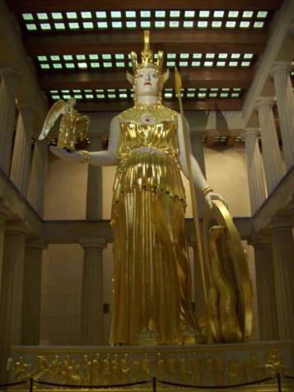
- Mythical Births
- Aphrodite born from the genitals of father
- Athena born out of Head of Zeus after Zeus swallowed mom Metis Goddess of wisdom
- Helen born from an egg (Zeus swan)

- Real Births
- father much older than mother maybe twice the age, men got married 30 or older
- father either cousin or uncle and is arranged marriage
- mothers gave birth at 14

- Women
- mother under the control of the father
- mother could not own property unless Spartan
- expected of her to stay at home, provide heirs and supervise the household/ slaves and weaving to make the clothing
- fetching water allowed women to get out of house
- fountains= social interaction with other women
- festivals allowed women to get out of the house

- Women and Festivals
- Eleusinian Mysteries (Demeter) all citizens of Athenians participate including slaves
- Panathenaia (Athena)
- Thesmophoria (Demeter)
- exclusively for women in the fall
- 3 day festival women camp out in the Acropolis
- on second day was fasting
- on third day retrieve object that have been buried earlier in the years fertility symbols, for example piglets fertility symbol since pigs give births to most number of babies another thing dug up is clay or teracotta figures of male penis
- Aristophanes wrote comedy play of this festival women on sex strike to stop the war
- Brauronia (Artemis)
- for girls rather than women
- coming of age celebration for girls just before marriage like barmitzva

- Infancy in Greek Antiquity
- father's role: had to acknowledge the child as his (decided if baby lived or died)
- if the family is poor, a girl or deformed babies, then legally exposed babies left outside the city sometimes rescued and raised as slaves or by couples but mostly left to die
- boy babies were a form of pension, look after parents in old age and expected to arrange and pay for funerals
- amphidromia = father walks baby around the house accepted baby as his and expected to grow up and survive and take care of father in old age, father will carry baby around house and baby is named

- Feeding Baby
- rich moms had wet nurses to feed the babies
- pg. 32
- feeding bottles found

- Anthesteria
- 3 year olds given a miniature oinochoe (wine jugs) no longer drinking milk instead water mixed with diluted wine
- symbolized weaning (process of gradually introducing infant to adult diet) and survival
- celebration they survived infancy

- Early Elite Burial Customs
- grave goods represented wealth and status
- tells us Greeks believed in afterlife (Underworld Hades)

- Types of Sarcophagus
- 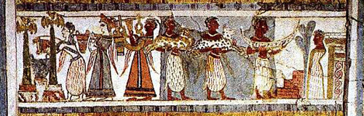
- Figure: Aghia Triadha sarcophagus religious theme, offering animals, libations, music
- 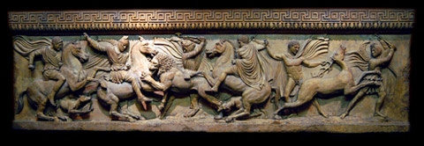
- Figure: Sarcophagos Alexander fighting Persians
- 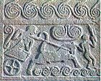
- Figure: Stele from Grave Circle A

- 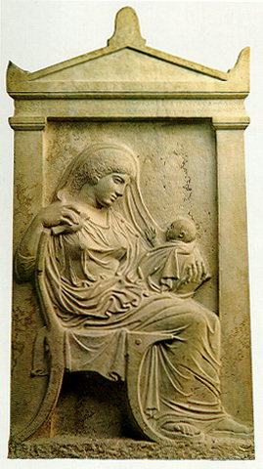
- Figure: Ampharete grandma holding infant, both die and buried together beneath tombstone, tombstone identified the two by name and date of birth pg.140
- 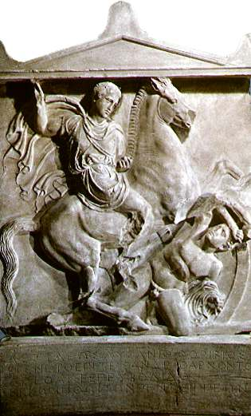
- Figure: Dexileos warrior on horse gives name date of birth and date of death pg.180
- Some other Grave markers
- Kourois
- amphoras
- 192 Athenian buried under soros huge mount
- Honouring the Dead
- lekythos container used to commemorate the dead (olive oil placed in container and poured on grave filled up to specific point to save money or left on grave)
- libations (poured olive oil) or grave offerings
- pg183
- reefs also left on graves

- 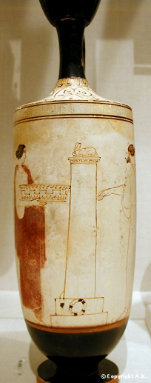
- Very Early Education
- mother raised children until they began education
- children potty trained
- Parents primary educators

- Education for Girls
- household management
- Mother taught the girls how to weave and make baskets and cook

- Women's Work :
- Women's job was to make textiles
- peplos: garment worn by women (Peplos Kore)
- chiton (short or long)
- himation (blanket wrapped around)
- elaborate patterns woven into the fabrics
- wool mostly or linen and silk appears from China

- School for Girls?
- rarely taught to read or write
- schools for girls existed but very few of them
- waste of time to teach girls how to read and write since household management important

- Solon's Legistlation:
- fathers must teach sons a trade
- no law for boys to attend school
- child should not be put to work or go to school before age of 5
- 7 normal age boys went off to schools
- schools privately run, cheap and strict
- They had heavy discipline, and teachers weren’t paid much
- Teachers not held in high regard

- Education Reading, Writing and Music:
- Music
- lyre: accompany poetry
- kithera : accompany poetry
- diaulos: one type of flute with two tubes
- aulos : one single cylinder second type of flute
- rhythm and harmony for life
- Reading and Writing
- little wooden book with depression on sides that had beeswax medium that can be erased for practicing writing
- writing or reading from scrolls made from Papyrus from Egypt
- Also had parchment (velum) made from animal skin pg.138-139
- Homer in curriculum
- measure poetry from Homer
- Taught boys to act as heroes
- taught simple arithmetic

- 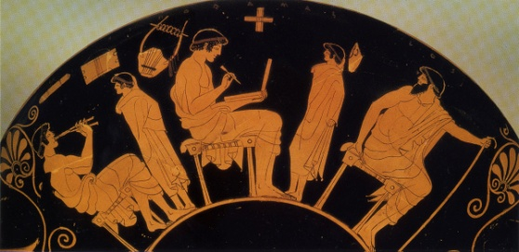
- Plato:
- "an uneducated man is one who lacks chorus training"
- pg.114 phalanx
- pg.111 trireme
- chorus training taught you to move to dance or sing together as you would move or row together in war

- Gymnasium (gymnos)
- wrestling competitions happened in the open space known as the palaistra
- Hermes and Herakles Gods of Gymnasium
- The poleis ran this sport complex
- Gymnasiums outside of the asty
- (this idea of gymnasium was uniquely greek)
- colonnade (place to rest, equipment stored, sometimes classrooms, oiling self, baths)
- physical training centres part of education
- social centres for men
- pickup spots for homosexual activity
- outside walls of asty
- Direct Democracy requires:
- good public speaking technique to persuade:
- ekklesia
- Heliaia
- if you were not a good public speaker can lose property, citizenship or life
- rehetoric= good speaking technique
- sophist ("wise man")= teacher travelled from polis to polis rhetoric most important subject
- where there is democracy rhetoric important
- did not teach to be ethical citizens
- win arguments without regard for truth
- Protagoras (teacher of rhetoric)= once spent a whole day arguing about javelin throwing accident someone was killed, whether the thrower or the javelin itself was guilty!

- Was Sokrates a Sophist?
- Sophists took money to earn living for teaching
- 1st true Greek philosopher
- was not a Sophist
- turned away from natural science and focused attention on ethics rather than the physical world
- Socratic method
- Oracle of Apollo claimed no one wiser than Socrates and proved that oracle was right
- He thought thinking for one self is key
- Served on council of 500 for one year
- charged with corruption of youth of Athens and impiety disregard for Gods declared guilty, cannot defend himself because does not have rhetoric skills, accuser asked for death penalty and condemned him to drink poison
- Aristophanes play writer on "the clouds" depicting Socrates

- Sokrates takes the cup of hemlock
- hemlock paralysis of nervous system
- hemlock= poison
- Account of death by Xenephon and Plato

- Plato
- pupil of Socrates
- wealthy
- never married
- Socratic dialogues (wrote down work)
- Wrote Laws
- Founded Academy (Hekademos) first western university higher education, specialist teachers, integrated curriculum, no tuition fees
- over the door of academy it said let it be no-one ignorant of geometry entry
- two pupils women
- his star pupil was Aristotle
- wrote book The Republic = ideal polis expressed in book
- he thought educate a few people and they would rule
- did not like democracy
- Sicily
- Aristotle
- not Athenian
- tutored Alexander
- Lyceum
- research and record info on cities constitutions
- only surviving is Athenian
- primarily scientist: astronomer (earth center of universe), botanist and zoologist
- was a scientist and philosopher
- after Aristotle science and philosophy split

- Diogenes of Sinope
- philosopher
- poor man
- whatever is natural cannot be dishonourable or indecent therefore can be done in public
- archive building he lived in Stoa of Zeus
- searches for an honest man
- cynic

- Stoa Poikele:
- Stoic meeting place
- Zeno
- Hellenistic philosopher came from Cyprus
- followers became stoics
- teachings was that only real good is virtue
- Only evil is to be non virtuous
- Classical period
- The center to study philosophy
- Basically like a museum

- Epicurus and the Garden
- Epicurean: highest good is pleasure
- slaves and women
- death is the end of body and soul
- Gods neither rewarded or punished humans
- like atheist
- lived life to the fullest
- Words to Remember
- People: Thespis, Thespian, Lysikrates, Aeschylus, Sophocles, Euripides, Aristophanes, Menander
- Places: Athens
- Terms: dithyramb (chorus), tragedy, satyr play, comedy, Lenaia, City Dionysia, komos, theatron, orchestra, thymele, skene, proskenion, parados, tragedy, satyr, comedy, chiton, himation, kothornoi, phalloi, choregos, obscene, prologue, parodos, episode, stasimon, exodos, ekkyklema, mechane

- cynic philosopher DIOGENES
- stoic philosopher ZENO
- founder of the academy PLUTO
- founder of the Lyceum ARISTOTLE

- X (chi) is for 1000
- pente = 5
- deka = 10
- hekaton = 100

- Classical Age (479-323)
- -democracy
- -drama
- -philosophy
- -the arts

- Fifth Century Wars
- Persian wars
- Peloponnesian wars
- pg.114

- Fifth Century Alliances
- Delian League (pink): Athens & her allies

- Athenian Tribute Lists
- -dues recorded on marble
- -acrophonic system

- Fifth Century Alliances

- Athenian Empire: Athens & her subject poleis
- Peloponnesian League: Sparta and her allies

- Peloponnesian War Sources:
- -Thucydides, Xenophon, Aristophanes

- Peloponnesian War (431-421) Strategy of Perikles
- -long walls
- -rely on fleet
- -refuse battle
- -typhoid epidemic (plague)
- earthquake

- 425/4: Sphakteria (Messenia)
- -Spartans surrender hoplites
- -blow to Spartan prestige
- -boost for Athens
- -Peace of Nikias

- Mutilation of the Herms
- -religious vandalism
- -Eleusinian Mysteries mocked
- -Alcibiades charged with impiety

- Sicilian Expedition
- Syracuse: stone quarries, Euripides

- Aegispotamoi (Hellenspoint)
- -Lysander
- -starves Athens into surrender

- Spartan Hegemony
- -‘reign of 30 Tyrants’ in Athens
- -399: death of Sokrates
- -371: Battle of Leuktra: Thebes wins
- 370: Messsenia freed

- Theban Hegemony
- -Leuktra
- -freed Messenia
- -Sacred Band defeated

- The style changes, and material used >how sculptures changed

- Hollow Cast Bronze Statues:
- -easy to:
- -correct mistakes
- -handle
- -balance
- -cheaper than marble
- pg.178

- Expression: Archaic Smile VS. Classical Calm

- Classical Sculpture
- -new material: bronze
- action or relaxed poses
- -standard proportions
- -realistic anatomy
- -calm expressions

Polykleitos Doryphoros

(Roman copy of original bronze)

-perfected sculpting of human figure

-standardized pose for statuary

-‘canon’ of classical proportions

Pheidias: Olympian Zeus

-bronze Athena Promachos

-chryselephantine statues:

-Athena Parthenos at Athens

-Zeus at Olympia

-1 of 7 wonders

Praxiteles: Aphrodite of Knidos

Lysippos: Agias

-bronze

-Alexander

-slender proportions

-original in marble from Delphi

Halicarnassus, capital of satrapy of Caria

Mausoleum at Halicarnassus:

marble tomb of Mausolus, satrap of Caria

Odeion (Ephesus)

-concert hall

-roofed

-sunken orchestra

-later became the bouleuterion

discuss 5 influences from ancient greek world on us today

- psyche = breath or soul
- -pythagoras famous for theorem
- born is Samos
- transmigration of souls (reincarnation)
- ^^believed that after death, your body transformed to a plant or animal
- Spartan Hegemony
- -404 (Aegospotamoi)
- -471 (Leuktra)
- ^beginning of Theban Hegemony

- a tribal society
- thought Macedonians were barbarians
- why? they did not dilute their wine with water
- and also practiced polygamy

- a Macedonian wanted to compete in Olympics but to do so you might speak Greek

- Macedonia:Pella: pebble mosaics (pg.188)

- Phillip of Macedonia (pg.192)
- -he extended his kindom
- phil – like ippos – horse > A HORSE LIKER
- held hostage in Thebes

- Philip’s Military Reforms –pg.92

- -> professional army (trained and payed, no amateurs)
- (spartians didn’t have a choice to participate, Macedonians did)
- -> standard uniforms
- -> deeper phalanx
- -> sarissas (longer spears)

- Cavalry provided infantry support

- Improved siege warfare
- -> helepolis (a giant tower)
- -> city taker

Philip II became head of the Delphic amphikteony

Battle of Chaironeia (338 BCE)

-Philip & Alexander

-end Theban hegemony

–Macedonia became top dog in Hellas

Olympia: Philippeion

-chryselephantine statues of Philp, Alexander, and Olympia

Tells the Greeks to get revenge in Persia for all the damages from the Persian Wars 150 years ago. in reality, this campaign that Philip suggested was to gain wealth

Vergina: Tomb of Philip II

-he was assassinated by an ex lover of Philip

-at the time, Alexander and his mom were though to have planned this assassination

-Alexander: “if Phil doesn’t stop getting all this territory, there will nothing be there for me”

~pg.193~

gold quiver for arrows

Alexander’s Inheritance

Alexander’s Divine Ancestry

-descendant of Heracles

-Dionysis

Battle 1: Granicus River (pg.334)

-Boukephalos

-cavalry battle vs. Persian satraps

-King Darius III absent

At Priene, Alexander

-temple of Athena Polias

At Halicarnassus, Alexander

-restored throne to Queen Ada who adopted Alexander as her son

why? because when she died, he could also be her heir –ensured loyalty of Turkey to him

The Gordion Knot of Midas: whoever unties the knot will rule Asia

Battle 2: Issus (333 BCE) ~pg.195

After Isssus, Alexander

-does not pursue Darius

-heads for Egypt

-siege of Tyre

Enroute to Egypt

333: Siege of Tyre

In Egypt, Alexander

-becomes pharaoh

-founds Alexandria

-consults oracle of Zeus Ammon

-leaves Ptolemy behind as governor

Battle 3: Gaugamela (331 BCE)

Babylon: Ishtar Gate

Susa: the Tyrannicides

Persepolis: burned in revenge?

After Persepolis

-pursuit of Darius again

-4 year campaign in Afghanistan

-more Alexandrias founded

A painting of the Wedding

exhibited at Olympic Games in 324 BCE

326: Battle at the Hydaspes River

-porus & his elephants

-death of Boukephalos

-founded town name for horse

-Roxane’s baby son dies

324:Mass Wedding at Susa

Death of Alexander a year later, June 10th, 323 BCE in Babylon

maybe from malaria, alcoholism.. dunkoee

he left the kingdom to “the strongest”

some thought son of phillip the 2nd …the half brother should ^

- EXAM TING Thursday, December 20, at 9:30 am

- What’s purple and conquered the world? Alexander the Grape. TEHEE

- Alexander’s sarcophagus
- -vergina
- -ptolemy

- Alexandria, Egypt: Alexander’s tomb
- pg.181

- Hellenistic Age: 323-30 BCE

- 323: Death of Alexander III
- 30: Death of Cleopatra VII of Egypt
- Hellenistic: Greek-like
- Hellenic: Greek

- Hellenistic Age marked:
- -3rd expansion of the Greek world
- ~koine
- -Hellenization of Persian empire
- -interface between Greeks & Romans
- -many changes

- When Alexander died, the land he had conquered, dissolved

- Wars of the Successors

- Major Hellenistic Dynasties
- Ptolemies: Egypt, Cyrene; Seleucids: Syria, Lebanon, Iran, Iraq
- Attalids: Pergamon

- The Hellenistic Monarchs were:
- -generals of large, mercenary armies
- -patrons of the arts
- -objects of ruler cults

- Egypt + Cyrene:
- Ptolemy I Soter (Saviour)

- Alexandria, Egypt: Change in Hellenistic Cities

- The Pharos of Alexandria: example of public benefaction

- Ptolemy LL Philadelphos
- -library on papyrus
- -Mouseion: research centre
- -sister/wife: Arsinoe II

- Cleopatra VII of Egypt:
- last Hellenistic monarch (committed suicide)

- Changes in style, subject and scale (pg.180)

- Pergamon: 281-133 BCE

- “The Dying Gaul” commemorates Attalid victory over Galatians

- Great Altar: Gods VS. Giants –pg.179

- Athens: prefabricated stoa of Eumenes

- Pergamon Library consisted of parchment scrolls
- The library at Alexandria consisted of Papyrus scrolls
- Parchment: made from animals skkins
- Papyrus: made from plant fiber
- ^ they wouldn’t trade papyrus!

- Ai Khanoum, Afghanistan: a Greco-Bactrian city
- ^ great example of Hellenization

- Changes in Religion: Isis, Serapis, Tyche (Fortuna)

- Hellenistic Changes:
- -government
- -language: koine Greek
- -coinage
- -cities & architecture
- -art: use & style
- -religion

