September 7, 2012

Chapter 1:

Archaeoastronomy and Sun:
- The man kind understanding the sky
- Motion of the sun and starts undertood enough to understand the celestial bodies
- Archeological connections
- Common connection to the sky is to sun
- Sky has heat and light
- Easily rrcoginizable to follow time
- 3 topics:
  - Newgrange
  - Sundagger
  - Stonehenge

Newgrange:
- Located at the eastern Ireland
- Ruined before and people fixed it
- 5000 years old
- Aligned with winter solstice
- Rock roof under the grass
- About 2 story building
- Oldest known building for astronomy
- Rock passageway 20 m long
- 3 rooms after the long passageway
- Spiral carvings and the rocks in the rooms and in the main entrance
- Water rocks at the end (left)
  - Probably used to hold ashes of people (rebirth of dead)
- Roof box faces the direction that the sun rises on the shortest day (Dec 21)
- When beam of light hits the roof box, the beam gets longer (when the sun goes higher up)
- The alignment of the tomb likely reflects a belief in rebirth or reincarnation
- After that day each day gets longer and longer
  - Warmer earth
  - Rebirth of grass and crops
  - More sun
  - Dead would be rebirth
- Large ricks are heavy and creation of this structures without machinery need lots of effort by many people
  - Believed that Newgrange should be important and made for big and imp. Person
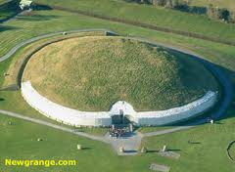
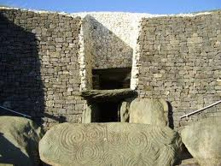
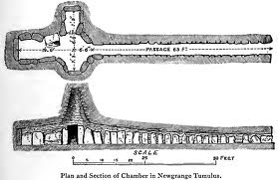
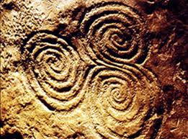

***Also, wash the video***

Sundagger (Located at Fajada Butte):
- Someone was doing a study about this and found this out
- On the summit of Fajada Butte in Chaco Canyon, New Mexico (USA), 2 spiral carvings were found behind 3 stone slabs
  - 1 large and 1 small carving
  - Made by Aboriginal Indians
- Very knowledgeable to make this (smart)
- Spirals behind 3 large slabs
- At noon on the solstices and equinoxes, the Sundagger exhibits 2 beams of sunlight which either bisect or frame the spiral
- It cut In the middle in the summer solstice (longest day)
  - Highest point of the sun in the sky
- During the Winter solstice there were two lines right at the corners of the spiral carvings (Shortest day)
  - Shortest point of sun in the sky
- Position of the new sun throughout the year moves horizontal and vertically,
- Pictures: ABCD are all at noon:
  - Winter 2 beams
  - Summer 1 beam
  - 2 equinox days: 1 big beam on the big spiral and other small beam on the middle of small spiral
- This Indians predicted the time travellers (smart)

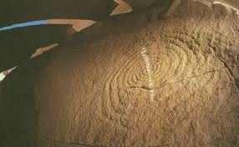
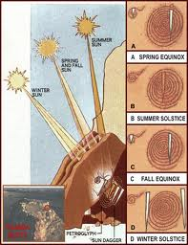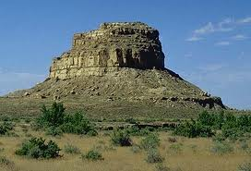
Light placed on carvings like in the picture at noon. Sun moves vertically and horizontally. Summer Solstice is the highest in the sky (1 line). Vertical motion is when the seasons change (can be seen on the sky). Horizontal motion can be seen by the number of lines there are on the carvings. Fajada Butte shown on right picture.

Stonehenge:
- Located in England
- Made after Newgrange
- Most famous because have complex arrangements of stones
- Stonehenge’s Heel Stone is aligned to the Summer solstice sunrise
- Big and heavy rocks
- Aligned to eclipses (Ex: when sun is blocked by moon) and moon rise as well as summer solstice
- Some people say Stonehenge is not very good at determining the summer Solstice
  - Probably mostly for the events not mostly for sky
  - Or some say that it was for moon or Eclipse
- Unmistakable alignments to the sun
  - These might be time for the ceremonies
  - Most prominent thing is that staying inside the Stonehenge and looking at the Heel Stone, when sun rises, almost looks like a torch in summer solstice
  - Also there was an Alter stone where the sun light gets to
- The summer solstice sun rises behind the Heel stone.
- Used for and they still worship today
- Earthhenge, then Timberhenge
- A theory says that it was used as predicting eclipses
- Stone structures was there before people made the stone heel and used it
- Mystery is why it was built before

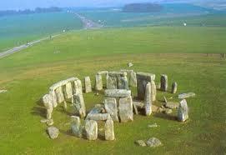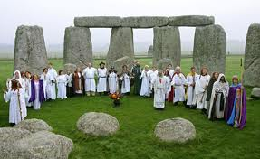
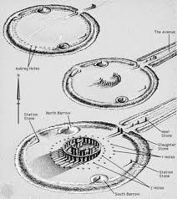
The sun hits the Heel Stone, passes the Slaughter Stone and stops at Alter Stone on Summer Solstice sunrise.

September 10, 2012

- When the Stonehenge, the current appearance several stones have knocked over an some are missing
  - One that was missing Is that it was a beside the heel stone but missing
  - Today it rises behind heel stone
  - Precise location of solstice changes a bit year to year
  - But hard to notice with eye
  - Before today and when it was built it was risen left of heel stone, between the two stones
  - So the stone beside it was the other stone where light was coming between them
- When Stonehenge was built, the summer solstice sun rose beside the Heel stone (due to precession of equinox)
- This suggests: there used o be 2 heel stones to frame the sunrise
- The sun rose between the two heels
- So this was built to show stuff (not cover sun)

The sun’s daily cycle:
- Due to earth’s 24 hour eastward-spin around its polar axis, “the sun moves westward across the sky”; it rises in the east, reaches its highest point in noon, then sets in the west
- The sun rises and sets everyday
- Rises in the east, goes highest to noon and goes down in west
- This is due to earth spin, not the sun
- The earth actually moves in the opposite motion (west to east)
- Earth only moves not the sun
- N-hemisphere: sun is mostly seen on the south side of sky, reaching due South at noon
- S-hemisphere: Sun is mostly seen on the north side of the sky, reaching due (exact) North at noon
- due=exact

Time of day due to earth spin:
- Local Noon: when your location is facing the sun
- Local midnight: when your location is facing the opposite side of the sky from the sun
- Local sunrise or sunset: when the Sun’s direction is perpendicular to your location

Sun’s annual cycle:
- Fall and Spring Equinox (Sep 23 and Mar 21): Sun rises due E and sets due W spending equal time above and below the horizon (equal day and night). (Equinox: Latin for “equal night”)
- Suns path in the sky determines day
- Because of the sunrise and sunset on these days, sun spends the most time above the horizon, equal length of day and night is seen
- After fall, equinox, sun shift downward (due to earth’s movement around)
- Winter Solstice (Dec 22): sun rises and sets at its southward position, traversing a short, low arc in the sky (shortest day of the year and lowest noon sun). (Solstice: Latin name for “solar standstill).
  - This bad, because of less light and colder weather
  - Indirect light is also seen (angle)
- Summer Solstice (Jun 22): Sun rises and sets at its northernmost position, traversing a long, high arc (longest day, highest noon sun)
  - Days are longer than the night
  - Sun is getting higher and higher each day until summer solstice
- The arc is still turned towards the north
- After Summer Solstice, they will move toward the south (in N-hemisphere)
- In S-hemisphere, everything is the same but the only difference is that everything is turned towards the North side
- Identifying the Sun’s rising and setting positions on the solstices simply requires finding its northernmost and southernmost positions.
- The shifting of the sun’s path is happening is by annual cycle
- In the prehistoric, didn’t have to understand the reason for the movement, they thought sun was moving, they just saw the path and how it was moving
- The seasonal changes in the sun’s daily are due to Earth’s 23.5 degree tilt from its orbit around the sun
- Winter: when a hemisphere is tilted away from the sun, sunlight hits indirectly (at an angle) causing low arcs and less light per area.
- The angle of the observer in the winter is large and in the summer it’s low (direct and warmer)
- Sunlight is more spread in winder (indirect)
- Summer: when a hemisphere is tilted toward the sun, sunlight hits more directly, causing high arcs and more light per area

September 12, 2012

- The picture 8 with the four globes, it shows the two solstices and the equinoxes
- The tilt is not changing but the tilt compared to the sun changes
- The northern and southern hemispheres see the summer and winters at different times (opposite exactly)

The animation 9:
- In the northern summers, the most of the northern hemisphere is light (longest days)
- In summer time, the north pole, they have 24 day time and opposite in the winter (all night) for that region
- If the earth was not tilted there would be no season and everyday would be about same temperature

The Sun and Latitude:
- Latitude (l): a location’s angle N or S of earth’s equator.
  - The latitude also changes the sun you get
  - Latitude of north pole is 90 degrees north
  - South pole is 90 degrees south
  - The earth is tilted (23.5 degrees tilted)
  - The lines of 23.5 degrees have the direct sun lights (tropics)
- Only within the tropics (l<23.5 degrees) can the sun be seen directly overhead
- At 23.5 degrees North (Tropic of Cancer), the noon sun is in the Cancer constellation when the Sun is directly overhead (June solstice)
  - The cancer picture
- At 23.5 degrees south (Tropic of Capricorn), during the winter solstice on the one day of the year the sun is directly on the Capricorn, the noon sun in the Capricorn constellation when the sun is directly overhead (Dec solstice)
  - The Capricorn Picture
- The lower the latitude, the higher the Sun’s daily paths
- Low latitudes are therefore warmer because they receive more direct light throughout the year

The latitudes (11):
- On the equinox days, at noon it will hit the very top at 0 degrees
  - 100% direct light at noon
- At 20 degrees, on the one day of the year, we will get 100% day light
- At the 50 degrees and 70 degrees no getting direct light
- Out of the tropics, there will be no direct light due to being so turned
- At the 23.5 degrees of polar, 24 hour of night at winter
  - 24 hour of day light in Summer
- Within 23.5 degrees of the poles (Arctic and Antarctic regions), the summer solstice set (24 hours of day light- a polar day) and the Winter solstice sun doesn’t rise (24 hours of night- a polar night)
- The higher the latitude, the more consecutive polar days/nights.
- In the tropics it seems like the sunrise and sunset are very fast, at the shorter of time due to the steep sunrise and sunset (Sun has to go on the steeper and longer way to finish the day in the same number of hours that it has to finish the smaller arc in the north parts (ex. 50 degrees)
  - All parts of the earth at the same vertical line experience day and night together
  - Higher or lower latitudes so not change the time of the day.
Stars:

Positional Astronomy and the Cycles for the Stars:
- For the centuries, sailor relied on the celestial bodies to navigate
  - E.G. the Polynesians, who were scattered over 1000 islands in the South Pacific, traversed their islands by canoeing the stars.
  - Star navigation by polynesians
- The only accurate way of using the way at night would be the stars, because this is the only possible way when we have no GPS or other signs at dark nights
- Very precise way of giving directions
- Polynesians migrated to pacific islands (like Hawaii)
  - Accomplished by canoe
  - Polynesians depended on people (astronomers) to get directions
  - Most other cultures and countries did not think about this very much
  - Until the 16th century they passed the info from generation to generation until Europeans colonized in 16th century and got that info.

- The celestial Sphere: Our view of the sky projected onto the surface of an imaginary sphere, a visual tool for describing the positions of the celestial bodies.
  - Imaginary globe of the sky and we are inside this sphere
  - The observer would on the pole inside
  - The small arrow at the top of the N-S axis shows that the earth moves in the anti clock wise motion
  - Any city can be described in the global points (like N, W, W, E)
  - Celestial bodies can also describe things
  - The North Celestial Pole (NCP) and the South Celestial Pole (SCP)
- Horizon: The circle around the observer which separates the visible and invisible hemisphere of sky
  - If the person is above the horizon then he cannot see the south celestial pole (SCP)
- Zenith: point on the sky directly above the observer
  - Alt = 90 degrees
  - On the first question on the first exam the zenith is directly on top of you!!!
- A celestial body’s position can be described by its relative coordinates
  - Altitude: the object’s angle upwards from the horizon (between 0-90)
  - Azimuth: The objects direction along the horizon
    - Since altitude and azimuth are the relative coordinates, they can differentiate form location to another
- CE = Celestial Equator

September 14, 2012

News: Planets can form in the galactic center:
- We have learned that our solar system is not alone or unique
- Billions of other stars, which have planets around them (called exoplanets)
- Planets can form in all sorts of shapes and galaxies
- Planets can form in multiple star system, or starts colder or hotter than our sun
- Searching for exoplanets in expensive, the range f the galaxy is tiny
- In order to search for planets we should look for the best place to find planets
- Long thought that the centre of the galaxy, bad place for looking for planets is the middle of the galaxy, the reason is that there are so many satrs that we cannot even see in there
- Planets are made from disk of gas, when stars are born.
- The stars will pull and push on each other and destroy planets in the middle of galaxy due to high number of stars. Then the stars explode
- However, there are some evidence that the disk of gas can survive in the middle of galaxy so the planets can survive
- The curve that they saw (gas cloud)
  - The star that made the gas is not close
  - This is very recent, so it is weird that the star left quickly
  - This is maybe the explanation is that the black hole actually suck the star, when the disk of gas was making the planet
  - The gas cloud is actually being sucked in as well so it won’t survive!
  - Lots of black hole in the middle of galaxy
  - Since the center of galaxy is made up of lots of star, as long as there are lots of gas disks there is a possibility for planets
  - The evidence is that there are other new stars around them
  - This is interesting because if one star was in the middle, then it means that there were many as well (the grand parents) should be somewhere in there as well

Stars (14):
- A celestial body’s position can also be measured by its absolute coordinates relative to the Celestial Equator (CE):
  - Declination (DEC): The object’s angle; N or S of the CE
  - Right Ascension (RA): the object’s angle (in hours, h) E or W along the CE (RA =0th is the sun’s position at the Spring Equinox)
- In the star chart, declination line of 0 is during the both equinoxes, the sun is seen right directly on top of the equator
- In the 24 hour of the sky RA during spring equinox is 0
- DEC and RA are not relative (they are absolute), while Az and Alt are relative (coordinate dependent, can change depending on the location)
- They are absolute, since the celestial sphere does not rate on daily basis. It only travels around the sun.

Star (13):
- Since we can’t measure length on the sky with a ruler, they are expressed as angles (the angle spanned by a length of sky).
- Example:
  - The full moon’s length spans 0.5 degrees in the sky
  - The 2 pointer stars of the Big Dipper span 10 degrees of the sky
- The altitude of the sky can be measure by the fist (width of hand) which is 10 degrees
- 9 hands make a right angle
- To measure smaller lengths, the width of any finger is 1 degree

The movement of stars:
- As earth spins daily around its polar axis, the stars appear to rotate the NCP and SCP.
- The cause of the stars motion is the same as te daily sunrise and the set of the sun.
- The Polaris is the star due north of the NCP
  - The other stars move around it
  - It has 3 stars that are seen as polaris
- The SCP does not have a star right at it
- At north and south poles, they move around the NCP and SCP
- At due west and due west or east, some go up, other go around NCP and SCP
- They move anticlockwise in north and clockwise in south clelestial poles

Stars (17):
- As the earth spins daily around tits polar axis, the stars appear to rotate around The SCP and NCP
- The Altitude of the visible Celestial Pole (CP) is equal to an observer’s latitude (The higher the latitude, the higher the CP)
- Since Polaris (the North Star, actually a Triple-star system) marks the NCP, a northern observer’s latitude equals Polaris’ latitude
- Polaris is not a single star
- Three stars that are put together by the gravity
- Only Polaris A is seen by naked eye
- Since the SCP doesn’t have a polar star, it is located using nearby constellations or bright star systems.
September 17, 2012

Constellations:

- The constellations we see depend on our latitude:
  - N-hemisphere: we see all constellations N of the CE
  - S-hemisphere: we see all the constellations S of CE
- If we are in N and we would move S, the stars in the N disappear and the S stars would be shown more
- These pic are the constellations looking at the North pole and south pole respectively
- A constellation: is a set of stars that various populations that people connected together to make a shape
- In the southern constellations, there are more constellations, but they are smaller
- Not only the constellations change with altitude, but they also change with the seasons
  - This is due to the earths movement due to season changes
- Every night at a given latitude, each star rises and sets at the exact same azimuth
- The azimuth of all stars never change every single day at specific latitude.
- If you memorize the sets and rising the each stars you will know the directions
- Direction can be found with a “star compass”, in which the horizon is divided into directions marked precisely by the rising or setting of bright stars.
- For example, if the star is rising from 45 degrees east (stars rise from East), then you will know where to go.
- In the England this was not possible, since the ski wasn’t cloudy
  - This is a disadvantage of using this method (when cloudy).

