Module 1: Introduction to Physiology Contents
Thursday, May 07, 2009
1:10 PM
1.1 Objectives

- Define physiology
- Define homeostasis
- Describe negative feedback control systems
- List the levels of organization in the human body

1.2 Introduction

In this section, we will introduce the study of physiology and some of the basic concepts necessary to understand how the body works. Essentially, the problem faced by the body and all of its cells is how to surround themselves with barriers that allow desired substances to pass in and waste to pass out while maintaining their own internal environments. This section will define the internal environment, the external environment, and homeostasis. We will also explain the importance of negative feedback control systems and how they are involved in regulating the internal environment.

What Is Physiology?
Physiology is the study of function in living organisms. It explores the mechanisms by which the organisms control their internal environments regardless of what happens in the outside (or external) environment. Physiology also attempts to explain the physical and chemical factors responsible for both normal function and disease (also called pathology).

1.3 Homeostasis

Homeostasis
The internal environment is the fluid in which the cells of the body are bathed. This essentially consists of the interstitial fluid and blood plasma—a region we will examine in more detail in module 2. The external environment is the region outside the body. The external environment also includes the space and contents of the digestive, respiratory, and urogenital tracts—as shown at right.

Homeostasis is defined as the maintenance of relatively stable conditions within the internal environment regardless of what is happening in the external environment.

Consider this situation: If you removed a dozen cells from your body and placed them in a dish on a beach in the Bahamas, they would likely dry up and die within a few minutes. If, on the other hand, you were to lie on a beach in the Bahamas, you would last a much longer time and would likely even enjoy it. What is the difference? The difference is our body is capable of maintaining our internal environment so that our cells can function regardless of what is happening in the external environment. This is homeostasis.
The body maintains homeostasis using negative and positive feedback control mechanisms. Let's have a closer look at these two important mechanisms now.

1.5 Negative Feedback Control Systems

Negative feedback control systems are found throughout the body and perform different functions, from maintaining body temperature to maintaining body fluid volumes. All negative feedback control systems operate the same way to maintain homeostasis. They contain a set point, a control center (also called an integrator), an effector, a controlled variable, and a sensor (also called a receptor), as shown at right.
Let's look at an everyday example that explains each of these components. We'll then look at an example found within the body.

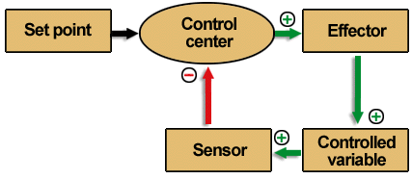

The simplest example of a negative feedback control system is the heating system in your house. The set point is the temperature at which the room is set (for example, 20°C or 68°F). The sensor/control center, which are combined in our example (this usually is not the case in the body), represent the thermostat. The effector is the furnace, and the controlled variable is heat.
This is a negative feedback system because the controlled variable (the heat), which is detected by the sensor, eventually shuts off its own production by the effector (the furnace).

Here is how negative feedback controls body temperature. The set point for body temperature is 37°C (98.6°F). This is the temperature that you want your body to maintain. Your actual body temperature could be different; it could drop on a cold day to 35°C (95°F). This actual body temperature would be detected by sensors in the nervous system which would signal a control center in a specific region of the brain called the hypothalamus. The control center would notice a difference between the set point (what you want) and the actual value of 35°C (95°F). The control center would then activate organs and systems (the effector) to generate heat (the controlled variable) by shivering and conserving heat by decreasing blood flow to the skin.
Once the body temperature rises back to 37°C (98.6°F), the control center would stop the shivering and would return the blood flow to the extremities. The opposite would happen if body temperature increased above the set point. The sensors would detect the rise in temperature and signal the hypothalamus. Utilizing the nervous system, the hypothalamus would signal blood vessels in the skin to dilate and sweat glands to sweat. Heat would dissipate and body temperature would drop to normal.

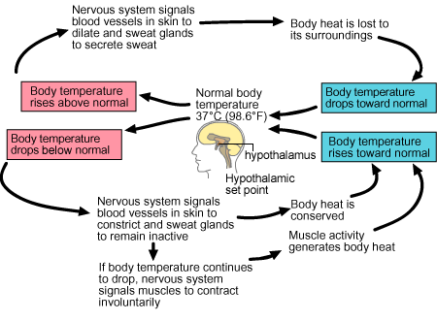

1.8 Positive Feedback Control Systems

Unlike negative feedback systems where the controlled variable eventually shuts off its own production, a positive feedback control system (also called feedforward systems) is a mechanism where the controlled variable actually stimulates its own production. Positive feedback systems are self-amplifying mechanisms that can produce a very rapid change in a physiological system. As shown at right, the controlled variable is detected by the sensor that signals the control center to activate the effector to produce more of the controlled variable. In this way, large amounts of the controlled variable are produced very rapidly.
Throughout the modules, we will see several positive feedback systems, including the generation of the action potential in nerve cells and the surge of luteinizing hormone that causes the ovulation of the egg from the ovary.

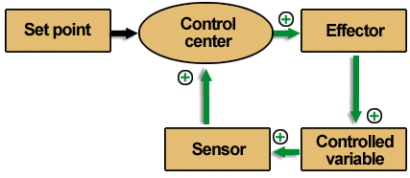

1.9 Negative and Positive Feedback Systems

All of the systems in the body use negative or positive feedback to regulate their functions; these, in turn, maintain homeostasis. These feedback mechanisms rely on two control systems to function properly: the nervous system and the endocrine system.
The nervous system (brain, spinal cord, and all of the nerves) is especially adapted for rapid communication through its complex system of neurons and nerves. The endocrine system responds more slowly, communicating by the release and distribution of hormones in the blood. We will be looking more closely at these two systems as we go along, so it is important to understand how feedback systems work.
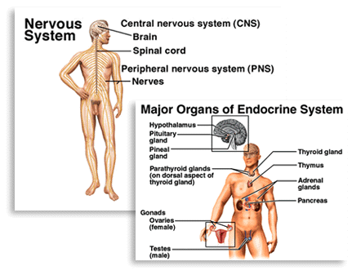

1.10 The Body's Structural Hierarchy

Atoms make up molecules. Molecules make up macromolecules, which can form cellular organelles. Almost all cells of the body contain similar organelles like the nucleus, the cell membrane, proteins, and so on. Some cells have taken these basic structures and have turned them into highly specialized structures. These specialized structures give each cell in the body a specific purpose. For example, muscle cells contain large quantities of special proteins that cause the muscle to contract.
When groups of cells that all have the same specialization are grouped together, they are called a tissue. For example, muscle tissue is specialized because it contains cells that can contract. When two or more types of tissues are combined to form a complex, functional unit, they are called organs. For example, the heart is composed of connective tissue, muscle tissue, and specialized conducting tissue. When several organs cooperate for a common function, we call them organ systems. When you combine blood vessels (veins, arteries, and capillaries) and the heart, for instance, you get the cardiovascular system. When all of the organ systems are grouped together, we have an organism.

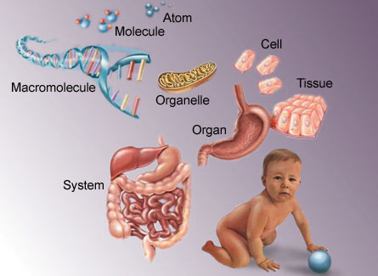

A Quick Look Back
In order for all of the cells and, ultimately, all of the organ systems to function properly, the internal environment of the body must be maintained at relatively stable conditions, regardless of what is happening in the external environment. This includes maintaining a relatively constant body temperature, water balance, salt concentrations, and so on. The body achieves this by detecting changes then, through negative feedback control systems, correcting the change. We have seen that each organ system is made up of different organs working together for a common function. Each organ is made up of several different types of tissues, while each tissue is made up of cells with similar specializations.
We will see how the fluid and ion composition inside of the cell is different from that outside and how these differences come about. We will then begin to look at a typical cell in the body and some of its basic structural features.

