- Requirements for the Formation of glacier:
  - Cold temperature
  - Sufficient precipitation
- Glacier mechanics
  - Internal Visco-Plastic Flow:the glacier expands outward after its own weight becomes too heavy, similar to what happens to heated cookie dough
  - Basal sliding: e glacier is stationed on a slope and pressure melts ice at the bottom, forming a thin layer of water. The loss of friction allows the glacier to "slip," or slide down the slope.
  - More ice = accumulation = will go forward
  - Less ice = ablation = will retreat
- Erosion
  - Plucking: glacier flows over a fractured bedrock surface,it loosens and lifts blocks of rock and adds into the ice. known as plucking. Land left fine to big boulders

  - Abrasion: glacier scrapes over bedrock, grinding it into rock flour. Very fine
- Types of deposit
  - 1)Materials deposited directly by the glacier, which are known as till, and

  - 2)Sediments laid down by glacial meltwater, called stratified drift.- SORTED

    - Kame- terrace
    - Kettle- hole in ground
    - Esker-tunnel

  - Drumlin – gentle slop – ice going in that direction ( to many contours close by)

- Engineering effect
  - Glacial-fluvial sediment: more gravel ( good for water)
  - Glacial-lacustrine sediments: more clay , less gravel , easily compress with heavy building ( good for getiing clay)
- Rivers
  - Sediment transportation :
  - Bed load: with the bed of the channel
  - Suspended load: muddy . pulp in OJ
  - Dissolved: dissolved and dispered throught the water. Sugar in organe juice

- Depostional environements:

- braided streams
- 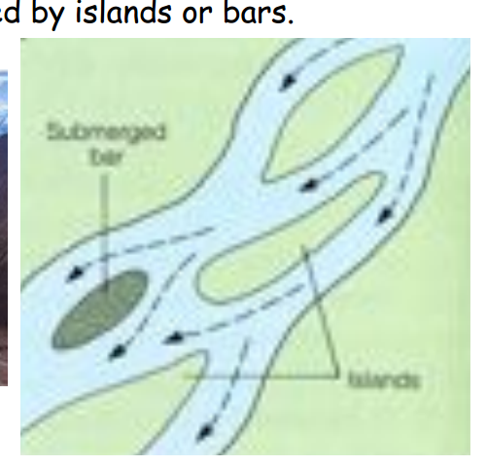

- Meandering streams
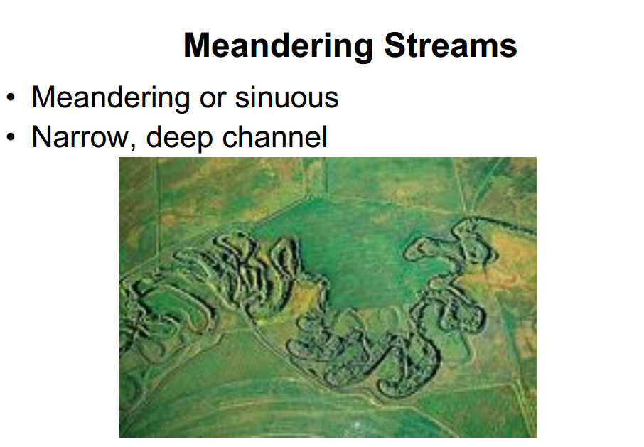
- Deposit on inside & erode on outside of bends

Flood plains
- Alluvial fans and deltas ( energy is lost , sediments are depositied) : alluvival :
  - hits the valley
  - Delta: hits ocean

- Graded streams and rivers: has the slope to maintain minimum velocity ( just transporting no erosion or deposition)
- Habitation on floodplains.
  - Bridges & construction altering river channels.
  - Transportation along rivers.
  - Dams (hydroelectric, reservoir, navigation,
- Coastlines
  - Big waves – steep slope
  - Small wave- gentle slope
- Solutions
  - Jetty
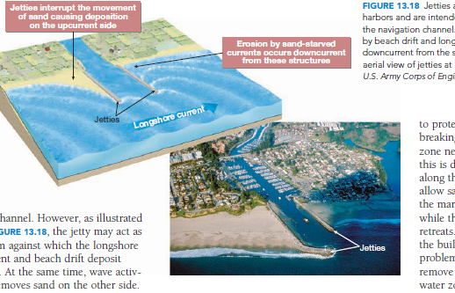
- Groins: at 90 degree angle . they are in pairs
- Breakwater: random wall in the middle of the ocean divert the waves back
- Seawall: wall at shoreline

- Weathering
- Mechnanical wethering
  - Frost
    - Water in crack feezes and expands
  - Salt
    - Crystalization of salt in pores
  - Exfoliations
    - Fractures in rock
  - Root
  - They grow in rocks and expand
- Chemical
  - Solution / dissolution
    - Soft rock dissolve as mineral react with acid and water
  - Hydrolysis
    - React with water
  - Carbonation
    - React with carbonic acid
  - Hydrations
    - Absorbing water
  - Oxidations
  - React with oxygen
- Reasons for weathering
  - Fractures
  - Porosity of rock

  - High temperature is more likely to weather on earth’s surface
  - Movment in piece: erosion
  - Just break down : weathering

  - Ground water

  - Porosity: how much void space is there
  - Permeability: transport water

  - Hydrallic head: pressure head + elecvation head
  - Hydrallic gradient = i = h1-h2/l
  - Specific flux= q=ki
  - Volumetric flux: KiA
  - K = hydrollic conductivity
  - Velocity=discharge(q)/porosity (n) (m/s)
  - discharge = V A

  - Aquifer: transfer water
- Confined : aquitard below and above
- Unconfined: direct to surface
  - Result in drop of water table / cone of depression
  - Aquitard: slow transfer but store water
  - Aquiclude: prevents the water movement

  - Soil
  - Top soil : Holds moisture, include organic shit . prevents erosion
  - Sub soil: holds clay and oxides. Has small rock material
  - Expansive soil = a lot of swelling clay = hold water = roller coaster roads/ cracks

  - Hydrocompaction refers to the tendency for loose, uncompacted soils that are found in some arid environments to compact under load when they are wetted
  - Collapsing soil is defined as a weakly cemented soil subject to large settlements under load and as a result of deterioration of the cementing agent in presence of water

