HANDOUT: ANTH 241—Visit to MOA: The Collection and The Catalogue
Thursday 20 September, 2012

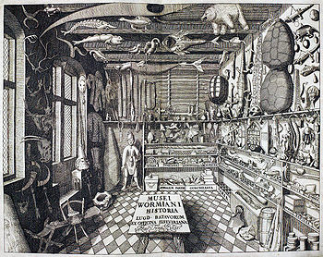
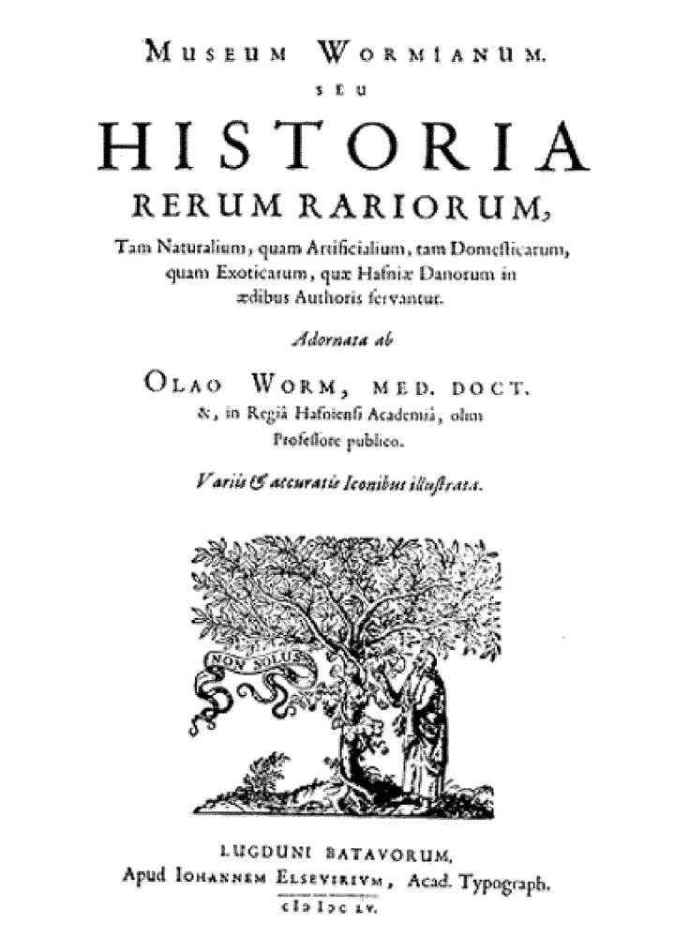
“During the seventeenth century, new ideas about how to organize and order objects into meaningful collections began to supersede some of those that had informed earlier practices […] The curiosity ceased to be such a focus in these newer epistemologies and notions of typological mapping, or what Foucault refers to as ‘tabulation’ (1970), and ‘coverage’ gained ground. Taxonomies flourished […] Evident in all of these collecting practices are the notions that objects are meaningful and that collecting and organizing them can be a means of making sense and gaining knowledge of the world” (Macdonald, 84-5)
Collection

…According to Jean Davallon, in a museum “the objects are always parts of systems and categories” (Davallon, 1992). Among the systems relating to a collection, besides the written inventory which is a basic requirement of a museum collection, it is just as essential to adopt a classification system which describes and can also rapidly find any item among the thousands or millions of objects (taxonomy, for example, is the science of classifying living organisms). Modern classification systems have been greatly influenced by information technology, but documenting collections remains an activity requiring specific and rigorous knowledge, based on building up a thesaurus of terms describing the relations between the different categories of objects. (D&M, 27)
Preservation

…In museology, preservation covers all the operations involved when an object enters a museum, that is to say all the operations of acquisition, entering in the inventory, recording in the catalogue, placing in storage, conservation, and if necessary restoration.

The preservation of heritage generally leads to a policy which starts with the establishment of a procedure and criteria for acquisition of the material and intangible heritage of humanity and its environment, and continues with the management of those things which have become museum objects, and finally with their conservation.

In this sense the concept of preservation represents that which is fundamentally at stake in museums, because the building up of collections structures the mission of museums and their development. Preservation is one axis of museal action, the other being transmission to the public. (D&M, 65)

Collection cont…

…The recent development of museums – in particular the recognition of intangible heritage – has emphasized the more general nature of collections while also raising new challenges. Intangible collections (traditional knowledge, rituals and myths in ethnology, ephemeral gestures and performances in contemporary art) have led to the development of new systems for acquisition. The material com position of objects alone sometimes becomes secondary, and the documentation of the collecting process – which has always been important in archaeology and ethnology – now becomes the most important information. This information is not only part of research, but also part of communicating to the public. (D&M, 28)

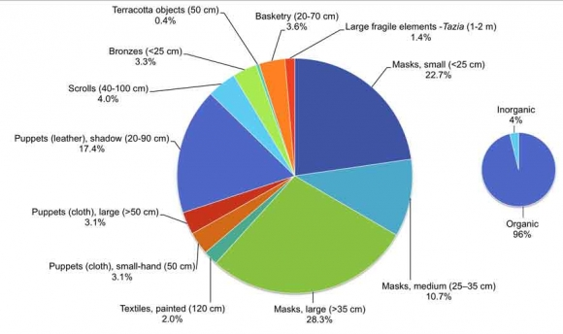
The Janapada Sampada ethnographic collection of the IGNCA (Indira Gandhi National Centre for the Arts), New Delhi India

The primary purpose of our visit to MOA today is to familiarize ourselves with the collection (on display) and the catalogue. We will be meeting Ann Stevenson, Information Manager at MOA, who will talk to us about the MOA CAT (the museum’s digital on-line catalogue) and give some tips for finding objects (very useful for your Object of Choice assignment). She will also explain the differences between the MOA CAT and the Collections online site. She will briefly describe how the Museum developed the collections information system--classification by culture (Murdock)--and talk about the organizational changes in the Multiversity Galleries that are reflected, or not, in the MOA CAT.

Meeting in the Bill Reid Rotunda:
2.00--2.20: GROUP 1 (Rachel, Kelsey, Eliza, Evelyn, Nancy, Kara, Carol, Raven, Ethan, Stefan)
2.20--2.40: GROUP 2 (Juliette, Alex, Pilar, Evan, Asako, Lauren, Mariko, Christie, Stephanie)
2.40--3.00: GROUP 3 (Woojae, Anna, Laura, Lorenda, Lisa, Krystina, Tania, Blake, Sharon, Caitlin)
3.00--3.20: GROUP 4 (tbc)
MOA Press Release: December 17, 2009

Save the dates! MOA Presents 'A Celebration of Creativity' - Jan 23, 24, 26

MOA's $55.5 million expansion and renewal project is nearly complete. For several years, MOA staff and a host of community partners and talented associates have been working hard to create new and amazing opportunities for visitors to explore different ways of knowing, understanding, and appreciating the world’s arts and cultures.

As part of the project, we are dramatically redesigning our Visible Storage Galleries – to be known as the Multiversity Galleries – to provide maximum visual access to some 16,000 objects from around the world. Our innovative new MOA CAT (digital catalogue) system will make additional collections information – images, audio, and video – available throughout MOA at the touch of a screen. (A variation of the MOA CAT will also be accessible from MOA’s website, so you can search the collections online, anytime.) In partnership with the Musqueam Indian Band, Stó:lō Nation, Stó:lō Tribal Council, and U’mista Cultural Society, MOA has also created the first-ever digital network (the Reciprocal Research Network) linking Northwest Coast collections in institutions worldwide. Our new 5,800 sq ft major exhibit hall – The Audain Gallery – along with enhanced visitor amenities and additional storage, research, teaching, and public programming spaces, have all been designed to provide students, scholars, visitors, artists, and community members with unprecedented access to the collections of the Museum and the Laboratory of Archaeology.

For today’s visit I would like you to focus on four distinctive, long-term display areas in the Museum (see attached plan): the Great Hall (E); the Koerner European Ceramics Gallery (L); the Bill Reid Rotunda (K) and the Multiversity Galleries (J). We want think about the relations within and between these different display areas, particularly within the framework of collections and collectors.
We will meet in the corridor, next to the Bill Reid Rotunda, with the iconic Raven and the First Men sculpture.

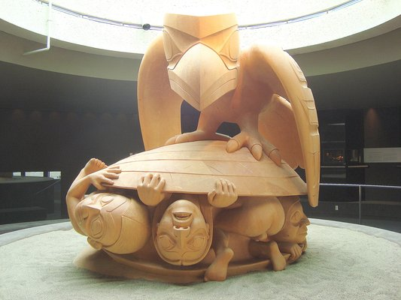

After your group has met with Ann Stevenson, I will briefly talk to you about your Object of Choice assignments.

We will be discussing this assignment in more depth (with a guiding- notes handout next week).

We will be visiting MOA next week (Thursday 27 September) to meet with the librarian, Shannon LaBelle, who will talk to us about the library resources and research. During this visit you will have an opportunity to work on your Object of Choice assignment.

First, take a stroll through all of the museum galleries. Think about the scope of the collection on display (the cultural areas; the different types of object; how the collection is ordered, classified and interpreted. Think about the visual language of display and sensory inflections: the light/s; colours; glass cases and/or barriers; the interpretative media (graphics, texts, etc.), as you move through these exhibitionary spaces. Look at the objects: how are they displayed? how are they mounted/installed? are they grouped? is it a low density or a high density display? what are the relations between the exhibits? what are the relations between text and objects?

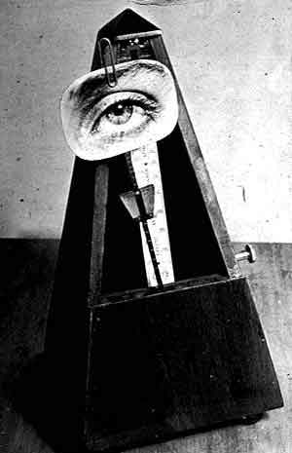
Object to Be Destroyed or Indestructible Object (originated by Man Ray in 1923)

Now, take time to look in more depth at the four areas—the Great Hall (E); the Koerner European Ceramics Gallery (L); the Bill Reid Rotunda (K) and the Multiversity Galleries (J)--and critically reflect (don’t worry, if you don’t manage to look at all four spaces–we will be returning to MOA).

Search for traces of ‘material immortality’ (Pearce 1999, 27); can you identify collectors/a history of collecting?

a few PROMPTS
** (plus some blank space to facilitate and document your thought processes)

(A) IMPRESSIONS. Make sketches, if you like, to aid your understanding of the scope of the collection and the visual language of display. Register your initial impressions.)

(B) CLASSIFICATION. How are the objects ordered and grouped? (eg. by object type; ethnic/cultural group; geographical area; technology; materials; maker; other criteria?) Are different ways of classifying made visible?

(C) DISPLAY. How are the objects displayed? (cues: installed, mounted, materials used, background colour, lighting)

(D) INTERPRETATION. What kinds of interpretative media (textual, graphic, digital, photographic, filmic) are available? How is knowledge and information organized? Look at the catalogue information on the objects labels: what categories are included? Is this a systematic approach throughout the Museum? Do you think there is one, a few or many “voice/s of interpretation”? Whose voices are they?

(E) REMEMBER: name a few collectors? When and what type of material did they ` collect? Have you any idea why?

  YOUR OBSERVATIONS

