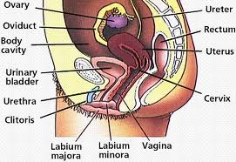
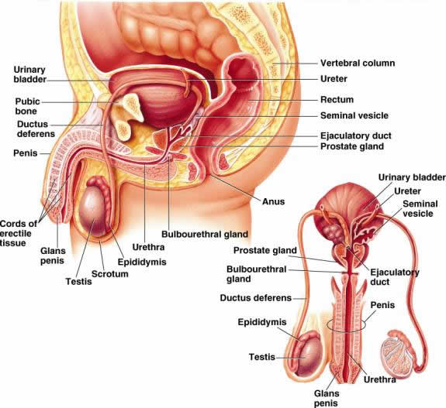
Describe the feedback loop involved in labour and delivery of a baby.
- During last few weeks, estrogen reaches high levels of estrogen forming abundant oxytocin receptors in myometrium & interferes progesterone’s quite influence on uterine muscle.
- Cells of fetus release oxytocin stimulating prostaglandins, causing more frequent, powerful contractions.
- Emotional stress causes hypothalamus to stimulate pituitary gland to release more oxytocin & prostaglandins.
- Positive feedback is activated creating stronger contractions and further release of oxytocin & prostaglandins.

Describe the structure and function of the amnion, placenta,
and umbilical cord.
Amnion
- Protects embryo.
Placenta
- Allows the placenta villi to exchange materials with maternal blood.
Umbilical Cord
- Carries blood between fetal circulatory system & placenta.

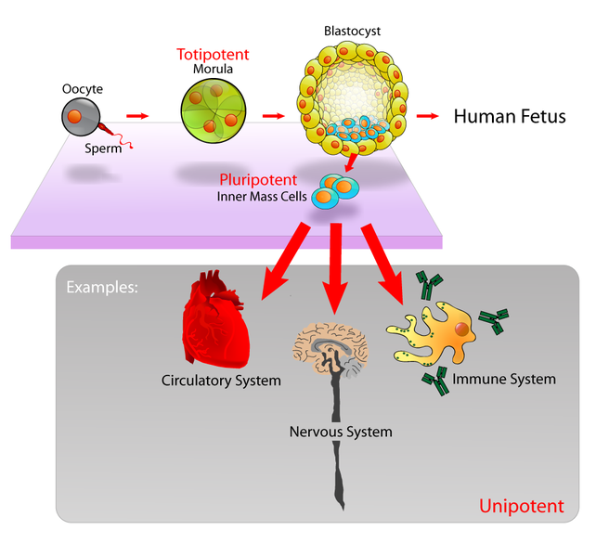
Describe human development from zygote, cleavage, morula, to blastocyst to embryo to fetus.
-Zygote journeys down uterine tube undergoing rapid mitotic cell divisions (stage called cleavage).
- 3 days after ovulation (or 17 of the women’s cycle) it becomes a ball of 16 cells called the morula.
- Uterine endometrium is not ready to receive embryo yet, so it floats free in uterine cavity feeding of uterine secretions, until it has 100 cells.
- It then forms into a blastocyst & by day 7 it attaches to endometrium.
- By the 3rd week, the placenta provides embryo with oxygen nutrients, and removes its wastes & by end of 2nd month, it produces hormones to maintain pregnancy.
- By 8th week all groundwork is complete.
- By 9th week it becomes a fetus.

Explain cell differentiation and explain differences
between endoderm, mesoderm, and ectoderm in the embryo.
Cell Differentiation
- A cell dividing to produce all other cells in the organism.
Ectoderm
- Gives rise to nervous system & epidermis of skin.
Endoderm
- Forms mucosae & associated glands.
Mesoderm
- Gives rise to everything else.

Describe fertilization.
- Genetic material of sperm combining with an ovum to form a zygote.

Identify the alveolar glands and lactiferous ducts of the mammary gland and describe their functions.
Alveolar Glands
- Produce milk when a women is lactating.
Lactiferous Ducts
- Open the outside at the nipple.
Chapter 16

