A mutant Fas ligand-EGFP fusion protein does not induce apoptosis in HeLa cells

NAME E-MAIL
STUDENT NUMBER

Performed at the University of Ottawa
Ottawa, Ontario

December 3rd 2012
BPS4127

Abstract
Fas ligand (FasL) is a type-II transmembrane protein, and part of the tumor necrosis factor (TNF) family. Upon binding to Fas receptor, it triggers the activation of apoptotic machinery in the target cell, a fact which has led to its study as a possible targeted anti-tumoral agent. It features three key regulatory regions that may lower levels of expression or downregulate its action. A mutant FasL (mtFasL) has been constructed lacking amino acids 8-69, containing a protein binding site as well as casein kinase substrate region, both involved in regulating FasL expression, and 111-133, containing a regulatory cleavage site. An mtFasL-EGFP fusion protein was created by subcloning mtFasL into pEGFP-N1. HeLa cells, a cervical cancer cell line, were transfected with the construct and shown to successfully express the mtFasL-EGFP construct. Cell death was measured 24 and 48 hours post transfection and in both cases, mtFasL with a C-terminal bound EGFP protein does not show any apoptotic effect on cervical cancer cells in vitro.

Introduction
Fas ligand (FasL, CD95L, CD178, APO-1L) is a type-II membrane bound protein and one of the key signaling factors in the extrinsic apoptotic pathway (reviewed by Strasser in (1)). It binds as a homotrimer to its similarly homotrimerized receptor, Fas receptor (Fas, CD95, APO-1) and in doing so, triggers the formation of the death-inducing signaling complex (DISC) and ultimately results in the apoptosis of the target cell (2). Biologically, the main purpose of this pathway is in preserving homeostasis in the immune system (3). Therapeutically, however, researchers are seeking to take advantage of this pathway as a method to induce apoptosis in cancerous cells (reviewed by Villa-Morales in (4)).
An obvious challenge to overcome in the use of FasL as a targeted cancer treatment is that cancer cells have some inherent ability to escape or tolerate immune expressed FasL, as is evidenced by their ability to proliferate in otherwise healthy humans. Another is that of hepatotoxicity. Being the most potent extrinsic apoptosis activator, CD95L has a tendency to cause massive liver failure and death (reviewed by Mahmood in (5)). Though this eliminates the cancer, a more targeted approach is required in order not to eliminate the host.
Both of these challenges can be overcome through gene therapy. By expressing FasL within the cancer cells, immune evasion is completely circumvented and FasL becomes localized instead of systemic (4). Many groups have already had success in attenuating or eliminating tumors using this method (6-11).
Despite itself being a regulatory protein, the body regulates the function of FasL by shedding it from its membrane through cleavage by metalloproteinases (12-15). The cleavage site is located between amino acids Lys 129 and Gln 130, part of its extracellular domain. Important as this is for maintaining homeostasis, tempering the action of FasL would impede the destruction of cancer cells. Further regulating the function of FasL are two key domains located in the cytosolic region: a casein kinase (CK) substrate region (aa 17-21 in humans) and a proline rich domain (PRD) (aa 37-70 in humans) (reviewed by Lettau in (16)). Both domains decrease expression levels by allowing serine phosphorylation and protein binding respectively.
This experiment examined the efficacy of a mutant FasL (mtFasL) lacking amino acids 8-69 and 111-133 (kindly provided by Dr. Shigekazu Nagata of Kyoto University) on inducing apoptosis in HeLa cells, previously shown to be FasL sensitive (17) . This mutant lacks all three regulatory domains mentioned above: the cleavage site, CK substrate region and PRD. The increased expression levels combined with lack of regulation are thought to make mtFasL a potent anti-cancer agent in gene therapy. For purposes of visualization, a fusion protein consisting of mtFasL and enhanced green fluorescent protein (EGFP) was created by subcloning mtFasL into pEGFP-N1, a vector containing the EGFP encoding gene. The presence of EGFP would allow visualization through fluorescence microscopy as well as flow cytometry. Indeed, some groups have already had success using FasL-GFP fusion proteins in cancer treatment (8, 10). The expectation was that insertion and expression of the mtFasL-EGFP gene into cancer cells would dramatically reduce their viability.
The addition of EGFP to the extracellular N-terminal as opposed to cytosolic C-terminal of mtFasL was likely not the ideal placement of this protein. It is important to keep this in mind when reading this paper as the results could be somewhat discouraging for those hoping to use this theoretically highly effective apoptotic agent.

Results

Bioinformatics
In order to amplify the provided mtFasL gene to a sufficient level to be used for subcloning, a PCR was performed. Before this was done, the optimal annealing temperature for the gene specific primers was determined (Fig. 1). The primers design incorporated restriction sites to allow directional cloning, with XhoI at the 5’ end and PstI at the 3’ (Fig. 2A). Primer BLAST estimated the melting temperatures for the forward and reverse primer to be 59.25°C and 56.16°C respectively, so temperatures of or around 60°C were evaluated as prospective annealing temperatures. The clarity of the bands indicated that any one of the annealing temperatures would adequately produce the expected gene. Based on results on other trials (data not shown) 62.5°C was selected as the annealing temperature that would be used in all PCRs.

Sub-Cloning mtFasL to create a fusion protein
After amplification of the gene, mtFasL was ligated into pDrive vectors. Upon transformation of Escherichia coli (E. coli) with the plasmid construct, presence of the gene was evaluated by DNA digest (using the PstI and XhoI sites in the primers) of colonies grown on LB with kanamycin, resistance to which was conferred only by transformation with pDrive. mtFasL is 600bp in length, pDrive 3.85kbp, and only a band around 3.85kbp was observed from all six digests by group T8 (data not shown). This indicated an issue with ligation of the gene into the vector. Both bands, however, were observed in all six colonies selected by group T6 (Fig. 3), indicating successful ligation and subsequent transformation. Colony 5 from this group was selected for digestion.
With E. coli having amplified the gene extensively through the use of a pDrive plasmid, the fusion protein was to be constructed to complete the subcloning. To this end, digests (again using XhoI and PstI) of both pEGFP, and mtFasL from pDrive were made. mtFasL was ligated into pEGFP and a second group of E. coli were transformed. Again, the presence of the gene was to be verified.
As before kanamycin resistance was used to screen for successful transformation. A PCR of purified transformant DNA was conducted using the mtFasL forward primer and a reverse primer including a 109bp portion of EGFP (Fig. 2B). Unfortunately once again either the ligation was unsuccessful or some contaminating pDrive had been transformed to the colonies selected by group T8 (Fig. 4A). The presence of a 709bp band from group T2 was observed however in each of the colonies selected, indicating presence of the 600bp gene and following 109bp fragment including part of EGFP (Fig. 4B). This showed that the mtFasL-EGFP fusion gene had been successfully transformed and constructed. The plasmid purified from colony 4 was used for transfection of HeLa cells.

Transfection and expression of mtFasL-EGFP
Once HeLa cells were transfected with the fusion plasmid, it was important to ensure that they were expressing the gene. Two methods were employed for this evaluation. The first was reverse-transcription PCR (RT-PCR). Total RNA extra from cells was incubated with reverse transcriptase and, using the mtFasL forward and EGFP reverse primers as before (Fig. 2B), in conjunction with forward and reverse primers for a 300bp portion of GAPDH, a PCR was performed. Expression of the fusion gene was then compared to that of GAPDH, a constitutively expressed housekeeping gene (Fig. 5). The intensity of the 709bp band relative to that of GAPDH, as well as the similarity to the provided standard, suggested that the RT-PCR was successful and that mtFasL-EGFP was being expressed in transfected cells.
Fluorescence microscopy was the second method used to evaluate expression. The presence of EGFP on the fusion protein allowed visualization of protein directly, using EGFP’s intrinsic fluorescent properties. Cells were observed through both reflected visible light and emitted fluorescence (Fig. 6). The presence of green fluorescence, provided by EGFP, and similarity to the provided standard indicate successful expression as well as translation of mtFasL-EGFP.

Effects of mtFasL-EGFP on cell viability
Cell viability was assayed 24 and 48 hours post-transfection. Trypan blue staining was used to visually assess cell death. Cells were counted using a hematocytometer and data recorded as a percent cell death (Fig. 7). The variability from one sample to the next and lack of clear patterns seems to indicate mtFasL-EGFP has a minimal effect on cell viability. Statistical analysis confirms that there is no significance to be found in these counts (Supplemental Table 1).
Flow cytometry was also performed to help differentiate cells that had undergone apoptosis from those that had simply died from necrosis (Fig. 8). Propidium idodide and Annexin V conjugated to FITC (Annexin-V/FITC) were used as stains to differentiate between the two. There is a marked decrease in cell viability from untreated HeLa cells (Fig. 8A) to the mtFasL-EGFP construct (Fig. 8F), however the empty pEGFP-N1 vector alone is more effective in this regard (Fig. 8E). This seems to indicate that mtFasL is not inducing apoptosis as expected.
It should be noted that the provided mtFasL in Dr. Nagata’s expression vectors did show the expected results. The mutant (Fig. 8C) was responsible for around a 3% increase for Annexin-V/FITC positive cells, indicating apoptosis, as compared to the wild type (Fig. 8D). The mutant also showed a roughly 17.5% decrease in overall cell viability from the untreated cells (Fig. 8A).
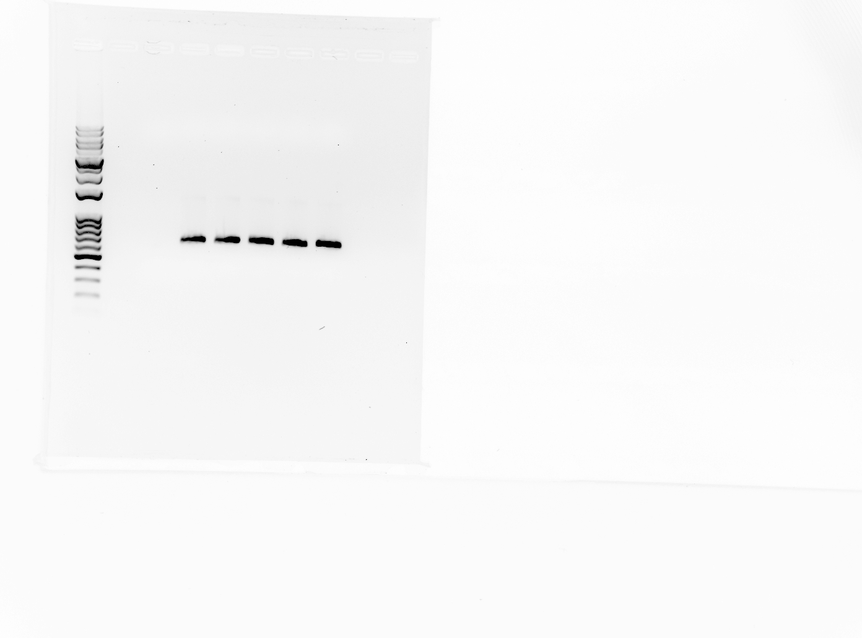
FIGURE 1. Assay for optimal PCR temperature and confirmation of primer viability. Gel electrophoresis of PCR products generated over 35 cycles at annealing temperatures from 50 to 70°C on an ethidium bromide laced 1% agarose gel. No band is seen without the presence of primers, while marginal increase in band intensity is witnessed with increasing annealing temperature. From the clarity of the band and the theoretical optimal melting temperature for the selected primers, the 60°C was selected.
DNA Ladder
65°C
500
bp
60°C (no primers)
50°C
55°C
60°C
70°C
Annealing temperature
600
700
mtFasL
600bp
CMV IE promoter
mtFasL
EGFP
0
600
645
1361
3’
5’
Start
Stop

A
B
FIGURE 2. Primer locations and resulting PCR products used in this experiment and diagram of target construct within pEGFP-N1 vector. (A) Primers complementary to both ends of mtFasL including an XhoI restriction site at the 5’ end of the forward primer and a PstI restriction site at the 3’ end of the reverse primer. (B) The same mtFasL forward primer and an EGFP primer ending 65 bp into the gene.
600bp

709bp
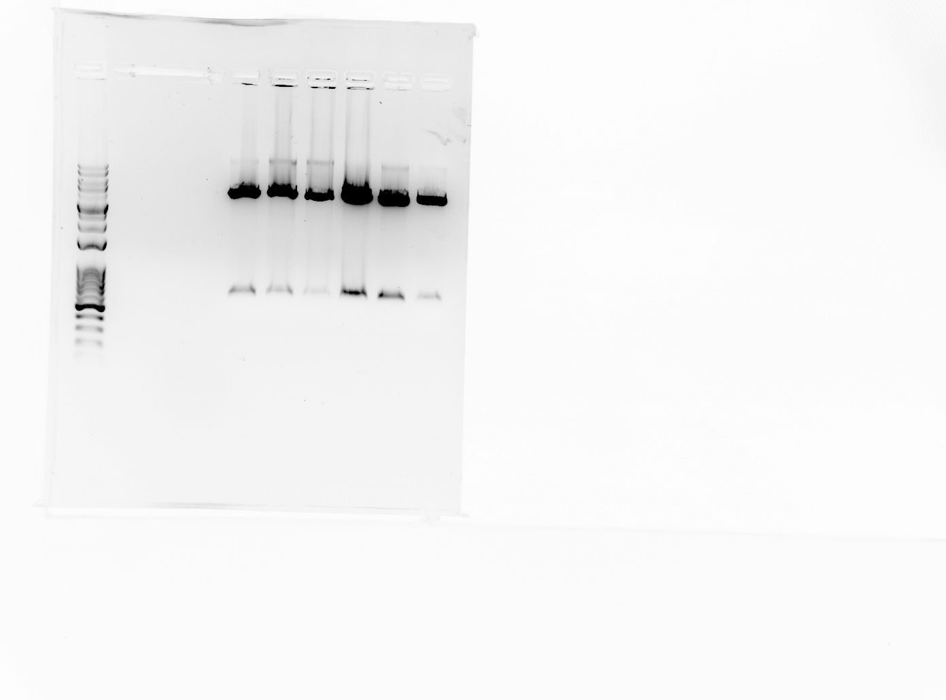
FIGURE 3. Purified DNA from six E. coli colonies thought to be transformed with mtFasL in pDrive, digested and run on an ethidium bromide laced 1% agarose gel to ensure presence of mtFasL gene. The expected band for the gene around 600bp was seen in all six colonies, suggesting successful ligation into each transformed vector. Colony 5 was selected for digestion of mtFasL. Presented here are the results of group T6 due to lack of successful gene expression in colonies grown by group T8.
Colony
1
2
3
4
5
6
500
bp
700
4000
mtFasL
600bp
pDrive
3.85kb
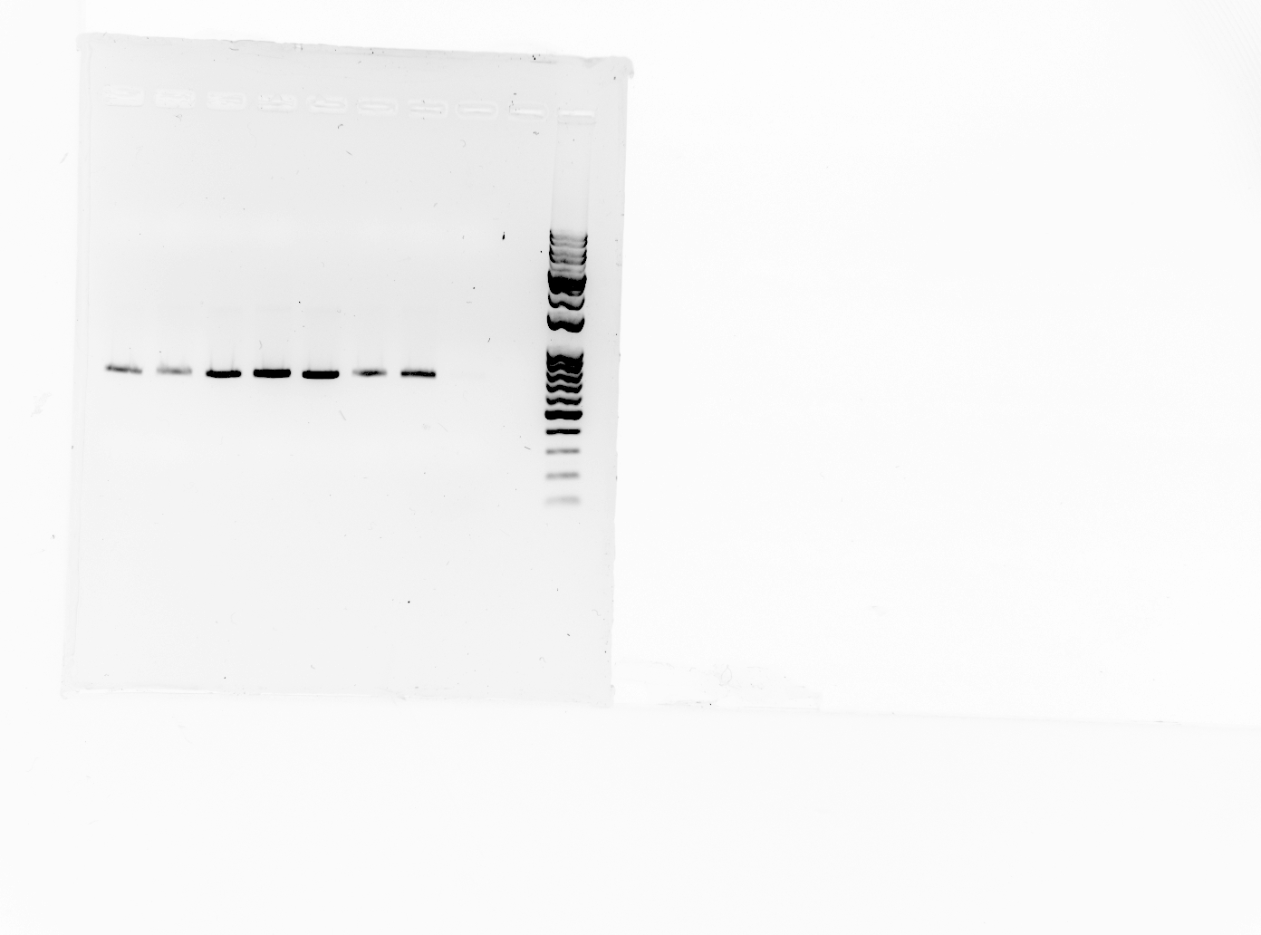
A
B
FIGURE 4. PCR verification of the presence of the mtFasL-EGFP fusion protein gene in transformed E. coli colonies. Purified DNA was amplified using the mtFasL forward primer and a reverse primer located within EGFP, then run on an ethidium bromide laced 1% agarose gel. (A) The primers successfully amplified the original gene insert, but the lack of bands in selected colonies indicates absence of gene in colonies selected by team T8. (B) Due to lack of successful ligation in colonies from first gel, a second was used. Each colony exhibits the expected band, indicating presence of the gene. This gel was borrowed from team T2. Colony 3 was selected for transfection of mtFasL-EGFP into HeLa cells.
DNA Ladder
No DNA
Original insert
Original insert
Colony 1
Colony 2
Colony 3
Colony 4
Colony 5
Colony 6
bp
700
800
mtFasL-EGFP
709bp
mtFasL-EGFP
709bp
700
800

GAPDH
300bp
FIGURE 4. mtFasL-EGFP expression level in transfected HeLa cells was assessed through RT-PCR and compared to that of GAPDH. mtFasL forward and EGFP reverse primers were used (Fig. 2B) with three samples: one with no cDNA present, one with cDNA known to contain mtFasL-EGFP and GAPDH and one with cDNA isolated from HeLa cells. Two clear bands indicate successful expression of mtFasL-EGFP in transfected cells.
No cDNA
bp
Standard
RT cDNA
DNA Ladder
mtFasL-EGFP
709bp
400
900
800
700
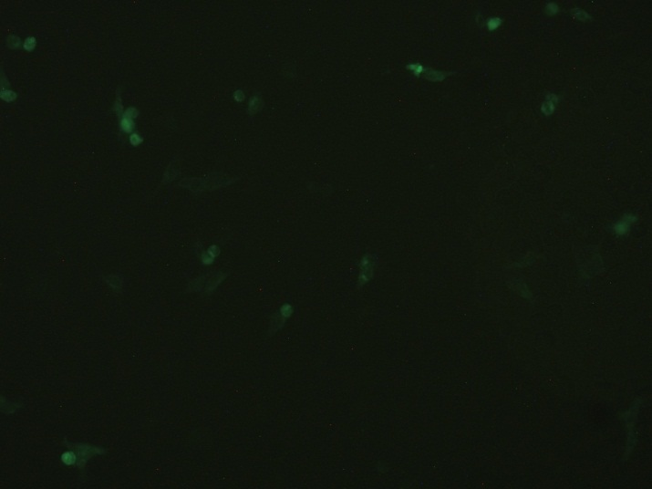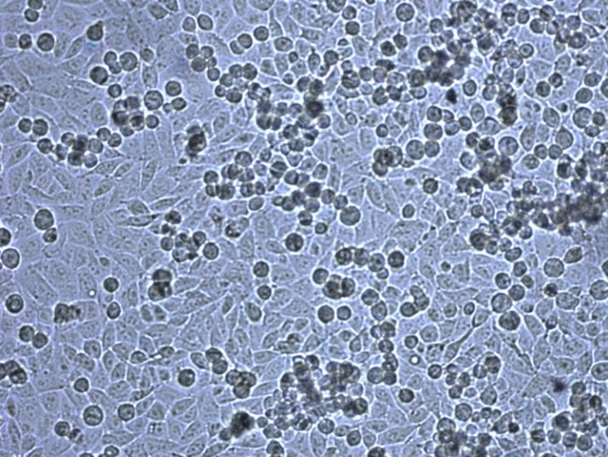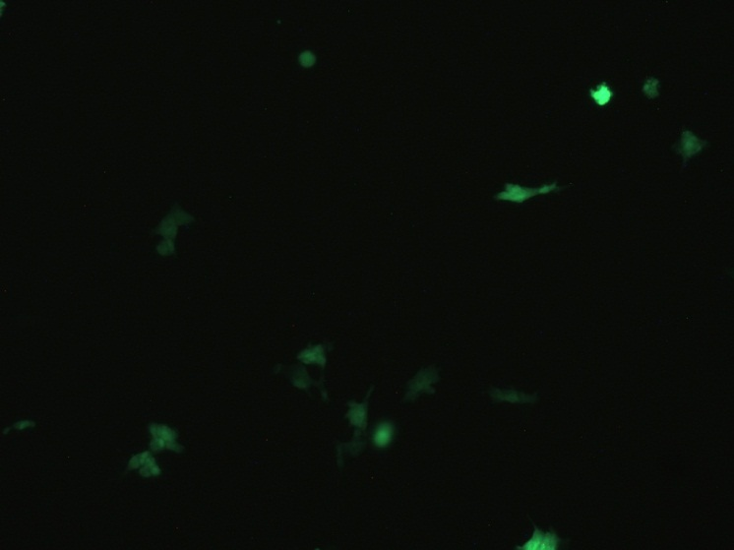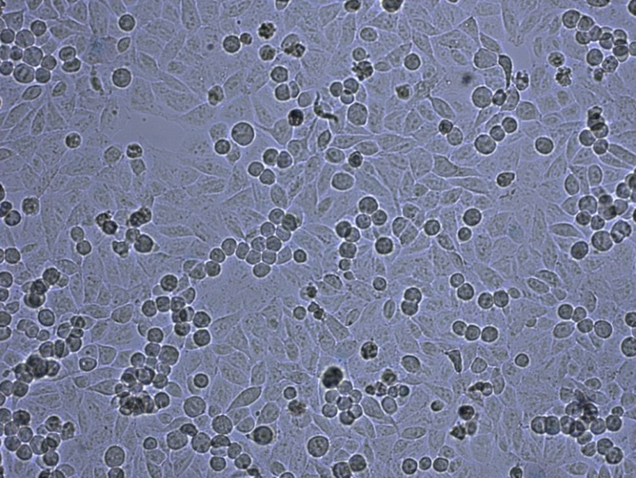
FIGURE 6. Expression of mtFasL-EGFP in HeLa cells was confirmed through fluorescent microscopy. HeLa cells at 60-80% confluency were transfected with the mtFasL-pEGFP-N1 vector and are here viewed under visible and fluorescent light. (A and B) Cells transfected with an mtFasL-pEGFP vector previously used successfully to this end viewed with reflected visible and emitted fluorescent light respectively. (C and D) Cells transfected by mtFasL-pEGFP-N1 vector purified from E. coli colony 3 from plate T2 (previously assessed in Fig. 3) viewed with reflected visible and emitted fluorescent light respectively. Arrows indicate the same cell in both views.
200μm
A
C
B
D

FIGURE 7. Amount of cell death observed in HeLa cells 24 (F1-F3) and 48 (T1-T8) hours post-transfection of either empty pEGFP-N1 or mtFasL-EGFP as determined through trypan blue staining. Each sample from each group is presented as an average of four counts. Counting was done with a hematocytometer.

FIGURE 8. Flow cytometry results for HeLa cells stained with Annexin V conjugated to FITC (Annexin-V/FITC), measuring levels of apoptosis, and propidium iodide (PI), measuring levels of overall cell death. Cells were incubated for 24 hours after transfection of: (A) Untreated (no transfection), (B) mtFasL-pDrive, (C) wtFasL-pNagata, (D) mtFasL-pNagata, (E) Empty pEGFP-N1, (F) mtFasL-pEGFP. pNagata was the expression vector provided with the gene from Dr. Nagata. The difference in both Annexin-V/FITC and PI staining from E to F alone is enough to cast serious doubt on the efficacy of mtFasL-EGFP at inducing apoptosis.
B
A
C
D
E
F

Discussion
The cell viability assay (Fig. 6) was prone to bias, as human counting was done. If any bias influenced the counting, however, it is not apparent based on the lack of significance or tenuous trends apparent in the data. This lack of significance was mirrored in the flow cytometry results. pEGFP-N1 was found to be just as, if not more, effective at inducing apoptosis on its own (Fig. 8E) as it was with an inserted mtFasL gene (Fig. 8F).
At first glance, these results indicate that mtFasL did not behave as expected. It was proposed mtFasL would have an increased apoptotic effect over that of wtFasL but in fact, these results show that mtFasL has no such effect. As stated in the introduction, this may well be due to the addition of EGFP to the C-terminus of mtFasL. Attaching such a large peptide to the end of the ligand that binds to its receptor could impair its ability to act as a ligand. A very simple solution to this would be to use pEGFP-C1 vectors, localizing mtFasL inside the cell. In support of the proposed increased apoptotic effect are two samples from the flow cytometry data: mt and wtFasL in pNagata showed the expected decrease in cell viability (Fig. 8).
As mentioned, it appears that the pEGFP vector alone is responsible for elevated levels of apoptosis. This may be somewhat of a false positive though as there is an enormous amount of overlap between the emission spectra of FITC, the fluorochrome indirectly measuring levels of apoptosis through conjugation to Annexin V, and EGFP. The effect is that any sample containing the pEGFP vector will show numerous false positives for signs of apoptosis. These false positives could be combatted by conjugating Annexin V to a fluorochrome more distinct from EGFP, such as Alexa Fluor ® 555 (Life Technologies Corp.). Despite this, propidium iodide-positive signals were also increased in cells transfected by pEGFP-N1 (Fig. 8E) compared to those transfected by mtFasL-pEGFP (Fig. 8F).
These changes in experimental design could be implemented and the experiment performed again. A more useful study on the effect of mtFasL on cervical cancer could also include a wtFasL-EGFP construct in order to confirm the enhanced apoptotic capabilities of the mutant. Between wt and mtFasL-pNagata these differences are observed (Fig. 8), but it would not be difficult to include as a further control in future experiments.
A viral vector could also be explored in the case that the increased levels of cell death witnessed in samples treated with pEGFP-N1 were caused by the transfection process itself. Once transfected, however, the gene did appear to be highly expressed. Despite these appearances, the relative expression of mtFasL to wtFasL is out of the scope of this study. In the future, by performing the experiment with both mt and wtFasL, efficacy of the deletion of amino acids 8-69 in increasing mutant expression could be confirmed.
Though the results of this experiment itself do not warrant further research into the use of mtFasL as an anti-tumoral agent, the samples provided by Dr. Nagata do. A future experiment that takes into account the recommendations found here could still show mtFasL to effectively kill cervical cancer cells through gene therapy.

References
1. Strasser, A., P. J. Jost, and S. Nagata. 2009. The Many Roles of FAS Receptor Signaling in the Immune System. Immunity 30: 180-192.
2. Edmond, V., B. Ghali, A. Penna, J. L. Taupin, S. Daburon, J. F. Moreau, and P. Legembre. 2012. Precise Mapping of the CD95 Pre-Ligand Assembly Domain. PLoS One 7.
3. Krammer, P. H. 2000. CD95's deadly mission in the immune system. Nature 407: 789-795.
4. Villa-Morales, M., and J. Fernandez-Piqueras. 2012. Targeting the Fas/FasL signaling pathway in cancer therapy. Expert Opinion on Therapeutic Targets 16: 85-101.
5. Mahmood, Z., and Y. Shukla. 2010. Death receptors: Targets for cancer therapy. Exp. Cell Res. 316: 887-899.
6. Hedlund, T. E., S. J. Meech, S. Srikanth, A. S. Kraft, G. J. Miller, J. B. Schaack, and R. C. Duke. 1999. Adenovirus-mediated expression of Fas ligand induces apoptosis of human prostate cancer cells. Cell Death Differ. 6: 175-182.
7. Maleniak, T. C., J. L. Darling, P. R. Lowenstein, and M. G. Castro. 2001. Adenovirus-mediated expression of HSV1-TK or Fas ligand induces cell death in primary human glioma-derived cell cultures that are resistant to the chemotherapeutic agent CCNU. Cancer Gene Therapy 8: 589-598.
8. Rubinchik, S., D. Wang, H. Yu, F. Fan, M. Luo, J. S. Norris, and J. Y. Dong. 2001. A complex adenovirus vector that delivers FASL-GFP with combined prostate-specific and tetracycline-regulated expression. Molecular Therapy 4: 416-426.
9. Ji, X. J., C. Jiang, Y. H. Liu, D. F. Bu, and S. F. Xiao. 2011. Fas ligand gene transfer effectively induces apoptosis in head and neck cancer cells. Acta Oto-Laryngologica 131: 876-881.
10. ElOjeimy, S., J. C. McKillop, A. M. El-Zawahry, D. H. Holman, X. Liu, D. A. Schwartz, T. A. Day, J. Y. Dong, and J. S. Norris. 2006. FasL gene therapy: a new therapeutic modality for head and neck cancer. Cancer Gene Therapy 13: 739-745.
11. Arai, H., D. Gordon, E. G. Nabel, and G. J. Nabel. 1997. Gene transfer of Fas ligand induces tumor regression in vivo. Proceedings of the National Academy of Sciences of the United States of America 94: 13862-13867.
12. Tanaka, M., T. Itai, M. Adachi, and S. Nagata. 1998. Downregulation of Fas ligand by shedding. Nat. Med. 4: 31-36.
13. Schulte, M., K. Reiss, M. Lettau, T. Maretzky, A. Ludwig, D. Hartmann, B. de Strooper, O. Janssen, and P. Saftig. 2007. ADAM10 regulates FasL cell surface expression and modulates FasL-induced cytotoxicity and activation-induced cell death. Cell Death Differ 14: 1040-1049.
14. Reilly, L. A. O., L. Tai, L. Lee, E. A. Kruse, S. Grabow, W. D. Fairlie, N. M. Haynes, D. M. Tarlinton, J. G. Zhang, G. T. Belz, M. J. Smyth, P. Bouillet, L. Robb, and A. Strasser. 2009. Membrane-bound Fas ligand only is essential for Fas-induced apoptosis. Nature 461: 659-U106.
15. Suda, T., H. Hashimoto, M. Tanaka, T. Ochi, and S. Nagata. 1997. Membrane fas ligand kills human peripheral blood T lymphocytes, and soluble fas ligand blocks the killing. Journal of Experimental Medicine 186: 2045-2050.
16. Lettau, M., M. Paulsen, H. Schmidt, and O. Janssen. 2011. Insights into the molecular regulation of FasL (CD178) biology. European Journal of Cell Biology 90: 456-466.
17. Lafont, E., D. Milhas, J. Teissie, N. Therville, N. Andrieu-Abadie, T. Levade, H. Benoist, and B. Segui. 2010. Caspase-10-Dependent Cell Death in Fas/CD95 Signalling Is Not Abrogated by Caspase Inhibitor zVAD-fmk. PLoS One 5.

Supplemental Material
Supplementary Table 1
Cell Viability (as % Death) Post-Transfection
Time |  | 24 hrs |  |  |  |  | 48 hrs
Group | F1 |  | F2 | F3 |  | T1 |  | T2 | T4 | T5 | T6 | T7 | T8
Empty pEGFP | 52.0 |  | 2.8 | 2.0 |  | 7.1 |  | 9.0 | 14.7 | 6.4 | 9.9 | 19.5 | 8.6
mtFasL-pEGFP | 19.0 |  | 60.0 | 11.7 |  | 32.4 |  | 19.3 | 16.2 | 8.7 | 9.4 | 11.9 | 8.1
T-Testsª |  |  | 0.35 |  |  |  |  |  |  | 0.16
a: One-tailed T-test indicates the chance that the mean of one group being larger than the other is explained solely due to variance. In both cases the α-values are not met therefore we fail to reject the null hypothesis; there is so significance.

