Adrenergic Signaling 2
(Continued Nov 15th)

- Functional impact of beta adrenergic stimulation
- When you stimulate beta adrenergic system what happens?
- This section reviews the autonomic nervous system and summarizes the major targets of adrenergic and muscarinic (M2) activation
- So what happens when you exercise?
  - The lower part of the diagram tell you the cardiac output under resting conditions (5l/min) and it goes up to 25 in trained athlete
  - When you exercise, almost all of the extra cardiac output is oing to skeletal muscle because all is local regulation
  - The muscle decided how much blood it is going to take from the storage binds(large arteries)
What are the targets that allow for, what allows the heart to increase its cardiac output by a factor of 4-6 depending on the ind under conditions of stress when in requirement (FIGHT OR FLIGHT REFLEXES)

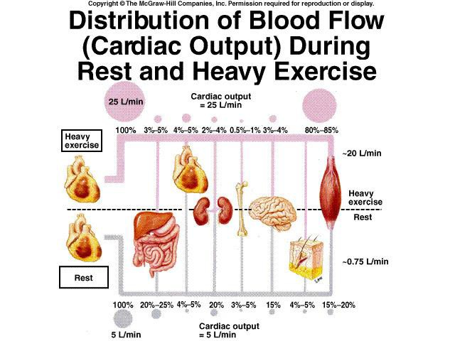

Autonomic Nervous System – A Quick Review
Sympathetic and Parasympathetic Innervation of the Heart

-sympathetic and parasympathetic arms of ANS
-the anatomy is that the brainstem that is getting signals constantly and it turns out that the signals are going to the vagus
-Vagus is the cranial nerve 10 & goes up your neck (along jugular veins and it goes to the brainstem and gives the cardiac center info and the main info give to that center is what the blood pressure is)
-as soon as your blood pressure drops, your heart gets turned on because you can’t operate with low blood pressure
-you can’t push the blood to the tissues
-then there is outflow from that cardiac center and it is either parasympathetic or sympathetic
-the way sympathetic flows is that they go thru the spinal cord and they go out thru periveterbral ganglion that originate form cervical and thoracic vertebrate
-so as you go down the back, there are nerves that come out all the way along the spine and these fibers form ganglia (pre-ganglionic synapses within perivetebral ganglion)
-so if you look along the back, you’ll see little nodes of nerves that are running along right beside the spinal cord and those are the perivetebral, beside the vertebrae ganglion
-that’s where the synapses form and that’s where efferent axon goes
-perivetebral ganglion on the sympathetic system, it innervates the entire heart so all of the heart ACTUALLY gets stimulation from the sympathetic nervous system
-on the other hand, vagus which comes down cranial nerve 10 is actually originating from brainstem (it is one of the cranial nerves and loops down along jugular veins and then innervates the heart and lots of other organs as well)but it primarily innervates the nodes and atria
-so SANODE/AV NODE/ATRIA
-and we know what it does in the SA node, it dampens and slows the heart rate and in the sympathetic side, it is going to increase heart rate and change contractility

-the other thing about sympathetic that is not shown is that it innervates every blood vessel
-almost all of the veins and all small arteries are innervated by sympathetic nervous system
-so when you change the heart’s activity, at the same time you are changing a lot of things in the blood vessels
-you modify the pump’s behavior, you want to modify the pipe as well
-so they coordinate in a way to maintain the appropriate level of cardiac output and blood flow to the body

-the sympathetic are one of the main effects is to alter contractility and it does that by manipulating calcium

-this is what happens as you increase isoprpternol
-isoproternol is a pure beta adrenergic agonist
-noreadrenalinem, the natural sympathetic agonist that does most of the sympathetic signaling activates both alpha and beta adrenergic receptors
-you see the impact as you increase the amount of isoproterenol shown here, you get a LARGER calcium transient and that makes the force larger and larger
-but it has lots of other effects besides increasing the height of calcium transient, it also increases and accelerates the rate of decay of it and that is going to reduce the systolic period and there are other factors that go into it as well
-so there is a increase in the force, but there is a decrease in duration
-this is the kind of diagram that is under representation of what really happens
-your systolic period can be easily reduced by a factor of 2 or 3
-its showing a 30% change (in real life it is much greater than that)
-when you activate the adrenergic system, you also accelerate relaxation

Targets of ß-adrenergic signaling
-L-type calcium channel, ryanodine receptors, phospholamban, sarcolipin, troponin I(contractile proteins) heart rate modulation
-what is the extra target that we have here in the case of heart rate regulation? L-type calcium channels are involved in that, phospholambans are involved and ryanodine receptors are involved in heart rate regulation
-what is missing in this list?
-changes in conduction
-the first 4 of these, we already know
-the one not in the list is I_{f} (the funny current): the pacemaker current
-BINDS CYCLIC AMP (IT’S A TARGET OF SYMPATHETIC STIMULATION), CYCLIC AMP goes up this current shifts its activation curve to more +ve potentials
-it’s a protein, a channel that turns on negative potentials and depolarizes the cell, when cyclic amp comes along, it actually gets turned on at more +ve potentials it is going to drive things more quickly in the depolarized direction and that’s what this diagram is showing you that the current increases
-so this is the absence of cyclic amp
And the voltage is very negative here, un-physologic but the point is when you get to negative potentials, this channel turns on and introduces a DOWNWARD current (inward current-positive charge going into the cell) which is causing a depolarization and that’s what is showing here
-cyclic amp goes up and drives heart rate
-this is under normal circumstances and with sympathetic stimulation, the membrane doesn’t get as depolarized and accelerates its speed which it gets to the threshold and that threshold crossings that determine the actual heart rate
-the number of times that this group of SA NODAL cells crosses threshold and becomes very +ve is you HR because that’s going to drive +ve charge to atria…turn on the entire contraction process
-so that’s one of the target
-cyclic amp dependent and because it is cyclic amp dependent, it is even more profoundly affected by muscarinic activation

Funny current: Hyperpolarization-activated cation (HCN) channels or If

-so if you turn on the muscarinic system, this channel turns itself off because there is a fair amount of basal cyclic amp generation in the SA nodal cell
-when you activate the vagus, you strongly turn off this channel
-the other ones we talked about before, for the purposes of review are L-type calcium channels

L-type Ca²⁺ Channel: ICa_{L}, Cav1.2/Cav1.3

-so this is without sympathetic stimulation, and this is with sympathetic stimulation
-it is a lot bigger for any voltage and shifts toward a more negative potential (turn on at more negative potentials)
-this is underlying this at a molecular level
-And it is waking up SLEEPY CHANNELS

-many channels are not opening with depolarization,
-after phosphorylation, or after sympathetic stimulation, they open up every time, and the likelihood goes up
-when you increase the probability of opening, you’ll get more current

-these l-type calcium channels are controlling clusters and controlling couplons(groups of ryanodine receptors)
-if most of the times these guys are sleepy, most couplons will not be activated
-if you wake them up, now they are going to stimulate the couplons and many more of these get recruited
-that’s 1 of the main ways you increase, the calcium transients by just recruiting these couplons
-these are the clusters of ryanodine receptors
-controlled by few L-type calcium channels
-and if the l-type calcium channels that control that cluster, are very likely to open up, they are going to bring enough calcium to cause that cluster to activate & release the calcium that is stored in that region of SR
-the calcium transient is the summation of all of the releases of the releases of various couplons

-phospholamban: how phospholamban turns on/off SERCA2
-when it gets phosphorylated, it turns it on
-SERCA 2 is the calcium pump. And it is regulated by phospholamban and when phospholamban is present, the phospholamban has to come off of the pump in order for it to go thru the cycle in order for it to become phosphorylated it has a LOWER affinity constant & it comes OFF
-and once it comes off, it tends to form these pentamers
-with phosphorylation, they dissociate from the pump and form internal pentameric clusters and that is going to dis-inhibit SERCA 2 and go faster and has a increase in affinity
-pumps calcium into SR much more effectively
-SERCA 2 compete with NCX
-if you increase SERCA2 activity, it is stealing calcium from NCX pointing more calcium into SR which is another factor that contributes to larger increase in calcium transients
-you have more in SR when the cluster activates, a lot more calcium comes out and that is another factor in increae in amount of calcium and therefore the strength of contraction

-sarcolipin is also phosphorylated and that also DIS-INHIBITS the SERCA 2 pump although this is less important in ventricle than it is in Atria

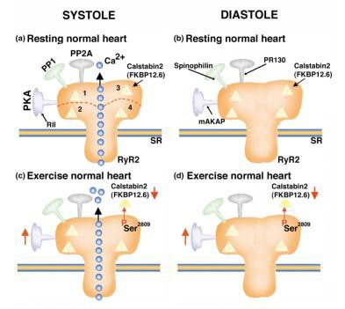
Ryanodine receptors: RyR2

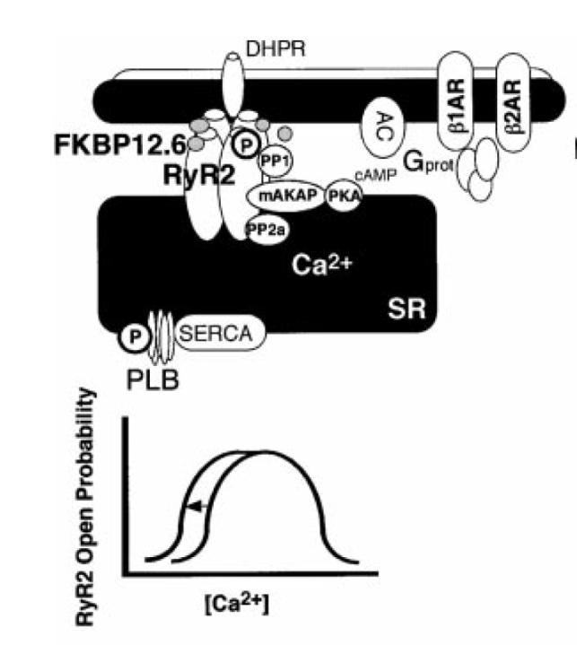
 
- increases PO of RyR2 and Ca2+ release from cluster/couplons by reducing calstabin2 binding
- Increases PO and Ca2+ release from cluster/couplons by increasing SR Ca2+
levels
- increases spontaneous Ca2+ and arrhythmias

Net effect: increases amplitudes relaxation of Ca2+ transients and pressure plus increases arrhythmias

Contractile Proteins
-it is all about desensitizing the contractile proteins
-when calcium goes up (with phosphorylation of TN-I) the binding of calcium is reduced to contractile proteins and it is done by enhancing the rate of dissociation of calcium from TN-C and that is part of the process of enhancing relaxation

- Cardiac troponin I (cTnI)
- phosphorylation of cTnI reduces myofilament Ca2+ sensitivity and shifts the force–pCa relationship rightwards
- increases the rate of Ca2+ dissociation (off-rate) from TnC and enhances pressure relaxation (lusitropy).

PKA stimulation reduces Ca2+ sensitivity of “skinned” cardiac muscle

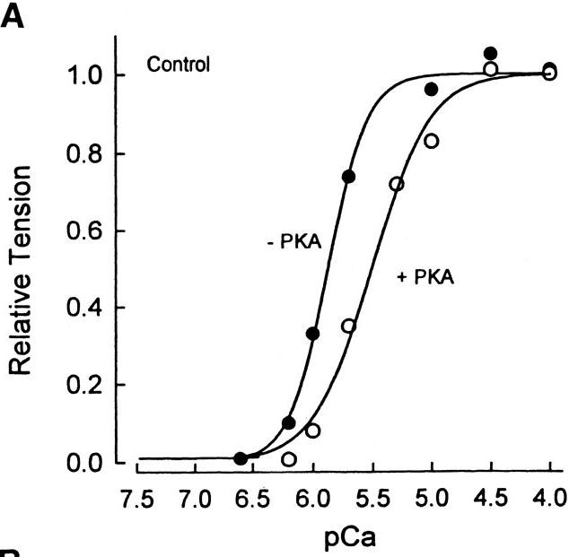

- Myosin Binding Protein C
-MYOSIN BINDING PROTEIN C is phosphorylated
-there are these internal repeart domain in MyBPC and if you look at N-terminus of these proteins which is labeled as “0”, there is a phosphorylation ste there that then modulates the extent to wich myosin is pushed over toward s thin filament and that’s how MyBPC (by pushing it over) modulates the cross bridge activity and how it is with phosphorylation actually accelerate the crossbrige myosin cycling thru MyBPC
- N-terminal region of myosin binding protein C (MyBPC) interacts with myosin
S2 (tail). Phosphorylation of MyBPC disrupts this binding, and brings the myosin S1 (head) closer to actin increasing the likelihood of crossbridge formation and rate of cross-bridge cycling.

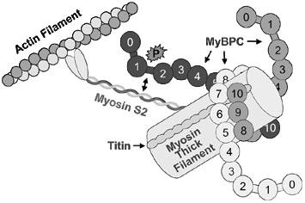
 
 
 
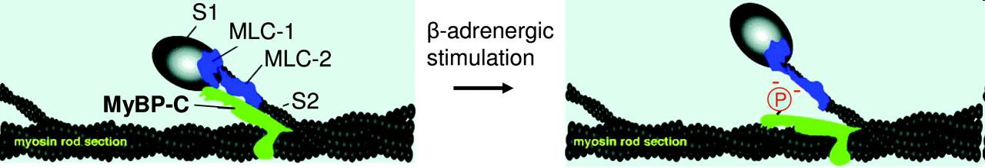
 
 
 
 

 

Electrical Conduction
-the p-wave to the QRS duration is called PR INTERVAL
-that is telling you the time it takes for electrical signal to come from atria and hit ventricle
-that duration is modified dramatically with sympathetic stimulationif you turn it ON/OFF that duration changes dramatically
-the directional changes are as follows: if you activate SNS, the PR interval, the time it takes for P-WAVE to QRS to take place, dramatically is shorted with Sympathetic stimulation
-why?
-if you sped up the HR by a dramatic level if you kept your PR interval exacyly the same, you’d have a delay between the time the atria contract and the ventricles contract (not very efficient)
-so it will impinge your ability to increase HR
-so nature abbreviates that tiem
-so atria contract and immediately after, ventricles turn ON
-so the conduction of electrical signal thru AV node has to be acceletrated because that’s where the signal is delayed
-because you have the SA NODE driving the whole heart ATRIA contractit goes down to AV nodeit goes down to ventricles
-this is where PR interval is held up (where the delay actually occurs)
-so if it is sped up, this is where the speeding up of the conduction occurs to a large extent
-in atria things are sped up substantially
-how is it that it is slow in AV and fast in Purkinje?
-concentration of diff types of ion channels
-WHICH ION CHANNELS are imp?
-the purkinje are light ventricular cells and things are very fast
-what factors are responsible for such a high conduction?
-why do you want it fast?
-You want the signal because the contraction starts down here
-so you need the signal to jump on very quickly, get itself down here and get things going and ejection going
-how do you make the conduction, the speed of which the electrical signal go down purkinje cabels?
-by the # of channels (sodium channels)
-PURKINJE has the HIGHEST density of sodium channels
-AV node has no Sdoium chane;s
-sodium channe;s are the really fast ones
-fastet chanel in heart(open/close within milisecodns in cell)
-thye activate and inactivate (take themselves out of the circuit)
-so purkinje have lots of sodium channe;s and av node has few
-what is the other factor?
-the connexons (the more connexon, the more electrically coupel 2 cells are)-so if something is happening in 1 cell if you have a lot of connexons linking 1 cell to the next cell (anything that happens to the cell is going to instantecousely affect the next cell)
-on the other hand if you don’t have many cnjnxexion, its going to take a while for those charge to go thru those few holes and there us agoign a delay
-av node has its own subset of connexons
-connexons have a low conductance
-very few of connexons that are linking cell to cell in av node, so no sodium channels and very few connexons
-purkinje have lots of connexons

-would the inward rectifier higher in ventricles?
-purkinje have little inward rectifier current
The inward rectifier will tend to delay conduction velocity
-so purkinje have not many
-AV node doesn’t have much inward rectifier as well

-especially through the AV node (i.e. decrease in P-R intervals) The conduction velocity of the action potential is different throughout the myocardium.
- SA Node 0.05 m/sec (SLOW CONDUCTION)
- Atrium 0.50 m/sec (pretty fast)
- AV Node 0.05 m/sec (slowed)
- Purkinje 2.00 m/sec (very fast)
- Ventricle 0.50 m/sec

-In the ventricle and atria, conduction velocity correlates with the rate of change of the voltage of the action potential upstroke (dV/dt max) (i.e. phase 0) which depends on the amplitude of the voltage-gated Na+ currents and the cell-to-cell conductance.
-In AV node, conduction is highly dependent on ICa,L. -Adrenergic stimulation increases ICa,L which accelerates conduction through the AV node and delay the time between atrial and ventricular contraction.
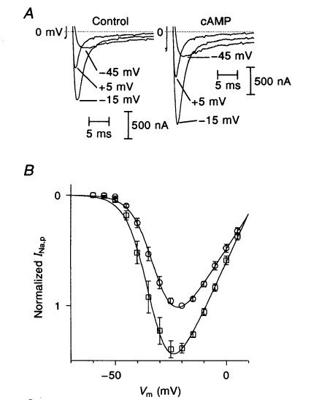

- Sympathetic (i.e. -adrenergic) stimulation also increases the rate of the upstroke (dV/dt) of the ventricular and atrial action potentials. The upstroke (dV/dt or Vmax) is highly correlated with the activity of the voltage-gated Na+ channel.
- -adrenergic stimulation increases in the magnitude of the voltage-gated Na+
currents.

-In the AV node, what causes the progapagitoof electricity from cell to cell is into sodium channe;s because there aren’t any sodium chanesl (few) its
-what channes cause conduction of electricity fro mcell to cell (from atria to ventricles)?
-calcium channels
And they have the 2 l-type calcium channels and they have the t-type channels
-it is the calciumchanels responsible for depolarizating the AV nodal cells and propagating that electricity to next cell
-here is where sympathetic stimulation comes in
-when you activate SNS that causes phosphorylation of something in l-type calcium channel
(prototype protein regulated by PKA)and its 1 protein we don’t know what residue phosphorylate to turn the channel on by PKA
-but it does get activated, system neverocus system and both of these channels something opens it and increases its activity –so more of them and turn on more easily and their IV curve is shifted to negative direction
Those 2 cobine to increase conduction velocity of AV node
SO WITH SYMPATHETIC STIMULATION, THIS NUMBER INCREASES BECAUSE ITS PHOSPHORYLATION OF L=TYPE CALCIUM CHANELS

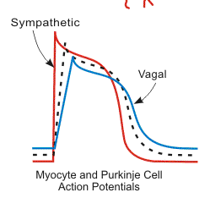
Action potential in the ventricles also get propagated more rapidly by sympathetic stimulation and its not dramatic although its shown in diagram as dramatic
-true exaggeration
-this is what happens with vagus-if you look at the upstroke which is the speed with which the cell is going to depolarize (telling you how quickly your propagating the electricity)
-because if slope is shallow, it is going to take a while for that cell to influence the next cell
-With symapthrtc, there is a tendency eith the slope of depolarization to be elevated and vagal stimulation, reduction ins slope
-if you loo kat dosium channels, sodium channel activity goes up with phosphorylation
-the cardiac version of the voltage depenent sodium chanel is phosphorylated and regulated by PKA (impact as well)
-YOU WANT EVERYTHING TO SPEED UP SO CONDUCTION SPEED UP AS WELL IN VENTRICLE

-connecxin 43, thisi s where conduction is most impacted in aatria is by phosphorylation of conexin 43
-responsible for allowing charge to go fro mcell to cell
-more conexin or incresase their activityenhance conduction velocity
And conexin 43 is phosphorylated and its probability of opening
-conexin are like voltage gated channels, they have a probability of opening and are not always open and their activity goes up when they become phosphorylated
Speculation isthat the gate is PROTECTIVE
So if a cell doesn’t lose its ability to generate atp and starts to drain on adjacent cell(hear attack) you can isolatwe electrically those areas by shuittinf off gap junction
-one main factor that gates conexin is ATP
So if atp goes down the conexin shit off and you electrically isolate regions that are sick form rest of the heart=causes arythmias
-so conexin 43 gate, P0 increases with phosphorylation and that speesdas up conduction AND THIS IS INEFFC IN ATRIA AND VENTRICLES
-ATRIA HAS C0NEXIN 40 AND 43 and ventricles are exclusively conexin 43
-most of the thigns we talk about is conduction thru VENTRICLE

- Conduction velocity also depends on cell-to-cell communication via gap junctions.
- connexin43 (Cx43) conductance increases with sympathetic stimulation
- Fluorescent dyes injection into cells can be used to examine the communication between myocytes.

-LAST THING IS FACTOR THAT WHEN YOU ACTIVATE sns CYCLIC AMP RESPONSE LEEMENT INM MANY GENES OF GENOME

-SO THIS IS REPRESENTING A GENE THAT HAS A PROMOTER REGIOSN AND CUYCCLIC AMP RESPONSIVE ELEMENT
AND THERE IS A CUYCCLIC AMP RESPONSIVE ELEMENT BINDIGN PROTEIN THAT TURNS ON/OFF GENE EXRESIION AND THIS PROTEIN IS PHOSPHORYLATED BY PKA AND THAT CHANGES ITS LEVEL OF ACTIVITY
-NOW YOU CAN TURN ON DIFF KIDNS OF GENES ON BASIS ON WHETHER OR NOT SYMOPATHTIC SYSTME IS STIMULATED
-IF YOU WORK OUT AND ACTIVATE SNS CONSTANTLY, THERE IS GOING TO BE BIOCHEMICAL MODIFICATION OF BODY
-IF YOU TRIAN FOR CERTIA NTIME, YOU START OFF AS SEDENTARY THEN YOU STARTY PLAYING YOU GET BETER AND BETER AND CARDIOVASCULAT CONDTION GETS BETER AND EXERCISE BICOHEMIALY MOFIDT EVEY CELL IN SYSTEM,
So cyclic amp driven alteration sin gene expression which modifies how those heart cell behsave at rest and increased demand

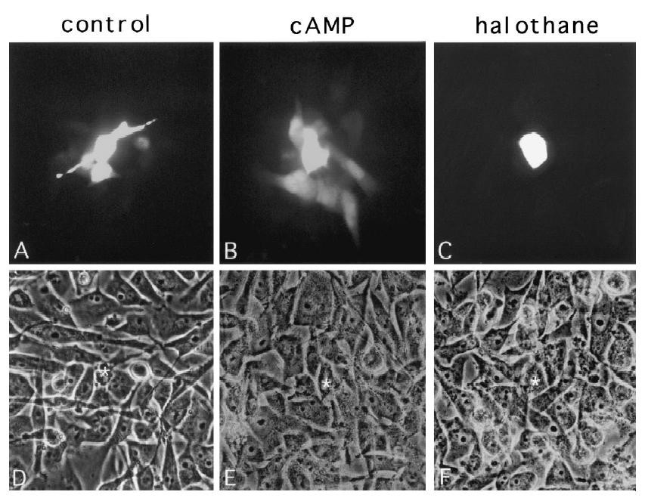
- cAMP increases rate of dye movement between myocytes. Halothane (volatile anesthetic), reduces dye spreading (because it blocks gap junction channels.

Changes in Gene Expression/Hypertrophy
-changes gene expression via cAMP responsive elements (CRE) which are transactivating factors that bind to the corresponding cis-elements (for example the - receptor gene is itself regulated by a CRE)
- hypertrophic effect is weak but has major effect on apoptosis/myocyte survival

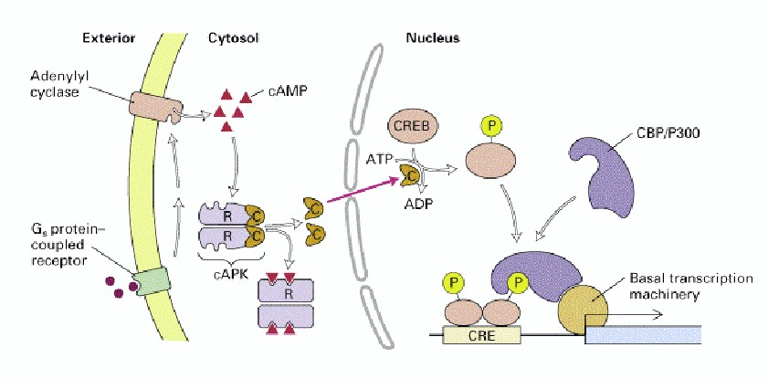
PKA activation leads to alterations in gene expression leading to increased apoptosis and hypertrophy
 

