Economics 1BB3
Chapter 5

Microeconomics: the study of how households and firms make decisions and how they interact in markets
Macroeconomics: the study of economy-wide phenomena, including inflation, unemployment, and economic growth
GDP:
- Measures the total income of a nation, is the best single measure of a society’s economic well being
- Measures two things at once: the total income of everyone in the economy and the total expenditure on the economy’s output of economy’s output of goods and services
  - For an economy as a whole, income must equal expenditure, because every transaction has two parties: buyer and a seller
  - in this economy, money flows from households to firms and then back to households
- can compute GDP for this economy in one of two ways: by adding up the total expenditure by households or by adding up the total income (wages, rent and profit) paid by firms
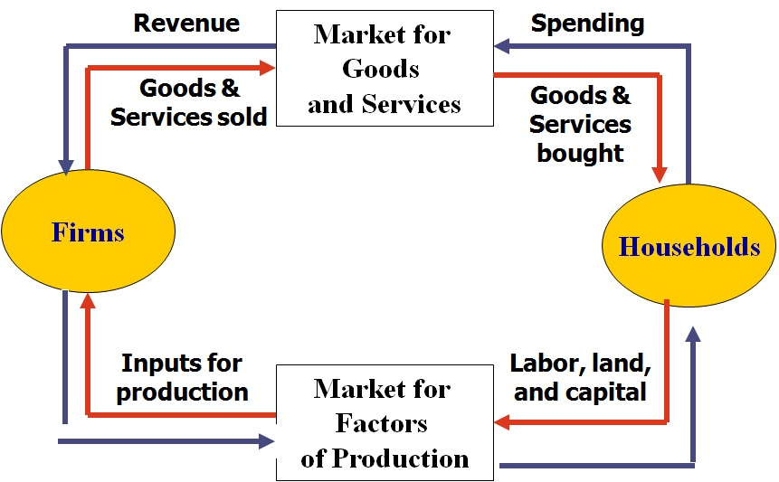

The Measurement of Gross Domestic Product

Gross Domestic Product (GDP): the market value of all final goods and services produced within a country in a given period of time
- Market value: uses market prices, market prices measure the amount people are willing to pay for different goods, they reflect the value of those goods
- Of all: it includes all items produced in the economy and sold legally in markets.
  - Also includes market value of the housing services provided by the economy’s stock of housing. Rent equals both the tenant’s expenditure and the landlord’s income, if you own the place where you live, government includes this owner occupied housing in GDP by estimating its rental value
  - GDP excludes most items produced and sold illicitly, such as illegal drugs, excludes most items that are produced and consumed at home and therefore never enter the market
- Final : GDP only includes only the value of final goods
  - Intermediate goods vs. final goods
  - Value of intermediate goods is already included in the prices of the final goods
  - Important exception when intermediate good is produced and, rather than being used, is added to a firm’s inventory of goods to be used or sold at a later date. Here, intermediate good is taken to be final for the moment and its value as inventory investment is added to GDP. When the inventory of the intermediate good is later used or sold, the firm’s inventory investment is negative and GDP for the later period is reduced accordingly
- Goods and Services: includes tangible goods and intangible services
- Produced: GDP includes goods and services currently produced, does not include transactions involving items produced in the past
  - When one person sells a used car to another person, the value of the used car is not included in the GDP
- Within a country: GDP measures the value of production within the geographic confines of a country.
- In a given period of time: GDP measures the value of production that takes place within a specific interval of time. Usually that interval is a year or a quarter (three months). GDP measures the economy’s flow of income and expenditure during that interval

The Components of GDP

- GDP (Y) divided into 4 components: consumption (C), investment (I), government purchases (G), and net exports (NX):
$$Y=C+I+G+NX$$
- Consumption: spending by households on goods and services, with the exception of purchases of new housing
  - Durable goods and non-durables goods, intangible services including post-secondary education
- Investment: spending on capital equipment inventories, and structures, including household purchases of new housing
  - Purchase of goods that will be used in the future to produce more goods and services, sum of purchases of capital equipment, inventories and structures
  - Treatment of inventory accumulation: when company produces computer, instead of selling, adds to inventory, assumed to have purchased computer for itself, national income accountants treat computer as part of investment spending, if computer is sold out of inventory, company inventory investment will then be negative, offsetting the positive expenditure of the buyer
  - Aim of GDP is to measure the value of the economy’s production, goods added to inventory are part of the period’s production
  - Investment means purchases of goods used to produce other goods
- Government Purchases : spending on goods and services by local, territorial, provincial, and federal governments: includes the salaries of government workers and spending on public workers
  - Government purchases: government pays the salary of a Canadian Forces general, salary is part of government purchases
  - Pension Plan: Transfer Payment, not made in exchange for a currently produced good or service, transfer payments alter household income, but they do not reflect the economy’s production
  - Transfer payments are not counted as part of government purchases
- Net Exports: the value of a nation’s exports minus the value of its imports; also called the trade balance
  - Imports are subtracted from exports
  - Net exports include goods and services produced abroad (with a minus sign) because theses goods and services are included in consumption, investment and government purchases (with a plus sign

Real versus Nominal GDP

- If total spending rises from one year to the next:
  - The economy is producing a larger output of goods and services
  - Goods and services are being sold at higher prices
- Want a measure of the total quantity of goods and services the economy is producing that is not affected by changes in the prices of those goods and services
- Use a measure called real GDP
- Evaluating current production using prices that are fixed at past levels; shows real GDP
- Nominal GDP: the production of goods and services valued at current prices
- Real GDP: the production of goods and services valued at constant prices; used to obtain a measure of the amount produced that is not affected by the changes in prices, choose one year to be the base year
- Nominal GDP uses current prices to place a value on the economy’s production of goods and services, Real GDP uses constant base-year prices to place a value on the economy’s production of goods and services
- Real GDP is not affected by changes in prices; changes in real GDP reflect only changes in the amounts being produced. Real GDP is a measure of the economy’s production of goods and services
GDP Deflator
- is a measure of the price level calculated as the ratio of nominal GDP to real GDP times 100
- Real GDP reflects only the quantities produced. GDP deflator reflects the prices of goods and services but not the quantities produced:
$$GDP Deflator=\frac{Nominal GDP}{Real GDP}*100$$

- GDP deflator for the base year always equals 100, the GDP deflator measures the current level of prices relative to the level of prices in the base year
- Inflation: economy’s overall price level is rising, the inflation rate is the percentage change in some measure of the price level from one period to the next
$$Inflation rate in year 2=\frac{\left(GDP deflator in year 2-GDP deflator in year 1\right)}{GDP deflator in year 1 }*100$$

- GNP (Gross National Product); measures the value of all income earned by Canadians, regardless of whether that income is earned in Canada or in foreign countries; GDP measures the value of all income earned in Canada, regardless of the nationality of the person earning the income

GDP and Economic Well-Being

- GDP measures both the economy’s total income and the economy’s total expenditure on goods and services, GDP per person tells us the income and expenditure of the average person in the economy
- Some people dispute the validity of GDP as a measure of well-being
- GDP does not directly measure those things that make like worthwhile, but it does measure our ability to obtain inputs into a worthwhile life
- Some things that contribute to a good life are left out of GDP : Leisure
- The loss from reduced leisure would offset the gain from producing and consuming a greater quantity of goods and services
- Excludes value of almost all activity that takes place outside of markets ; omits the value of goods and services produced at home
- GDP excludes well-being of the environment
- GDP also says nothing about the distribution of income.

