Identify the axial and appendicular subdivisions of the skeleton
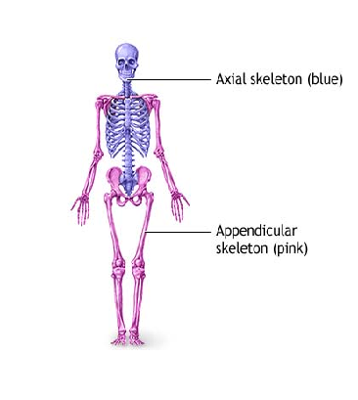
Identify the major anatomical parts of a long bone and state the function of each
Articular cartilage
- Decreases friction at joint surfaces
Medullary cavity
- Stores adipose tissue
- Forms red blood cells and red marrow in infants
( in adults it’s found in the epiphysis)
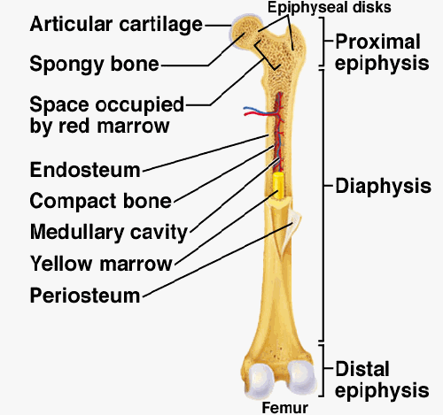
Name and describe the main differences of a male & female pelvis
- Female inlet is larger and more circular
- Female pelvis is shallower & bones are thinner
- The female ilia flare more laterally
- The female sacrum is shorter and less curved
- The female ischial spines are shorter and farther apart
-The female pubic arch is more rounded


