Chapter 4
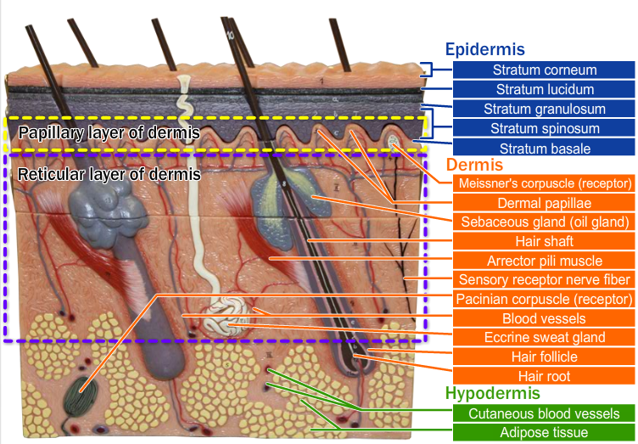
Describe the location and function of melanocytes and keranocytes
Melanocytes
- Found in the stratum basale
- Produce more melanin when exposed to the sun, which is what we call a tan
Keratinocytes
- Found in the stratum corneum
- Form keratin which is though and protects the skin
List four major functions and six protective functions of the Integumentary system
Major Functions
- Protects underlying tissues
- Thermoregulation
- Nitrogenous waste regulation
- Vitamin D Synthesis
Protective Functions
- Mechanical
- Chemical
- Bacterial
- Ultraviolet
-Thermal
- Desiccation

Describe the structure and list the functions of each membrane type. State an example of the location of each type of membrane in the body
Cutaneous Membrane (your skin)
- Its superficial epidermis is composed of keratinizing stratified squamous epithelium
- Its underlying dermis is dense fibrous connective tissue
- Its exposed to air and is a dry membrane
Mucous Membrane
- Made of epithelium resting on loose connective tissue called lamina propria
- Lines body cavities that open to the exterior
Ex. Hollow organs of respiratory, digestive urinary & reproductive tracts
* Not all mucosae secrete mucus
Serous Membranes
- Composed of a layer of simple squamous epithelium on a thin layer of areolar connective tissue
- Line the cavities closed to the exterior
- Except dorsal body cavities & joint cavities
- The parietal layer (which lines a specific portion of the ventral body cavity) folds itself to form the visceral layer (which covers the outside of the organs in that cavity)
- These layers are separated by a liquid called serous fluid (which is secreted by both membranes)
- Serous fluid allows organs to slide across cavity walls (and one another) without creating friction
Connective Tissue Membranes
- Are Synovial membranes
- Composed of areolar connective tissue & don’t have any epithelial cells
- They line fibrous capsules surrounding joints
- Which provide a smooth surface and secrete a lubricating fluid
- They also line bursea sacs & tendon sheaths
- Which cushion organs moving against each other during muscle activity

