Epithelium type | Structure | Location | Diagram
Simple Squamous | - Thin single layer  - Cells close together. | Capillary walls | 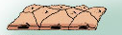
Simple Cuboidal | -One layer of cuboidal cells | Walls of kidneys | 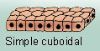
Simple Columnar | - Single tall layer  - Sometimes contain goblet (mucus) cells | Digestive tract | 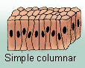
Pseudostratified Columnar | - Cells may be shorter than others  - Nuclei appear at different heights | Lining of the trachea | 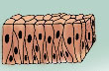
Stratified Squamous | - Consists several layers | Esophagus | 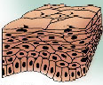
Stratified Cuboidal | - Typically two layers  - Surface cells are cuboidal | Large ducts of exocrine glands | 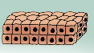
Transitional | - Highly modified, stratified squamous epithelium | - Urinary bladder | 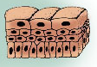
Glandular | - Made of one or more cells that make& secrete a particular product | Endocrine Glands | 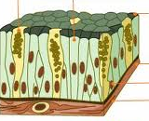

Type | Sub type | Function | Characteristic
Bone | Lacunae | Protect & support body parts | Composed of hard matrix containing salts & collagen fibers
Cartilage | Hyaline Cartilage | Forms supporting structures of larynx and covers ends of bones | Composed of abundant collagen fibers hidden by rubbery matrix
Cartilage | Fibro Cartilage | Forms cushion like disks between vertebrae | Highly compressible
Cartilage | Elastic cartilage | Supports external ear | Found where a structure with elasticity is required
Blood |  | Transports nutrients, wastes and respiratory gases | Matrix is plasma
Loose | Areoral Tissue | Cushions and protects organs it wraps | Most matrix is empty space and fluid contains all types of fibers
Loose | Adipose Tissue | Insulates body & protects it from extreme weather | Oil occupies most of a cell’s volume
Loose | Reticular Tissue | Supports free blood cells | Network of reticular fibers with associated cells
Dense | Dense Fibrous Tissue | Form strong structures such as ligaments and tendons | Crowded between collagen fibers & rows of fibroblasts

