Chapter 3
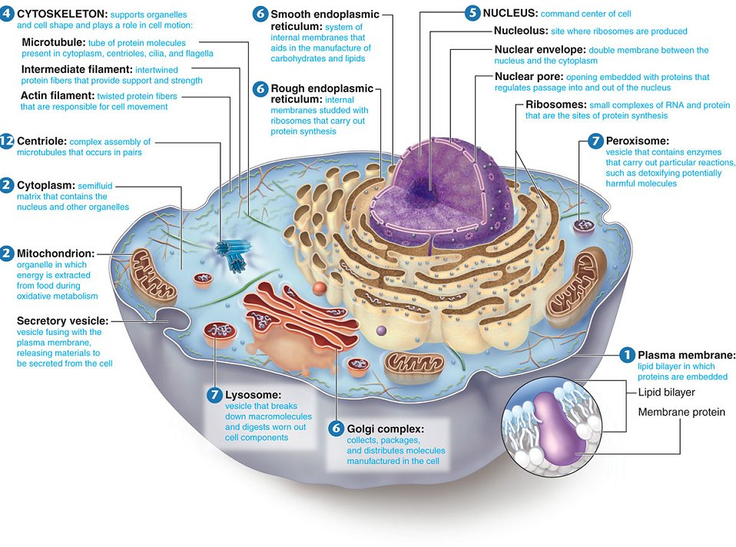
List 3 functions and 2 characteristics of connective tissue. Describe the structure of the extra cellular matrix
Functions
- Protecting, supporting and binding to other tissues
Characteristics
- Variations in blood supply
- Extra cellular matrix
Extracellular matrix
Ground Substance
- Contains cell adhesion proteins that help glue it to fibers
- Acts as a water reservoir
Fibers
- Collagen gives it its strength
- Elastic allows it to stretch and recoil
- Reticular form the internal “skeleton” of soft organs like the spleen
List 4 functions and 5 characteristics of epithelial tissue
Functions
- Absorption
- Filtration
- Protection
- Secretion
Characteristics
- Cells fit closely together to form continuous sheets
- The membranes always have one free surface or edge (called apical surface which is exposed to the body’s exterior or the cavity of an internal organ)
- Lower surface rests on a basement membrane
- Have no blood supply & depend on diffusion
- Cells regenerate easily

Define selective permeability, passive transport, simple & facilitated diffusion, osmosis, filtration, active transport, solute pump, exocytosis, endocytosis, phagocytosis, and receptor-mediated endocytosis
Selective Permeability
- Allows certain molecules to pass through it by passive transport
Passive transport
- Movement through membrane without energy from cell
Simple Diffusion
- Unassisted diffusion of small/hydrophobic solutes through selectively permeable membrane
Facilitated Diffusion
- Protein membrane channel or transport protein carrying larger molecules
Osmosis
- Water passing through aquaporins down its concentration gradient
Filtration
- Fluid forced across cell membrane due to fluid pressure
Active Transport
- ATP provided by the cell moves substances across the membrane
Solute Pump
- Specialized protein carriers in active transport that use ATP
Exocytosis
- Materials in the intracellular fluid are engulfed by a vesicle which secretes the contents into the extracellular fluid
Endocytosis
- Materials in the extracellular fluid are engulfed by a vesicle which secretes the contents into the intracellular fluid
Phagocytosis
- Larger particles are engulfed by the cell
Receptor-Mediated Endocytosis
- Taking up specific molecules, which are detected by a cell membrane surface detector

