Lecture 5: Global Context I
Chapter 6
What is Globalization?
What are its driving forces?
Specify the basic global strategy and global organizational structure a manager should pursue, and why.
The Importance of Global Business to Canada:
- Canada exported over $455 billion
- Canada imported over $404 billion
- The United Nations has ranked Canada as one of the world’s best countries to live in.
- Canada exports nearly 45 % of what it produces
- 33% of all Canadian jobs are related to our exports
What is Globalization?
- A process involving the integration of world markets and economies
- Through cross-border transactions among people, assets, goods and services
- Through growth in direct foreign investment
- Through transactions increasing economic interdependence
Why is global trade important to the Canadian economy?
- Global or international trade between countries around the world improves relationships with allies and has economic benefits such as:
- Creating growth in the economy,
- Increasing profits,
- Providing jobs, and
- Raising living standards that improve the
- Quality of life.
Management in The Global Context:
- International Trade
- The export or import of goods or services to consumers in another country.
- International Business
- Any firm that engages in international trade or investment; also refers to business activities that involve the movement of resources, goods, services, and skills across national boundaries.
- International Management
- The performance of the management process across national boundaries.

Management in the Global Context:
- Multinational Corporation (MNC)
A company that operates manufacturing and marketing facilities in two or more countries: managers of the parent firm, whose owners are mostly in the firm’s home country, coordinate the MNC’s operation.
Some Reasons for Expanding Abroad:
- Sales expansion
- Reducing labour and other costs
- Sourcing high quality goods and services
- Smoothing out sales and profit swings
The Driving Forces to Globalization:
- The pull and push factors (EXPAND)
***What are some ways that organizations can engage in global business activity?
Strategies of Global Activity:
- Exporting
- Selling abroad, either directly to target customers or indirectly by retaining foreign sales agents and distributors.
- Licensing
- An arrangement whereby a firm (the licensor) grants a foreign firm the right to use intangible property.
- Franchising
- The granting of a right by a parent company to another firm to do business in a prescribed manner.
- Foreign Direct Investment
- Operations in one country controlled by entities in a foreign country.
- Strategic Alliance
- An agreement between potential or actual competitors to achieve common objectives.
- Joint Venture
- The participation of two or more companies in an enterprise such that each party contributes assets, owns the entity to some degree, and shares risk.
- Wholly Owned Subsidiary
- A firm that is owned 100% by a foreign firm.

Levels of Global Involvement:
Exporting Licensing Franchising Joint ventures/ strategic alliances Foreign direct investments
Less involvement More involvement
Exporting as a Global Business Strategy:
•Selling goods and services to other countries
ADVANTAGES
- Avoids the need to build factories in host country
- It is a relatively quick way of going international
- It is a good way to “test the waters” in the host country
- Offers 6 billion potential customers around the world
DISADVANTAGES
- Transportation and tariff costs can be substantial
- Hard to find reliable intermediaries
Licensing as A Business Global Strategy:
- What do we mean by Licensing?
Licensing is an agreement where the licensor or exporter grants a foreign firm the right to use intellectual property (I.e. patents, copyrights, manufacturing processes, trade names etc. for royalties – a percentage of total earnings
What are the Losses for Canadian Companies Licensing Foreign Technologies?
- Canadian money is used for the licensing agreements and royalties where it could have been otherwise spent on “home-grown” research and development
- Canadian companies became dependent on foreign technologies
- Canadians lose the opportunity to develop their expertise in high tech industries
Franchising as a Global Strategy:
- What do we mean by Franchising?
Franchising is the granting of a right by the parent company to a foreign firm to do business in a prescribed manner following strict guidelines proven to be profitable in return for royalties
Joint Ventures & Strategic Alliances as a Global Strategy:
- It involves the arrangement between two or more companies from different countries to produce a product or service together or to collaborate in the research development or marketing of this product or service.

Franchising as A Global Strategy:
- What do we mean by Franchising?
Franchising is the granting of a right by the parent company to a foreign firm to do business in a prescribed manner following strict guidelines proven to be profitable in return for royalties.
Joint Ventures & Strategic Alliances as a Global Strategy:
- It involves the arrangement between two or more companies from different countries to produce a product or service together or to collaborate in the research development or marketing of this product or service.
Advantages of Joint Ventures & Strategic Alliances:
- Quick entry in a foreign market
- A way to obtain new knowledge and expertise in a foreign country
- A way to achieve economies of scale (cost efficiencies through large scale production)
- Sharing of costs
- Sharing of risk
- Entry into a regulated industry
- Increase connections among economies
Foreign Direct Investment as a Global Strategy:
- Acquisition of local companies
- Establishment of subsidiaries (branch plants)
Factors to consider before expanding abroad:
- Cultural distance (languages and religions)
- Administrative distance (absence of shared monetary or political associations)
- Geographic distance (physical remoteness)
- Economic distance (differences in consumer incomes).
Barriers to Trade:
- Natural Barriers: Distance, language, culture, legal and regulatory
- Tariff Barriers: Import taxes, protective tariffs.
- Non-Tariff Barriers: quotas, embargoes, buy-national regulations, custom regulations, exchange controls

Determinants of Global Distance:
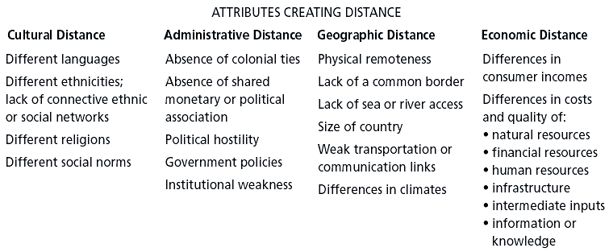
Key Points to Remember:
- Globalization is a phenomenon that will have profound effects on a business and societies
- There are driving forces to globalization
- In today’s world, competing successfully may mean competing globally
- There are many options to “go global”
- Opinions include exporting, licensing, franchising, joint ventures/strategic alliances and foreign direct investment
Key Measures of International Trade:
- Exports
- Imports
- Balance of Trade
- Balance of payments
- Exchange Rates

Levels of Economic Intergation:
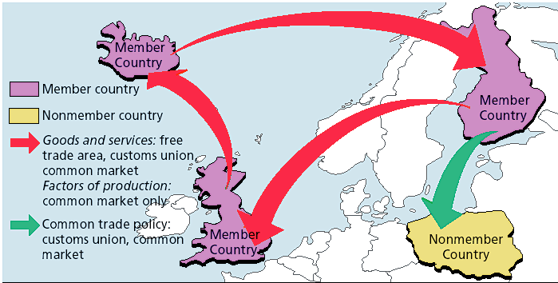
Economic Integration and Free Trade:
- Exchange Rate
The rate at which one country’s currency can be exchanged for another country’s currency.
- Trade Barrier
A governmental influence that is usually aimed at reducing the competitiveness of imported products or services.
- Tariff
A government tax on imports
- Quota
•A legal restriction on the import of particular goods.
- Trade Barrier
•A governmental influence that is aimed at reducing the competitiveness of imported products or services.
Tariff: A government tax on imports.
Quota: A legal restriction on the import of particular goods.
Subsidy: A direct payment a country makes to support a domestic producer.
- Free Trade
All trade barriers among participating countries are removed, so there is an unrestricted exchange of goods among these countries.
- Economic Integration
The result of two or more nations minimizing trade restrictions to obtain the advantages of free trade.
- Free Trade Area
A type of economic integration in which all barriers to trade among members are removed.
- Customs Union
A situation in which trade barriers among members are removed and a common trade policy exists with respect to nonmembers.

- Common Market
A system in which no barriers to trade exist among member countries, and a common external trade policy is in force that governs trade with nonmembers
Factors of production, such as labour, capital, and technology, move freely among members.
Why Countries Trade With Each Other?
- Is it the best way to help the domestic economy to stop imports from other countries?
Absolute Advantage:
- The situation when a country can produce and sell a product at a lower cost or with better results than any other country, or when it is the only country that can provide the product.
Comparative Advantage:
- The concept that each country should specialize in the products that it can produce most effectively and cheaply, and trade those products for those that other countries can produce more effectively and cheaply.
The Multinational Corporation:
- What is a multinational corporation
- Why are we seeing its presence increase across the globe?
Defining the Multinational Corporation:
- It is an enterprise that operates manufacturing and marketing facilities in two or more foreign countries controlling its operations from the firm’s home country
- It is on the rise due to the gradual reduction in trade barriers among many nations of the world
- Multinational corporations capitalize on national differences in the cost and quality of production
The Emergence of the Borderless Corporation:
- An enterprise that can be global without any clear nationality
- The company ownership and management are international
- There is no home country or location
- Business is simply set up wherever profits can be maximized
What are the Potential Threats of MNC’s & Borderless Corp?
- Difficulty to control and hold these organizations accountable -ethical issues
- Profits are not reinvested in the country of operation – they are usually transferred out
- Decisions are usually highly centralized and usually do not include local needs
*NAFTA Business, consumers, employment, trade, culture

Facilitating Global Business:
- Is free trade good or bad for Canada?
- Is there a connection between free trade and job losses in Canada?
- What are the central benefits of free trade?
- What evidence is there of the benefits or consequences that free trade had brought?
Advocates of Free Trade vs Critics of Free Trade:
- ADVOCATES OF FREE TRADE:
- One of the central objectives was to encourage Canadian businesses to become more competitive through exposing Canadian businesses to greater competition from American business.
- Canadian consumers are given more choice and exposed to competitive products with free trade.
- Canadian companies that require inputs from American businesses can now obtain them more cheaply and pass these savings on to the consumers.
- Canada cannot afford to ignore the United States markets.
- The Agreement is not signing away Canada’s cultural heritage.
- Canadian culture exports exceed $4.5 billion, and more royalty money for music is coming into Canada than is leaving.
- Foreign competition forces domestic businesses to improve their operations and their products or services.
- Protecting domestic business amounts to discouraging competitiveness and innovation, and will lead to job losses, given the inability to remain competitive in world markets.
- Free trade encourages countries to abort inefficient operations and focus on the relatively stronger commodities or services in which they have a competitive or comparative advantage.

- CRITICS OF FREE TRADE:
- NAFTA has not encouraged any increase in productivity.
- United States productivity rates have increased at approximately twice the rate of Canadian productivity increases.
- Free trade failed one of its central objectives – to improve Canada’s competitiveness.
- The success that Canada has experienced in international trade has been achieved largely through Canada’s relatively weak dollar.
- As another form of protectionism, the weak Canadian dollar is artificially making Canadian businesses seem competitive.
- There is a need to really improve productivity through updating equipment, retraining workers and building competitiveness.
- Canada’s record exports area result of the relatively low value of the Canadian dollar, making Canadian goods cheaper.
- Free trade will encourage the destruction of a unique Canadian culture.
- Increasing foreign domination of the Canadian economy will transform Canada into a pure economic subsidiary of the United States.
- American competitors and the increasing presence of American-based media threaten publishing and broadcasting industries.
- The presence of the United States in areas like the Canadian entertainment industry would pose a serious threat to the transmission of Canadian culture.
- Many Canadian manufacturers cannot compete with United States imports, and will be forced out of business.
- Job losses could arise from United States companies deciding to shut down their Canadian subsidiaries and exporting their tariff-free goods to Canada.
- Many manufacturing jobs will be lost to Mexico, given the country’s relatively cheap labour and lower-priced goods.

Lecture 6: GLOBAL CONTEXT II:
Chapter 6
SOCIETAL IMPLICATIONS
- What are the critical implications of globalization for societies across the world?
- What are some of the evolving problems with multinational corporations in the global environment?
- What are some ethical challenges of multinational corporations?
Improving Global Business Ethics:
- Should a business adhere to its home country’s ethical standards for business practices or to the host country’s ethical standards?
- If the host country has no environmental protection laws, does the MNC need to be sensitive to environmental standards?
- Which ethical standards should transcend national boundaries?
Actions for Improving International Business Ethics:
- Develop and use codes of conduct geared to worldwide operations.
i.e. guidelines banning the use of child labour.
- Guidelines on environmental standards
- Integrate social policy guidelines into the decision making process of the MNC.
- Conduct an independent audit to assess the underlying moral justification for corporate actions and the consequent results of those actions. (Ethical Impact Statement)

Lecture 7: Political Context
Chapter 7
Purpose of Lecture:
- What is government’s role in the Canadian Economy?

- How has that role been changing and why?

Government as a Guardian of Society:
- Funding Services and Programs
- Establishing Crown Corporations
- Regulating Business – Modifying Economic Behavior
- Safeguarding Canadian Interests
Laws and Regulations Affecting Business:
- Consumer Protection
- Product quality and operations
- Taxations
- Human resources
- Marketing

Public Law: The law relating to the relationship between the individual or business and the government.
Private Law: The law relating to the relationship between individuals, businesses, or individuals and businesses.
The Main Sources of Law:
- Common law
- Civil law
- Statute law
- Administrative law
- Business law
Important Laws That Regulate Business:
- Charter of Rights and Freedom
- Canadian Human Rights Act
- Canadian Labour Code
- Bankruptcy and insolvency Act
- Consumer Protection
- Taxes: income, property, payroll, sales, excise

Establishing Crown Corporations:
- To help facilitate the implementation of government policy in safeguarding national interests
- To protect industries deemed to be vital to the economy
- To provide special services not available by the private sector
- To nationalize industries that are considered to be important to the economy
Modifying Economic Behavior Regulating the Business Sector:
- Imperfect Competitions
To respond to consumer demand in needed markets
- Public Interest
To protect public interests (i.e. safety, pricing etc.)
Safeguarding Canadian Interests:
- Focuses on the protection of the Canadian national identity and culture by limiting the extent of foreign ownership
Government as Guardian of the Private Business Sector:
- GOVERNMENT PROTECTION OF CANADIAN BUSINESS
Nurturing young industries
Encouraging direct foreign investment
Maintaining favorable balance of trade
Protecting against unfair global competition
Maintaining adequate levels of domestic employment
Offering subsidies to compete globally

Forms of Government Influence:
- Low interest loans
- Tax breaks
- Subsidies
- Tariffs
- Quotas
- Restricting legislation
- Government grants
- Bailouts
Trend Toward a Reduction of Government Involvement in the Business Sector:
- Deregulation
- Reduction in the number of regulations (laws) affecting business activities
- Privatization
- Transfer of business activities from the government to the private sector

Why Privatization and Deregulation?
- To encourage increased competition making Canadian industries more competitive, resulting in lower prices and better products
- To improve efficacy and innovation in the industry
- To increase productivity
- To gain financial benefits from the sale of government assets to use in other more needed areas
What are Some of the Challenges of Privatization and Deregulation
- The risk to consumers of exploitation, as a result of the reduction in laws governing industry
- Intense competition in Canadian companies as foreign companies enter Canadian industries
- Massive layoffs of public employees as privatized enterprises restructure
- Private interests are less likely to serve the public’s interests than a government-owned enterprise

Lecture 8: Developing Business Strategy
Chapter 9
Purpose of Lecture:
- Describe the nature of strategic management
- What drives organizational strategy?
- Describe generic strategies and business level strategies
Strategy and Planning:
Strategy:
•A comprehensive and integrated plan that states how the organization will use its resources in the pursuit of its mission and objectives.
Strategic Planning:
•A process that involves defining the mission of the business and laying out the broad strategies or courses of action the firm will use to achieve that mission.
Strategic Principles:
COMPANY
America Online- Consumer connectivity first—anytime, anywhere
Dell - Be direct
eBay- Focus on trading communities
General Electric- Be number one or number two in every industry in which we compete, or get out
Southwest Airlines- Meet customers’ short-haul travel needs at fares competitive with the cost of automobile travel
Vanguard- Unmatchable value for the investor-owner
Wal-Mart- Low prices, every day
Types of Strategies:
Corporate-level strategy:
•Identifies the portfolio of businesses that compose the corporation and the ways in which these businesses fit together
Competitive strategy:
•Identifies how to build and strengthen the business’s long-term competitive position in the marketplace

Functional strategies:
•Identify the basic courses of action that each department will pursue to contribute to the attainment of its goals
Generic Corporate Strategies:
•Concentration
•Market penetration
•Geographic expansion
•Product development
•Horizontal integration
•Vertical integration
•Diversification
•Status quo
•Retrenchment
•Strategic alliances and Joint ventures
•Virtual Corporation

Relationships Among Strategies in Multiple-Business Firms:
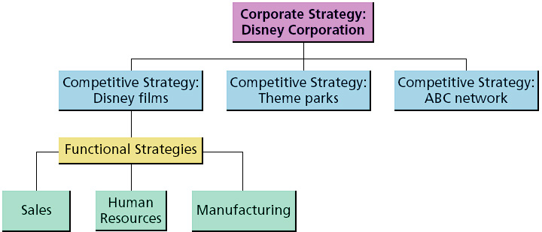

The Vision and Mission Statement:
•Vision:
A mental image of a possible and desirable future of the organization. It articulates a view of a realistic, credible and attainable future.
•Mission:
A statement that broadly outlines the organization’s purpose. It serves to communicate, “who we are as an organization, what we do, and where we are headed”.

Forms of Strategy:
The Strategic Process:
1.Define the business and its mission.
2.Perform external and internal audits
3.Translate the mission into strategic goals
4.Formulate a strategy to achieve the strategic goals
5.Implement the strategy
6.Evaluate performance
A Comprehensive Strategic-Management Model:
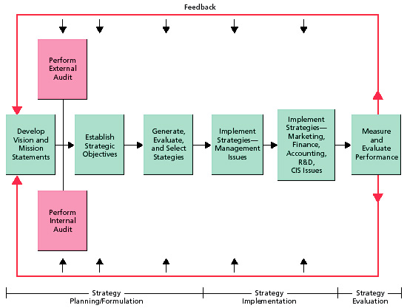

Examples of a Company’s Strengths, Weaknesses, Opportunities, and Threats:
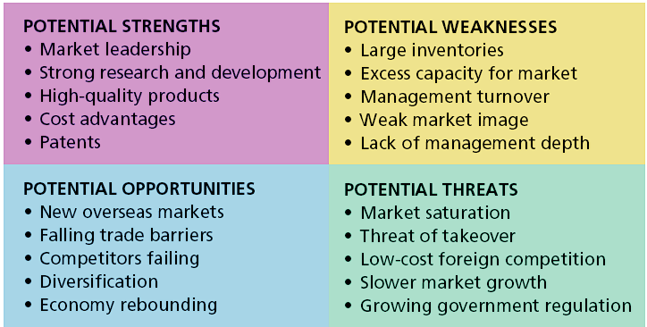
How to Test the Quality of Your Strategy?
- Does your strategy fit with what’s going on in the environment?
- Does your strategy exploit your key resources?
- Will competitors have difficulty keeping up with you?
- Are the elements of your strategy internally consistent?
- Do you have enough resources to pursue this strategy?
- Can your strategy be implemented?
Implementing Strategy:
- Achieving strategic fit
- Leveraging core competencies
- Effectively leading the change process

Organization Life Cycle:

Generic Competitive Strategies:
- Low-cost leader
- Differentiator
- Focuser

Formulating Specific Competitive Strategy:
- Requires understanding the competitive forces that determine how intense the competitive rivalries are and how best to compete

Forces Driving Industry Competition:
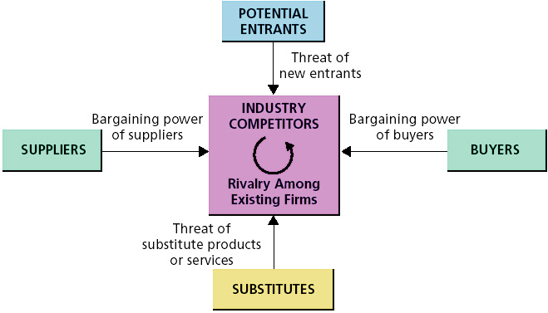
How Competitive Forces Shape Strategy:
- Rivalry Among Established Firms
Bargaining Power Of Buyers
Bargaining Power of Suppliers
Threat of Substitute Products
Risk of Entry By Potential Competitors
1. Threat of New Entrants:
- Can be new firms or diversifying entrants
- Incumbents must create barriers to entry:
- Economies of scale
- Capital requirements
- Switching costs
- Access to distribution channels
- Cost disadvantages unrelated to scale
- Intellectual property (patents, trademarks, trade secrets)
2. Bargaining Power of Suppliers:
- How critical are the inputs provided by suppliers?
- Are there many suppliers relative to producers?

3. Bargaining Power of Buyers:
- Are switching costs for buyers high?
- Are competitive products undifferentiated?
- How important are the products to buyers?
- Are there many buyers relative to producers?

4. Threat of Substitutes:
- Is the industry facing many competitive substitutes?
- Air vs. rail travel
- Movie theaters vs. DVD rentals
- CDs vs. MP3 downloads
5. Rivalry Against Existing Firms:
- Undifferentiated products and low switching costs encourage more intense rivalry
- Many similar producers tend to compete more fiercely
- High exit barriers increase competitive rivalry
- High fixed costs
- Specialized assets and sunk costs
- Escalating commitment
- Social pressures

Lecture 9: Confronting Changing Contexts:
Chapter 10
Purpose of Lecture:
- What are the actual internal and external forces instigating change?
- What does change entail?
- What are the barriers to change?
- What are some ways of reducing resistance to change?
Forces of Change:
- Organizational Change:
Societal changes
Economic changes
Legal/Political changes
Competitive changes
Technological changes

Strategic Change:
- A change in a firm’s strategy, missions, and vision.
- Sources and Effects of Strategic Change
•Strategic changes are usually triggered by uncontrollable external events.
•Strategic changes are often required for survival and have company-wide implications.
- Strategic changes implemented under crisis conditions and with short time constraints are highly risky.
Other Approaches to Change:
- Technological Change
Changing the way the company creates and markets its products or services.
- Structural Change
Changing one or more aspects of the company’s organization structures.
Reorganizing: changing the firm’s organization chart and structural elements.
Organizational Change and the Learning Organization:
- Effective organizational change involves the ability of an organization to learn to recognize the need for change and to learn to adapt to its environment

How Do Organizations Learn? (Chris Argyris & Donald Schon)

How Do Organizations Change?
- Change is accomplished through double-loop learning
- Challenging the status quo
- Examining the assumptions and values underlying an organization’s functioning
Why Do People Resist Change?
- Lack of information or honest disagreement over the facts concerning change.
- Personal and emotional fear of loss of job, relationships, and/or status.
- Personality traits: poor self-image, low tolerance for ambiguity and risk.
- Change creates competing commitments
Resistance to Change:
                - Individual resistance to change:

HABIT:
•Change forces us to break old habits
•It is much easier to Continue performing in the way we learned
FAILURE TO RECOGNIZE NEED FOR CHANGE
• Failure to unfreeze, results in neither appreciating nor accepting the planned change
THREATS TO SOCIAL RELATIONSHIPS
• The pattern of relationships (professional and social) may change.
•We resist this threat to our established relationships.

FEAR OF THE UNKNOWN
• Security from routine – doing things the way we are accustomed
•Security from the well-established relationships
•Change means changing the status quo
•Consequently, change brings uncertainty.
ECONOMIC INSECURITY
• The potential loss of job security – job status, pay or the job itself
• Perceived as a threat to economic security

Organizational Resistance to Change:
WORK GROUP INERTIA
- Group norms that dictate how individuals behave in groups may not be readily amendable to change
STRUCTURAL INERTIA
• Employees are trained to perform
their job according to specified guidelines and to do so on a consistent basis
•This discourages organizations from seeking and adapting to change
THREATS TO EXISTING BALANCE OF POWER:
• The balance of power may change as changes are made in work relationships
Those currently in control may fear losing control after an organizational change has occurred
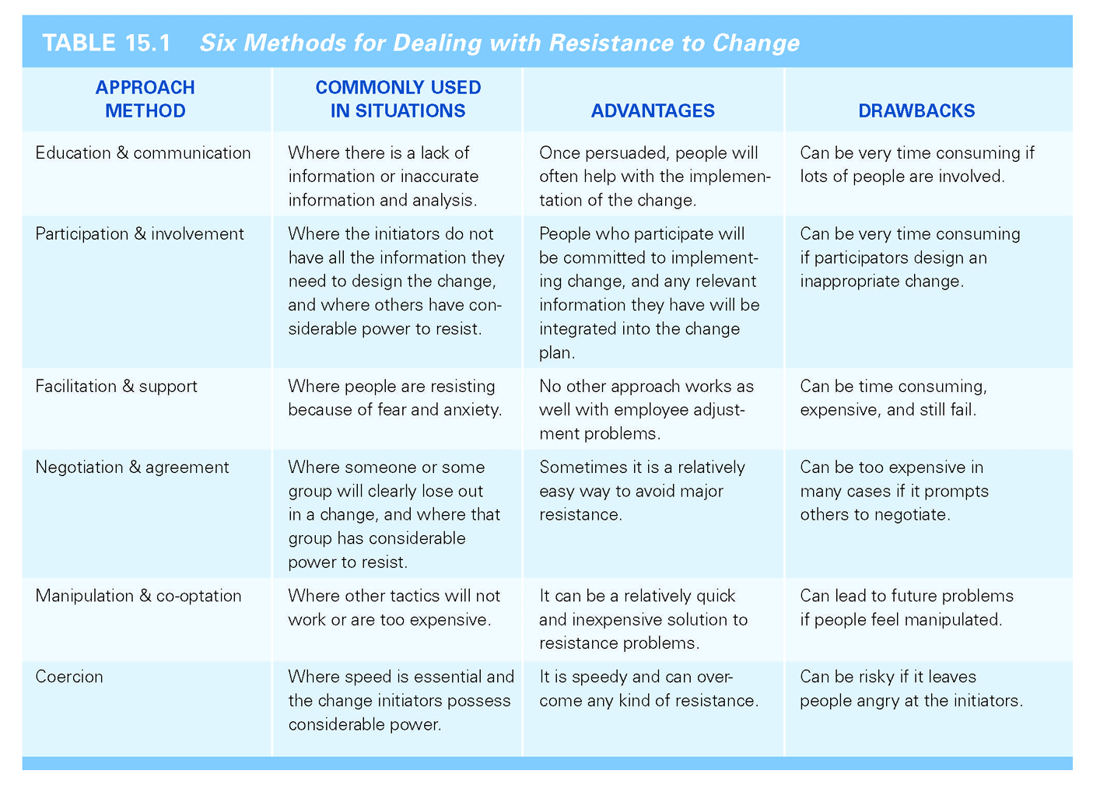

Managing Organizational Chang: Lewin’s Change Model:
The Change Process
Unfreezing Change Refreezing

Kurt Lewin’s Model of Change:
- Unfreezing
–Involves reducing the forces for the status quo, usually by presenting a provocative problem or event to get people to recognize the need for change and to search for new solutions.
- Change
–Using techniques and actually altering the behaviours, values, and attitudes of the individuals in an organization.
- Refreezing
-Preventing a return to old ways of doing things by instituting new systems and procedures that reinforce the new organizational changes.

Three Phases of Lewin’s Change Model:
- Unfreezing
Recognition that the current state of affairs is inadequate - i.e. might occur through environmental pressures – globalization/competition or from recognition that performance is declining
Organizations may fail to detect gradual change until it is too late/ the “boiled frog phenomenon”
- Change
Involves some action – i.e. structural changes; adoption of new technology; implementation of new programs or changes in human resources
Whether the change is effective or ineffective often depends on how well the organization has prepared for change
- Refreezing
Occurs when the newly developed behaviors, attitudes, or structural changes become an enduring part of the organization - reinforced and supported by management

Facilitating Organizational Change:
- Training
- Employee involvement
- Coercion
- Communication and negotiation
- Shift paradigms
Strategies for Managing Change:
- Diagnose a true need for change
- Find an idea that fits the need
- Engage management goals and support
- Design change for incremental implementation
- Plan to overcome resistance to change
- Alignment with needs and goals of users
- Communicate and educate
- Participate and involve
- Force and coerce
- Establish change teams
- Foster idea champions
A Nine-Step Process for leading Organizational Change:
1.Create a Sense of Urgency
2.Decide What to Change
3.Create a Guiding Coalition and Mobilize Commitment
4.Develop and Communicate a Shared Vision
5.Empower Employees to Make the Change
6.Generate Short-Term Wins
7.Consolidate Gains and Produce More Change
8.Anc.hor the New Ways of Doing Things in the Company Culture
9.Monitor Progress and Adjust the Vision as Required

What are the Barriers to Change?
- Adherence to Institutionalized Behaviors
Refers to following organizational policy without critically examining behavior or the policy that dictates behavior
Single-loop learning would seem to be a natural consequence of adherence to institutionalized structure

- Reliance on Cognitive Scripts
Refers to mental scripts that individuals carry with them regarding on how they should conduct themselves in the performance of their duties
Reduces the need to question and confront environmental cues

- Fear of the Unknown
Change brings uncertainty
The potential loss of status, pay or the job itself

- Fear of loss of security
There is security from routine by doing things the way an individual has become accustomed

- Failure to recognize the need for change

- Structural Inertia
Employees are trained to perform their jobs according to specified guidelines and to do so on a consistent basis.
Change is disruptive to the work process

- Threat to existing Balance of Power
Those currently in control may fear losing control after an organizational change has occurred

