Chapters 1-9 I wrote the summaries for and I would say they're pretty thorough.
Sorry if they're confusing and disorganized, but they're more condensed than the textbook!
9-12 I got from online other Notebro submissions . 12 is really not done at all.
13-16 are just taken from slideshows online that really aren't that great but if you do the practice tests attached, you should cover the majority of the stuff.

GOOD LUCK :)

Chapter 1
Marketing is a set of business practices designed to plan for and present an organization's products or services in ways that build effective customer relationships

how the product or service will be conceived or designed, how much it should cost, where and how it will be promoted, and how it will get to the consumer

Marketing is about an exchange - trade of things of value between buyer and seller
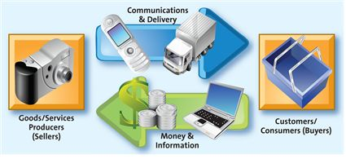
Marketing mix: Product, price, place, promotion

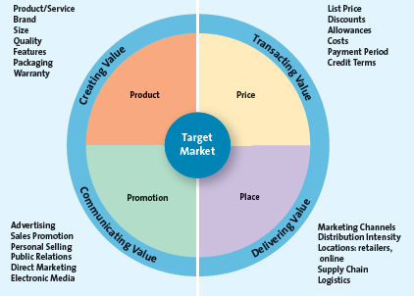

Promotion is communication by a marketer that informs, persuades, and reminds potential buyers about a product or service to influence their opinions or elicit a response.

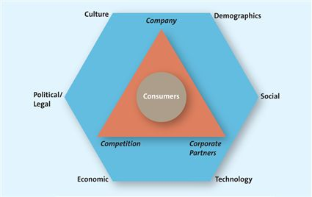

B2B (business-to-business) and B2C (business-to-consumer) and C2C

Social media is the use of Internet tools and software by individuals to easily and quickly create and share content, such as information, knowledge, and insights, with people who have similar interests to foster dialogue, social relationships, and personal identities. Participants act as both publishers and consumers by creating, sharing, or re-mixing content, such as videos, images, and texts. Social media conversations and relationships may move freely between the online and physical context. That is, they may originate online and continue offline, or vice versa. Openness, authenticity, and transparency are key elements of effective social media.

First, more than 90 percent of Canadian Internet users are actively engaged with social media, with each visitor interacting with it for an average of 6.5 hours per month and downloading an average of 120 videos per month.¹⁵ Social media is an excellent way to reach these consumers. Second, consumers are already carrying on conversations about companies, their brands and services; therefore, to be part of the conversation or to initiate conversations, companies must participate in social media. Third, social media enables marketers to accomplish many marketing goals, such as promoting corporate social responsibility, building customer relationships, enhancing customer service, building or defending their brands, engaging customers in research and new product development, and recruiting talent.

Four different marketing orientations or philosophies: product orientation, sales orientation, market orientation, and value-based orientation.

Product-oriented companies focus on developing and distributing innovative products with little concern about whether the products best satisfy customers’ needs. Make product first, and then try to sell without thinking of needs and then making the product.

Companies that have a sales orientation basically view marketing as a selling function where companies try to sell as many of their products as possible rather than focus on making products consumers really want. Generally believe that if consumers try their products, they will like them.

Market-oriented companies start out by focusing on what consumers want and need before they design, make, or attempt to sell their products and services.

Most successful firms today are market oriented. That means they have gone beyond a production or sales orientation and attempt to discover and satisfy their customers’ needs and wants. Value reflects the relationship of benefits to costs, or what you get for what you give.

WHAT IS VALUE BASED

BECOMING VALUE DRIVEN:
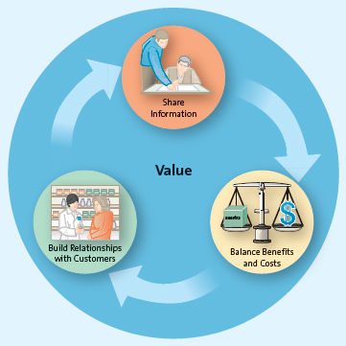

A transactional orientation regards the buyer–seller relationship as a series of individual transactions, so anything that happened before or after the transaction is of little importance.

A relational orientation, in contrast, is based on the philosophy that buyers and sellers should develop a long-term relationship. According to this idea, the lifetime profitability of the relationship matters, not how much money is made during each transaction. i.e. UPS becoming part of the fabric of the shippers' organizations

Firms that practise value-based marketing also use a process known as customer relationship management (CRM), a business philosophy and set of strategies, programs, and systems that focus on identifying and building loyalty among the firm's most valued customers.²² Firms that employ CRM systematically collect information about their customers’ needs and then use that information to target their best customers with the products, services, and special promotions that appear most important to those customers.

Importance of Marketing:
-can be entrepreneurial
-enriches society
-makes life easier
-pervasive across supply chain
-expands global presence
-pervasive across organization

Steps of Internet Usage:
-static, text-based websites calling phone number to order things
-email marketing
-dynamic and interactive website that had modest interactivity and multimedia technology
-e-commerce was next step of ordering things off of the actual site
-next step was when internet could be used for personalization and customization

Challenges of Internet Usage:
-making marketing strategies that can evolve as new technologies do
-making mobile marketing strategies that work
-figure out profitable social media marketing strategy (has yet to generate profits for companies)

MOBILE, MULTICHANNEL, and SOCIAL MEDIA MARKETING - future

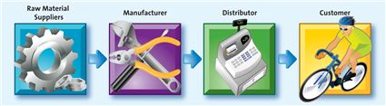

SUPPLY CHAIN
-need to exchange information

Marketing's responsibility also includes offering pleasant and convenient places for you to shop, appropriate opening hours for you to shop, products and services in the form you want, and purchase options. These are often referred to as time, place, form, and ownership utility.

Jobs in marketing:
-animators
-sales associates
-analysts
-strategists
-graphic designers
-writers

Each understood the marketing opportunity (i.e., the unfilled need), conducted a thorough examination of the marketplace, and developed and communicated the value of their products and services to potential consumers.

Chapter 2

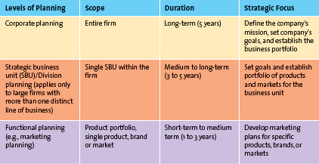

Marketing Plan:
A marketing plan is a written document composed of an analysis of the current marketing situation, opportunities and threats for the firm, marketing objectives and strategy specified in terms of the four Ps, action programs, and projected or pro forma income (and other financial) statements.⁴ The three major phases of the marketing plan are planning, implementation, and control.

WHAT DOES FOUR P'S REPRESENT

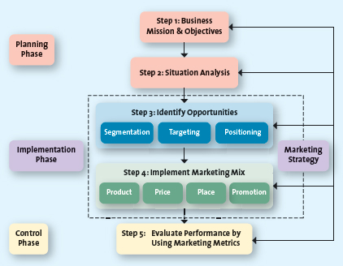

The mission statement, a broad description of a firm's objectives and the scope of activities it plans to undertake,⁶ attempts to answer two main questions: What type of business are we? and What do we need to do to accomplish our goals and objectives?

After developing its mission, a firm next must perform a situation analysis, using a SWOT analysis that assesses both the internal environment with regard to its strengths and weaknesses (internal analysis) and the external environment in terms of its opportunities and threats (external analysis).

Additionally, the firms should assess the opportunities and uncertainties of the marketplace due to changes in cultural, demographic, social, technological, economic, and political forces (CDSTEP).

SWOT analysis requires the firm to undertake a critical assessment of its resources, capabilities, organization, strategies, and performance in relation to competitors.

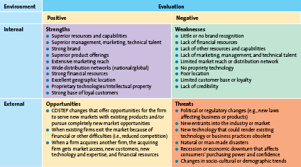

STP: Segmentation, Targeting, and Positioning

Segmentation:
The process of dividing the market into distinct groups of customers where each individual group has similar needs, wants, or characteristics—who therefore might appreciate products or services geared especially for them in similar ways

Targeting:
After a firm has identified the various market segments it might pursue, it evaluates each segment's attractiveness and decides which to pursue by using a process known as target marketing or targeting.

Positioning:
Market positioning involves the process of defining the marketing mix variables so that target customers have a clear, distinct, desirable understanding of what the product does or represents in comparison with competing products.

Setting Marketing Objectives:
These objectives may include market share, revenues and profitability targets, unit sales volume, and brand awareness.

PRODUCT PLACE PRICE PROMOTION:

Product: Including service. Because the key to the success of any marketing program is the creation of value, firms attempt to develop products and services that customers perceive as valuable enough to buy.

Price: Only activity that actually brings in money by influencing revenues. If a price is set too high, it will not generate much volume. If a price is set too low, it may result in lower-than-necessary margins and profits. Therefore, marketers should base price on the value that the customer perceives.

Place: The firm must be able to, after it has created value through a product and/or service, make the product or service readily accessible when and where the customer wants it.

Promotion: Marketers therefore must consider which are the most efficient and effective methods to communicate with their customers. Marketers communicate the value of their offering, or the value proposition, to their customers through a variety of media, including TV, radio, magazines, buses, trains, blimps, sales promotion, publicity, the sales force, and the Internet.

The final step in the planning process includes evaluating the results of the strategy and implementation program by using marketing metrics. A metric is a measuring system that quantifies a trend, dynamic, or characteristic. Understanding the causes of the performance, regardless of whether that performance exceeded, met, or fell below the firm's goals, enables firms to make appropriate adjustments.

-One approach is to compare a firm's performance over time or to competing firms, using common financial metrics such as sales and profits. Another method of assessing performance is to view the firm's products or services as a portfolio.

Financial performance metrics, social responsibility performance metrics

In portfolio analysis, for example, management evaluates the firm's various products and businesses—its “portfolio”—and allocates resources according to which products are expected to be the most profitable for the firm in the future. Portfolio analysis is typically performed at the strategic business unit (SBU) or product line level of the firm, though managers can also use it to analyze brands or even individual items.

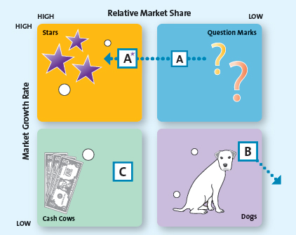

Boston Consulting Group Product Analysis

Stars: occur in high-growth markets and are high–market share products. That is, stars often require a heavy resource investment in such things as promotions and new production facilities to fuel their rapid growth. As their market growth slows, stars will migrate from heavy users of resources to heavy generators of resources and become cash cows.

Cash cows: are in low-growth markets but are high–market share products. Because these products have already received heavy investments to develop their high market share, they have excess resources that can be spun off to those products that need it. For example, in Exhibit 2.8, Brand C uses its excess resources to fund products in the question mark quadrant.

Question marks: appear in high-growth markets but have relatively low market shares; thus, they are often the most managerially intensive products in that they require significant resources to maintain and potentially increase their market share. Managers must decide whether to infuse question marks with resources generated by the cash cows, so that they can become stars, or withdraw resources and eventually phase out the products. Brand A, for instance, is currently a question mark, but by infusing it with resources, the firm hopes to turn it into a star.

Dogs: are in low-growth markets and have relatively low market shares. Although they may generate enough resources to sustain themselves, dogs are not destined for stardom and should be phased out unless they are needed to complement or boost the sales of another product or for competitive purposes. In this case, the company has decided to stop making Brand B.

-difficult to accurately measure both relative market share and industry growth
-suppose a product is classified as a dog although it has the potential of being a question mark. The firm might reduce support for the product and lose sales to the point that it abandons the product, which might have become profitable if provided with sufficient resources

FOUR GROWTH STAGES

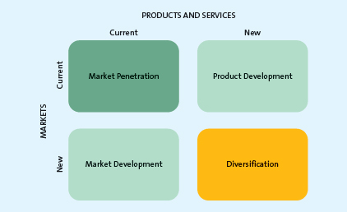

AND DOWNSIZING

A market penetration strategy employs the existing marketing mix and focuses the firm's efforts on existing customers. Such a growth strategy might be achieved by encouraging current customers to patronize the firm more often or buy more merchandise on each visit or by attracting new consumers from within the firm's existing target market.
-Includes greater marketing efforts, such as advertising, additional sales, and promotions, or intensified distribution in area

A market development strategy employs the existing marketing offering to reach new market segments, whether domestic or international or segments not currently served by the firm.
-Have to deal with government regulations, cultural traditions, supply chain considerations, and language

A product development strategy, offers a new product or service to a firm's current target market. i.e. adding a online shop for a retail store

A diversification strategy introduces a new product or service to a market segment that is currently not served. Diversification opportunities may be either related or unrelated. In a related diversification opportunity, the current target market and/or marketing mix shares something in common with the new opportunity. In other words, the firm might be able to purchase from existing vendors, use the same distribution and/or management information system, or advertise in the same newspapers to target markets that are similar to their current consumers. In contrast, in an unrelated diversification, the new business lacks any common elements with the present business.

Downsizing: They may exit markets or abandon products for many reasons, for example, because they have entered new markets where they have little or no experience; diversified into markets or products that do not quite fit with current products, markets, or capabilities; developed products that offer very little value for customers; or encountered declining demand for some products.

Marketing strategy identifies a firm's target market(s), a related marketing mix (four P's) and the bases upon which the firm plans to build a sustainable competitive advantage.

Sustainable competitive advantage is advantage over the competition that is not easily copied and thus can be maintained over a long period of time.

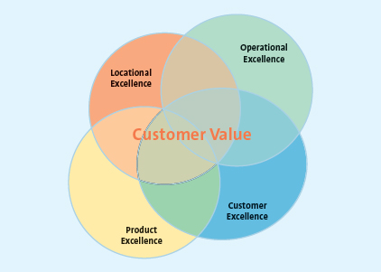

SUSTAINABLE COMPETITIVENESS THROUGH:
- Customer Excellence
Loyalty:
having a strong brand, unique merchandise, and superior customer service all help solidify a loyal customer base. But in addition, having loyal customers is, in and of itself, an important method of sustaining an advantage over competitors. Not just preferring to buy a brand, but will continuously, no matter what, buy it.

-can get data and use information to learn what the customer's really like
-loyalty programs create attachments

Customer service. Marketers may also build sustainable competitive advantage by offering excellent customer service.

- Operational Excellence:
efficient operations, excellent supply chain management, strong relationships with suppliers, and excellent human resource management (which yields productive employees).

Firms with strong relationships may gain exclusive rights to (1) sell merchandise in a particular region, (2) obtain special terms of purchase that are not available to competitors, or (3) receive popular merchandise that may be in short supply.

- Product Excellence:
Product excellence, the third way to achieve a sustainable competitive advantage, occurs by having products with high perceived value and effective branding and positioning. Investing in their brand itself; positioning their product or service by using a clear, distinctive brand image; and constantly reinforcing that image through their merchandise, service, and promotion.

Customers don't want to be talked to, they want to be talked with. This can be done through internet and social media.

Chapter 3
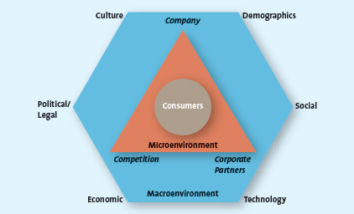
Understanding the Marketing Environment

they monitor their macroenvironment to determine how such factors influence consumers and how they should respond to them

Microenvironment Factors:
Company Capabilities:
-Successful marketing firms focus their efforts on satisfying customer needs that match their core competencies.
-Marketers can use an analysis of the external environment, like the SWOT analysis described in Chapter 2, to categorize an opportunity as either attractive or unattractive and, if it appears attractive, to assess it relative to the firm's existing competencies.

Competition:
-Marketers understand their firm's competitors, including their strengths, weaknesses, and likely reactions to the marketing activities their own firm undertakes
-Firms use competitive intelligence (CI) to collect and synthesize information about their position with respect to their rivals. In this way, CI enables companies to anticipate changes in the marketplace rather than merely react to them

STRATEGIES:
simply sending a retail employee to a competitive store to check merchandise, prices, and foot traffic to more involved methods, such as
- Reviewing public materials, including websites, press releases, industry journals, annual reports, subscription databases, permit applications, patent applications, and tradeshows.
- Interviewing customers, suppliers, partners, or former employees.
- Analyzing a rival's marketing tactics, distribution practices, pricing, and hiring needs.

-Problems ethically arise with how info is gathered. i.e. Schick and Gillette or Westjet stealing Canadian Airlines' passwords and information

Corporate Partners:
-Parties that work with the focal firm are its corporate partners.
-Nau makes outdoor and ski clothing from renewable sources such as corn and recycled plastic bottles
-To develop clothing from sustainable materials that were rugged and beautiful, these founders turned to manufacturing partners around the world to develop new fabrics, such as PLA (polylactic acid).

Macroenvironmental Factors:
CDSTEP

Culture:
-The challenge for marketers is to have products or services identifiable by and relevant to a particular group of people. Our various cultures influence what, why, how, where, and when we buy.
-Country culture: producing advertising that appeals to the same target market across countries. The pictures and copy are the same. The only thing that changes is the languages
-Regional cultures: The region in which people live in a particular country affects the way they react to different cultural rituals, or even how they refer to a particular product category. A resident of Quebec is 25 percent less likely to buy a hot prepared meal or reheatable meal than a resident of Ontario. This difference is attributed to Quebec women's desire to cook and be involved in their family's lives. As well, Quebec consumers are less price sensitive when grocery shopping than residents of Ontario. In Quebec, the most popular stores are IGA and Metro, as compared with No Frills and Food Basics in Ontario.
-even different names of "pop" different everywhere

Demographics:
-characteristics of human populations and segments, especially those used to identify consumer markets. Typical demographics such as age—which includes generational cohorts—gender, income, race, and ethnicity
-“snapshot” of the typical consumer in a specific target market.
-General Cohorts: A group of people of the same generation have similar purchase behaviours because they have shared experiences and are in the same stage of life.
-Tweens: intense buying power and influence family purchases. Into tech, food, drinks, clothes. Move on quickly. Multi-tasking. Easily bored.
-Gen Y: Media-intensive and brand-conscientious. More skeptical about what they hear in the media. Believes the sell is “too hard,” they won't buy. Regardless of where they live, they watch an hour less TV than an average household, use the Internet at work for personal reasons, and expect a healthy option at fast-food restaurants. In the next 10 years or so, many gen Yers will be starting new families and will be prime targets for homes and durable household products. Entering the workplace. Balancing work and life. US
-Gen X: People between the ages of 36 and 47. First generation of latchkey kids: those who grew up in homes in which both parents worked. Economic recession. More likely than previous generations to be unemployed, carry higher debt loads, travel the world, and move far away from their parents; they are also more likely to live longer with their parents, compared with baby boomers, who, at their age, couldn't wait to move away from home. Considerable spending power because they tend to wait to get married and buy houses later in lifeless interested in shopping than their parents. Demand convenience and tend to be less likely to believe advertising claims or what salespeople tell them. Word-of-mouth advertising from people they know and trust can give marketers the credibility needed to market to this cohort. More knowledgeable about products. MOM
-Baby Boomers: After World War II. Between the ages of 48 and 66. They are the largest cohort of Canadians. Individualistic. Leisure time represents a high priority for them. They believe that they will always be able to take care of themselves, partly driven by their feeling of economic security, even though they are a little careless about the way they spend their money. obsession with maintaining their youth. They will always love rock 'n' roll. Big on rejuvenation. GRANDMA
-Seniors: Over 65. Fastest growing group. They're more likely to complain, need special attention, and take time browsing before making a purchase compared with younger groups. However, they generally have time to shop and money to spend. Older people seem to be buying goods and services at the same pace as younger generations. Travel, second homes, luxury cars, electronic equipment, investments, home furnishings, and clothing are frequent purchases. Internet usage quadrupled over decade. Specifically, seniors tend to like “made in Canada” items and recognizable brand names (but generally not designer labels), value, quality, and classic styles. They're typically loyal and willing to spend but are extremely quality conscious and demand hassle-free shopping, particularly in terms of convenient locations. Because most mature customers don't need the basics, they prefer to buy a few high-quality items rather than a larger number of low-quality items.

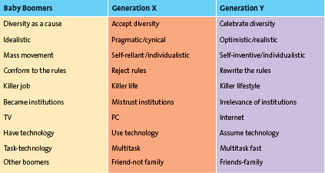

Income:
-Upper class consumers are very affluent, and their spending patterns are not influenced by economic conditions. About 48 percent of Canadian households are in the upper class. Middle class families earn between $30,000 to $70,000,careful about their spending and are often value-conscious. Under class families earn less than $20,000 and often rely on assistance to cover their basic needs.
-According to a report published by the Canadian Centre for Policy Alternatives, the richest 20 percent of Canadians spend 6 or 7 times more in every shopping category than the poorest 20 percent of Canadians

Education:
-60 percent with university degrees earn more than $80,000. In 2007, the median earnings for Canadians with a bachelor's degree were $45,000, a master's degree $60,000, and a doctorate $65,000.

-Marketers are therefore quite cognizant of the interaction among education, income, and occupation.

Gender:
-From cars to copiers, sweaters to sweeteners, women make the majority of purchasing decisions and then influence most of the remainder. To reflect changing family roles, commercials for most children's gear now include Dad interacting with the kids and being involved in purchase decisions. Although the gap is narrowing, men still earn more money than women. In 2008, women earned an average of 71.3 percent of what men earned

Ethnicity:
-Current research shows that 1 out of every 5 Canadians was not born here, accounting for nearly 70 percent of Canada's population growth. Chinese (from Hong Kong, mainland China, and Taiwan) and South Asians (from India, Pakistan, Sri Lanka, and Bangladesh)choose to settle in Montreal, Toronto, or Vancouver; however, areas such as Calgary, Edmonton, Winnipeg, and London are growing in popularity. These groups of South Asians and Chinese are typically young, educated, and wealthy. Currently, more than a quarter of all visible minorities in Canada are under 14 years; thus, they are likely to have considerable influence over the economy in the future.
-South Asians: largest group.
-The challenge is for marketers to understand the culture, value, and spending patterns of the various groups and figure out the best way to communicate and serve them.
-Ethnic Canadians also have an affinity for brand-name products because they equate them with quality.
-FreshCo based on meeting international needs.

Social Trends:
Greener consumers: monomial compensation, "green bin" composting, companies selling green products to stay up to date.

Marketing to Children: (CSPI) has proposed Guidelines for Responsible Food Marketing to Children, which outlines a variety of changes to advertising directed at children. The CSPI notes that children are highly impressionable, and most food advertising to these young consumers touts high-calorie, low-nutrition products, associated in advertising with various toys, cartoons, and celebrities. advertising also cannot be aired during children's programming, and companies cannot link unhealthy foods with cartoon and celebrity figures

Privacy Concerns: Consumers worldwide sense a loss of privacy. "Identity theft."

Bullfrog Power addresses climate change and environmental issues that are growing social trends. The company uses electricity that comes from wind and hydro facilities instead of more-polluting sources such as coal, oil, nuclear, and natural gas. Residents do not need to purchase any additional equipment or wiring to switch to a greener energy alternatives. Expensive. But targets smart, rich individuals that have high values.

The Time-Poor Society: majority of families, both parents work, and the kids are busier than ever. Consumers today have hundreds of shows and programs available to them through TV, radio, PDAs, DVDs, smartphones, personal computers, and the Internet. By fast-forwarding thorough the commercials, they can catch an entire one-hour show in approximately 47 minutes, which means they miss all the messages marketers are attempting to send them. Many consumers attempt to cope with their lack of leisure time by multitasking.

Technological Advances:
-New advances in all aspects.
-Firms are able to track an item from the moment it is manufactured, through the distribution system, to the retail store, and into the hands of the final consumer by using radio frequency identification device (RFID) chips that are affixed to the merchandise. retailers also can communicate with their suppliers—instantaneously over the Internet—and collaboratively plan to meet their inventory needs.
-Some firms have embraced social media as a way to get excellent feedback from consumers, which is then used to design new or redesign existing products, services, and marketing campaigns and strategies. i.e. people complaining about Sears stoves turning on and Sears' response was bad, so they went public.
-Track pizza, find out snow conditions, locate washrooms, etc.

Economic Situation:
-Inflation, foreign currency fluctuations (exchange rate, i.e. spending American money at appropriate times influences our GDP and foreign investment), interest rates (low rates, more mortgages.. High rates, more savings), recession (stock market declines, unemployment, less big ticket purchases)
-When inflation increases, consumers probably don't buy less food, but they may shift their expenditures from expensive steaks to less-expensive hamburgers. Grocery stores and inexpensive restaurants win, but expensive restaurants lose. curiously, the sale of low-cost luxuries, such as personal care products and home entertainment, tends to increase.

Political/Legal Environment:
-Trade and marketing activities influenced.
-Enacted laws that promote both fair trade and competition by prohibiting the formation of monopolies or alliances that would damage a competitive marketplace, fostering fair pricing practices for all suppliers and consumers, and promoting free trade agreements among foreign nations.
-Legislation: regulations require manufacturers to abstain from false or misleading advertising practices that might mislead consumers, such as claims that a medication can cure a disease when in fact it causes other health risks. Manufacturers are required to identify and remove any harmful or hazardous materials. Organizations must adhere to fair and reasonable business practices when they communicate with consumers.
-As described in the chapter vignette, implementing the government-mandated HST will cost Canadian Tire millions of dollars. Similarly, the government has developed laws to regulate consumer behaviour, such as banning smoking, mandating child car seats, and requiring drivers to use only hands-free cellphones.

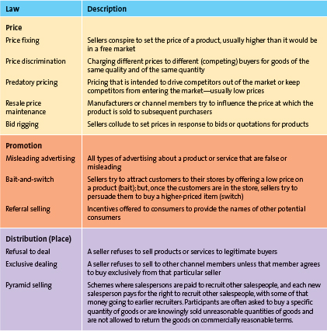

Chapter 4
-Marketing research consists of a set of techniques and principles for systematically collecting, recording, analyzing, and interpreting data that can aid decision makers involved in marketing goods, services, or ideas.

Why do marketers find this research valuable?
First, it helps reduce some of the uncertainty under which they currently operate.
Second, marketing research provides a crucial link between firms and their environments, which enables firms to be customer-oriented because they build their strategies by using customer input and continual feedback.
Third, by constantly monitoring their competitors, firms can anticipate and respond quickly to competitive moves. Fourth, ongoing marketing research can identify emerging opportunities and new and improved ways of satisfying consumer needs and wants from changes in the external environment.

Managers consider several factors before embarking on a marketing research project.
First, will the research be useful? Will it provide insights beyond what the managers already know and reduce uncertainty associated with the project?
Second, is top management committed to the project and willing to abide by the results of the research?
Third, should the marketing research project be small or large?

"World Washer" didn't respond to findings of market research that said that places had different needs and they wanted to make a universal one. Expensive personal interviews or quick online questionnaires? Cost/effectiveness tradeoffs.

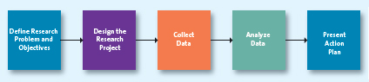

Step 1: Define the Research Problem and Objectives:
If you define the problem incorrectly, you will more than likely end up with the wrong solution even though the rest of the process is done perfectly. Once the research problem is defined, marketers must specify the research objectives or questions to be answered. Marketing research efforts and resources can be wasted if the research objectives are poorly defined. Poor design arises from three major sources: basing research on irrelevant research questions, focusing on research questions that marketing research cannot answer, or addressing research questions to which the answers are already know.

Step 2: Design the Research Project
-The second step in the marketing research project involves design. In this step, researchers identify the type of data needed and determine the type of research necessary to collect it. The company's marketers might want to assess customers' brand loyalty, because if the company enjoys high levels of loyalty, the future looks rosier than if loyalty is low. The marketer must now decide whether the data required to make a decision should be obtained from secondary sources or primary sources.
-Secondary Data: pieces of information that have been collected prior to the start of the focal research project .A marketing research project often begins with a review of the relevant secondary data. Free or very inexpensive external. Primary data, in contrast, are those data collected to address the specific research needs/questions currently under investigation. Some primary data collection methods include focus groups, in-depth interviews, and surveys.

Sources:
-Guides, indexes, directories
-Statistics Canada and Other Gov't Publications
-Trade Sources
-Online Sources
-Periodicals and Newspapers
-Databases

-Purchase external secondary data called syndicated data, which are data available for a fee from commercial research firms such as Symphony, IRI Group, National Purchase Diary Panel, Nielsen, and Leger Marketing.
-Consumer packaged goods firms that sell to wholesalers often lack the means to gather pertinent data directly from the retailers that sell their products to consumers, which makes syndicated data a valuable resource for them. Some syndicated data providers also offer information about shifting brand preferences and product usage in households, which they gather from consumer panels.
-Leger Marketing can offer marketers a 48-hour service—a solution for businesses and decision makers who wish to receive reliable information quickly from a large representative sample of consumers regarding their marketing campaigns, products, and brands.
-Information pertaining to the purpose of the research, sample size, respondents, response rate, questions asked, and so on, researchers could make wrong or misleading inferences or conclusions.

-Primary Data: Data collected to address the specific research needs/questions currently under investigation. observing consumer behaviour, conducting focus groups, or surveying customers by using the mail, telephone, in-person interviews, or the Internet.
-Can be tailored to fit the research questions. More costly. Typically takes longer. Marketers often require extensive training and experience to design and collect primary data that are unbiased, valid, and reliable. Biased data results when, for example, the sample does not represent the entire population, researchers inject their own biases by the way they ask questions or try to get respondents to answer in specific ways, or the respondents may be the wrong people or provide answers they think researchers want to hear.

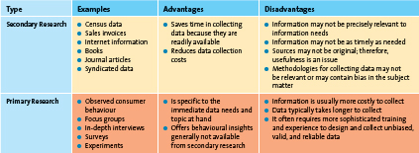

-While marketers are getting customer satisfaction information, they may be missing out on deeper thinking on what motivates, disappoints, satisfies, frustrates, impresses, or delights customers.
-Captures the views of only consumers who opt to participate. Marketers must recognize the limitations.

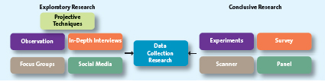

-Reliability is the extent to which you will get the same result if the study is repeated under identical situations.
-Validity is the extent to which the study actually measures what it is supposed to measure.
-A sample: a segment or subset of the population that adequately represents the entire population of interest. Three important questions that must be answered are (1) who should be surveyed, (2) how big should the sample be, and (3) what types of sampling procedure to use, for example, simple random sampling, convenience sampling, stratified sampling, or cluster sampling.

Step 3: Collect Data:
-Depending on the nature of the research problem, the data collection method can employ either an exploratory method or a conclusive research method.
-Exploratory research attempts to begin to understand the phenomenon of interest; it also provides initial information that helps the researcher more clearly formulate the research problem or objectives. Exploratory research is more informal and qualitative than conclusive research methods and includes observation, following social media sites, in-depth interviews, focus groups, and projective techniques.
-If the firm is ready to move beyond preliminary insights gained from exploratory research, it is likely ready to engage in conclusive research, which provides the information needed to confirm those insights and which managers can use to pursue appropriate courses of action. conclusive research offers a means to confirm implicit hunches through surveys, formal studies such as specific experiments, scanner and panel data, or some combination of these. Enables researchers to test their prediction or hypothesis.

Exploratory (Qualitative) Research Methods
-Observation: entails examining purchase and consumption behaviours through personal means or the use of technology, such as video camera or other tracking devices. When consumers are unable to articulate their experiences, observation research becomes particularly useful.
-Ethnography: an observational method that studies people in their daily lives and activities in their homes, work, and communities. It is often used when market researchers believe that potential respondents may be unable to express in a useful way their experiences with a product or service. People have selective memories and might tell a market researcher that they brush their teeth three times a day for two minutes each time. Camera crews capture a different picture though, sometimes leading to new products.

-In-Depth Interviews: an exploratory research technique in which trained researchers ask questions, listen to and record the answers, and then pose additional questions to clarify or expand on a particular issue. They also can communicate how people really feel about a product or service at the individual level, a level that rarely emerges from other methods that use group discussions. Finally, marketers can use the results of in-depth interviews to develop surveys.
-Successful marketing starts with knowing your customers: the more intimately you know them, the more likely you will be able to serve them. The key to learning about consumers is to get into their heads. The ethical dilemma for marketing researchers centres on whether using observational techniques in which the subjects are not informed that they are being studied, such as viewing customers in a mall or a retail store, violates the rule of fair treatment.

-Focus Groups: a small group of persons (usually 8 to 12) comes together for an in-depth discussion about a particular topic. Using an unstructured method of inquiry, a trained moderator guides the conversation on the basis of a predetermined general outline of the topics of interest. Researchers usually record the interactions on videotape or audiotape so they can carefully comb through the interviews later to catch any patterns of verbal or nonverbal responses. In particular, focus groups gather qualitative data about initial reactions to a new or existing product or service, opinions about different competitive offerings, or reactions to marketing stimuli, like a new ad campaign or point-of-purchase display materials.

-Projective Technique: type of qualitative research in which subjects are provided a scenario and asked to express their thoughts and feelings about it.

-Social Media: Can provide insights into what consumers are saying about the firm's own products or its competitor's products. Companies are learning a lot about their customers' likes, dislikes, and preferences not only by monitoring their past purchases, but also by monitoring their interactions with social network sites such as Facebook.
-Social media searches find all info relating to a brand online.

Generally, focus groups and in-depth interviews are used more frequently than personal observations, especially ethnography. Deciding which technique to use depends on several important considerations, such as the objective of the research, the cost to undertake the research, the time required to undertake the research, how soon the results are needed, and whether the marketer has the research expertise in-house or has to hire a market research firm to do the research, especially with methods such as ethnography and projective techniques.

Use multiple modes.

Conclusive (Quantitative) Research Methods

-Conclusive research is intended to verify insights and to aid decision makers in selecting a specific course of action.
-Survey Research: Most popular type of conclusive research method used in marketing research. Widely used to study consumers' attitudes, preferences, behaviours, and knowledge about products and brands. It is generally more cost-effective than other methods for reaching a large sample of consumers. yield quantitative data that can be easily analyzed by using sophisticated statistical methods to examine the relationships among variables. May be unable to answer some of the questions on the questionnaire, may not be able recall the information, or may even interpret the questions differently from what the researchers intended. Some may even try to answer the questions according to what they think the researchers want. Respondents answer some but not all the questions on the questionnaire.
Unstructured questions are open-ended and allow respondents to answer in their own words. Structured questions thus are closed-ended questions for which a discrete set of response alternatives, or specific answers, is provided for respondents to evaluate. Typical response rates run from 1 to 2 percent for mail and 10 to 15 percent for phone surveys. For online surveys, in contrast, the response rate can reach 30 to 35 percent, or even higher in B2B research. It is inexpensive. Results are processed and received quickly. Reports and summaries can be developed in real time and delivered directly to managers in simple, easy-to-digest reports, complete with colour, graphics, and charts.
-Experimental Research: a type of quantitative research that systematically manipulates one or more variables to determine which variable(s) have a causal effect on another variable.
-Scanner Research: a type of quantitative research that uses data obtained from scanner readings of UPC codes at checkout counters. a firm can determine what would happen to sales if it reduced its price by 10 percent in a given month. Did sales increase, decrease, or stay the same?
-Panel Research: a type of quantitative research that involves collecting information from a group of consumers (the panel) over time.

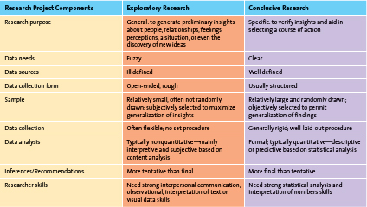

Step 4: Analyze Data:
Should be both thorough and methodical. data can be defined as raw numbers or other factual information that, on their own, have limited value to marketers. However, when the data are interpreted, they become information, which results from organizing, analyzing, and interpreting the data, and putting it into a form that is useful to marketing decision makers.

Step 5: Present Action Plan:
In the final phase of the marketing research process, the analyst prepares the results and presents them to the appropriate decision makers, who undertake appropriate marketing actions and strategies. A typical marketing research presentation includes an executive summary, the body of the report (which discusses the research objectives, methodology used, and detailed findings), the conclusions, the limitations, and appropriate supplemental tables, figures, and appendices.

Ethics of Using Customer Information:
Unauthorized sharing of customer data with third parties or for purposes other than legitimate company business is a serious breach of customer trust. Also, marketers must take every step possible to protect customer data from security breaches from hackers and other unauthorized individuals. In the event of a security breach, the company must quickly notify its affected customers and state clearly what steps it is taking to protect their data and privacy. Privacy Act, that govern the collection, use, disclosure, and retention of personal information by federal government institutions, and the Personal Information Protection and Electronic Documents Act (PIPEDA), which governs the collection, use, disclosure, and retention of personal information by certain parts of the private sector

Without such assurances, consumers will be reluctant to either provide honest responses to marketing research inquiries or even agree to participate in the first place. The Canadian Marketing Association, for example, provides three guidelines for conducting marketing research: (1) it prohibits selling or fundraising under the guise of conducting research, (2) it supports maintaining research integrity by avoiding misrepresentation or the omission of pertinent research data, and (3) it encourages the fair treatment of clients and suppliers.

Chapter 5
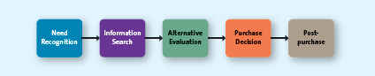
Consumer Decision Process

- Need Recognition
The greater the discrepancy between these two states (unsatisfied and desire to fulfill it), the greater the need recognition will be.

Functional needs pertain to the performance of a product or service.

Psychological needs pertain to the personal gratification consumers associate with a product and/or service.

Researching and understanding what products and services customers need or want and why, are the first steps in developing appropriate tactics. Common tactics marketers employ include using reminder advertising for their products, creating awareness about a new product and its capabilities, showing how a product could enhance consumers' image, and even altering the physical layout of a store or where products are placed in stores.

- Information Search
search for information about the various options that exist to satisfy that need

-in an internal search for information, the buyer examines his or her own memory and knowledge about the product or service, gathered through past experiences
-in an external search for information, the buyer seeks information outside his or her personal knowledge base to help make the buying decision

Factors Affecting Consumers' Search Processes
-The perceived benefits versus perceived costs of search
-The locus of control
-Actual or perceived risk
Five types of risk associated with purchase decisions can delay or discourage a purchase: performance, financial, social, physiological, and psychological. The higher the risk, the more likely the consumer is to engage in an extended search.
Performance risk involves the perceived danger inherent in a poorly performing product or service.
Financial risk is risk associated with a monetary outlay and includes the initial cost of the purchase, as well as the costs of using the item or service.
Social risk involves the fears that consumers suffer when they worry others might not regard their purchases positively.
Physiological risk could also be called safety risk.
Psychological risks are those risks associated with the way people will feel if the product or service does not convey the right image.
-Type of product or service.
Specialty goods/services are products or services toward which the customer shows a strong preference and for which he or she will expend considerable effort to search for the best suppliers.
Shopping goods/services are products or services, such as apparel, fragrances, and appliances, for which consumers will spend a fair amount of time comparing alternatives.
Convenience goods/services are those products or services for which the consumer is not willing to spend any effort to evaluate prior to purchase. They are commodity items that are frequently purchased, usually with very little thought. Items such as pop, bread, and soap typically fall into this category.

-Must try to understand the sources of information customers use to search for information and the importance of each source.
-With this knowledge, marketers could implement various tactics, including providing information about their products or even educating customers about their product in general or a product category as a way to build trust and credibility
-Tactics aimed at reducing the various risks should be communicated to customers by providing guarantees through which defective products can be returned for a full refund or replaced at the company's expense, show proud users

- Alternative Evaluation:
Evaluative criteria consist of a set of salient, or important, attributes about a particular product that are used to compare alternative products.
-Determinant attributes are product or service features that are important to the buyer and on which competing brands or stores are perceived to differ.
-Consumer decision rules are the set of criteria that consumers use consciously or subconsciously to quickly and efficiently select from among several alternatives. These rules take several different forms: compensatory, noncompensatory, or decision heuristics.
-A compensatory decision rule assumes that the consumer, when evaluating alternatives, trades off one characteristic against another, such that good characteristics compensate for bad characteristics.
-Noncompensatory decision rule, in which they choose a product or service on the basis of a subset of its characteristics, regardless of the values of its other attributes.
-Not everyone uses compensatory or noncompensatory decision rules. Some people use decision heuristics, which are mental shortcuts that help them narrow down their choices.
-Price: assume highest price will be best product? Spend the least amount? Trade off between both?
-Brand: Always buying brand name goods allows some consumers to feel safe with their choices. Sense that they are buying a higher quality item.
-Product Presentation: the manner in which a product is presented can influence the decision process. i.e. pretty packaging

-The purchase of highly expressive products that carry greater risks and that are more important to consumers involve
more evaluation than the purchase of products that are less expressive or that have lower perceived risks.

-Marketers can assist consumers in their evaluation process not only by educating them about the company's products,
but also by providing detailed comparison information on price, technical specifications, unique features and benefits, and so on. Marketers may even provide free samples or trials of their products, which may enable consumers to compare the actual products.

- Purchase Decision:
-Customers seek out and purchase the products and services that they believe provide them with the best value. They don't always patronize the store or purchase the brand or item on which they had originally decided. Their choice may not be available at the retail store or there may be some other stumbling block.

-After consumers purchase the product or service, they usually consume it, or “put it to the test.”
-A special type of consumption is called ritual consumption, which refers to a pattern of behaviours tied to life events that affect what and how we consume.
-They might take the form of everyday rituals, such as Brad going to Tim Hortons for his daily morning coffee or you brushing your teeth, or they can be reserved for special occasions, such as rites of passage or holiday rituals.
-Several situational factors, such as the following, help facilitate purchases: having the merchandise in stock that customers want, offering multiple payment options (e.g., cash, cheque, credit card, debit card, interest-free loans, no down payment), having many checkout lanes open and placing the checkouts conveniently in the store, installing digital displays to entertain customers waiting in line, and offering such tactics as delivery, price-match guarantee, a warranty, or a simple return policy. Additional factors that affect whether the purchase decision is made immediately or later, such as store atmospherics, shopping situation, and temporal states.

- Postpurchase
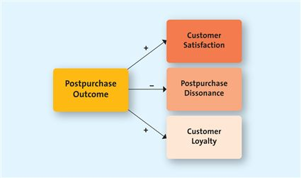

-Customer Satisfaction: setting expectations both high and low can be dangerous through letdown or companies not showing how great they are.
-Marketers can take the following steps to ensure postpurchase satisfaction:
- Build realistic expectations—not too high and not too low—and deliver on those expectations.
- Demonstrate correct product use; improper usage can cause dissatisfaction.
- Stand behind the product or service by providing money-back guarantees and warranties.
- Encourage customer feedback, which cuts down on negative word of mouth and helps marketers adjust their offerings.
- Periodically make contact with customers and thank them for their support.

-Postpurchase Dissonance: (or buyer's remorse) is an internal conflict that arises from an inconsistency between two beliefs, or between beliefs and behaviour.
-Postpurchase cognitive dissonance is a feeling of regret, guilt, or grave uneasiness, which generally occurs when a consumer questions the appropriateness of a purchase after his or her decision has been made.
-When consumers feel, for example, that they made the purchase without all the information they needed, they were persuaded by a salesperson, they liked the good features of the product or service but do not like the negative aspects of the product or service, or if immediately following the purchase they see the product or service advertised elsewhere at a better value.
-Postpurchase dissonance is especially likely for products that are expensive, infrequently purchased, highly expressive, and associated with high levels of risk.
-To reduce the dissonance, Brad can take several actions:
- Pay attention to positive information about the Honda Civic, such as looking up reviews by owners and car buffs on the Internet.
- Get positive feedback from friends about his new sports car.
- Seek negative information about sports cars he did not buy. Reading these reviews makes him feel more comfortable with his purchase decision.

-Customer Loyalty: Customer loyalty develops over time with multiple repeat purchases of the product or brand from the same marketer.
-In the postpurchase stage of the decision-making process, marketers attempt to build and nurture a loyal relationship with their customers from the very first purchase and with each subsequent purchase.
-They do not consider other brands or firms in their decision.
-Marketers have designed customer relationship management (CRM) programs specifically to retain them.

Undesirable Consumer Behaviour
-Negative word of mouth occurs when consumers spread negative information about a product, service, or store to others. When customers' expectations are met or even exceeded, they often don't tell anyone about it. But when consumers believe that they have been treated unfairly in some way, they usually want to complain, often to many people.
-If the customer believes that positive action will be taken as a result of the complaint, he or she is less likely to complain to family and friends or through the Internet.

Factors Influencing Consumer Buying Decisions
- Psychological factors, which are influences internal to the customer, such as motives, attitudes, perceptions, learning, and lifestyles.
- Social factors, such as family, reference groups, and culture, also influence the decision process.
- Situational factors, such as the specific purchase situation, a particular shopping situation, and temporal states (the time of day), affect the decision process.

Psychological Factors:
-Motives: a need or want that is strong enough to cause the person to seek satisfaction. Maslow's Hierarchy of Needs.
-Physiological: food, water, rest, shelter.
-Love: relationships.
-Esteem: satisfy inner desires.
-Self-Actualization: satisfied with your life and how you live.
-Attitude: An attitude is a person's enduring evaluation of his or her feelings about and behavioural tendencies toward an object or idea. Attitudes are learned and long-lasting, and they might develop over a long period of time, though they can also abruptly change.
-An attitude consists of three components. The cognitive component reflects what we believe to be true, the affective component involves what we feel about the issue at hand—our like or dislike of something—and the behavioural component comprises the action(s) we take based on what we know and feel.
-Marketing communication—through salespeople, advertisements, free samples, or other such methods—can attempt to change what people believe to be true about a product or service (cognitive) or how they feel toward it (affective).
-Perception: the process by which we select, organize, and interpret information to form a meaningful picture of the world. Perception influences our acquisition and consumption of goods and services through our tendency to assign meaning to such things as colour, symbols, taste, and packaging.
-Marketers must understand and focus on the four components of perception: selective exposure, selective attention, selective comprehension, and selective retention.
-People who look at the news and sports channels only, but not the comedy or women's TV network channels, are engaged in selective exposure because they are excluding other programs or channels.
-Consumers who only listen to messages that are consistent with their beliefs, and not others, are practicing selective attention.
-Selective comprehension occurs when consumers interpret a marketing message in a way that is different from what the marketer intends.
-Selective retention describes the situation where consumers do not remember all the information they see, read or hear. Marketers can provide the information in various other forms such as print, online, and other displays to reinforce their message.
-Learning: refers to a change in a person's thought process or behaviour that arises from experience and takes place throughout the consumer decision process.
-Learning affects both attitudes and perceptions.
-The cognitive component changed for him when he learned that the dealership offers various additional services at low costs to Honda Civic owners
-Lifestyle: refers to the way consumers spend their time and money to live. For many consumers, the question of whether the product or service fits with their actual lifestyle, which may be fairly sedentary, or their perceived lifestyle, which might be outdoorsy, is an important one.

Social Factors:
-Family: Many purchase decisions are made about products or services that the entire family will consume or use.
-Despite that example, children and adolescents play an increasingly important role in family buying decisions. For instance, the tween segment alone in Canada is estimated to spend more than $3 billion per year on personal items such as snacks, soft drinks, electronics, and apparel.
-Tweens in Canada also indirectly influence family purchases in excess of $20 billion on big ticket items such as recreation, vacations, technology, and the family car.
-Reference Groups: A reference group is one or more persons an individual uses as a basis for comparison regarding beliefs, feelings, and behaviours. A consumer might have various reference groups, including family, friends, co-workers, or famous people the consumer would like to emulate. These reference groups affect buying decisions by (1) offering information, (2) providing rewards for specific purchasing behaviours, and (3) enhancing a consumer's self-image.
-Reference groups provide information to consumers directly through conversation or indirectly through observation.
-She quickly decided it was time for her to purchase a smartphone in order to fit in with her peers.
-Some reference groups also influence behaviours by rewarding behaviour that meets with their approval or chastising those who engage in behaviour that doesn't.
-Consumers can identify and affiliate with reference groups to create, enhance, or maintain their self-image.
-Cultures: hared meanings, beliefs, morals, values, and customs of a group of people. Your cultural group might be as small as your reference group at school or as large as the country in which you live or the religion in which you participate. i.e. high achieving household

Situational Factors:
-Purchase Situation: Customers may be predisposed to purchase certain products or services because of some underlying psychological trait or social factor, but these factors may change in certain purchase situations.
-For instance, Priya Persaud, a Vancouverite, considers herself a thrifty, cautious shopper—someone who likes to get a good deal. But her best friend is getting married, and she wants to buy the couple a silver tray. If the tray were for herself, she would probably go to Stokes, Bowring, or possibly even Walmart. But since it is for her best friend, she went to Birks. Why? To purchase something fitting for the special occasion of a wedding.
-Shopping Situation:
-Store atmosphere
-Salespeople
-Crowding(avoiding)
-In-store demonstrations
-Promotions
-Packaging
-Temporal State: Our state of mind at any particular time can alter our preconceived notions of what we are going to purchase. For instance, some people are “morning people,” whereas others function better at night.
-Mood swings can also alter consumer behaviour.
-Her bad mood may even cause her to have a less positive postpurchase feeling about the store.

Consumers engage in two types of buying process/decisions depending on their level of involvement: extended problem solving for high-priced, risky, infrequent, or highly expressive purchases; and limited problem solving, which includes impulse buying and habitual purchases/decision making.

Involvement is the consumer's degree of interest or concern in the product or service.

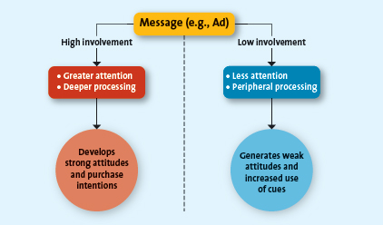

If both types of consumers viewed ads for hybrids produced by Toyota and Ford, the high-involvement consumer (e.g., Katie who is researching hybrids) will scrutinize all the information provided (e.g., gas savings, eco-friendly) and process the key elements of the message deeply. As a consequence, Katie, an involved consumer, is likely to either end up judging the ad to be truthful and form a favourable impression of the product or alternatively view the message as superficial and develop negative product impressions (i.e., her research suggests the product is not as good as it is being portrayed).

In contrast, a low-involvement consumer will likely process the same advertisement in a less thorough manner. Such a consumer might pay less attention to the key elements of the message (e.g., gas savings, eco-friendly) and focus on heuristic elements such as brand name (Toyota), price, and the presence of a celebrity endorser. The impressions of the low-involvement consumer are likely to be more superficial.

Extended Problem Solving:
This process is an example of extended problem solving, which is common when the customer perceives that the purchase decision entails a great deal of risk. The potential risks associated with Katie's decision to buy her car include financial (Did I pay too much?), physiological (Will it keep me safe in an accident?), social (Will my friends think I look cool?), performance (Will the car perform as expected?), and psychological (Will the car convey the right image of me?) risks. To reduce her perceived risk, Katie spent a lot of effort searching for information about cars before she actually made her purchase.

Limited Problem Solving:
occurs during a purchase decision that calls for, at most, a moderate amount of effort and time. Customers engage in this type of buying process when they have had some prior experience with the product or service and the perceived risk is moderate. Limited problem solving usually relies on past experience more than on external information. For some people even a car purchase could require limited effort. impulse buying, a buying decision made by customers on the spot when they see the merchandise. Habitual decision making describes a purchase decision process in which consumers engage with little conscious effort.

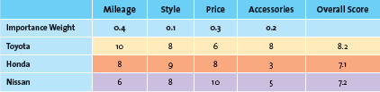

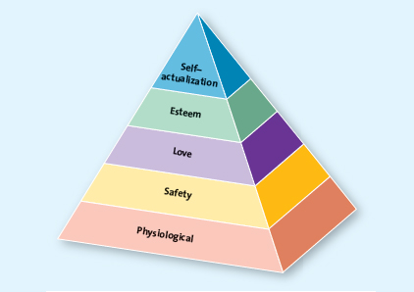

Chapter 6
Business-to-business (B2B) marketing refers to the process of buying and selling goods or services to be used in the production of other goods and services, for consumption by the buying organization, or for resale by wholesalers and retailers.
-Therefore, B2B marketing involves manufacturers, wholesalers, retailers, and service firms that market goods and services to other businesses but not to the ultimate consumer.
-The jeans are being purchased and used by a business rather than by an individual household consumer.

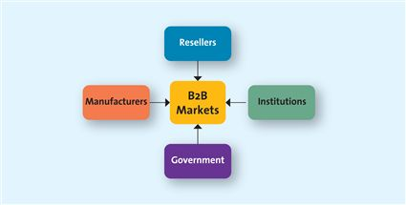
Manufacturers or Producers: buy raw materials, components, and parts that allow them to manufacture their own goods.not only does the manufacturer purchase products from other firms to make its products, but it also works with its corporate partners, such as transportation companies and retailers, to facilitate the movement of the raw supplies to the factory and finished products to the stores.

Resellers: are marketing intermediaries that resell manufactured products without significantly altering their form.
-Wholesalers and distributors buy jeans from 7 For All Mankind and sell them to retailers (a B2B transaction), and retailers in turn resell those same jeans to the ultimate consumer (a B2C transaction). Wholesalers, distributors, and retailers are all resellers.

Institutions: Institutions, such as hospitals, educational organizations, prisons, religious organizations, and other nonprofit organizations, also purchase all kinds of goods and services for the people they serve.

Government: In most countries, the central government tends to be one of the largest purchasers of goods and services.
The bulk of the federal government's buying of goods and services is done centrally by Public Works and Government Services Canada on behalf of more than 85 departments, agencies, Crown corporations, and Special Operating Agencies.

Key Challenges of Reaching B2B Clients
For marketers to be effective and successful at B2B marketing, they must master three key challenges for each business customer they want to serve.
- Identify the right persons or decision makers within the organizations who can authorize or influence purchases.
- Marketers must understand the buying process of each of its potential clients.
- Identify the factors that influence the buying process of potential clients.
-governments spend more, schools spend less
-institutional organizations rarely disclose info and practices, so they're less transparent
-private sector companies are private and engage in reciprocal buying, a situation where two companies agree to buy each other's products as appropriate

Market Characteristics: In B2B markets, demand for goods and services is derived from B2C sales in the same supply chain. More specifically, derived demand is the linkage between consumers' demand for a company's output and its purchase of necessary inputs to manufacture or assemble that particular output.
-Demand for raw denim used to make 7 For All Mankind jeans is derived from the sale of the jeans to consumers. Thus, demand for raw material and semifinished goods purchased by business firms tend to fluctuate more, and more frequently.
-In addition, demand in many business markets is inelastic—that is, the total demand for goods is not affected much by price changes in the short run. For instance, a small increase in the price for raw denim will not cause a huge drop in the demand for denim in the apparel industry in the short run. Another characteristic of B2B markets is that the number of business buyers is substantially fewer than in B2C markets, and the business buyers are more concentrated in big cities, towns, and industrial areas.

Product Characteristics: In B2B markets, the products ordered are primarily raw materials and semifinished goods that are processed or assembled into finished goods for the ultimate consumers.
-Companies such as Bombardier often provide vendor financing—a practice where a company provides its customer with a loan that is used to buy goods from the company.

Buying Process Characteristics: More people are usually involved in complex buying decisions. They are usually technically trained and qualified professionals, and they represent different interests
-Most companies have formal policies and procedures to guide buying decisions that must be closely followed by the people involved in the buying decisions. Examples of such procedures include rules governing competitive bidding, negotiated pricing, complex financial arrangements, buying criteria, and objectives, as well as procedures for evaluating competitive bids.
-Generally, the buying decision is based on negotiations, which for complex purchases could be quite extended.
-The negotiated contract normally covers a range of concerns, including price, delivery, warranty, technical specifications, and claim policies
-Strive to develop close relationships with each other and so will often provide help or advice to ensure a win-win situation for both parties

Marketing Mix Characteristics: On the other hand, in most B2B sales, the salesperson is an integral component of the transaction. Pharmaceutical manufacturers rely primarily on sales representatives to promote their drugs to doctors. Also, many manufacturers provide trade and quantity discounts to resellers for carrying their products.

Statistics Canada collects data about business activity in Canada through its classification scheme, which categorizes all firms into a hierarchical set of six-digit North American Industry Classification System (NAICS) codes. The NAICS codes replaced the Standard Industrial Classification (SIC) system that had been in use since the 1930s.The first two digits represents the sector in the economy (e.g., 51 is the information sector); the third digit represents the subsector (e.g., 515 is “Broadcasting except Internet”); the fourth digit represents the industry group; the fifth digit represents a specific subgroup within the industry; and the full six-digits refer to the country-level or national industry.

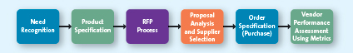

- Need Recognition: In the first stage of the B2B buying process, the buying organization recognizes, through either internal or external sources, that it has an unfilled need.
-Through suppliers' salespeople, tradeshow demonstrations, ads in trade journals, Internet searches, and white papers, the company also has become aware of the benefits of different tire manufacturers.

- Product Specification: considers alternative solutions and comes up with potential specifications that suppliers might use to develop their proposals to supply the product

- Request for Proposals (RFP) Process: buying organizations invite alternative suppliers to bid on supplying their required components.

- Proposal Analysis and Supplier Selection: The buying organization, in conjunction with its critical decision makers, evaluates all the proposals it receives in response to its RFP. Firms are likely to narrow the process to a few suppliers, often those with which they have existing relationships, and discuss key terms of the sale, such as price, quality, delivery, and financing. Some firms have a policy that requires them to negotiate with several suppliers, particularly if the product or service represents a critical component or aspect of the business.

- Order Specification (Purchase): the firm places its order with its preferred supplier (or suppliers). The order will include a detailed description of the goods, prices, delivery dates, and, in some cases, penalties if the order is not filled on time.

- Vendor Performance Assessment Using Metrics: firms analyze their vendors' performance so they can make decisions about their future purchases. The difference is that, in a B2B setting, this analysis is typically more formal and objective.

The six-stage B2B buying process may be influenced by three factors within the purchasing organization: the buying centre, the buying organization's philosophy or corporate culture, and the buying situation.

The Buying Centre: These buying centre participants can range from employees who have a formal role in purchasing decisions (e.g., the purchasing or procurement department), to members of the design team that is specifying the particular equipment or raw material needed, to employees who will be using a new machine that is being ordered.
-One or more people may take on a certain role, or one person may take on more than one of the following roles: “(1) initiator, the person who first suggests buying the particular product or service;
(2) influencer, the person whose views influence other members of the buying centre in making the final decision; (3) decider, the person who ultimately determines any part of or the entire buying decision—whether to buy, what to buy, how to buy, or where to buy;
(4) buyer, the person who handles the paperwork of the actual purchase;
(5) user, the person(s) who consumes or uses the product or service; and
(6) gatekeeper, the person(s) who controls information or access, or both, to decision makers and influencers.

Organizational Culture: reflects the set of values, traditions, and customs that guides its managers' and employees' behaviour.
-Corporate buying centre cultures might be divided into four general types: autocratic, democratic, consultative, and consensus:
-In an autocratic buying centre, though there may be multiple participants, one person makes the decision alone, whereas the majority rules in a democratic buying centre. Consultative buying centres use one person to make a decision, but he or she solicits input from others before doing so. Finally, in a consensus buying centre, all members of the team must reach a collective agreement that they can support a particular purchase.

-Building B2B Relationships: -blogs, social media raise awareness, provide search engine results, educate potential and existing clients about products or services
-expert advice offers advice and knowledge increasing brand awareness
-web analytics (traffic on website and comments) can offer tangible evaluations
-but a better measure is how often the blog gets mentioned elsewhere, the media attention it receives, and the interaction, involvement, intimacy, and influence that it promotes
-LinkedIn: social network for professional networking in B2B

Buying Situations:
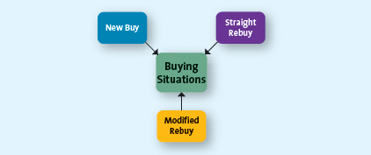

New Buy Situation: a customer purchases a good or service for the first time, which means the buying decision is likely to be quite involved because the buyer or the buying organization does not have any experience with the item.

Modified Rebuy: the buyer has purchased a similar product in the past but has decided to change some specifications, such as the desired price, quality level, customer service level, and options. Current vendors are likely to have an advantage in acquiring the sale in a modified rebuy situation, as long as the reason for the modification is not dissatisfaction with the vendor or its products.

Straight Rebuy: occurs when the buyer or buying organization simply buys additional units of products that had previously been purchased. A tremendous amount of B2B purchases are likely to fall in the straight rebuy category. The most complex and difficult is the new buy because it requires the buying organization to make changes in its current practices and purchases. Similar to a consumer's habitual purchase, straight rebuys often enable the buyer to recognize the firm's need and go directly to the fifth step in the B2B buying process

-online trade shows

A private exchange occurs when a specific firm (either buyer or seller) invites others to participate in online information exchanges and transactions.
-Which provides tremendous cost savings through the elimination of periodic negotiations and routine paperwork, as well as the ability to form a supply chain that can respond quickly to the buyer's needs.

Private exchanges -> Internet & B2B <- Auctions

In an English auction, goods and services are simply sold to the highest bidder.

In a reverse auction, however, the buyer provides specifications to a group of sellers, who then bid down the price until the buyer accepts a specific bid.

Chapter 7
Step 1: Establish Overall Strategy or Objectives
-Articulate the mission and the objectives of the company's marketing strategy clearly. The segmentation strategy must then be consistent with and derived from the firm's mission and objectives, as well as its current situation—its strengths, weaknesses, opportunities, and threats (SWOT)

Step 2: Segmentation Bases
-This step develops descriptions of the different segments, their needs, wants, and characteristics, which helps firms better understand the profile of the customers in each segment. Marketers use various segmentation bases, including geographic, demographic, psychographic, and behavioural, or a combination of these segmentation approaches

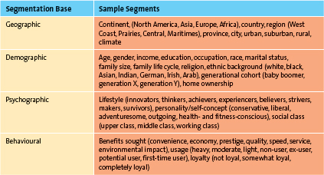

I think like them, so I should buy their products

Psychographic: how they describe themselves
-Determining psychographics involves knowing and understanding three components: self-values, self-concept, and lifestyles.
-Self-values are life goals, not just the goals one wants to accomplish in a day. They refer to overriding desires that drive how a person lives his or her life. Examples of self-value goals might include self-respect, self-fulfillment, or a sense of belonging.
-Self-concept, or the image people have of themselves. Has a goal to belong may see, or want to see, himself or herself as a fun-loving, gregarious type whom people wish to be around. Marketers can make use of this image through communications that show their products being used by groups of laughing people who are having a good time
-Lifestyles, the third component of people's psychographic makeup, are the ways we live. If values provide an end goal and self-concept is the way one sees oneself in the context of that goal, lifestyles are how we live our lives to achieve goals

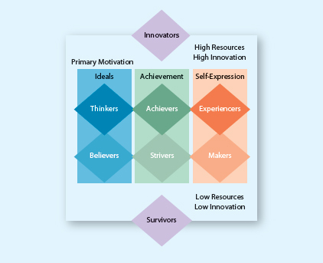

VALS Categories

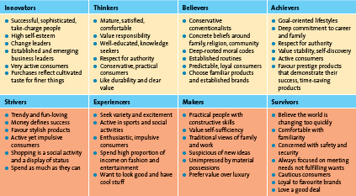

Behavioural segmentation groups consumers on the basis of the benefits they derive from products or services, their usage rates of products or services, their user status, and their loyalty.

Benefit segmentation looks at the benefits customers derive from products or services. Because marketing is all about satisfying needs and wants, dividing the market into segments according to which consumers' needs and wants your offerings can best satisfy makes a lot of sense.
-RBC divides personal (i.e., nonbusiness) customers into five primary benefit groups: Youth, Nexus, Borrowers/Builders, Wealth Accumulators, and Wealth Preservers.

In light of the high cost of finding new customers and the profitability of loyal customers, today's companies are using loyalty segmentation and investing in retention and loyalty initiatives to retain their most profitable customers. Canadians are crazy about loyalty cards, with nearly 9 in 10 adults (87 percent) actively participating in at least one loyalty program, whether it's retail or air travel.

Usage rate (heavy users, regular users, light users, occasional users) as well as user status (current users, ex-users, potential users) can also be used as segmentation variables. For example, fast-food restaurants often use promotional coupons to target occasional visitors to their restaurant or to entice people who have never visited their restaurants to come in and try their food and services.

Because “birds of a feather flock together,” companies use a combination of geographic, demographic, and lifestyle characteristics, called geodemographic segmentation, to classify consumers.
-Consumers in the same neighbourhoods tend to buy the same types of cars, appliances, and apparel, shop at the same types of retailers, and behave similarly to media and promotions.
-One of the most widely used tools for geodemographic segmentation in Canada are PSYTE cluster profiles, developed by Compusearch.
-The PSYTE system groups all neighbourhoods in Canada into 60 different lifestyles clusters with specific locations.

Step 3: Evaluate Segment Attractiveness

Is the segment identifiable, reachable, responsive, and substantial and profitable?

Identifiable Firms must determine who is within their market to be able to design products or services to meet their needs. It is equally important to ensure that the segments are distinct from one another because too much overlap between segments means that distinct marketing strategies aren't necessary to meet segment members' needs.
Reachable The best product or service cannot have any impact if that market cannot be reached (or accessed) through persuasive communications and product distribution. Consumers must know the product or service exists, understand what it can do for them, and recognize how to buy it.
-If something's too mainstream, university students won't buy it.
Responsive For a segmentation strategy to be successful, the customers in the segment must react similarly and positively to the firm's offering.
-La Senza has built a reputation for carrying a full range of intimate, stylish, and sexy daywear and sleepwear bras, panties, camisoles, pyjamas, and nightshirts and competes best in this apparel line. Although the formal dress wear segment meets all the other criteria for a successful segment, La Senza should not pursue it because the market probably will not be responsive to it.
Substantial and Profitable Once the firm has identified its potential target markets, it needs to measure their size and growth potential. If a market is too small or its buying power insignificant, it won't generate sufficient profits or be able to support the marketing mix activities. Marketers must also focus their assessments on the potential profitability of each segment, both current and future.
-Some key factors to keep in mind in this analysis include market growth (current size and expected growth rate), market competitiveness (number of competitors, entry barriers, product substitutes), and market access (ease of developing or accessing distribution channels and brand familiarity). Some straightforward calculations can help illustrate the profitability of a segment:

  - Segment size = Number of people in the segment
  - Segment adoption percentage = Percentage of customers in the segment who are likely to adopt the product/service
  - Purchase behaviour = Purchase price × Number of times the customer would buy the product or service during a given time period
  - Profit margin percentage = (Selling price − Variable costs) ÷ Selling price
  - Fixed costs = Advertising expenditure, rent, utilities, insurance, administration, salaries

Step 4: Select Target Market
The key factor likely to affect this decision is the marketer's ability to pursue such an opportunity or target segment
-A firm is likely to assess both the attractiveness of the opportunity (opportunities and threats based on the SWOT analysis—i.e., profitability of the segment) and its own competencies (strengths and weaknesses based on SWOT analysis) very carefully.

Undifferentiated Segmentation Strategy, or Mass Marketing If the product or service is perceived to provide the same benefits to everyone, there simply is no need to develop separate strategies for different groups.
-Such as salt, sugar, or greetings cards.
-An undifferentiated strategy also is common among smaller firms that offer products or services that consumers perceive to be indistinguishable, such as a neighbourhood bakery.

Differentiated Segmentation Strategy: target several market segments with a different offering for each
-La Senza, for instance, employs three store formats—La Senza, La Senza Girl, and La Senza Express

Concentrated (Niche) Segmentation Strategy: When an organization selects a single, primary target market and focuses all its energies on providing a product to fit that market's needs, i.e. cora's only being open until three, hearing aids, A&F

Micromarketing: When a firm tailors a product or service to suit an individual customer's wants or needs, it is undertaking an extreme form of segmentation called micromarketing or one-to-one marketing
-mass customization, providing one-to-one marketing to the masses

Step 5: Identify and Develop Positioning Strategy
Positioning is the mental picture or perception—the thoughts, feelings, and impressions—that people have about a company, its products and brands relative to competing products, brands, or companies. This mental picture is formed from multiple sources such as friends, family, relatives, reference groups, published articles in magazines and newspapers, reports and stories from radio, TV, and the Internet, as well as the customer's own experience.

Positioning strategies are realized by communicating particular messages (i.e., the positioning statement) in persuasive communications through different media. Usually, firms position their products and services according to value, product attributes, benefits and symbolism, and against competition

Value Value is a popular positioning method because the relationship of price to quality is among the most important considerations for consumers when they make a purchase decision.Other value-based positioning strategies emphasize that consumers are offered the best product or service but must pay a premium price to cover the additional cost.Finally, companies may use value positioning that lets consumers know they are getting much less but they are also paying much less.

Product Attributes Another common positioning strategy focuses on those attributes that are most important to the target market.

Benefits and Symbolism This type of positioning emphasizes the benefits of the brand as well as the psychological meaning of the brand to consumers.The meanings created by these brands are often the reasons why consumers buy them rather than lesser known brands that sometimes offer similar benefits or quality.Competition Firms can choose to position their products or services head-to-head against a specific competitor or an entire product/service classification on similar attributes within the target market.must be careful that they don't position their product too closely to their competition because they risk confusing customers or facing legal challenges.

Market Leadership Instead of positioning head-to-head, companies, especially market leaders, may emphasize their leadership position within their industry

Positioning by Using Perceptual MappingA perceptual map displays, in two or more dimensions, the position of products or brands in the consumer's mind. The position of each brand is denoted by a small circle, and the numbered asterisks denote consumers' ideal points—where a particular market segment's ideal product would lie on the map.

To derive a perceptual map such as this, marketers follow five steps.

Determine consumers' perceptions and evaluations of the product or service in relation to competitors'.

Identify competitors' positions. For instance, Powerade (“Liquid Hydration”) positions itself closely to Gatorade (“Is It in You?”), which means they appear next to each other on the perceptual map and appeal to target market

3.Determine consumer preferences.Now it must find out what the consumer really wants—that is, determine the “ideal” product or service that appeals to each market.

4. Select the position. New product? Adjust? Ignore?

Monitor the positioning strategy. Markets are not stagnant. Consumers' tastes shift, and competitors react to those shifts.

RepositioningSometimes firms try to change their positioning. i.e. Tiffany's prices changing, Pizza Pizza trying to be healthy

Brand repositioning refers to a strategy in which marketers change a brand's focus to target new markets or realign the brand's core emphasis with changing market preferences.

Chapter 8
“new-to-the-world”—as HDTV was a few years ago—to “slightly repositioned,” such as the repositioning of Kraft's Capri Sun brand of ready-to-drink beverages, which was repackaged in a bigger pouch to appeal more to teens

10% of "new products" are actually new
3% usually only make it

Innovation is the process by which ideas are transformed into new products and services that will help firms grow. Without innovation and its resulting new products and services, firms would have only two choices: continue to market current products to current customers or take the same product to another market with similar customers.

Innovation is for:
Changing customers' needs (sometimes you create a new need that customers didn't think they needed)

Managing Risk Through Diversity firms often create a broader portfolio of products, which helps them diversify their risk and enhance firm value better than a single product can

Firms with multiple products are better able to withstand external shocks, including changes in consumer preferences or intensive competitive activity.

Companies have to have a certain percent made from new products each year

Arts have a short lifespan and need new products more often

Pioneers, breakthroughs, or disruptive: new-to-the-world products that create new markets, can add tremendous value to firms

first movers; as the first to create the market or product category, they become readily recognizable to consumers and thus establish a commanding and early market share lead.

Easier to be a follower because you need to just focus on establishing your brand, not the whole idea

Why there are such high failure rates on existing products:
(1) they offer consumers too few benefits compared with existing products; (2) they are too complex or require substantial learning and effort before consumers can use them, and (3) bad timing—that is, they are introduced at a time when consumers are not ready for such new products or services

The process by which the use of an innovation—whether a product or a service—spreads throughout a market group, over time and over various categories of adopters, is referred to as diffusion of innovation¹³ or adoption of innovation. generally follows a bell-shaped curve

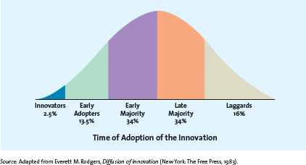

Innovators are those buyers who want to be the first on the block to have the new product or service. These buyers enjoy taking risks, are regarded as highly knowledgeable, and are not price sensitive.

early adopters. They generally don't like to take as much risk as innovators but instead wait and purchase the product after careful review. Early adopters tend to enjoy novelty and often are regarded as the opinion leaders for particular product categories. Opinion leaders and spread word to next group.

The early majority, which represents approximately 34 percent of the population, is crucial because few new products and services can be profitable until this large group buys them. If the group never becomes large enough, the product or service typically fails.Its members don't like to take as much risk and therefore tend to wait until “the bugs” are worked out of a particular product or service.

the late majority is the last group of buyers to enter a new product market; when they do, the product has achieved its full market potential. By the time the late majority enters the market, sales tend to level off or may be in decline.

Laggards make up roughly 16 percent of the market. These consumers like to avoid change and rely on traditional products until they are no longer available.¹⁶ In some cases, laggards may never adopt a certain product or service.

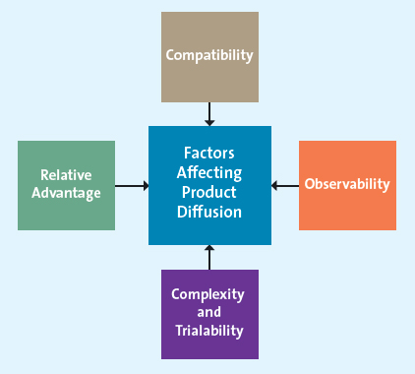
Factors Affecting Product Diffusion Speed

Relative Advantage If a product is perceived to be better than substitutes, then the diffusion will be relatively quick. Compatibility Most business professionals and executives have to make decisions in a timely fashion and be able to communicate their decisions in a timely manner also; they need real-time information to do this. How does it fit in their lifestyle?
Observability On the one hand, when products are easily observed, their benefits or uses are easily communicated to others, thus enhancing the diffusion process.
Complexity and Trialability Products that are relatively less complex are also relatively easy to try.

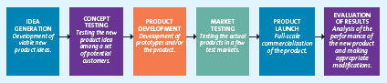

Idea Generation:
-employees, R&D, other firms, customers, suppliers, trade shows, partners, brainstorm, competitors
-Licensing For many new scientific and technological products, firms buy the rights to use the technology or ideas from other research-intensive firms through a licensing agreement. This approach saves the high costs of in-house R&D, but it means that the firm is banking on a solution that already exists but has not been marketed.
-Brainstorming One of the key characteristics of a brainstorming session is that no idea can be immediately accepted or rejected. The moderator of the session may channel participants' attention to specific product features and attributes, performance expectations, or packaging, but only at the end of the session do the members vote on the best ideas or combinations of ideas. Those four to eight ideas that receive the most votes are carried forward to the next stage of the product development process.
-Reverse engineering involves taking apart a competitor's product, analyzing it, and creating an improved product that does not infringe on the competitor's patents, if any exist.
-Prior studies have found that as much as 85 percent of all new business-to-business (B2B) product ideas come from customers.²² Because customers for B2B products are relatively few in number, firms can follow their use of products closely and survey them often for suggestions and ideas to improve those products.
-A particularly successful customer input approach is to analyze lead users, those innovative product users who modify existing products according to their own ideas to suit their specific needs. Manufacturers and retailers of fashion products often spot new trends by noticing how trendsetters have altered their clothing and shoes.

Concept Testing:
-Ideas with potential are developed further into concepts, which in this context refer to brief written descriptions of the product; its technology, working principles, and forms; and what customer needs it would satisfy.²⁸ A concept might also include visual images of what the product would look like. Concept testing refers to the process in which a concept statement is presented to potential buyers representative of the target market or users to obtain their reactions. These reactions enable the developer to estimate the sales value of the product or service concept, possibly make changes to enhance its sales value, and determine whether the idea is worth further development.
-Concept testing progresses along the research techniques described in Chapter 4. The firm likely starts with exploratory research, such as in-depth interviews or focus groups, to test the concept, after which it can undertake conclusive research through Internet or mall-intercept surveys. Video clips on the Internet might show a virtual prototype and the way the product or service works so that potential customers can evaluate it.³¹ In a mall-intercept survey, an interviewer would provide a description of the concept to the respondent and then ask several questions to obtain his or her feedback.
-The most important question pertains to the respondent's purchase intentions were the product or service be made available. Marketers also should ask whether the product would satisfy a need that other products currently are not meeting. Depending on the type of product or service, researchers might also ask about the expected frequency of purchase, how much customers would buy, whether they would buy it for themselves or as a gift, when they would buy, and whether the price information (if provided) indicates a good value. In addition, marketers usually collect some demographic information so they can analyze which consumer segments are likely to be most interested in the product.

Product Development:
-Product development or product design entails a process of balancing various engineering, manufacturing, marketing, and economic considerations to develop a product's form and features or a service's features. A prototype is the first physical form or service description of a new product, still in rough or tentative form that has the same properties as a new product but is produced through different manufacturing processes, sometimes even crafted individually.³²
-Product prototypes are usually tested through alpha and beta testing. In alpha testing, the firm attempts to determine whether the product will perform according to its design and whether it satisfies the need for which it was intended.³³ occur in the firm's R&D department
-In contrast, beta testing uses potential consumers, who examine the product prototype in a “real use” setting to determine its functionality, performance, potential problems, and other issues specific to its use.

Market Testing:
-Now it must test the market for the new product with a trial batch of products. Firms conduct premarket tests before they actually bring a product or service to market to determine how many customers will try and then continue to use the product or service according to a small group of potential consumers. One popular proprietary premarket test version is called Nielsen BASES. During the test, potential customers are exposed to the marketing mix variables, such as the advertising, and then surveyed and given a sample of the product to try.³⁷ After some period of time, during which the potential customers try the product, they are surveyed about whether they would buy/use the product again. This second survey indicates an estimation of the probability of a consumer's repeat purchase. From these data, the firm generates a sales estimate for the new product that enables it to decide whether to introduce the product, abandon it, redesign it before introduction, or revise the marketing plan.
-Test Marketing: A method of determining the success potential of a new product, test marketing introduces the offering to a limited geographical area (usually a few cities) prior to a national launch. Uses marketing mix.
-Sometimes customers skip all of these processes and just go with their gut.
-New products are placed in stores within one week of introduction, rather than the typical 8- to 12-week period. Since more sales data are collected in a shorter period of time than conventional test-marketing methods, first-year sales can be estimated after just 16 to 24 weeks in the test market.⁴² Once the market demand is estimated, the product is released nationally.

Product Launch:
-Then the firm finalizes the remaining marketing mix variables for the new product, including the marketing budget for the first year.⁴⁵PromotionFor products that are somewhat complex or conceptually new, marketers may need to provide for more consumer education about the product's benefits than they would for simpler and more familiar products. For technical products, technical support staff must be trained to answer any customer questions that may arise immediately after the launch.
-Place The firm must have an adequate quantity of products available for shipment and to keep in stock at relevant stores. The product offering should also be as complete as possible. I.e. toners at the store for printers, cases for phones
-Price The firm needs to ensure that it gets the price right. It is sometimes easier to start with a higher price and offer promotions (e.g., coupons, rebates) and then over time to lower the price than it is to introduce the new product at a low price and then try to raise it.
-Timing The timing of the launch may be important, depending on the product. i.e. fashion put out a bit before intended season, movies during the summer when kids are off

Evaluation of Results:
-postlaunch review to determine whether the product and its launch were a success or a failure and what additional resources or changes to the marketing mix are neededFirms measure the success of a new product by three interrelated factors: (1) its satisfaction of technical requirements, such as performance; (2) customer acceptance; and (3) its satisfaction of the firm's financial requirements, such as sales and profits

Product Life Cycle

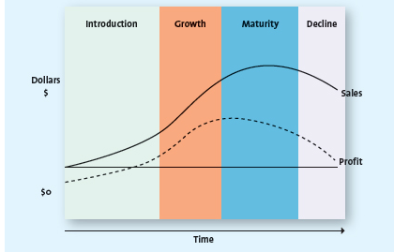

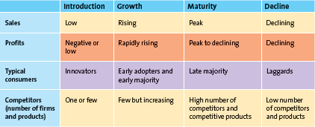

Introduction Stage:
-The introduction stage for a new, innovative product or service usually starts with a single firm, and innovators are the ones to try the new offering.
-The introduction stage is characterized by initial losses to the firm because of its high start-up costs and low levels of sales revenue as the product begins to take off. If the product is successful, firms may start seeing profits toward the end of this stage.

Growth Stage:
-The growth stage of the product life cycle is marked by a growing number of product adopters, rapid growth in industry sales, and increases in both the number of competitors and the number of available product versions.
Innovators start rebuying the product, and early majority consumers enter.
-Also during the growth stage, firms attempt to reach new consumers by studying their preferences and producing different product variations—varied colours, styles, or features—which enables them to segment the market more precisely.
-firms that have not yet established a stronghold in the market, even in narrow segments, may decide to exit in what is referred to as an “industry shakeout.”

Maturity Stage:
-The maturity stage of the product life cycle is characterized by the adoption of the product by the late majority and intense competition for market share among firms. Marketing costs (e.g., promotion, distribution) increase as these firms vigorously defend their market share against competitors.
-Price competition.
-Firms may pursue several strategies during this stage to increase their customer base and/or defend their market share, such as entering into new markets and market segments and developing new products or promotions.

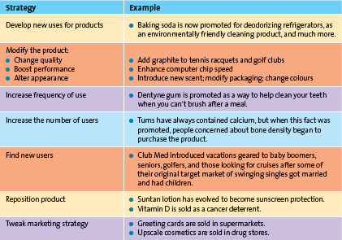
Strategies for Extending Life

-Develop new products
-entry into new markets or new market segments i.e. clorox making a toilet want, olay making facial wipes

Decline Stage:
-Firms with products in the decline stage either position themselves for a niche segment of diehard consumers or those with special needs, or they completely exit the market.

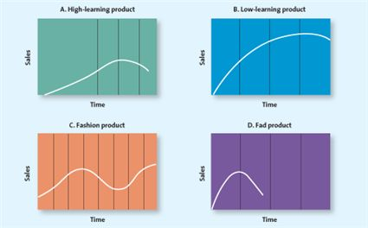
managers do not know exactly what shape each product's life cycle will take, so there is no way to know precisely what stage a product is in. If, for example, a product experiences several seasons of declining sales, a manager may decide that it has moved from the growth stage to the decline stage and stop promoting the product. As a result, of course, sales decline further. The manager then believes he or she made the right decision because the product continues to follow a predetermined life cycle.
-There are now rules for determining the stage it’s in.

Chapter 9
Marketers convert core customer value into an actual product. Attributes such as the brand name, features/design, quality level, and packaging are considered, though the importance of these attributes varies depending on the product.

The associated services in Exhibit 9.1, also referred to as the augmented product, include the nonphysical aspects of the product, such as product warranties, financing, product support, and after-sale service.

Types of Products: (Consumer)
-Specialty Products/Services Specialty products/services are products or services toward which customers show such a strong preference that they will expend considerable effort to search for the best suppliers.
-Shopping Products/Services Shopping products/services are products or services, such as furniture, apparel, fragrances, appliances, and travel alternatives, for which consumers will spend a fair amount of time comparing alternatives.
-Convenience Products/Services Convenience products/services are those products or services for which the consumer is not willing to spend any effort to evaluate prior to purchase. They are frequently purchased commodity items, usually purchased with very little thought, such as common beverages, bread, or soap.
-Unsought Products/Services Unsought products/services are products consumers either do not normally think of buying or do not know about.

The complete set of all products offered by a firm is called its product mix. The product mix typically consists of various product lines, which are groups of associated items, such as items that consumers use together or think of as part of a group of similar products.

Within each product line, there are often multiple product categories. A product category is an assortment of items that the customer sees as reasonable substitutes for one another.Each category within a product line may use the same or different brands, which are the names, terms, designs, symbols, or any other features that identify one seller's good or service as distinct from those of other sellers.A firm's product mix breadth (sometimes also referred to as variety) represents the number of product lines offered by the firmProduct line depth, in contrast, is the number of products within a product line.

Within each product category are a number of individual items called stock keeping units (SKUs), which are the smallest unit available for inventory control. For instance, within the toothpaste category, Colgate-Palmolive offers 49 Colgate SKUs that represent various sizes, flavours, and configurations of Colgate Herbal White, Colgate Total, and Colgate Fresh Confidence.The category depth is the number of SKUs within a category. Each SKU has its own unique product code (UPC) code as well.

It's bad to have too many product lines as well.

Changing Product Breadth
Increase Breadth Firms often add new product lines to capture new or evolving markets, increase sales, and compete in new venues Decrease Breadth Sometimes it is necessary to delete entire product lines to address changing market conditions or meet internal strategic priorities

Changing Product Line Depth
Increase Depth Firms may add new products within a line to address changing consumer preferences or pre-empt competitors while boosting sales.
-Reach new target markets by selling through other retailers. A firm may also add new products to its product line to serve new target segments.

Decrease Depth From time to time, it is necessary to delete product categories to realign resources.
-The decision to delete products is never taken lightly. Generally, substantial investments have been made to develop the brand and manufacture the products.

A very common and ongoing activity for many firms is the addition or deletion of SKUs in existing categories to stimulate sales or react to consumer demand.

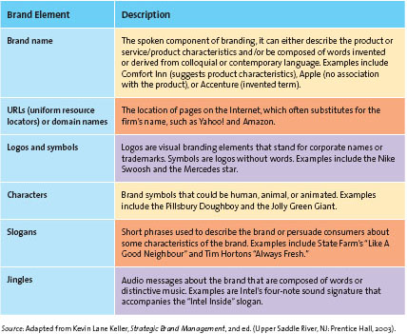

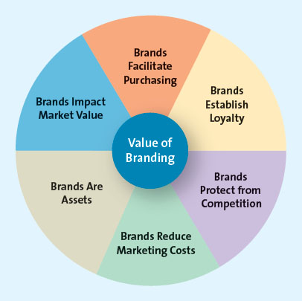

Brands Facilitate Purchasing Brands are often easily recognized by consumers and, because they signify a certain quality level and contain familiar attributes, brands help consumers make quick decisions.

Brands Establish Loyalty Over time and with continued use, consumers learn to trust certain brands.

Brands Protect from Competition and Price Competition Strong brands are somewhat protected from competition and price competition. Because such brands are more established in the market and have a more loyal customer base, neither competitive pressures on price nor retail-level competition is as threatening to the firm.

Brands Reduce Marketing Costs Firms with well-known brands can spend relatively less on marketing costs than firms with little-known brands because the brand sells itself.

Brands Are Assets Brands are also assets that can be legally protected through trademarks and copyrights and thus constitute a unique ownership for the firm. Firms sometimes have to fight to keep their brands “pure.”
-i.e. No counterfeit brands

Brands Impact Market Value Having well-known brands can have a direct impact on the company's bottom line. The value of a brand can be calculated by assessing the earning potential of the brand over the next 12 months;

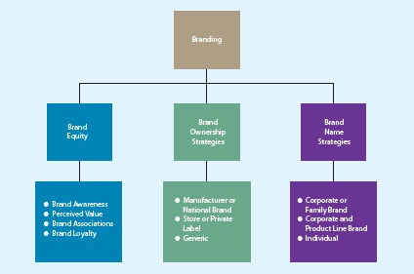

Brand Awareness Brand awareness measures how many consumers in a market are familiar with the brand and what it stands for, and have an opinion about that brand.
-More likely to buy if familiar.
-Some brands lose trademark status, such as trampoline, thermos, etc. because they're used so generically
-Marketers create brand awareness through repeated exposures of the various brand elements (brand name, logo, symbol, character, packaging, or slogan) in the firm's communications to consumers. Such communication media include advertising and promotions, personal selling, sponsorship and event marketing, publicity, and public relations

Perceived Value Perceived value, therefore, is the relationship between a product or service's benefits and its cost. Customers usually determine the offering's value in relationship to that of its close competitors. If they feel an inexpensive brand is about the same quality as a premium brand, the perceived value of the cheaper choice is high. Many customers tend to associate higher prices with higher quality, they want products to do what they were designed to do and be available at a reasonable price.

Brand Associations Brand associations reflect the mental links that consumers make between a brand and its key product attributes, such as a logo, slogan, or famous personality. These brand associations often result from a firm's advertising and promotion efforts.Associations with specific attributes help create differentiation between the brand and its competitorsFirms also attempt to create specific associations for their brands with positive consumer emotions, such as fun, friendship, good feelings, family gatherings, and parties.Brand personality refers to a set of human characteristics associated with a brand,²⁷ which has symbolic or self-expressive meanings for consumers.²⁸ Brand personality elements include male, female, young, old, fun-loving, and conservative, as well as qualities such as fresh, smooth, round, clean, or floral.

Brand Loyalty Brand loyalty occurs when a consumer buys the same brand's product or service repeatedly over time rather than buying from multiple suppliers within the same category.First, such consumers are often less sensitive to price. In return, firms sometimes reward loyal consumers with loyalty or customer relationship management (CRM) programsSecond, the marketing costs of reaching loyal consumers are much lower because the firm does not have to spendThird, a high level of brand loyalty insulates the firm from competition

Firms can manage brand loyalty through a variety of CRM programs. They create associations and clubs to provide a community feeling among loyal customers,Harley-Davidson's Harley Owners Group (H.O.G.), which the company formed in 1983 so Harley owners could meet with other owners in their communities.Other firms, such as airlines, hotels, long-distance telephone providers, credit card companies, and retailers, have developed frequent buyer/user programs to reward their loyal customers.

There are three basic brand ownership strategies: manufacturer or national brands, private-label or store brands, and generic brands Manufacturer brands are owned and managed by the manufacturer, are also known as national brands, and include Nike, Mountain Dew, KitchenAid, and Marriott. The majority of the brands marketed in Canada are manufacturer brands. By owning their brands, manufacturers retain more control over their marketing strategy, are able to choose the appropriate market segments and positioning for the brand, and can build the brand and thereby create their own brand equity.

Brands that are owned and managed by retailers, in contrast, are called private-label brands or store brands. Some manufacturers prefer to make only private-label merchandise because the costs of national branding and marketing are prohibitive, whereas other firms manufacture both their own brand and merchandise for other brands or retailers. Their popularity among consumers depends on several factors, including consumer preferences for a lower-cost brand and the trust consumers have in the store and its brand.
-such as president's choice and pink

Generic products are those sold without brand names, typically in commodities markets.
-i.e. nuts and bolts found randomly in hardware stores, or items found in bulk barn
-not entirely successful anymore so people put brands on them (Dole on bananas)

Corporate or Family Brand A firm can use its own corporate name to brand all its product lines and products, such as the General Electric Company, which brands its appliances prominently with the GE brand name. Similarly, all products sold through The Gap stores When all products are sold under one corporate brand or family brand, the individual brands benefit from the overall brand awareness associated with the family name.

Corporate and Product Line Brands A firm also could use combinations of the corporate and product line brands to distinguish its products. For example, Kellogg's uses its family brand name prominently on its cereal brands (e.g., Corn Flakes, Froot Loops, Rice Krispies) helping to maintain its powerhouse status on grocery store shelves.
-Kellogg's is written smaller than the actual name, but still there

ndividual Brands A firm can use individual brand names for each of its products. For example, in its house and home products line, P&G markets various detergent products (Tide, Gain, Cheer, Downy, Febreze), paper products (Bounty, Charmin), household cleaners (Mr. Clean, Swiffer), and dishwashing products (Cascade, Dawn, Joy). Furthermore, it markets brands in various other product lines, such as personal and beauty products (Olay, Old Spice, Secret, CoverGirl), health and wellness products (Pepto-Bismol, Oral-B, Puffs), baby products (Pampers, Luvs), and pet nutrition and care products (Iams).
-if one brand name suffers, another may not because they aren't really associated

Choosing a Name (1) The brand name should be descriptive and suggestive of benefits and qualities associated with the product. (2) The brand name should be easy to pronounce, recognize, and remember (3) The company should be able to register the brand name as a trademark and legally protect it. (4) For companies looking to global markets, the brand name should be easy to translate into other languages.

A brand extension refers to the use of the same brand name for new products being introduced to the same or new markets.The dental hygiene market, for instance, is full of brand extensions; Colgate, Crest, and Butler all sell toothpaste, toothbrushes, and other dental hygiene products.There are several advantages to using the same brand name for new products. First, because the brand name is already well established, such as the Dove example discussed in the chapter vignette, the firm can spend less in developing consumer brand awareness and brand associations for the new product

Second, if the brand is known for its high quality, that perception will carry over to the new product. Third, the marketing costs for a new product by an established brand are lower because consumers already know and understand the brand. Second, if the brand is known for its high quality, that perception will carry over to the new product. Third, the marketing costs for a new product by an established brand are lower because consumers already know and understand the brand. Fourth, when brand extensions are used for complementary products, a synergy exists between the two products that can increase overall sales. Fifth, successful brand extensions can result in cross category trial and boost sales because adopters of the new extended brand may try other products in the brand family they are not already using.

Second, if the brand is known for its high quality, that perception will carry over to the new product. Third, the marketing costs for a new product by an established brand are lower because consumers already know and understand the brand. Fourth, when brand extensions are used for complementary products, a synergy exists between the two products that can increase overall sales. Fifth, successful brand extensions can result in cross category trial and boost sales because adopters of the new extended brand may try other products in the brand family they are not already using. Brand dilution occurs when the brand extension adversely affects consumer perceptions about the attributes the core brand is believed to hold.
To prevent the potentially negative consequences of brand extensions, firms must consider the following caveats:
-Marketers should carefully evaluate the fit between the product class of the core brand and that of the extension.
-Firms should carefully evaluate consumer perceptions of the attributes of the core brand and seek out similar attributes for the extension because brand-specific associations are very important for extensions.
-Firms should refrain from extending the brand name to too many products and product categories to avoid diluting the brand and damaging brand equity.
-Firms should consider whether the brand extension will be distanced from the core brand, especially if the firm wants to use some but not all of the existing brand associations. i.e. Marriott owning Ritz-Carlton and people not knowing about it. Different names so that the same quality isn't expected.

Cobranding is the practice of marketing two or more brands together, on the same package or promotion. such as the CIBC Aeroplan Visa Card

Cobranding enhances consumers' perceptions of product quality⁵⁷ by signalling otherwise unobservable product quality through links between the firm's brand and a well-known quality brand.NutraSweet's claim to be a sugar substitute that was safe and left no aftertaste got a boost after both Coca-Cola and Pepsi started offering products that contained it. Tim Hortons found that its customers responded enthusiastically to its efforts to cobrand with Cold Stone Creamery ice cream in the United States and is now testing the concept in Canada.⁶² Cobranding may also fail if the brands' owners cannot resolve financial disputes about revenue or royalty sharing.

Brand licensing is a contractual arrangement between firms, whereby one firm allows another to use its brand name, logo, symbols, and/or characters in exchange for a negotiated fee.The firm that provides the right to use its brand (licensor) obtains revenues through royalty payments from the firm that has obtained the right to use the brand (licensee). Also includes using characters on things or putting brand names on other products.
-Generates additional revenue.
-For the licensor, the major risk is the dilution of its brand equity through overexposure of the brand, especially if the brand name and characters are used inappropriately.

Licensors also run the risk of improperly valuing their brand for licensing purposes or entering into the wrong type of licensing arrangement. For example, Marvel Entertainment's previous deals with movie studios for the use of its comic book characters were “undervalued,” because the firm took lump-sum licensing fees upfront rather than pegging its royalty fees to sales.In entertainment licensing, both licensors and licensees run the risk that characters based on books and movies will be only a fad. Moreover, the success or failure of merchandise based on movies is directly affected by the success or failure of the movie itself.

Packaging
Consumers typically seek convenience in terms of storage, use, and consumption.But packaging also serves to protect products. Wrappers and exterior cartons protect eggs from being broken and help prevent tampering with products such as toothpaste. Packaging provides the UPC label used by retail scanners as well as contents, directions, and other additional product information. The package can also be an important marketing tool for the manufacturer if it is used to convey the brand's positioning.
-Kids like cool packaging.
-Also eco-friendly packaging is big.

many innovations in design and materials have occurred in the past few decades.Stand-up, reclosable zipper pouches.Aluminum beverage cans.Aseptic packaging. Child-resistant/senior-friendly packages.Green and biodegradable packaging.

Labelling
In that they identify the product and brand, labels are also an important element of branding and can be used for promotion. The information required on them must comply with general and industry-specific laws and regulations, including the constituents or ingredients contained in the product, where the product was made, directions for use, and/or safety precautions.

Chapter 10

service: intangible customer benefits that are produced by people or machines and cannot be separated from the producer
customer service: specifically refers to human or mechanical activities firms undertake to help satisfy their customer’s needs and wants
  - good customer service adds value to products/services
  - the dependence and growth of service-oriented economies in developed countries is because:
    - it is less expensive for firms to manufacture in less developed countries
    - household maintenance activities, which many people used to perform by themselves, have become quite specialized (lawn care, food prep, laundry, house cleaning)
    - people place high value on convenience and leisure
    - as the Canadian population ages, the need for healthcare professionals also increases
Services Marketing Differs from Product Marketing
  - Intangible: services cannot be touched, tasted, or seen
    - difficult to convey benefits of services
    - difficult to promote as it cannot be shown directly
    - marketers use symbols and images to sell services and reinforce the benefit/value
  - Inseparable: services are inseparable from their providers as they are produced and consumed at the same time
    - service marketers try to get their customers directly involved
    - consumers rarely have the opportunity to try the service before purchase
  - Variable (inconsistent): the quality of a service varies in consistency as it is provided by humans who are fallible
    - ways to get over the variability:
    - micromarketing segmentation strategy: can customize a service to meet customers' needs exactly (it can be expensive to produce)
    - replace people with machines
  - Perishable (inventory): services cannot be held in inventory for future use
    - critical to match supply and demand
Providing Great Service: The Gaps Model
service gap: results when a service fails to meet the expectations that customers have about how it should be delivered
  - knowledge gap: reflects the difference between customers expectations and the firms perception of those expectations
    - understanding customer expectations
      - based on their knowledge and experiences
      - expectations vary according to the type of service
      - expectations vary depending on the situation
    - evaluating service quality
      - to meet or exceed customers expectations, marketers must determine what those expectations are
      - customers generally use five distance service dimensions to determine overall service quality:
        - reliability: the ability to perform the service dependably and accurately
        - responsiveness: the willingness to help customers and provide prompt service
        - assurance: the knowledge of an courtesy by employees and their ability to convey trust and confidence
        - empathy: the caring, individualized attention provided to customers
        - tangible: the appearance of physical facilities, equipment, personnel, and communication materials
      - service quality: customers perceptions of how well a service meets or exceeds their expectations
    - marketing research: understanding customers
      - provides a means to better understand consumers service expectations and their perceptions of service quality
      - extensive and expensive
      - integrated into a firms everyday interactions with customers
      - voice-of-customer (VOC) program: an ongoing marketing research system that collects customer inputs and integrates them into managerial decisions
      - zone of tolerance: the area between customers expectations regarding their desired service and the minimum level of acceptable service - that is, the difference between what the customer really wants and what he or she will accept before going elsewhere
        - evaluates how well firms perform on the "five service quality dimensions"
        - to define the zone of tolerance, firms ask a series of questions about each service quality dimension that relate to:
        - the desired and expected level of service for each dimension, from low to high
        - customers perceptions of how well the focal service performs and how well a competitive service performs, from low to high
        - the importance of each service quality dimension
      - straightforward & inexpensive to collect consumers perceptions of service quality at time of sale
      - another method is to use the customer complaint behavior

  - standards gap: pertains to the difference between the firms perceptions of customers expectations and the service standards it sets
    - achieving service goals through training
      - to deliver consistently high-quality service: firms must set specific, measurable goals based on customers' expectations; to help ensure that quality, the employees should be involved in the goal setting
      - service providers generally want to do a good job, but need to know what is expected of them
    - commitment to service quality
      - service providers take their cues from management

  - delivery gap: the difference between the firms service standards and the actual service it provides to customers
    - where the customer directly interacts with the service provider
    - empowering service providers - empowerment becomes more important when price points edge higher and services are more individualized
      - empowerment: in context of service delivery, means allowing employees to make decisions about how service is provided to customers
    - providing support and incentives - to ensure that service is delivered properly, management needs to support the service provider
      - managers and coworkers should provide emotional support to service providers by demonstrating a concern for their well-being and standing behind their decisions
      - the support that managers provide must be consistent and coherent throughout the organization
      - a key part of any customer service program is providing rewards to employees for excellent service
    - use of technology
      - facilitates delivery systems - benefits:
        - access a wider variety of services
        - a greater degree of control by the customer over the services
        - the ability to obtain information
        - increased efficiency in service processes through reduced servicing costs
        - develop a competitive advantage over less service-oriented competitors
      - kiosks are convenient - open longer hours and consistent for users

  - communication gap: refers to the difference between the actual service provided to customers and the service that the firms promotion program promises
    - promise only what you can deliver (or possibly even less, then they will be impressed)
    - customer expectations are created through promotions and can be managed when the service is delivered
Service Recovery
  - make amends with the customer and learn from the experience
  - effective service recovery efforts can significantly increase customer satisfaction, purchase intentions, and positive word of mouth
  - customers post recovery satisfaction levels usually fall lower than their satisfaction level prior to the service failure
  - effective service recovery entails:
    - listening to the customer
    - providing a fair solution
    - resolving the problem quickly
Listening to the Customer
  - service providers therefore should welcome the opportunity to be that sympathetic ear, listen carefully, and appear anxious to rectify the situation to ensure it doesn’t happen again
Finding a Fair Solution
  - perceptions of what "fair" means is based on their previous experience with other firms
  - distributive fairness: Pertains to a customer’s perception of the benefits he or she received compared with the costs (inconvenience or loss) that resulted from a service failure
  - procedural fairness: Refers to the customer’s perception of the fairness of the process used to resolve complaints about service.
Resolving Problems Quickly
  - the longer it takes to resolve a service failure, the more irritated the customer will become and the more people he or she is likely to tell about the problem
  - to resolve service failures quickly firms need: clear policies, adequate training for their employees, and empowered employees
  - firms must listen to customer complaints and act on them

Chapter 11
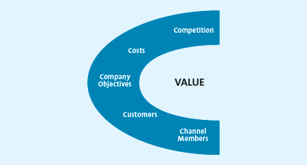

Company Objectives

Profit Orientationby focusing on target profit pricing, maximizing profits, or target return pricing.Firms usually implement target profit pricing when they have a particular profit goal as their overriding concern. To meet this targeted profit objective, firms use price to stimulate a certain level of sales at a certain profit per unit.maximizing profits strategy relies primarily on economic theory. If a firm can accurately specify a mathematical model that captures all the factors required to explain and predict sales and profits, it should be able to identify the price at which its profits are maximized.Other firms, less concerned with the absolute level of profits and more interested in the rate at which their profits are generated relative to their investments, typically use target return pricing and other pricing strategies designed to produce a specific return on their investment.

Sales Orientationbelieve that increasing sales will help the firm more than increasing profits. For example, a new health club might focus on unit sales or market share and therefore be willing to set a lower membership fee and accept less profit at first. In contrast, a high-end jewellery store, such as Tiffany & Co. might focus on dollar sales and maintain higher prices.Finally, some firms may be more concerned about their overall market share than about dollar sales per se because they believe that market share better reflects their success relative to the market conditions than do sales alone. A firm may set low prices to discourage new firms from entering the market, encourage current firms to leave the market, take market share away from competitors—all to gain overall market share.In all the above cases, profits are of lesser concern; the focus is on increasing sales.
-companies can gain market share simply by offering a high-quality product at a fair price, as long as they generate high-value perceptions among consumers.

Competitor Orientationthey strategize according to the premise that they should measure themselves primarily against their competition. Some firms focus on competitive parity, which means they set prices that are similar to those of their major competitors.competitors may be using value as part of their pricing strategies, so copying their strategy might provide value.

Customer Orientationexplicitly invokes the concept of value. Sometimes a firm may attempt to increase value by focusing on customer satisfaction and setting prices to match consumer expectations. Or a firm can use a “no-haggle” price structure to make the purchase process simplerFirms also may offer very high-priced, “state-of-the-art” products or services in full anticipation of limited sales. These offerings are designed to enhance the company's reputation and image and thereby increase the company's value in the minds of consumers.

Customers

Customers
§ Demand curve: shows how many units of a product or service consumers will demand during a specific period at different prices.
§ Prestige products or services: those that consumers purchase for status rather than functionality
§ Price elasticity demand: measures how changes in a price affect the quantity of the product is demanded; specifically, the ratio of the percentage change in quantity demanded to the percentage change in price
§ Elastic: refers to a market for a product or service that is price sensitive; that is, relatively small changes in price will generate fairly large changes in the quantity demanded.
§ Inelastic: refers to a market for a product or service that is price insensitive; that is, relatively small changes in price will not generate large changes in the quantity demanded.

Factors Influencing Price Elasticity of Demand
§ Income effect: refers to the change in the quantity of a product demanded by consumers due to a change in their income.
§ Substitution effect: refers to consumers’ ability to substitute other products for the focal brand, thus increasing the price elasticity of demand for the focal brand.
§ Cross-price elasticity: the percentage change in demand for product A that occurs in response to a percentage change in price of product B
§ Complementary products: products whose demand curves are positively related, such that they rise or fall together; a percentage increase in demand for one results in a percentage increase in demand for the other.
§ Substitute products: products for which changes in demand are negatively related; that is, a percentage increase in the quantity demanded for product A results in a percentage decrease in the quantity demanded for product B.
§ Variable costs: those costs, primarily labour and materials that vary with production volume.
§ Fixed costs: those costs that remain the essentially at the same level, regardless of any changes in the volume of production.
§ Total costs: the sum of variable costs and fixed costs

Break-Even Analysis
§ Break-even point: the point at which the number of units sold generates enough revenue to equal the total costs; at this point, profits are zero.
§ Contribution per unit: equals the price less the variable cost per unit, variable used to determine the break-even point in units.

Competition
§ Oligopolistic competition: occurs when only a few firms dominate the market.
§ Price war: occurs when two or more firms compete primarily by lowering their prices.
§ Monopolistic competition: occurs when there are many firms that sell closely related but not homogenous products; these products may be viewed as substitutes but are not perfect substitutes.
§ Pure competition: occurs when different companies sell commodity products that consumers perceive as substitutable; price usually is set according to the laws of supply and demand.

Channel Members
§ Grey market: employs irregular but not necessarily illegal methods; generally, it legally circumvents authorized channels of distribution to sell gods at lower prices than those intended by the manufacturer.

Other Influences on Pricing
§ The internet
§ Economic factors
§ Cross-shopping: the pattern of buying premium and low-priced merchandise or patronizing both expensive, status-oriented retailers and price oriented retailers.
Pricing Strategies
§ Cost-based pricing method: determines the final price to charge by starting with the cost, without recognizing the role that consumers or competitors’ prices play in the marketplace.
§ Competitor-based pricing method: an approach that attempts to reflect how the firm wants consumers to interpret its products relative to the competitors’ offerings.
§ Premium pricing: a competitor based pricing method by which the firm deliberately prices a product above the prices set for competing products to capture those consumers who always shop for the best or for whom price does not matter.
§ Value-based pricing method: focuses on the overall value of the product offering as perceived by consumers, who determine value by comparing the benefits they expect the product to deliver with the sacrifice they will need to make to acquire the product.
§ Improved value: represents an estimate of how much more (or less) consumers are willing to pay for a product relative to other comparable products.
§ Cost of ownership method: a value-based method for setting prices that determines the total cost of owning the product over its useful life.

New Product Pricing
§ Price skimming: a strategy of selling a new product or service at a high price that innovators are early adapters are willing to pay in order to obtain it, after the high-price market segment becomes saturated and sales begin to slow down, the firm generally lowers the price to capture (or skim) the next most price sensitive segment.
§ Market penetration pricing: a pricing strategy of setting the initial price low for the introduction of the new product or service, with the objective of building sales, market share, and profits quickly.
§ Experience curve effect: refers to the drop in unit cost as the accumulated volume sold increases; as sales continue to grow, the costs continue to drop, allowing even further reductions in the price.

Psychological Factors Affecting Value-Based Pricing Strategies
§ Reference price: the price against which buyers compare the actual selling price of the product and that facilitates their evaluation process.
§ External reference price: a higher price to which the consumer can compare the selling price to evaluate the purchase.
§ Internal reference price: price information stored in the consumer’s memory that the person uses to assess a current price offering-perhaps the last price he or she paid or what he or she expects to pay.
§ Everyday low pricing (EDLP): a strategy companies use to emphasize the continuity of their retail prices at a level somewhere between the regular, no sale price and the deep-discount sale prices their competitors may offer.
§ High/low pricing: a pricing strategy that relies on the promotion of sales, during which prices are temporarily reduced to encourage purchases.
§ Odd prices: prices that end in odd numbers, usually 9, such as $3.99.

§ Pricing Tactics: short-term methods, in contrast to long-term pricing strategies, used to focus on company objectives, customers, costs, competition, or channel members; can be responses to competitive threats (e.g., lowering price temporarily to meet a competitor’s price reduction) or broadly accepted methods of calculating a final price for the customer that is short term in nature.
§ Seasonal discount: pricing tactic of offering an additional reduction as an incentive to retailers to order merchandise in advance of the normal buying season.
§ Cash discount: tactic offering a reduction in the invoice cost if the buyer pays the invoice prior to the end of the discount period.
§ Advertising allowance: tactic offering a price reduction to channel members if they agree to feature the manufacturer’s product in their advertising and promotional offerings.
§ Listing allowance: fees paid to retailers simply to get new products into stores or to gain more or better shelf space for their products.
§ Quantity discount: pricing tactic of offering a reduced price according to the amount purchased; the more the buyer purchases, the higher the discount and, of course the grater the value.
§ Cumulative quantity discount: pricing tactic that offers a discount based on the amount purchased over a specified period and usually involves several transactions.
§ Noncumulative quantity discount: pricing tactic that offers a discount based on only the amount purchased in a single order.
§ Uniform delivered pricing: the shipper charges one rate, no matter where the buyer is located.
§ Geographic pricing: the setting of different prices depending on a geographical division of the delivery areas.
§ Price lining: consumer market pricing tactic of establishing a price floor and a price ceiling for an entire line of similar products and then setting a few other price points in between to represent distinct differences in quality.
§ Price bundling: consumer pricing tactic of selling more than one product for a single, lower price than what the items would cost sold separately; can be used to sell slow moving items, to encourage customers to stock up so they won’t purchase competing brands, to encourage trial of a new product, or to provide an incentive to purchase a less desirable product or service to obtain a more desirable one in the same.
§ Leader pricing: consumer pricing tactic that attempts to build store traffic by aggressively pricing and advertising a regularly purchased item, often priced at or just above the store’s cost.
§ Markdowns: reductions retailers take on the initial selling price of the product or service.
§ Size discount: the most common implementation of a quantity discount at the consumer level; the larger the quantity bought, the less the cost per unit.
§ Coupon: provides a stated discount to consumers on the final selling price of a specific item; the retailer handles the discount.
§ Rebate: a consumer discount in which a portion of the purchase price is returned to the buyer in cash; the manufacturer, not the retailer, issues the refund.

Legal Aspects and Ethics of Pricing
§ Loss leader pricing: loss leader pricing takes the tactic of leader pricing one step further by lowering the price below the store’s cost.
§ Bait-and-switch: a deceptive practice of luring customers into the store with a very low advertised price on an item (the bait), only to aggressively pressure them into purchasing a higher-priced item (the switch) by disparaging the low-priced item, comparing it unfavorably with the higher-priced model, or professing an inadequate supply of the lower-priced item.
§ Predatory pricing: a firm’s practice of setting a very low price for one or more of its products with the intent to drive its competition out of business; illegal under the Competition Act.
§ Price discrimination: the practice of selling the same product to different resellers (wholesalers, distributors, or retailers) or to the ultimate consumer at different prices; some, but not all, forms of price discrimination are illegal.
§ Price fixing: the practice of colluding with other firms to control prices.
§ Horizontal price fixing: occurs when competition that produce a sell competing products collude, or work together, to control prices, effectively taking price out of the decision process for consumers.
§ Vertical pricing fixing: occurs when parties at different levels of the same marketing channel (e.g., manufacturers and retailers) collude to control the prices passed on to consumers.

Chapter 12
Not complete at all.

Importance of Distribution
- Distribution channels, supply chain and logistics are related
  - Distribution channel: the institutions that transfer ownership of and move foods from the point of production to the point of consumption
  - Wholesalers: firms engaged in buying, taking title to, storing and physically handling goods in large quantities, then reselling the goods to retailers or industrial or business users
- Direct distribution: manufacturers deal directly with consumers
- Indirect distribution: one or more intermediary works with a manufacturer to provide goods and services
  - Push strategy: manufacturers focus on its promotion to convince suppliers to carry its product
  - Pull strategy: if channel members are reluctant to stock new products, promotional efforts are directed at consumers
- Multichannel distribution
  - Use a combination of both direct and indirect distribution channels
- Customer expectations
  - Knowing where target market customers expect to find their products
- Distribution Intensity
  - The number of supply chain members to use at each level of the supply chain
    - Intensive distribution: designed to get products into as many outlets as possible
    - Exclusive distribution: granting exclusive rights to sell to one or very few retail customers
    - Exclusive geographic territories: territories granted to one or very few customers by an manufacturer using an exclusive distribution strategy
    - Selective distribution: lies between exclusive and intensive distribution strategies; uses a few selected customers in a territory

Chapter 13
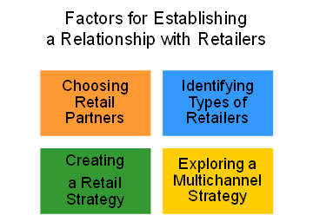
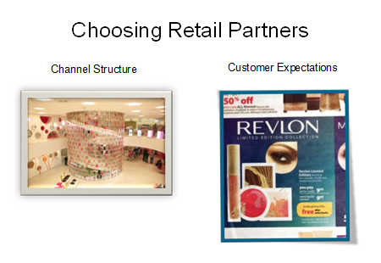

1. Channel Structure: degree of vertical integration, manufacturer’s brand, power of manufacturer and retailer
Ask students to describe what is meant by “degree of vertical integration”. This is discussed in chapter 12 and refers to a supply chain where the members act as a unified system.
Ask students how vertical integration effects a manufacturer who is introducing a new product and choosing a retail partner. Students will mention that if the manufacturer and retailer already have a relationship from previous products that the retailer will be more likely to accept the new product.
2. Customer Expectations: how manufacturers determine which retailers would be best for consumers and where consumers expect to find certain products

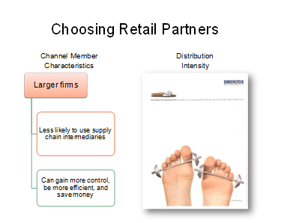

3. Channel Member Characteristics: Larger firms often find that by performing the channel functions themselves, they can gain more control, be more efficient, and save money.
4. Distribution Intensity
Ask Students: Why might Birkenstock choose an exclusive distribution intensity?
Answer: Birkenstock’s can only be purchased through certain retailers – this helps control conflict between retailers and gives the manufacturer better control. Some might argue that for products is the later stages of the product life cycle, it implies higher quality to the end consumer.

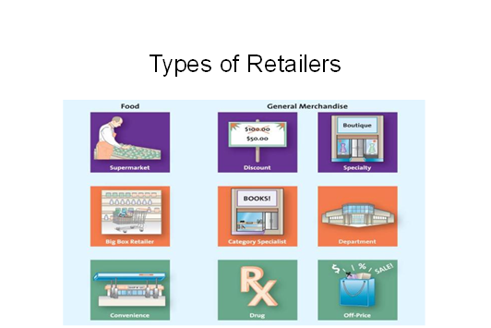

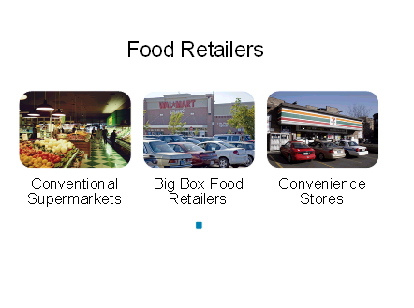

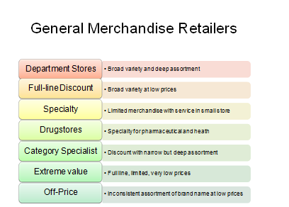

Multichannel retailing is the merging of retail operations in such a manner that enables the transacting of a customer via many connected channels. Channels include: retail stores, online stores, mobile stores, mobile app stores, telephone sales and any other method of transacting with a customer. Transacting incudes browsing, buying, returning as well as pre and post sale service.
Multichannel retailing is often said to be dictated by systems and processes when in fact it is the customer that dictates the route they take to transact. Systems and processes within retail simply facilitate the customer journey to transact and be served. Pioneers of multichannel retailing include Macy's, Next PLC, John Lewis and Neiman Marcus. The pioneers of multichannel retail built their businesses from a customer centric perspective and served the customer via many channels long before the term 'multichannel' was used. Recent variations of the term include omni-channel.

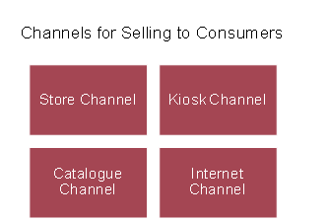

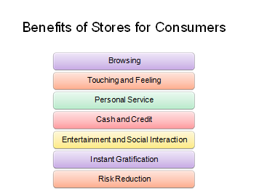

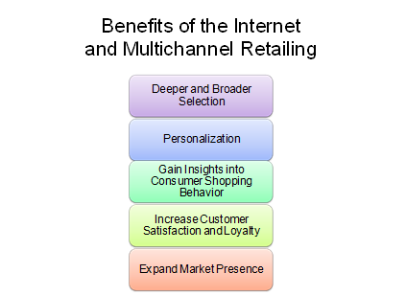

Shopping over the Internet provides the convenience offered by catalogs and other nonstory formats. However, the Internet, compared with store and catalogue channels, also has the potential to offer a greater selection of products and more personalized information about products and services in a relatively short amount of time. It also offers sellers the unique opportunity to collect information about how consumers shop—information that they can use to improve the shopping experience across all channels.
The Internet has radically altered the retail marketplace. Many traditional bricks-and-mortar retailers create synergy between online and traditional retailing. Multi-channel customers buy more than single channel customers.
Ask students: Have you ever started shopping online, then visited the store to make the actual purchase? What kind of product did you buy using this method?
The Internet has also opened opportunities to sell beyond a limited geographic region.
Ask students: Have you ever purchased something online from a retailer that does not have a physical store in your area?
This will hopefully identify niche retailers that have expanded their trade area by using the Internet.

Internet improves multichannel shopping by allowing for easy research.

Ask students what information Home Depot might gather research from web visits and how they would use it? Students might mention that they will search for products that the company does not currently stock. They might see products that consumers browse often but purchase little. For instance, they might look for lamps quite often but this is a low seller for Home Depot? What is it about the product that makes people come looking and leave not buying?

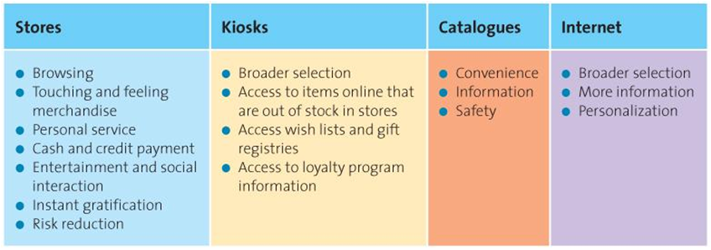

Creating Retail Strategy Using Four P's
Product: Provide assortment for customers.
Price: Defines the value of both the merchandise and the service provided.

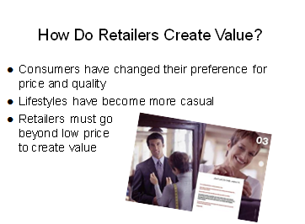

The consumer experience includes personalization and involvement in creating unique products.

Promotion: Retailers use a wide variety of promotions, both within their retail environment and through mass media
Place: Convenience is a key ingredient to success

In retailing there are two aspects to “place.” The first is location, and the second is supply chain management. Both are important.
Location is important because it is one of consumers’ most important criteria in choosing a retailer and it is a very long-term investment.

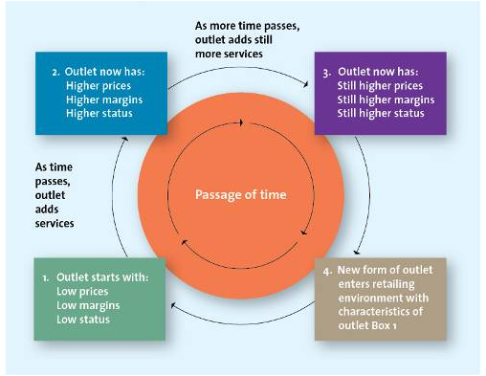
The Wheel of Retailing

Chapter 14
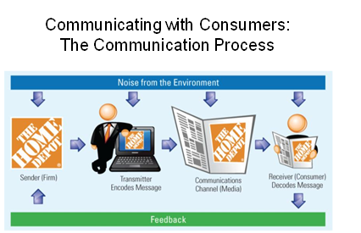

New media options fragment communications and make it more difficult and complex to reach the desired target audience.
Ask students: What media do you use on a daily basis?
This should lead to a discussion of new and alternative media.
Marketers must understand how the communication process works and identify possible communication breakdowns.
Group activity: Play the game of telephone. Start with a short message, verbally pass it around the room, and see what emerges.
Sample phrase: I caught the train heading for Richmond but went to Richland instead.

Is It Deception to Disguise
the Message Sender?
Marketers use websites to promote movies and TV shows
Some sites do not identify that they are promotional tools
Is this deception?

Ask students: Should marketers be required to disclose the purpose of their marketing communications? Do these messages deceive consumers?
There is no correct answer to these questions; the creators of these sites argue that confusion and the resultant buzz ARE the point. So why should they tell consumers and ruin the fun?

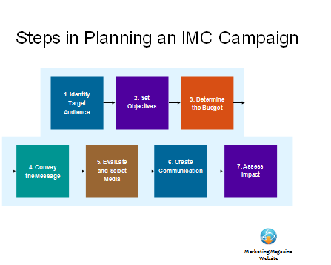

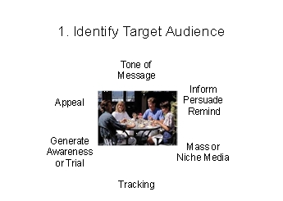
Just as the target market is at the center of all marketing mix decisions, the target audience is at the center of all advertising-related decisions.

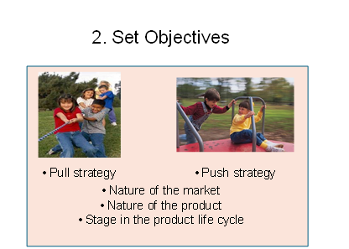

The advertising plan must be specific to the identified target audience and include the strategic objectives and tactics to be used.
Objectives can be short-term (generate inquiries, increase awareness, prompt trial) or long-term (increase sales, market share, loyalty) and may aim to inform, persuade or remind customers. (These objectives are discussed in more detail in Chapter 15.)

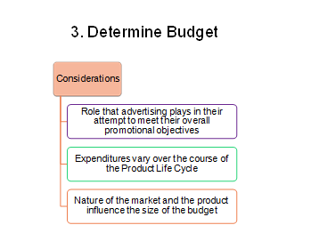

Setting the promotional budget is not easy, and advertising often is the largest single expenditure in the promotional budget. Thus, firms must carefully weigh the benefits of advertising versus other communications when deciding how much to allocate.

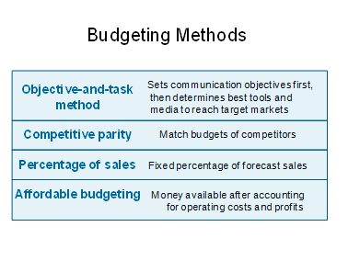
Many IMC elements require significant expenditures, and firms are reluctant to invest in marketing communications without some guarantee of return.

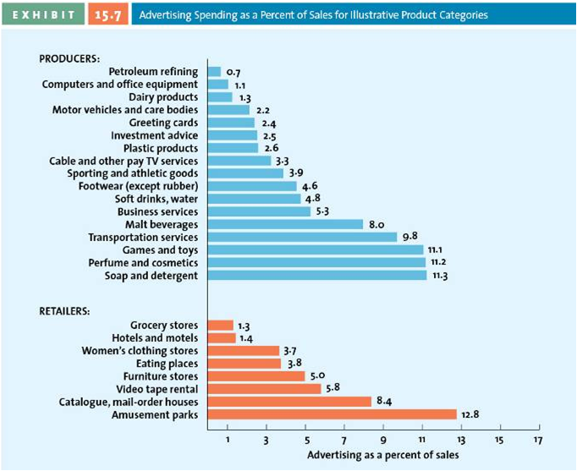

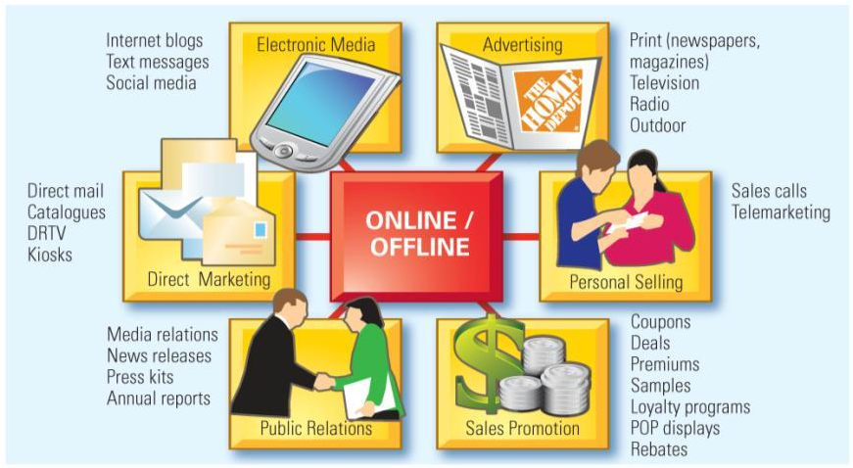
The goal of IMC is to ensure all the various marketing mix elements work together to deliver a consistent message. Therefore, IMC takes the best of each communications medium and combines it to achieve the most effective marketing communications campaign possible. There are six key IMC tools, most of which can be used in both online and offline environments. Each tool can range from being passive to very interactive. To get the right message to the right audience through the right tool and medium, an IMC planner must understand how each medium communicates and how to combine it with other media to generate the most impact.

Advertising:
-Most visible element of IMC
-Extremely effective at creating awareness and generating interest

Personal Selling:
-Some products require the help of a salesperson
-More expensive than other forms of promotion
-Salespeople can add significant value, which makes the expense worth it
-this form of IMC works best when the purchase is complicated, because the salesperson can customize the communication to meet the needs of that specific buyer and purchase situation, which other IMC elements cannot.

Sales Promotions:
-Can be aimed at both end user consumers or channel members
-Used in conjunction with other forms of IMC
-Can be used for both short-term and long-term objectives

Direct Marketing
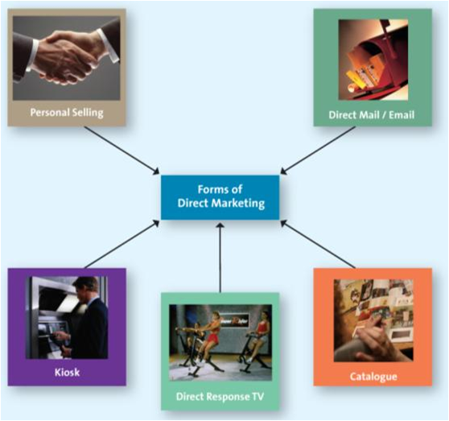
As advertising has declined as a percentage of the total communications budget, direct marketing has increased. Direct marketing is easily personalizable. The growth of databases has fueled its growth and new technologies have enabled new channels.
Ask students: What characteristics of direct marketing might explain this increased popularity? Direct marketing allows marketers to personalize their message. This enables marketers to communicate with an audience that is more likely to respond to their efforts.

Note: While all forms of direct marketing are shown, the section that follows focuses on direct mail, catalogues, direct response television, kiosks, and internet or electronic marketing. Personal selling and telemarketing are addressed in Chapter 15.

Direct Marketing Characteristics:
Annual growth rates outstrip
retail sales
One of the fastest-growing
forms of retailing with $51 billion
in annual sales
Four defining characteristics:
targeted
motivates an action
measurable
can provide information for a
marketing database

Forms of Direct Marketing:
-Direct Mail: targeted, printed communication sent to a prospective consumer’s mailbox
-Catalogues: hard copy and online welcomed in 80% of Canadian homes
E.g. Sears, Ikea, and Business Depot
-DRTV: short television commercials and/or infomercials, strong call to action via 1-800 number, mail or website
For example, Canadian Blood Services Save a Life campaign
-Kiosks: Facilitate service delivery, e.g. airline ticket printing, Sell services and products to consumers, e.g. Dell, Virgin Mobile, Hallmark

Online Marketing:
-Websites
-Blogs
-Social Media

The Internet has radically altered the retail marketplace. Many traditional bricks-and-mortar retailers create synergy between online and traditional retailing. Multi-channel customers buy more than single channel customers.
Ask students: Have you ever started shopping online, then visited the store to make the actual purchase? What kind of product did you buy using this method?
Ask students: What problems might firms that use text messaging to disseminate marketing communications face?
Answer: There may be a backlash against the firm and the wireless provider if consumer phones are constantly flooded with such messages.
Ask students: How would you like to receive advertising text messages?
Answer: A lot of folks do not want such messages. However, the instant-messaging generation is likely to be much more tolerant about it.

Social media is media content distributed through social interactions. Three major online facilitators of social media are YouTube, Facebook, and Twitter.

Public Relations:
“Free” media attention
Importance of PR has grown as cost of other media has increased
Consumers becoming more skeptical about marketing, PR becoming more important

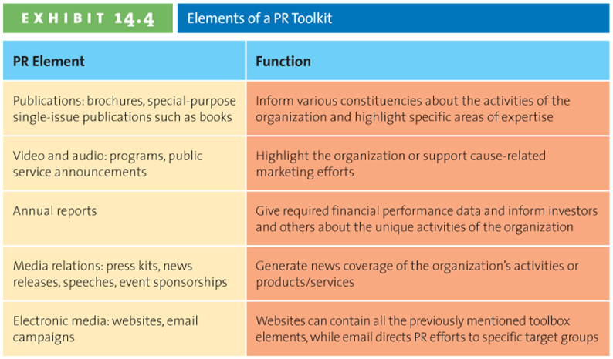

- Convey the Message

The USP concept conveys core benefits to the target audience. The best USPs stand the test of time; consider examples such as those on the slide.
Ask students: Do you believe these will stand the test of time?
Nokia has been using “connecting people” for a long time; however Boost Mobile is using a popular slang phrase that is more likely to become dated and will probably have to be changed.

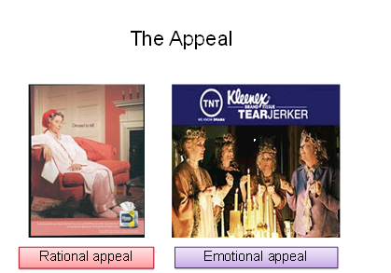

Appeals depend on the target audience, chosen media, and type of product/service. Each appeal persuades in different ways. Whereas rational appeals are more cognitive and persuade using rational thought, emotional appeals persuade by triggering an emotional response rather than offering rational arguments.

Informational appeals are more cognitive and persuade using rational thought.
Emotional appeals persuade by triggering an emotional response rather than offering rational arguments.

- Evaluate and Select Media

-Media Planning
-Media Mix
-Media Buy

The ability of any one media outlet to reach a mass audience is declining due to the fragmentation of media and the proliferation of new media outlets. This trend represents a double-edged sword, because fragmenting media have also allowed for very fine targeting in media buys.

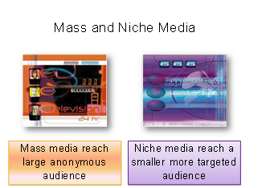

Often firms will use mass media to reach a broad audience with a product message and then choose specific niche media to customize that same message for various audiences. In the McDonald’s Case in Point in chapter 17 we discussed how McDonald’s is using both mass and niche media.

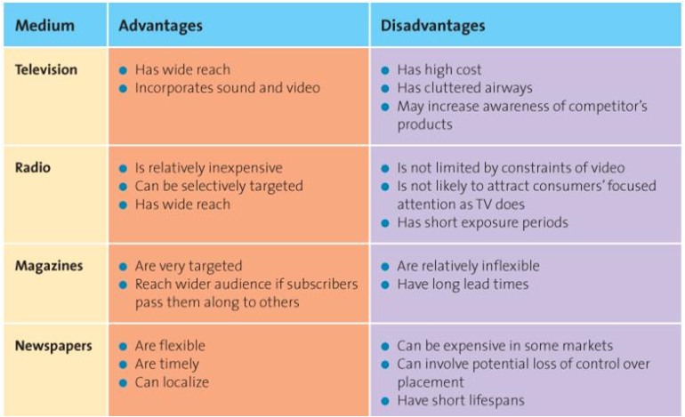

For example most people listen to radio in their cars, often by themselves. Radio is considered a more personal medium, thus marketers often use ads that employ dialogues. This allows the person to place themselves in the conversation. This same technique cannot be used in print.

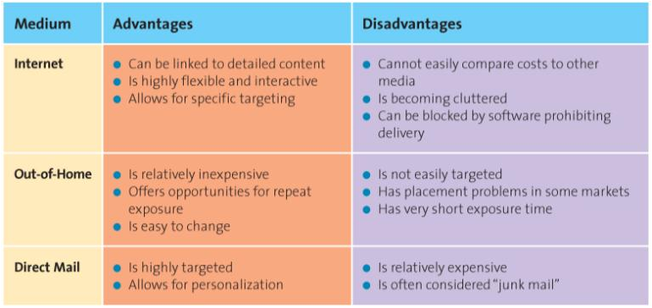

Determine the Advertising Schedule:
-Continuous
-Flighting
-Pulsing

Every advertising campaign has a set duration, and during that period, marketers must determine how often and when to show the ads.
Ask students: In a media buy when would each strategy be employed?
For a frequently purchased good such as soda, most firms use a continuous strategy. A flighting schedule is often used for seasonal goods since they are only advertised during certain times of the year. A pulsing schedule is used by firms who have certain fluctuations in their demand and need to increase advertising during the periods of high or low demand.

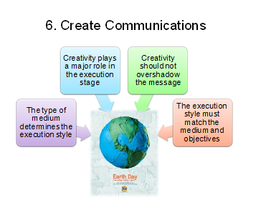
Ads attempt to make maximum use of the medium’s ability to deliver the message.
Discuss the benefits and limitations of various media. For example, television enables advertisers to combine imagery, movement, and music, whereas radio must rely solely on sound to deliver the message.

- Assess Impact Using Marketing Metrics

-Pretesting
-Tracking
-Protesting

Results: Measuring IMC Success
-Understand desired outcome at outset
-Short-term or long-term
-Should be explicitly defined and measured:
-Frequency
-Reach
-Gross Rating Points
-Web Tracking

It depends on the IMC objective. If the objective is to create awareness for a new product, then the firm would measure increases in customer knowledge and awareness. If it were to generate sales, like an ad in the paper, then sales would be the objective measure.

Every communication may be measured in terms of reach and frequency. Remind students that because of the lagged effect, marketers must not only expose the target audience to the message but also ensure that it has multiple opportunities to view it. This combined measure is GRP. Technology has introduced a host of new products for tracking online communications, as well as new communication formats.
Group activity: List the types of information firms might gather from Web-tracking software, click-through tracking, online couponing, and online referrals. What can firms do with this information? Many firms use this type of information in direct mail or other campaigns, it can also be used to customize the website and to build a network of buyers that are interlinked. Answer: Firms can use this type of information to better understand the consumer decision process and, their purchase patterns. This information can used to redesign the website, develop loyalty programs, and direct mail/e-mail campaigns.

Search Engine Marketing:
-Clicks
-Impressions
-Click Through Rate
-Return on Investment

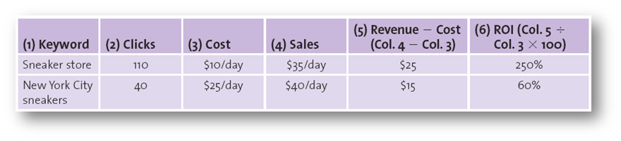
He can see his total cost in column 3 and the sales from his adwords in column 4. The ROI in column 6 is higher for “sneaker store” due to its lower cost even though the sales were a bit lower.

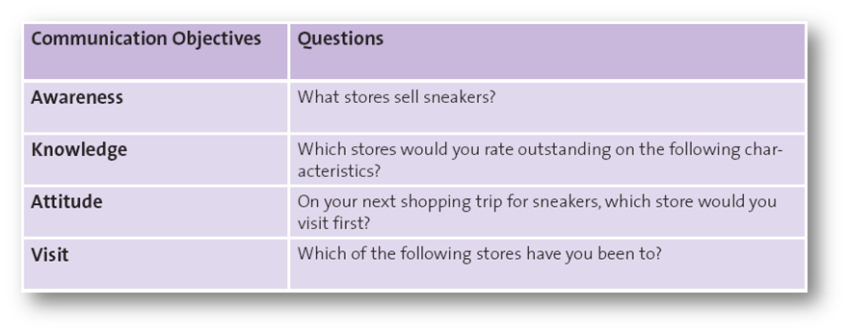

Chapter 15
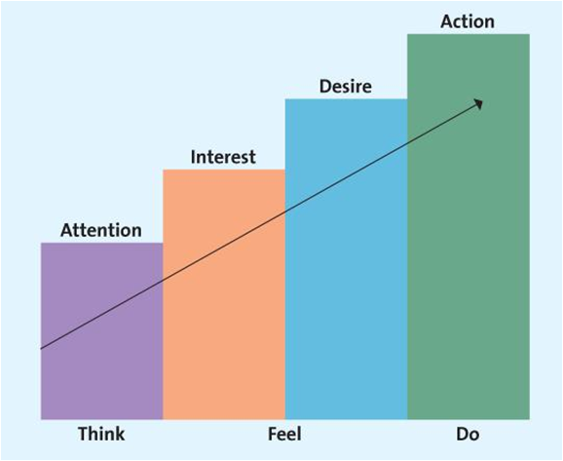

AIDA

The AIDA model provides a basis for understanding how marketing communications works. Consumers move through a readiness continuum. At each stage they need information to help them progress to the next stage. The objective of some IMC campaigns may primarily be to generate awareness (e.g. new technology such as BluRay) while other campaigns aim to have consumers buy a new product (e.g. iPod Touch.) Each IMC tool can be used to move consumers through a buyer readiness continuum in different ways. For example, advertising may do a good job of creating awareness and even knowledge for a company that offers marketing consulting services but it may require a call from a sales person at that company to convince a small business, new start-up venture or entrepreneur to enlist the services of that consulting company.
Ask students to pick a product. The decision to buy this product must be somewhat complex. Then walk them through AIDA using the accompanying slides.

Awareness:
-Senders first must gain the attention of the consumers
-A multichannel approach increases the likelihood the message will be received

Interest:
-After the customer is aware, they must be persuaded.
-The customer must want to further investigate the product/service.

Other than purchase, what can IMC prompt consumers to do?
Possible answers include behavioral changes (don’t drink and drive), attitude changes (that product is high quality), or physical actions (pick up the phone, log on to the Website, volunteer).

Desire:
-I like it, I want it.
-Goal of subsequent IMC messages should move the consumer from like to want.

Action:
-Purchase is just one type of action.

Lagged Effect:
-Advertising does not always have an immediate impact.
-Multiple exposures are often necessary.
-Difficult to determine which exposure led to purchase.
-Delayed response to a marketing communication campaign.

Advertising:
-Paid message
-Delivered through media
-Must have identifiable source
-Designed to persuade
-Technically, word of mouth is not advertising

Advertising Objectives:
-Inform
-Persuade
-Remind

Informative Advertising:
-Early in PLC, firms use informative advertising to educate consumers about the product/service.

Persuasive Advertising:
-Generally occurs in the growth and early maturity stages of the PLC when competition is most intense
-In the later stage of the PLC may be used to reposition an established brand
-Use to motivate to take action

Reminder Advertising:
-After the products have gained market acceptance
-Top-of-the-mind-awareness
-Usually in maturity stage and reminding.

Focus of Advertisements:
-Institutional Advertisements
-Product-Focused Advertisements

Social Marketing:
-Public Service Advertising (PSA)
-Under Canadian Radio-Television and Telecommunications Commission rules broadcasters must devote a specific amount of free airtime to PSAs
-Raise awareness of public welfare issues and receive free airtime

Regulatory and Ethical Issues:
-Messages with an Economic Motivation
-Must be fact based
-Examples: Advertising and direct marketing
-Messages with no economic motivation
-Protected under the Charter of Rights and Freedoms
-Example: PR

Most marketing communications have an economic motivation, so they do not have the same level of protections as non-economically motivated communications. The first is regulated, meaning that the firm engaging in it is responsible for the contents of the message.

You might encourage students to discuss the implications of Charter of Rights and Freedoms rulings regarding what speech is regulated and what is not.

Puffery: Unlike many European countries, puffery is legal in Canada. Generally these claims are so outrageous that no rational consumer would believe them.

Sales Promotions:
-Can be targeted at either the end user consumers or channel members.
-Can be used in either push or pull strategies.

Remind students that as advertising has decreased as a portion of total marketing communications budgets, sales promotions have increased. Promotions can be used to stimulate sales by either the end user consumers or to stimulate channel members to sell more of a given product/service. If focused on the end user, the promotion is using a “pull strategy.” If focused on channel members , it is using a “push strategy.”

Types of Consumer Sales Promotion:

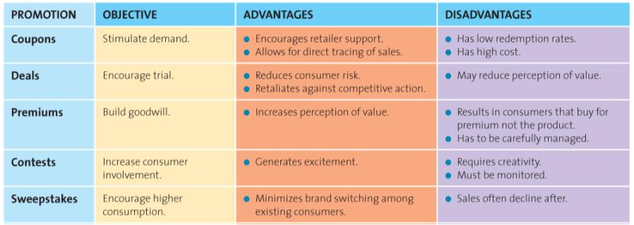

Sales promotions occur either in conjunction with an advertising campaign or as a stand-alone component of a marketing communications plan. In either case, they must be consistent with the brand image.

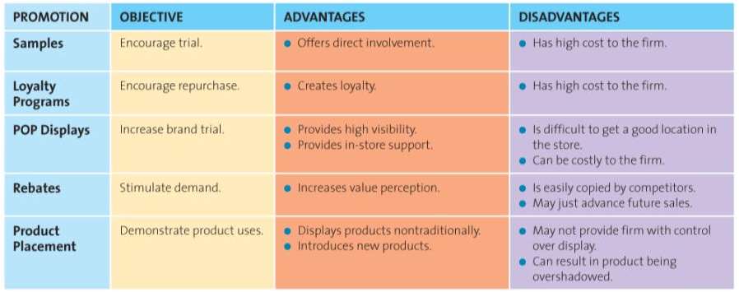

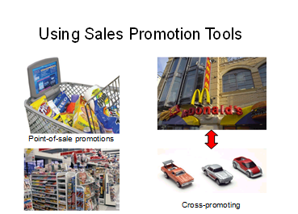

Pop-Up Beauty

Short term (30 days) store at Bloor & Yonge
Focus on Pantene, Cover Girl, Olay, Nice’n Easy, Crest and Venus brands
Over 12,000 visitors and 4,000 hair and make-up consultations

Types of Trade Sales Promotion:
-Discounts and Allowances
-Co-Operative Advertising
-Salesforce Training

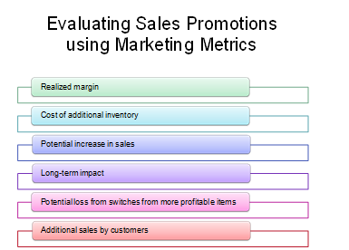

The Scope and Nature of Personal Selling:
-Internet
-Telephone
-Face-to-Face
-Teleconference

Professional Selling as a Career:
People love the lifestyle
There is a lot of flexibility
There is a lot of variety in
the job
Can be very lucrative, among the highest–paying careers for college graduates
Very visible to management, good for promotions

Personal Selling and Marketing Strategy:
Can customize the message for a specific buyer
Assists in creating strong supply chain relationships
Increased customer loyalty through relationship selling
Gather research input from customers
Crucial to the success of CRM

How does the sales force create value for the firm through relationship selling? Through relationship selling the sales force: focuses on building long term customer relationships, contributes to building customer loyalty, assists the firm in identifying new opportunities with existing customers.

The Value Added by Personal Selling:
-Salespeople educate and provide advice
-Salespeople save time and simplify buying

The sales force also simplifies buying by helping the customer understand and evaluate various choices.
For many products, the sales force educates customers and advises them about the best products/services to meet their needs.

Personal Selling Process:

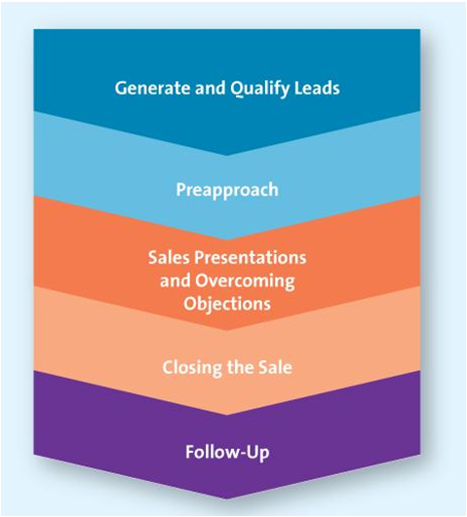

Step One: Generate and Qualify Leads

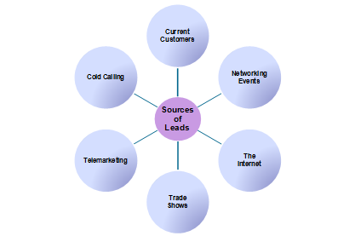

-Best success is through other people. "Often the best source of new customers are other people"

Step Two: Preapproach
-Extend the qualification procedure
-Set goals for what is to be accomplished
-A qualified lead requires a meeting
-Need to have investigated the customer's business and defined how the customer can benefit from the firm's product/services

Step Three: Sales Presentation and Overcoming Objections
-The presentation
-Handling objections

Step Four: Closing the sale
-Getting the order
-Often most stressful part
-A no one day may be the foundation for a yes another
-ABCs: Always Be Closing

Step Five: Follow Up
Five Service Quality Dimensions:
-Reliability
-Responsiveness
-Assurance
-Empathy
-Tangibles

-Just beginning of relationships.
-Telephone, email, person.

Aligning the Personal Selling Process with the B2B Buying Process:
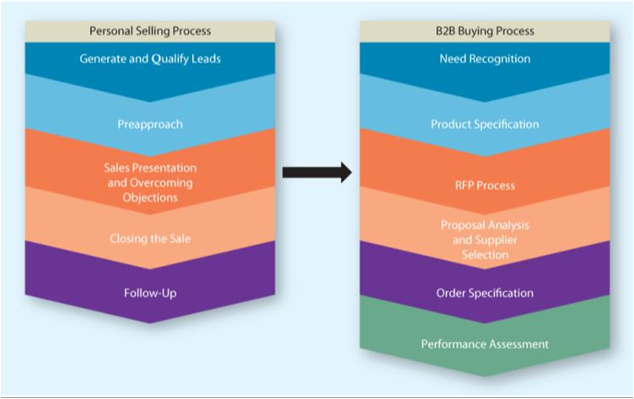

The B2B process must align closely with the selling process. A seller, for instance, shouldn’t be trying to close a deal when the buyer is just determining the product specifications.

Impact of Technology on Personal Selling:
Instant access to their customers
Access to customer research and information
Training programs are more effective, easier to operate, less expensive
Less time on order tracking

Managing the Sales Force:
Sales force structure
Company sales force vs. manufacturer’s reps
Recruiting and selecting salespeople
Sales training
Motivating and compensating salespeople
Evaluating salespeople

Sales management plans, directs, and controls personal selling activities, from recruitment to evaluation.

Chapter 16
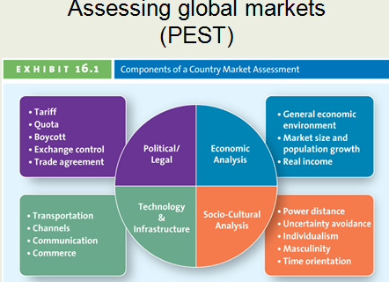

Screen clipping taken: 10/12/2012 9:38 PM

Political-legal environment: Do any legal restrictions complicate entering the market?
Economic environment: What is the state of the nation’s economic health?
Social-cultural environment: How do cultural factors affect business opportunities?
Technological environment: To what degree are technological innovations used by consumers in the market?

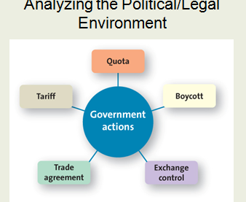

Screen clipping taken: 10/12/2012 9:40 PM

Including nongovernmental organizations.

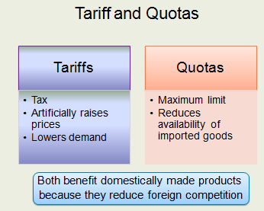

Screen clipping taken: 10/12/2012 9:40 PM

Boycott:
Dissatisfied global consumers
Voiced dissatisfaction with U.S. war policy
Avoidance of U.S. products and services
How do firms respond to these actions?

General Agreement on Tariffs and Trade (GATT)
World Trade Organization (WTO)

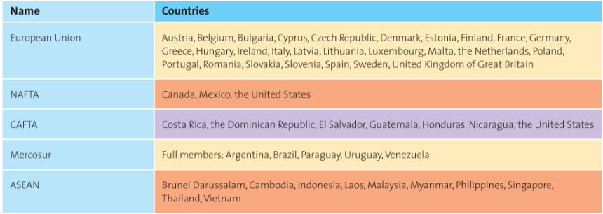

The European Union

Monetary and Trade Union
Euro (not in the UK)
Membership consists of Western & Eastern European countries
Turkey most recent petitioner

The conversion to the Euro presented serious concerns for marketers, most of which have been resolved. But in France, retailers still list prices in both Euros and the now defunct French Franc, which allows consumers, especially older consumers, to make better purchasing decisions. Since the Euro is used across all EU countries, it makes pricing a challenge. Many items do not sell for the same price across the EU. Will different Euro prices irritate consumers? However, having one currency across all EU countries does facilitate trade. For instance, tourists across the EU find it easier to gauge value when everything is priced in Euros.

Analyzing the Economic Environment:
Three parts

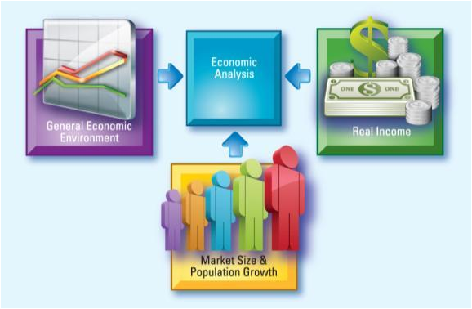

General Economic Environment: gross domestic product, gross national income (includes the economic impact of firms that earn income from their global operations), purchasing power parity (Big Mac index), human development index (people's ability to afford subsistence)
-Some Western countries have shortages of population.
-Although population and population growth may be important criteria for marketers to consider when entering a market, it must be considered along with other factors such as buying power and income.
-Successful firms often make smaller products so other countries can better afford them.
-Firms can make adjustments to an existing product or change the price to meet the unique needs of a particular country market.

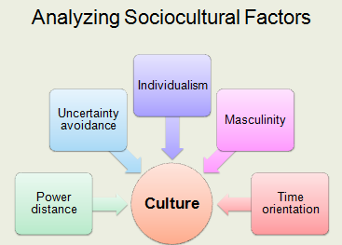

Screen clipping taken: 10/12/2012 9:53 PM

Perhaps no other aspect of globalization has posed more difficulties to marketers than culture. Outsiders often have trouble understanding the detailed meanings associated with proper communication in a foreign culture.

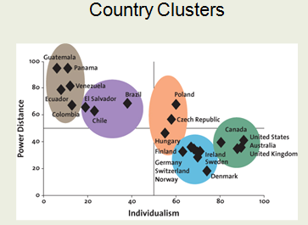

Screen clipping taken: 10/12/2012 9:54 PM

Hofstede's cultural dimensions.

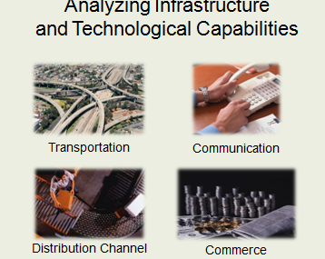

Screen clipping taken: 10/12/2012 9:55 PM

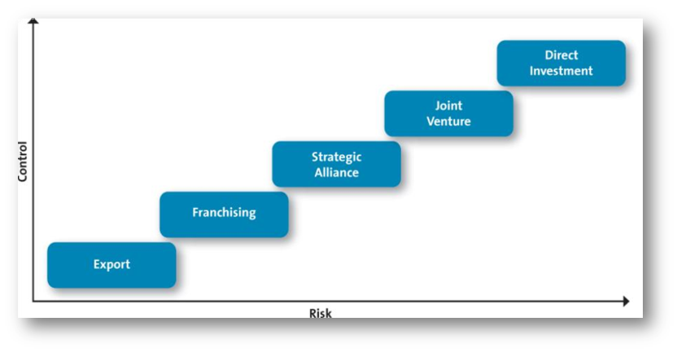

Choosing a Global Marketing Strategy:
-Cultural Nuances
-Subcultures
-View of product and consumer role
-Different positioning
-Adaptation
-Single positioning strategy

The Global Marketing Mix:
Product of Service Strategies
-Sell the same product or service in both the home country market and host country
-Sell a product or service similar to that sold in home country but include minor adaptations
-Sell totally new products or services

-Products at the extreme ends of high tech or high touch (luxury) are easy to standardize. But those in the middle need to adapt.

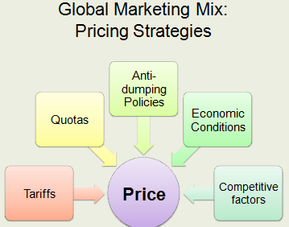

Screen clipping taken: 10/12/2012 10:18 PM

Global Marketing Mix:
Global Distribution Strategies:
Some global channels are very long and complex.
Consumer shop local small local stores.
Suppliers must be creative in delivering to these outlets.

Global Marketing Mix:
Global Communication Strategies:
-Literacy levels vary by country
-Firms choose whether to adapt to language differences
-Cultural and religious differences also matter

Ethical Concerns: Waste Management
80/20 rule: 80% of waste created by 20% of the population
Developing countries don't manage well
According to the author and commentator Thomas Friedman, the next global growth industry will be green industries.

Ethical Concerns: Global Labour Issues
-Fair wages
-Working conditions
-Child labour

Global firms must address the issue of who produces their products—literally, factory workers in developing countries. Most manufacturers do not own the plants in which workers create their goods and therefore must negotiate with factory owners to bring the factory into compliance with global labour standards. Many firms are partnering with labour advocates to improve working conditions and wages.

Ethical Concerns: Impact on Host Country Culture
Cultural Imperialism:
-Active, formal policy
-Subtle, general attitude

