Chapter 9: Product, Branding, And Packing Decisions
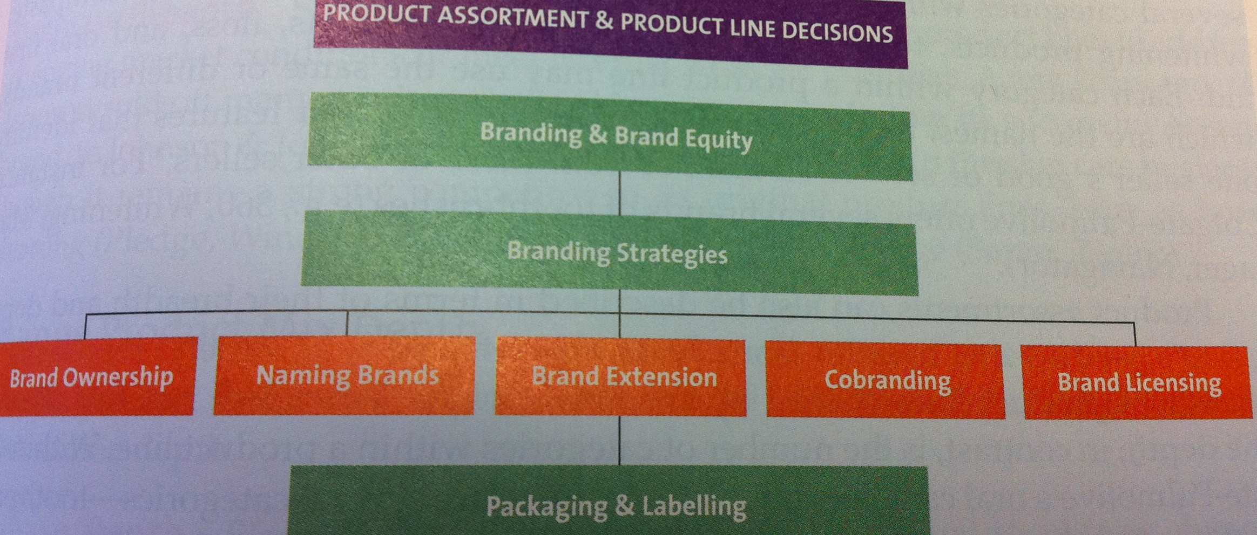

Product Assortment and Product Line Decisions:
- Product Assortment (aka Product Mix): the complete set of all products offered by a firm.
- Product Lines: Groups of associated items, such as those that consumers use together or think of as part of a group of similar products.
- Product (line) Breadth: The number of product lines offered by a firm.
- Product Line Depth: The number of categories within a product line.
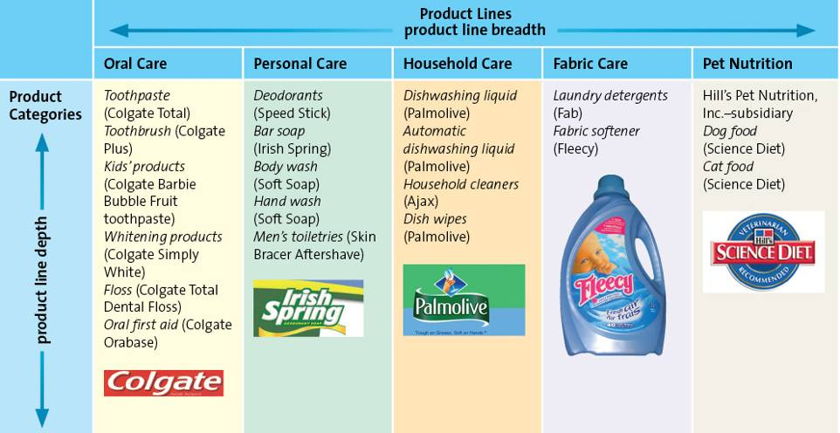
- Change Product Mix Breadth (Adopting Product Breadth to Meet Consumer Demand):
  - Increase Breadth: Firms often add new product lines to capture new or evolving markets, increase sales, and compete in new venues.
    - ConAgra added extensively to its product mix through the 1980s and 1990s
  - Decrease Breadth: Deleting entire product lines to address changing market conditions or meet internal strategic priorities.
    - ConAgra has also taken products out of its product mix in response to changing market conditions and strategy
  - How do firms decide which products to add or subtract from their product mix?
    - Explore new flavours that appeal more to customers than current flavours.
- Change Product Mix Depth:
  - As with product line breadth, firms occasionally add or delete from their product line depth.
  - ConAgra expanded its presence in popcorn by including three popular brands.
Branding and Brand Equity:
- A brand can use (What Makes a Brand?)/Brand elements: name, logo symbols, characters, slogans, jingles and even distinctive packages.
- Value of Branding for the Customer and the Marketer
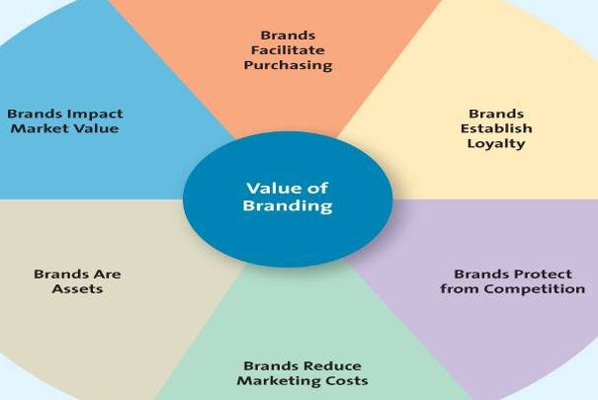
- The purpose of branding is to help consumers distinguish one company’s products from another.
Branding Overview

Brand Ownership Strategies
Brand Name Strategies
Brand Equity

- Family Brand
- Individual
- Brand Awareness
- Perceived Value
- Brand Associations
- Brand Loyalty
- Manufacturer or
National Brand
- Store or Private
Label
- Generic

Brand Strategies

- Brand Awareness: measures how many consumers in a market are familiar with the brand and what it stands for; created through repeated exposures of the various brand elements (brand, name, logo, symbol, character, packaging or slogan) in the firm’s communications to customers.
- Perceived Value: the relationship between a product or service’s benefits and its cost.
  - Customers tending to associate higher prices with high quality are known as perceived value.
- Brand Associations: The mental links that consumers make between a brand and its key product attributes; can involve a logo, slogan or famous personality.
  - Brand personality: refers to a set of human characteristics associated with a brand, which has symbolic or self-expressive meanings for consumers.
- Brand Loyalty: occurs when a consumer buys the same brand’s product or service repeatedly over time rather than buying from multiple suppliers within the same category.
- Consumers are often less sensitive to price
- Marketing costs (of reaching loyal consumers) are much lower
- Firm insulated from the competition
Brand Ownership Strategies
- Brand ownership: brands can be owned by any firm in the supply chain
  - Manufacture/national brands: brands owned and managed by the manufacturer
  - Brands that are owned and managed by retailers (available only from that retailer) are called private-label brands.
  - Generic: a product sold without a brand name, typically in commodities markets.
Brand Name Strategies (Naming Brands and Product Line):
- Choosing a Brand Name: desirable qualities:
  - Suggest benefits and qualities
  - Easy to pronounce, recognize, and remember
  - Capable of registration of legal protection
  - Translated easily
- Corporate brand (family brand): the use of a firm’s own corporate name to brand all of its product lines and products.
- Individual brands: the use of individual brand names for each of a firm’s products.
- Corporate and Product Line Brands: combine the above two
Brand Extension: the use of the same brand name for new products being introduced to the same or new markets.
- Benefits of Brand Extension:
- Well established Name
- Brand known for high quality
- Lower Marketing costs
- Synergy (collaboration) among products
- Boost sales of the core brand
- Brand Dilution: occurs when a brand extension adversely affects consumer perception about the attributes the core brand is believed to hold.
  - To avoid Brand Dilution:
- Marketers should evaluate the fit between the product class of the core brand and the extension.
- Firms should evaluate consumer perceptions of the attributes of the core brand and seek out extensions with similar attributes.
- Firms refrain from extending the brand name to too many products.
- Is the brand extension distanced enough from the core brand?
Cobranding: the practice of marketing two or more brands together, on the same package or promotion.
Brand Licensing: a contractual arrangement between firms, whereby one firm allows another to use its brand name, logo, symbols, or characters in exchange for a negotiated fee.
Packaging: Consists of the wrapper or exterior carton, information about contents, the UPC code, and content.
Product Labeling: labels on products and packages provide information the consumer needs for his or her purchase decision. More than a sticker, it’s a communication tool.
1. What is co-branding? When does it make sense for a company to use a co-branding strategy?
Co-branding is marketing two brands together for the purpose of leveraging the existing positioning of one of the brands.
This type of strategy makes sesnse when a certain brand possesses key, unobservable traits that are desired by another brand.
As well, there should be synergy between the two brands to some extent, like similar customer groups, for example.
Co-branding is a good way for companies to share risks , leveraging resources, gain access to each other’s markets, and to build credibility or establish a market presence quickly.
2. Explain how marketers increase the value of their product offering through packaging. Discuss the ethical issues surrounding product packaging and labelling? How might some of these issues be resolved?
Packaging is one of the most important and tangible aspects of product marketing.
It has functional benefits like protecting the product, providing ingredients or directions and making it recognisable.
It is also an extremely valuable advertising tool because it is the last chance to influence a consumer’s choice – right in the store where they are making decisions.
Innovative packaging alone can influence a consumer’s choice.
The colour, design and words used on a package also work to establish the brand and product positioning while also communicating specific product information.

