Lecture 21 Dams

Learning Goals:

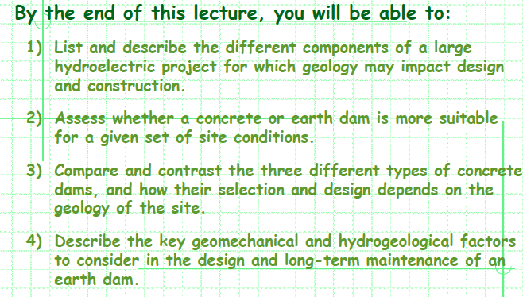

- Dam Stability
  - Foundation/abutment failure
  - Overturning/sliding

- Spillway
  - Dissipate energy
  - Prevent overtopping of dam structure

- Dam Leakage
  - Erosion of dam material or dam foundation/abutment material

- Reservoir Slopes
Landslide generated waves

- Dam geology considerations:
Site Selection
Material Selection
Subsurface Investigation
Geology mapping

Foundation Support
Ground water control
Grouting
Instrumentations

- The principle attributes required of a dam foundation are adequate strength and low compressibility.

- Unfavorable Geological Conditions:
  - Flat (low dipping) faults containing sheared, gauge materials of very low strength.
  - Folded rocks containing thin, weak layers of shale present a potential for foundation failure
  - Weak Soils or those susceptible to liquefaction
  - Highly permeable soils

Concrete Dam  Come in a variety of types and rely on the weight and/or shape to hold water back | Earth Dam  Built with clay, sand, and gravel. Relatively smaller in height and broad at the base (trapezoidal shape)
PROS:  - Rigid and offer more resistance to compressive forces  - Offer significant resistance to:  - Water erosion  - Overtopping  - Piping failure  - Can be shaped to:  - Support imposed loads  - Reduce tensile stresses  - Minimize concrete usage | PROS:  - Constructed where the foundation of the underlying material or rocks are weak or where the suitable competent rocks are at greater depth as they can accommodate more differential settlement than concrete dams  - Safest off all against risk of damage by earthquake
CONS:  - Expensive  - More labor intensive than earth dams  - Concrete has low tensile strength, making it susceptible to differential settlements  - Construction require appropriate sources of:  - Sand  - Gravel  - Aggregate for concrete  - Suitable access to the site | CONS:  - Large size requires large volumes of suitable materials  - Susceptible to:  - Wave erosion  - Catastrophic failure if overtopped  - Piping failures  - Do not last as long as concrete dams  - Extra care required in:  - Designing internal structure  - Selection of material grain sizes  - Quality control during emplacement and compaction of soil material.

- Three types of concrete dams:
GRAVITY DAMS | BUTTRESS DAMS | ARCH DAMS
- Use their bulk weight and low center of gravity to hold back water in the reservoir  - Can be built across long distances over relatively flat terrain  - Very applicable in non-mountainous regions  - Constructed where the foundation material is competent and stable | - Multiple reinforced columns to support a relatively thin structure  - Often use half as much concrete as gravity  - Structure can be considered even if the foundation materials are a little weaker | - Utilize the strength of an arch to displace load of water behind it into its abutments  - Use less material than gravity dams, but more expensive because of expertise required to build one  - Built across narrow, deep river gorges  - Have been considered for wider valleys in some cases.  - Can only be built where the walls of a canyon are of unquestionable stability.  - Also must be impervious to seepage around the dam, as this could cause failure

Gravity Dam:
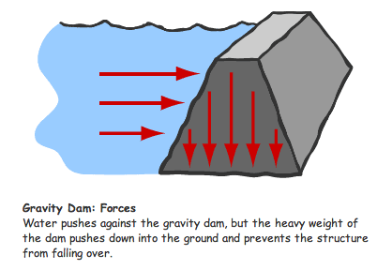
Buttress Dam:
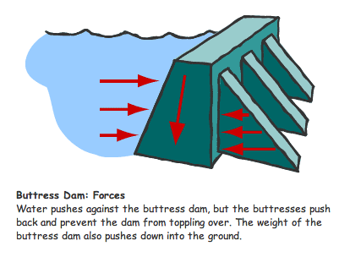
Arch Dam:
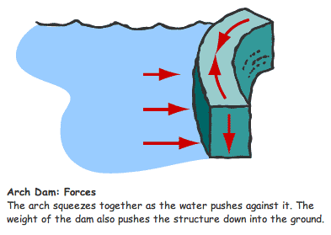

- Key geo-mechanical and hydrogeological factors to consider in the design and long-term maintenance of an earth dam:

- Materials:
  - Large amounts of clay, sand, and gravel
  - Collect as near to the site of dam as possible

- Slope Stability:
  - Stability of a dam can be threatened by earthquakes
  - Fernando Dam in California did fail which caused the fill in the dam to liquefy resulting in the collapse of the upstream part of the dam.

- Overtopping
  - Overtopping causes erosive action of water due to uncontrolled flow over the dam.
  - Once erosion has begin, it is almost impossible to stop
  - Can be prevented through use of a spillway

- Piping
  - All earth dams have seepage resulting from water percolating slowly through the dam and its foundation.
  - Seepage must be controlled in both velocity and quantity
  - If uncontrolled, progressively erode soil from the dam or its foundation, resulting in rapid failure of the dam
  - Erosion of soil begins at the downstream side of the dam and works towards the reservoir, developing a “pipe” to the reservoir.
  - Can be recognized by an increased seepage flow rate, the discharge of muddy water, sinkholes on or near the dam, or a whirlpool in the reservoir.
  - Piping failures usually attributed to poor construction methods

- Seepage Control
  - To control seepage, the phreatic surface should be kept at or below the downstream toe. This can be managed by: properly designed clay core, and or internal drains.
  - Piping can be avoided by lengthening the flow paths of water within the dam and under its foundations.
  - This decreases hydraulic gradient of the water flow and hence its velocity

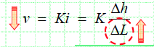

Lecture 22 Tunneling

Learning Goals:

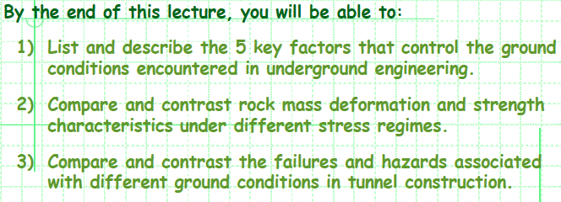

- Factors that control ground conditions encountered in underground engineering:

  - Intact Rock:
    - Most important and frequently ignored aspect
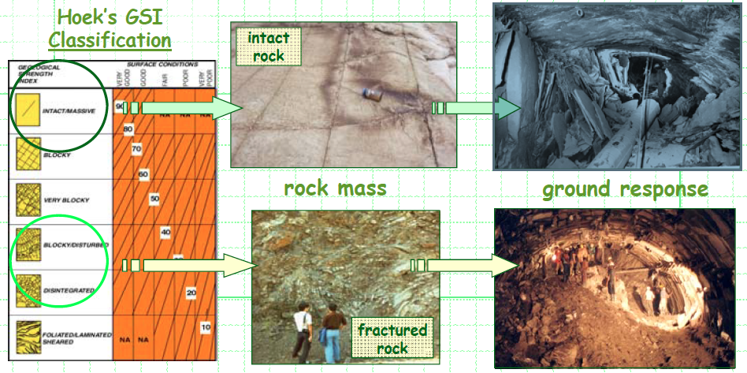
    - Utilizing an existing material which usually highly variable

  - Discontinuities:
    - Discontinuities such as faults and joints may lead to instabilities
    - Blocks form through intersection of several discontinues
    - Are free to fall or slide from the excavation periphery as a result of gravity

  - In-situ-stress:
    - In situ a pre-existing state of stress that already exists in the rock
    - Total Stress = In Situ Stress + Excavation-Induced Stress

  - Pore Pressure:
    - Primary concern is water under pressure
    - Acts to reduce the effective stress and/or induce instabilities

  - Other aspects such as ground water chemistry, and the alteration of rock and fracture surfaces by fluid movement may also be of concern.

- X
- Failures and Hazards associated with ground conditions in tunnel construction:

  - Water Inflows:
    - Encountering large quantities of water may lead to flooding of the excavation, especially if there is no natural outlet for the water to drain out too

  - Fault Zones:
    - Fault zones may also form highly permeable conduits for groundwater, leading to tunnel inflows

  - Squeezing:
    - Weak plastic rock material, which displaces into the tunnel excavation under the action of gravity and induced stresses.
    - Squeezing action may result in damage/failure to the ground support system, or require costly re-excavation of the tunnel section

  - Bursting:
    - Rock-bursts involve sudden releases of stored strain energy through the brittle failure of strong rock
    - Manifest themselves through the sudden ejection of rock into the excavation
    - Concern in deep tunneling where high stress concentrations form due to overburden loads or tectonic activity

  - Running Ground:
    - Ground possesses ability to flow freely, as for example with loose sand or other cohesionless materials, then special support and control difficulties can arise
    - Major inflows may not only flood tunnel works, but may also develop into a chimney collapse feature which may propagate to the surface

