Module A: Lesson 11 – Study Notes

The 4 Cs

Cut and polished diamonds are evaluated by four primary variables, all beginning with the letter C (hence the 4 Cs):

What are the 4 Cs for evaluating polished diamonds?
- Colour
- Clarity
- Cut
- Carat

All variable are equally important and it is their unique combination that defines the value of a diamond.

Who introduced the 4 C system?
- De Beers in the late 1930s
- Since then, the 4 C system has become standardized and has gained widespread use by gemological libraries like GIA, EGL, and jewelers and consumers

Variations on the 4 Cs have been used for other gemstones as well, but not to the same extent as with diamonds

Identify and explain the fifth C.
- A fifth C has been proposed in recent years to reflect the stone’s country of origin
- The fifth C has bearings on the historical significance of the stone but more importantly it determines whether or not the stone came from conflict zones

The image and video link below are about a wonderful faceted gemstone, which it is not a diamond. The mineral is called cerussite and is a lead carbonate with particularly high average refractive index and dispersion. Terri Ottaway of the Royal Ontario Museum speaks about the properties of this particular gemstone and the difficulty of the cutting process - a nice primer before understanding the 4 Cs.
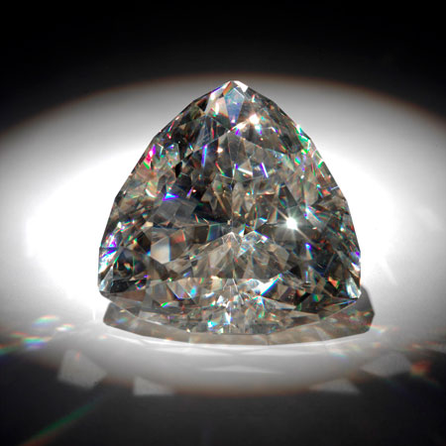

"The Light of the Desert", a faceted cerussite PbCO₃ from Namibia, 898 carats. Image from the Royal Ontario Museum.

Cut: The External Anatomy of a Gemstone

What does the cut of a gemstone refer to?
- The quality of the facets that define the stones proportions
- Cut is not to be confused with the shape of a cut gemstone (round, brilliant, cushion, pear etc.)

This C is probably the least understood, intuitive, and appreciated of the four.

What role does cut play in the quality of the gemstone?
- Cut plays a huge role in the gem’s resulting optical effects of fire and brilliance
- Cut can also have a significant impact on the weight of the stone (carat). For example, stones with the same face-up diameter can differ in weight depending on how thick the cutlet or pavilion is.

What is the difference between a poor and excellent cut?
- Poor cuts are too shallow or too deep which can leave the stone dull and lacking life
- An excellent cut will return all the light entering the stone back to the eye through the top or table of the stone
- Stones with excellent (also known as ideal) cut will show good symmetry of facets as well as good length to width ratios when comparing the top-down dimensions of the table and full diameter.

In modern-cut gemstones the culet is often absent from the final shape or at least very small.

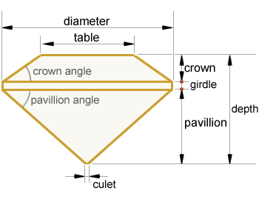

Simplified anatomy of a Round Brilliant cut diamond.

How are cuts graded?
- The quality of the stone’s facets and polish and the physical proportions of the stone are assessed
- Girdle diameter and angles for the crown and pavilion are assessed
- GIA ranking (excellent, very good, good, fair, and poor)
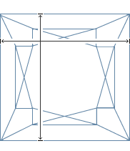
This wire drawing of a Princess cut diamond has a perfectly proportioned top-down view, with a Length to Width ratio of 1.00. An ideal cut ~5 carat stone would measure approximately 9.3 mm by 9.3 mm with a full depth of about ~6.95 mm.

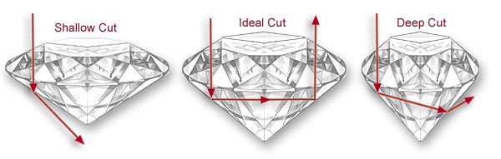
Drawings of diamonds showing light paths into and out of each of the stone. Cuts from left to right are shallow (poorly cut), ideal (well cut), and deep (poorly cut).

Clarity

Clarity is a variable that is straight-forward and intuitive.

What does clarity describe?
- Clarity describes the internal and external imperfections of a stone.
- All diamonds are in some way flawed (imperfect) to be truly flawless is extremely rare

What are some common flaws observed in diamonds?
- Many flaws are inherent in the stone and present in rough form as well
- Solid mineral inclusions
- Blemishes such as fluid-filled inclusions, clouds, and feathers
- External features such as scratches, abrasions, or burns
Diamond cutters will often sacrifice carat weight of a diamond by removing included sections of a rough diamond in order to improve clarity.

Explain the diamond clarity grading system.
- Range from I (included) to FL (flawless)
- Has six tiers or categories with further subdivisions

What is used to detect imperfections in a diamond?
- A 10x magnification device called a loupe

Why is the loupe used despite existing laboratory grade equipment?
- If a higher magnification was used, imperfections will eventually be detected in most stones
- Therefore, the loupe is used for classification purposes
- It is more rational to use simple tools

GIA definitions for clarity grading:
Flawless (FL): no blemishes or inclusions when examined by a skilled grader under 10X magnification.
Internally Flawless (IF): no inclusions when examined by a skilled grader, and only insignificant blemishes under 10X.
Very Very Slightly Included (VVS1 > VVS2): contains minute inclusions that are difficult for even a skilled grader to locate under 10X. VVS1: extremely difficult to see, visible only from the pavilion or small and shallow enough to be removed by minor repolishing. VVS2: very difficult to see.
Very Slightly Included (VS1 > VS2): contains minor inclusions ranging from difficult (VS1) to somewhat easy (VS2) for a trained grader to see under 10X.
Slightly Included (SI1 > SI2): contains noticeable inclusions which are easy (SI1) or very easy (SI2) to see under 10X. In some SIs, inclusions can be seen with the unaided eye.
Included (I1 > I2 > I3): contains inclusions which are obvious to a trained grader under 10X, can often be easily seen face-up with the unaided eye, seriously affects the stone's potential durability, or are so numerous that they affect transparency and brilliance.

To the consumer, inclusions tend to be viewed in a negative light.

What are the benefits of a stone with solid or fluid inclusions?
- Inclusions hold a wealth of information
- Solid and fluid inclusions can provide information on the formation of diamonds in their stability stones and also allude to their growing conditions
- Inclusions can also be considered evidence that a stone is not synthetic or has not undergone any treatments
- Provides evidence for the original source of the stone.

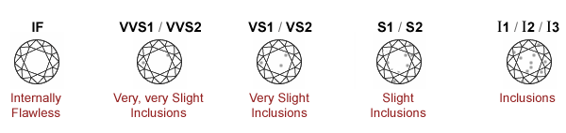

Colour

Colour of a diamond is one of the more important variables to consumers when choosing a diamond. Ideally, a diamond is colourless. In reality, almost all diamonds have a yellow undertone and this affects their outward image.

Describe the colour scale gemologists use to grade colour
- A range between D to Z
- D – F colourless
- G – J near colourless
- K – M faint yellow
- N – R very light yellow
- S – Z light yellow

How do gemologists grade colour?
- Gemologists have a master set of diamonds within the ranges of D – Z that are compared with the stone being graded

What ranges will appear the same to an untrained eye?
- D – I depending on what metal the stone is set in

Stones set in yellow metals may inherit some of the colour from the ring below, while those in white metals will not receive an undertone from the setting.

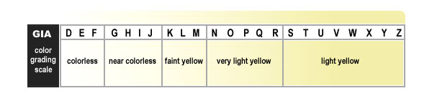

Carat

What is a carat?
- A carat is used to measure the total weight of a stone.
- One carat is 0.2 grams
- 5 carats is 1 gram

Jewelers or gemologists may also speak of points when describing carats. Explain the points system
- 0.01 carats is 1 point
- 0.5 carats is 50 points
- 1 carat is 100 points

Weights are usually recorded to the second decimal point; however, measurements with 3 decimal points are also common.

Why isn’t the value of a stone linearly related to its size?
- Bigger stones are progressively rarer
- The price of larger stones actually increase at a slower rate the bigger it gets

For example, a 1 carat stone will be worth more than twice a 0.5 carat stone that has the same cut, clarity, and colour. Stones of above 3 or 4 carats are still within the price range for consumers while a great increase in price is expected from that point up to about 7 carats. Beyond that, the price of larger stones (i.e., 10 carats and up) increases at a slower rate. Note though that the price of diamonds can fluctuate considerably depending on the global production of diamonds and the prevalence of larger stones.

Diamond Shapes

Diamond cuts, or any gemstone cut for that matter, are varied. Certain cuts have been designed to maximize brilliance and fire, while others have been designed to intensify colours.

Name the classic shape seen in most diamonds today.
- Round brilliant
- This cut was designed to return the most light back up the table of the stone
Historically, diamond cuts had to be physically undertaken to see the end result. Today, computer modeling software lets us play with how a cut might represent itself on the table or side view of a stone. Multitudes of "designer cuts" have been created but a few notable ones have been well marketed. Examples include "Hearts and Arrows", "Amore", "Arctic Empress" and "Star Cut". The Diaco Inc. website includes 3D animations of the most common cuts and a few other specialty stones (click on 'Shapes' and choose from the drop down list).
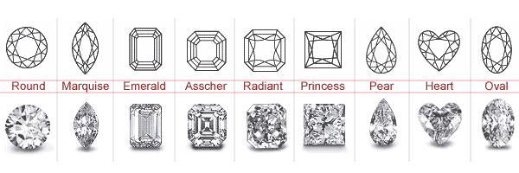

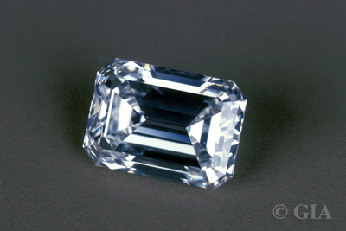

Emerald cut diamond, 2.02 carats. Photo from the Gemological Institute of America.

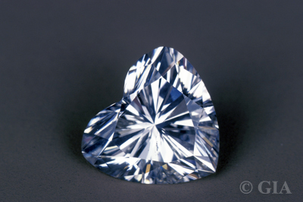

Heart shaped diamond, 2.70 carats. Photo from the Gemological Institute of America.

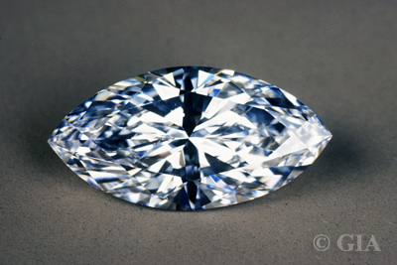

Marquise cut diamond, 2.44 carats. Photo from the Gemological Institute of America.

Below are 3D renderings of "perfectly" cut stones. Modeling ray paths of light to emulate a natural setting is a particularly intensive task for computers as there are many many more light sources than we normally think about. Consequently, computer-aided modeling of diamonds has its limitations but can still give us a good idea of what a stone might look like when cut to specific proportions. You may have even noticed the lack of fire, or dispersion in those models seen in Diaco Inc.'s animations. Below are examples of computer generated models of various diamond shapes.

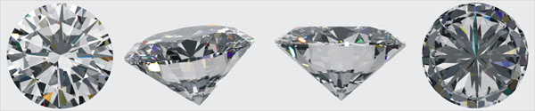

Round Brilliant cut diamond viewed from from different angles, left to right: top, oblique, side, and bottom.

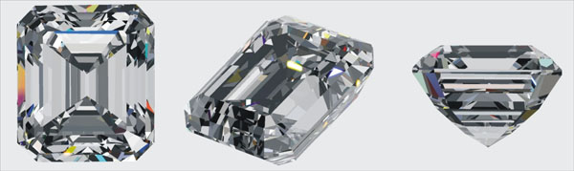
Step cut diamond viewed from different angles, left to right: top, oblique, and side.
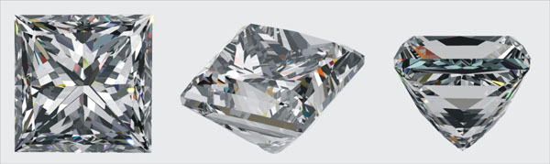
Princess Cut diamond viewed from different angles, left to right: top, oblique, and side.
Grading Reports

Now that we have looked at the 4 Cs, let's look at a sample grading report that puts the four together. Grading reports are produced by a long list of gemological institutes and laboratories worldwide that grade stones and jewellery for assessment purposes. One of the larger institutes is California-based Gemological Institute of America, which has established offices around the globe.

In the grading report shown above, note how the main physical properties of the graded diamond are clustered together in sets, and how each diamond graded by the GIA receives a certificate number. This certificate number is engraved on the girdle of each diamond for identification purposes. The number is too small to be seen with the naked eye, but a 10X loupe will allow you to read the number to verify its identity.
Rapaport

We now understand what variables affect a diamond's value, but what is an individual diamond actually worth? As with grading reports, pricing reports are also made available for the diamond and jewellery industry by many institutions.

What is the most commonly used summary of diamond prices?
- The rapaport

The graphs below are based on excerpts of a recent (early 2009) Rapaport report for Round cut diamonds without consideration for quality of cut. The prices (in US$1,000) are considered wholesale based on asking prices at New York firms. As a retail consumer, you would probably expect to pay double this. You must note though that many dealers buy stones at a discount from the "Rap" price.

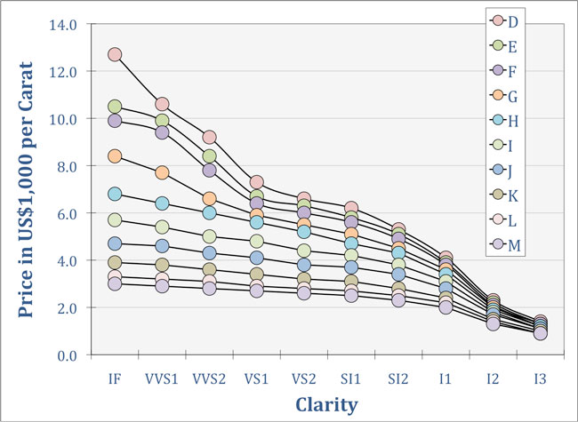

Aside from the 4 Cs what variables determine the price of a stone?
- The number of stones purchased at a time
- The type of jewelry the stone is used in
- Whether or not the pieces are specially designed

In the graph above, note the dramatic jumps in prices for G and better colours beyond VS1, but not for H and worse. This pricing trend is a result of high demand for clean stones of good colour. In other words, for clean stones (VS1 and better), a good colour (G and better) is considerably more important (and noticeable) than for dirty stones where an off-colour is not a big deal against its many inclusions. Also note the small price difference between E and F colours. This is because of the difficulty in noticing the slight colour difference. Now ask yourself, since D colour is close to E, why would it demand such higher prices?
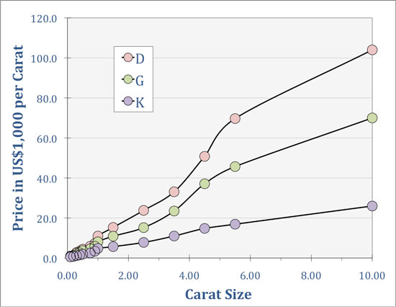
Price in US$1,000 per carat according to carat size and colour. Data from Rapaport Report, early 2009.

In the plot above, note how each colour category experiences a dramatic rise in price per carat leading up to ~5 carats. Beyond that, a similar trend would make the cost to the consumer unsustainable. The larger stones (10+ carats) are also less common and tend to only appear in specialty shops. For the retailer, a large stone sold at a bit of a discount would generate the same profit as that for a smaller stone sold without discount.

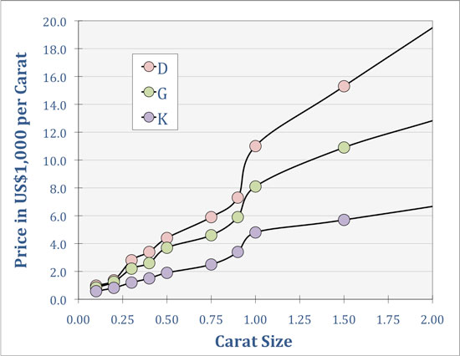

Price in US$1,000 per carat according to carat size and colour, with a focus on smaller stones. Data from Rapaport Report, early 2009.

The graph above is the same as the previous one but with a closer look at the "smaller" stones. Note that the steepest rise in value for a diamond occurs in two places: leading up to the 1 carat range and leading to the 0.5 carat range. This is a direct relationship to demand from consumers that want stones close to these "benchmarks". Note, too how on the low end of the scale, the differences in price per carat for the various colour grades are very small. Why would this be?

Pricing of diamonds can be made available directly to consumers through jewellery shops and online retailers.

Name an online jewellery store.
- Blue Nile

A company called Blue Nile has been selling diamonds online since the late 1990's directly to consumers. They offer a very large range of stones, all of which are listed with their prices. eBay is also a "good" resource for consumers to check-out what diamonds (and coloured gemstones) can fetch, however, there is no control or moderation for those auctions.

Kimberly Process: The 5th C?

Name an organization that is involved in the monitoring of the diamond industry.
- World Diamond Council

What was the council’s original mandate?
- The council’s mandate is now known as the Kimberly process
- To address the development, implementation, and oversight of a tracking system for the export and import of rough diamonds to prevent the exploitation of diamonds for illicit purposes such as war and inhumane acts

What is the main goal of Kimberly process? How do they go about achieving this goal?
- To eliminate blood or conflict diamonds
- Kimberly process endorses stable countries with their own regulations regarding the import and export of diamonds and allows them to produce conflict-free diamonds (which includes mining, cutting, or polishing)
- These conflict-free diamonds are tracked in parcels and can only be sold to other endorsed stable countries

By facilitating the trade of legitimate stones, the Kimberley Process has significantly reduced global trafficking of conflict stones. The Process has provided more confidence to retailers and consumers that they are not supporting illegitimate mining operations.

The Kimberley Process is not simply a collection of international laws, but rather an agreement between the major diamond mining, exporting, and importing countries and companies.

How many countries are parts of the Kimberley Process agreement?
- 74. Some countries have a greater impact than others

For example, the United States imports huge volumes of diamonds and therefore has a very significant impact on the success (or failure) of the consumption aspect of the Kimberley Process. Conversely, poverty stricken regions with diamond production can significantly impact the success (or failure) of the Kimberley Process through proper implementation and regulation in areas that are prone to illicit diamond trade. Other countries that neither produce diamonds nor import significant volumes of diamonds will not have a significant impact on the success (or failure) of the Kimberley Process.

It is the cooperation amongst all the countries involved that gives the Kimberley Process its strength.

Who assists the World Diamond Council in ensuring the validity and effectiveness of Kimberley Process?
- Non-governmental human rights organizations such as Global Witness and Partnership Africa Canada

Identify one of Kimberley Processes’ flaws
- The process is more geared to monitoring large scale production from more significant sources such as hard rock mine.
- Thus, Kimberley process has difficulty monitoring smaller artisanal scale diamond operations

