Module A. Lesson 10 – Study Notes

The Origins and Geology of Diamonds and Kimberlite

Diamonds occur in primary and secondary deposits.

Where are primary diamond deposits located?
- Primary diamond deposits are found in volcanic rock (kimberlite and lamproite) on the surface and in un-erupted magma

Where are secondary diamond deposits located?
- In a concentrated area away from the primary deposit.
- Common transport mechanisms include rivers and near shore currents

Diamond Growth

At what depths is diamond stabilized?
- At 150 km where pressures are high

At these depths, underneath large amounts of rock, temperatures are typically on the order of 1500 °C; this temperature is too hot for diamond to grow!

At what temperatures will diamond stabilize?
- A "cool region" between 900 and 1200 °C is required.

We cannot just pile a bunch of rocks up and expect diamond to form. Instead, we need to pile up a bunch of "cold" rocks so that a locally cool region can exist even at a great depth.

Name and describe a type of rock that is favourable for diamond growth.
- Archean cratons are an old collection of rocks found in the middle of a continent.
- These rocks are typically cool and thick.

Explain why archean cratons are favourable for diamond growth.
- Their great thicknesses push a keel down into the upper mantle.
- At the base of this keel is something called a diamond window, an environment that is favourable for diamond growth because it has high pressures and “cool” temperatures (900 to 1200 degrees)

A keel is similar to how only the tip of a floating iceberg will show above the water's surface.

What is found outside the diamond window?
- Pure C graphite

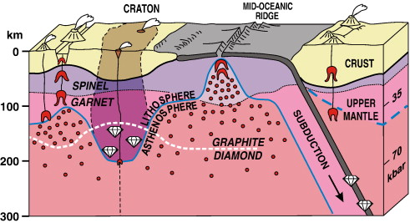

Schematic vertical section through the Earth's crust and part of the upper mantle. Figure from Stachel, T. and J.W. Harris (2008, "The origin of cratonic diamonds - Constraints from mineral inclusions", Ore Geology Reviews, Volume 34, Issues 1-2, pp 5-32).

The cartoon diagram of the Earth's crust (above) shows an old craton with a deep keel, the outline of which is indicated by a blue line. The Stability Zone separating diamond from graphite is indicated by the dashed white line: below the line, diamond is the stable C mineral, whereas above it, graphite is the stable C mineral. The red dots indicate areas where igneous magma is being generated and the red chevrons (V-shaped patterns) indicate where magma has accumulated. Note how even though igneous rocks formed at mid-ocean ridges and along subduction zones are sourced from the same general magmatic region, they are generated above the diamond-graphite line, resulting in the production of only graphite, the stable C mineral.

This Temperature-Pressure diagram highlights the relationship between the two carbon minerals; graphite and diamond. The area in red indicates the typical pressures and temperatures in cratonic lithosphere, whereas the area in green indicates the typical temperatures and pressure in the asthenosphere. Diamonds will only form in the lithosphere (not the asthenosphere), so the "fertile" region for diamonds is a small window (yellow area) within the lithospheric region below the diamond-graphite line. Figure from Stachel, T. and J.W. Harris (2008, "The origin of cratonic diamonds - Constraints from mineral inclusions", Ore Geology Reviews, Volume 34, Issues 1-2, pp 5-32).
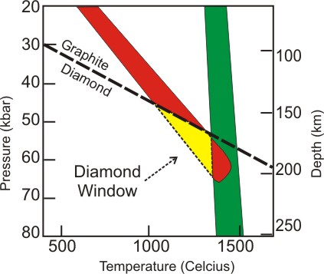

Kimberlite Volcanoes

Sourcing diamonds from underneath 150 km of cold cratonic rock is not an easy task. Special conditions are required to bring these crystals from deep within the Earth to the surface.

Explain how diamond crystals are brought to the surface of the earth.
- Kimberlite magma forms at the base of the craton. The magma ascends fairly quickly through the 150km of crust picking up diamonds that are in its path.
- The magma erupts at special volcanoes at the surface of the earth
- This process needs to be fast in order to prevent the diamond from transforming into graphite and to prevent the diamond from corroding.

The deep-seated magma for these odd volcanic rocks is sourced from the upper mantle and is Fe- and Mg-rich (also termed ultramafic) as well as rich in K (or ultrapotassic). Kimberlite magmas can also be generated away from diamond-bearing regions below the cratons, but these kimberlites will never carry diamonds. In fact, they are classified as barren kimberlite.

The morphology of kimberlite volcanoes on the surface is tied to their igneous nature as well as the nature of the rocks they are passing through.

Why does magma proprogate faster as it ascends through the crust?
- As the magma ascends, the pressure is decreasing as it moves into regions with less confining pressure

What happens when magma approaches the Earth’s surface?
- The magma will likely interact with ground water. The magma will boil the ground water when it comes in contact with it causing a rapid and violent expansion of gas leading to a volcanic eruption.

What is a diatreme?
- The vertical and carrot shaped body of a kimberlite volcano.

Although no kimberlite eruptions have been witnessed, the textures found in the rock record support an explosive depositional environment. Emplacement of kimberlite volcanoes often results in a vertical and carrot-shaped body known as a diatreme, typically up to 1 km across at the surface. The figure below shows an idealized schematic of all parts to a kimberlite volcano, however, in most geological settings not each and every part is present. This is either due to variations in the emplacement of the volcano or subsequent erosion on the Earth's surface since eruption.

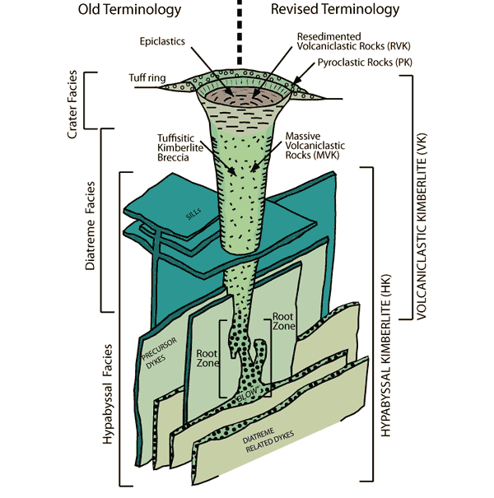
Typical morphology of a classical kimberlite diatreme, or pipe, with other associated igneous rock bodies, based on examples from South Africa. Terminology on the left reflects nomenclature generated from South African kimberlite, and terminology on the right reflects nomenclature as revised from studies of kimberlites across the globe. Figure from Kjarsgaard, B. (2007, "Kimberlite Diamond Deposits", In Mineral Deposits of Canada, Goodfellow, W. D., ed., Geological Association of Canada, Mineral Deposits Division, Special Publication No. 5, p. 245-272).

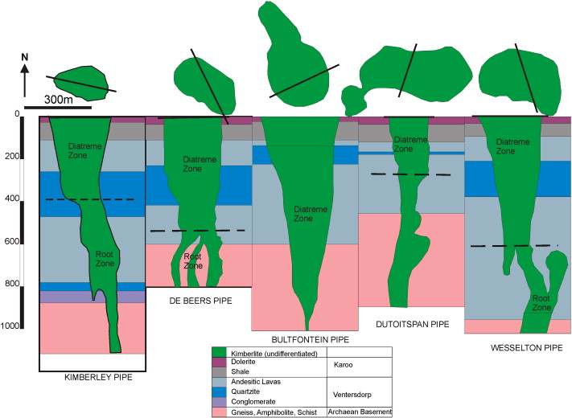

This figure shows the plan views (top) and vertical side views (bottom, also known as a "Cross Section") of the five diamondiferous kimberlite pipes that make up the Kimberley mine site kimberlite cluster. Note their close approximation to the 'carrot-shaped' schematic above. (From Field et al 2008)

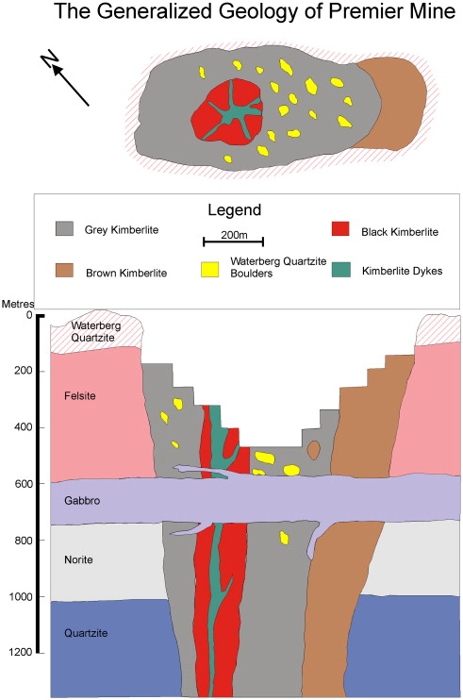
This figure shows the plan views (top) and vertical side views (bottom, also known as a "Cross Section") of the Premier Mine, historically known as the Cullinan Mine. Note the close approximation to the 'carrot-shaped' schematic above as well as the horizontal gabbro intrusive body that cuts across the kimberlite - this later feature actually destroyed diamonds within a few meters from the contact between it and the kimberlite rocks. (From Field et al 2008)

Besides bringing diamond to the surface, kimberlite also entrains non-gem minerals and other rocks formed in the same deep environment. Sampling such super-deep material allows geoscientists to look at material otherwise inaccessible and to study the inner workings of the Earth. The rocks and minerals that get pulled up are more abundant than diamond, but are not necessarily common minerals on the surface of the Earth.

Name the common minerals that occur in diamond-bearing kimberlites.
- Green olivine
- Purple pyrope garnet
- Chromium-bearing diopside
- Chromium-bearing spinel
- Iron Titanium oxide ilmenite

What is so significant about these minerals?
- They serve as indicator minerals. Their presence on the earth’s surface indicates that diamond-bearing kimberlite rocks are nearby.

Lamproite

What is the difference between lamproite and kimberlite?
- Both rocks host diamonds except lamproite is less common than kimberlite
- Lamproite differs in geochemistry, it contains the mineral leucite whereas kimberlite does not
- Lamproite exists in areas outside of archean cratons

Name the one diamond mine that produce diamonds from lamproite rocks.
- Argyle diamond mine

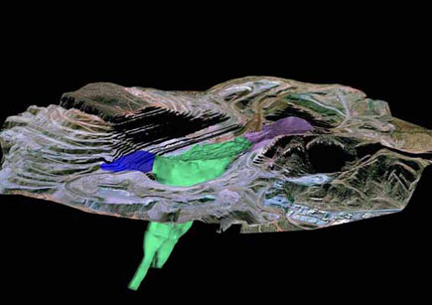

Computer-generated 3D model of an Australian diamond mine. The lamproite is the body shown in green, blue, and purple. Image from Argyle Diamond Mine.

Why are Diamonds Rare?

Why are diamonds rare?
- Diamonds are rare because they are formed below the surface of the earth and only special geological conditions allow their transport upwards.

Diamonds are not as rare as most people are led to believe. Their great historical value coupled with a greater geological understanding of their formation since the early 1900’s have prompted and facilitated exploration for new sources.

Hundreds of new diamond-bearing pipes have been discovered across the globe although only a handful of those have been rich enough to be developed into mines.

How many diamonds per carat have been produced annually throughout the 20th to 21st century?
- In the early 1900s, millions of carats were produced annually
- By the 1950s, tens of millions of carats were produced annually
- Today nearly 170 million carats are produced annually

Prior to discoveries in South Africa at the end of the 19th century, diamonds were only sourced from alluvial deposits in India (and briefly from Brazil). There, perhaps only 50,000 carats would be produced annually.
The concept of diamonds as being rare has been perpetuated through history from times when production was scarce.
Where is Diamond Found and Mined Globally?
The current understanding of diamond deposit geology is far beyond that of even 20 years ago. Consequently, the distribution of known diamond deposits and the exploration for new deposits is rapidly becoming more refined. Recent articles by Groat et al (2012), Read & Janse (2009), Field et al (2008), Stachel (2007), Janse (2007) and Shor (2005) paint a pretty good picture regarding both the science of diamond deposits as well as the commercial side of production.
A histogram of diamond-related research in peer-reviewed publications shows an interesting trend (see below), with pulses of published research in the early 1990's and mid-late 2000's. These pulses probably lag times after the 'shake up' and 'deregulation' in diamond trade during the mid 1980's (e.g., Argyle and Udachnaya mines) and then the diamond rushes and mine openings in Canada and elsewhere during the late 1990's and early 2000's (e.g., Ekati, Diavik and Catoca). Cutting edge research is used in the diamond industry during exploration and mining, however, publishable peer-reviewed research findings typically lag behind due to confidentiality clauses and simply access to sites, samples and information. Also influencing the histogram are the International Kimberlite Conferences that are held approximately every 4 years.

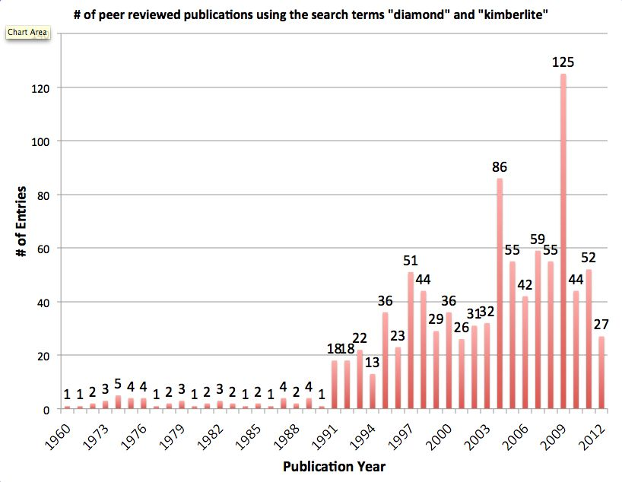
Histogram by year showing the distribution of "diamond + kimberlite" related references in the scientific literature.

As we learned in Lession 10.1, diamond-bearing kimberlites occur exclusively in areas with "old" and "cold" Archaen-aged (older than 2.5 billion years) cratonic basement rocks, such as the cratons of the Canadian Shield or the Kaapvaal craton of southern Africa. By focusing on these Archean-aged cratons (sometimes known as Archons) we can draw a map of the most relevant areas with diamond potential.

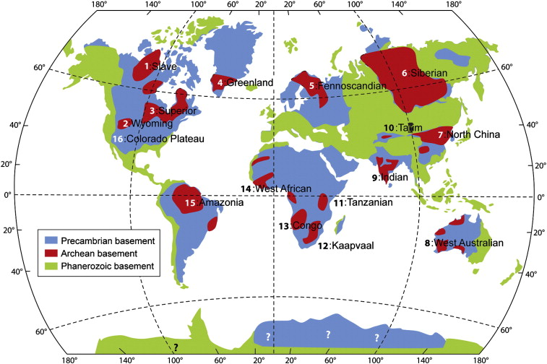
World map showing distribution of 16 Archean cratons (red) underlain by Precambrian (> 540 Ma; blue) and Phanerozoic (< 540 Ma; light green) crustal basement. From Yoshida (2012).
Name two cratons.
- The Canadian Shield
- The Kaapvaal craton of southern Africa

In earlier lessons we've touched on the fact that many historical diamonds originated from India with Brazil becoming a somewhat significant source in the 18th century, and then of course South Africa's important role in the diamond industry starting in the 19th century. It should be no surprise then that each of these areas have areas of Archean cratons (red)! Following South Africa in the 20th century were significant diamond-bearing kimberlite discoveries in Russia, Australia, Canada and other regions of Africa. Many of these are shown on the following map of the world, which also includes major diamond mines and type of basement rocks. You may notice differences in the two author's interpretations of what are Archean basement (Archon), Precambrian basement (Proton + Tecton) and Phanerozoic basement ('young' rocks) regions.

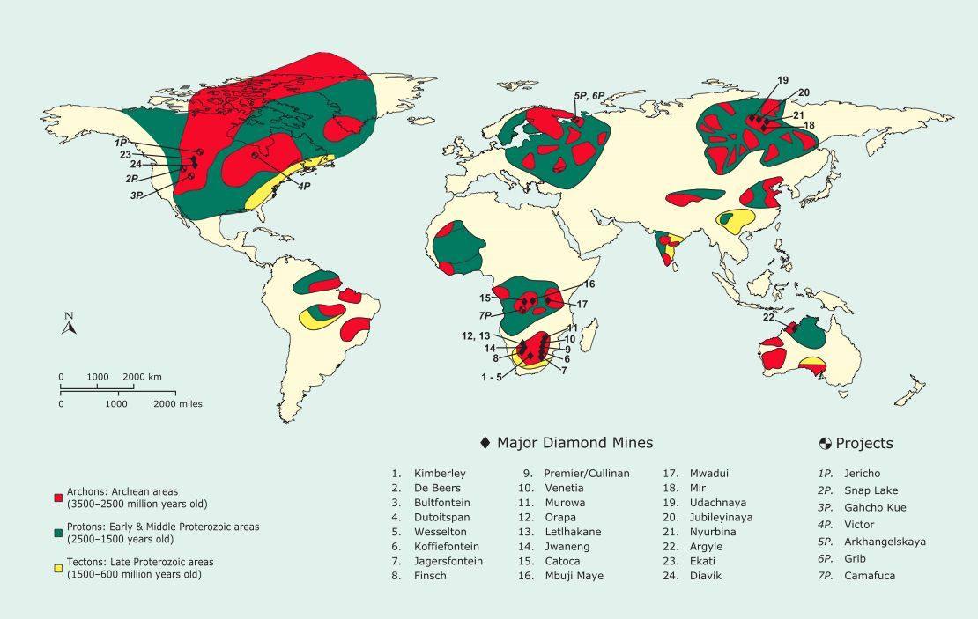

This map shows the tectonic location of 24 major diamond mines and seven advanced diamond projects. All major mines developed on kimberlite pipes are located within the boundaries of an archon, while those developed on lamproite pipes are located on a proton. Click image to open larger format. (From Read & Janse 2009)

With only ~30 active major mines and advanced projects from primary "in-situ" kimberlite sources, the diamond industry collects the bulk of its rough material from a relatively small batch companies and locations. Particularly notable is the fact that many of the mines are located in Africa, which has a turbulent past and uncertain future stability.
Historically, India was the sole source of diamonds, however, all of these were mined from secondary transported sources (we'll learn more about these in L15 and L24) and production is thought to only equate to ~10 million carats over its ~4,000 year history. Although this quantity pales in comparison to today's annual global production of around 125 million carats, it is extremely significant because of its historical importance prior to the 18th century and the number of larger diamonds produced (e.g., the Koh-I-Noor). During the exploration of the "New World" by early Portuguese explorers diamonds were discovered in the Minas Gerais region of Brazil. This new source impacted the global industry but was soon eclipsed by the sweeping changes that came with the diamond discoveries in South Africa during the late 19th century.
What discoveries lead to the transition towards the modern diamond industry?
- The discovery of kimberlite (primary diamond source) in South Africa rather than secondary alluvial river deposits

As the volume of newly mined diamonds increased new markets for diamond consumption were also developed and no longer were diamonds held only for royalty and the wealthy.

In fact, diamond production from South Africa reached ~1 million carats by 1872, only 6 years after the first diamond pebble was found on the banks of the Orange River near Hopetown by a farmer (Erasmus Jacobs).

What was this region called?
- The big hole or Kimberly mine

The big hole was taken over by De Beers Consolidated Mines in 1873.

By the early 1900's production in South Africa had increased to ~5 million carats annually from 8 mines and as new mines gradually opened on the African continent annual production was driven to ~15 million carats by 1950.

Name the significant mines and secondary deposits in Africa.
- Premier mine (1903, South Africa)
- Mwadui (1942, Taznania)
- Mbuji Maye (1942, DRC)
- Orapa Mine (no date, Botswana)
- Alluvial and beach deposits (no date, Namibia)
- Catacoa mine (no date, Angola)

Numerous other African diamond-producing countries exist, however, only those mines on primary kimberlite have any significant production.

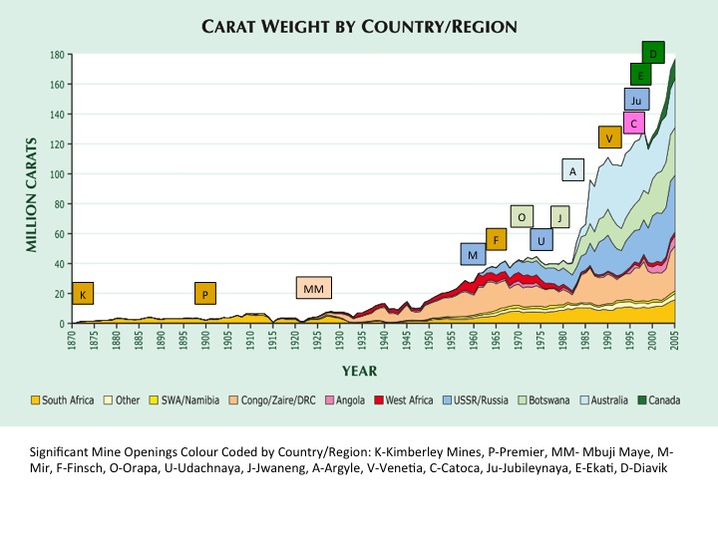
This chart shows global diamond production by carat weight (not value) from 1870 to 2005 for eight countries, one region in Africa, and all other producers ("Other"). South Africa's early dominance gave way to production from the Belgian Congo in the 1930s, which in turn was eclipsed by production from Russia (Mir, Udachnaya), Botswana (Orapa, Jwaneng), and Australia (Argyle). (From Janse 2007)

Name significant non-African mines
- The Mir Diamond Mine (Russia, 1957)
- Udachnaya (Siberia, 1976)
- Jubileynaya (Siberia, 1997)
- Nyurba (Siberia, 2004)
- The Argyle Diamond Mine (1986, Australia)
- Ekati (1998, Canada)
- Diavik (2003, Canada)
- These mines were major blows to the DeBeers monopoly
The opening of the first significant non-African mine, the Mir Diamond Mine in Russia, was in 1957 shortly after its 1955 discovery. Annual production from Mir by Alrosa Mining Corp quickly reached ~5 million carats and by the mid 1970's it was producing nearly 10 million carats annually. This non-DeBeers mine was the first major blow into the previously established and very strong DeBeers monopoly. Following Mir was a series of additional Siberian mines: Udachnaya (1976), Jubileynaya (1997) and Nyurba (2004).

The next significant event in global diamond mining was the opening of the Australian Argyle Diamond Mine by Rio Tinto in 1986 after the discovery of the "non-traditional" diamond-bearing lamproite in 1979. Australia's annual production started at ~30 million carats, a good proportion of the market share by volume at that point but much of those diamonds were of industrial quality (ie, non-gem quality). In fact, in 1994 the Argyle Mine produced 40% of the world's diamonds by volume! This was the second significant shift of DeBeers' global monopoly and together with the Siberian diamonds was a significant shift in the global diamond trade.
Finally, Canada entered the global diamond trade in 1998 with the opening of Ekati (BHP Billiton), followed by Diavik (Rio Tinto) in 2003. Interestingly enough, neither of these mines are operated by DeBeers despite intense but unsuccessful exploration by DeBeers in Canada during the previous ~3 decades. Just years after startup, Ekati was producing ~5 million carats annually and Diavik showed similar productions also with ~5 million carats annually after a few years of operation. Since then production has been relatively steady and the diamonds produced from the Canadian mines tend to have a higher average value per carat when compared against other nations with similar production volumes.
By 2006, DeBeers had dropped from 11 major active mines to 7 (South Africa, Tanzania and Botswana), and was competing against 11 other major active mines spread across the globe with significant production volumes and values. Despite this, DeBeers maintains significant control of the way diamonds are mined, held, distributed, faceted and sold to the end consumer.
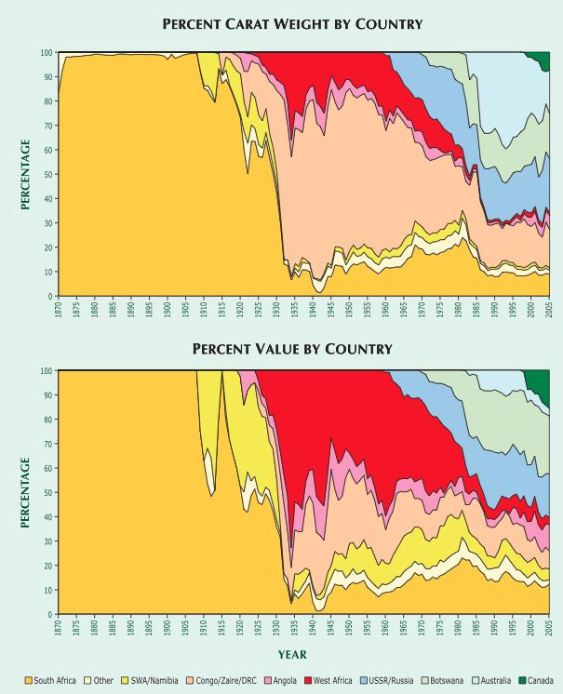
These charts compare percentages of world diamond production by country by year in terms of both volume and value. The early dominance of Congo/ Zaire/DRC production is clear when considered by carat weight (top), giving way to Australia, Russia, and Botswana. Considered by dollar value (bottom), however, the alluvial production from West Africa is dominant from 1935 to the early '70s, while the lower value of Australia's production greatly reduces its impact. Canada's role starts in the late 1990's and you can see the relative difference between carat produced and value contributed as compared to other countries (such as Australia which shows the opposite trend).

These charts compare percentages of world diamond production by country by year in terms of both volume and value. The early dominance of Congo/ Zaire/DRC production is clear when considered by carat weight (top), giving way to Australia, Russia, and Botswana. Considered by dollar value (bottom), however, the alluvial production from West Africa is dominant from 1935 to the early '70s, while the lower value of Australia's production greatly reduces its impact. Canada's role starts in the late 1990's and you can see the relative difference between carat produced and value contributed as compared to other countries (such as Australia which shows the opposite trend).

In 2011, almost 125 million carats of rough diamond were produced globally with an estimated value of $14.4 billion US dollars and over 75% were produced by only 5 companies (De Beers > Alrosa > Rio Tinto > BHPB > Harry Winston Diamonds). The majority of these diamonds originated from Africa (e.g, Botswana, Congo, Angola, South Africa and Zimbabwe) with significant amounts coming from Russia, Canada and Australia. Total cumulative global production of diamonds is estimated to be around 6 billion carats, with nearly 15% of this total production from only the last ~5 years.
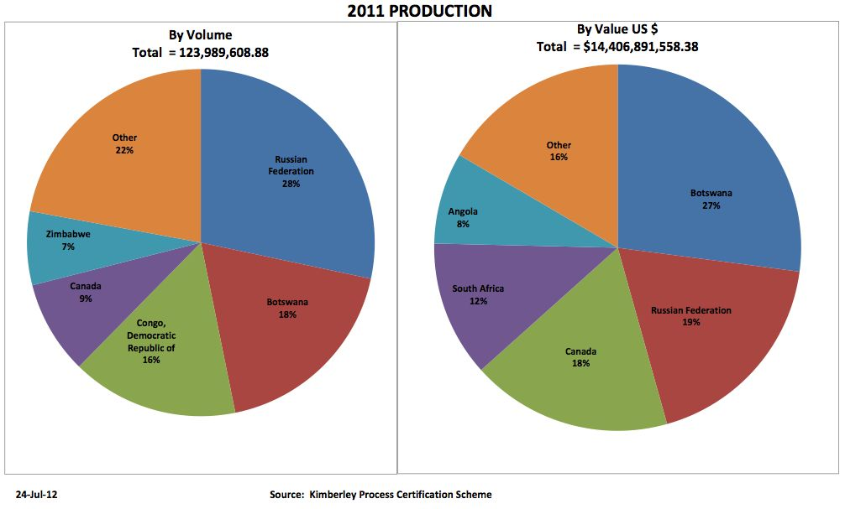
Pie charts showing the proportional contributions of countries to the global diamond production by volume and value. Click to see larger format.

Where is Diamond Found Locally?
Geologists and exploration companies had postulated for many years that Canada's north should host diamond bearing kimberlite but it wasn't until the 1980's that serious discoveries began. Today, Canada is the world's 3rd top producer of diamonds by value (representing 14% of global production), with four operating mines. The rise of Canada as a diamond producing country has had a major impact on the global industry.
In 1991 the first economic diamond-bearing kimberlite pipe was discovered in the Lac de Gras area in the Northwest Territories. This would become established in 1998 as the Ekati Mine, owned by BHP Billiton. It took just under one year for Ekati to produce its 1 millionth carat and now produces between 3 to 5 million carats annually.

A stone's throw away from Ekati (30 km to the SE) is the Diavik Diamond Mine, which officially opened its doors in 2003 and produces approximately 8 million carats annually. Canada's third economic deposit is De Beers' Snap Lake Mine, also located in the NWT. It was discovered in 1997 and started production in 2008 with an expected ~1.5 million carats to be produced annually.
De Beers' also claims ownership of Canada's fourth diamond mine, the Victor Mine, which is located in northern Ontario. It also began production in early 2008 and is expected to produce ~600,000 carats annually. Many other sites are on the verge of becoming mines, including the Jericho and Gahcho Kué Diamond Mine projects.
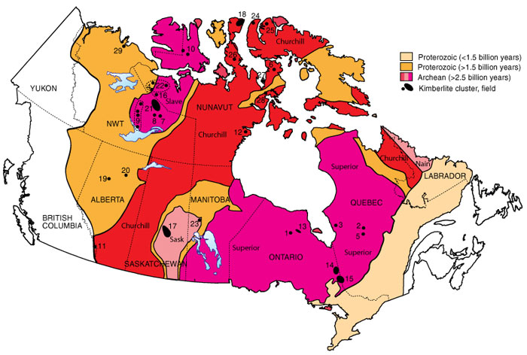
Distribution of clusters of diamond-bearing kimberlite in Canada in areas that are underlain by the Canadian Shield. Note how the majority of the known kimberlite localities are hosted in Archean Rocks older than 2.5 billion years. Localities as follows: 1) Kyle Lake cluster, Ontario; 2) Renard cluster - north Otish Mountains, Quebec; 3) Wemindji sills, Quebec; 4) Anuri, Nunavut; 5) Lac Beaver - south Otish Mountains, Quebec; 6) Aviat cluster, Melville Peninsula, Nunavut; 7) southeast Slave field, Gahcho Kué cluster, NWT; 8) southeast Slave field, Snap Lake area, NWT; 9) southwest Slave field, including the Drybones Bay and Upper Carp Lake clusters, NWT; 10) Victoria Island field (with four distinct clusters), Nunavut and NWT; 11) Crossing Creek cluster, southeast British Columbia; 12) Rankin Inlet field, Nunavut; 13) Attawapiskat field, Ontario; 14) Kirkland Lake field, Ontario; 15) Lake Timiskaming field, Ontario and Quebec; 16) Jericho cluster, Nunavut; 17) Fort à la Corne field (with six distinct clusters), Saskatchewan; 18) Somerset Island field, Nunavut; 19) Buffalo Head Hills field, Alberta; 20) Birch Mountains cluster, Alberta; 21) Lac de Gras field, NWT; 22) Coronation Gulf field, Nunavut; 23) Snow Lake - Wekusko, Manitoba; 24) Brodeur Peninsula cluster, Nunavut; 25) Baffin Island, Nunavut; 26) Boothia Peninsula, Nunavut; 27) Wales Island, Nunavut; 28) Repulse Bay cluster, Nunavut; 29) Darnley Bay cluster, NWT. Figure adapted from Kjarsgaard and Levinson (2002).

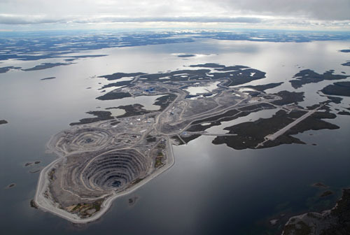

The Diavik Diamond Mine in Lac de Gras, NWT, Canada. Photo courtesy of Diavik Diamond Mine.

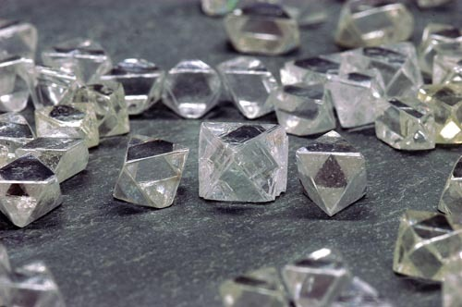

Diamonds with perfect octahedral shapes from Diavik Diamond Mine, Lac de Gras, NWT, Canada. Photo courtesy of Diavik Diamond Mine.

Why is Canada a great area for prospective kimberlite host rock diamond mineralization?
- Archean cratons stretch across Canada from Northern BC all the way across Nunavut and Quebec

Indeed, a number of advanced exploration projects and feasibility studies are underway by many different companies. Old craton is also present in the United States and Greenland. Although some discoveries have been made in both places, none are (yet) of the scale that Canadian occurrences have shown to be.

What Current Research Is Being Conducted?

Many researchers across the globe are working on projects, either directly related to diamonds or linked to kimberlite processes

What current research is being conducted?
- Diamond formation
- Kimberlite formation
- Mantle petrology
- Kimberlite emplacement

At the University of British Columbia, two research groups in the Earth and Ocean Science Department, the Mineral Deposit Research Unit and the Diamond Research Laboratory, work collaboratively on various research areas related to diamonds. Research conducted by these groups include, among others, the volcanology and genesis of the Diavik and Jericho kimberlite fields as well as isotopic and petrologic studies of the Jericho and Snap Lake kimberlite systems.

