Module A – Lesson 9 Study Notes:

What Is a Diamond and what are its Basic Qualities?

Describe the properties of a diamond.
- A diamond is pure carbon that is packed in a dense crystalline structure (3.51 g/cm³)
- Has a cubic symmetry and perfect octahedral cleavage
- Top rank in moh hardness scale with a rank of 10
- High durability
- High refractive index of 2.42
- Great dispersion (the splitting of light into the spectral colour of a rainbow)

What colour is pure diamond?
- Colourless

How can diamonds show a full range of colours found in the rainbow?
- Structural defects, elemental substitutions, and lab procedures can allow diamonds to display a full range of colours found in the rainbow

Name the four Cs of stone/gems.
- Colour, cut, clarity and carat

Many people are familiar with the 4Cs of diamonds: colour, cut, clarity and carat. These four variables are important for describing specific stones, but the qualities described by the 4Cs vary from stone to stone and we'll cover their importance later. The physical properties mentioned in this section and lesson apply (mostly) to all diamonds.

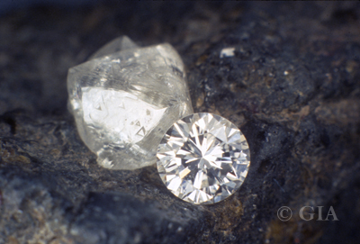
Uncut (rough) diamond octahedron (left) and cut (polished) diamond in a round brilliant shape sitting on kimberlite rock. Photo courtesy of the Gemological Institute of America.

Aside from physical properties, what other properties allow for the confirmation or rejection of a material as diamond?
- Thermal conductivity
- Electrical conductivity
- Refractive index
- Dispersion

Why does diamond have such high thermal conductivity?
- The high thermal conductivity of diamond is due to the covalent bonds of Carbon

The very high thermal conductivity of diamond is due to the covalent bonding that holds its carbon atoms together, and is three times higher than that of gold and silver, two metals known for their own high thermal conductivity. Compared to its simulants, such as cubic zirconia or quartz, diamond's thermal conduction is leaps and bounds higher. However, there are some simulants, such as moissanite, which have similar thermal conductivities and so additional properties are required to be tested.

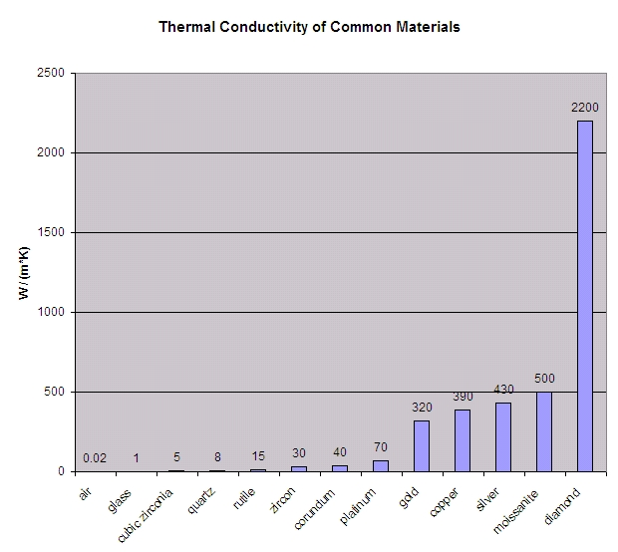
Thermal conductivities of some materials commonly encountered in the gem and jewellery industries.

The electrical conductivity of diamond is not remarkable per se, however, its low electrical conductance paired with high thermal conductance is unusual. Consequently, these properties together can also be distinctive from other materials, such as moissanite. Diamond itself is an insulator (high resistivity) whereas some of its simulants, such as moissanite, are semiconductors and will more readily pass electricity when an electrical charge is placed across the stone in question.

What Are Its Crystal Structures and Chemistry?

Crystal Structure

What class of crystallagrophy does diamond belong in?
- Isometric or cubic crystal system
- This means that the crystallographic axes are all the same length and at 90 degrees to one another

What is so beneficial about isometric arrangements?
- This arrangement allows for strong covalently bonded atoms.
- Therefore, the material is hard, durable, and dense

This differentiates diamond from many other minerals in this respect, as ionic bonding is more common than covalent bonding in minerals.

Identify and explain the flaw of diamonds crystallography.
- Imaginary flat planes within the diamond’s atomic structure display perfect cleavage
- These planes or described as 111. In other words, a plane intersects each of the three ortagonal axes at an equal unit of 1 away from the origin.
- The shape of these intersecting planes is that of an octahedron

The shape of the intersecting planes is that of an octahedron (an eight-sided polyhedron), hence the descriptor "octahedral" for its cleavage.

What must diamond cutters know before making cuts and grinding facets on polished stones?
- Diamond cutters require a good understanding of the mineral’s crystallography and where the mineral’s weaknesses lie before they can expertly cut and grind out the flat parts of the polished stones

Before the advent of analytical techniques using x-ray diffraction, information on the weakness of diamond were derived from observations that often came from gemstone cutters.

The images below show 3 views of the crystal structure of diamond, looking down a crystallographic axis, perpendicular to a perfect cleavage plane, and at an oblique angle to the cleavage plane to show the inherent weakness in the crystal. The red balls symbolize carbon atoms, and the grey bars illustrate the covalent bonds that link them together.

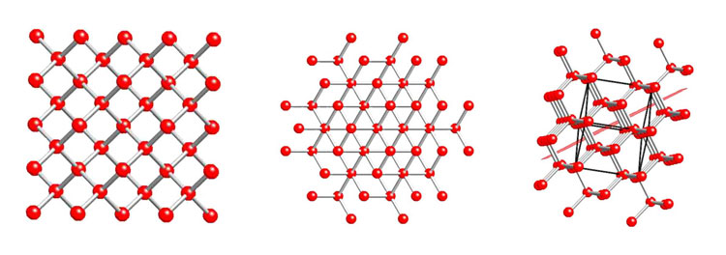

Diamond's crystal structure looking along a crystallographic axis (left image); along [111], perpendicular to the plane that characterizes (111) (middle image); and looking at an oblique angle to emphasize where the C–C bonds are the furthest apart and weakest (right image). This last view allows a cleavage plane (in light red) to be described in 3D space. The black 3D cube is the unit cell or building block for diamond.

What is a polymorphism?
- Polymorphism describes the phenomenon where materials have the same chemical composition but different crystal structures. The difference in crystal structures is what distinguishes one polymorph from another.
- For example, diamond and graphite are polymorphs of the chemical composition comprised of carbon. They have their own crystal structures.

Carbon atoms within graphite are partially covalently bonded, but strong bonds only exist in 2-dimensional sheets. Bonding between these sheets (ie, perpendicular to these planes) is of the Van der Waals type and are very weak. Graphite therefore cleaves parallel to these sheets along the (001) plane. Comparing the crystal structures of diamond and graphite using the linked 3D models below, you'll notice that in diamond the C atoms are strongly bonded to each other in 3-dimensions. Each carbon atom is bonded to 4 other carbon atoms forming a tetrahedron. When you rotate the crystal structure of graphite, you'll notice that the C atoms are only strongly bonded to each other in 2-dimensions forming infinitely linked hexagons. Each carbon atom is bonded to 3 other carbon atoms. It is between these planes that the Van der Waals bonding occurs.

Crystal Chemistry and Classification of Diamond

How do scientists classify diamonds?
- Diamonds are classified based on variations of crystal chemistry
- One classification scheme is based on the amount of nitrogen substituted into the crystal structure

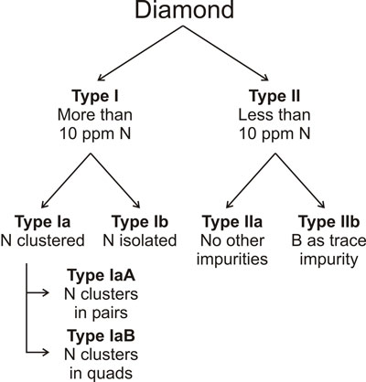
Classification of diamonds based on its crystal chemistry.

Type I diamonds have N concentrations greater than 10 ppm (and up to ~3000 ppm) and Type II diamonds have N less than 10 ppm (i.e., considered to be nitrogen-free). Type I diamonds are further grouped into two: Type Ia where N atoms occur in clusters within the diamond and Type Ib where N in the diamond structure is dispersed. In the next level, Type Ia diamonds with clustered N are subdivided into Types IaA with paired N atoms and IaB where 4 N atoms (quads) are clustered. Type II diamonds with little to no N in their crystal structure can be subdivided into Type IIa, those that are boron (B)-free and Type IIb, those that contain minute amounts of B, up to about 10 ppm.

Most diamonds (~98%) belong to the Type Ia group, those containing appreciable amounts of N that are clustered in the crystal structure. Type Ia diamonds exhibit absorption of blue light and therefore show an overall yellow hue. Type IIa is the next most common type of diamond (<2%). These diamonds have no appreciable N or B substituting for carbon in the crystal structure. Due to a lack of impurities, these diamonds tend to show the whitest colour with little to no absorption of light across the visible spectrum. Physical deformation and resulting crystal defects in Type IIa crystals give rise to most pink, purple, and brown diamonds.

Type IIb diamonds are very rare and contain minute amounts of B in the crystal structure but no appreciable N. Optically, the incorporation of boron causes most light except blue to be absorbed, imparting a blue to grey hue. These diamonds are very rare and include specimens like the Hope Diamond. Finally, Type Ib diamonds are also very rare and are characterized by appreciable N, but scattered about the crystal lattice. Diamonds of this type occur in a range in colours including yellow, brown, orange, and green or can be colourless.

Coloured Diamonds

How is colour generated in diamonds?
- Colour is generated by natural means.
- Various treatment such as irradiation also forms colours
- Crystal deformation resulting in changes to the arrangement of atoms within the crystal generates colour

As we learned in the previous section, the natural colour of diamond is primarily related to its classification type, and therefore the types of impurities that are present.

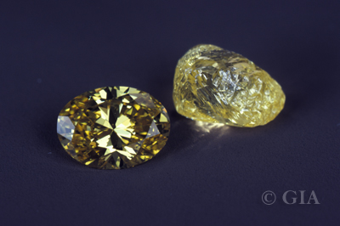
Yellow diamonds: from the rough starting material to the oval shaped-cut final product. Photo courtesy of the Gemological Institute of America.
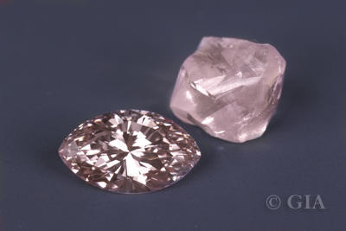

Pink diamonds: from the rough starting material to the marquise shaped-cut final product. Photo courtesy of the Gemological Institute of America.

It takes very little of an impurity or crystal defect to generate vivid colours in stones (as we will see with the conventional coloured stones). As a result, not all colours have been fully explained. This means there are likely multiple explanations for similar colours in diamond. For example, not all diamonds of a particular brown hue have acquired that hue in exactly the same way. The following table lists the colours exhibited by diamond, their most common causes, and notable specimens.
Colour | Type and Cause | Notable Specimens
Colourless | IIa, pure | Best achievable is 'D' colour, theses stones command premium prices
Blue to grey | IIb, Boron | Hope Diamond
Yellow to orange, subdued to intense | Ia, Nitrogen | Tiffany Diamond
Pink, purple, red, cognac | Usually Ia, but colour may be from deformation of crystal structure | Rob Red and Agra Diamonds.
Green | natural irradiation | The Dresden Green (a Type IIa diamond too!)
Black | abundant graphite and other opaque inclusions | Black Orlov

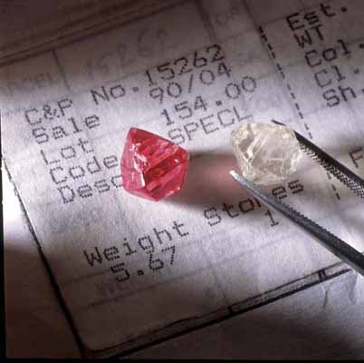
Pink and colourless diamond octahedrons from the Argyle Mines in Australia. Photo courtesy of Argyle Diamonds.

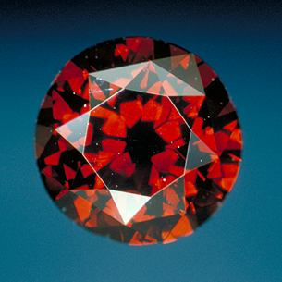
The DeYoung Red Diamond is of the finest red colour and large size (5.03 carats). It has a round brilliant cut and good clarity (Graded at VS2). Acquired through an estate auction, it was originally thought to be a normal red garnet! Photo courtesy of the Smithsonian National Museum of Natural History.
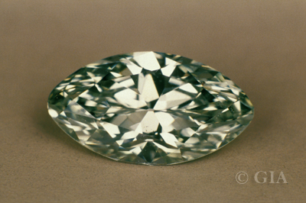
Green diamond with marquise shape. Photo courtesy of the Gemological Institute of America.
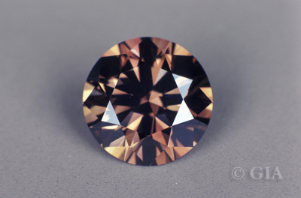
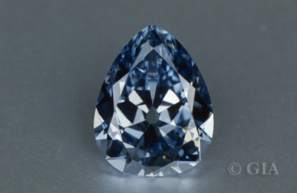
Blue diamond with pear shape. Photo courtesy of the Gemological Institute of America.

Brown diamond with round brilliant shape. Photo courtesy of the Gemological Institute of America.

Coloured diamonds are generally more expensive than colourless diamonds; however, weakly coloured stones are usually less desirable than perfectly colourless diamonds. There is a bit of subjectivity and marketing skill for pricing intermediate off-colour diamonds. Strongly coloured diamonds (of which only a dozen or so are found globally per year) on the other hand, can be extremely valuable and command top dollar per carat. In natural stones, the best reds, blues, and greens can cost on the order of ~$1,000,000 per carat or more depending on the history of a stone. The 35.56 carat Wittlesbach blue diamond recently sold at Christie's Fine Art Auctions for $24.3 million USD, about ~$680,000 per carat!
Diamonds In The Rough

What controls the external shape of any mineral?
- The shape of a mineral is controlled by its internal arrangement of atoms

The primary shapes that diamond can take are restricted in a way. Why is this?
- The carbon atoms of diamond have crystal symmetry. Therefore, the primary shapes that diamonds can take must adhere to the rules of this symmetry

What are secondary or modifying shapes?
- Shapes that can change the initial (primary shape) of a mineral through processes such as corrosion or abrasion

What would be the shape of a diamond that was cut by natural means?
- The resulting shape would be a combination of varying degrees of secondary shape modification processes and primary crystallography

What can certain morphologies indicate about a mineral?
- The mineral’s specific growth environments and geological history.

Identify the most common shapes of diamonds.
- Octahedron
- Cubes
- Combinations of cube and octahedron (octahedron modified by cube faces or cube modified by octahedron faces)

Identify the uncommon shapes of diamonds
- Twinned
- Flat tubular form called a Macle

Why are diamonds harder than other minerals?
- Diamonds tend to be harder than other minerals because they are formed in polycrystalline aggregates whereas other minerals are often formed in monocrystalline aggregates

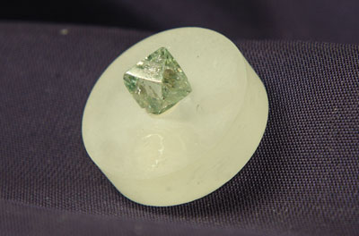
Diamond octahedron, as exhibited at the UBC Pacific Museum of the Earth.

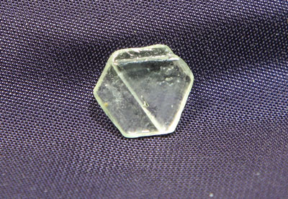
Diamond macle with a thin tabular shape, as exhibited at the UBC Pacific Museum of the Earth.
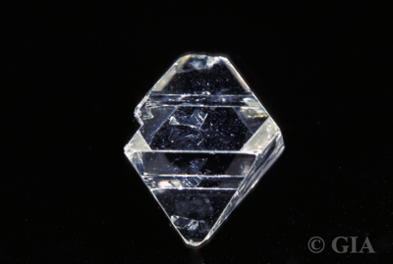
Twinned diamond octahedron. Photo courtesy of the Gemological Institute of America.

What force(s) are shown to be a strong determining factor of diamond morphology?
- Temperature
- Higher temperatures yield octahedral shapes
- Saturation conditions in which the diamond grows in
- Under supersaturated conditions, diamonds grow too fast and subsequently result in cloudy crystals or fibre-like overgrowths

Secondary modifications of diamonds often occur within two distinct phases of the diamond’s life. Name and describe them.
- The first modification takes place after the growth stage, during transportation of the mineral to the surface
- In this phase, the modification includes the corrosion of the diamond only its preferential weaknesses
- The second modification takes place during the transport of the mineral while on the Earth’s surface
- In this phase, the modification is primarily due to abrasion during river or alluvial transport

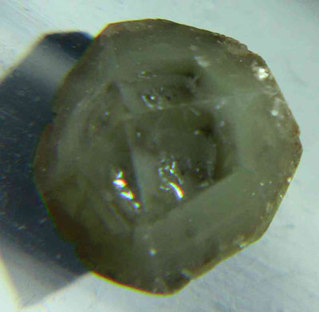
This Canadian diamond grew initially as a unincluded (clean) crystal but later growth periods resulted in a murky low quality outer core. Dirty diamonds, called bort, are often used to impregnate the diamond discs that faceters use.

Describe the end product of corrosive modifications.
- Corrosive modifications or unstable growth environments give rise to rounded edges of primary crystal growths (usually octahedrons)
- The end product is a diamond with strongly rounded features that close to resemble a beach ball

Sometimes there will be multiple growth and corrosion events in a diamond crystal's history, which can lead to highly complex and intricate shapes.

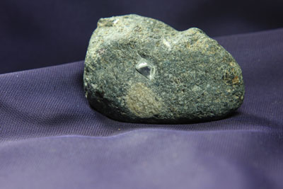
An octahedral diamond like this one would have been slightly resorbed (corroded) during magmatic transport but could not have endured mechanical abrasion during alluvial transport since it is still encased in rock. Exhibited at the UBC Pacific Museum of the Earth.

Describe the end product of abrasive or alluvial modifications
- Due to the high durability and hardness of diamond only scratched surfaces and abraded crystal structures are consequent of these above surface processes. These modifications are the most common above the surface

Modifications during transport of diamonds in alluvial settings are minor when compared to modifications during magmatic transport.

Because of the good durability and high hardness of diamonds, it can take many millions of years to significantly abrade a diamond from processes on the Earth's surface.

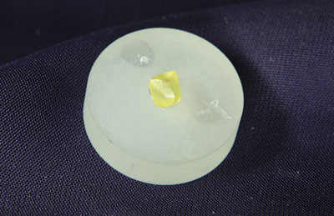
Yellow diamond (mounted on epoxy puck) showing strong resorption features. Exhibited at the UBC Pacific Museum of the Earth.
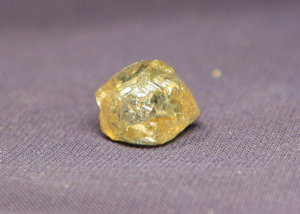

Yellow tinted diamond with resorption and stepped growth features. Exhibited at the UBC Pacific Museum of the Earth.

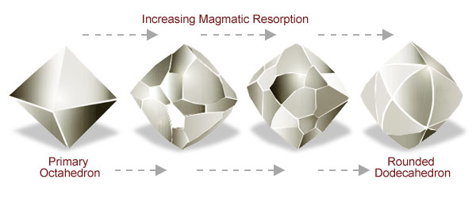
Secondary shapes through increasing degrees of magmatic resorption. From left to right: 1) sharp edged primary octahedron (100% mass preserved); 2) octahedron with dodecahedral faces; 3) rounded dodecahedron with residual octahedral faces; 4) rounded dodecahedron (less than 55% of original mass preserved).
How is Diamond Recognized and Distinguished from Other Materials?
Diamond has some unique properties that distinguish it from other minerals or gem material fairly readily.

Why is it important to be able to recognize and distinguish diamond from other material?
- Diamonds are very valuable. Therefore, people are always trying to find diamond imitations to make a quick dollar

Identify the individual properties that are commonly tested to determine whether a mineral is diamond or not.
- The first property tested is the minerals hardness. To test hardness the mineral is scratched. No minerals will scratch diamond. The flaw with this test is that something must be scratched.

Ideally, non-destructive tests should be used

- Most professional gemologists test the minerals electrical and thermal conductivities

Specifically, diamond testers have been developed to measure thermal conductivity for stones mounted in jewellery.

Electrical conductivity is used to discern diamond from other high thermal conductivity materials, such as moissanite.

- Refractive index
- Dispersion
- The minerals isometric/cubic optic nature
- Diamonds repel water and stick slightly to grease

Diamond also repels water and sticks slightly to grease – a property exploited in processing diamond ore.

- Some diamonds also fluoresce under UV light.

Testing for fluorescence under UV light only reveals information 'about' diamond, not whether the material tested 'is' a diamond.

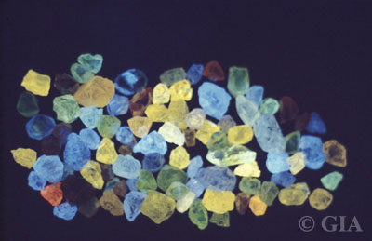
Fluorescence of rough diamonds under UV light. Photo courtesy of the Gemological Institute of America.
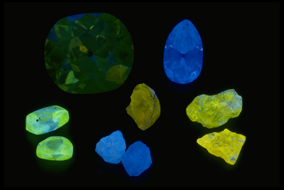
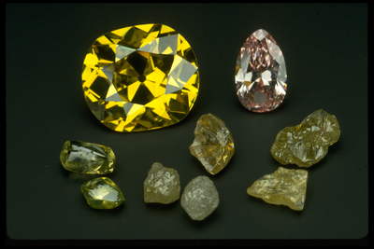
Fluorescence of cut and rough diamonds under normal and UV light. Photo courtesy of the Smithsonian Institute.

Name common materials used to imitate diamonds and identify their properties relative to diamond.
- Mossanite (higher dispersion, greater refractive indices, not isometric)
- Cubic Zirconia (lower thermal conductivity)
- Glass (lower thermal conductivity)
- Strontium Titanite (lower thermal conductivity)
- Yttrium-aluminum-garnet (lower thermal conductivity)

From this listing, it is clear that thermal conductivity is the best property to test for since it rules out many possible imitations.

What has been causing problems in the identification and characterizations of gem materials?
- Nanocrystalline diamond has been applied onto the surface of various gems and imitation material
- This is done to modify colour and improve durability but has caused problems in gem material identification and characterization.

The Scientific Method and Diamond Testing?
Let's see how to apply the Scientific Method (refer to Lesson 5.4) to identification a gemstone of unknown identity. In this example we'll try to identify a brilliant-cut gemstone mounted in a ring that weighs 0.5 carats:
- Compile observations: Making detailed unambiguous and clear observations is vital to any scientific investigation whether that is recording results in a laboratory or describing the geology and mineralogy of a gem bearing rock.
  - Our initial observations: The mounted gemstone is colourless, transparent, reflective, and shows relative high dispersion (fire).
- Form a Hypothesis: This is a provisional theory to explain the observations made.
  - Our provisional hypothesis: This gemstone is either a diamond or diamond simulant.
- Test the Hypothesis: Procedures or tests used to collect data in order to determine if the hypothesis is correct or not.
  - Our tests: Since the gemstone is cut and mounted in a piece of jewellery, it reduces the range of properties that are easy to test. For example, hardness would damage the gemstone, and density would require the gemstone to be loose (not attached to the jewellery). Consequently, we'll test two diagnostic physical properties; refractive index and thermal conductivity.
  - Our results: Refractive Index = 2.42, Thermal Conductivity = 22 W/cm·K (very high)
  - Our conclusion: The results indicate that the gemstone is a diamond since the compiled data eliminate the most common diamond simulants from 'the list' and are within the accepted range for diamond.
- Repeated testing, if needed, on the hypothesis will aid in enhancing the confidence of your conclusions.
  - Do you feel that our test results confirm or reject the hypothesis that this is a diamond?
  - If the tests were inconclusive or reject the hypothesis that the identity of the unknown is diamond, what other properties could be tested?
What Are Common Treatments for Diamond?
Gemstones have been treated since antiquity in order to improve their shine, polish, aesthetics, colour and ultimately their value. The world of diamond treatments and imitations is vast and many diamonds are treated to improve their clarity and/or modify their colour. Because of the high quality of new diamond treatments it is a continual challenge for gemologists to keep up with new techniques and the fingerprints they leave. Overton and Shigley (2008) published an article titled "History of Diamond Treatments", which is summarized in the text below.
Diamond-specific treatments are believed to have originated in India well before the 2nd century BCE. These treatments were simple and likely consisted of coatings and dyes applied directly to the surface of the stone in order to neutralize an undesirable body colour (e.g., yellow/brown) or enhance a desirable one (e.g., blue). Archaeological evidence also indicates the use of foil backings in Roman rings to give the stone an apparent colour. Modern diamond treatment techniques, however, did not really take off until the 1950’s.
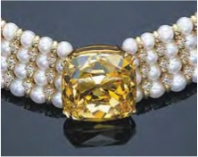
The Deepdene diamond (currently 104.53 ct), which was irradiated and heated in 1955 to intensify its yellow hue, is perhaps the most famous treated-color diamond in the world. Figure from Overton and Shigley (2008).

Identify the modern diamond colour-alternating techniques.
- HPHT annealing
- LPHT annealing
- Irradiation

HPHT annealing is the most important and prominently used process.

Describe the colour-altering process of irradiation
- This technique creates vacancies within the atomic lattices of the diamond
- Vacancies generate colour centers that absorb light in the visible and near infrared portions of the electromagnetic spectrum

These treatments of diamonds were first employed around the turn of the 20th century and the process generally involved exposure of stones to the element radium

What are the flaws of radium exposed irradiation?
- Limited to a bluish to green colouration
- Takes several months of exposure to achieve the colour.
- Limited to a very thin outer layer of the stone
- Leaves residual radioactivity in the stone that could last for hundreds of years.

What kind of irradiation does not exhibit these flaws?
- Neutron radiation

With the advent of neutron radiation, the defects (and therefore colour) were able to be imparted throughout the entire stone and leave no detectable radioactivity.

Green-coloured diamonds can also be produced naturally if the stones are situated in proximity to certain minerals which emit natural radiation.

What happens when diamond is exposed to too high of temperatures and pressure?
- A process called graphitization occurs.
- Graphitization converts diamond into graphite

HPHT annealing is by far the most common colour treatment for diamonds. By employing this technique, technicians are able to increase the temperature of a diamond while maintaining a very high pressure, and preventing graphitization (conversion of diamond to graphite) of the stone.

Describe the colour-altering process of HPHT annealing
- HPHT leaves profound effects on the crystal structure which alters the combination states nitrogen impurities (ie: Type Ia to Type Ib or vise versa).
- HPHT “heals” lattices
- A wide variety of colours can be produced depending on the starting type of nitrogen impurity and the exact temperature and pressure used.

What is often the result of HPHT annealing?
- Removal or enhancement of the dominant existing colour body
- Other colours such as blue, green, pink, and yellow can be produced indirectly after the dominant existing colour (brown) is removed. Thus, other colour centres are no longer obscured by the dominant colour

The most common result of this method is the removal of a brown body colour; and removing or enhancing an existing yellow colour. Other colours such as blue, green, pink and yellow can be produced indirectly after the dominant brown colour is removed and other colour centres are no longer obscured.

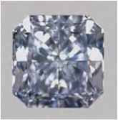
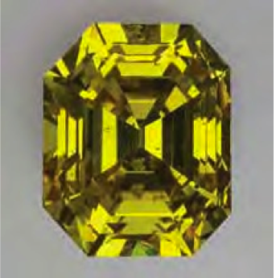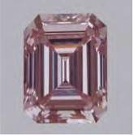

These examples illustrate some of the fancy colors that can be produced by HPHT treatment of type Ia (left), type IIa (center), and type IIb (right) diamonds. Figure from Overton and Shigley (2008).
Describe the colour-altering process of LPHT.
- Similar to HPHT except graphitization is encouraged at low pressures
- LPHT is often the technique chosen for highly-flawed stones with numerous inclusions and fractures
- By increasing the temperature at a relatively low pressure, the crystal structure of the diamond starts to change to graphite along the fractures

What is often the result of LPHT?
- A black/dark stone appearance is typical.
- This hides the internal imperfections of the stone

Combinations of all three colour treatments are possible. This gives researchers and technicians the ability to produce virtually the entire colour spectrum of diamond depending on the starting stone type and existing colour centres.

What is the most common colour treatment pairing?
- HPHT and irradiation

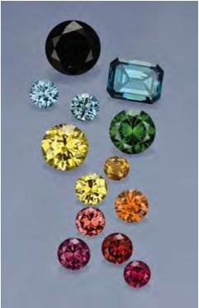
A broad array of colors are currently achievable by exposure to radiation and high temperatures+pressures. All of these diamond (0.12–1.38 ct) were color treated by irradiation and— except for the black, blue, and green stones—subsequent heat treatment. Figure from Overton and Shigley (2008).

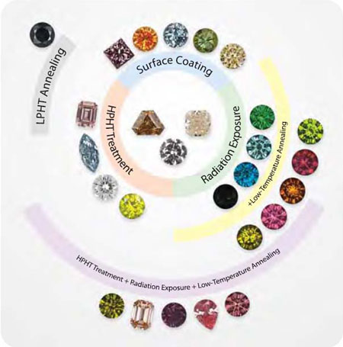
This figure shows a full range of colours that can be produced in diamonds through a range of diamond treatments. Starting stones (in the center) can be clean or 'dirty' depending on the subsequent treatment(s) and the hopeful outcome. HPHT = High Pressure High Temperature, LPHT = Low Pressure High Temperature. Figure by C. Breeding in Overton and Shigley (2008).

Other treatments are often applied to diamonds (and other gems) that are not aimed towards colour, but are used to treat the stone’s clarity.

Name three processes done to treat clarity.
- Glass-filling
- Laser-drilling
- Acid-boiling

Describe the process of glass-filling.
- This technique fills in surface-reaching fractures and flaws to improve the overall clarity of the stone
- The glass needs to be of appropriate refractive index in order to reduce the visibility of a fracture within the diamond
- Diamond’s refractive index is 2.435

In modern treatments, lead-bismuthate glass is typically used which has a refractive index greater than 2 depending on its composition.

Describe the process of laser-drilling.
- A high powered laser is used to drill into the diamond to reach inclusions that are sealed from the surface of the stone

Describe the process of acid-bath.
- Once the inclusion is reached, the diamond is put into an acid bath to dissolve or bleach the inclusion

These three techniques are commonly used in combination with each other. Identify the steps involved in the entire process of treating an inclusion within the surface of the stone.
- Laser-drilling -> acid bath -> glass-filling (to fill in the drill hole or pit)

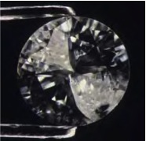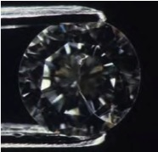

Introduction of a glass filler into this 0.30 ct diamond's cleavage cracks produced a dramatic change in apparent clarity (before filling, left; after filling, right). Figure from Overton and Shigley (2008).

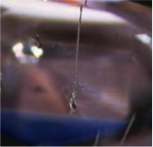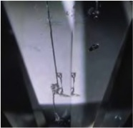

The laser drill holes in these diamonds serve as a conduit from the diamond's surface to mineral inclusions, which have been lightened or removed by acid boiling. Magnified 10X. Figure from Overton and Shigley (2008).

Although the main objective of treating gemstones is to hide or remove imperfections or undesirable features, it is important for merchants to list all the treatments that have been applied.

Why is it important for merchants to list all treatments that have been applied to a gemstone?
- Failure to do so could deceive the buyers. Buyers may apply further treatment which may damage the stone (i.e. HPHT on a diamond with glass fillings).

Can Diamond be Produced Synthetically?

Diamonds have been produced synthetically since the early 20th century. However, early experiments were only able to produce small diamonds that were better suited for industrial applications rather than as gemstones. It hasn't been until recently that producers have been able to move away from industrial quality into gem quality stones.

Identify the two methods used to grow gem quality synthetic diamonds.
- Carbon Vapour Deposition (CVD)
- HPHT

How big are these synthetic diamonds?
- 0.5 to 25 carats

Name synthetic diamond producing companies.
- Gemesis, Element 6, and Apollo

Companies producing synthetic diamonds (e.g., Gemesis, Element Six, and Apollo) often provide authenticity certificates for their products and inscribe the girdles (the 'waist' of a cut diamond) with identification numbers.

Describe the HPHT method for growing synthetic diamonds.
- This method imitates the natural environment where natural diamonds grow (60000 atm and 1500 degrees).
- Seed diamond crystals are placed in a chamber. The chamber is then flooded with molten carbon and metal catalysts. These seed diamond crystals act as growing points where C atoms attach to as the diamond grows
- The growth process is fairly slow
- 1 carat is produced daily using this method
- Using faceted crystals will produce 0.5 per day

Describe the CVD method for growing synthetic diamonds.
- Growth is conducted under low pressure.
- A seed diamond crystal is also placed in a chamber and used as a nucleation point for the diamond to grow
- The key to this method is to flow hydrogen and methane gas through the chamber with a plasma flame in the flow path. This will destabilize the methane to release carbon. Carbon attaches to the nucleation point
- Single 0.5 carat crystals are produced using this method.

